Intro from worksheet:
Astronauts workout on a Treadmill with Vibration Isolation Stabilization System (TIVS) to allow them to workout in space. These treadmills feature elastic straps connecting a harness on the astronaut's shoulders and waist to the sides of the treadmill. These straps prevent the runner from launching across the space station with the first hard step. The vibration isolation stabilization system is underneath the treadmill to prevent the reaction forces creating movement that could interfere with other things happening on the space station.
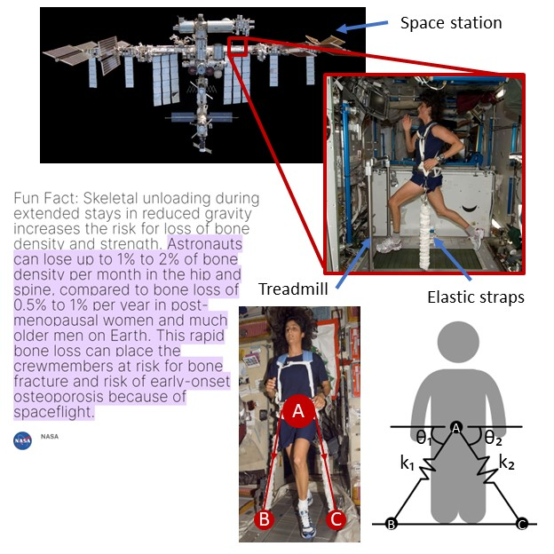

Bone loss in space: https://www.nasa.gov/directorates/esdmd/hhp/bone-and-mineral-evaluation-and-analysis/ This article has two good YouTube videos in it.
Running in space: https://www.youtube.com/watch?v=Pcnz6u5yBdk
Image citation:
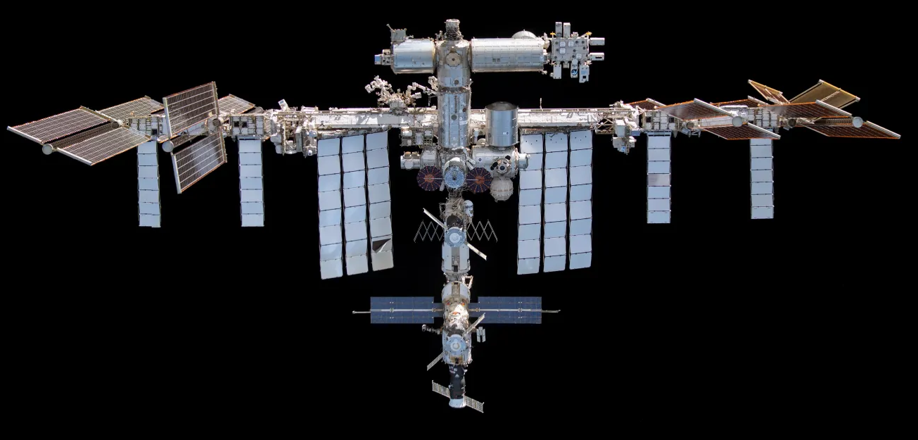 https://www.nasa.gov/international-space-station/

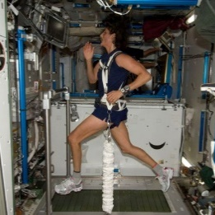 https://en.wikipedia.org/wiki/Space_Marathon_%28in_space%29

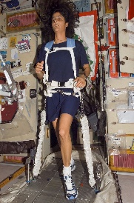 https://en.m.wikipedia.org/wiki/File:TVIS_treadmill.jpg

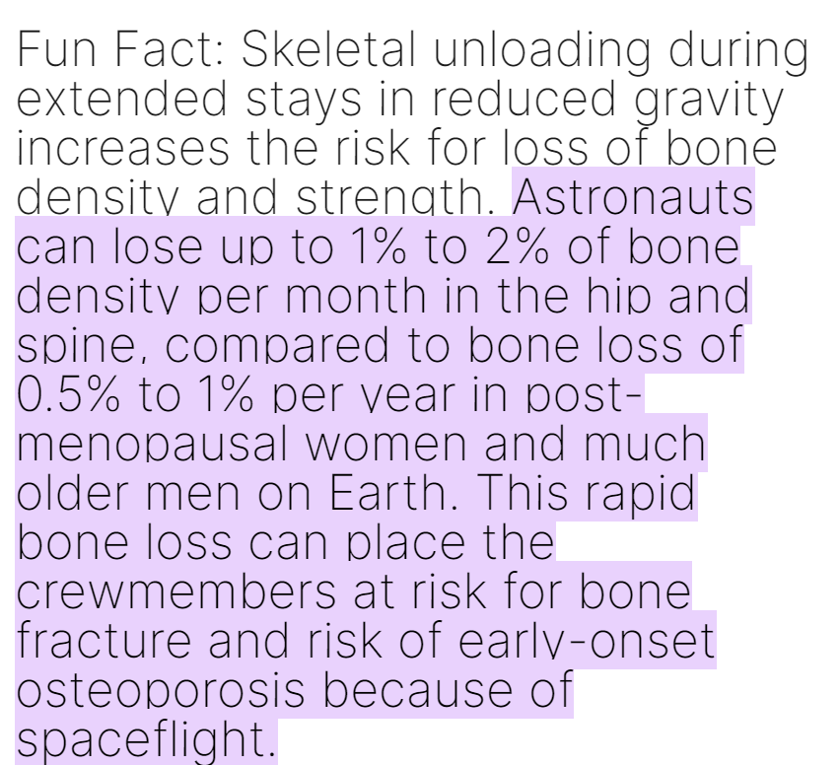https://www.nasa.gov/directorates/esdmd/hhp/bone-and-mineral-evaluation-and-analysis/#:~:text=Fun%20Fact%3A%20Skeletal%20unloading%20during,much%20older%20men%20on%20Earth. (screenshot from webpage)

