ME170 Lecture Class Assignment #15 DUE April 19th, 8pm
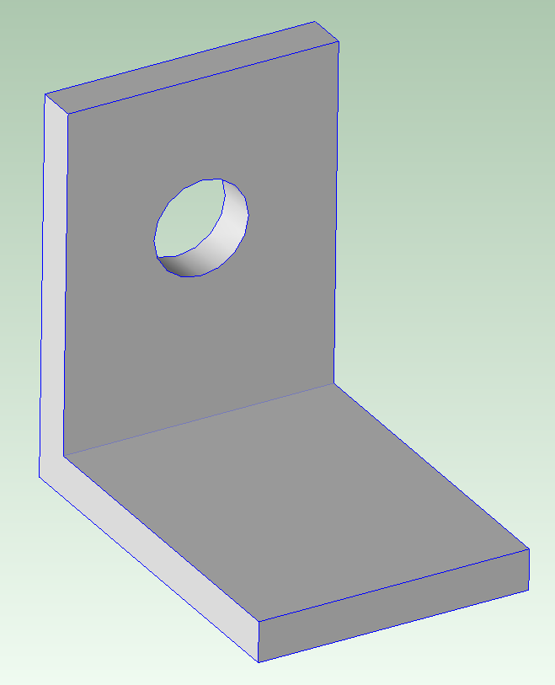
1. Machining from Rectangular Bar Stock:
What is the Material cost?
What is the Fully Burdened Cost?
What is the Investment Cost (hard tooling) ?

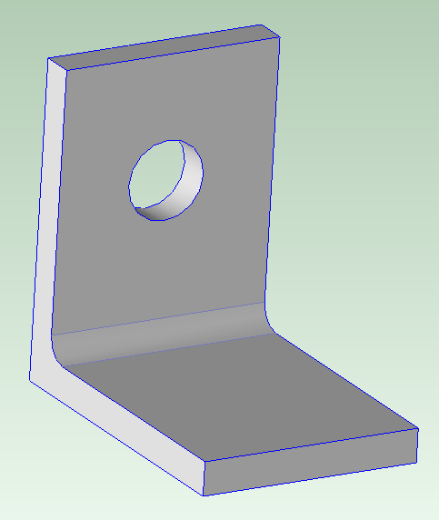
2. Machining from Angle Iron:
What is the Material cost?
What is the Fully Burdened Cost?
What is the Investment Cost (hard tooling)?

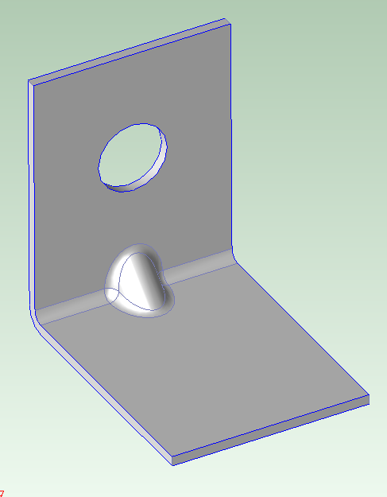
3. Sheet Metal:
What is the Material cost?
What is the Fully Burdened Cost?
Material Nesting - one part per strip:
Material Nesting – two parts mirrored per strip:
What is the Investment Cost (hard tooling)?

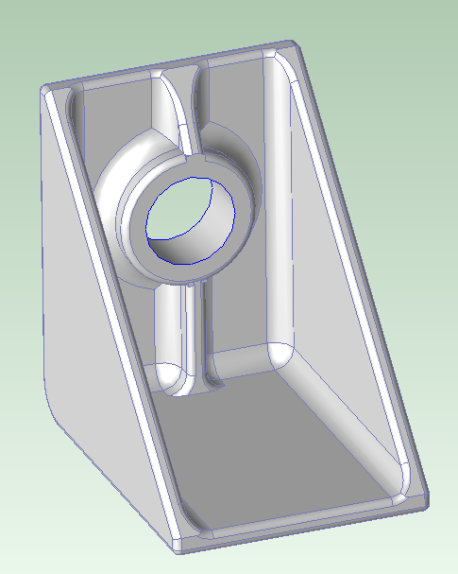4. Injection Molding: for comparison
The Material cost:
The Fully Burdened Cost (optimized number of cavities)?
The Investment Cost (hard tooling – optimized)?

