CS440/ECE448 Spring 2018 Exam 2 Review

Be able to define the following terms and answer basic questions about them:
- Probability
  - Random variables
  - Axioms of probability
  - Joint, marginal, conditional probability distributions
  - Independence and conditional independence
  - Bayes rule
- Bayesian inference
  - Likelihood, prior, posterior
  - Maximum likelihood (ML), maximum a posteriori (MAP) inference
  - Naïve Bayes
  - Parameter learning
  - Laplace smoothing
- Machine learning
  - Naïve Bayes as a linear classifier
  - The perceptron learning rule; multi-class perceptrons
  - Differentiable perceptron (two-class)
  - Training, testing, generalization, overfitting, regularization
  - Different types of supervision (supervised, unsupervised, self-supervised, etc.)
  - Neural networks (incl. training procedure)
  - Deep convolutional neural networks

- Bayesian networks
  - Structure and parameters
  - Conditional independence assumptions
  - Calculating joint and conditional probabilities
  - The sum-product algorithm for trees
  - The junction tree/join tree algorithm for almost-tree graphs
  - Complexity of inference: the SAT problem as a Bayes net
  - Parameter estimation for fully observable problems
  - Parameter estimation for partially observable problems: expectation maximization
  - Hidden Markov models (definition, types of inference problems)

- Markov decision processes and reinforcement learning
  - Markov assumption, transition model, policy
  - Bellman equation
  - Value iteration, policy iteration
  - Model-based vs. model-free approaches
  - Exploration vs. exploitation
  - Q-learning: TD and SARSA
  - Deep Q-learning: Q(s,a) as a function, the advantage function A(s,a)
  - Policy learning: softmax function, actor-critic network
  - Imitation learning: policy imitation
Sample exam questions
- Use the axioms of probability to prove that P(¬A) = 1 – P(A).

- You have a friend with two children, and at least one is a boy. What is the probability that both are boys?
- Consider the following joint probability distribution:
P(A = true, B = true) = 0.12
P(A = true, B = false) = 0.18
P(A = false, B = true) = 0.28
P(A = false, B = false) = 0.42
What are the marginal distributions of A and B? Are A and B independent and why?
- A friend who works in a big city owns two cars, one small and one large. Three-quarters of the time he drives the small car to work, and one-quarter of the time he drives the large car. If he takes the small car, he usually has little trouble parking, and so is at work on time with probability 0.9. If he takes the large car, he is at work on time with probability 0.6. Given that he was on time on a particular morning, what is the probability that he drove the small car?
- We have a bag of three biased coins, a, b, and c, with probabilities of coming up heads of 20%, 60%, and 80%, respectively. One coin is drawn randomly from the bag (with equal likelihood of drawing each of the three coins), and then the coin is flipped three times to generate the outcomes X₁, X₂, and X₃.
  - Draw the Bayesian network corresponding to this setup and define the necessary conditional probability tables (CPTs).
  - Calculate which coin was most likely to have been drawn from the bag if the observed flips come out heads twice and tails once.

- Consider the data points in the table below representing a set of seven patients with up to three different symptoms. We want to use the Naive Bayes assumption to diagnose whether a person has the flu based on the symptoms.
Sore Throat | Stomachache | Fever | Flu
No | No | No | No
No | No | Yes | Yes
No | Yes | No | No
Yes | No | No | No
Yes | No | Yes | Yes
Yes | Yes | No | Yes
Yes | Yes | Yes | No

  - Show the structure of the network and the conditional probability tables.
  - If a person has stomachache and fever, but no sore throat, what is the probability of him or her having the flu (according to your learned naive Bayes classifier)?

- Consider training a perceptron for the same binary classification problem. Treat every “yes” as +1, treat every “no” as -1. Start with the weight vector equal to [0,0,0] and the bias equal to 0. Break ties in favor of the decision “no flu.”
Sore Throat | Stomachache | Fever | Flu
No | No | No | No
No | No | Yes | Yes
No | Yes | No | No
Yes | No | No | No
Yes | No | Yes | Yes
Yes | Yes | No | Yes
Yes | Yes | Yes | No

Assume that examples are presented one after the other, in the order shown in the table, and that the weight vector and bias are adapted after every example, with a learning rate of 1.0. Provide a table with seven rows; in the nth row, show the weight vector and bias after presentation of the nth training example.

- Consider a Naïve Bayes classifier with 100 feature dimensions. The label Y is binary with P(Y=0) = P(Y=1) = 0.5. All features are binary, and have the same conditional probabilities: P(X_{i}=1|Y=0) = a and P(X_{i}=1|Y=1) = b for i=1, ..., 100. Given an item X with alternating feature values (X₁=1, X₂=0, X₃=1, ..., X₁₀₀=0), compute P(Y=1|X).

- Consider the Bayesian network with the following structure and conditional probability tables (all variables are binary):
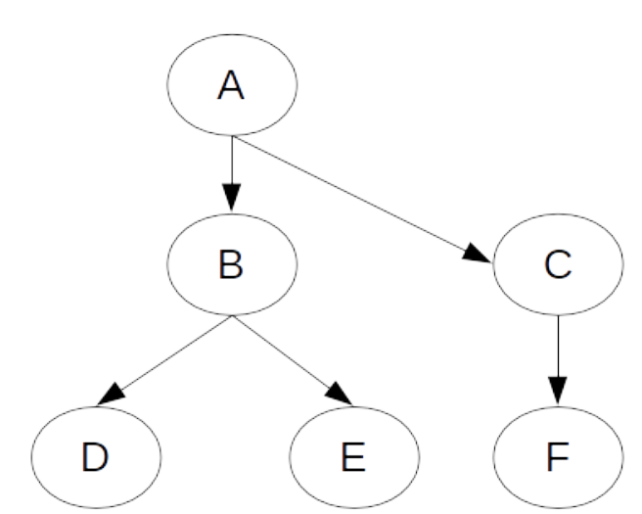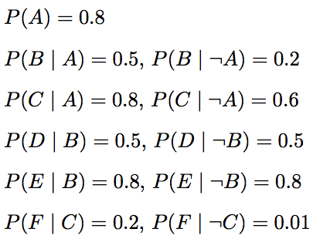
= 0.4
= 0.6

  - Is this a polytree?

  - Are D and E independent? Are they conditionally independent given B?

  - If you did not know the Bayesian network, how many numbers would you need to represent the full joint probability table?

  - If the variables were ternary instead of binary, how many values would you need to represent the full joint probability table and the conditional probability tables, respectively?

  - Write down the expression for the joint probability of all the variables in the network.

  - Find P(A = 0, B = 1, C = 1, D = 0).

  - Find P(B | A = 1, D = 0).

  - Using the sum-product algorithm, it is possible to compute the joint probability table P(C,E) using a series of sum-product operations in which the total computational complexity of each operation is never more than 8 (i.e., there are never more than 8 entries in the probability table after a product operation, and a sum operation never involves more than 8 additions). Write a series of sum-product operations that satisfies this constraint and results in the correct answer for the table P(C,E).

- Two astronomers in different parts of the world make measurements M₁ and M₂ of the number of stars N in some small region of the sky, using their telescopes. Normally, there is a small probability e of error by up to one star in each direction (and if there is such an error, it is equally likely to be +1 or -1). Each telescope can also (with a much smaller probability f) be badly out of focus (events F₁ and F₂), in which case the scientist will undercount by three or more stars (or if N is less than 3, fail to detect any stars at all).
  - Draw a network for this problem and show the conditional probability tables.
  - Write out the conditional distributions for P(M₁ | N) for the case where N ∈ {1,2,3} and M₁ ∈ {0,1,2,3,4}. Each entry in the conditional distribution table should be expressed as a function of the parameters e and/or f.

- In micro-blackjack, you repeatedly draw a card (with replacement) that is equally likely to be a 2, 3, or 4. You can either Draw or Stop if the total score of the cards you have drawn is less than 6. Otherwise, you must Stop. When you Stop, your utility is equal to your total score (up to 5), or zero if you get a total of 6 or higher. When you Draw, you receive no utility. There is no discount (γ = 1).
  - What are the states and the actions for this MDP?
  - What is the transition function and the reward function for this MDP?
  - Give the optimal policy for this MDP.
  - What is the smallest number of rounds of value iteration after which estimated utility of each state in this MDP will converge to its true utility (if value iteration will never converge exactly, state so).

- In K-Means clustering, a dataset gets partitioned into “k” clusters where the algorithm tries to cluster similar data entries. Is this a type of supervised, unsupervised, semi-supervised, or active learning? Why?

- We want to implement a classifier that takes two input values, where each value is either 0, 1 or 2, and outputs a 1 if at least one of the two inputs has value 2; otherwise it outputs a 0. Can this function be learned by a linear classifier? If so, construct a linear classifier that does it; if not, why not.

- You are a Hollywood producer. You have a script in your hand and you want to make a movie. Before starting, however, you want to predict if the film you want to make will rake in huge profits, or utterly fail at the box office. You hire two critics A and B to read the script and rate it on a scale of 1 to 5 (assume only integer scores). Each critic reads it independently and announces their verdict. Of course, the critics might be biased and/or not perfect, therefore you may not be able to simply average their scores. Instead, you decide to use a perceptron to classify your data. The features and labels of your perceptron are defined as follows:
FEATURES: There are three features: a constant bias, and the two reviewer scores. Thus f₀ = 1 (a constant bias), f₁ = score given by reviewer A, and f₂ = score given by reviewer B.
LABELS: The label is Y=+1 if the movie returns a profit, Y=-1 otherwise.
- Suppose that you are given the following five training examples, as shown in Table 1. The initial weights are $w_{0}=-1, w_{1}=0, w_{2}=0$. Suppose you train using the examples in Table 1 with a learning rate of $α=1$. The perceptron is trained sequentially: each row in the table is classified, then the perceptron weights are either updated, or not updated, depending on the classification result. After this process has been performed for one row of the table, the updated weights are then used to classify the next row of the table, and so on. After learning has gone through the table once, what are the weights?
Movie Name | A | B | Profit
Pellet Power | 1 | 1 | No
Ghosts! | 3 | 2 | Yes
Pac is bac | 4 | 5 | No
Not a Pizza | 3 | 4 | Yes
Endless Maze | 2 | 3 | Yes

- Instead of Table 1, suppose instead that you want to learn a perceptron that will always output $\hat{Y}=+1$ when the total of the two reviewer scores is more than 8, and $\hat{Y}=-1$ otherwise. Is this possible? If so, what are the weights w₀, w₁, and w₂ that will make this possible?

- Instead of either Table 1 or part (b), suppose you want to learn a perceptron that will always output $\hat{Y}=+1$ when the two reviewers agree (when their scores are exactly the same), and will output $\hat{Y}=-1$ otherwise. Is this possible? If so, what are the weights w₀, w₁ and w₂ that will make this possible?

- Explain the advantages of using convolutional neural networks for images (as opposed to fully connected networks).

- When we apply the Q-learning algorithm to learn the state-action value function, one big problem in practice may be that the state space of the problem is continuous and high-dimensional. Discuss at least two possible methods to address this.

- Suppose you have an MDP with N possible states, and with M possible actions. Specify, in terms of M and N, the space complexity TD learning and SARSA learning.

- In an actor-critic deep learning paradigm, what does the actor compute? What does the critic compute? How are these two types of information combined to estimate the value of a state?

