Final Report for ECE 445, Senior Design, Spring 2024
7 March 2024
Project No. 11
Luting Lei
Siyi Li
Tianle Wu
Xiaoxiao Pan
By

Automated Chinese Traditional Chimes with Song
Contents

1. Introduction 1
1.1 Problem 1
1.2 Solution 1
1.3 Visual Aid 1
1.4 High-level requirements list 1
2. Design 2
2.1 Block diagram 2
2.2 Subsystem overview 2
2.2.1 Melody Recognition and Generating System 2
2.2.2 Electrical Control System 2
2.2.3 Mechanical System 2
2.3 Subsystem Requirements 3
2.3.1 Melody Recognition and Generating System 3
2.3.2 Electrical Control System 3
2.3.3 Mechanical System 3
2.4 Tolerance Analysis 3
3. Ethics and Safety 5
References 6

1. Introduction

1.1 Problem
Few people play Chinese traditional Chimes, and they're often stuck in traditional music, which seems to be a barrier of traditional instruments. Additionally, the lack of research on blending modern music with Chinese traditional genres is another challenge. By addressing these issues, the project contributes to the inheritance of Chinese culture in a modern context and innovatively researches the possible music style transformation between model music and traditional Chinese music.

1.2 Solution
The project aims to revive the melody played by smartphones in the Chinese traditional Chimes. We will first recognize a melody from a smartphone and generate the adapted melody for chimes, then transform the melody to signals, and then control a mechanical design to ring the chimes with the motor.

1.3 Visual Aid
The project aims to revive the melody played by smartphones in the Chinese traditional Chimes. We will first recognize a melody from a smartphone and generate the adapted melody for chimes, then transform the melody to signals, and then control a mechanical design to ring the chimes with the motor. The diagram for visual aid is shown in Figure 1.
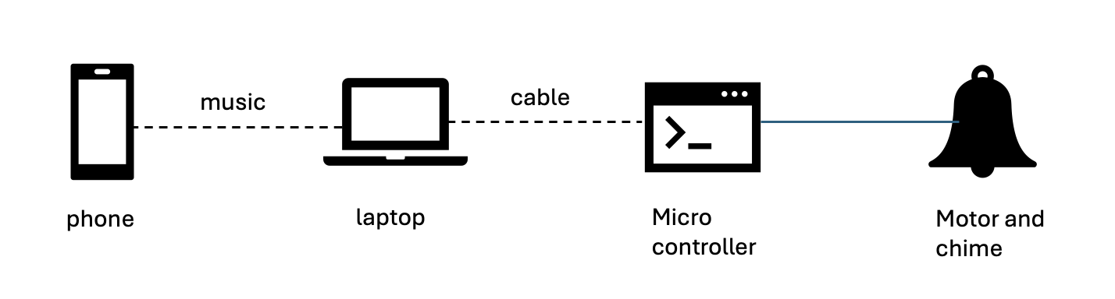
Figure 1 visual aid

1.4 High-level requirements list
1. Training a machine learning model that could correctly recognize the melody from a smartphone (with noise). Apply the algorithm to adapt the recognized melody for chimes play.
2. Generating correct position and time signals and successfully controlling motor operation.
3. Easy and flexible structure for hammer ringing every chime.
4. Make the adapted music pleasant and make the whole structure as simple as possible.

2. Design

2.1 Block diagram
The block diagram of our design is shown in Figure 2.
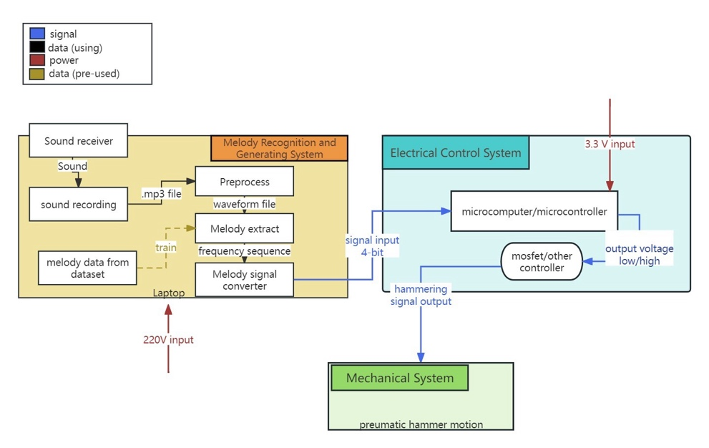
Figure 2 Block Diagram

2.2 Subsystem overview

2.2.1 Melody Recognition and Generating System
The model will be trained to automatically recognize the main melody from a period of sound played by the smartphone and adapt to Chinese traditional style for chimes.
Firstly, we will record the sound and generate an mp3 file. Then load it to python, and further process it and generate the control signals for the microcontroller. If we could finish this goal successfully, we will try to make this process more accurate and minimize the time consumption for recognizing melodies.

2.2.2 Electrical Control System
The system will transform the generated melody to location and time signals (for different pitches and rhythms) and build a microcontroller.
Based on the information obtained from python, we could generate the control signals for microcontrollers, for example, we have a series of bits, and the first bit represents whether one note should be generated at this interval, then the following 4 bits represents the one should be knocked (14 in total), the following 2 bits represents the strength (4 in total). We will also design a control circuit to transmit signals from the microcontroller to the mechanical part.

2.2.3 Mechanical System
A hammer structure hanging horizontally at the top of a series of chimes controlled by a motor. It will ring the corresponding chimes controlled by the electrical control system.

2.3 Subsystem Requirements

2.3.1 Melody Recognition and Generating System
To recognize the melody, at the first stage, we will test monophonic songs, e.g.,“twinkle twinkle little star”. Firstly, we do preprocess to the mp3 file, enhance the frequency of the music part. Then identify where each note occurs, then find the speed and beat of the song and put each note into certain intervals. For each time interval, we also identify the pitch with predomainant frequency by transmitting the signal into frequency domain and eliminate all the white noise by only detect the pitch with amplitude higher than a certain level and round the pitch to the standard pitch. For example, A = 442 Hz and we have detected a pitch at 440 Hz, we will round it to 442 Hz. We will also identify the strength by rounding it to four levels. With certain interval, pitch frequency, and strength, the information of notes could be proceeded to the microcontroller digitally at certain frequency. If we could finish this goal successfully, we could work on the generation of multiple bits at the same time, so that we could generate harmonics.
For polyphonic musical context, we would apply similar process as monophonic songs, but apply salience-based approach, source seperation-based approach or data-driven approach （select the best one） to fetch the predomainent frequency.
The machine will first temporarily record the mp3 file and a machine learning model may possibly be applied to recognize the melody and an algorithm will be applied to transform the melody to the 4-bit signal. It needs certain storage space and memory, so a laptop with sound receiver, python environment is required to complete this task.

2.3.2 Electrical Control System
The system will transform the generated melody to location and time signals (for different pitches and rhythms) and build a microcontroller.
The plan is to use a microcontroller to convert the input signal (4-bit signal) into a switch to control the circuit, and to control the thyristor to realize the circuit on and off. By connecting twelve mechanical hammers to each of the twelve circuits, the signal input to the mechanical part of the conversion is realized by using controllable thyristors such as MOSFET or IGBT to control the on-off time of the circuit. The control voltage of the microcontroller is in the range of 3.3-5V, and the control voltage of the controllable thyristor is controlled by the output of the microcontroller.

2.3.3 Mechanical System
Power Subsystem should contain relays, pulse control instrument and PLC, and be able to supply the rest of the system continuously at 5V ~12V. The hammer should provide at least 5 N·m exciting force. The hammer should be well controlled after the first strike to avoid redundant strike.

2.4 Tolerance Analysis
at the moment, based on the materials we have purchased, the chimes themselves do not have the intonation we would expect, and to a certain extent they are not even playable in their entirety; the pitches the twelve bells can produce are not fully recognizable by professional software and are in a range of fluctuations that are not fully under control.
The rest of the error may arise in the following parts:
1. Recognition of known songs.
2. Delay in hitting the hammer due to variations in signal transmission.

3. Ethics and Safety
The IEEE Code of Ethics emphasizes the importance of protecting the public, so we will ensure the entire chime and the mechanical parts of its striking are capable of safe operation. However, there are still the following points worth noting:
1. The overall mechanical part of the false placed on the horizontal surface to prevent accidental fall damage, affecting safety.
2. The whole mechanical structure should be placed in a place that is not easily touched by children, to prevent children from accidentally ingesting or being injured.
3. It may not be suitable for people with impaired hearing to use it, and some of the chimes are too high-pitched, which may cause auditory impacts to some groups of people.

References
[1] IEEE. (2024). IEEE Code of Ethics. Available at: https://www.ieee.org/about/corporate/governance/p7-8.html. Accessed March 2024.

