Final Report for ECE 445, Senior Design, Spring 2026
TA: Yujie Gong
17 May 2026
Project No. 49
Lehan Pan
Tianyi Xu
Zhizheng Ju
Zihan Wang
By

Eco-Trim: Smart Scratch Pad Recovery System
Abstract
Eco-Trim is a compact mechatronic system designed to recover reusable blank regions from partially used office paper. The prototype feeds a sheet through a roller mechanism, scans surface reflectivity with an optical sensor, tracks paper position using a microcontroller-based finite state machine, and actuates a cutter when the detected blank region reaches the cutting stage. The system integrates low-voltage power distribution, motor-driver interfaces, optical sensing, and position-based motion control to coordinate the automated recovery process. During prototype testing, Eco-Trim successfully demonstrated the intended single-sheet workflow, including paper feeding, blank-region detection, controlled paper advancement, and automated cutting. The completed prototype shows that a dry, local paper-reuse process can convert partially used sheets into reusable scratch-pad sections through coordinated sensing, embedded control, and mechanical actuation.

目录
1. Introduction 1
1.1 Problem and Objective 1
1.2 Final System Overview 1
1.3 High-Level Requirements 1
2. Design 3
2.1 Top-Level System Architecture 3
2.2 Power and Interface Architecture 4
2.3 Sensor Subsystem 5
2.4 Motor Driver Module 8
2.5 Control and Positioning Design 11
2.6 Actuation and Safety Subsystem 12
2.7 Software Finite State Machine 15
3. Design Verification 17
3.1 System-Level Test Method and Result 17
3.2 Paper Feeding Verification 17
3.3 Blank-Region Detection Verification 18
3.4 Cutting Performance Verification 18
3.5 Safety Operation Verification 19
4. Costs 20
4.1 Parts 20
4.2 Labor 22
5. Conclusion 23
5.1 Accomplishments 23
5.2 Uncertainties 23
5.3 Ethical considerations 24
5.4 Future work 24
References 26
Appendix A Requirement and Verification Table 27
Appendix B Verification paper template 28

1. Introduction

1.1 Problem and Objective
University libraries, study rooms, and campus workspaces generate a large amount of paper waste from single-sided printouts, draft notes, and partially used sheets. Many of these sheets still contain blank regions that are large enough for scratch work, but manually finding and trimming those regions is inconvenient and inconsistent. As a result, usable paper is often discarded together with printed content.
Eco-Trim addresses this problem by demonstrating a dry, local paper-reuse workflow. Instead of chemically recycling paper or shredding the entire sheet, the system identifies reusable blank regions and cuts them away so that they can be used as scratch-pad sections. The objective of the project is to build a compact prototype that combines paper feeding, optical sensing, embedded control, and mechanical cutting into one automated process. The final prototype focuses on a single-sheet workflow, in which the user inserts a sheet, starts the system, and the machine feeds, scans, advances, and cuts the paper automatically.

1.2 Final System Overview
Figure 1 shows the final system overview of Eco-Trim. The prototype is organized into four main functional blocks: the power and interface architecture, the optical sensing subsystem, the control subsystem, and the actuation subsystem.
The power and interface architecture provides low-voltage DC power to the controller, sensor, and motor driver. The optical sensing subsystem detects changes in paper surface reflectivity as the sheet moves through the paper path. This reflectivity information is used to distinguish printed regions from reusable blank regions. The control subsystem is implemented with a microcontroller-based finite state machine. It reads the sensor signal, tracks the paper position, and determines when the detected blank region reaches the cutting stage. The actuation subsystem advances the paper using a roller mechanism and performs the cutting operation when commanded by the controller.
During prototype testing, Eco-Trim successfully demonstrated the intended end-to-end single-sheet workflow. The prototype was able to feed a representative sheet, detect a usable blank region, advance the paper through the cutting path, and complete an automated cut. This result demonstrates the feasibility of using coordinated sensing, embedded control, and mechanical actuation to recover reusable blank sections from partially used paper.

1.3 High-Level Requirements
The final prototype was designed around the following high-level requirements:
- The system shall feed one representative sheet of paper through the roller path without requiring manual repositioning during the automated cycle.
- The optical sensing and control system shall distinguish a reusable blank region from printed content and use that decision to trigger the appropriate cutting sequence.
- The control subsystem shall coordinate sensor readings, paper advancement, and cutter actuation so that the selected blank region reaches the cutting stage before the cut is executed.
- The actuation subsystem shall complete the paper advancement and cutting operation automatically after the user starts the system.
- The completed prototype shall demonstrate the full single-sheet workflow from paper input to reusable scratch-pad output.
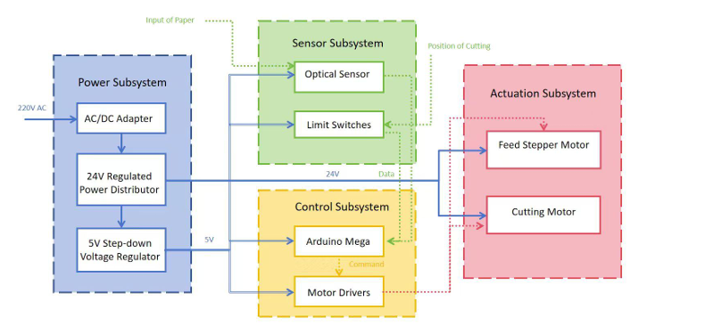
Figure 1 Conceptual overview of the Eco-Trim paper-reuse workflow.

2. Design
Eco-Trim was designed as a compact mechatronic prototype that combines paper feeding, optical sensing, embedded control, and mechanical cutting. Several design alternatives were considered before the final architecture was selected. For paper handling, a full automatic stack feeder was considered, but the final prototype uses a simpler single-sheet roller path to reduce mechanical complexity and focus on the core sensing-to-cutting workflow. For blank-region detection, a camera-based image-processing method was considered, but the final design uses a reflective optical sensor because it is simpler, lower cost, and does not require storing or processing document images. For positioning, the system uses feed-motion timing and step-based position tracking instead of a more complex closed-loop linear encoder. For power and interface design, the prototype uses commercial low-voltage power and driver modules rather than a custom mains-powered circuit, which reduces electrical risk during testing.
The following sections describe the final system architecture and the design of each major subsystem. The control and positioning section includes the main equations used to relate sensor position, paper feed motion, and cutter timing. The software finite state machine section describes the flowchart-level logic used to coordinate feeding, scanning, positioning, and cutting.

2.1 Top-Level System Architecture
Eco-Trim is organized as a compact mechatronic system that combines paper feeding, optical sensing, embedded control, and mechanical cutting. The purpose of the design is to move a partially used sheet of paper through a controlled paper path, detect a reusable blank region, and cut that region away for use as scratch paper.
Figure 2 shows the top-level system architecture of the Eco-Trim prototype. The final prototype is divided into four major functional blocks: the power and interface architecture, the sensor subsystem, the control and positioning subsystem, and the actuation and safety subsystem. The power and interface architecture supplies low-voltage DC power to the controller, sensor, and motor driver. The sensor subsystem measures paper surface reflectivity as the sheet moves through the paper path. The control subsystem reads the sensor output, tracks the paper position, and decides when to trigger the cutter. The actuation subsystem advances the paper and performs the cutting operation.
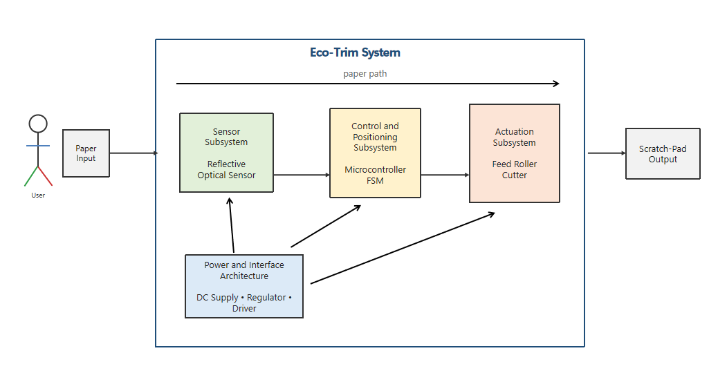
Figure 2 Top-level system architecture of the Eco-Trim prototype
The final prototype focuses on a single-sheet workflow. After the user places one representative sheet into the input path and starts the system, the feed mechanism moves the sheet past the optical sensor. The controller monitors the sensor signal to identify the transition between printed and blank regions. Once a usable blank region is detected, the controller advances the sheet by a calculated distance so that the selected region reaches the cutter, then activates the cutting mechanism. This architecture allows the prototype to demonstrate the complete sensing-to-cutting process with a relatively simple mechanical and electrical structure.

2.2 Power and Interface Architecture
The prototype uses a low-voltage DC power architecture to simplify integration and reduce electrical risk during testing. A purchased external DC power supply provides the main motor supply voltage, while a step-down voltage regulator provides the logic-level supply for the microcontroller and sensor interface. This approach avoids exposing the student-built portion of the prototype to mains voltage and keeps the electrical design focused on system integration, motor control, and signal interfacing.
The motor driver receives the higher-voltage DC supply needed to drive the feed and cutting actuation hardware. The microcontroller and optical sensor operate from the regulated logic rail. All control signals share a common reference ground so that the microcontroller can reliably command the motor driver and read the sensor output. The wiring between modules is arranged so that power, ground, sensor signal, and motor-control signals are separated as clearly as possible.
Because the final prototype is a functional demonstration rather than a production-ready product, the power and interface architecture is implemented using commercial modules and direct wiring. The main design requirement for this portion is stable power delivery during feeding and cutting. The logic rail must remain stable while the motor driver switches load current, and the motor supply must provide sufficient current for the roller and cutter motion without causing the controller to reset.

2.3 Sensor Subsystem
The sensor subsystem is responsible for distinguishing printed regions from reusable blank regions. This section describes the circuit design, PCB implementation, and operation principle.

Circuit Design
Given that the TCRT5000 offers adequate sensitivity for our application, we selected it as the optimal choice. Each TCRT5000 consists of an infrared LED and a phototransistor. When blank paper is underneath (high reflectivity), the phototransistor conducts strongly and pulls the output low. When a printed region is underneath (low reflectivity), the output remains high.
An LM393 comparator converts this analog signal into a digital 0 (blank) or 1 (printed). A trimmer potentiometer adjusts the reference voltage per channel, allowing fine-tuning of sensitivity. Filter and decoupling capacitors suppress power noise and high-frequency interference.
Since one LM393 contains two comparators, each LM393 handles two sensor channels. With six channels total covering the full paper width, three LM393 ICs are required. An 8-pin header connects the module to an Arduino, and a TVS diode provides ESD and overvoltage protection.
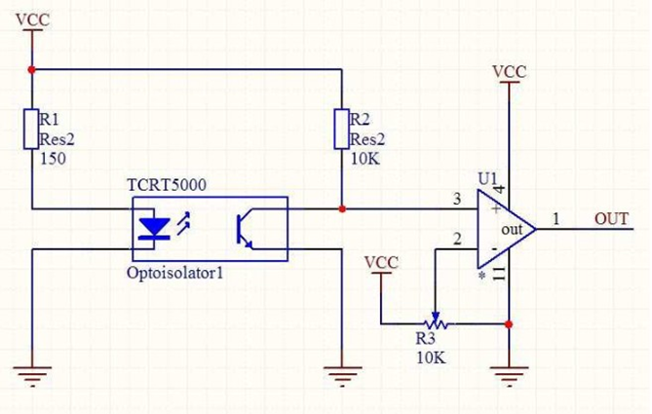
Figure 3 Single-channel schematic: TCRT5000 + LM393 + potentiometer + capacitors

PCB Design
The six channels are laid out on a single PCB as shown in Figure 2.3.2. The board contains the following components:
Component | Quantity | Function
TCRT5000 | 6 | Optical detection
LM393 | 3 | Analog-to-digital conversion
Trimmer potentiometer | 6 | Sensitivity adjustment
Filter capacitor | 1 | Power noise filtering
Decoupling capacitor | 3 (one per LM393) | High-frequency noise suppression
LED | 1 | Power indicator
Resistors | Several | Current limiting, pull-up
8-pin header | 1 | Arduino connection
TVS diode | 1 | ESD/overvoltage protection
The six TCRT5000 sensors are arranged in a linear array to cover the entire paper width. Each sensor’s output is routed to its corresponding comparator input. The trimmer potentiometers are placed on the board edge for easy calibration.

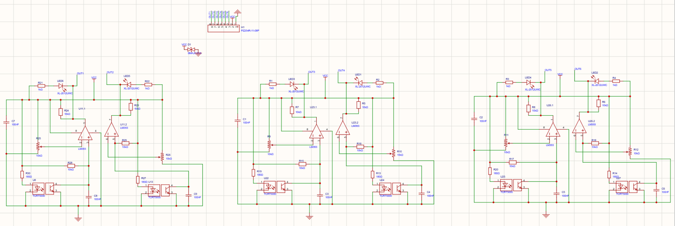
Figure 4 Overall six-channel PCB schematic: three LM393s, six sensors, potentiometers, and supporting components
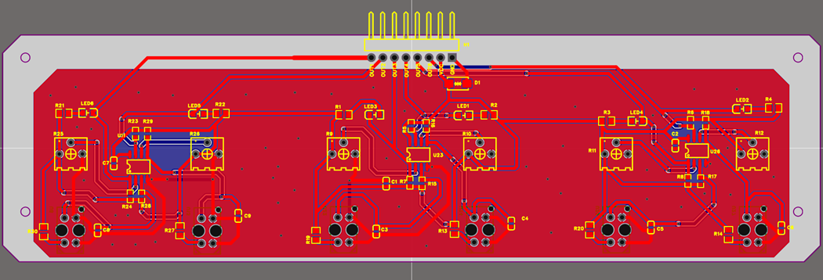
Figure 5 PCB layout (top view) showing component placement and traces
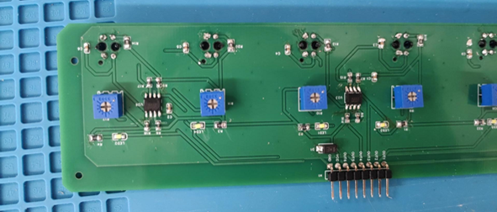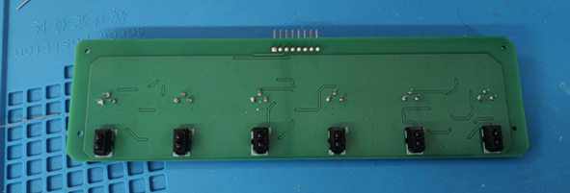
Figure 6 Photograph of the assembled six-channel sensor PCB

The grayscale sensor module contains multiple reflective optical sensing channels arranged across the paper width. Each channel uses an infrared emitter and receiver to measure the reflected light from the paper surface. Blank white paper reflects more light, while printed or written regions reflect less light because ink absorbs more light. Therefore, the sensor output changes when the paper surface changes from printed content to blank area.
In the implemented prototype, the controller compares each sensor channel output with a calibrated threshold. When most channels indicate high reflectivity, the region is treated as unused blank paper. When one or more channels detect low reflectivity for a continuous distance, the region is treated as used or printed paper. This digital decision is then used by the finite state machine to identify the boundary between used and unused regions and determine when the paper should be advanced to the cutter.

2.4 Motor Driver Module
The motor driver module controls the paper feed motor and the cutter motor. This section describes the component selection, circuit design, and PCB implementation.

Component Selection
We selected the L298N as the motor driver IC for the following reasons:
Requirement | L298N Feature
Drives N20 motors | Compatible voltage and current range
Two motors (feed + cutter) | Dual H-bridge – one chip handles both
Direct connection to Arduino | 5V logic input
Speed control | PWM capable

Circuit and PCB Design
The module includes the following components:
Component | Quantity | Function
L298N | 1 | Dual H-bridge motor driver
Capacitors | 2 (or as needed) | Power noise filtering
Diodes | 8 | Protect driver from motor kickback (flyback)
8-pin header | 1 | Connects to Arduino for control signals
Screw terminals | 3 | 12V power input, motor A (feed), motor B (cutter)
The 8-pin header carries enable signals and PWM speed inputs from the Arduino. The eight diodes are arranged in a standard H-bridge protection configuration across the two motor outputs. The screw terminals provide secure connections for the 12V power supply and the two motors.
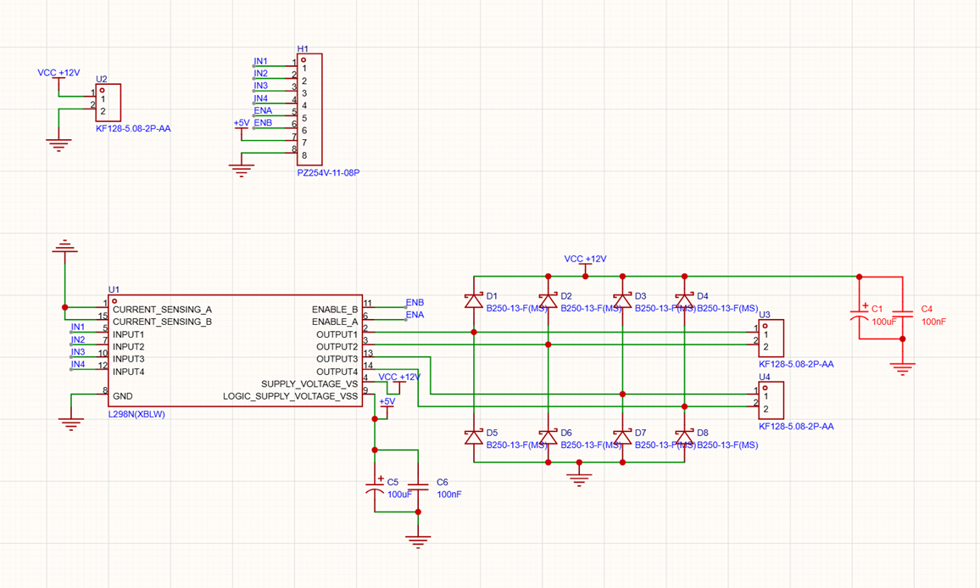
Figure 7 L298N module schematic showing connections: Arduino header, capacitors, diodes, screw terminals for 12V and two motors
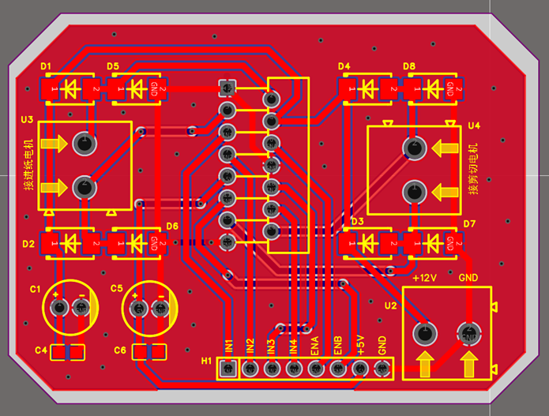
Figure 8 PCB layout of the motor driver module
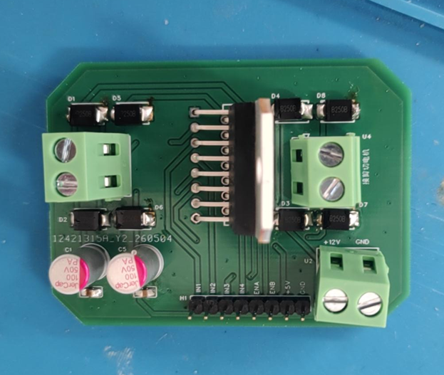
Figure 9 Photograph of the assembled motor driver board

2.5 Control and Positioning Design
The control subsystem coordinates sensor reading, paper movement, and cutter timing. A microcontroller runs the main control program as a finite state machine. This structure allows the system to move through a predictable sequence of operations: waiting for the user to start the system, feeding the paper, scanning the sheet, validating a blank region, advancing the paper to the cutting position, and triggering the cutter.
Position tracking is based on the feed motion of the roller mechanism. The sensor is mounted a fixed distance D before the cutting stage. When the controller detects a valid blank region at the sensor, it must continue advancing the paper until that same region reaches the cutter. If the feed speed is treated as approximately constant, the delay can be estimated by
$$t=D/v$$ | (1)
where D is the sensor-to-cutter distance and v is the paper feed speed. If the feed motor is controlled by step commands, the same positioning problem can be handled by counting motor steps instead of using time alone.
For a stepper-driven roller, the nominal paper travel per motor step can be estimated by
$$s_{step}=2πr/N$$ | (2)
where r is the roller radius and N is the number of motor steps per revolution. For example, using a roller radius of 15 mm and 200 full steps per revolution gives an estimated travel distance of approximately 0.471 mm per step. This calculation shows that step-based positioning provides sufficient resolution for a prototype paper-cutting system.
The major positioning errors come from roller slip, imperfect roller radius, sensor threshold variation, and step quantization. These tolerance effects are considered in the control design rather than as a separate report chapter. In the final report, the detailed calculation can be placed in an appendix, while this section only explains how the controller uses the fixed sensor-to-cutter distance and feed motion to determine the cut timing.
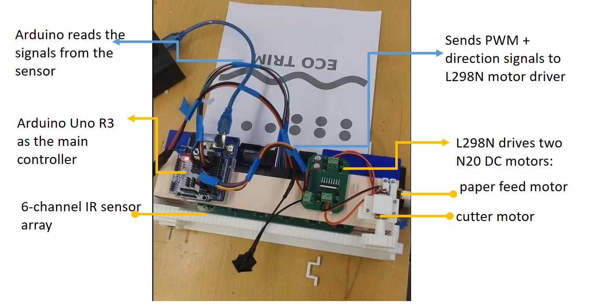
Figure 10 Electrical signal flow and motor-control connections of the Eco-Trim prototype
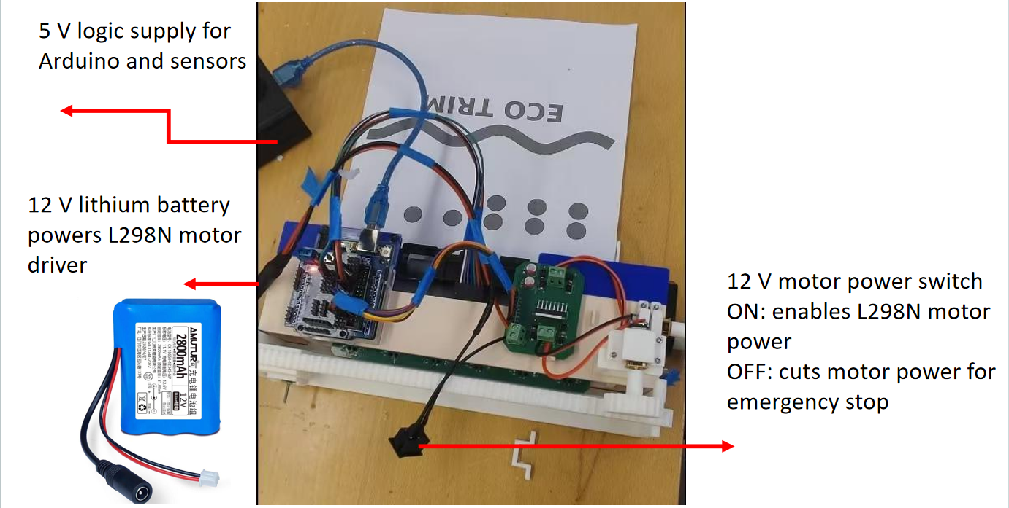
Figure 11 Controller and power distribution of the Eco-Trim prototype

2.6 Actuation and Safety Subsystem
The actuation subsystem performs the physical movement required for paper recovery. It includes the feed mechanism, the motor driver, the roller path, and the cutting mechanism. The feed mechanism advances the paper through the sensor and cutter stages. The cutting mechanism is activated only after the controller determines that the selected blank region has reached the cutting stage.
Figure 3 shows the mechanical layout of the prototype. The roller path guides the paper in a fixed direction, the optical sensor is mounted above the paper path, and the cutter is located downstream from the sensing position. This layout is important because the controller uses the fixed sensor-to-cutter distance to determine when the detected blank region should be cut.
The two side gears enable the motor to drive the paper feeder(Part 1 in Figure 3). The drive of the cutting head is achieved by a motor connected to a gear and rack mechanism(Part 2 in Figure 3). The cutting head can secure a blade for cutting, and it passes through two crossbars to slide left and right(Part 3 in Figure 3).
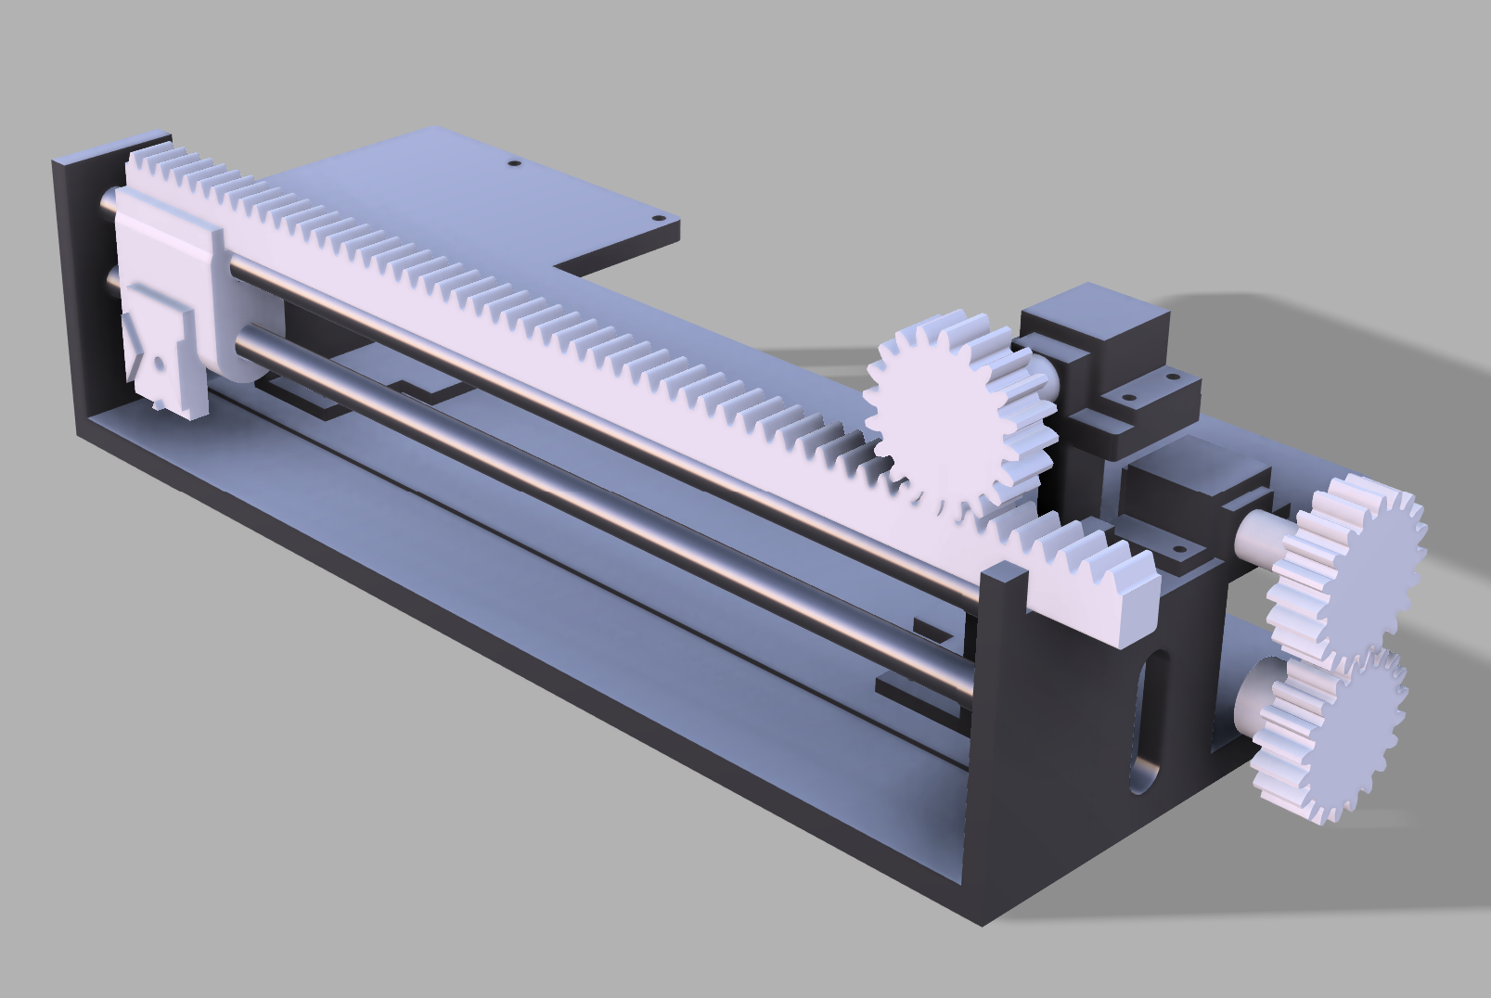
1

3

2

Figure 12.1 Mechanical layout of the Eco-Trim prototype
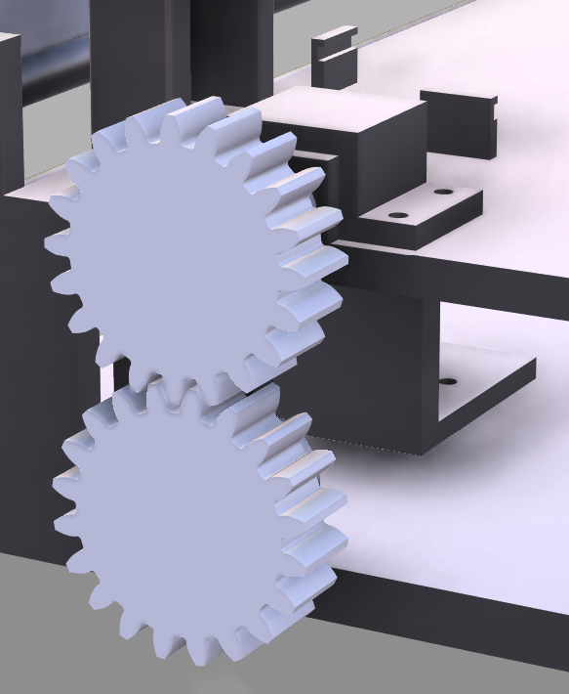
Figure 12.2 Part 1 of Mechanical layout of the Eco-Trim prototype
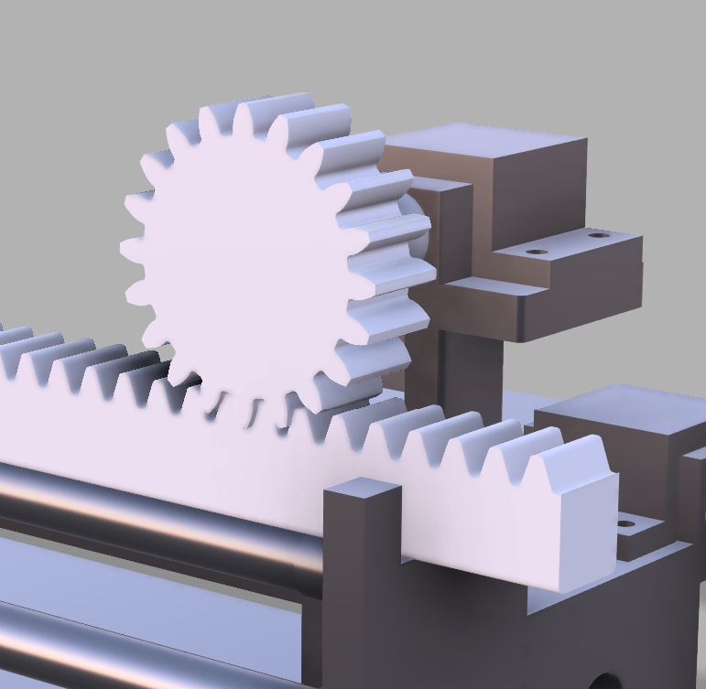
Figure 12.3 Part 2 of Mechanical layout of the Eco-Trim prototype
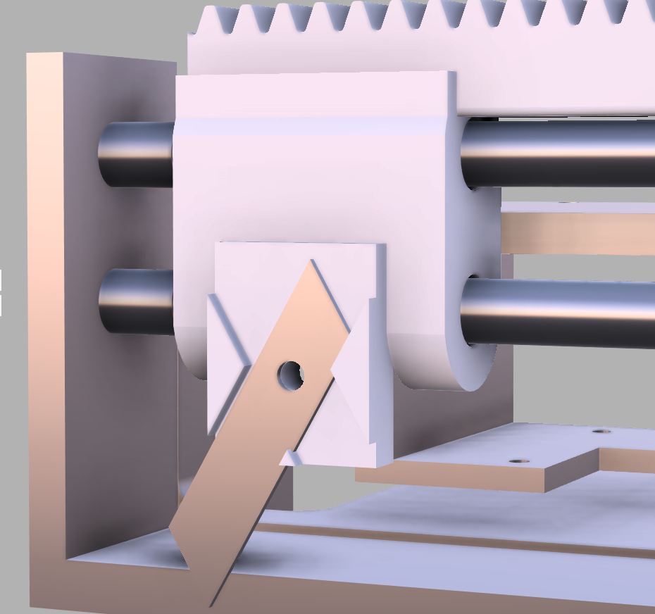
Figure 12.4 Part 3 of Mechanical layout of the Eco-Trim prototype
A roller-based feed path was selected because it provides a compact and mechanically simple way to move paper through the prototype. The roller applies friction to the sheet and advances it along a fixed path. This arrangement is suitable for the final single-sheet demonstration because it avoids the additional complexity of a full automatic stack feeder while still showing the essential paper-handling behavior required by Eco-Trim.
The cutter is controlled by the microcontroller through the motor-driver interface. After the controller reaches the cut state, it commands the cutter to complete one cutting motion. The actuation sequence is designed so that feeding and cutting do not occur as independent actions; instead, both actions are coordinated by the control subsystem. This coordination is necessary because the cut position depends on the earlier optical sensing result.
Figure 4 shows the final assembled prototype used for the demonstration. The prototype was operated as a supervised low-voltage bench system. The electrical design keeps mains voltage outside the student-built mechanism by using an external power adapter, and the internal wiring distributes only low-voltage DC power. During testing, the cutting mechanism was operated only when the paper was positioned and the operator was clear of the moving parts. Although the final prototype does not include a production-level safety enclosure or IR light curtain, the design limits the demonstration to controlled operation and avoids presenting the system as a public-ready machine.
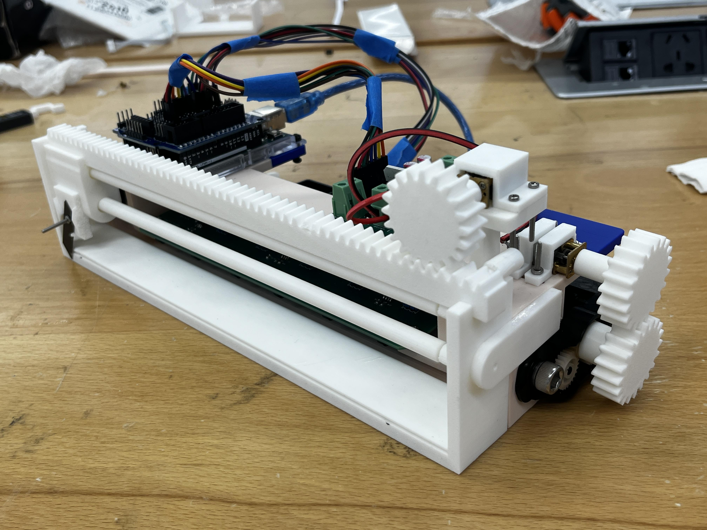
Figure 13 Final assembled Eco-Trim prototype

2.7 Software Finite State Machine
The software is implemented as a finite state machine so that each stage of the paper-recovery process has a defined purpose and exit condition. This structure makes the prototype easier to debug because the controller always operates in one known state at a time.
Figure 5 shows the software finite state machine. The main states are Idle, Feed Paper, Scan Paper, Validate Blank Region, Advance to Cut Position, Execute Cut, and Stop. In the Idle state, the system waits for the user to start the cycle. In the Feed Paper state, the controller commands the feed mechanism to move the sheet into the sensing path. In the Scan Paper state, the controller repeatedly reads the optical sensor while the paper moves. In the Validate Blank Region state, the controller determines whether the sensor readings indicate a usable blank region. If a valid region is detected, the controller enters the Advance to Cut Position state and moves the paper by the required distance from the sensor to the cutter. The Execute Cut state then activates the cutting mechanism. After the cut is complete, the system enters the Stop state and waits for the next manual reset or cycle.
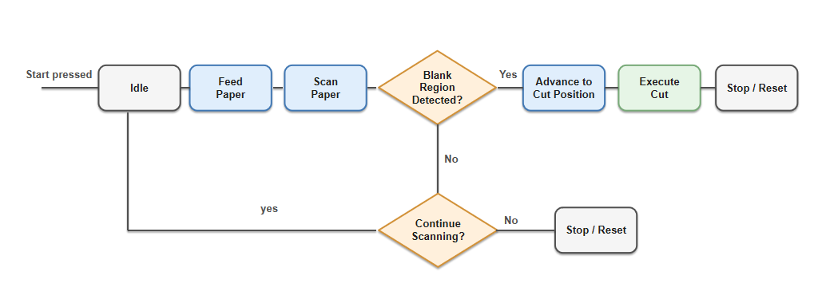
Figure 14 Software finite state machine for coordinating feeding, sensing, positioning, and cutting
The finite state machine is important because the system depends on the timing relationship between sensing and cutting. A sensor reading does not immediately trigger the cutter; instead, it marks a paper position that must be advanced to the cutter before actuation. By separating scanning, validation, advancement, and cutting into different states, the software reduces the chance of triggering the cutter at the wrong time and makes the overall control sequence more predictable.

3. Design Verification
The design verification process evaluated whether the final Eco-Trim prototype could complete its intended single-sheet paper-recovery workflow. Since the final prototype was built as a supervised demonstration system rather than a complete public-use product, the verification focused on the core implemented functions: feeding one representative sheet, detecting a reusable blank region, advancing the paper based on the detected position, and completing an automated cut.
The original project concept included continuous multi-sheet feeding, a complete safety enclosure, and production-level safety interlocks. The final prototype instead demonstrates the essential sensing-to-cutting behavior on prepared single-sheet test samples. Therefore, the verification discussion in this chapter focuses on the implemented prototype and the functional results obtained from the final demonstration.

3.1 System-Level Test Method and Result
The system-level test was designed to verify that the major subsystems could operate together as one coordinated workflow. During the test, a prepared paper sheet containing both printed and blank regions was placed into the input path. After the user started the cycle, the expected sequence was that the roller mechanism would feed the paper, the optical sensor would scan the paper surface, the controller would identify the reusable blank region, the feed mechanism would advance the sheet to the cutting position, and the cutter would separate the blank section from the original sheet.
The test evaluated the following behaviors: whether the paper could enter the roller path and pass under the sensor, whether the optical sensor produced a usable response, whether the controller entered the correct state based on the sensor result, whether the paper could be advanced to the cutting position, and whether the cutting mechanism could complete the cut.
The final prototype successfully completed the intended single-sheet workflow. The paper entered the feed path, passed through the sensing region, was advanced toward the cutting stage, and was cut automatically. This result shows that the sensing, control, feeding, and cutting subsystems were integrated well enough to demonstrate the core Eco-Trim recovery process.

3.2 Paper Feeding Verification
The paper feeding verification evaluated whether the roller mechanism could move a representative sheet through the prototype during the automated cycle. The test method was to insert a prepared sheet into the input path and activate the feed mechanism under controller command. During the test, the team observed whether the sheet entered the rollers, stayed aligned well enough to pass under the sensor, and continued moving toward the cutting stage.
The prototype successfully fed one representative sheet through the intended path during the final demonstration workflow. The roller mechanism provided enough friction to move the sheet from the input position to the sensing and cutting stages. This verified the basic feeding function of the implemented single-sheet prototype.
The final prototype did not verify automatic multi-sheet feeding from a stack. Therefore, this verification result only supports the single-sheet workflow that was actually implemented. Additional testing and mechanical development would be required before claiming reliable repeated sheet feeding.

3.3 Blank-Region Detection Verification
The blank-region detection verification evaluated whether the optical sensing subsystem could distinguish printed regions from reusable blank regions well enough to support the cutting decision. The reflective optical sensor was mounted above the paper path and connected to the microcontroller input. As the paper moved under the sensor, the controller monitored the sensor output and compared it against the selected threshold.
Verification was performed using prepared test sheets that contained both printed content and blank regions. The expected behavior was that printed regions and blank paper would produce different sensor responses, allowing the controller to identify when a usable blank region was passing through the sensing position. During testing, the prepared verification sheet contained both printed regions and blank regions. The sensor successfully produced different digital outputs for these areas, allowing the controller to recognize the transition between used and unused paper and trigger the advance-to-cut sequence.
During the final demonstration, the sensor response was sufficient for the controller to recognize the reusable blank region and continue the cutting sequence. This verified the functional role of the optical sensor in the single-sheet workflow. The team also prepared test sheets with different blank-region widths to evaluate the minimum detectable and recoverable blank region. The minimum blank-region width that could be reliably detected and recovered was measured as 15mm.
Because the test did not cover a large number of paper types, ink densities, lighting conditions, or surface finishes, this result should be treated as a functional verification rather than a statistical detection-accuracy measurement.

3.4 Cutting Performance Verification
The cutting performance verification evaluated whether the prototype could advance the detected blank region to the cutting stage and complete the cut. The controller used the fixed geometric distance between the optical sensor and the cutter to determine when the cut should occur. After the blank region was detected, the system continued advancing the paper until the selected region reached the cutter.
The test evaluated three main behaviors: whether the system continued feeding after detecting the blank region, whether the paper reached the cutter position, and whether the cutting mechanism could complete one automatic cut to produce a reusable blank paper section.
During the final workflow test, the prototype completed an automated cut after feeding and sensing the sheet. The cutter separated a reusable blank section from the original sheet, demonstrating that the controller, paper-feed motion, and cutting mechanism were coordinated successfully.
The final verification did not include repeated cut-position error measurements or a full cut-time study. Therefore, the result should be described as an end-to-end functional demonstration. The prototype verified that the core sequence of feeding, blank-region detection, paper advancement, and automated cutting is feasible for a prepared single-sheet sample.

3.5 Safety Operation Verification
The final prototype was operated as a supervised low-voltage bench prototype rather than a public-ready enclosed machine. Since the production-level enclosure interlock and IR light curtain were not implemented in the final build, this verification does not claim full hardware safety-interlock performance. Instead, the safety verification focused on controlled operating procedure and low-voltage electrical operation.
During testing, the prototype was powered through an external power adapter so that mains voltage remained outside the student-built mechanism. The internal system distributed only low-voltage DC power to the controller, sensor, and motor driver. Before each test, the operator checked that the paper path was clear and that hands were away from the roller and cutter areas. The cutting mechanism was activated only during supervised demonstrations.
The prototype was able to complete the demonstration under controlled low-voltage test conditions. However, it should not be described as ready for unsupervised public use. A future version intended for libraries, study rooms, or other public spaces would require a complete enclosure, a lid or door interlock, an emergency-stop path, and shutdown-time verification before deployment.

Costs
This chapter summarizes the estimated cost of the Eco-Trim prototype. The total project cost includes the purchased parts used to build the system and the estimated labor cost of the team members. The parts cost mainly comes from the feeding and cutting motors, motor drivers, optical sensing components, Arduino-compatible control board, custom PCBs, passive components, wiring, connectors, and mechanical assembly hardware. Table 1 lists the material cost of the prototype based on the actual purchased quantities and prices. The total estimated material cost is RMB 676.72.
The prototype was built for demonstration and verification rather than mass production. Therefore, many components were purchased in small quantities, and several electronic parts were bought in packs even though only a portion of each pack was used in the final system. For a larger production run, the per-unit cost could be reduced by purchasing motors, PCBs, connectors, and passive components in bulk and by integrating the control and driver interfaces into a more compact custom board.
Labor cost was estimated using the ECE 445 formula: ideal hourly rate multiplied by actual hours spent and an overhead factor of 2.5. As shown in Table 2, each team member was estimated to spend 30 hours on the project at an ideal hourly rate of RMB 50 per hour. With the overhead factor included, the labor cost for each team member is RMB 3,750, giving a total labor cost of RMB 15,000. Combining the material and labor costs, the total estimated project cost is RMB 15,676.72.

Parts
Table 1 lists the estimated parts cost of the Eco-Trim prototype
Part / Item | Qty | Cost (RMB)
Precision N20 geared motor | 4 packs / 8 motors | 26.66
GA12-N20 DC geared motor | 4 pcs | 32.00
L298N motor driver module | 2 pcs | 11.13
L298N driver IC | 4 pcs | 24.48
Arduino Nano compatible board | 1 pc | 153.00
5-channel grayscale sensor module | 1 pc | 61.38
TCRT5000 reflective optical switch | 12 pcs | 93.72
LM393 comparator | 10 pcs | 2.54
XL-2012UWC LED | 50 pcs | 3.67
Grayscale sensor PCB | 1 order / 5 pcs | 57.24
Motor driver PCB | 1 order / 5 pcs | 33.00
12 V lithium battery pack | 1 pc | 23.80
DC5.5 connector cable | 1 pc | 9.90
SMAJ5.0CA | 5 pcs | 3.79
B250-13-F(MS) | 20 pcs | 10.08
PA50V100M6x12 | 5 pcs | 6.95
3362P-1-103 | 15 pcs | 15.80
TCC0603X7R104K101CT | 100 pcs | 2.55
TCC0805X7R104K500DT | 100 pcs | 2.63
0805W8F1800T5E | 100 pcs | 1.53
RT0805BRD071KL | 20 pcs | 4.25
FRC0603F1002TS | 100 pcs | 0.63
KF128-5.08-2P-AA | 10 pcs | 11.77
PZ254V-11-08P | 10 pcs | 2.81
PZ254R-11-08P | 10 pcs | 3.27
Dupont wires | 3 packs | 25.32
HP 510 paper pickup roller | 1 pc | 16.46
M2 stainless steel screws | 2 packs | 10.62
Shaft pins / small pins | 30 pcs | Included
Utility blade | 1 pack | Included
Hardware + blade order subtotal | 1 order | 25.74
Total estimated material cost |  | 676.72

Labor
Table 2 summarizes the estimated labor cost for the project team
Team Member | Hourly Rate  (RMB/hour) | Hours Spent | Overhead Factor | Total Cost (RMB)
Zhizheng Ju | 50 | 30 | 2.5 | 3750
Tianyi Xu | 50 | 30 | 2.5 | 3750
Lehan Pan | 50 | 30 | 2.5 | 3750
Zihan Wang | 50 | 30 | 2.5 | 3750
Total |  |  |  | 15000

5. Conclusion
The Eco-Trim prototype successfully demonstrated the core workflow of a dry, local paper-reuse system. The completed prototype integrated paper feeding, optical sensing, microcontroller-based control, and mechanical cutting into one coordinated process. During the final demonstration, the system was able to feed a representative sheet, detect a usable blank region, advance the paper through the cutting path, and complete an automated cut. This result shows that reusable blank sections can be recovered from partially used paper through coordinated sensing, positioning, and actuation.
Although the final prototype is not a public-ready machine, it provides a functional proof of concept for the Eco-Trim system. The project demonstrates that a relatively simple sensing and control architecture can support local paper reuse without using camera-based document imaging or wet chemical reprocessing.

5.1 Accomplishments
The main accomplishment of the project was the successful completion of the single-sheet sensing-to-cutting workflow. The final prototype combined the mechanical, electrical, and software portions of the system into an integrated demonstration. The paper feed mechanism moved a representative sheet through the sensing and cutting path. The reflective optical sensor provided a usable signal for distinguishing blank regions from printed regions. The microcontroller used this sensing result to coordinate paper advancement and cutter activation.
Another accomplishment was the implementation of a finite state machine for the control sequence. The software separated the process into clear states, including feeding, scanning, blank-region validation, advancing to the cut position, and executing the cut. This made the system behavior more predictable and easier to debug.
The project also demonstrated a practical mechanical layout for the Eco-Trim concept. The final prototype placed the sensor upstream of the cutter and used the fixed distance between these two components to determine cut timing. This confirmed that the basic architecture of detecting a blank region first and cutting it after controlled advancement is feasible.

5.2 Uncertainties
The final prototype was designed and tested as a supervised single-sheet demonstration rather than a complete public-use product. Therefore, the main limitation is that the prototype does not yet support reliable automatic feeding from a stack of multiple sheets. The current paper path demonstrates the core feeding behavior, but additional mechanical development would be required to prevent multi-sheet feeding, skew, and jamming in repeated operation.
The blank-region detection method also has limitations. The prototype uses threshold-based reflective sensing, which is simple and effective for the demonstration sheet, but its performance may change with different paper colors, ink densities, lighting conditions, and surface finishes. A larger test set would be needed to quantify detection accuracy across many paper types.
The final prototype also does not include a production-level safety enclosure, IR light curtain, or fully verified hardware interlock system. For this reason, the system should only be considered a controlled bench prototype. It should not be operated as an unsupervised public machine without additional safety hardware, enclosure design, and shutdown-time verification.
Finally, the cut quality and cut position were verified at a functional demonstration level rather than through extensive repeated measurement. The prototype showed that the sensing-to-cutting sequence can work, but a later version would need more repeated trials to characterize cut-position error, cutting consistency, and long-term mechanical reliability.

5.3 Ethical considerations
Eco-Trim was designed to support local paper reuse by recovering blank regions from partially used sheets. This goal has a positive environmental motivation because it encourages reuse before disposal or recycling. However, the project must be presented honestly. The system does not create new paper, and it does not replace industrial recycling. Instead, it salvages usable blank areas from paper that would otherwise be discarded.
User privacy is also an important ethical consideration. Since the system processes partially printed documents, it should avoid storing, imaging, or transmitting document content. The final prototype uses reflectivity-based sensing rather than a camera, which helps reduce privacy risk because the system only needs to detect whether a region is blank or printed.
Safety must also be treated as a primary ethical responsibility. The prototype contains moving rollers and a cutting mechanism, so the system must not be represented as safe for unsupervised public use in its current form. During testing, the prototype was operated under supervision and with low-voltage internal power distribution. A future public-facing version would require a complete enclosure, physical interlocks, emergency-stop behavior, and careful safety validation before deployment.
These considerations are consistent with the engineering responsibility to protect users, avoid misleading claims, and report system capabilities accurately.

5.4 Future work
Future work should first focus on improving the mechanical feeding system. A more complete version of Eco-Trim should include a reliable stack-feeding mechanism that can separate and feed multiple sheets without repeated manual loading. This would require improved roller pressure control, paper alignment guides, and jam-detection behavior.
The sensing subsystem could also be improved. Instead of relying only on a fixed threshold, a future version could include calibration routines or adaptive thresholding to handle different paper types and lighting conditions. A larger test set should be used to evaluate blank-region detection accuracy more rigorously.
The actuation and cutting system should be refined to improve consistency. Future testing should measure cut-position error, cutting time, and edge quality over repeated trials. These measurements would help determine whether the system can reliably produce reusable scratch-pad sections under normal use.
Finally, a public-ready version of Eco-Trim would require a complete safety redesign. This should include an enclosed paper path, lid or door interlocks, emergency-stop behavior, and verification that motor power is removed quickly during unsafe access events. With these improvements, Eco-Trim could move from a functional prototype toward a more reliable and user-safe paper-reuse device.

References
[1] Arduino, “Mega 2560 Rev3,” Arduino Documentation.
[2] Texas Instruments, “LM2596 SIMPLE SWITCHER Power Converter,” Datasheet.
[3] IEEE, “IEEE Code of Ethics.”

Appendix A Requirement and Verification Table
To be completed in the final submission
Requirement | Verification Method
HLR 1. System shall feed one representative sheet through the roller path without manual repositioning during the automated cycle. | Run a live single-sheet feed test and observe whether the sheet moves through the roller path and under the sensor without manual repositioning.
HLR 2. System shall distinguish reusable blank regions from printed content using the optical sensor. | Use a representative sheet with printed and blank regions and show that the sensor/controller detects the transition.
HLR 3. System shall coordinate sensor readings, paper advancement, and cutter actuation so the selected blank region reaches the cutter before cutting. | Demonstrate that after detection, the Arduino FSM continues feeding for a calibrated distance before triggering the cutter.
HLR 4. System shall complete paper advancement and cutting automatically after the user starts the system. | Show feed motor stop, cutter actuation, and output section produced under controller command.
HLR 5. System shall demonstrate the full single-sheet workflow from paper input to reusable scratch-pad output. | Run the complete live demo: insert paper -> feed -> sense -> advance -> cut -> output.

Appendix B Verification paper template



