Responses to Reviewers (Group 39)
Response to Reviewer 1 Comments
1. Summary
We sincerely thank the reviewer for the positive evaluation of our final report. No specific shortcomings were raised by the reviewer.
2. Questions for General Evaluation | Reviewer’s Evaluation
Introduction | 5/5
Design | 9/9
Cost and Schedule | 2/2
Requirements and Verification | 8/8
Conclusions | 6/6
Total Score | 30/30
3. Point-by-point response to Comments and Suggestions for Authors
Comment 1: A well-written report!
Response 1: We sincerely thank the reviewer for the positive comment and the full-score assessment. And we deeply appreciate the reviewer’s recognition of the quality of our report.

Response to Reviewer 2 Comments
1. Summary
We sincerely thank the reviewer for the detailed feedback on our final report. We agree that the original report did not sufficiently present the project schedule and the quantitative results. In response, we added the weekly schedule that was followed throughout the project. We also agree with the reviewer’s comment that the original report lacked sufficient quantitative evaluation. To address this concern, we added quantitative results together with a supporting discussion in the following section.
2. Questions for General Evaluation | Reviewer’s Evaluation
Purpose | 1/1
Functionality | 1/1
Subsystem Overview | 3/3
Equations & Simulations | 1/1
Design Alternatives | 2/2
Design Description & Justification | 3/3
Subsystem Diagrams & Schematics | 3/3
Cost | 1/1
Schedule | 0/1
Completeness of Requirements | 2/2
Appropriate Verification Procedures | 3/3
Quantitative Results | 1/3
Accomplishments | 2/2
Uncertainties | 2/2
Future Work / Alternatives | 1/1
Ethical Considerations | 1/1
Total Score | 27/30
3. Point-by-point response to Comments and Suggestions for Authors
Comment 1: Provide the schedule that was followed for the project.
Response 1: We agree with the reviewer that the original final report did not provide a clear project weekly schedule. We added the weekly schedule that was followed by all team members during the project.
In addition, we added two specific records of the real in-water experiments.
On May 11, all team members went to the Yuquan Campus pool laboratory and conducted the first real in-water experiment with the first complete version of our robotic fish. This experiment was used to evaluate waterproof sealing, basic swimming stability, propulsion and morphing behavior in a real pool environment.
On May 17, all team members returned to the Yuquan Campus pool laboratory and conducted the second real in-water experiment after further adjustment. The primary objective of this experiment was to conduct a second round of testing to verify the feasibility of propeller-mode propulsion in water, as well as to record videos for the final demo. In addition, we tested the robotic fish’s speed, turning radius, and power monitoring module.
Table 1. Weekly Schedule Table
Week | Bowen Zhang | Xuanyu Ke | Kaijun Zheng | Libin Wang
03/23 | Created the initial CAD model of the fish body and morphing structure. | Developed the initial fish concept and waterproof enclosure design. | Defined PCB requirements and selected components. | Defined the ROS architecture and control framework.
03/30 | Refined the mechanical layout and internal structure; drafted the design document. | Refined the waterproof housing; supported design document preparation. | Completed schematic design and PCB layout planning; supported design document preparation. | Built the ROS node skeleton and basic control workflow; drafted the design document.
04/06 | Continued fish body and tail CAD modeling; finalized the design document. | Continued waterproof and structural CAD refinement. | Completed the PCB layout and prepared board fabrication. | Set up ROS nodes and controller communication; finalized the design document.
04/13 | Refined the body/tail model; integrated the mechanical structure with the electronics and software. | Finalized the waterproof structure and manufacturing drawings. | Began PCB assembly and initial bench testing. | Implemented the control algorithm and mode-switching logic.
04/20 | Tuned the mechanical fit and tail motion; supported subsystem testing. | Tuned the waterproof structure and sealing; supported subsystem testing. | Debugged the PCB, power system, and actuator connections; supported subsystem testing. | Tuned control parameters and ROS communication; supported subsystem testing.
04/27 | Manufactured and assembled structural parts; fixed prototype mechanical issues; began prototype testing. | Completed waterproof sealing tests; supported prototype testing. | Installed the PCB and wiring; checked electrical safety; supported prototype testing. | Completed software integration; supported prototype testing.
05/04 | Led the mock demo; refined the mechanical structure based on demo results. | Prepared for the mock demo; improved waterproof reliability and assembly details. | Prepared for the mock demo; fixed electrical issues and improved PCB stability. | Prepared for the mock demo; refined the control and locking algorithm for transformation.
05/11 | Participated in the first real in-water experiment at the Yuquan Campus pool laboratory
05/11 | Optimized the mechanical structure; documented results for the final report draft. | Optimized the waterproof design; documented assembly and testing results. | Summarized PCB/electrical results; improved electronics integration. | Refined software performance; documented control results; organized final project materials.
05/17 | Participated in the second real in-water experiment at the Yuquan Campus pool laboratory;
05/18 | Completed final mechanical maintenance and tuning; led final demo and presentation preparation. | Completed final waterproof check; supported final demo and presentation preparation. | Completed the final electrical reliability check; supported final demo and presentation preparation. | Completed final software tuning; supported final demo; polished presentation materials.
Comment 2: The biggest shortcoming of the final report is the lack of quantitative results. Please complete further testing and provide the results and a supporting discussion of them, however they turn out.
Response 2: We agree with the reviewer’s comment that the original report lacked sufficient quantitative evaluation. To address this concern, we added quantitative results together with a supporting discussion in the following section.
Water tank experiments:
For the fish-swimming mode of the robotic fish, water tank experiments were conducted to evaluate its straight-swimming and turning capabilities.
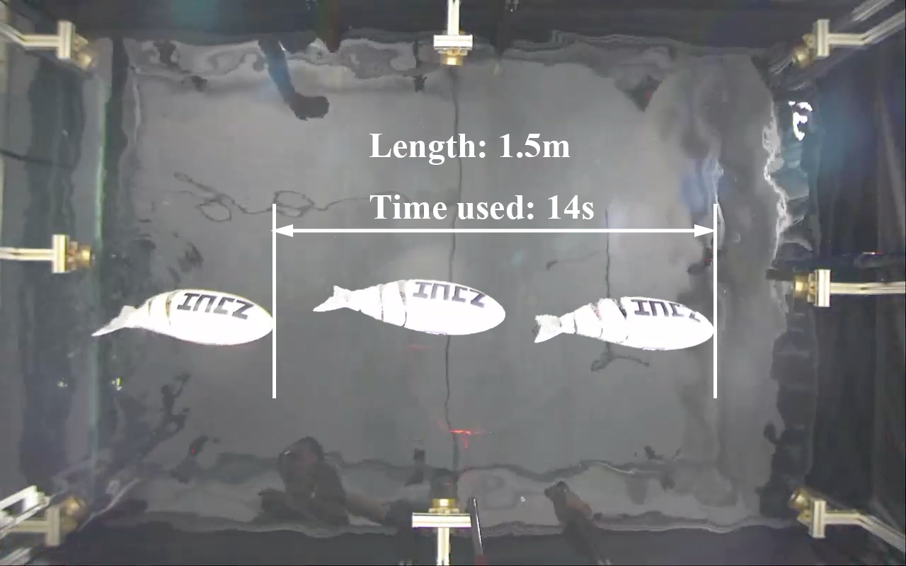
Figure 1. Water tank experiment of straight swimming
In the 1.5 m straight-swimming test, the robotic fish completed the distance in 14 s, corresponding to an average speed of approximately 10.7 cm/s. Since this process included both acceleration and deceleration, the maximum cruising speed is estimated to be higher, at approximately 20 cm/s.
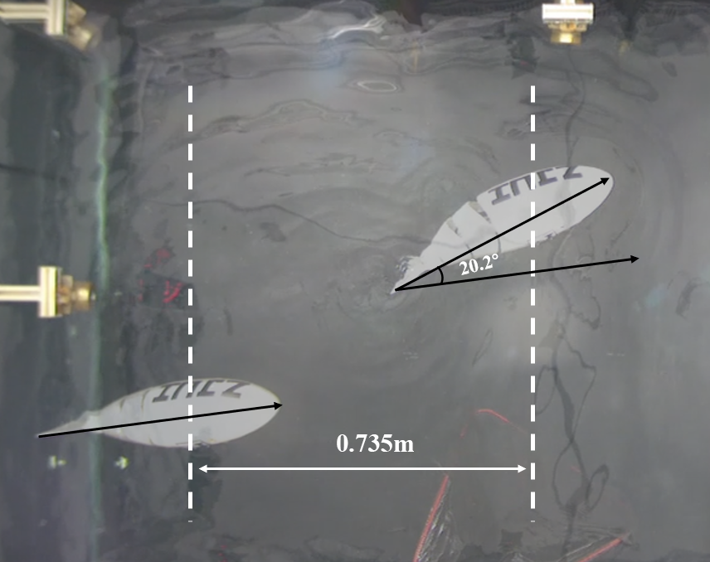
Figure 2. Water tank experiment of turning
In the turning test, the robotic fish achieved a turning angle of 20.2° over a longitudinal displacement of 0.735 m. The average turning efficiency was therefore 27.5°/m. Considering the fish body length of L = 0.6 m, this corresponds to a turning efficiency of 16.5° per body length.CFD simulation experiments:
CFD simulation experiments:
Because the motor used in the prototype could not provide sufficient torque to drive the propeller transformed from the tail fin, CFD simulations were conducted to obtain theoretical quantitative data. The simulation setup is listed in the table below.

Table 2. CFD Simulation Setup
Item | Setting
Software | ANSYS Fluent 2024R1.
Solver Type | Steady-state pressure-based solver.
Rational Model | Multiple Reference Frame.
Turbulence Model | SST k–ω
Boundary Conditions | Pressure inlet, pressure outlet; no-slip  on blades and hub; symmetry on far  field boundaries; interface between rotat  ing and stationary zones.
Speed Sweep | 24 operating points from 15 to 180 rpm,  with denser sampling between 80 and  165 rpm
Output Quantities | Thrust, torque, shaft power.
The results are shown below:
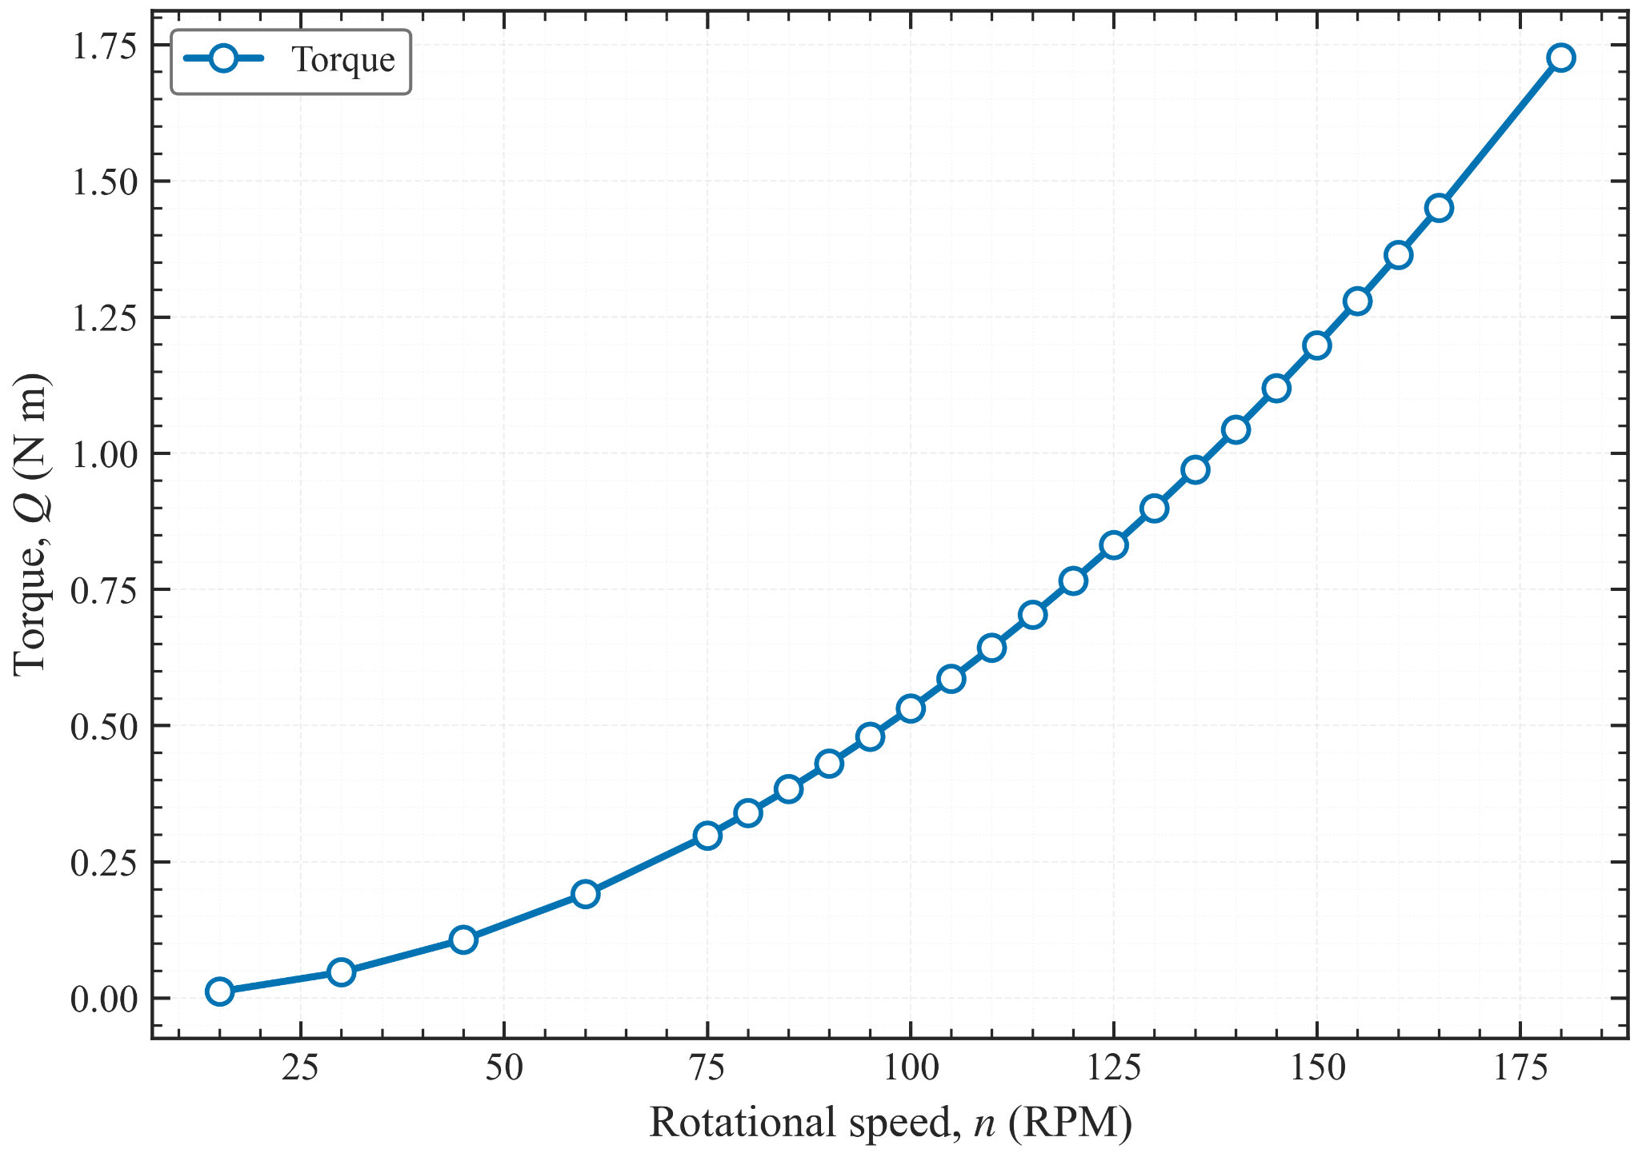
Figure 3. Torque vs roational speed plot of the propeller mode

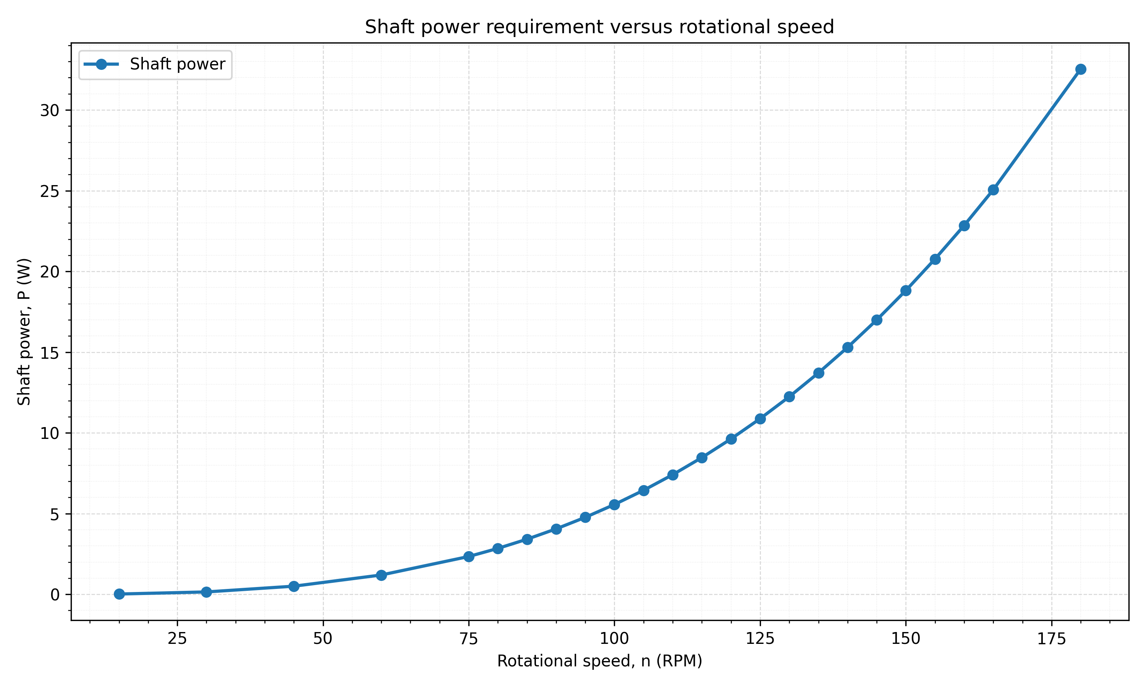
Figure 4. Shaft power vs roational speed plot of the propeller mode

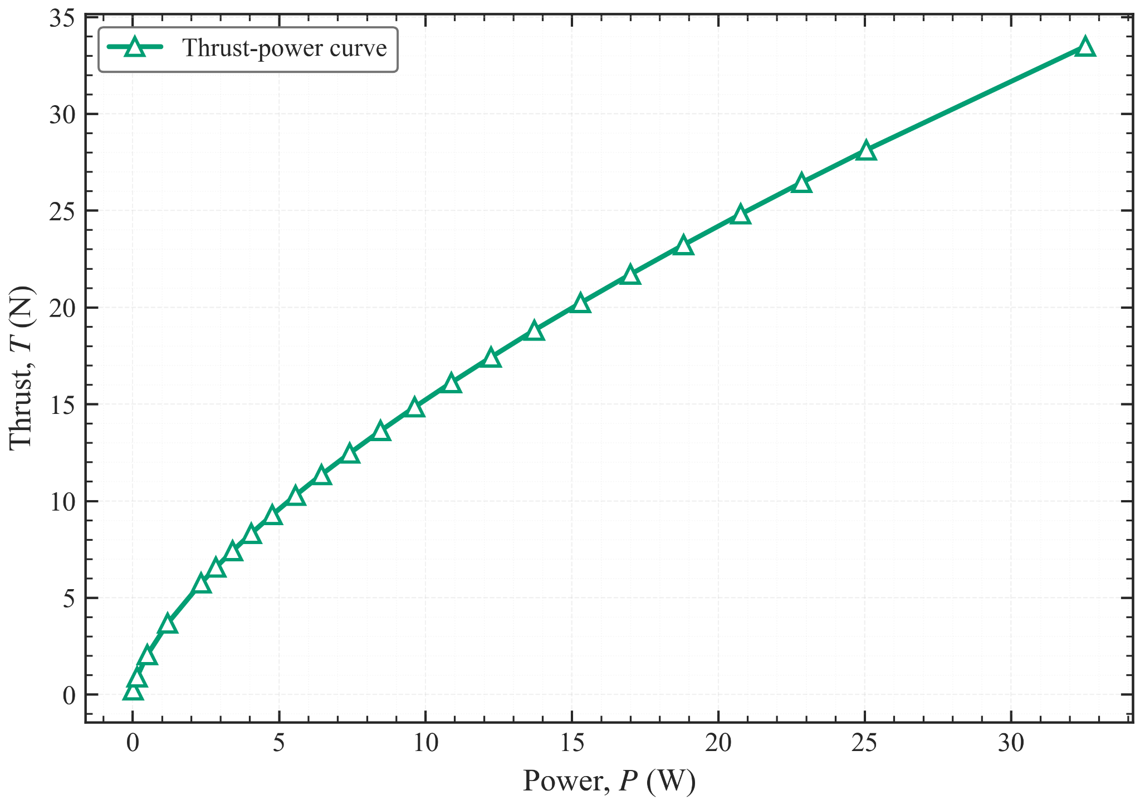
Figure 5. Thrust vs power plot of the propeller mode

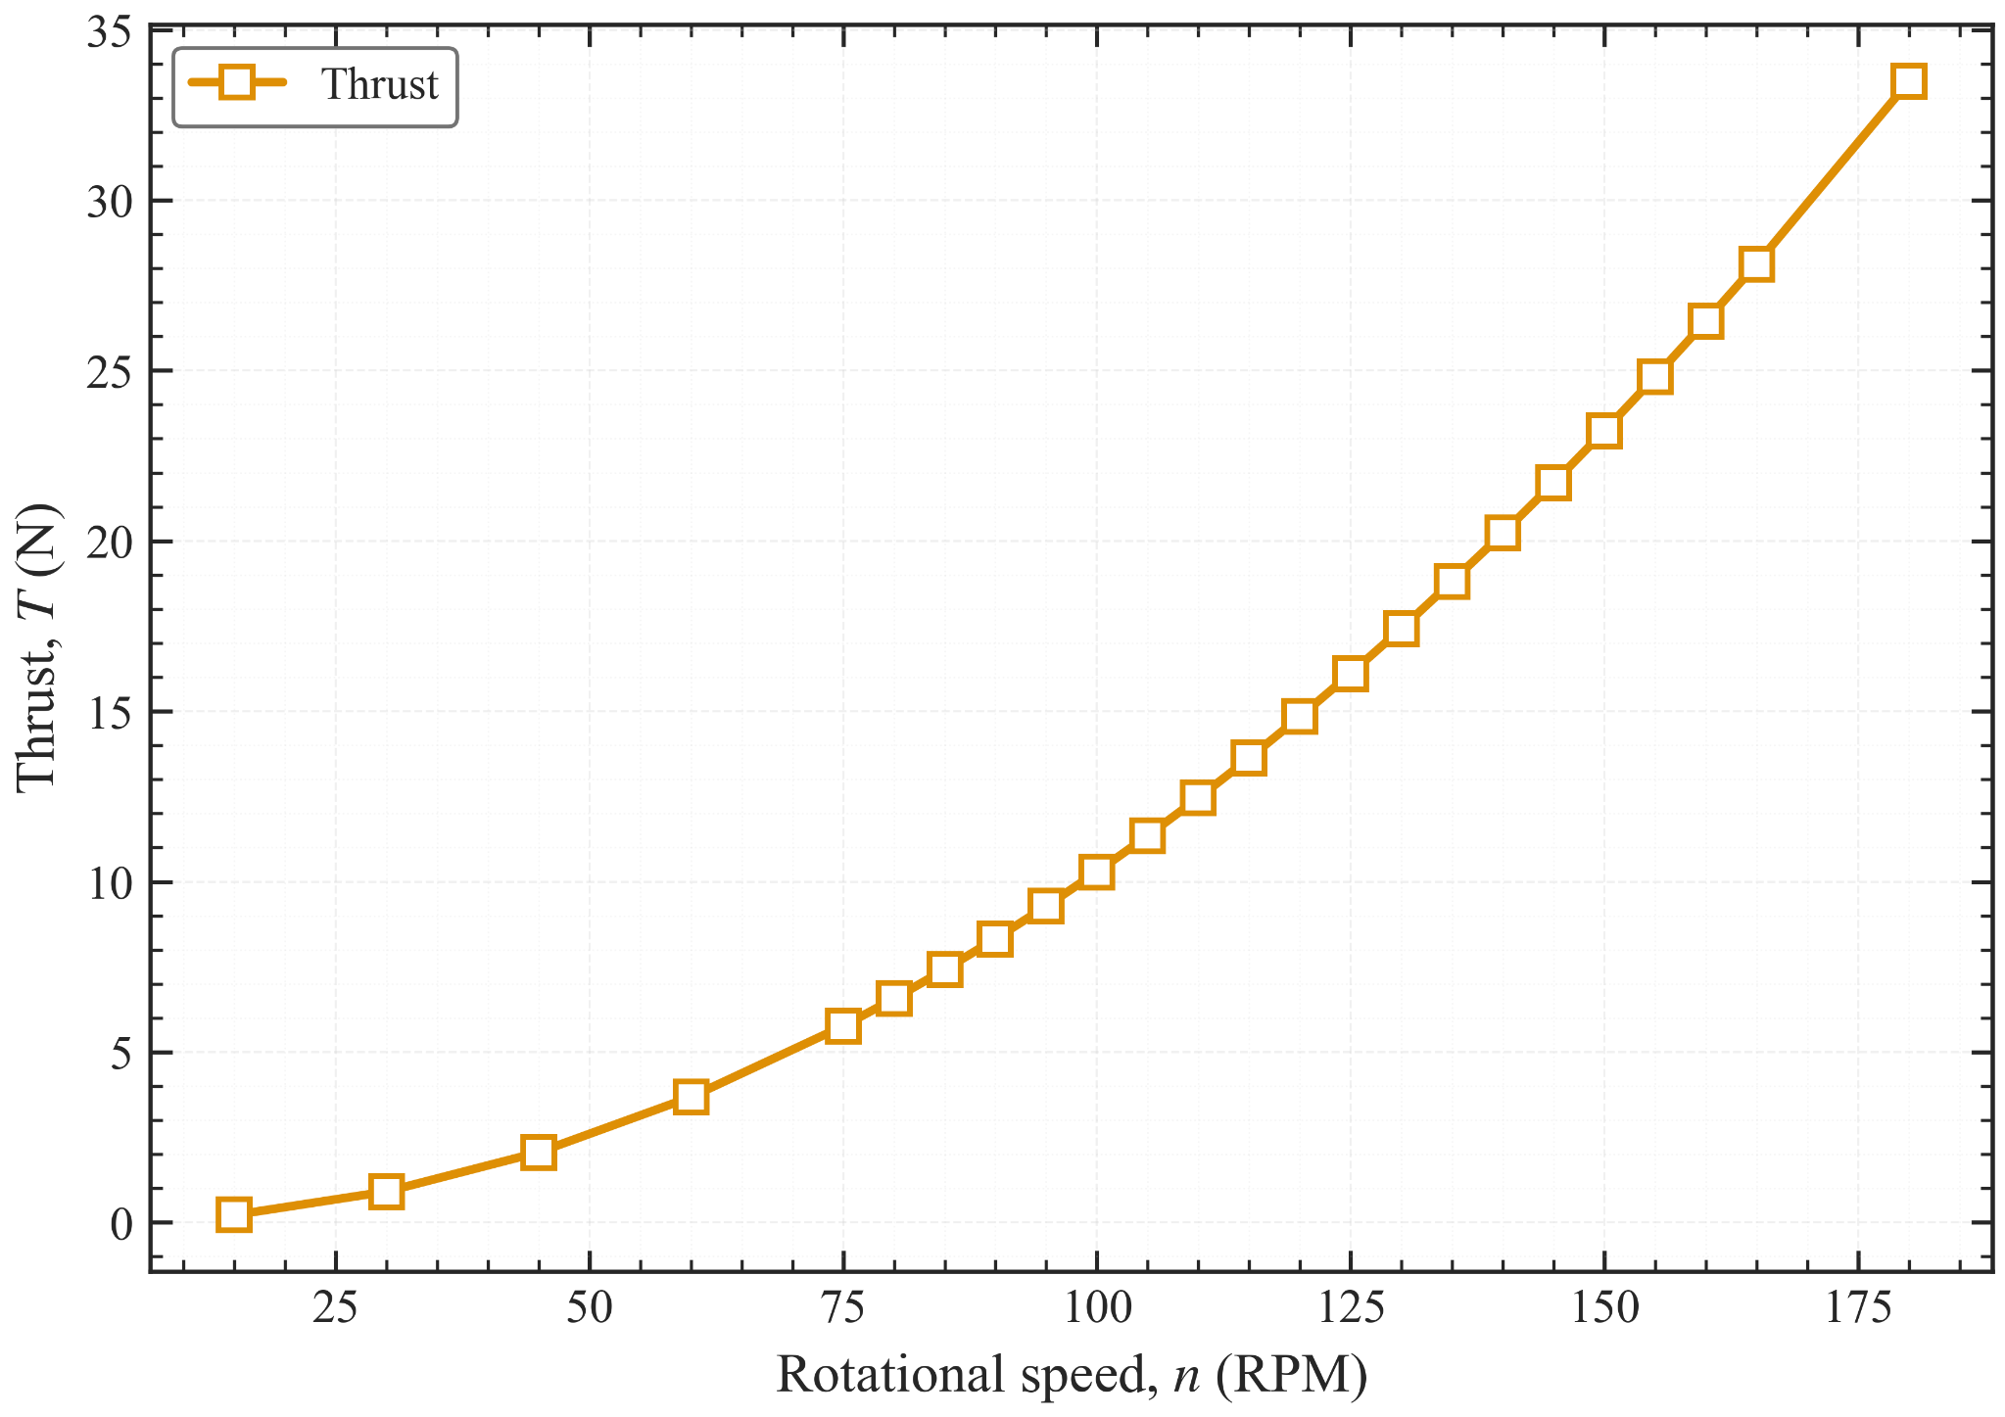
Figure 6. Thrust output vs roational speed plot of the propeller mode
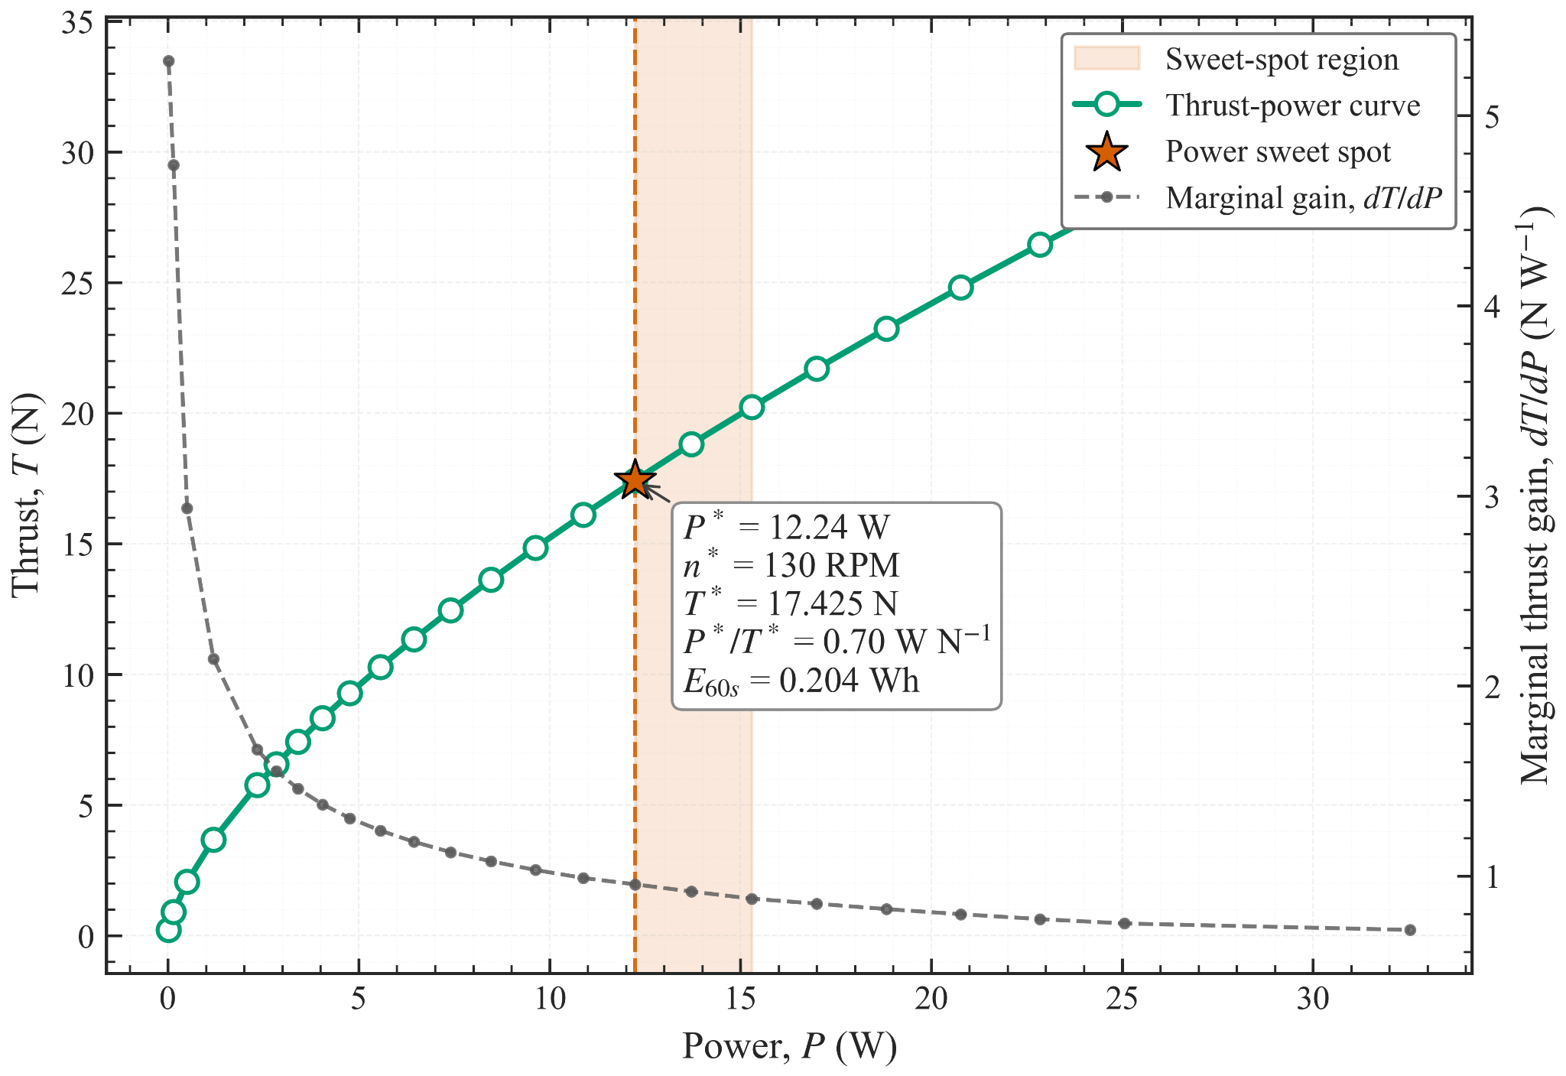
Figure 7. Power sweet spot analysis of the propeller mode

Discussion about the result:
The CFD results provide detailed quantitative information on the propeller performance. Figures 3 to 6 show the relationships between torque, thrust, shaft power, and rotational speed. To identify a representative operating speed, the power sweet spot was defined as the knee point of the dThrust/dPower curve, where the curvature reaches its maximum. As shown in Figure 7, the power sweet spot occurs at 130 rpm.
At a rotational speed of 130 rpm, the shaft power is 12.24 W, the thrust is 17.425 N, and the required torque is 0.9 Nm. The shaft power is reasonable for a brushless motor, and the thrust output is sufficient. However, the required torque of 0.9 Nm exceeds the capability of the motor without a reducer, which is approximately 0.2 Nm. Therefore, the CFD results provide a theoretical explanation for the unsuccessful water tank experiment of the propeller mode.

