Response to Viewers
- Summary
We sincerely thank Professor Huan and Professor Tim for reviewing our senior design final report draft. The comments identify the same core issue: the report did not provide enough visual and design evidence to show the completed automated room-access device, the system-level architecture, the mechanical implementation, and the project schedule.
- Point-by-point response to Comments and Suggestions
  - Response to Professor Huan
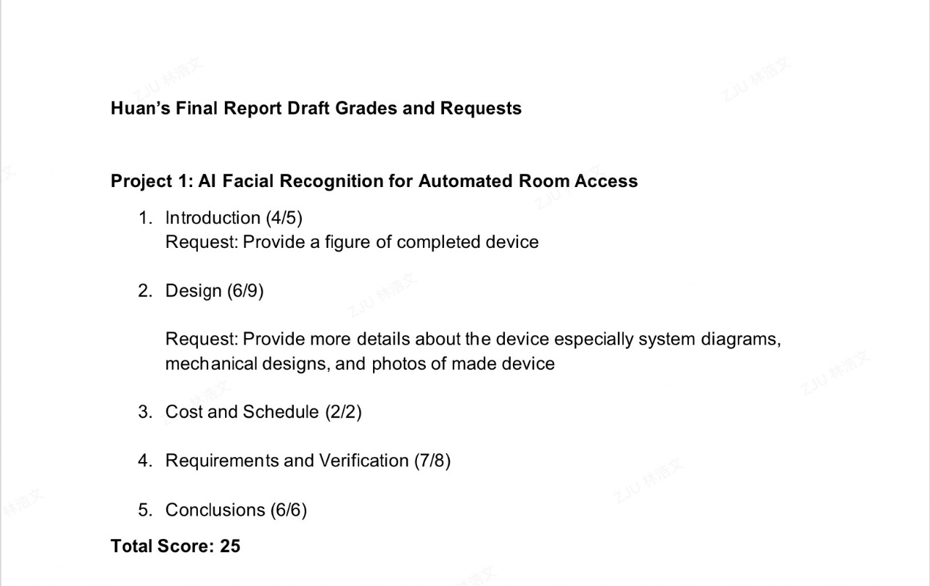
- Provide a figure of completed device 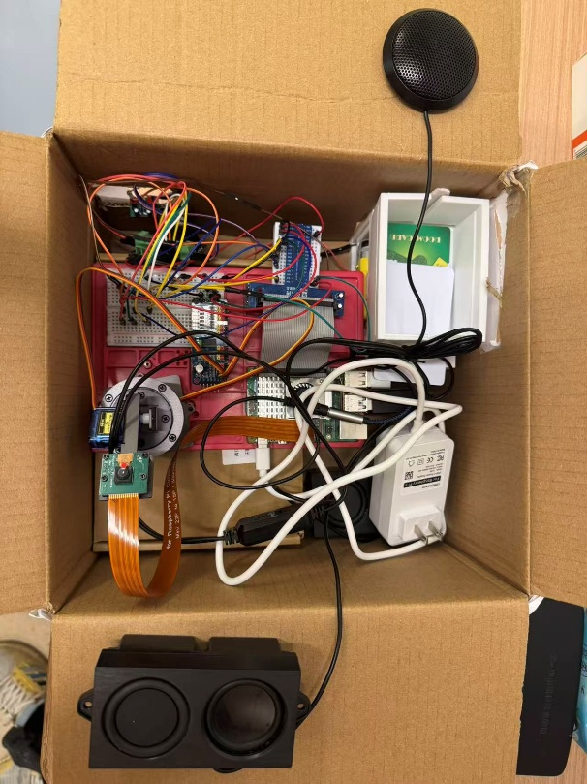
- Provide more details about the device especially system diagrams, mechanical designs, and photos of made device
System Diagram
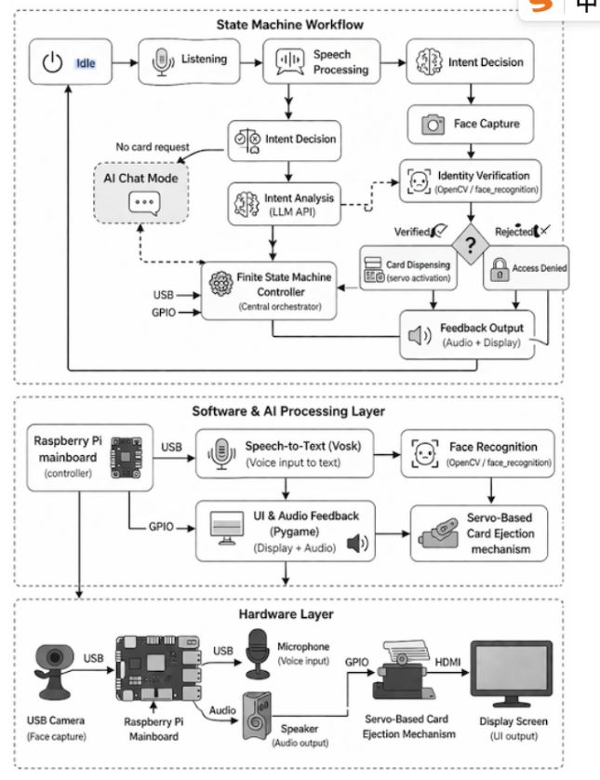

Mechanical Designs
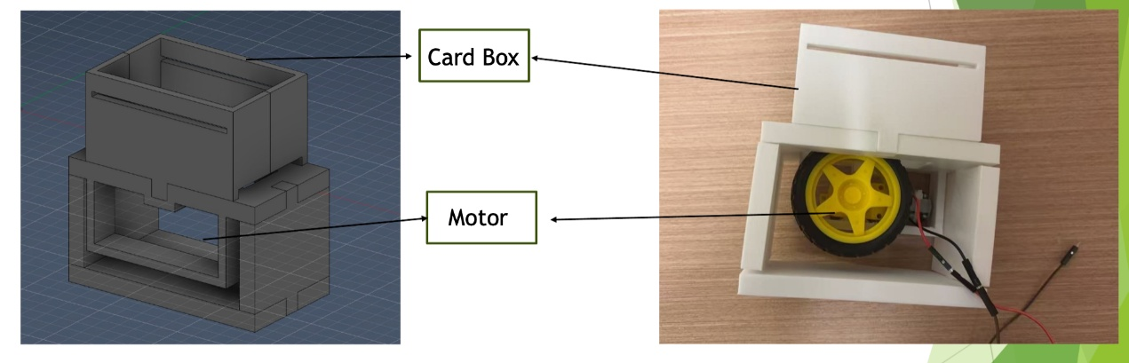

Device
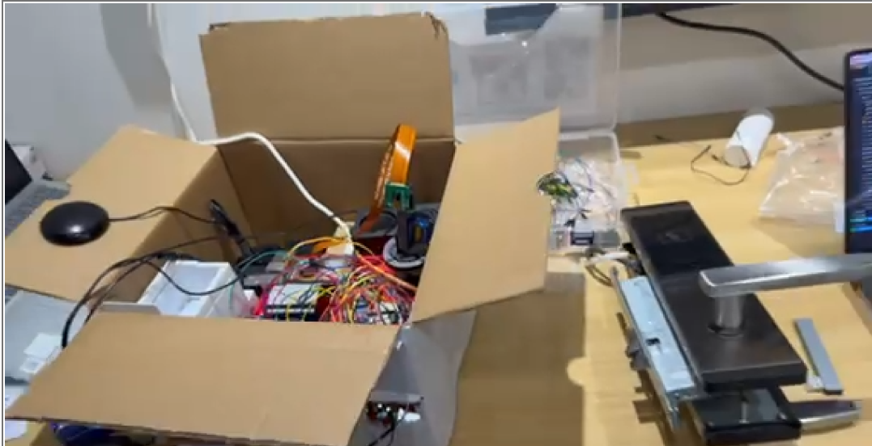

  - Response to Professor Tim
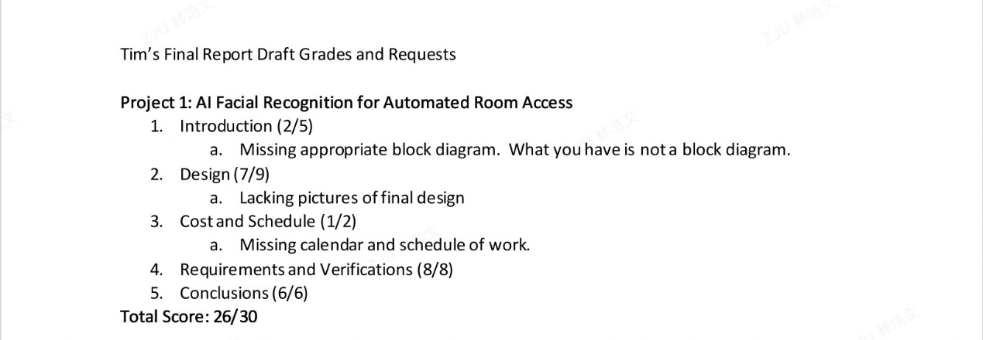
    - Missing appropriate block diagram. What you have is nota block diagram.
Block Diagram
    - Lacking pictures of final design
Final Design
    - Missing calendar and schedule of work.
Work Schedule
