Final Report for ECE 445, Senior Design, Spring 2026
TA: Yujie Gong
17 May 2026
Project No. 49
Lehan Pan
Tianyi Xu
Zhizheng Ju
Zihan Wang
By

Eco-Trim: Smart Scratch Pad Recovery System
Abstract
Eco-Trim is a compact mechatronic system designed to recover reusable blank regions from partially used office paper. The prototype feeds a sheet through a roller mechanism, scans surface reflectivity with an optical sensor, tracks paper position using a microcontroller-based finite state machine, and actuates a cutter when the detected blank region reaches the cutting stage. The system integrates low-voltage power distribution, motor-driver interfaces, optical sensing, and position-based motion control to coordinate the automated recovery process. During prototype testing, Eco-Trim successfully demonstrated the intended single-sheet workflow, including paper feeding, blank-region detection, controlled paper advancement, and automated cutting. The completed prototype shows that a dry, local paper-reuse process can convert partially used sheets into reusable scratch-pad sections through coordinated sensing, embedded control, and mechanical actuation.

Contents

1. Introduction 1
1.1 Problem and Objective 1
1.2 Final System Overview 1
1.3 High-Level Requirements 1
2. Design 3
2.1 Top-Level System Architecture 3
2.2 Power and Interface Architecture 4
2.3 Sensor Subsystem 5
2.4 Control and Positioning Design 5
2.5 Actuation and Safety Subsystem 6
2.6 Software Finite State Machine 7
3. Design Verification 9
3.1 System-Level Test Plan 9
3.2 Paper Feeding Verification 9
3.3 Blank-Region Detection Verification 10
3.4 Cut Accuracy and Cut-Time Verification 10
3.5 Safety Interlock Verification 11
4. Costs 12
4.1 Parts 12
4.2 Labor 12
5. Conclusion 13
5.1 Accomplishments 13
5.2 Uncertainties 13
5.3 Ethical considerations 14
5.4 Future work 14
References 16
Appendix A Requirement and Verification Table 17

1. Introduction

1.1 Problem and Objective
University libraries, study rooms, and campus workspaces generate a large amount of paper waste from single-sided printouts, draft notes, and partially used sheets. Many of these sheets still contain blank regions that are large enough for scratch work, but manually finding and trimming those regions is inconvenient and inconsistent. As a result, usable paper is often discarded together with printed content.
Eco-Trim addresses this problem by demonstrating a dry, local paper-reuse workflow. Instead of chemically recycling paper or shredding the entire sheet, the system identifies reusable blank regions and cuts them away so that they can be used as scratch-pad sections. The objective of the project is to build a compact prototype that combines paper feeding, optical sensing, embedded control, and mechanical cutting into one automated process. The final prototype focuses on a single-sheet workflow, in which the user inserts a sheet, starts the system, and the machine feeds, scans, advances, and cuts the paper automatically.

1.2 Final System Overview
Figure 1 shows the final system overview of Eco-Trim. The prototype is organized into four main functional blocks: the power and interface architecture, the optical sensing subsystem, the control subsystem, and the actuation subsystem.
The power and interface architecture provides low-voltage DC power to the controller, sensor, and motor driver. The optical sensing subsystem detects changes in paper surface reflectivity as the sheet moves through the paper path. This reflectivity information is used to distinguish printed regions from reusable blank regions. The control subsystem is implemented with a microcontroller-based finite state machine. It reads the sensor signal, tracks the paper position, and determines when the detected blank region reaches the cutting stage. The actuation subsystem advances the paper using a roller mechanism and performs the cutting operation when commanded by the controller.
During prototype testing, Eco-Trim successfully demonstrated the intended end-to-end single-sheet workflow. The prototype was able to feed a representative sheet, detect a usable blank region, advance the paper through the cutting path, and complete an automated cut. This result demonstrates the feasibility of using coordinated sensing, embedded control, and mechanical actuation to recover reusable blank sections from partially used paper.

1.3 High-Level Requirements
The final prototype was designed around the following high-level requirements:
- The system shall feed one representative sheet of paper through the roller path without requiring manual repositioning during the automated cycle.
- The optical sensing and control system shall distinguish a reusable blank region from printed content and use that decision to trigger the appropriate cutting sequence.
- The control subsystem shall coordinate sensor readings, paper advancement, and cutter actuation so that the selected blank region reaches the cutting stage before the cut is executed.
- The actuation subsystem shall complete the paper advancement and cutting operation automatically after the user starts the system.
- The completed prototype shall demonstrate the full single-sheet workflow from paper input to reusable scratch-pad output.
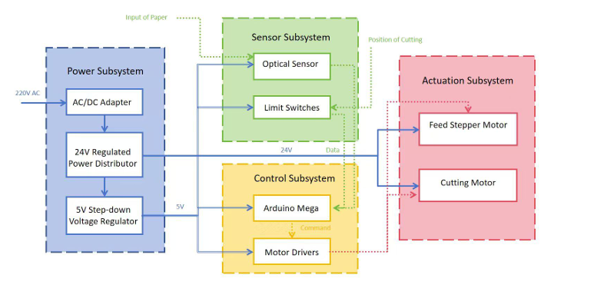
Figure 1 Conceptual overview of the Eco-Trim paper-reuse workflow.

2. Design
Eco-Trim was designed as a compact mechatronic prototype that combines paper feeding, optical sensing, embedded control, and mechanical cutting. Several design alternatives were considered before the final architecture was selected. For paper handling, a full automatic stack feeder was considered, but the final prototype uses a simpler single-sheet roller path to reduce mechanical complexity and focus on the core sensing-to-cutting workflow. For blank-region detection, a camera-based image-processing method was considered, but the final design uses a reflective optical sensor because it is simpler, lower cost, and does not require storing or processing document images. For positioning, the system uses feed-motion timing and step-based position tracking instead of a more complex closed-loop linear encoder. For power and interface design, the prototype uses commercial low-voltage power and driver modules rather than a custom mains-powered circuit, which reduces electrical risk during testing.
The following sections describe the final system architecture and the design of each major subsystem. The control and positioning section includes the main equations used to relate sensor position, paper feed motion, and cutter timing. The software finite state machine section describes the flowchart-level logic used to coordinate feeding, scanning, positioning, and cutting.

2.1 Top-Level System Architecture
Eco-Trim is organized as a compact mechatronic system that combines paper feeding, optical sensing, embedded control, and mechanical cutting. The purpose of the design is to move a partially used sheet of paper through a controlled paper path, detect a reusable blank region, and cut that region away for use as scratch paper.
Figure 2 shows the top-level system architecture of the Eco-Trim prototype. The final prototype is divided into four major functional blocks: the power and interface architecture, the sensor subsystem, the control and positioning subsystem, and the actuation and safety subsystem. The power and interface architecture supplies low-voltage DC power to the controller, sensor, and motor driver. The sensor subsystem measures paper surface reflectivity as the sheet moves through the paper path. The control subsystem reads the sensor output, tracks the paper position, and decides when to trigger the cutter. The actuation subsystem advances the paper and performs the cutting operation.
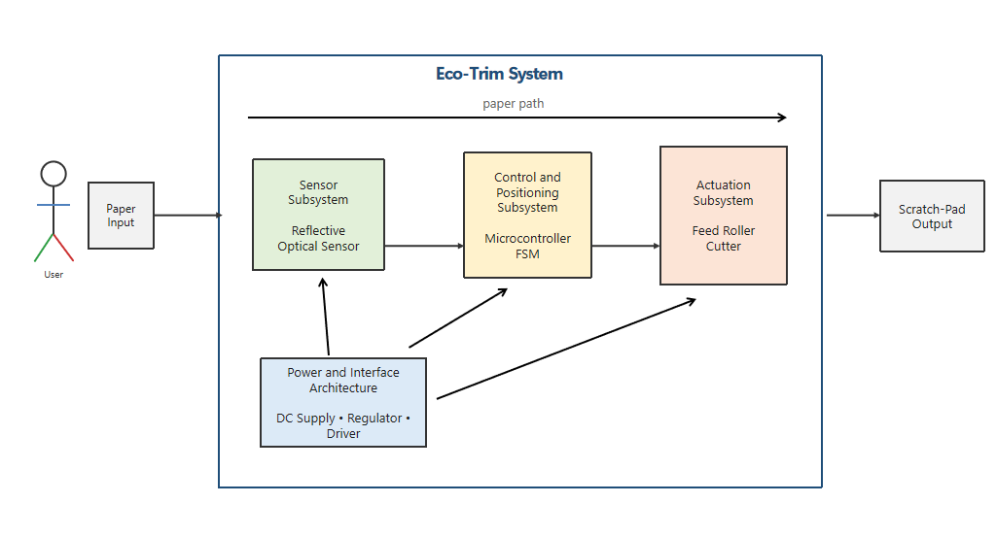
Figure 2 Top-level system architecture of the Eco-Trim prototype
The final prototype focuses on a single-sheet workflow. After the user places one representative sheet into the input path and starts the system, the feed mechanism moves the sheet past the optical sensor. The controller monitors the sensor signal to identify the transition between printed and blank regions. Once a usable blank region is detected, the controller advances the sheet by a calculated distance so that the selected region reaches the cutter, then activates the cutting mechanism. This architecture allows the prototype to demonstrate the complete sensing-to-cutting process with a relatively simple mechanical and electrical structure.

2.2 Power and Interface Architecture
The prototype uses a low-voltage DC power architecture to simplify integration and reduce electrical risk during testing. A purchased external DC power supply provides the main motor supply voltage, while a step-down voltage regulator provides the logic-level supply for the microcontroller and sensor interface. This approach avoids exposing the student-built portion of the prototype to mains voltage and keeps the electrical design focused on system integration, motor control, and signal interfacing.
The motor driver receives the higher-voltage DC supply needed to drive the feed and cutting actuation hardware. The microcontroller and optical sensor operate from the regulated logic rail. All control signals share a common reference ground so that the microcontroller can reliably command the motor driver and read the sensor output. The wiring between modules is arranged so that power, ground, sensor signal, and motor-control signals are separated as clearly as possible.
Because the final prototype is a functional demonstration rather than a production-ready product, the power and interface architecture is implemented using commercial modules and direct wiring. The main design requirement for this portion is stable power delivery during feeding and cutting. The logic rail must remain stable while the motor driver switches load current, and the motor supply must provide sufficient current for the roller and cutter motion without causing the controller to reset.

2.3 Sensor Subsystem
The sensor subsystem is responsible for distinguishing printed regions from reusable blank regions on the paper. The prototype uses a reflective optical sensor mounted above the paper path. As the paper moves under the sensor, the sensor output changes according to the surface reflectivity of the region being scanned. Blank paper generally produces a different reflectivity response from printed text or darker markings, so the controller can use the sensor signal to identify candidate blank regions.
The sensor is positioned before the cutting stage so that the controller has time to process the reading and move the paper to the correct cutting position. The fixed distance between the sensor and cutter is an important geometric parameter in the system. Once the sensor detects the start of a usable blank region, the controller must advance the sheet by this known distance before executing the cut.
The sensing algorithm uses a threshold-based decision. During setup, representative blank and printed paper regions are observed, and a threshold is selected to separate the two conditions. When the measured sensor value corresponds to a blank region for a sufficient distance, the controller treats that region as a valid candidate for cutting. This method is simple enough for the microcontroller to run in real time and is appropriate for the final single-sheet prototype demonstration.

2.4 Control and Positioning Design
The control subsystem coordinates sensor reading, paper movement, and cutter timing. A microcontroller runs the main control program as a finite state machine. This structure allows the system to move through a predictable sequence of operations: waiting for the user to start the system, feeding the paper, scanning the sheet, validating a blank region, advancing the paper to the cutting position, and triggering the cutter.
Position tracking is based on the feed motion of the roller mechanism. The sensor is mounted a fixed distance D before the cutting stage. When the controller detects a valid blank region at the sensor, it must continue advancing the paper until that same region reaches the cutter. If the feed speed is treated as approximately constant, the delay can be estimated by
$$t=D/v$$ | (1)
where D is the sensor-to-cutter distance and v is the paper feed speed. If the feed motor is controlled by step commands, the same positioning problem can be handled by counting motor steps instead of using time alone.
For a stepper-driven roller, the nominal paper travel per motor step can be estimated by
$$s_{step}=2πr/N$$ | (2)
where r is the roller radius and N is the number of motor steps per revolution. For example, using a roller radius of 15 mm and 200 full steps per revolution gives an estimated travel distance of approximately 0.471 mm per step. This calculation shows that step-based positioning provides sufficient resolution for a prototype paper-cutting system.
The major positioning errors come from roller slip, imperfect roller radius, sensor threshold variation, and step quantization. These tolerance effects are considered in the control design rather than as a separate report chapter. In the final report, the detailed calculation can be placed in an appendix, while this section only explains how the controller uses the fixed sensor-to-cutter distance and feed motion to determine the cut timing.

2.5 Actuation and Safety Subsystem
The actuation subsystem performs the physical movement required for paper recovery. It includes the feed mechanism, the motor driver, the roller path, and the cutting mechanism. The feed mechanism advances the paper through the sensor and cutter stages. The cutting mechanism is activated only after the controller determines that the selected blank region has reached the cutting stage.
Figure 3 shows the mechanical layout of the prototype. The roller path guides the paper in a fixed direction, the optical sensor is mounted above the paper path, and the cutter is located downstream from the sensing position. This layout is important because the controller uses the fixed sensor-to-cutter distance to determine when the detected blank region should be cut.
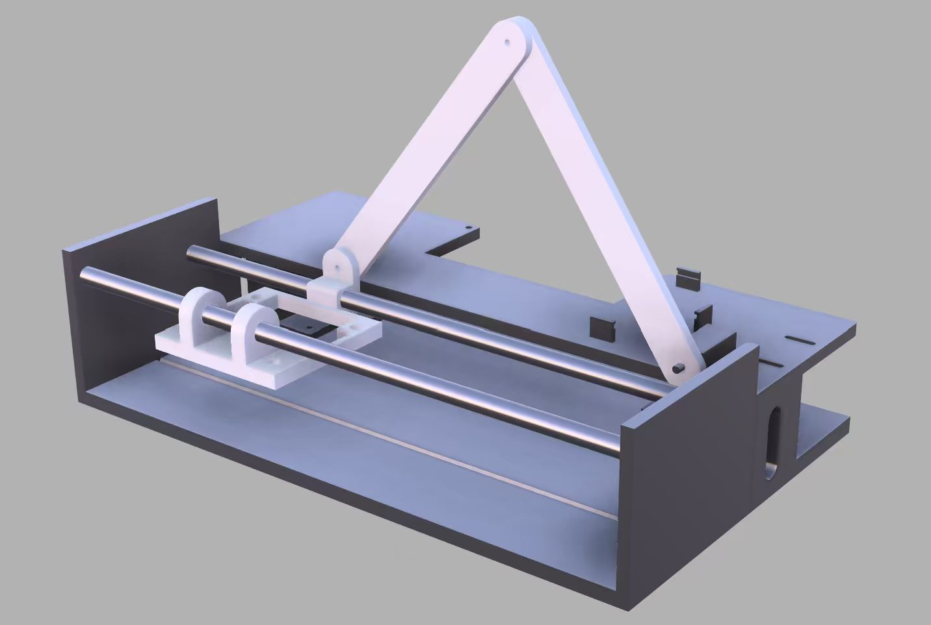
Figure 3 Mechanical layout of the Eco-Trim prototype
A roller-based feed path was selected because it provides a compact and mechanically simple way to move paper through the prototype. The roller applies friction to the sheet and advances it along a fixed path. This arrangement is suitable for the final single-sheet demonstration because it avoids the additional complexity of a full automatic stack feeder while still showing the essential paper-handling behavior required by Eco-Trim.
The cutter is controlled by the microcontroller through the motor-driver interface. After the controller reaches the cut state, it commands the cutter to complete one cutting motion. The actuation sequence is designed so that feeding and cutting do not occur as independent actions; instead, both actions are coordinated by the control subsystem. This coordination is necessary because the cut position depends on the earlier optical sensing result.
Figure 4 shows the final assembled prototype used for the demonstration. The prototype was operated as a supervised low-voltage bench system. The electrical design keeps mains voltage outside the student-built mechanism by using an external power adapter, and the internal wiring distributes only low-voltage DC power. During testing, the cutting mechanism was operated only when the paper was positioned and the operator was clear of the moving parts. Although the final prototype does not include a production-level safety enclosure or IR light curtain, the design limits the demonstration to controlled operation and avoids presenting the system as a public-ready machine.
[Insert Figure 4 here]
Figure 4. Final assembled Eco-Trim prototype.

2.6 Software Finite State Machine
The software is implemented as a finite state machine so that each stage of the paper-recovery process has a defined purpose and exit condition. This structure makes the prototype easier to debug because the controller always operates in one known state at a time.
Figure 5 shows the software finite state machine. The main states are Idle, Feed Paper, Scan Paper, Validate Blank Region, Advance to Cut Position, Execute Cut, and Stop. In the Idle state, the system waits for the user to start the cycle. In the Feed Paper state, the controller commands the feed mechanism to move the sheet into the sensing path. In the Scan Paper state, the controller repeatedly reads the optical sensor while the paper moves. In the Validate Blank Region state, the controller determines whether the sensor readings indicate a usable blank region. If a valid region is detected, the controller enters the Advance to Cut Position state and moves the paper by the required distance from the sensor to the cutter. The Execute Cut state then activates the cutting mechanism. After the cut is complete, the system enters the Stop state and waits for the next manual reset or cycle.
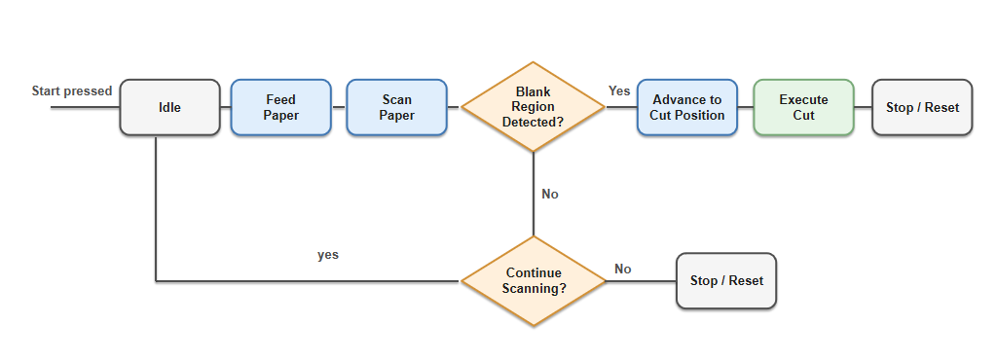
Figure 4 Software finite state machine for coordinating feeding, sensing, positioning, and cutting
The finite state machine is important because the system depends on the timing relationship between sensing and cutting. A sensor reading does not immediately trigger the cutter; instead, it marks a paper position that must be advanced to the cutter before actuation. By separating scanning, validation, advancement, and cutting into different states, the software reduces the chance of triggering the cutter at the wrong time and makes the overall control sequence more predictable.

3. Design Verification
The design verification process evaluated whether the final Eco-Trim prototype could complete its intended single-sheet paper-recovery workflow. Because the final prototype was built as a supervised demonstration system, the verification focused on the core functional sequence: feeding one representative sheet, detecting a reusable blank region, advancing the paper based on the sensed position, and completing an automated cut. The verification also checked that the prototype could be operated safely under controlled low-voltage test conditions.
The original project concept included a more complete public-facing machine with repeated sheet feeding and hardware safety interlocks. The final prototype instead demonstrates the essential sensing-to-cutting behavior on a single sheet. Therefore, the verification discussion in this chapter focuses on the implemented prototype rather than unbuilt production-level features.

3.1 System-Level Test Plan
The system-level test was designed to confirm that the major subsystems could work together as one coordinated prototype. The test began with a representative sheet of partially used paper placed into the input path. After the user started the cycle, the prototype was expected to feed the paper through the roller path, scan the paper surface using the reflective optical sensor, identify a reusable blank region, advance the paper toward the cutting stage, and execute the cut.
The main purpose of this test was not to independently test each component, but to verify the complete sequence from paper input to scratch-pad output. A successful system-level test required the following conditions:
1. The paper entered the feed path and moved under the sensor.
2. The sensor produced a usable response as the paper passed through the sensing position.
3. The controller used the sensor response to determine when to continue advancing the paper.
4. The actuation subsystem moved the paper to the cutting stage.
5. The cutter completed the cutting action after the controller reached the cut state.
The final prototype successfully demonstrated this intended single-sheet workflow. This result shows that the sensing, control, and actuation subsystems were integrated well enough to complete the core Eco-Trim recovery process.

3.2 Paper Feeding Verification
The paper feeding verification evaluated whether the roller mechanism could move a representative sheet through the prototype without manual repositioning during the automated cycle. The test sheet was inserted into the input path, and the feed mechanism was activated under controller command. During the test, the team observed whether the sheet entered the roller path, stayed aligned well enough to pass under the sensor, and continued moving toward the cutter.
The prototype successfully fed one representative sheet through the intended path during the final demonstration workflow. The roller mechanism provided enough friction to advance the sheet from the input position to the sensing and cutting stages. This verified the basic function of the paper feed mechanism for the implemented single-sheet prototype.
The final prototype did not verify automatic multi-sheet feeding from a stack. Instead, the feeding verification was limited to the single-sheet workflow that was actually implemented. This limitation does not prevent the prototype from demonstrating the core Eco-Trim concept, but it should be considered when evaluating the system as a future public-use device.

3.3 Blank-Region Detection Verification
The blank-region detection verification evaluated whether the optical sensing subsystem could distinguish a reusable blank area from printed content well enough to support the cutting decision. The reflective optical sensor was mounted above the paper path and connected to the microcontroller input. As the paper moved under the sensor, the controller monitored the sensor output and compared it against the selected threshold.
For the implemented prototype, verification was performed using a representative sheet that contained both printed and blank regions. The expected behavior was that printed regions would produce a different sensor response from blank paper, allowing the controller to identify the blank region as a valid candidate for cutting. During the demonstration, the sensor response was sufficient for the controller to recognize the usable blank region and proceed with the cutting sequence.
This result verified the functional role of the sensor subsystem in the final single-sheet workflow. The prototype demonstrated that a simple reflective sensing approach can support blank-region detection without using a camera or storing document images. A larger test set would be required to claim a specific detection accuracy across many paper types, ink densities, and lighting conditions, so this report treats the result as a successful functional demonstration rather than a statistical accuracy measurement.

3.4 Cut Accuracy and Cut-Time Verification
The cut accuracy and cut-time verification evaluated whether the prototype could advance the detected blank region to the cutting stage and complete the cutting action. The controller used the fixed geometric relationship between the sensor and cutter to determine when the cut should occur. After the blank region was detected, the system continued advancing the paper before activating the cutter.
During the final workflow test, the prototype completed an automated cut after feeding and sensing the sheet. The cut separated a reusable section from the original sheet, demonstrating that the controller, paper-feed motion, and cutter actuation were coordinated successfully. This verified the basic timing relationship between blank-region detection and cutter activation.
The final verification did not include a full numerical cut-position error study or repeated timing trials. Instead, the result was evaluated as an end-to-end functional demonstration: the sheet was fed, the blank region was detected, the paper was advanced, and the cutter was actuated to produce a reusable output section. The positioning calculation in the design section supports the feasibility of the approach, while more detailed quantitative testing would be appropriate for a later prototype revision.

3.5 Safety Interlock Verification
The final prototype was operated as a supervised low-voltage bench prototype rather than a public-ready enclosed machine. Because the production-level enclosure interlock and IR light curtain were not implemented in the final build, this verification focused on controlled operating procedure and low-voltage electrical safety rather than claiming full hardware interlock performance.
During testing, the prototype was powered through an external power adapter so that mains voltage remained outside the student-built mechanism. The internal system distributed only low-voltage DC power to the controller, sensor, and motor driver. Before each test, the operator checked that the paper path was clear and that hands were away from the roller and cutter areas. The cutting mechanism was activated only during controlled demonstrations.
This safety verification confirmed that the completed prototype could be operated under supervised test conditions. However, the prototype should not be described as ready for unsupervised public use. A future version intended for libraries or study spaces would need a complete enclosure, a lid switch or equivalent interlock, an emergency-stop path, and quantitative shutdown-time testing before deployment.

4. Costs
This section will be completed after the remaining components are purchased and the final bill of materials is confirmed.

4.1 Parts
A preliminary parts table will be added after the final purchase list is completed.
Table X Parts Costs
Part | Manufacturer | Retail Cost ($) | Bulk Purchase Cost ($) | Actual Cost ($)
Total

4.2 Labor
Team Member | Hourly Rate  (RMB/hour) | Hours Spent | Overhead Factor | Total Cost (RMB)
Zhizheng Ju | 50 | 30 | 2.5 | 3750
Tianyi Xu | 50 | 30 | 2.5 | 3750
Lehan Pan | 50 | 30 | 2.5 | 3750
Zihan Wang | 50 | 30 | 2.5 | 3750
Total |  |  |  | 15000

5. Conclusion
The Eco-Trim prototype successfully demonstrated the core workflow of a dry, local paper-reuse system. The completed prototype integrated paper feeding, optical sensing, microcontroller-based control, and mechanical cutting into one coordinated process. During the final demonstration, the system was able to feed a representative sheet, detect a usable blank region, advance the paper through the cutting path, and complete an automated cut. This result shows that reusable blank sections can be recovered from partially used paper through coordinated sensing, positioning, and actuation.
Although the final prototype is not a public-ready machine, it provides a functional proof of concept for the Eco-Trim system. The project demonstrates that a relatively simple sensing and control architecture can support local paper reuse without using camera-based document imaging or wet chemical reprocessing.

5.1 Accomplishments
The main accomplishment of the project was the successful completion of the single-sheet sensing-to-cutting workflow. The final prototype combined the mechanical, electrical, and software portions of the system into an integrated demonstration. The paper feed mechanism moved a representative sheet through the sensing and cutting path. The reflective optical sensor provided a usable signal for distinguishing blank regions from printed regions. The microcontroller used this sensing result to coordinate paper advancement and cutter activation.
Another accomplishment was the implementation of a finite state machine for the control sequence. The software separated the process into clear states, including feeding, scanning, blank-region validation, advancing to the cut position, and executing the cut. This made the system behavior more predictable and easier to debug.
The project also demonstrated a practical mechanical layout for the Eco-Trim concept. The final prototype placed the sensor upstream of the cutter and used the fixed distance between these two components to determine cut timing. This confirmed that the basic architecture of detecting a blank region first and cutting it after controlled advancement is feasible.

5.2 Uncertainties
The final prototype was designed and tested as a supervised single-sheet demonstration rather than a complete public-use product. Therefore, the main limitation is that the prototype does not yet support reliable automatic feeding from a stack of multiple sheets. The current paper path demonstrates the core feeding behavior, but additional mechanical development would be required to prevent multi-sheet feeding, skew, and jamming in repeated operation.
The blank-region detection method also has limitations. The prototype uses threshold-based reflective sensing, which is simple and effective for the demonstration sheet, but its performance may change with different paper colors, ink densities, lighting conditions, and surface finishes. A larger test set would be needed to quantify detection accuracy across many paper types.
The final prototype also does not include a production-level safety enclosure, IR light curtain, or fully verified hardware interlock system. For this reason, the system should only be considered a controlled bench prototype. It should not be operated as an unsupervised public machine without additional safety hardware, enclosure design, and shutdown-time verification.
Finally, the cut quality and cut position were verified at a functional demonstration level rather than through extensive repeated measurement. The prototype showed that the sensing-to-cutting sequence can work, but a later version would need more repeated trials to characterize cut-position error, cutting consistency, and long-term mechanical reliability.

5.3 Ethical considerations
Eco-Trim was designed to support local paper reuse by recovering blank regions from partially used sheets. This goal has a positive environmental motivation because it encourages reuse before disposal or recycling. However, the project must be presented honestly. The system does not create new paper, and it does not replace industrial recycling. Instead, it salvages usable blank areas from paper that would otherwise be discarded.
User privacy is also an important ethical consideration. Since the system processes partially printed documents, it should avoid storing, imaging, or transmitting document content. The final prototype uses reflectivity-based sensing rather than a camera, which helps reduce privacy risk because the system only needs to detect whether a region is blank or printed.
Safety must also be treated as a primary ethical responsibility. The prototype contains moving rollers and a cutting mechanism, so the system must not be represented as safe for unsupervised public use in its current form. During testing, the prototype was operated under supervision and with low-voltage internal power distribution. A future public-facing version would require a complete enclosure, physical interlocks, emergency-stop behavior, and careful safety validation before deployment.
These considerations are consistent with the engineering responsibility to protect users, avoid misleading claims, and report system capabilities accurately.

5.4 Future work
Future work should first focus on improving the mechanical feeding system. A more complete version of Eco-Trim should include a reliable stack-feeding mechanism that can separate and feed multiple sheets without repeated manual loading. This would require improved roller pressure control, paper alignment guides, and jam-detection behavior.
The sensing subsystem could also be improved. Instead of relying only on a fixed threshold, a future version could include calibration routines or adaptive thresholding to handle different paper types and lighting conditions. A larger test set should be used to evaluate blank-region detection accuracy more rigorously.
The actuation and cutting system should be refined to improve consistency. Future testing should measure cut-position error, cutting time, and edge quality over repeated trials. These measurements would help determine whether the system can reliably produce reusable scratch-pad sections under normal use.
Finally, a public-ready version of Eco-Trim would require a complete safety redesign. This should include an enclosed paper path, lid or door interlocks, emergency-stop behavior, and verification that motor power is removed quickly during unsafe access events. With these improvements, Eco-Trim could move from a functional prototype toward a more reliable and user-safe paper-reuse device.

References
[1] Arduino, “Mega 2560 Rev3,” Arduino Documentation.
[2] Texas Instruments, “LM2596 SIMPLE SWITCHER Power Converter,” Datasheet.
[3] IEEE, “IEEE Code of Ethics.”

Appendix A Requirement and Verification Table
To be completed in the final submission
Table X System Requirements and Verifications
Requirement | Verification | Verification status  (Y or N)
- Requirement  - Subrequirement  - Subrequirement  - Subrequirement | - Verification  - Subverification  - Subverification  - Subverification
- Requirement  - Subrequirement  - Subrequirement  - Subrequirement | - Verification  - Subverification  - Subverification  - Subverification

