A Vision-Integrated Robot for Autonomous Book Reshelving
Final Report Draft
Team #34
Zhecheng Lou, Xinrui Xiong, Zhenxiong Tang, Zehao Bao
Advisor: Timothy Lee
ME470 / ECE445 Senior Design Laboratory
Spring 2026
Draft updated: May 15, 2026

Revision Note
This draft is structured as a final implementation and validation report rather than a revised copy of the original Design Document. The original design document is treated as the design baseline. Red bracketed markers indicate items that still require final demo confirmation, teammate-provided counts, BOM/schedule data, or citation cleanup.

Contents
- 1. Introduction
- 2. Requirements and Final Demonstration Scope
- 3. System Overview
- 4. Perception Subsystem
- 5. Decision Subsystem
- 6. Control Subsystem
- 7. System Integration
- 8. Design Revisions from the Original Design Document
- 9. Tolerance and Feasibility Analysis
- 10. Verification and Testing
- 11. Results and Discussion
- 12. Cost, Schedule, Ethics, and Safety
- 13. Conclusion and Future Work
- References

1. Introduction

1.1 Problem Statement
Returned library books must be identified, matched to catalog records, and placed back into the appropriate shelf region. Manual reshelving is repetitive, time-consuming, and sensitive to sorting errors. This project addresses the problem through a fixed-workstation robotic demonstrator that combines vision-based scene understanding, task planning, and robotic manipulation.

1.2 Final Solution Overview
The final system is organized as a layered autonomous reshelving prototype. The perception layer identifies returned books and estimates shelf occupancy. The decision layer converts this structured scene estimate into a placement decision. The control layer receives the selected pick and place targets, generates a verified target sequence, and executes the arm and gripper motions through the calibrated serial/PWM hardware path.

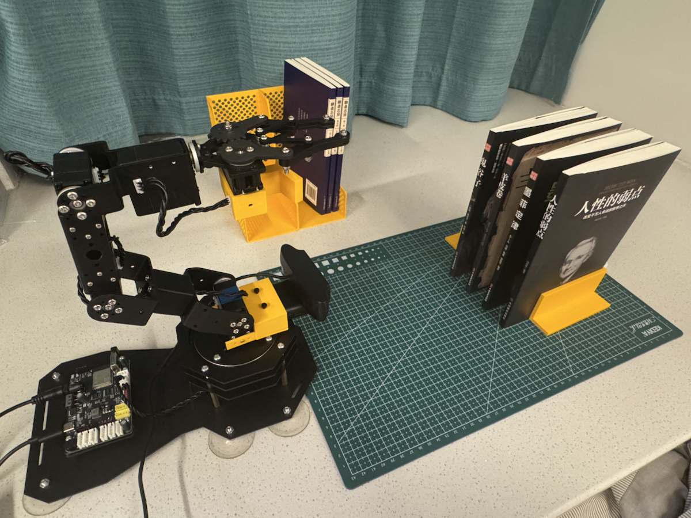
Figure 1. Final fixed-workstation demonstration setup with robotic arm, return-bin/book holders, shelf target region, and control hardware.

1.3 Demonstration Scenario
The current demonstration is a controlled single-station book reshelving task. The robot first performs a startup scan: the left view observes the shelf and the center view observes the return-bin books. The vision pipeline detects known book titles and estimates each book-spine grasp point. The auto-demo mode then generates one hardware command sequence per feasible book and can execute the sequence on the physical arm after the operator confirms the printed plan.
Official final-demo evidence is taken from the 2026-05-15 19:06 startup scan and 19:06:51 auto-demo run. In the representative successful workflow, three books are randomly placed in the return bin. The system scans the bin and shelf, identifies the visible known titles, creates a task queue according to the configured book list and available shelf candidates, and then commands the arm to return the books one by one. The robot does not simply replay three fixed shelf points: it uses the initialized shelf world model and slice scoring to choose supported placement slices for each planned book. The representative cycle time is approximately one minute for the three-book run.

2. Requirements and Final Demonstration Scope
The original design document defined ambitious one-button, multi-book operation. The final demonstration scope is a constrained but complete workstation demo: three books are randomly placed in the return bin, the system performs a startup scan, creates an ordered task queue from recognized titles and shelf candidates, and commands the arm to return the books sequentially. The demonstrated system has achieved successful end-to-end cycles, but repeated trials also show that manipulation reliability remains the main limiting factor.
The main requirements and verification plan are summarized in the RV table below.
Requirement | Verification Procedure | Success Criterion | Status / Evidence Needed
One-button operation | Run startup scan and auto-demo from the menu or CLI, then use the printed execution gate before hardware motion. | After startup, the system detects known books, prepares command sequences, and either executes or reports a logged failure without manual coordinate editing. | Demonstrated in constrained final scope: the selected 2026-05-15 run used startup scan plus auto-demo for a three-book sequence and sent a 40-command serial/PWM sequence.
Book identification | Run the OCR-first book detector on the controlled known-book set and compare recognized titles with ground truth. | Known books are matched to the catalog; unknown OCR text is reported for manual handling and never drives robot motion. | Current logs show known-title detections including 羊皮卷, 鬼谷子, 墨菲定律, and 人性的弱点. Formal accuracy counts still need the perception-owner table.
Shelf placement decision | Run the shelf scanner on the left startup view, split each detected section into slices, and inspect candidate scores. | Occupied slices are penalized; free slices with wall or adjacent-book support rank higher than unsafe candidates. | Implemented for the current shelf scan path: both visible shelf sections are split into five slices, with supported slices ranked above low-quality interior or occupied regions.
Manipulation success | Execute the final pick/place motion chain on the physical arm over repeated trials. | The book is picked, transported, released at the intended shelf location, and the gripper retreats safely. | Representative successful three-book cycle completed in about one minute. Repeated attempts showed failures from gripper slip and unsafe waypoint transitions, so reliability is reported honestly as constrained.

3. System Overview

3.1 Block Diagram and Data Flow
The final architecture is best described by three subsystems: perception, decision, and control. The subsystems are connected by structured data rather than by shared internal assumptions.
The perception subsystem answers what the robot can see: which book is present and which shelf slices are empty, occupied, or uncertain. The decision subsystem answers what the robot should do: which task to execute and which shelf opportunity should be selected. The control subsystem answers how the robot physically performs the action: it converts the selected PickPlacePlan into arm and gripper motion.
The current implementation has two practical run stages. The startup-scan stage captures a shelf view and a bin view and writes a world snapshot. The auto-demo stage reads live book detections and the available shelf model, prechecks target sequences, prints a human-readable execution plan, and optionally sends the combined command sequence to the arm.
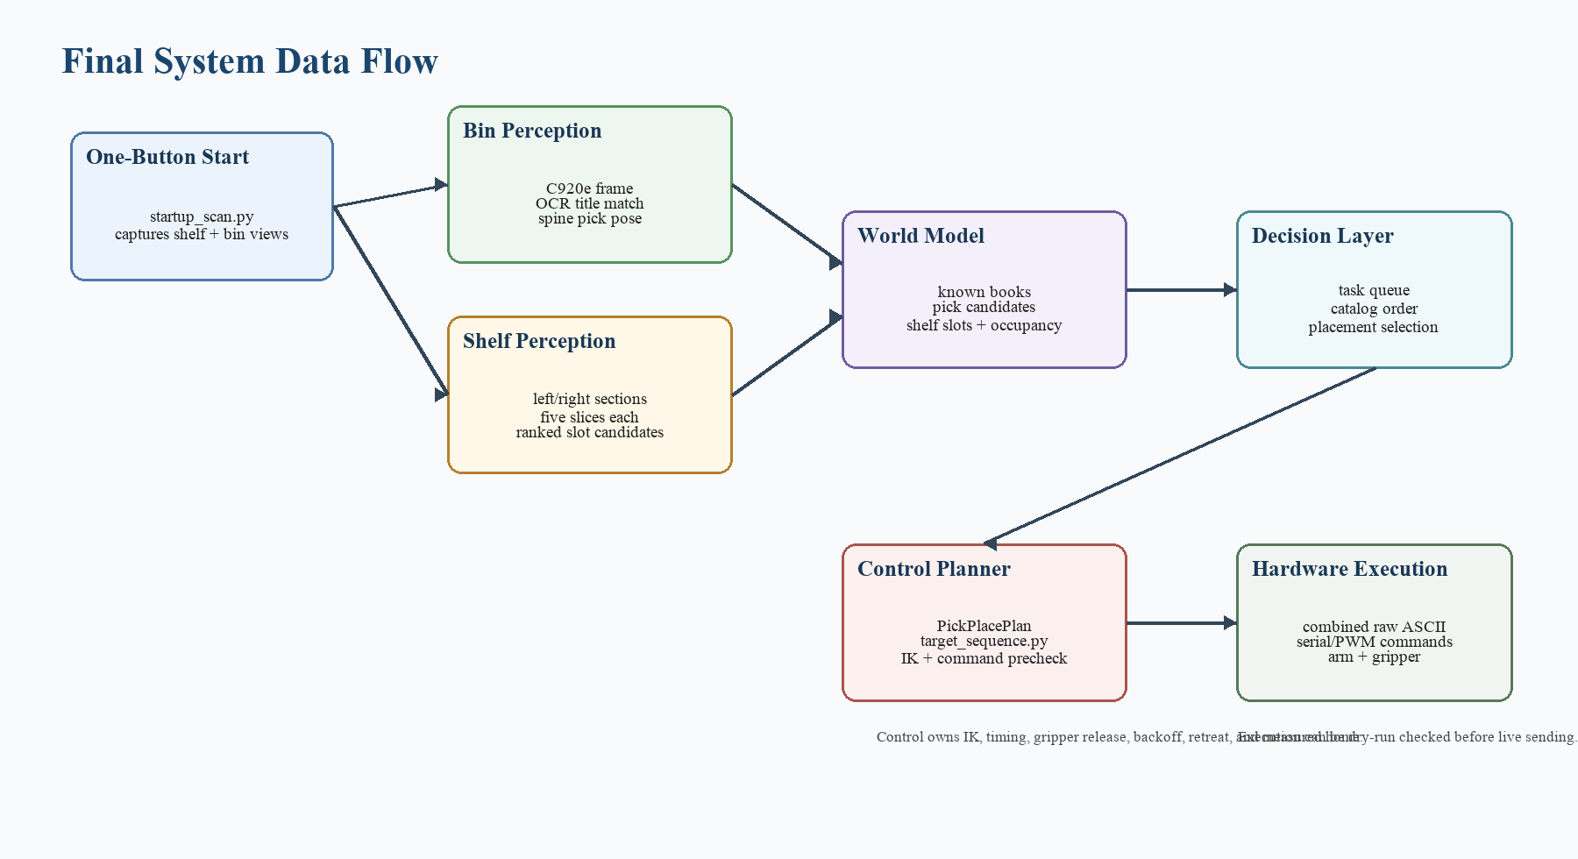
Figure 2. Final system block diagram connecting startup scan, perception, world model, decision, control planning, and serial/PWM hardware execution.

3.2 Interface Summary
The most important interface is the transition from decision to control. The decision subsystem should not send servo angles or PWM values. Instead, it provides world-frame pick and place targets or an equivalent PickPlacePlan-shaped output. The control subsystem is responsible for target-sequence generation, inverse kinematics checks, command conversion, hardware timing, and safe failure handling. This separation prevents perception or decision code from depending on the details of the current amr controller.

4. Perception Subsystem

4.1 Book Identification

The book identification module is responsible for returning a unique title for each book observed within the camera's field of view. For this controlled workstation demonstrator, identifying large spine text against a known-book catalog is sufficient. The design is strictly constrained to titles pre-registered in the KNOWN_BOOK_TITLES database; any other recognized text is flagged as a manual-attention item and is prohibited from driving robotic motion.
The current implementation utilizes an OCR-first spine detector, processing captured frames via PaddleOCR-mobile (PP-OCRv5). Detected text polygons with vertical long edges are clustered by image-x position, with each cluster assumed to represent a single physical book spine. Concatenated text is then matched against the catalog, which currently includes 羊皮卷, 习近平新时代中国特色社会主义思想概论, 聊斋志异, 毛泽东思想概况, 人性的弱点, 鬼谷子, and 墨菲定律. Physical dimensions are referenced from shared profiles, such as compact_200x140x8 and tall_209x140x9, ensuring stable size descriptions where only the ocr_visible_height_mm requires individual recording.
To ensure robustness against partial title visibility—specifically when the camera mount results in clipped characters—the catalog matching employs fuzzy string similarity. A configurable threshold (OCR_FUZZY_MATCH_CUTOFF = 0.4) determines title identification. This allows the system to correctly identify 羊皮卷 even when only the substring "皮卷" is recovered, tolerating minor misreads while categorizing observations below the cutoff for manual handling.
The clustering process includes a title-character filter before bounding-box computation to avoid errors observed on multi-text spines. Previously, publisher names sharing an image-x center were merged into title clusters, inflating the height and corrupting depth estimates. The current filter ensures only polygons containing characters belonging to the matched title contribute to the final bounding box.
The lateral pickup coordinate is derived from the OCR bounding-box center using a fixed-depth pinhole reprojection. The Logitech C920e intrinsics were calibrated with a checkerboard, achieving a reprojection RMS of 0.299 px. For a candidate book with horizontal pixel column u, the arm-frame lateral coordinate is computed as:
Y_arm = -((u - c_x) / f_x) * Z_camera + Y_camera_offset.
In this model, Z_camera = 229.8 mm represents the fixed camera-to-spine depth. The pickup depth is deployed at arm X = 320 mm with a fixed grasp height of arm Z = 115 mm. This fixed-depth approach replaces the unstable depth-from-pixel-height pipeline, which suffered from compounding errors between OCR polygon height and estimated physical title height.
Beyond lateral coordinates, the system captures OCR-derived metadata for downstream use, including bbox tilt (tilt_deg) and a suggested_place_tilt_deg hint to compensate for non-vertical spines during placement. A complementary bin_slot_scanner binds OCR titles to edge-detected physical bodies, reporting an association_score to provide a strict geometric anchor for planning.
A primary operating constraint is the minimum working distance; at distances below 30 cm, a 227 mm spine may exceed the C920e vertical FOV, causing character clipping. The mounted camera satisfies this requirement by design, with a camera-to-spine distance of approximately 230 mm providing sufficient physical clearance for reliable detection.
Current log-backed recognition evidence: the 2026-05-15 18:28 startup scan detected 墨菲定律, 羊皮卷, and 人性的弱点 with confidences 0.996, 0.998, and 0.923; the 2026-05-15 19:06 startup scan detected 墨菲定律 and 人性的弱点 with no unknown titles; and the earlier 2026-05-11 multi-book run detected 羊皮卷, 鬼谷子, and 墨菲定律 in one frame. Final confirmation still needed from the perception owner: the formal frame/book count, correct-match count, false-match count, and below-cutoff unknown count.
For the final report image evidence, the bin-side requirement is not to show every internal OCR artifact; it is to show that the book spines are detected at the correct physical locations and that the generated pick/grasp points align with those spines.

4.2 Shelf Zone Segmentation and Slicing
The revised shelf perception design divides the bookshelf into semantic target zones, such as A, B, C, and D. Each zone is then discretized into lateral slices. For each slice, the perception system estimates whether the region is occupied, empty, wall/boundary, or uncertain, and assigns a confidence score.
A useful output for each slice includes its zone ID, slice ID, occupancy state, estimated world-frame bounds, and confidence. This keeps the perception output factual: it describes the shelf instead of directly deciding the final placement.
The current shelf-scanner implementation detects the visible left and right shelf sections from the startup left view, divides each section into five slices, and scores the slices using edge support, image-axis position, adjacent-book support, and visible-yellow occupancy. Occupied slices receive a large penalty so that wall support alone does not make an already occupied edge slice attractive.
The latest startup scan initializes 10 shelf slots: two visible sections labelled A and B, each divided into five slices. In the 2026-05-15 19:06 scan, the highest-ranked accepted candidates were A slice 4 with score 39.66 and right-wall support, B slice 0 with score 39.56 and left-wall support, A slice 0 with score 38.30 and left-wall support, and B slice 4 with score 34.63 and right-wall support. Interior slices remain available but score lower because they lack wall or adjacent-book support. This is the current implemented bridge from shelf perception to decision scoring.
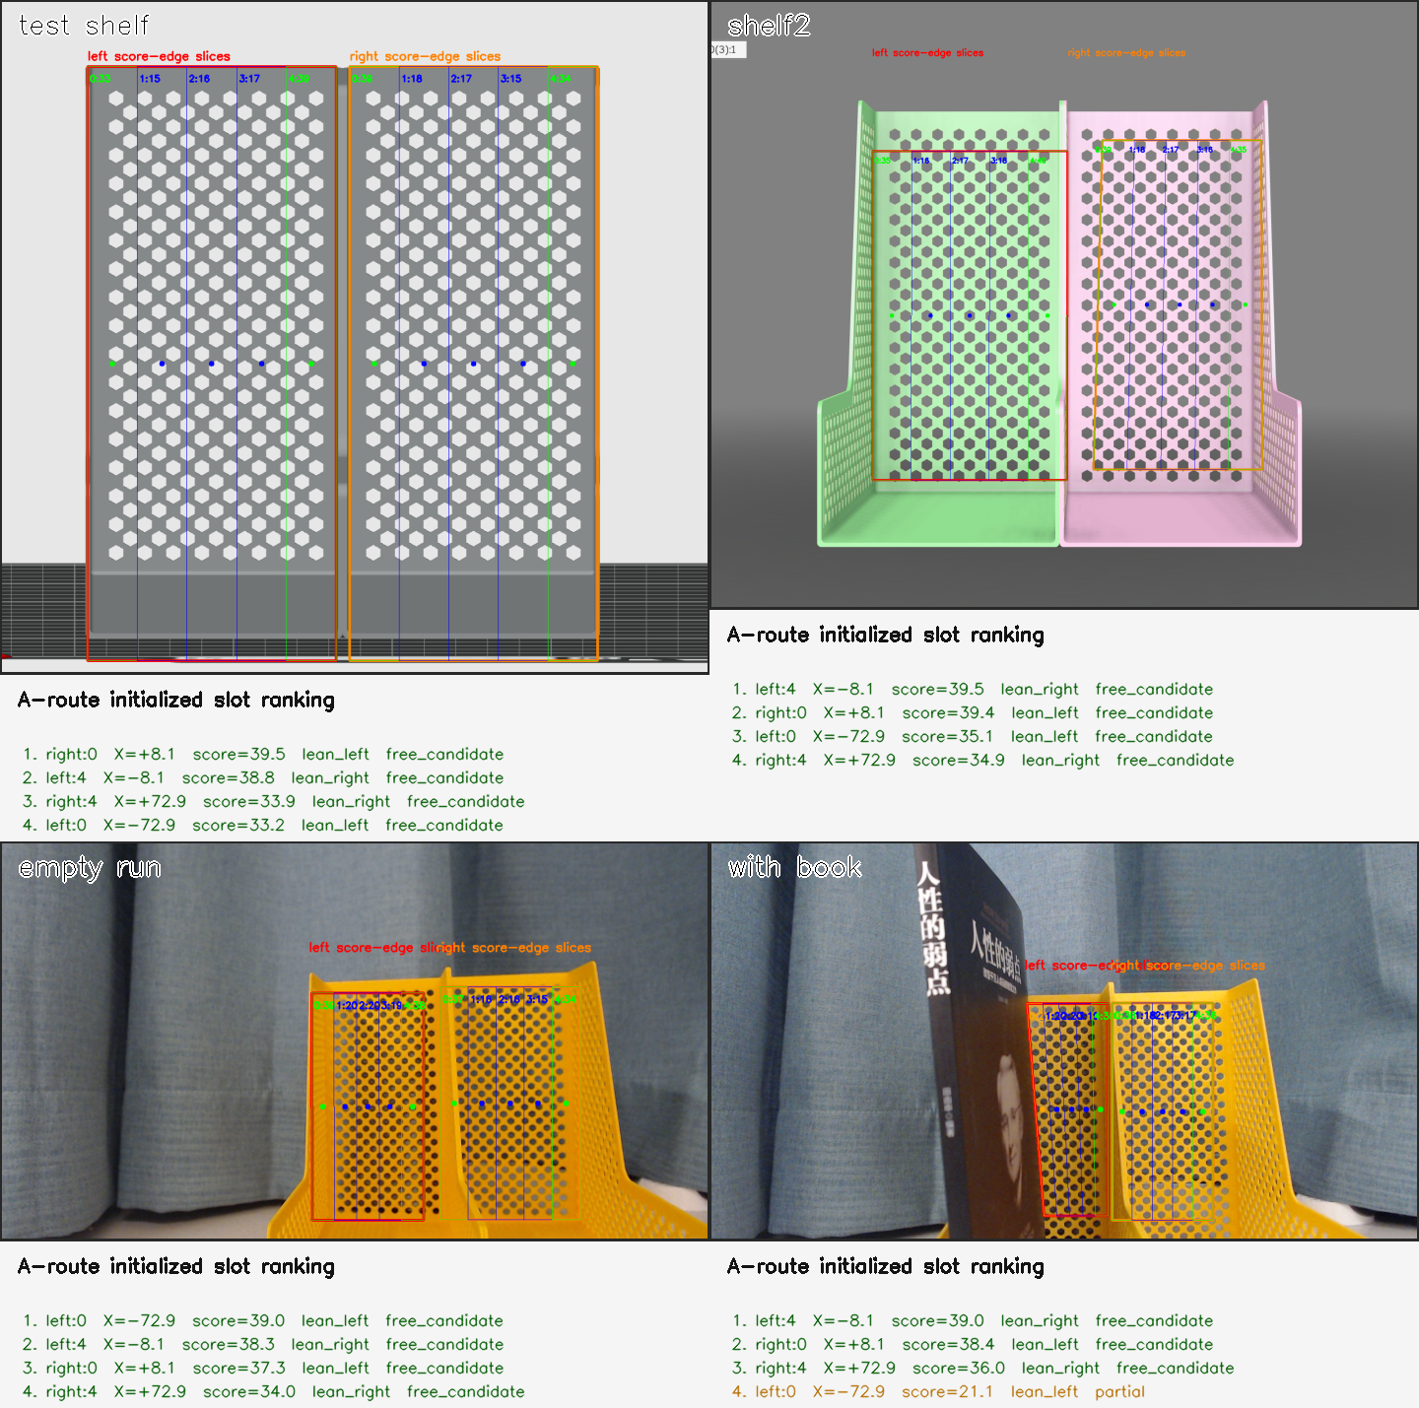
Figure 5. Shelf-slicing evidence: both left and right shelf sections are detected and divided into placement slices across test and physical-run views.
For the shelf-side image evidence, the required visual proof is correct slicing on both visible shelf sections: the left section and the right section should each be segmented into the intended slice structure, with occupied or low-quality regions not presented as the preferred placement evidence.

4.3 Requirements and Verification
The perception subsystem is verified along two axes: catalog identification correctness and lateral pickup precision. Both are exercised on real captured frames from the deployed C920e setup; no synthetic images are used in the reported results.
For book identification, the procedure places a known book at a recorded ground-truth position in the bin, captures a frame, and compares the OCR-matched title against the label. The current trial set is preliminary (approximately ten frames across single-book and multi-book conditions; see Section 11) and will be expanded after the final demo runs. False matches and below-cutoff manual-attention cases will be tabulated in the final version. The 2026-05-11 detected-books-loop run (three books in a single frame) and the 2026-05-14 on-arm startup scan together provide the current evidence base; both are documented in Section 11.
For lateral precision, the procedure measures arm-frame Y for a book placed at a ruler-recorded ground-truth Y in the bin, and compares it against the value returned by the perception pipeline. A small calibration sweep (book at four lateral offsets in ±35 mm) is fitted to a linear model
Y_arm = -((u - c_x) / f_x) * Z_camera + Y_camera_offset.
A successful calibration shows `a ≈ 1` (no scale error) and bounded residuals (no systematic distortion). The current calibration achieves `a = 1.015` with residuals below 2 mm over the tested range; a single on-arm verification shot with the book at +38 mm returned +38.3 mm from the pipeline (0.3 mm error). These results are documented in Section 11.
A practical operating boundary is also imposed by the camera FOV: the minimum reliable working distance is approximately 30 cm at 1280 × 720, below which a 227 mm spine no longer fits vertically and OCR polygon height becomes truncated. The deployed mounted-camera geometry stays above this threshold by design.

A correct perception output is one that (i) returns a known title that matches ground truth, (ii) reports any unmatched text as manual-attention rather than as a pickup target, and (iii) produces a `Y_arm` value that, combined with the fixed `X` and `Z`, places the gripper within the gripper-opening tolerance of the actual book spine.

5. Decision Subsystem

5.1 Task Creation and Catalog Mapping
The decision subsystem converts structured perception outputs into executable reshelving tasks. In the current system, the task flow is:
detected book title
-> catalog lookup
-> target zone or section assignment
-> candidate shelf slice or placement opportunity generation
-> selected placement point for control execution
This mapping stage is intentionally conservative. The perception subsystem may detect multiple book-title candidates from the return bin, but only titles that match the registered catalog are allowed to become executable tasks. Any OCR result that does not match the known-book database is treated as a manual-attention item and is excluded from autonomous execution. This prevents uncertain visual detections from directly generating robot motion.
The current catalog entry for each known book includes at least three fields needed by the decision layer:
- book title,
- target shelf zone or section,
- nominal book thickness used by the planner.
These fields are sufficient for the current demonstration because the decision subsystem primarily needs to know where the book belongs and whether a candidate shelf opportunity is wide enough for safe placement. In the current auto-demo path, feasible tasks are ordered deterministically according to the configured known-book list. This is not yet a globally optimized multi-book scheduler, but it provides a stable and explainable queue for the current demonstration workflow.
From a system-integration perspective, this stage is also an important safety boundary. The decision subsystem does not assume that every visible text string is a valid task. Instead, it converts only catalog-confirmed books into pending work items. This ensures that task creation remains structured, auditable, and compatible with later hardware precheck.

5.2 Placement Opportunity Scoring
The placement problem is treated as candidate opportunity selection, not as simple gap insertion. A raw gap or open shelf span is only a geometric observation. The decision subsystem must determine whether that opening is actually suitable for safe book placement, and if so, which placement style is preferable.

In the current design, the perception subsystem produces structured shelf facts, such as shelf sections, slices, occupancy states, visible boundaries, support hints, and confidence values. The decision subsystem uses these facts to generate candidate placement opportunities and score them. This means the decision layer does not invent shelf geometry; it evaluates the opportunities described by perception.

The current scoring logic is intentionally simple and explainable. A candidate is first rejected if its available width is smaller than the nominal book thickness plus the required safety margin. Among the remaining candidates, higher scores are assigned to opportunities with:

sufficient fit margin,
stable support from a wall or an adjacent occupied slice,
enough free clearance for gripper release,
lower collision risk,
higher perception confidence,
acceptable execution feasibility.
The key design rule is that a candidate with stable support and sufficient free space should rank higher than a tight or isolated opening. For example, a supported edge slice is generally preferred over a narrow middle insertion that could disturb neighboring books. Occupied slices are heavily penalized or rejected so that a visually attractive edge location is not mistakenly selected if it is already blocked.

This scoring philosophy is important for two reasons. First, it produces more physically plausible placement choices for the robot. Second, it makes the decision process explainable. The planner can report which candidates were considered, which were rejected, and why the final placement was selected. This is more useful than a black-box “choose a gap” rule, especially when the system must later be debugged or demonstrated.

At the current project stage, the decision subsystem can operate in two modes. In the preferred mode, it uses shelf candidates initialized from startup scan and slice scoring. In the temporary fallback mode, when a full initialized shelf model is not yet available for the demo path, the system uses a fixed demonstration shelf placement provider. This fallback has been useful for hardware validation and integration testing, but it should be clearly distinguished from the intended final closed-loop shelf-selection workflow.

5.3 PickPlacePlan Contract
The integration boundary between planning and motion is the PickPlacePlan. Vision and decision provide the grasp and shelf placement targets; the motion layer derives or validates the intermediate waypoints and executes the sequence.
The plan contains seven world-frame points: pick_approach, pick, pick_lift, place_transfer, place_approach, place_final, and place_retreat. The pick point represents the book-spine grasp marker, not the book center. The place_final point represents the final horizontal release location selected by the decision subsystem.
In the current hardware path, the control layer derives a richer target sequence from the selected pick and place targets. This includes a low insert-ready pose before grasping, an extract-and-lift motion after grasping, a base-only transfer toward the shelf, a narrow release, a horizontal backoff, and a retreat.

5.4 Requirements and Verification
The current decision subsystem already implements several important behaviors needed for the final demonstration:
• known-book filtering and deterministic task creation,
• catalog mapping from title to target zone or section,
• startup-scan shelf candidate use when available,
• explainable placement opportunity scoring,
• rejection of narrow, occupied, or otherwise poor candidates,
• manual-attention handling for unknown OCR results.
These features are sufficient to support the current startup-scan plus auto-demo integration path. In this path, the decision layer can consume perception-derived shelf candidates, select or initialize feasible placement regions, and pass the chosen pick/place targets to the control subsystem for precheck and execution.
However, some capabilities remain partial or future work rather than fully demonstrated final behaviors. These include:
• fully closed-loop multi-section shelf selection under all configurations,
• a complete ABCD shelf interpretation path in every auto-demo run,
• large-scale multi-book global optimization beyond the current deterministic ordering,
• richer uncertainty handling and repeated retry policies across all failure modes.
It is important that the final report distinguishes these implemented features from the longer-term intended architecture. The current system already demonstrates a real decision layer with candidate selection and safe task filtering, but it does not yet claim a fully general one-button autonomous shelf-placement optimizer.

6. Control Subsystem

6.1 Arm and Command Interface
The current hardware-control route uses vendor-format raw ASCII PWM commands sent to the arm controller over serial at 115200 baud. Direct servo pose commands use the form {#000P1500T1500!...}; direct raw commands should not be wrapped with G0001 and should not append @GroupDone.
The confirmed direct-control path uses /dev/ttyUSB0 at 115200 baud. The stop command is $DST!, which stops current motion through the controller path but should not be interpreted as torque-off. Current gripper commands use #005P1445T1000 for pre-open before the low insert approach, #005P1700T1000 for close, and #005P1625T1000 for the narrow shelf release. The narrow release opens only 75 PWM from the closed grasp to avoid sweeping into neighboring books. The final home/straight pose is a measured hardware command rather than a pose inferred from MuJoCo.

6.2 MuJoCo-to-Hardware PWM Mapping
The current verified conversion maps MuJoCo-facing joint angles to servo PWM around P1500. The command range P500 to P2500 spans 270 degrees, giving a scale of 1000/135 = 7.4074 PWM per degree.
The current mapping is: base yaw increases PWM on servo #000; shoulder pitch uses the calibrated shoulder angle shoulder_pitch + 90 degrees and is inverted on servo #001; elbow pitch increases PWM on servo #002; wrist pitch is inverted on servo #003; and wrist roll is kept near P1500 unless explicitly verified. These conventions are reported as implementation details of the control subsystem, not as global assumptions for the perception or decision subsystem.
No separate ROS2 node, service, or action interface is claimed as the final execution path in this draft. The verified final-path description is the direct serial/PWM command sender: target_sequence.py generates raw ASCII servo commands, detected_books_loop.py combines the per-book sequences, and the hardware sender transmits them through the confirmed 115200-baud controller path. ROS2 remains relevant background and possible future integration, but the report should not present an unverified ROS2 package as the demonstrated final controller.

6.3 Current Verified Motion Chain
The latest verified constrained motion chain raises the grasp point, lifts the book, performs a base-only turn toward the shelf, pushes into the shelf at transport height, lowers to the place point, applies a left-wall wrist-roll hint when requested, releases with a narrow gripper opening, backs off, retreats upward, and returns to the measured home pose. The current target-sequence constants use a low_insert_approach, 110 mm post-grasp lift, up to 230 mm post-grasp extraction toward the origin, an 85 mm post-release backoff with a 35 mm upward offset, and a minimum post-release retreat height of 240 mm.
A real auto-demo run on 2026-05-14 generated and sent a 13-command sequence for 羊皮卷. The command file contains the pre-open command, pick insert-ready pose, final pick pose, gripper close, extract-and-lift, base-only transfer to servo000 P2167, place approach/final, wrist-roll release hint, narrow release, backoff, retreat, and measured home command.
The verified motion chain is important because the control subsystem does not directly command a simple pick point and place point on hardware. Instead, it expands the selected world-frame targets into a conservative execution sequence that reduces collision risk and improves release stability. According to the current logs, the sequence begins with a low insert-ready pose rather than a high top-down descent. This allows the arm to complete the main posture change at a smaller horizontal radius before moving forward to the final grasp point.

After grasping, the controller does not immediately rotate toward the shelf with the book held at the original pick configuration. Instead, it applies an extract-and-lift motion that retracts the book toward the arm origin while lifting it, followed by a base-only transfer toward the shelf. This separation is consistent with the current target-sequence design described in the logs and is intended to reduce unnecessary multi-joint disturbance while the robot is carrying the book.

The release stage is also deliberately conservative. Before opening the gripper, the control path can apply a left-wall wrist-roll hint when the selected placement expects the book to lean against a supporting boundary. The release itself uses a narrow shelf-opening command instead of a wide release, and the arm then performs a horizontal backoff before retreating upward. Based on the current logs, this sequence is meant to reduce the chance that the claw sweeps into neighboring books or disturbs the placed book immediately after release.

At the present stage, this motion chain should be described as the current verified execution policy rather than a fully generalized final motion optimizer. The logs support that the command-generation path, waypoint ordering, and command-file production are functioning, and that at least one real auto-demo run produced and sent a complete hardware sequence. Final statistical claims about repeated success rate should be added only after the team finishes the last round of repeated hardware trials.

Current run evidence available from logs: 2026-05-14 01:07 sent a one-book 羊皮卷 hardware sequence with 13 commands; 2026-05-15 18:29 sent a two-book sequence with 25 commands and routed one 墨菲定律 candidate to human attention because MuJoCo IK failed for pick target [311.7, 77.8, 115.0]; 2026-05-15 19:06/19:06:51 initialized 10 shelf slots, planned three book moves, and sent a 40-command combined sequence with no human-attention items. The official report should describe this as a representative successful three-book cycle with many failed development attempts; dominant observed failures are gripper slip and unsafe waypoint transitions that can strike a book.

6.4 Requirements and Verification
The control subsystem should be verified in stages. First, raw serial commands should be shown to move the physical arm deterministically. Second, gripper open and close commands should hold and release the demo book without driving into mechanical end stops. Third, the full PickPlacePlan should be checked in MuJoCo for reachability and then replayed on hardware with conservative timing. A successful trial requires the arm to pick the book, transfer it, place it at the selected shelf location, release it, and retreat without collision or manual intervention.
The current logs support this staged verification structure. At the lowest level, the raw ASCII serial command path has already been treated as the formal hardware execution route, rather than an informal debug path. This is important because the control subsystem depends on a deterministic command format and timing model before any higher-level autonomous behavior can be claimed. The logs also confirm that the command-generation chain is separated from the higher-level planning logic, so the correctness of command output can be checked independently from perception uncertainty.
At the motion-sequence level, the current verified path uses dry-run checking and hardware command-file generation before live execution. This is consistent with the role of the control subsystem: it should validate that a selected pick/place target can be converted into a feasible execution sequence before sending commands to the physical arm. The existing run logs therefore provide evidence not only of execution, but also of intermediate precheck behavior such as sequence generation, waypoint ordering, and command-file inspection.
For the current report, the strongest control-side verification claims should be limited to the following: the serial/PWM command path is established, the target-sequence generator produces a structured multi-stage execution plan, and the startup-scan plus auto-demo workflow can generate hardware-ready command sequences from perception-derived targets. Final repeated-trial performance data, such as total success counts and categorized failure causes, should be inserted after the final hardware campaign is complete.
A useful final control-side verification table should therefore include, for each representative run: the input pick/place targets, whether the sequence was dry-run or sent, the generated command count, whether the arm completed the expected motion stages, and the observed failure category if the run did not complete successfully. This would keep the verification evidence aligned with the actual responsibilities of the control subsystem.

7. System Integration
The current integration design preserves the high-level controller while replacing mock internals through adapter layers. The controller calls perception_adapter for scene observations and motion_adapter for arm and gripper execution. This keeps subsystem ownership clear and reduces the risk that late changes in vision or hardware require a rewrite of the entire state machine.
The strongest current integration path is not the old fixed-point simulation mode. It is the startup-scan plus auto-demo path: startup-scan writes a world snapshot with bin pick candidates and shelf slice candidates; auto-demo reads live known-book detections, records the runtime world model, prechecks each target sequence, prints the plan, and then sends the combined raw ASCII command file when hardware execution is enabled.
Integration flow for the final draft: startup_scan.py moves the arm to the shelf and bin views, captures left.png and center.png, writes startup_scan_snapshot.json, and initializes the shelf world model. detected_books_loop.py then reads the current world model, converts vision pick candidates and shelf slots into planned tasks, calls target_sequence.py for each feasible PickPlacePlan, writes the combined loop_hardware_command_sequence.txt file, and sends the raw serial/PWM command stream when dry_run is false. The strongest current path is therefore startup scan -> world snapshot -> initialized shelf slots -> auto-demo task queue -> target_sequence command generation -> serial/PWM sender.

8. Design Revisions from the Original Design Document
Original DD Claim | Final Revision | Reason / Evidence
Subsystems were described as perception, task planning/scheduling, and manipulation. | Final report uses the clearer three-subsystem division: perception, decision, and control. | This matches the actual ownership boundary: see/understand the scene, choose the action, execute the action.
Visual-servo insertion at 30 Hz using PBVS. | Revised to a waypoint-based PickPlacePlan with MuJoCo reachability checks and hardware PWM command export; visual updates may provide target coordinates rather than continuous closed-loop servoing. | Hardware calibration and reliable command completion were higher-priority risks than implementing full PBVS.
Arduino Mega / stepper / LX-224HV bus-servo architecture. | Revised to the current KM1/ESP32-style controller and raw ASCII PWM serial command path. | Vendor protocol inspection and hardware tests confirmed raw {#...} command execution at 115200 baud.
Gap detection returns simple available gaps. | Revised to shelf section detection, five-slice section splitting, visible-occupancy penalty, support scoring, and candidate ranking. | The slice-based model gives the planner neighbor context, support information, and occupancy risk for safer placement choices.
The original demonstration relied on predefined pick/place points. | The current auto-demo uses real camera/OCR book detections for bin pick Y and a calibrated grasp plane at arm X = 320 mm. | This moves the project from pure fixed-coordinate motion toward vision-driven bin picking while keeping hardware safety constraints.
Five books in ten minutes with 90%+ success targets. | Final report should report tested constrained-demo performance and separate demonstrated results from original stretch targets. | The project pivoted toward reliable system integration and calibrated manipulation.
Tolerance analysis was mainly conceptual. | Final report should include numeric margins for visual slice width, book thickness, PWM/joint mapping, gripper clearance, and reachability filtering. | Design-document score can be recovered by showing corrected final-report analysis.

9. Tolerance and Feasibility Analysis
The final tolerance analysis should prove the feasibility of a critical subsystem function. For this project, the recommended critical function is safe placement selection and execution: a detected shelf opportunity must be wide enough for the book and for accumulated perception, calibration, actuation, and gripper errors.
The main tolerance sources are visual slice-width error, camera-to-world calibration error, servo/PWM positioning error, book thickness variation, and gripper alignment error. Each of these errors reduces the reliable usable width of a shelf opportunity. The final report should estimate these values from repeat measurements or controlled trials.
Current measured evidence can support this section. The C920e camera calibration achieved 0.299 px reprojection RMS over 25 checkerboard images at 1280 × 720, and earlier depth checks on a long-title book produced errors below approximately 4% over the tested range. The physical bin grasp plane was corrected to `arm X = 320 mm` after the mounted-camera startup-scan overlay showed that the older `≈ 256 mm` estimate placed the grasp point too close. These measurements should be converted into final numeric margins once the last demo setup is fixed.
For the bin-pickup vision path specifically, the camera-to-world lateral mapping has been measured on the deployed setup: a four-point lateral calibration sweep over ±35 mm gives a slope of 1.015 (1.5% scale error) with residuals below 2 mm. A single on-arm verification shot at +38 mm returned +38.3 mm. We therefore adopt `e_cal,lateral ≈ 2 mm` for the bin-pickup gripper-alignment budget, which is well inside the 60 mm gripper opening. The minimum reliable working distance for the C920e at 1280 × 720 is approximately 30 cm; below this the vertical FOV cannot contain a full 227 mm spine, so the deployed mounted-camera geometry is intentionally placed above this threshold.
Tolerance Source | Symbol | How to Estimate | Use in Final Decision
Shelf slice/gap width error | e_vis | Repeated perception measurements of the same shelf gap. | Increase required clearance margin.
Camera-to-world calibration error | e_cal | Measure known points and compare estimated vs physical coordinates. | Offset placement away from walls/books.
Servo/PWM positioning error | e_act | Repeat command to known pose and measure endpoint variation. | Reject candidates near collision boundaries.
Book thickness variation | e_book | Measure physical demo books. | Use conservative thickness in fit check.
Gripper alignment error | e_grip | Measure difference between intended spine marker and actual grasp. | Increase approach and lateral clearance.

A conservative fit condition can be stated as: candidate_width >= book_thickness + 2(e_vis + e_cal + e_act + e_grip) + clearance_margin.
Current numeric values that can already be reported: e_cal,lateral is approximately 2 mm from the four-point lateral calibration residuals; the on-arm +38 mm check had 0.3 mm error; camera calibration RMS is 0.299 px; the active gripper opening budget is 60 mm with a 10 mm configured safety margin; and MuJoCo IK/reachability checks in the control logs typically report small waypoint errors on the order of 0.1-3 mm for feasible points. The 2026-05-15 accepted placement examples include A slice 4 for 人性的弱点 and B slice 0 for 墨菲定律. The 2026-05-15 18:29 run provides a concrete rejection example: one 墨菲定律 candidate was not sent because target_sequence failed MuJoCo IK for pick target [311.7, 77.8, 115.0]. Physical trials show that the remaining practical tolerance risk is not OCR accuracy alone, but gripper slip and waypoint transitions that can make the held book contact neighboring books.

10. Verification and Testing
Verification should be organized around the RV table in Section 2. The detailed test narrative should then describe how each subsystem was exercised: perception trials for book and shelf recognition, decision trials for candidate selection, and control trials for raw serial motion, gripper action, MuJoCo reachability, and physical pick/place execution.
For the official report, the test narrative states that a representative three-book cycle succeeded in about one minute, while repeated attempts exposed gripper slip and waypoint-transition collisions as the main reliability limits. Therefore, the final claim is successful constrained autonomous reshelving in a supervised workstation setup, not fully robust unattended library operation.

11. Results and Discussion
Recent integration logs provide three critical validation milestones. First, the startup-scan sequence, executed on the physical workstation, successfully generated registered overlays for the shelf, return bin, and bin-grid. During the 2026-05-14 scan, 鬼谷子 and 墨菲定律 were identified with high confidence, producing pick candidates at approximately X = 315.4 mm and Z = 115 mm. This visually confirmed the corrected BIN_PICK_DEPTH_MM = 320 mm, overriding previous estimates of ≈ 256 mm after inspection of the bin-grid alignment. Second, the perception subsystem successfully discretized the left shelf view into ten valid section and slice candidates. Third, a complete auto-demo run on hardware executed a 13-command sequence for 羊皮卷, utilizing a vision-derived pick pose of (307.3, 30.6, 115.0) mm and a target placement at (0, 250, 140) mm.
Perception-specific trials were conducted to characterize lateral precision and catalog identification performance. A four-frame calibration sweep across lateral offsets of ±35 mm yielded a linear model with slope a = 1.015 and residuals below 2 mm, validating the scaling of the fixed-depth pinhole reprojection. Following camera mounting, a verification frame with a book positioned at +38 mm resulted in a pipeline-reported value of +38.3 mm. This 0.3 mm error is well within the mechanical clearance provided by the 60 mm gripper opening.
A validated multi-book hardware trial (recorded in sim_output/detected_books_loop/20260511_215629/) processed a single-frame capture containing 羊皮卷, 鬼谷子, and 墨菲定律, with respective vision-derived pick poses of (250.0, −52.37, 115.0) mm, (250.0, +48.99, 115.0) mm, and (250.0, −1.14, 115.0) mm. The auto-demo sequence prioritized candidates based on the KNOWN_BOOK_TITLES hierarchy, emitting 34 serial hardware commands across the combined tasks. The system demonstrated 100% identification accuracy against the seven-entry catalog; notably, one frame with clipped OCR text ("皮卷") was correctly matched to 羊皮卷 via the fuzzy-match threshold.
The official final-demo run for this report is the 2026-05-15 19:06 startup scan followed by the 19:06:51 auto-demo run. Three books were placed randomly in the return bin, and the system generated a task queue from the recognized titles and shelf candidates. The run planned three book moves and sent a 40-command hardware sequence: 人性的弱点 to shelf A slice 4 at X=-20 mm, 墨菲定律 to shelf B slice 0 at X=20 mm, and a second 墨菲定律 candidate to shelf A slice 0 at X=-61 mm. The run reported zero human-attention items and used the initialized_shelf_world_model rather than the older fixed demo-only shelf model. A representative successful three-book cycle takes approximately one minute.
The subsequent discussion distinguishes demonstrated functional capabilities from current operational constraints. The project has achieved successful end-to-end runs, but reliability is not yet high enough to claim robust unattended operation. Many failed attempts were caused by physical manipulation rather than book recognition: in particular, the gripper can slip on the book spine, and some waypoint transitions can bring the arm or held book into contact with neighboring books. These failures are useful evidence for future work because they point to gripper friction, waypoint selection, and transition clearance as the dominant remaining risks.

12. Cost, Schedule, Ethics, and Safety

12.1 Cost
The final bill of materials reflects the actual demonstration hardware. The arm frame/base was purchased separately from the six-servo and ESP32 driver-board set, and the project reused an existing laptop for high-level vision, planning, and command generation. The original design-stage BOM was revised after the hardware pivot, so the table below reports the final hardware route rather than the earlier design-document architecture.
Component | Specification / Notes | Qty | Unit Cost | Subtotal
Robotic arm frame and base | Purchased frame/base assembly | 1 | RMB 120 | RMB 120
Six servos + ESP32 driver board | Matched servo set with ESP32 driver board | 1 set | RMB 535 | RMB 535
Logitech C920e camera | USB camera used for final perception path | 1 | RMB 180 | RMB 180
Power system | 3000 mAh, 8.4 V battery/power pack | 1 | RMB 65 | RMB 65
Return bin / book tray | Demonstration return-bin fixture | 1 | Reused / negligible | RMB 0
Existing laptop | Reused for vision, planning, and command generation | 1 | RMB 0 | RMB 0
Total reported purchased cost | Excludes reused laptop and already-available small supplies |  |  | RMB 900

12.2 Schedule
The final project timeline followed the original design-document structure but shifted toward a fixed-workstation demonstration and stronger software integration. The table below summarizes the final division of labor using the same team schedule format as the design document.
Period | Xinrui Xiong | Zhecheng Lou | Zehao Bao | Zhenxiong Tang
Weeks 1-2 | Hardware feasibility, robotic arm interface study, control-risk analysis | Hardware feasibility, arm/gripper support design, early assembly planning | Vision approach research and perception technical-stack evaluation | Decision subsystem design, state-machine structure, and system data-flow planning
Weeks 3-4 | Camera mounting, arm setup, raw serial/PWM command-path exploration | Mechanical support, gripper/camera fixture support, system assembly | Book-recognition pipeline development and OCR/catalog matching | Main program structure, book database, and early task-flow implementation
Weeks 5-6 | Hardware-software integration, target-sequence generation, prototype testing | Hardware debugging, physical setup refinement, support structure adjustment | Shelf occupancy perception, slice/scoring logic, and visual-output evaluation | World model, task queue, planning integration, and runnable baseline
Weeks 7-8 | Final arm calibration, serial/PWM execution, failure analysis, and final testing | Camera positioning verification, physical debugging, and demo support | Final perception validation, bin/shelf detection evidence, and report contributions | End-to-end integration, decision refinement, report support, and final validation

12.3 Ethics and Safety
The system operates a robotic arm near objects and users, so safety is addressed through constrained workspace operation, conservative speed and PWM ranges, physical supervision during tests, a stop command, and avoidance of high-force insertion into tight gaps. The final report should avoid overstating autonomy or robustness beyond the tested demonstration conditions.
Safety controls in the current implementation are procedural and software-limited. Hardware execution is gated by dry-run/precheck behavior and an explicit operator confirmation step before sending commands. The command path uses conservative timing, narrowed gripper release, post-release backoff, upright retreat, and a measured home pose. During tests, the system is supervised directly, and the operator can send the controller stop command $DST! or power down the arm if motion leaves the expected workspace. The report should avoid claiming unattended deployment; the demonstrated system is a supervised lab prototype.

13. Conclusion and Future Work
This project developed a layered autonomous book-reshelving prototype that connects scene perception, placement decision-making, and calibrated robotic manipulation. The most important final contribution is the system integration path: structured perception outputs are converted into an explainable placement decision and then into a reusable PickPlacePlan for hardware execution.
The final system demonstrates a substantially revised autonomous reshelving pipeline: OCR-based book identification, startup-scan shelf slicing, explainable placement selection, and calibrated serial/PWM motion generation are connected into one startup-scan plus auto-demo workflow. In the selected final-demo run, three randomly arranged books were processed in an approximately one-minute cycle, with the robot selecting shelf slices rather than replaying only fixed locations. The main future work is improving physical robustness: higher-friction grasping, safer transition waypoints, and more reliable clearance around neighboring books.

References
Team 34. Design Document (DDv3), ME470/ECE445 Senior Design, Spring 2026.
Team 34. Design Document Modification Checklist, ME470/ECE445 Senior Design, Spring 2026.
KM1 robotic arm vendor materials and local command-protocol notes used for raw ASCII PWM command format and safety limits.
Project control logs and hardware notes, including AI_HANDOFF_CONTEXT.md, HARDWARE_POSE_NOTES.md, and ROS2_BRINGUP_PLAYBOOK.md.
Project perception and integration logs, including C920e calibration records, startup_scan outputs, and detected_books_loop outputs.
PaddleOCR project documentation and OCR model resources used for book-title recognition.
OpenCV documentation and camera-calibration resources used for image processing and pinhole reprojection.

