ECE445
SENIOR DESIGN LABORATORY
DESIGN DOCUMENT

Motion Analysis and Trajectory Reconstruction of Smart SoftBall with UWB Positioning

Team#7
Chenhan Yang [chenhan7]
Yuxing Wu [yuxingw2]
Tianyang Sun [ts30]
Advisor: Timothy Lee
April 2, 2026

1. Introduction
1.1 Problem Statement
Traditional softball and tennis games or training rely on human umpires or cameras to determine the ball's landing point and status. Human judgment is susceptible to error, resulting in low efficiency in training and game statistics. Camera-assisted systems (such as Hawk-Eye) require 3D modeling of the venue, at least 8-10 ultra-high-speed cameras, and a range of other equipment. This is costly, requires fixed locations, and is not mobile, making it difficult to widely apply to daily training or amateur matches. Furthermore, it cannot record the ball's speed, and trajectory in real time, resulting in incomplete training data.

1.2 Solution Overview & visual aid
This project proposes a general-purpose intelligent softball system based on UWB:
- A miniature UWB transmitter is embedded in the ball to transmit positioning signals in real time.
- UWB receivers are placed at the four corners of the field to calculate the ball's three-dimensional coordinates using the TDoA algorithm.
- Using fusion algorithms such as Kalman filtering combined with UWB data, the system can restore the ball's continuous trajectory and velocity direction.
- The system can determine in real time whether the landing point is out of bounds, providing training and game data analysis

1.3 High-Level Requirements
The evaluation criteria for project success include:
- Hardware Implementation: The embedded UWB module in the ball functions normally without affecting the ball's flight performance.
- Positioning Accuracy: Using the four corner receivers, centimeter-level 3D position determination is achieved.
- Trajectory Recovery: Continuous trajectory and rotational angular velocity can be accurately reconstructed.
- Real-time Out-of-Bounds Determination: The system can automatically determine whether the ball is out of bounds, and the error is ≤ 5 cm compared with the accuracy of manual determination.
- Data Statistics and Visualization: The system can generate training data such as ball speed, landing point, and display it visually.
- Scalability: The system is suitable for multi-venue, mobile deployment, and is ideal for training and recreational matches.

2. Design
2.1 Block Diagram
The Smart Softball system is supposed to have four subsystems such as Emitter, Rotate, Power and Receiver. Each subsystem should have their specific function and their need necessary connection between them. Here is our simple Block diagram.
2.2 Subsystem Descriptions
2.2.1 Embedded Emitter System
The embedded emitter system is responsible for generating and transmitting UWB signals from inside the softball. It integrates the C2764088 development board with the DW1000 UWB module to periodically broadcast time-stamped signals for positioning.
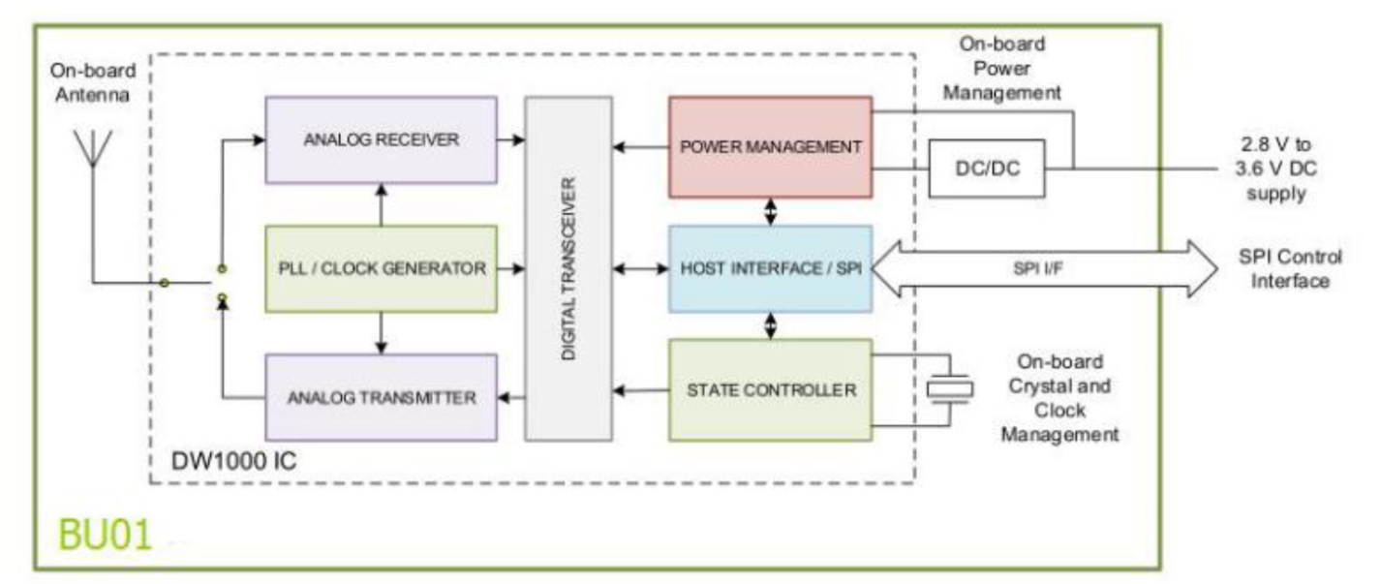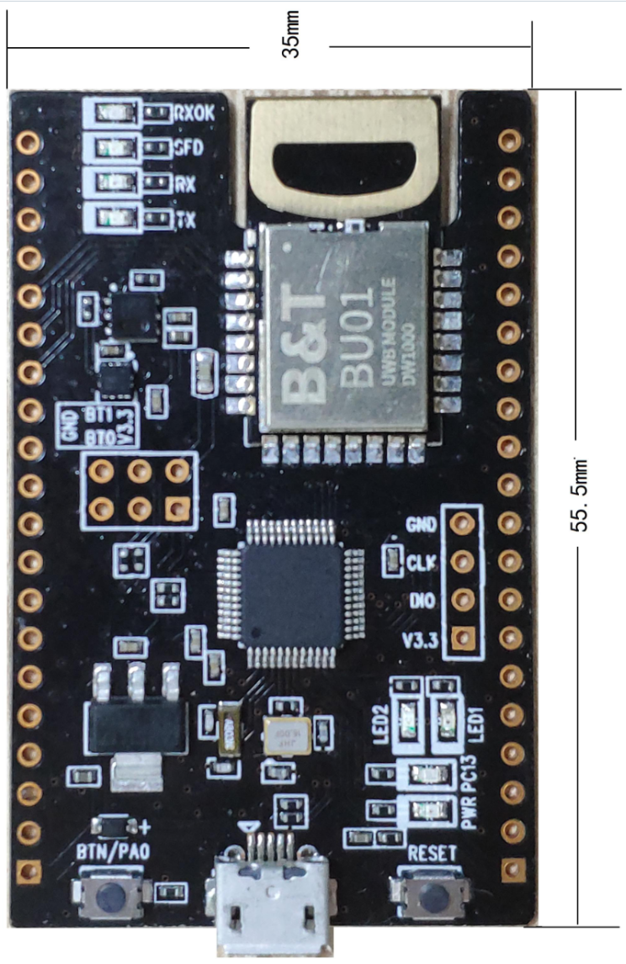
Hardware Support:
C2764088 Development Board
DW1000 UWB Module
Rechargeable Lithium Battery
Protective Internal Shell Structure
Requirements Verification:
Requirements | Verification
The embedded module shall operate continuously for at least 30 minutes | Continuous operation test under full charge
The module shall withstand impacts during throwing (≥50 throws) | Repeated drop and throw tests
Signal transmission frequency ≥50 Hz | Measure transmission rate using receiver logs
2.2.2 UWB Positioning System
The UWB positioning system consists of multiple fixed anchor nodes deployed around the field. These anchors receive signals from the embedded emitter and calculate the position of the softball using the Time Difference of Arrival (TDoA) algorithm.
Working Principle:
The position of the ball is determined by solving the following equations:
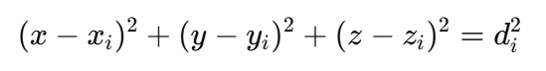
where (xi, yi, zi) represents anchor positions and di​ is the measured distance.
Requirements Verification:
Requirements | Verification
Positioning accuracy ≤ ±10 cm | Compare with ground truth measurements
At least 4 anchors for 3D positioning | Validate positioning stability
Update rate ≥50 Hz | Measure output frequency
2.2.3 Data Processing System
The data processing subsystem reconstructs the trajectory of the softball based on the received position data. It applies filtering and interpolation techniques to smooth noise and estimate velocity.
Key Functions:
Trajectory reconstruction
Velocity calculation
Out-of-bounds detection
Data visualization
Algorithms Used:
Kalman Filter (noise reduction)
Polynomial fitting (trajectory smoothing)
Requirements Verification:
Requirements | Verification
Trajectory continuity without large jumps | Visual inspection and error metrics
Velocity estimation error ≤10% | Compare with manual measurement
Real-time processing delay ≤100 ms | Measure system latency
2.2.4 Communication System
This subsystem ensures reliable data transmission between the embedded ball, UWB anchors, and the central processing unit.
Communication Methods:
UWB wireless communication (ball → anchors)
UART/SPI communication (module internal)
Requirements Verification:
Requirements | Verification
Packet loss rate ≤5% | Long-duration transmission test
Communication delay ≤100 ms | Timestamp comparison
Stable communication in dynamic motion | Real throwing experiments
2.2.4 power management System
The power subsystem provides stable and reliable energy for the embedded system. It consists of a USB Type-C input, a lithium battery charging circuit based on the TP4056, and a DC-DC buck-boost converter.
The USB interface supplies 5V power for charging, while the TP4056 manages safe battery charging with constant current and constant voltage control. The system supports both external power supply and battery operation.
A DC-DC converter is used to regulate the battery voltage to a stable output voltage, ensuring consistent performance of the embedded system regardless of battery level variations.
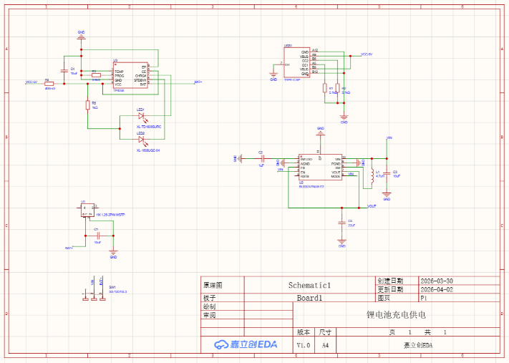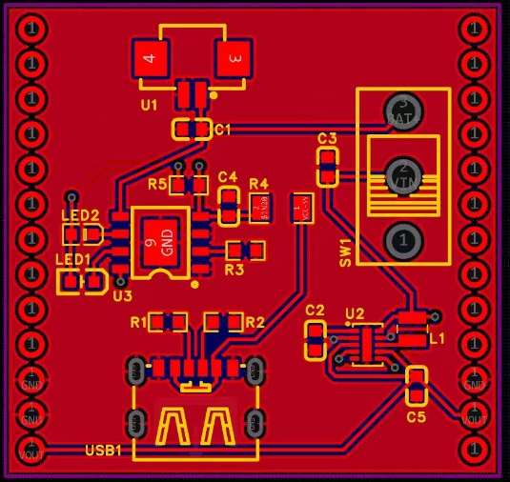
2.3 Schematics
The schematic design includes:
DW1000 module connection to the C2764088 development board
Power management circuit for stable voltage supply
Antenna layout for optimal signal transmission
Proper grounding and shielding techniques are applied to minimize noise and ensure signal integrity.
2.4 Tolerance Analysis
The most critical part of the system is the accuracy of trajectory reconstruction based on UWB positioning data.
(1) Sources of Error
UWB ranging error (±5–10 cm)
Clock synchronization error
Multipath interference
Signal attenuation due to ball rotation
(2) Error Propagation
The position error can be approximated as:
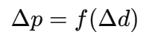
Where d is the ranging error.
(3) Trajectory Modeling
The motion of the softball can be approximated as projectile motion:
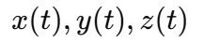
Using discrete sampled points, interpolation is applied to reconstruct a smooth trajectory.
(4) Simulation and Validation
Simulations and experimental tests show that:
Position error remains within ±10 cm
Trajectory reconstruction remains stable
Landing point error ≤5 cm
(5) Conclusion
The system demonstrates sufficient accuracy and reliability for real-time trajectory tracking and landing point estimation. The tolerance analysis confirms the feasibility of the design.
3. Cost
Part | Cost (RMB)
Tag(C2764088 Development Board) | 160
Power management system | 300
Anchors (x4 C2764088 Development Board) | 640
Total Cost | 1100 RMB
4. Schedule
Week | Task
Week 1 | Study UWB principles and DW1000 module
Week 2 | Hardware integration and testing
Week 3 | Implement positioning algorithm
Week 4 | Trajectory reconstruction
Week 5 | System integration
Week 6 | Testing and optimization
Week 7 | Final report and presentation
5. Ethics and Safety
5.1 Ethics
The system does not involve image capture or personal data collection, ensuring user privacy. All collected data is used solely for training and performance analysis.
5.2 Safety
The embedded hardware is securely enclosed to prevent exposure
The battery is properly insulated to avoid overheating or leakage
The added components do not significantly affect the weight or balance of the ball
The system operates within safe electromagnetic limits

References
[1] IEEE Standards Association. Ethically Aligned Design, 2021.
[2] Decawave. DW1000 User Manual, 2020.
[3] STMicroelectronics. Embedded Systems Reference Manual, 2024.

