Design Document: Intelligent Waste Sorting System
Team:
- Wentao Li (wentaol5)
- Canyu Li (canyuli2)
- Han Yin (hanyin3)
- Mingyang Gao (mg82)

1. Introduction
1.1 Problem Statement
With rapid urbanization, the volume of domestic waste has surged, making correct waste sorting a crucial part of environmental protection and resource recycling. However, current waste sorting in public areas relies heavily on public awareness, leading to a high error rate in source sorting. Incorrect sorting increases the cost of manual processing and can cause entire bins of recyclables to be contaminated and sent to landfills. While large treatment plants have automated sorting lines, there is a lack of compact, efficient, and low-cost automated sorting equipment at the source of waste generation (e.g., schools, office buildings). We need a smarter way to lower the barrier for ordinary people to sort waste, using machines instead of manual labor for initial screening to improve resource recovery rates.
1.2 Solution Overview & Visual Aid
Our solution is to design and build an intelligent waste bin integrating computer vision and a fixed mechanical device, deployed in public areas. Users simply throw their waste into a unified drop-in opening. A camera inside the system captures images of the items and uses a pre-trained machine learning model to identify and classify them (e.g., Recyclables, Food Waste, Hazardous Waste, Other Waste). Once identified, a microcomputer triggers the fixed mechanical device (such as servo-driven baffles or push rods) to automatically guide and sort the item into the corresponding internal waste bin. This provides a fully automated, touchless waste disposal process, greatly improving the accuracy and efficiency of source sorting.
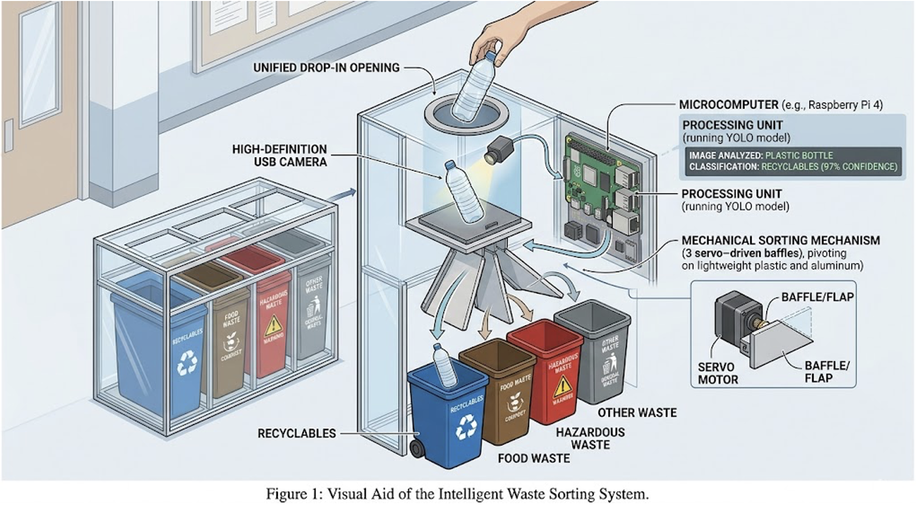
Figure 1: Visual Aid of the Intelligent Waste Sorting System. The user drops an item into the top opening. The camera captures the image, the microcomputer processes it, and the internal mechanical baffles route the item into the correct bin.
1.3 High-Level Requirements List
The Intelligent Waste Sorting System shall meet the following requirements:
- Classification Accuracy: Achieve at least 90% accuracy in classifying common domestic waste items into 4 categories (Recyclables, Food Waste, Hazardous Waste, Other Waste) under standard indoor lighting conditions.
- Processing & Sorting Speed: Complete the entire cycle—from image capture and classification to mechanical sorting and resetting—within 3 seconds per item.
- Mechanical Reliability & Capacity: The mechanical sorting subsystem must successfully route items weighing up to 1.5 kg without stalling, and operate for at least 500 consecutive cycles without mechanical failure.

2. Design
2.1 Block Diagram
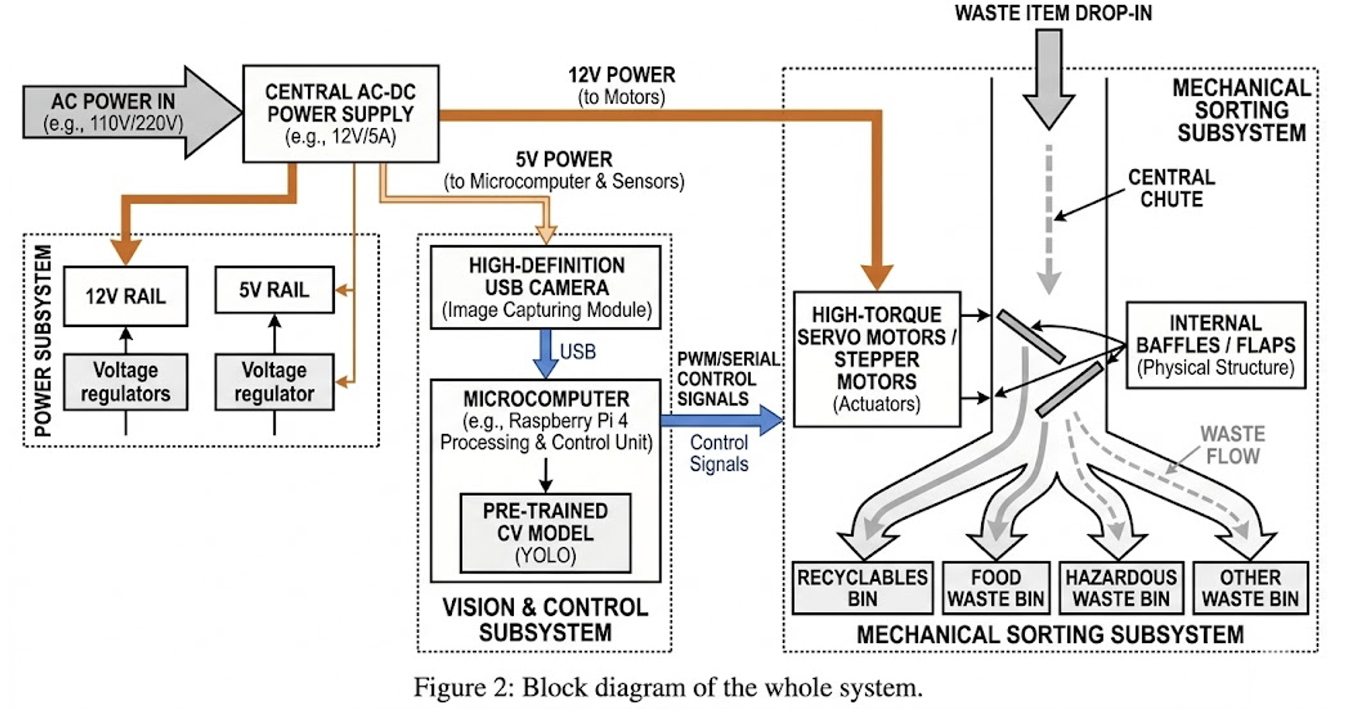
Figure 2: Block diagram of the whole system. The system consists of three main modules: Power, Vision & Control, and Mechanical Sorting.
2.2 Subsystems & Requirements
2.2.1 Vision and Control Subsystem
- Image Capturing Module: A high-definition USB camera deployed in the waste drop-in channel to capture clear images while the waste is temporarily stationary or falling slowly.
- Processing & Control Unit: A microcomputer (e.g., Raspberry Pi 4) to receive images, run the computer vision model (YOLO or similar object detection), and output PWM/serial signals to the mechanical subsystem.
Requirements | Verification
1. Camera shall capture clear images with less than 5% motion blur for items moving at up to 0.5 m/s. | 1. Drop test objects at 0.5 m/s; analyze captured frames to ensure object edges are sharp and identifiable.
2. The microcomputer must complete image inference in under 500 ms. | 2. Run the classification script 100 times and log timestamps; verify the average inference time is $\le$ 500 ms.
2.2.2 Mechanical Sorting Subsystem
- Actuators: High-torque servo motors or stepper motors used to drive the internal baffles/flaps.
- Physical Structure: A central chute with motorized flaps that open or close to route the garbage into one of the four bottom bins.
Requirements | Verification
1. Baffles must actuate to the correct position (e.g., 45$°$ or 90$°$) within 1 second of receiving the signal. | 1. Use an oscilloscope to measure the time between the GPIO control signal going high and the servo reaching its target angle.
2. Actuators must provide enough torque to hold baffles steady when a 1.5 kg object impacts them. | 2. Drop a 1.5 kg test weight onto the closed baffle; verify visually and via sensor that the baffle does not yield.
2.2.3 Power Subsystem
- Power Delivery: A central AC-DC power supply (e.g., 12V/5A) that steps down to 5V for the microcomputer and appropriate voltage for the motors (e.g., 5V or 12V) using voltage regulators.
Requirements | Verification
1. Regulators must output stable 5V under a maximum load of 3A for the microcomputer and sensors. | 1. Connect a 3A electronic load to the 5V rail and measure voltage with a multimeter; ensure it remains between 4.75V and 5.25V.
2.3 Tolerance Analysis
The most critical part of this project is ensuring the waste item does not fall past the sorting mechanism before the baffles are in position.
Let the distance from the drop-in point to the sorting baffle be $h$. If the item is in free fall, the time it takes to reach the baffle, $t_{fall}$, is given by:
$$t_{fall}=\sqrt{\frac{2h}{g}}$$
Where $g$ is the acceleration due to gravity ($9.81m/s^2$).
For our system to work, the total processing and actuation time $(t_{total})$ must be strictly less than $t_{fall}$
$$t_{total}=t_{capture}+t_{inference}+t_{actuation}$$
If we design $h=0.5$ meters:
$$t_{fall}\sqrt{\frac{2*0.5}{9.81}}≈0.319$$
However, our requirement for inference alone is up to 500 ms (0.5 s), and actuation is 1 s. Therefore, a pure free-fall design will fail.
Conclusion & Solution: The tolerance analysis dictates that we cannot use a free-fall chute. We must incorporate a temporary holding platform (a trapdoor) where the item rests while being photographed and processed. Once classified, the lower baffles move into position, and then the trapdoor releases the item. This ensures $t_{total}$ does not compromise sorting accuracy.

3. Cost & Schedule
3.1 Cost Analysis
Part | Cost (RMB)
Microcomputer (e.g., Raspberry Pi 4) | 450
HD USB Camera | 80
High-Torque Servo Motors (x3) | 150
Custom PCB (Motor drivers, regulators) | 100
Frame & Baffle Materials (Acrylic/Wood/3D Print) | 200
Total Cost | 980
3.2 Schedule
Week | Wentao Li | Canyu Li | Han Yin | Mingyang Gao
4/7 | Design PCB schematic (Power & Control) | Setup Raspberry Pi & OS | Collect/Label dataset for waste sorting | Design 3D CAD model for the bin
4/14 | Order PCB & components; solder prototype | Integrate Camera & test OpenCV | Train YOLO/Classification model | 3D print and assemble mechanical baffles
4/21 | Test motor drivers & voltage regulators | Write Python logic to link CV output to GPIO | Test model accuracy & optimize inference time | Mount motors to frame; test mechanics
4/28 | System integration (Hardware + PCB) | System integration (Software + Hardware) | Evaluate accuracy threshold requirements | Fix mechanical jams or torque issues
5/5 | Final verification testing against Reqs | Final verification testing against Reqs | Prepare Final Presentation slides | Polish physical prototype appearance

4. Ethics and Safety
4.1 Ethics
Our project adheres to the IEEE Code of Ethics. A primary ethical concern is privacy. Because the camera is placed inside a public waste bin, it may inadvertently capture images of sensitive documents, personal items, or reflections of users. To address this, the system will process images locally on the microcomputer ("edge computing") and immediately discard the image data after classification without uploading it to the cloud. Furthermore, our system promotes environmental sustainability by reducing recycling contamination.
4.2 Safety
Safety is paramount in a mechanical system accessible to the public.
- Pinch Points: The motorized baffles create pinch hazards. The drop-in opening will be designed with a long, narrow neck so users cannot reach their hands down to the moving parts.
- Sanitation & Biohazards: Waste bins can harbor bacteria and liquids. The electronic components (camera, PCB, motors) will be housed in sealed, splash-proof enclosures (IP54 rating minimum) to prevent short circuits and electrical fires caused by liquid spills.

