Design Document: Automated Intelligent Document Stamping System
Team numebr: 6
Team Members:
Yanzhen Chen [UID: 3220111908]
Zhiqiang Qiu [UID: 3220111914]
Xuliang Huang [UID: 3220111926]
Jiaheng Zeng [UID: 3220111929]
Advisor: Fangwei Shao
Date: April 2, 2026
1. Introduction
1.1 Problem Statement
In administrative offices, staff often spend hours manually stamping large volumes of documents. This repetitive task is inefficient and prone to errors, such as skewed stamps or inconsistent pressure. Currently, few affordable desktop solutions exist that can intelligently detect varying document layouts to place stamps accurately without manual pre-configuration.
1.2 Solution Overview & Visual Aid
We propose an automated mechatronic stamping system. It utilizes a high-resolution camera and a Vision-Language Model (VLM) to analyze document content in real-time. The system automatically feeds paper, identifies the ideal stamping location, moves an X-Y gantry to the target, and applies a motorized stamp with precise pressure control.

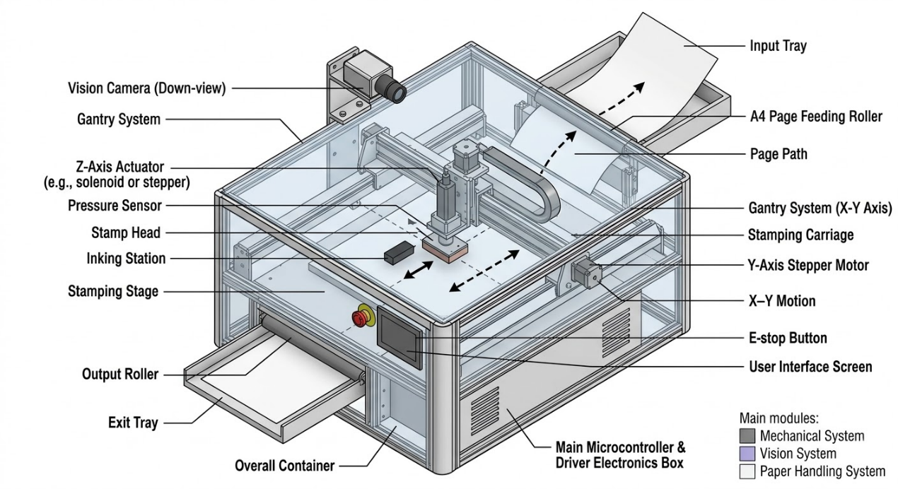1.3 High-Level Requirements List
- The Vision subsystem must identify the physical stamping coordinates (X, Y) with an accuracy of over 95% within 5 seconds under standard office lighting (300-500 lux).
- The mechanical gantry must achieve a positioning repeatability of +/- 2.0 mm and provide a consistent Z-axis stamping force between 15N and 25N.
- The page handling mechanism must maintain a successful single-sheet feeding rate of over 98% for a stack of 50 standard A4 pages.
2. Design
2.1 Block Diagram
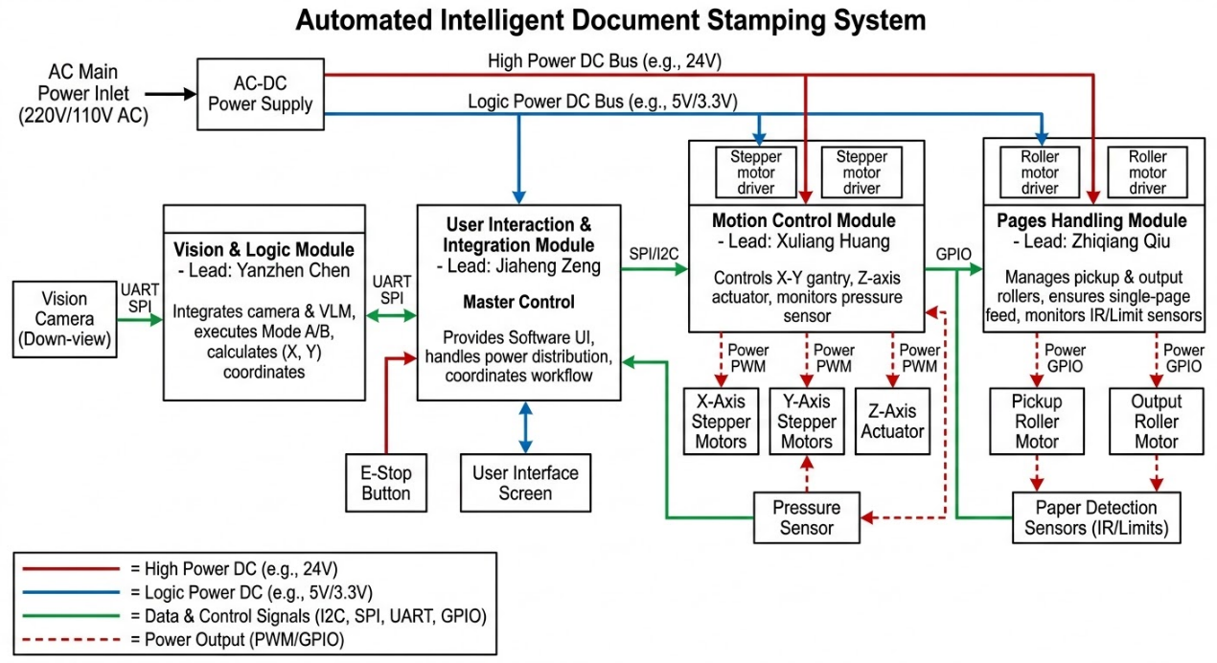2.2 Vision & Logic Module
The vision system is responsible for real-time capturing of the document and calculating the target location to guide the stamping mechanism.
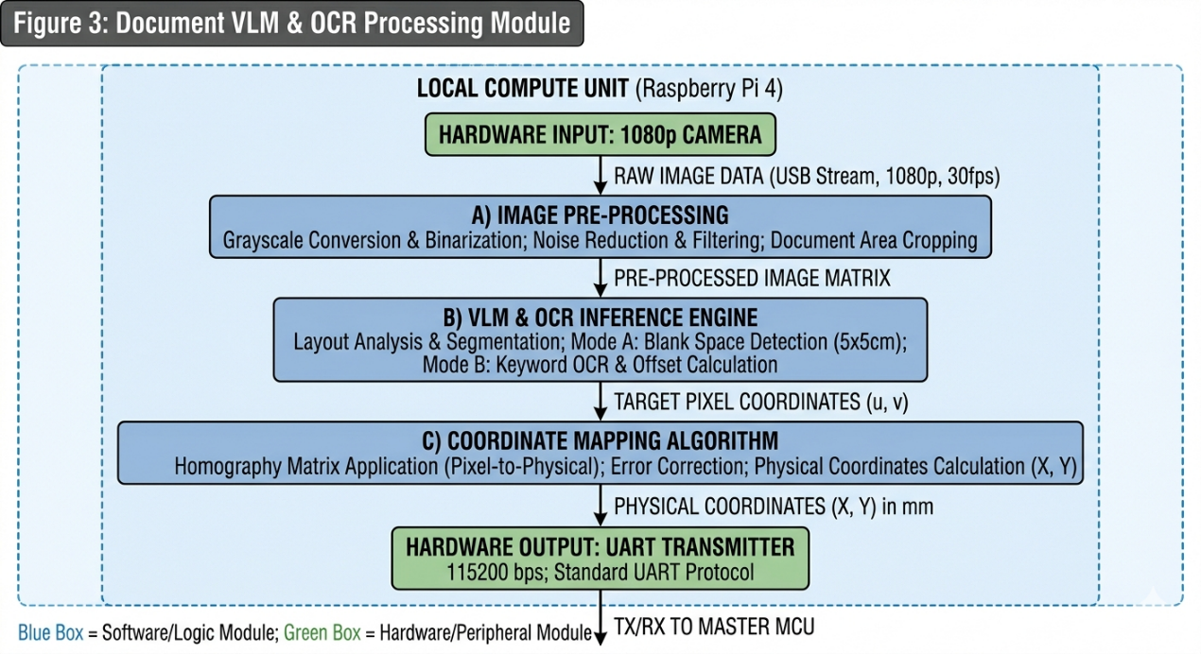
2.2.1 Camera Hardware Support
The system uses a down-view RGB camera connected via USB to capture the document layout.
Requirements | Verification
1. The camera shall maintain 1080p resolution and a framerate of >= 30 FPS. | 1. Use camera testing software to record a video; verify the output file properties show 1920x1080 resolution and >= 30 FPS.
2.2.2 VLM & OCR Processing
The processing unit runs a VLM/OCR algorithm to detect 5x5cm blank spaces or specific keywords.
Requirements | Verification
1. The algorithm shall execute coordinate detection with a processing latency of <= 4.5 seconds per frame. | 1. Run the script on 20 sample documents and log the system timestamp. The average latency must be <= 4.5s.
2.2.3 Coordinate Mapping
Converts pixel data to physical coordinates based on camera focal length and distance.
Requirements | Verification
1. The mapping algorithm shall convert pixel data to physical XY coordinates with an error of <= +/- 0.5 mm. | 1. Input 5 known pixel coordinates; compare the output physical values against ground-truth measurements using a caliper.
2.3 Motion Control Module
This module drives the X-Y gantry and Z-axis actuator to move the stamp head to the target position.
2.3.1 X-Y Gantry System
Driven by NEMA 17 stepper motors and timing belts for horizontal positioning.
Requirements | Verification
1. The X-Y gantry shall reach any target coordinate with a repeatability of +/- 2.0 mm. | 1. Send coordinates to move the gantry to 5 different points and return to origin 10 times. Measure the deviation at the origin.
2.3.2 Z-Axis Actuator & Pressure Sensor
A linear actuator pushes the stamp down, and an FSR sensor monitors the contact force.
Requirements | Verification
1. The Z-axis actuator shall apply a downward force of 20N +/- 2N upon contact with the paper. | 1. Place a digital force gauge on the stamping stage. Trigger a stamping cycle and verify the peak force is between 18N and 22N.
2.4 Pages Handling Module
Manages the physical transportation of the documents into and out of the stamping area.
2.4.1 Pickup & Feeding Mechanism
Uses friction rollers to separate and feed single sheets.
Requirements | Verification
1. The pickup roller shall feed exactly 1 sheet of A4 paper per cycle, with a failure rate of <= 2%. | 1. Load 50 sheets into the input tray and trigger 50 continuous feed cycles. Verify that >= 49 sheets are processed individually.
2.4.2 IR Sensor Tracking
IR sensors monitor the paper path to detect jams.
Requirements | Verification
1. The IR sensors shall detect paper presence within a response time of <= 100 ms. | 1. Block the IR sensor manually and measure the signal delay on an oscilloscope to ensure it drops below the threshold within 100 ms.
2.5 User Interaction & Integration Module
The core hub coordinating all subsystems, managing power, and providing the user interface.
2.5.1 Master Microcontroller & UART
An STM32/Raspberry Pi processes logic and communicates with the Vision module via UART.
Requirements | Verification
1. The UART communication rate shall reach 115200 bps with an error rate of <= 1%. | 1. Transmit 1000 test strings to the MCU. Verify on the serial monitor that the packet loss or corruption is <= 10 strings.
2.5.2 Power Distribution
Converts AC mains to DC to power logic and motors.
Requirements | Verification
1. The power regulator shall provide a stable 24V DC (+/- 0.5V) output under a 2A load. | 1. Connect a 2A electronic load to the 24V output. Monitor with a multimeter to ensure voltage remains between 23.5V and 24.5V.
2.6 Schematics
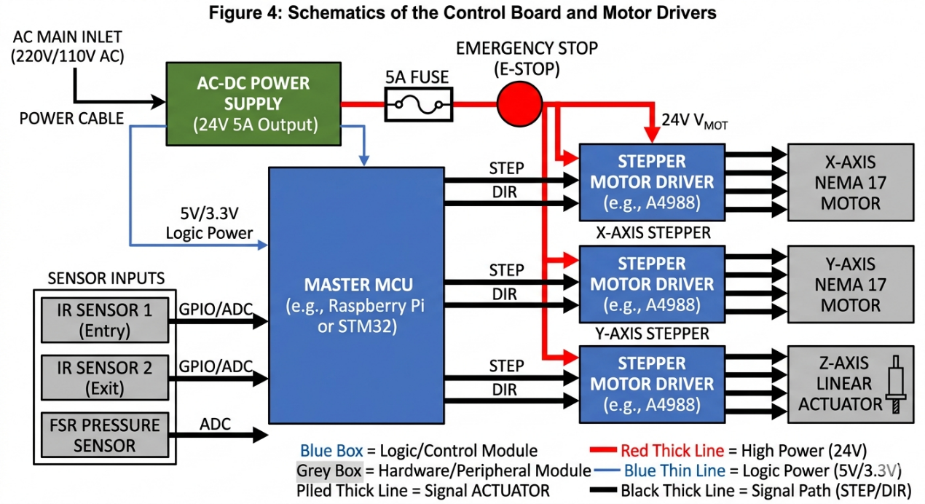
2.7 Tolerance Analysis
Critical Risk: Coordinate Mapping Accumulation Error.
The mapping from camera pixels to physical coordinates is the most critical function. Errors arise from lens distortion (E_cam is approx 0.4 mm) and mechanical backlash in the belts (E_mech is approx 2.0 mm).
The total worst-case error is calculated as:
E_total = E_cam + E_mech = 0.4 mm + 2.0 mm = 2.4 mm.
Since our High-Level Requirement allows for +/- 5.0 mm of error, our design provides a safety margin of 2.6 mm, proving the feasibility of the system.
3. Cost
Part | Cost (RMB)
RGB Camera (1080p, USB) | 150
Microcontroller (STM32/Raspberry Pi) | 350
NEMA 17 Stepper Motors (x3) | 120
Motor Drivers & Sensors | 150
Frame & Mechanical Parts | 300
Power Supply | 80
Total Cost | 1150
4. Schedule
Week | Zhiqiang Qiu | Yanzhen Chen | Xuliang Huang | Jiaheng Zeng
5 | Paper path CAD | VLM Model Setup | Gantry Frame Assy | Component Sourcing
6 | Roller Prototyping | OCR Testing | Motor Calibration | UI Design
7 | IR Sensor Integration | Pixel-to-MM Mapping | Z-axis Actuator Test | Power PCB Layout
8 | Mechanism Refinement | System Logic Integration | Accuracy Tuning | UI-MCU Comms
9 | Final Assembly | Debugging | Testing | Final Report
5. Ethics and Safety
5.1 Ethics
In adherence to the IEEE Code of Ethics, specifically regarding the protection of privacy, our system does not store document images. All data is processed in RAM and purged immediately after coordinate extraction.
5.2 Safety
- Mechanical: All moving belts and gears are housed within an acrylic enclosure. An Emergency Stop (E-Stop) button is placed on the front panel.
- Electrical: All AC-DC power components are grounded and fused to prevent short circuits and fire hazards.
References
[1] IEEE Code of Ethics. [Online]. Available: https://www.ieee.org/about/corporate/governance/p7-8.html
[2] "Stepper Motor Interfacing," Microchip Application Note, 2024.
[3] "Vision-Language Models for Document Analysis," OpenAI Research, 2025.

