Project Proposal

Introduction

Objective and Background

Traditional vision-based sorting systems often rely on frame-based cameras and external computers for image processing and classification. While these systems can achieve acceptable performance, they usually require higher data bandwidth, more computation, and more complicated setup. For embedded real-time applications, such designs are often too dependent on software processing and are not well suited for a compact, low-cost, standalone implementation. In addition, many existing object recognition demonstrations remain close to software-only projects, where the main result is classification on a screen rather than a full physical sensing-to-actuation pipeline.

This project aims to develop a low-cost standalone smart sorting system using a Dynamic Vision Sensor (DVS), FPGA-based event processing, and a physical output mechanism. In the proposed demonstration, objects move on a conveyor under a DVS camera. The DVS captures asynchronous brightness-change events, and the FPGA processes the event stream in real time to determine whether the passing object belongs to the target category. Based on this decision, the system generates a visible and physical response, such as turning on an LED indicator and actuating a simple sorting mechanism or diverter. Therefore, the demonstration is not only a software classification result, but a complete hardware loop in which the user can directly observe object movement, event sensing, FPGA decision making, and physical output behavior.

Another key goal of this project is to make the system operate as a true embedded device rather than a lab setup that depends on additional computers. The system is intended to be powered by a simple external power source and designed for one-button startup, so that after power-on it can automatically begin sensing, processing, and responding without extra software configuration. This makes the design more practical and more aligned with a real deployable product. By combining event-based sensing, FPGA real-time processing, and low-cost hardware implementation, this project explores the feasibility of a marketable embedded smart sorting platform for lightweight automation scenarios.

High-Level Requirements
- The system must demonstrate a complete physical sensing-processing-actuation loop, in which moving objects are detected in real time and trigger the correct visible or mechanical response.
- The system must operate as a standalone embedded platform without requiring an external computer for normal demonstration, and it must support one-button startup after power is applied.
- The system must achieve reliable real-time target detection for moving conveyor objects, with at least 90% accuracy under defined demonstration conditions.
- The system must be implemented on a low-cost hardware platform with stable operation under repeated test runs, showing feasibility for practical and potentially marketable deployment.

What will be demonstrated?
The final demonstration will be a standalone low-cost smart sorting system. A moving conveyor carries objects through the field of view of an overhead DVS camera. When an object passes directly under the camera, the FPGA-based event processing pipeline detects the motion/event pattern in real time and classifies whether the object belongs to the target category. The output is shown physically through LEDs and a simple actuator-based sorting mechanism. A green LED and diverter motion indicate a target object, while a red LED or no actuation indicates a non-target object.
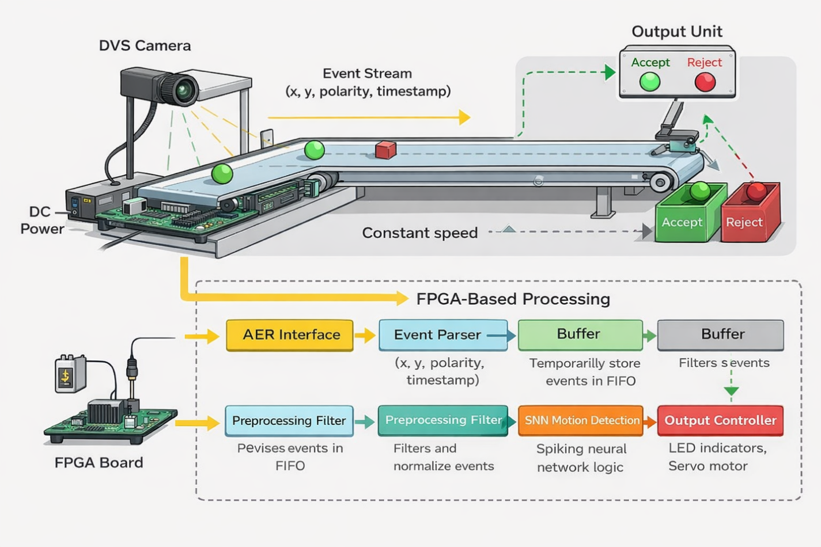
Figure 1 The block diagram
1. DVS Camera
The DVS camera detects pixel-level brightness changes and generates asynchronous event data, which is directly transmitted to the FPGA through a high-speed interface. It serves as the sensing front-end and provides sparse, low-latency visual input without full-frame capture. Its contribution is to reduce redundant data and enable real-time motion detection. The component is considered functional if it continuously outputs valid event streams when motion is present, maintains event latency below 1 ms, and does not drop more than 1% of events under normal motion conditions.
2. Conveyor Belt / Motion Platform
The conveyor provides controlled and repeatable motion by moving objects through the camera’s field of view at a consistent speed. It connects the physical environment to the sensing system by generating predictable motion stimuli. Its contribution is to ensure stable and testable input conditions for evaluating system performance. The component is considered functional if it maintains a speed variation within ±10% of the target value and consistently delivers objects through the sensing region without interruption.
3. FPGA Board
The FPGA receives the event stream from the camera, processes it through parsing, buffering, and SNN-based detection, and generates a decision signal. It connects the input sensing stage to the output stage and performs all real-time computation within a single embedded platform. Its contribution is to enable deterministic low-latency processing and eliminate the need for external computing. The component is considered functional if it processes incoming events without overflow, maintains resource utilization below 80%, and ensures internal processing latency does not exceed 40 ms.
4. Output Subsystem (LED / Actuator)
The output subsystem receives the decision signal from the FPGA and converts it into a visible or physical response, such as activating an LED or triggering a sorting mechanism. It connects system computation to observable behavior. Its contribution is to provide real-time feedback and demonstrate system functionality. The component is considered functional if it correctly reflects detection results in at least 90% of test cases and activates the output within 50 ms of motion detection.
5. Power Supply and System Integration
The power supply provides regulated electrical power to all components, enabling standalone system operation without external support. It connects to the camera, FPGA, and output modules to ensure synchronized startup and stable operation. Its contribution is to support the one-button requirement and continuous operation of the system. The component is considered functional if it delivers stable voltage within ±5% tolerance and allows the entire system to power on and begin operation automatically without manual configuration.
6. Overall System Functionality
All components are physically connected in a sequential flow from sensing to actuation, where motion is detected, processed, and converted into output signals. Each component contributes a necessary function, and the system operates as an integrated embedded platform. The system is considered successful if it achieves continuous operation, detects motion with at least 90% accuracy, and maintains end-to-end latency below 50 ms without requiring external computation.
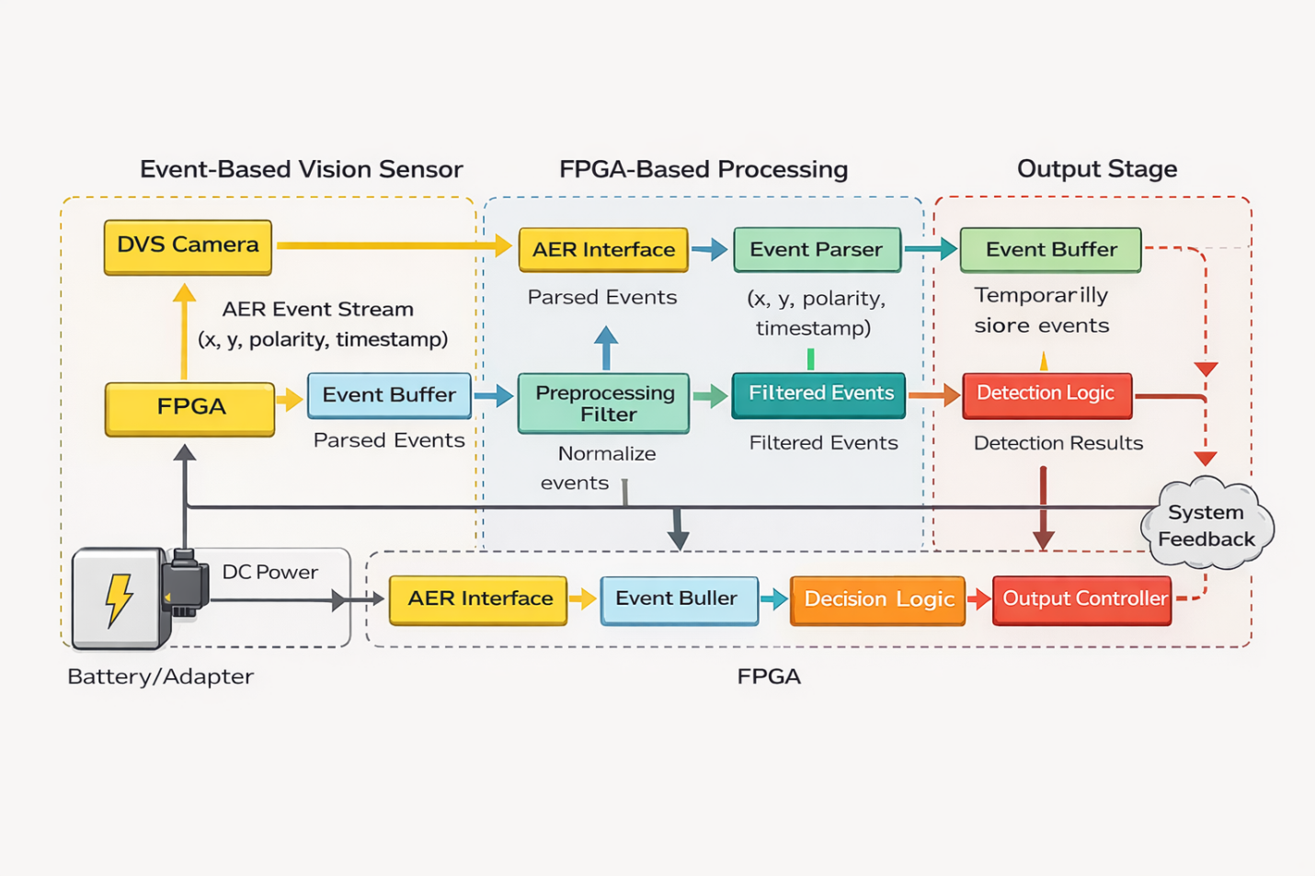
Figure 2 The Workflow
1. DVS Sensor Block: This block generates asynchronous event data when pixel-level brightness changes occur in the scene, outputting events in the form of address and polarity. It serves as the input source of the entire system and directly feeds the AER interface with a continuous event stream. Its contribution is to provide sparse, low-latency motion information without redundant frame data. The block is considered successful if it produces a continuous event stream during motion and maintains an event latency below 1 ms with no missing events under normal operating conditions.
2. AER Interface Block: This block receives the event stream from the DVS sensor and converts it into a synchronized digital format compatible with the FPGA clock domain. It connects the sensor to the internal processing pipeline and ensures correct timing and data integrity. Its contribution is to enable reliable high-speed communication between external hardware and FPGA logic. The block is considered successful if it correctly captures ≥99% of incoming events, maintains synchronization with the system clock, and introduces no more than 1 ms additional latency.
3. Event Parser Block: This block decodes the incoming event data into structured information, including pixel coordinates and polarity, and forwards it to the buffer. It connects the interface stage to the internal processing modules by standardizing the data format. Its contribution is to ensure that all subsequent processing operates on correctly interpreted event data. The block is considered successful if it correctly parses ≥99% of events without format errors and processes events at the full input data rate without stalling.

4. Event Buffer (FIFO) Block: This block temporarily stores parsed events to handle variations in event arrival rate and prevent data loss during bursts. It connects the parser to downstream processing stages by smoothing the data flow. Its contribution is to maintain system stability under high event rates. The block is considered successful if it prevents overflow under peak event rates (e.g., up to expected maximum events per second) and maintains continuous output without dropping events.
5. Preprocessing Filter Block: This block performs basic filtering on the event stream, such as removing isolated noise events or applying simple temporal/spatial filtering. It connects the buffer to the detection stage by improving data quality before analysis. Its contribution is to reduce false detections caused by noise while preserving meaningful motion events. The block is considered successful if it reduces noise-induced events by a measurable margin (e.g., ≥50%) while retaining ≥90% of motion-related events.
6. SNN-Based Motion Detection Block: This block accumulates event activity over a defined time window and generates a detection signal when the accumulated activity exceeds a predefined threshold. It connects preprocessing to decision logic by converting event streams into meaningful motion indicators. Its contribution is to perform core motion detection using an event-driven approach. The block is considered successful if it detects motion with ≥90% accuracy under test conditions and maintains detection latency within the specified system limit (e.g., contributes less than 30 ms to total latency).
7. Decision Logic Block: This block interprets the output of the detection module and generates a final classification or trigger signal. It connects the detection stage to the output controller by translating detection results into actionable signals. Its contribution is to ensure consistent and correct system-level decisions. The block is considered successful if it produces correct classification outputs in ≥90% of test cases and introduces negligible additional latency (e.g., <5 ms).
8. Output Controller Block: This block converts the decision signal into physical outputs such as LED activation or actuator control. It represents the final stage of the pipeline and connects internal computation to observable system behavior. Its contribution is to provide real-time feedback and demonstrate system functionality. The block is considered successful if it activates the correct output within 50 ms of motion detection and maintains stable operation without missed triggers.
9. Overall System Integration: All blocks are connected in a sequential streaming pipeline, where each block processes and forwards data to the next stage without interruption. The overall contribution of this architecture is to enable real-time, low-latency motion detection without frame reconstruction. The system is considered successful if it operates continuously without data loss, achieves end-to-end latency below 50 ms, and maintains stable performance under expected input conditions.
Tolerance Analysis
Critical Design Component: The most critical design component of this project is the end-to-end event-to-actuation pipeline, specifically the combination of (1) the DVS-to-FPGA event interface and buffering, and (2) the real-time detection and decision logic that drives the physical output actuator.
This is the highest-risk part of the design because it is the point where the project stops being a software-only classification task and becomes a standalone embedded hardware system. The success of the project is not determined only by whether events can be classified correctly in simulation, but by whether the system can reliably transform real sensor events into a timely physical response on a low-cost platform without the help of an external computer.
In the final demonstration, the audience should see a complete hardware loop: an object moves through the sensing region, the DVS camera generates events, the FPGA processes those events in real time, and the system produces an observable output such as LED indication and actuator or diverter motion. Therefore, the true critical function is not only detection accuracy, but deterministic real-time event handling under physical operating conditions.
Source of Risk: The main design risk is that the event stream generated by the DVS sensor is highly variable. Its rate depends on object speed, object contrast, ambient lighting variation, and scene noise. This creates three coupled risks:
- Event Burst Overflow: If the instantaneous event rate is too high, the FPGA input buffer may overflow before downstream logic can process all events. In that case, useful events are lost, which may cause missed detections or unstable output behavior.
- Threshold Instability: If the detection threshold is selected too low, noise or background flicker may trigger false detections. If it is selected too high, real objects may not produce enough accumulated activity to activate the sorter. This is a design tolerance issue because the correct threshold must remain valid across a range of real operating conditions rather than for only one ideal test case.
- End-to-End Timing Failure: Even if the logic is correct, the project fails its intended function if the decision arrives too late for the actuator to respond while the object is still in the sorting region. Thus, latency tolerance is as important as detection correctness.
For this reason, the most critical risk is not that the algorithm is difficult, but whether the hardware pipeline can tolerate realistic variation in event rate and still produce a correct physical sorting decision within the allowed time budget.
Mathematical Tolerance Analysis: To demonstrate that the proposed system can operate reliably under realistic conditions, the key design risks identified above are further analyzed from a quantitative perspective. The following subsections correspond to the three primary sources of tolerance concern: detection robustness, buffer stability, and real-time response capability.

- Quantitative Analysis of Detection Threshold
The reliability of the detection module depends on the separation between noise-induced activity and motion-induced activity within a fixed accumulation window. The accumulated event activity is determined by the event rate and the time window, and the detection threshold must be carefully selected to ensure robustness.
Let the event rate be λ (events/s) and the accumulation time window be T (s). The total accumulated activity is given by $A = λT$
For reliable detection, the threshold θ must satisfy the condition:
$$λ_{nT} < θ < λ_{mT}$$
where $λ_{n}$ is the noise event rate and $λ_{m}$ is the motion-induced event rate. This ensures that noise does not trigger detection while real motion does. For example, if $λ_{n}$ ≈ 1×10³ events/s and $λ_{m}$ ≈ 1×10⁴ events/s with T = 10 ms, then:
- Noise accumulation: $A_{n}$= 10
- Motion accumulation: $A_{m}$ = 100
A practical threshold such as θ ≈ 50 provides a clear separation margin between these two cases. This margin is important because in real-world operation, environmental factors such as lighting variation and object speed may slightly shift event rates. A sufficiently large separation ensures that the system remains stable under such variations.
- Buffer Stability and Overflow Tolerance
The second critical tolerance issue lies in the system’s ability to handle bursty event streams without data loss. Since the DVS sensor produces asynchronous events, the incoming event rate can temporarily exceed the processing capability of the FPGA.
To prevent overflow, the FIFO buffer must handle peak event rates. If the maximum expected event rate is $λ_{max}$ and the processing rate is μ, the buffer size B must satisfy:
$$B ≥ (λ_{max} - μ) · Δt$$
where Δt is the maximum burst duration. For example, if $λ_{max}$ = 2×10⁴ events/s, μ = 1.5×10⁴ events/s, and Δt = 10 ms, then B ≥ 50 events. Designing the buffer with at least 2× margin (e.g., B ≥ 100) ensures safe operation.
- Real-Time Response and Latency Budget
The total system latency is the sum of delays across all blocks:
$$L_{total} = L_{interface} + L_{buffer} + L_{Processing} + L_{output}$$
To meet the requirement L_total < 50 ms, each stage must be bounded. For example:
- Interface + parsing: < 5 ms
- Buffering: < 10 ms
- Detection: < 30 ms
- Output: < 5 ms
This ensures the system meets real-time constraints.

4) Standalone Power and System Integration Tolerance
Another important tolerance issue is system startup and standalone operation. Since the device is intended to function as a one-button embedded system, it cannot depend on manual software configuration, laptop-side processing, or repeated parameter loading after power-up.
The integrated hardware is considered tolerant at the system level if all modules power on from a single regulated supply, voltage variation remains within ±5%, FPGA configuration and peripheral initialization complete automatically, and the system enters detection mode without external computer intervention.
This requirement reduces the risk that the project appears as a partially assembled prototype rather than a complete embedded product. It also addresses the instructor’s concern that the project should be demonstrable as a real device rather than as a software pipeline assisted by external tools.

Tolerance Conclusion
The design can be considered feasible if the following conditions are simultaneously satisfied:
λn Tw < θ < λm Tw
B ≥ (λpeak - μ) Δt
Ltotal < min(50 ms, d / v)
and the system can boot and run from a single standalone power source without external computing support.
If these conditions are met, then the proposed architecture has sufficient tolerance to variation in sensor input, event burst rate, and physical timing, and the design should remain functional in a real demonstration environment.

Ethical Considerations
The ethical issues in this project are closely related to the intended function of the system itself. Our design is an event-based smart vision node for ultra-low-latency motion detection using a DVS camera, FPGA, and SNN-inspired processing. The system is designed to detect motion and possibly track moving objects in real time, so the most relevant ethical concern is reliability of result. A false positive signal may trigger an unnecessary output, while a false negative signal may miss real motion. Therefore, it would be unethical to present the system as more reliable or more robust than it has actually been verified to be, especially in applications related to robotics or automated sensing.
A second concern is the honest reporting of performance. Since this project emphasizes low latency, event-driven processing, and possible power advantages over frame-based methods, we have a responsibility to report only what is actually measured or demonstrated. Target values, expected improvements, and future work should be clearly distinguished from verified results.
Then comes to the potential surveillance use. Although an event-based camera does not record conventional full image frames, it still senses activity in the environment continuously. For this reason, the project should be viewed as a research and educational prototype for real-time sensing and low-latency perception, not as a tool for hidden monitoring or unauthorized observation deployed in safety-critical or high-consequence environments without much more validation.
Safety Guidelines
This project follows all ECE 445 lab safety requirements. At least two team members must be present in the lab at all times, and all team members must complete the required online safety training before working in the lab. Since our project does not involve high voltage or electric current applied to a human subject, the main safety concerns are related to low-voltage hardware operation, power supply handling, and correct equipment connections.
For this project, the system consists mainly of a DVS camera, FPGA-based processing hardware, power supply connections, and output devices. All wiring and power connections must be checked carefully before powering the system, in order to avoid short circuits, incorrect pin connections, or accidental damage to the FPGA board and sensor interface. The FPGA and peripheral modules should only be powered within their specified voltage ranges, and all devices must be turned off before changing major connections.
If external batteries or portable power modules are used, they must be handled according to the ECE 445 battery safety guidelines. In addition, the project should be tested in a controlled lab environment with stable mounting of the camera and hardware to prevent accidental falls, cable strain, or equipment damage during operation.
Because this is a real-time sensing system, responsible testing is another crucial issue. The design should first be validated on benign visual scenes and low-risk demonstrations before being used in more complex robotic or motion-tracking scenarios. This helps avoid unsafe behavior caused by false detections or unstable control outputs.
In addition, if a PCB board is used in the project, it should be handled carefully to avoid mechanical damage and unsafe placement. The board should be mounted on a stable, non-conductive surface and should not be placed directly on metal tables or conductive materials. All sharp leads, exposed solder joints, and loose wires should be checked before powering the circuit. When drilling, cutting, or modifying a plastic support board, safety glasses should be worn if required, and the board should be secured properly to prevent slipping or cracking. Proper mounting helps prevent short circuits, accidental contact, and hardware damage during testing.

References
[1] “Event-based vision on FPGAs – a survey,” arXiv, 2024. [Online]. Available: https://arxiv.org/html/2407.08356v1#bib.bib60 . Accessed: Mar. 24, 2026.
[2] “Neuro-Inspired Spike-Based Motion: From Dynamic Vision Sensor to Robot Motor Open-Loop Control through Spike-VITE,” Sensors, vol. 13, no. 11, 2013. [Online]. Available: https://www.mdpi.com/1424-8220/13/11/15805 . Accessed: Mar. 24, 2026.
[3] “A Reconfigurable Architecture for Real-time Event-based Multi-Object Tracking,” ACM Transactions on Reconfigurable Technology and Systems. [Online]. Available: https://dl.acm.org/doi/10.1145/3593587 . Accessed: Mar. 24, 2026.

