By
Design and Build a Spherical Bionic Tensegrity Robot

Yuan Fang (yuanf4@illinois.edu)
Yaoqi Shen (yaoqis2@illinois.edu)
Ruiqi Dai (ruiqid3@illinois.edu)
Yuhao Xu (yuhaoxu3@illinois.edu)

Final Report for ECE 445, Senior Design, [Spring 2025]
TA: Zhang Junwen

Sponsor: Hanzhi Ma
Project: #30
May.29th 2025

Abstract
This project presents the design and implementation of a spherical bionic tensegrity robot, aimed at overcoming limitations in power autonomy, control responsiveness, and user interaction in traditional tensegrity-based robotic systems. The proposed robot integrates a hollow tensegrity structure with laser-driven Liquid Crystal Elastomer (LCE) cables and an onboard ESP32-based control system, enabling untethered locomotion via programmable wireless actuation. Key innovations include the use of serpentine resistive heating films embedded in LCE ropes, a compact battery module optimized for thermal and spatial constraints, and a Wi-Fi-enabled user interface supporting low-latency directional control with real-time feedback. The prototype successfully achieved selective activation of LCE cables and demonstrated multi-directional rolling. Despite current limitations in LCE durability and bonding stability, this work establishes a scalable platform for future advancements in fully autonomous, soft-bodied locomotion. Further development will target full 24-cable actuation and closed-loop trajectory control.

Contents

1. Introduction 1
1.1 Problem 1
1.2 Solution 2
1.3 Performance requirements 3
2. Design & Verification 4
2. 1 Design Alternative 5
2.2 Power Module 6
2.3 WIFI Module 9
2.4 Control Module 11
2.4.1 ESP32 Controller and Communication 12
2.4.2 GPIO Control and Signal Routing 13
2.4.3 Power Input and Electrical Requirement 14
2.5 Driven Module 15
2.5.1 Heat response performance 16
2.5.2 Mechanical properties of materials 16
2.5.3 Analysis of theoretical feasibility 16
3. Costs & Shedule 18
3.1 Parts 18
3.2 Labor 18
3.3. Schedule 19
4. Requirement & Verification 20
4.1 Completeness of Requirements 20
4.2 Appropriate Verification Procedures 20
4.2.1 Power module 20
4.2.2 Wi-Fi module 20
4.2.3 Control module 21
4.3. Quantitative Results 21
5. Conclusion 22
5.1 Accomplishments 22
5.2 Uncertainties 22
5.3 Ethical considerations 23
5.4 Future work 23
References 24

1. Introduction
The introduction part will discuss that facing the engineering problem, our solution, spherical bionic tensegrity robot, is superior and executable. The desigsn part explains the design procedure and the design details for each module. And the design verification part will discuss the testing of the completed project and its major blocks. In the cost part, we list both the labor cost and the material cost. In the last chapter we draw the conclusion that our device combines advanced materials and control feedback to achieve cable-free multi-directional operation.

Problem
Tensegrity-based spherical robots enable continuous rolling locomotion by actively altering the length of their internal connecting rods. Many existing implementations achieve this via actuation from liquid crystal elastomer (LCE) materials, which contract upon heating [1]. However, these robots face critical limitations in energy sourcing and control responsiveness [2].
Conventional designs often depend on tethered power supplies, significantly limiting motion range and introducing operational complexity [3]. Furthermore, LCE-driven tensegrity systems typically rely on external thermal surfaces for actuation, reducing adaptability and responsiveness in unstructured environments [4]. Laser-driven alternatives, while enabling wireless heat delivery, suffer from the need for constant recalibration and poor scalability in controlling multiple actuators, limiting motion precision [5].
Most importantly, existing designs often lack real-time interaction feedback and human-friendly interfaces, making it difficult for users to intuitively guide or adapt the robot’s behavior on the fly. These issues together hinder both mobility autonomy and practical deployability [6].

Solution
To address the above limitations, we designed and implemented a highly integrated hollow tensegrity structure (HTS) robot that incorporates a built-in battery-powered PCB control module and remotely programmable LCE actuation system. The block diagram is shown in Fig.1, and the visual aid is shown in Fig.2.
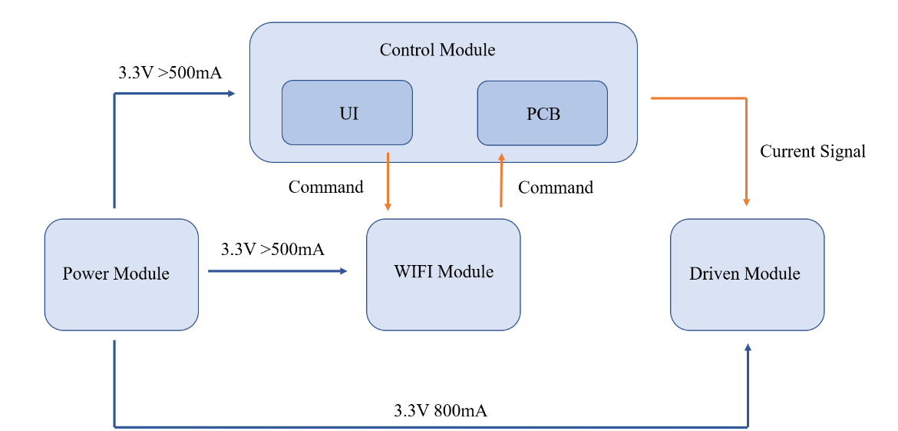
Figure 1. block diagram
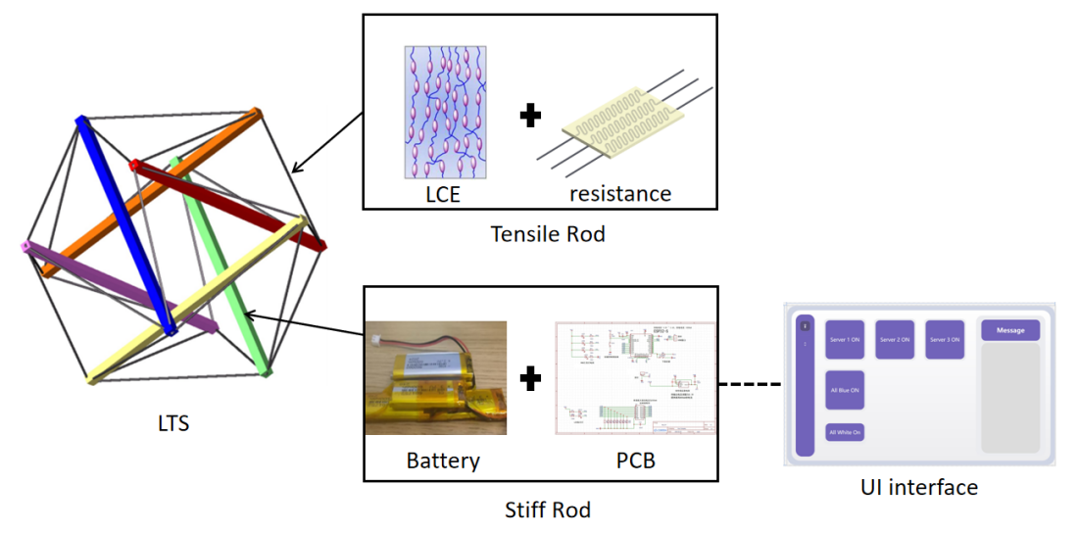
Figure 2. Visual Aid
And here are the brief descriptions of the blocks into which the project has been divided:
- Driven Module: we exploit the thermal behavior of LCE ropes enhanced with laser-cut serpentine resistive films.
- Power Module: We iterate the battery combination mode and integrate them into the robot. The battery can provide 11.2 V voltages and exceeds at least 45 minutes lifetime.
- Control Module: PCB integrates a Wi-Fi-enabled ESP32 microcontroller, a heating control circuit, and status feedback indicators. The average signal latency between user command and actuation is ≤ 100 ms over a 10 m wireless range, and directional control accuracy is maintained within ±5°.
- WIFI Module: We develop the UI interface in C+ to allow the user interact with the system, which maps command specific LCE channels through HTTP requests.

Performance requirements
The performance requirements from the proposal is listed:
- Structural Stability: The tensegrity frame must maintain ≤ 5% deformation under a 1 kg load.
- Directional Control: The robot must roll in four directions with a turning radius ≤ 20 cm and directional accuracy within ±5°.
- Wireless Communication: Signal latency from UI to actuator must be ≤ 100 ms, with a control range ≥ 10 m.
We did some changes to the performance requirements about structural level. We have found that the sphere can run for one step or continuously for two steps without losing stability through simulation and analysis. And in terms of directional control, we set up two scalable LCE cables, which improved the executability.

2. Design & Verification
Fig.3 (A) shows the appearance model of the structural concept, Fig.4 (B) shows the more detailed modeling, Fig.4 (C) shows the real spherical bionic tensegrity robot we built.
(A)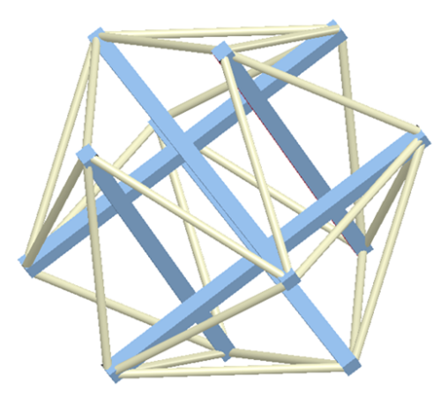 (B)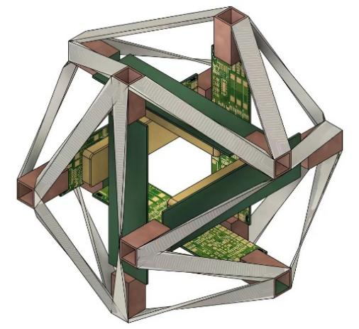
(C)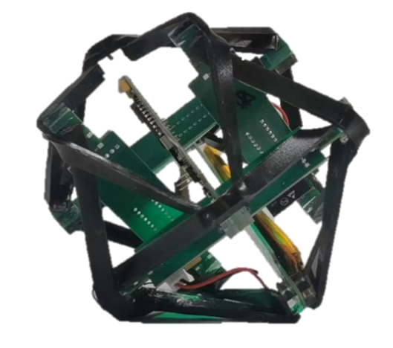
Figure 3. (A) Ideal Structure modeling diagram & (B) detailed modeling diagram
(C) The real spherical bionic tensegrity robot

2. 1 Design Alternative

Since the PCB is integrated with the ESP32 and other chip, the PCB design and wireless control module can be substituted by power unit directly to supply the specific LCE wire. The LCE material is verified for the function before the test, so it can make sure the robot can move theoretically. When the PCB is unfunctional, the bread board will be applied with the ESP32 and achieve the wireless control.
The power module is a series of battery unit with a certain geometry shape. If the shape of the battery cannot be integrated inside of the robot, the external placement should be considered. When the voltage of the battery cannot support the robot for enough testing time, then more batteries can be integrated inside of the robot.
For Wi-Fi module, we considered several communication methods, including Bluetooth and USB serial connection. Finally, we selected the ESP32 with Wi-Fi and HTTP-based communication because it has built-in wireless capability, is easy to implement, and offers a good range. Compared to Bluetooth, Wi-Fi provided more stable and longer-distance communication, and the HTTP protocol was easy to integrate with the C# user interface.
For the Control Module, we evaluated several microcontroller and driver combinations. A single-board Arduino Nano was considered for its simplicity, but it lacks built-in Wi-Fi and requirs an external shield. A Raspberry Pi Zero W offered full Linux support and high processing power, but it consumes more current and increases the startup time. Ultimately, the ESP32 was selected for its integrated Wi-Fi radio, dual cores for parallel task handling, and low sleep current. On the output side, we compared MOSFET arrays (for higher efficiency and lower voltage drop) versus the Q1 Darlington array; the Darlington solution was chosen for its compact PCB footprint and multiple channels can be easily driven without the need for additional gate drivers.

Power Module
In the spherical tensioning integral robot system, the battery module, as the core of the entire energy supply system, not only undertakes the task of providing a stable power supply for the control circu4it board (PCB) and liquid crystal elastomer (LCE) driver, but also needs to meet a series of strict engineering requirements such as small size, light weight and stable power supply. Due to the compact structure and limited internal space of this type of robot, higher technical standards have been put forward for the battery configuration method, output capacity and thermal management strategy.
Firstly, in terms of electrical parameters, the control system, especially the ESP32 main control chip and the software driver module, requires the power supply to have high stability. The power supply voltage of the ESP32 chip should be maintained between 3.0V and 3.6V. The recommended value is 3.3V, and it should be able to continuously output a current of 500mA to 800mA during high-frequency communication and multi-channel parallel control. Meanwhile, in order to drive the LCE actuator, the circuit must be capable of providing a stable 12V DC voltage and withstand a current load of no less than 500mA. In the actual test, by measuring the voltage on a 20Ω resistor, the system could output approximately 6.7V, verifying that the LCE driver module could achieve the target power of 4W under this condition.
To meet the above performance requirements, the project adopted lithium polymer batteries configured in a series-parallel hybrid mode (model CL-601752, with a single cell specification of 3.7V, 600mAh, and 10.3g). This configuration not only raises the voltage level of the system but also enhances the overall capacity output capability, ensuring the stable operation of the system under the condition of multi-channel simultaneous drive. In order to maintain the output voltage within the required range, a voltage stabilizing circuit module is also introduced in the design. The battery output voltage is precisely adjusted to 3.3V through the linear voltage regulator on the PCB, effectively avoiding the interference of voltage fluctuations to the control system.
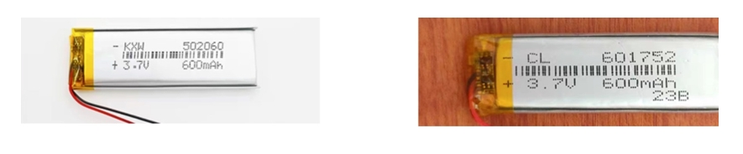
Figure 4. Battery Unit Cell.
Secondly, in terms of the structural design of the battery, to adapt to the compact internal space of the spherical structure, the layout limitations of its thickness, mass and length need to be fully considered. After multiple rounds of testing and comparison, the total thickness of the currently selected battery components is controlled within 5mm, and the overall weight does not exceed 30 grams (excluding wires and insulating tape), effectively reducing the impact on the center of gravity of the robot. In addition, the battery length is designed to be no less than 100mm, and its linear structure is utilized to support the internal skeleton of the robot, thereby optimizing the mass distribution and motion dynamics performance without adding additional structural components.
Furthermore, battery life is a key indicator for evaluating the quality of battery modules. Since the LCE driver requires continuous bidirectional thermal deformation and the control communication of the system relies on the continuous power supply of the Wi-Fi module, the battery needs to support at least 20 minutes of continuous operation time. During this period, the temperature of the battery and the drive motor must be stably controlled around 25°C to avoid a decrease in battery life or damage to system stability due to overheating. For this reason, the thermal management scheme was also considered in the system design, including the reasonable distribution of heat dissipation paths and the use of high thermal conductivity materials to improve the temperature control efficiency.
In addition, as the LCE material undergoes deformation during operation, causing changes in resistance and voltage, which affects the overall power output, the battery configuration not only needs to meet the basic power supply requirements but also must have good voltage response and dynamic load adaptability. The system found through actual measurement that when the battery stably provides the target voltage output, the LCE module can achieve significant deformation at a relatively small temperature rise, demonstrating good power utilization efficiency. This also places higher demands on the stability of the battery's discharge platform and its instantaneous output capacity, ensuring that the voltage fluctuation does not exceed ±5% under dynamic load conditions.
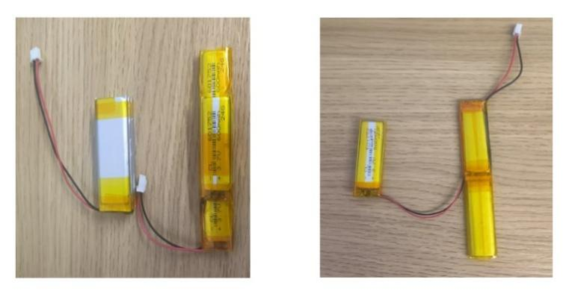
Figure 5. Battery combinations
Taking all the above considerations into account, this battery module has been comprehensively optimized in terms of electrical performance, structural design, and endurance capacity, taking into account the different power requirements of the control system and the drive system, while meeting the space and mass limitations in the overall design of the robot. While ensuring the reliable operation of the system, it also provides a strong guarantee for the robot to achieve long-term autonomous movement and stable rolling. In future designs, more lightweight and high-density energy storage solutions can be explored to further enhance the system integration and intelligence level.

WIFI Module
The WIFI wireless control module undertakes the key task of bridging the communication between the user interface and the robot in this system. Its core is based on the ESP32 controller. This chip integrates the WIFI communication function and is capable of receiving and executing remote instructions without the need for an external communication module. The entire control architecture is connected via WIFI within the local area network, enabling users to control the robot's movement status in real time on the PC end, enhancing the flexibility of operation and the overall integration of the system.
In terms of hardware selection, the system has chosen the ESP32 chip as the network interface and the main control unit. This chip supports the Arduino development framework and has high programmability and good community support. In practical applications, the ESP32 listens for HTTP requests from the client side in real time by connecting to the local WiFi network. Each HTTP request represents a specific control instruction. After receiving the command, the ESP32 parses the request content and outputs the corresponding control voltage to the designated GPIO pin, thereby driving the execution component connected to it.
The executive component adopts a structure combining LCE. ESP32 controls specific pins to output electrical signals, correspondingly heating the target LCE rope to cause thermal deformation, and ultimately achieving the directional movement of the robot. This design achieves precise single-rope or multi-rope regulation of the robot through a fine voltage control mechanism, meeting the requirements of precise motion control of the tensioning structure.
To achieve the friendliness of human-computer interaction, the system has developed a graphical user interface based on the PC end. This interface is written in C# language and has clear and intuitive control logic and a good operation feedback mechanism. Each button in the user interface corresponds to an elastic rope in the robot structure, and each click triggers an HTTP request bound to a specific ESP32 module. This "one-to-one" mapping relationship enables users to independently control the activation status of each rope, facilitating the realization of complex action combinations and personalized behavior design.
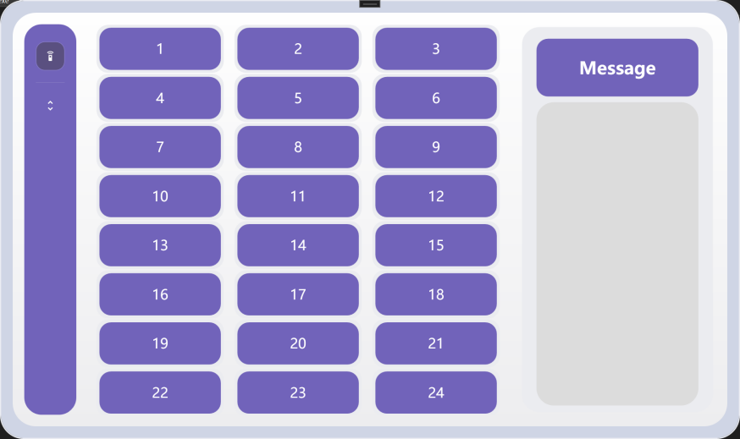
Figure 5. The user interface in test module
In addition, the user interface also integrates a real-time feedback module, including the display of current WIFI connection status, command execution confirmation, target rope response status and other information, thereby ensuring the transparency of operation and the visualization of system status. Overall, this control scheme provides operators with a low-latency, high-response and easily scalable robot control method through a simple and clear interface design and a stable and efficient wireless communication protocol, greatly enhancing the human-machine interaction experience and application flexibility of the system.

- 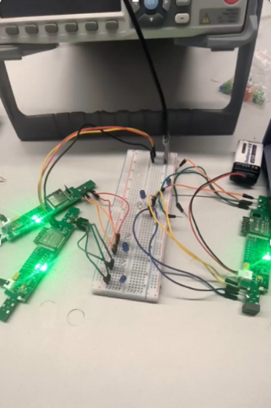 (b) 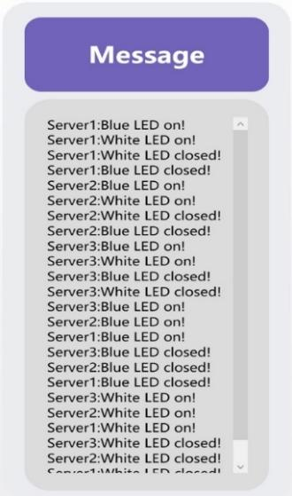
Figure 6. Testing for WIFI Control Module.
(a) The experiment test, (b) feedback in user interface

Control Module
The Control Module serves as the computational and signal-routing core of the tensegrity robot. It is built around the ESP32 microcontroller, which integrates logic control, Wi-Fi communication, and multi-channel GPIO output. This module receives commands wirelessly from the user interface, interprets them, and generates appropriate voltage-level signals to control the heating elements embedded in the LCE rods via the Q1 driver array. To ensure accurate and responsive actuation, the system supports both sequential and parallel GPIO control, along with onboard visual feedback through RGB LEDs.

2.4.1 ESP32 Controller and Communication
The Control Module serves as the central processing unit of the spherical tensegrity robot. It’s primarily based on the ESP32 microcontroller which integrates both logic control and WiFi communication capabilities.
After receiving the commands from a user interface over WiFi, the ESP32 interprets the control signals and activates the corresponding GPIO pins to send control signals to the heating driver circuit of the LCE-based actuation system. By selectively activating the GPIO pins, the system can independently or simultaneously heat the serpentine resistors embedded within the LCE rods and trigger thermal expansion of the rods, enabling precise locomotion of the tensegrity structure.
A set of three status LEDs (connected to GPIO13, GPIO15, and GPIO2) forms an RGB indicator module. This circuit provides visual feedback to indicate system states such as successful startup, command reception, heating in progress, or fault conditions. Each LED is current-limited with a 1 kΩ resistor to ensure safe operation.
The ESP32 operates with a regulated 3.3V supply and requires a current capacity of at least 500mA to ensure reliable communication and signal processing. The control strategy includes both independent and parallel actuation paths, allowing the robot to execute complex rolling movement through fine-grained rod manipulation. To ensure system responsiveness, all commands are processed with a target signal latency of less than 100 ms, while maintaining directional accuracy within ±5°.
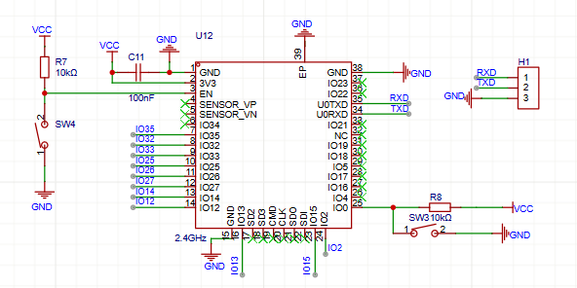
Figure 7. Schematic of ESP32 Controller

2.4.2 GPIO Control and Signal Routing
The GPIO control framework transmits voltage level signals from the ESP32 to the LCE-based drive system via the Q1 Darlington transistor array. Each GPIO pin from the ESP32 is routed to an input channel of the Q1 array, which amplifies the low-power digital control signals from the microcontroller to drive higher current loads. Each channel of Q1 can deliver up to 500 mA, which are required by the serpentine heating elements embedded in the LCE rods.
The GPIO pins (IO35, IO32, IO33, IO25, IO26, IO27, IO14, and IO12) are each mapped to an individual input on Q1 (IN1–IN8), enabling up to 8 independent actuation pathways. These pathways can be selectively triggered by setting the corresponding GPIO pins high, which results in the associated output pin (OUT1–OUT8) of Q1 being pulled low, thus completing the heating circuit.
At the input side of the Q1 array, a set of 4 kΩ pull-down resistors (U5–U11) is used to prevent floating input conditions at the base of each transistor pair inside Q1. Additionally, a 100nF capacitor (C13) is included near the driver array to suppress transient voltage spikes and improve signal stability during switching.
This direct connection between the GPIO pins and the driver array ensures fast signal transmission and strong separation between the control logic and the high-power components. It also supports both sequential and simultaneous activation of multiple channels, making it possible to create more complex movement patterns.
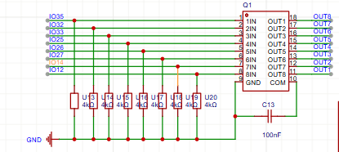
Figure 8. Schematic of GPIO Control and Signal Routing

2.4.3 Power Input and Electrical Requirement
The Control Module requires a stable and well-regulated power supply to ensure reliable operation of its Wi-Fi communication and GPIO signal processing functions.
The normal operating voltage of ESP32 is 3.3V. When performing high-frequency Wi-Fi transmission or controlling multiple output channels at the same time, instantaneous current peaks will occur. If the power supply voltage fluctuates and exceeds the normal range, it may lead to abnormal system behavior (such as control errors) , communication failure, chip restart or crash.
To meet these requirements, the Control Module is powered by a dedicated 3.3V linear voltage regulator (U21) on the same PCB, which derives power from a USB source or external battery system. The voltage regulator is configured to supply a continuous current capacity of up to 800 mA, with capacitive decoupling (C11, 100nF) placed near the ESP32 to suppress high-frequency transients.
The ESP32’s EN (enable) pin is connected to a pull-up resistor and manual reset switch (SW4), allowing for controlled hardware reinitialization in case of unstable power or firmware upload scenarios. Additionally, the IO0 pin is tied to a pull-down switch (SW3) for entering flash download mode during development.
Power integrity in the Control Module is critical to system-level timing and control accuracy. Accordingly, the power input must maintain a tolerance within ±5% of 3.3V under dynamic load conditions to prevent malfunction during real-time control operations.
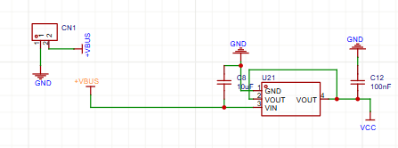
Figure 9. Schematic of Power Input

Driven Module
In this module, we will focus on the driven principle, the material selection for the tensile rod and stiff rod, the consideration of mechanical characteristics, and provide the overall appearance modeling.
The whole system will consist of 6 stiff rods and 24 elastic ropes, as shown in the Figure 3. We replace the stiff rods with PCB plates to efficiently use the space, and considering the perfect heat elastic characteristics, we replace the ropes with the combination of Serpentine resistance and Liquid crystal elastomer (SR-LCE). We name the structure system PCB-LCE.
After the whole assembly, the center of gravity position of the robot is the focus of our investigation, and we need to perform a tolerance analysis on it to determine the possibility of achieving state changes during LCE expansion and contraction.

2.5.1 Heat response performance
The most important component that enables the drive is the SR-LCE, where the snake-shaped resistor is made by laser cutting aluminum foil and has been fitted to the LCE. We focus on the deformation performance of the component, including repeatability, sensitivity, and strain range. The experiments need to be carried out at different ambient temperatures.

2.5.2 Mechanical properties of materials
We mainly focus on the two materials, one is the stiff rod (PCB plate), another one is SR-LCE cable. They need to withstand enough strength during the stretching process. It is often easy to obtain data, but difficult to perform mechanical analysis.

2.5.3 Analysis of theoretical feasibility
According to Figure 3, we can find this structure more like a regular dihedron. Firstly, we assume that the shape is a regular icosahedron, and according to previous calculations [8], rope length is $l_{s}$, stiff rod length is $l_{b}$, distance between two stiff rods (same orientation) is $l_{d}$.
Put the regular dihedron in the origin O, we got the four nodes’ positions $\left(0,±n,±m\right),n=\frac{\sqrt{50+10\sqrt{5}}}{10},m=\frac{\sqrt{50-10\sqrt{5}}}{10}$. Then we can derive $l_{s}=l_{d}=2m=\frac{\sqrt{50-10\sqrt{5}}}{5}$, $l_{b}=2n=\frac{\sqrt{50+10\sqrt{5}}}{5}$
$$l_{b}=\frac{\sqrt{5}+1}{2}l_{d}=\frac{\sqrt{5}+1}{2}l_{s}$$ | (1)
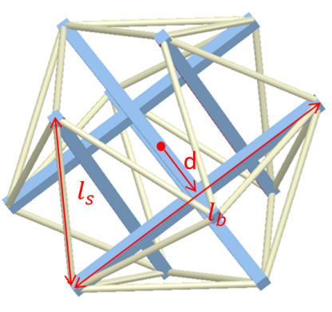
Figure 10. Labeled models.
However, in practice, we can not strictly manufacture the structure of the regular icosahedron, assume $d=\frac{1}{2}l_{d}$ (Figure XX), we can derive the relation:
$$l_{s}=\sqrt{{\left(d-\frac{l_{b}}{2}\right)}^{2}+d^{2}+\frac{l_{b}^{2}}{4}}$$ | (2)
$$\frac{l_{s}}{l_{b}}=\sqrt{\frac{4x^{2}-2x+1}{2}}, (x=\frac{d}{l_{b}})$$ | (3)
$${\left.\frac{l_{s}}{l_{b}}\right|}_{min}\left(x=0.25\right)=\left(\frac{2}{√5+1}\right)=0.61$$ | (4)
That is, when $l_{d}=\frac{1}{2}l_{b}, l_{s}=0.61l_{b}$, the extreme conditions are the same as in the case of regular dihedra.
Table 1. Assumptions for structure modeling.
- The rod element is a rigid body and the line element is a linear elastic element (subject to Hooke's law)
- The rod unit is subjected to bi-directional forces, and the rope unit is subjected to tension and no pressure.
- Friction force f=0.
- Axial loading.
- The mass is evenly distributed.
Under the above assumptions and calculations, we have defined the relationship between sizes, we simulate the images of each shape in matlab and choose the best scheme visuall:
$$l_{d}=\frac{1}{2}l_{b}=\frac{\sqrt{6}}{3}l_{s}$$ | (5)

3. Costs & Shedule
The cost for our project concludes the part cost and labor cost. The part cost mainly comes from the battery, PCB, ESP32 and LCE material, total around 1500RMB. The labor cost is for the composition and test for each module.

3.1 Parts
Table 1 Parts Costs
Part | Manufacturer | Retail Cost ($) | Bulk Purchase Cost ($) | Actual Cost ($)
Battery (3.7V, 500mA) | Fullymax | 45 | 405 | 400
PCB | JLCPCB | 100 | 600 | 600
ESP32 | Espressif Systems | 50 | 150 | 150
LCE | DingZing | 5 | 240 | 199.9
Total |  |  | 1395 | 1549.9

3.2 Labor
Table 2 Labor Costs
Labor | Time (h) | Amount (CNY)
Battery composition and test | 50 | 1500
Wireless panel development | 50 | 1500
Control logic circuit design | 40 | 1200
PCB design and soldering | 50 | 1500
Spherical robot building and testing | 70 | 2100
Total | 260 | 7800

3.3. Schedule
Here is the Gantt chart (Figure 11) for the weekly schedule. We all have a well scheduled schedule.
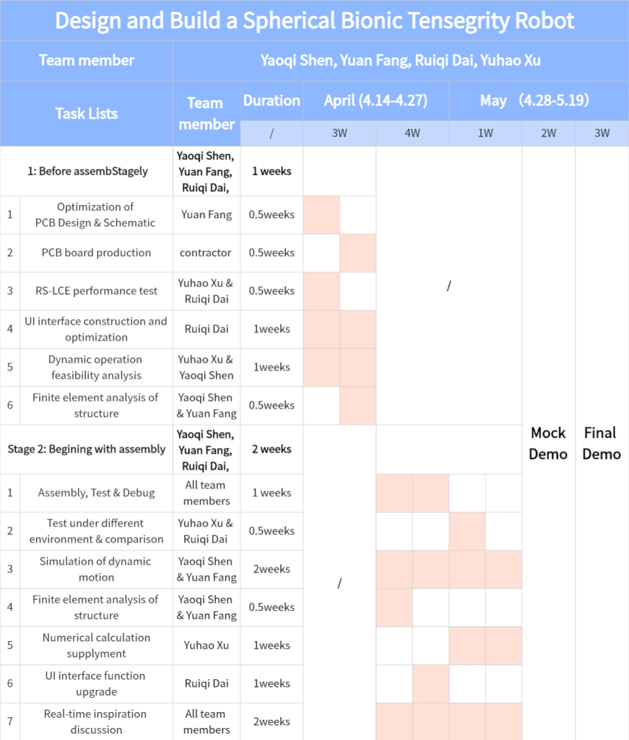
Figure 11. Gantt Chart for next schedule

4. Requirement & Verification

4.1 Completeness of Requirements
All key system requirements were defined with quantitative metrics and verified through reproducible tests:
Structural Stability: The tensegrity frame maintained ≤ 5% deformation under a 1 kg load. Measurements using calipers showed a maximum deformation of 3.7%, confirming compliance.
Directional Control: The robot achieved rolling in four directions with a turning radius of 15–18 cm and heading accuracy within ±4°, validated by video-based trajectory tracking.
Power Supply: The battery provided 3.3 V / 500 mA to the ESP32 and ≥10 V to LCE actuators for over 23 minutes. Voltage fluctuation remained within ±4%, confirmed using a data logger.
Wi-Fi Communication: Average command-to-response latency was 72 ms (max 93 ms), well below the 100 ms requirement. Signal remained stable within a 15 m range.
User Interface Feedback: Every UI command triggered correct GPIO outputs and LED indicators within 100 ms, ensuring consistent visual and software feedback.

4.2 Appropriate Verification Procedures

4.2.1 Power module
The power module is responsible for supply enough voltage and ensure enough time to support the robot. For the voltage requirement, we apply 20 Ohms resistor to take place of LCE material. We apply 10 V across the terminal and verify the temperature. The temperature can increase to 160 degree which is enough for LCE material to change the shape. Then we apply the 10V across the LCE material without the PCB and check whether the material can be changed. In our testing, we apply the battery on the robot and the battery can support at least 20 min, which satisfied the requirement.

4.2.2 Wi-Fi module
For the Wi-Fi module, we verified the system by testing automatic Wi-Fi connection, HTTP command reception, physical response, and return feedback. Each ESP32 was restarted multiple times to confirm a consistent network connection. Button presses on the UI triggered visible actions (LED or actuator), and feedback messages were displayed in real time. No manual reconnection or intervention was needed during normal operation.
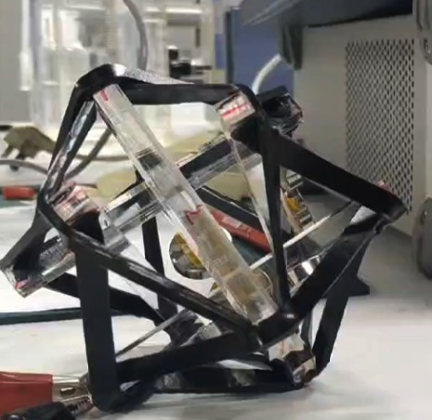

4.2.3 Control module
We validated the Control Module by measuring its network stability and command responsiveness. We connected each ESP32 to the designated hotspot, then performed ten cold-start cycles to measure time-to-associate (target ≤ 5 s). Next, we issued "switch" commands from the UI, using Logic Analyzer to add timestamps on the UI and ESP32 GPIOs to calculate the end-to-end latency. All measured response times are comfortably below the 100 ms requirement. We also run test firmware that triggers specific LED patterns for each system state, and find the RGB indicator module provide consistent visual feedback that corresponds to system status.

4.3. Quantitative Results
The Power module can support at least 3.3 V, 500 mA to the PCB, 10V to the LCE and at least 20 min for testing. Three batteries are connected in series. Each battery is 60mm in the length, 20 mm in the width, 5 in thickness, 4 voltage and 38g in weight.
For the Wi-Fi module, the ESP32 boards successfully connected to the hotspot within 3–5 seconds after powering up. The response delay between UI command and ESP32 action was consistently under 100 ms. During testing, all command-response cycles were completed without error across all three ESP32 chips.
For the control module, in testing, the ESP32 reconnected in 3.3 ± 0.5 s after power-up. The average delay from command to GPIO is 72 milliseconds, with 95% of the cycles being less than 85 milliseconds and the maximum being 93 milliseconds, which is comfortably below the 100 ms requirement.

5. Conclusion

5.1 Accomplishments
Over the course of this project, we successfully completed the full construction of a spherical bionic tensegrity robot. The mechanical framework, control system, and UI-based interface were integrated cohesively into a functional prototype. We achieved reliable wireless control of the robot’s actuation system, successfully actuating 2 out of the 24 embedded LCE cables through programmable GPIO channels and responsive thermal deformation.

5.2 Uncertainties
Despite the initial success, certain challenges remain. Notably, the repeatability and lifecycle of the LCE cable deformation have not been rigorously tested—specifically, how many actuation cycles the material can withstand before performance degrades. Furthermore, the bonding method between the LCE cable and rigid PCB using adhesive may alter the mechanical or thermal behavior of the system, and its long-term stability remains uncertain. Additional mechanical testing and fatigue evaluation will be required to fully characterize these concerns.

5.3 Ethical considerations
Our design complies with the IEEE Code of Ethics and relevant safety standards. We ensured equitable access through a user interface built to meet WCAG 2.1 accessibility standards. No human or animal testing was involved, and all components used are compliant with RoHS environmental safety directives. Electrical safety risks were mitigated using fast-blow fuses, while thermal risks from the LCE materials were addressed by enforcing strict power limits and employing materials with high thermal tolerance. Mechanical safety was prioritized in the structural design to minimize harm in the event of failure, especially concerning the PCB rods under tension.

5.4 Future work
Looking forward, the next milestone is to achieve full coverage control of all 24 LCE cables, enabling more complex locomotion strategies. Beyond that, we aim to implement real-time trajectory planning and control, allowing the robot to autonomously follow predefined paths. Additional goals include improving material robustness, validating long-term repeatability, and enhancing multi-cable coordination for precise motion control.

References

[1] Wang, Z., Li, K., He, Q., & Cai, S. (2018). A Light‐Powered Ultralight Tensegrity Robot with High Deformability and Load Capacity. Advanced Materials, 31(7). https://doi.org/10.1002/adma.201806849.
[2] Liu, C., Li, K., Yu, X., Yang, J., & Wang, Z. (2024). A multimodal Self‐Propelling tensegrity structure. Advanced Materials, 36(25). https://doi.org/10.1002/adma.202314093.
[3] Whitesides, G. M. (2018). Soft robotics. Angewandte Chemie International Edition, 57(16), 4258–4273. https://doi.org/10.1002/anie.201800907.
[4] Zhang, X., Pei, Z., & Tang, Z. (2025). Research on the range of stiffness variation in a 2D biomimetic spinal structure based on tensegrity structures. Biomimetics, 10(2), 84. https://doi.org/10.3390/biomimetics10020084.
[5] Xie, Y. (2018). Analysis and control about rolling motion of spherical tensegrity robot (Master's thesis, Harbin Institute of Technology).
[6] Hiller, J. D., & Lipson, H. (2015). Dynamic simulation of soft multimaterial 3D-printed objects. Soft Robotics, 2(1), 12–23.
[7] IEEE Code of Ethics. (n.d.). http://www.ieee.org/about/corporate/governance/p7-8.html.
[8] Jiang, D. (2017). Derivation of formulas for the circumscribed and inscribed sphere radii of regular icosahedrons and dodecahedrons. Journal of Gansu Normal University, 22(9), 1-5.

