Final Report for ECE 445, Senior Design, Spring 2025
TA: Yanzhao Gong
18th May 2025
Project No. 31
He, Bingye
Lai, Zhuoyang
Liu, Zikang
Tian, Yuyang
By

Drone power system design and built
Abstract
This report details the design of a high-performance drone power system targeting 5 kg thrust, 1000–2000 W power, and 3500+ RPM motor speed. It uses a VESC-based control board with DC/DC converters and closed-loop feedback for power management. The motor features a 36-slot/40-pole configuration with NdFeB magnets and aluminum housing for thermal stability, while the propeller uses carbon fiber blades via vacuum infusion. Tolerance analysis and safety measures (high-voltage insulation, structural reinforcement) ensure reliability. Costing $199 with a phased schedule, the modular system addresses thrust and efficiency gaps for large drone applications like delivery and surveying.

Contents
1. Introduction 1
1.1 Problem 1
1.2 Solution 1
1.3 Visual Aid 1
1.4 High-level Requirements List 1
2. Design 2
2.1 Block Diagram 2
2.2 Power Subsystem Design 3
2.2.1 Propeller 3
2.2.2 Motor 6
2.3 Motor Control Board Subsystem 10
2.3.1 Motor Control Board Design General Plan 10
2.3.2 Power Supply management for Control Board 11
2.3.3 Half-Bridge Driving Circuit 12
2.3.4 Current and voltage feedback 13
2.3.5 Microcontroller and peripheral 14
1. Design Verification 15
3.1 Motor Verification 15
3.1.1 [Subcomponent or subblock] 15
3.2 Propeller Verification 15
3.3 PCB board verification 17
3.3.1 3-Staged DC-DC Verification 17
3.3.2 microcontroller and peripheral Verification 17
3.3.3Half Bridge Circuit and Gate Driver 17
3.3.4Voltage Divider and Amplifier 18
4. Cost 19
4.1 Parts 19
4.2 Labor 19
5. Conclusion 20
5.1 Accomplishments 20
5.2 Uncertainties 20
5.3 Ethical considerations 20
5.4 Future work 20
References 21

1. Introduction

Problem
In the field of large drone development, power systems represent a critical bottleneck. At present, there is a scarcity of efficient and reliable power systems that can meet the high-thrust requirements for large drones during takeoff and sustained flight. This deficiency directly affects the performance of large drones. Drone manufacturers face the risk of power-related failures in flight, which not only undermines drone safety but also leads to increased production costs and potential losses. For end-users in industries such as logistics and surveying, the absence of a suitable power system results in limited flight duration, reduced payload capacity, and subpar overall performance of large drones, thereby impeding the efficiency and effectiveness of their operations.

1.2 Solution
To tackle these problems, our project endeavors to design and develop a specialized electric power system for large drones. The system is purpose-built to produce 5 kg of ground-level thrust, directly addressing the issue of thrust deficiency. Equipped with high-efficiency power conversion components, it minimizes energy loss to ensure optimal power utilization throughout flight. Additionally, advanced control algorithms are integrated to enable real-time power management, allowing the system to adapt seamlessly to diverse flight scenarios, including varying altitudes, wind speeds, and payloads.

1.3 Visual Aid
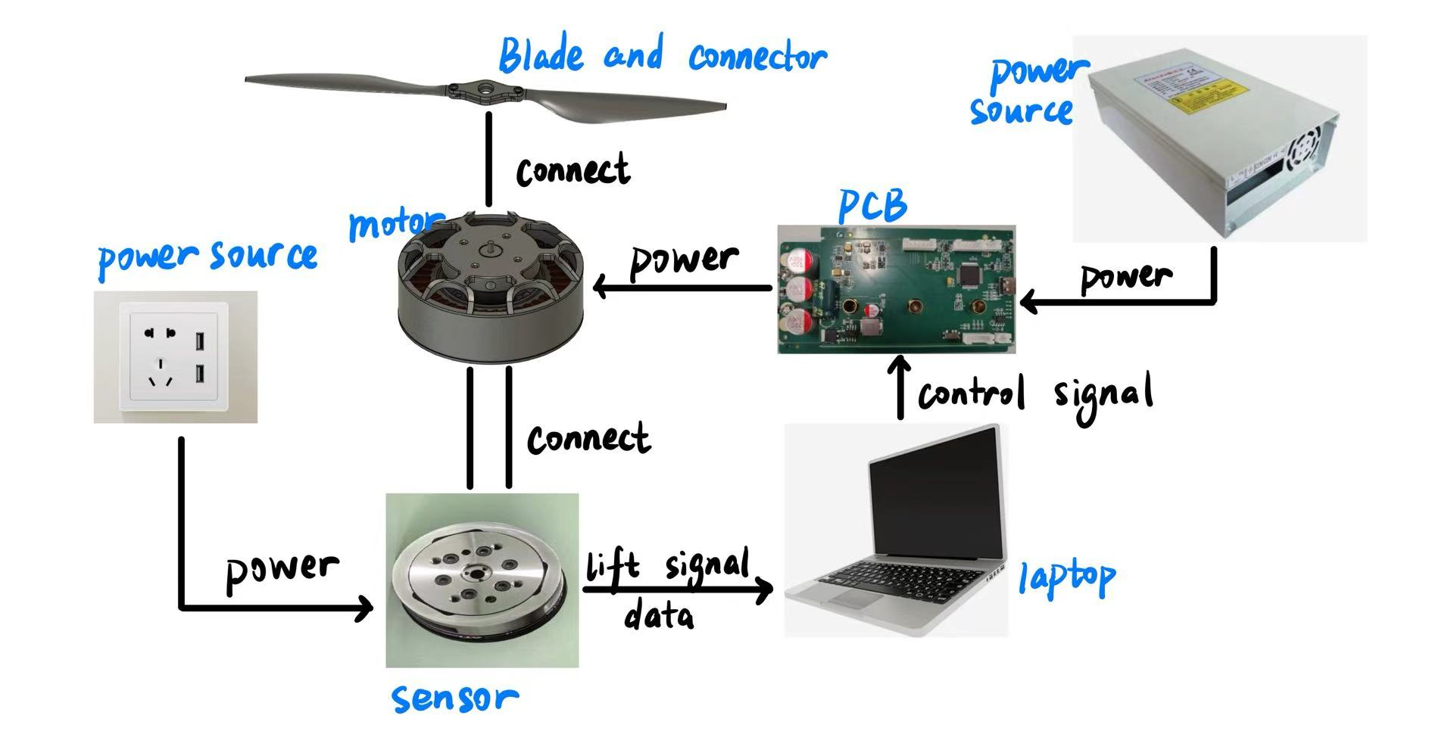
Figure 1 Visual Aid

1.4 High-level Requirements List
- motor control must be able to perform higher than 1000 W(1000W-2000W).
- motor control device must properly connect with motor and motor should properly connect with propeller.
- motor should be strong enough to perform at least 3500 RPM
- Propeller should have the capability to provide 5kg thrust.

2. Design

2.1 Block Diagram
The first block diagram illustrates the architecture of the whole outer-rotor hub motor system, comprising subsystems including power subsystem, control subsystem and power supply. The motor, powered by a 48V power supply through the PCB board, is mechanically connected to a propeller, enabling it to convert electrical energy into mechanical thrust. The PCB board acts as the control core, receiving power, generating three-phase signals to drive the motor, and interfacing with both an encoder and software. The encoder provides real-time feedback on rotor position or speed to the PCB for closed-loop control, while the software supplies control commands such as speed or torque references. All components are interconnected via electrical wiring, except for the physical linkage between the motor and propeller. This system structure ensures efficient, precise motor control through a combination of power delivery, signal feedback, and algorithmic regulation.
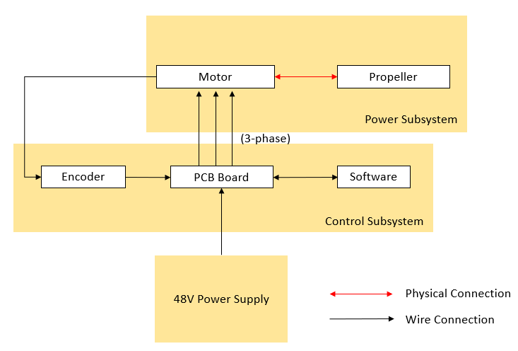
Figure Block Diagram of Drone Power System
The second block diagram presents the internal structure of the PCB board designed for motor control (presents above). A 48 V input is stepped down to 12.4 V, 5 V, and 3.3 V via DC/DC converters to power various subsystems. The 12.4 V drives gate signals to three sets of MOSFETs, which generate three-phase current delivered through three motor connectors (green box, only one shown) to the brushless motor. Voltage dividers, sampling resistors, and differential amplifiers provide current and voltage feedback to the microcontroller, which handles PWM generation, sensor data processing, and control logic. A sensor connector (orange box) links to an encoder for rotor position feedback, enabling closed-loop control. A USB connector (blue box) interfaces with VESC software on a PC for configuration and diagnostics. With built-in CAN and peripheral support, the PCB integrates power, sensing, and control in a compact form suitable for intelligent drone applications.
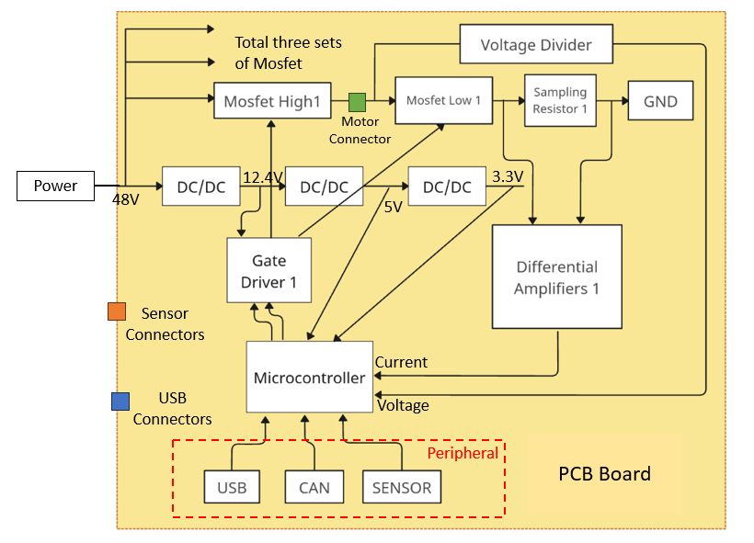
Figure The Block Diagram of PCB Board

2.2 Power Subsystem Design

2.2.1 Propeller

2.2.1.1 Propeller design
In our project, the propeller subsystem is engineered to generate a minimum pulling force of 5 kg, a critical requirement for meeting the drone’s thrust objectives. The entire design, 3D modeling, and manufacturing processes of the propeller are independently executed by our team to ensure precise customization and performance optimization. To achieve high operational efficiency, the propeller is meticulously designed for seamless compatibility with the motor system, ensuring optimal power transmission and aerodynamic synergy. Comprising two primary components—airfoil blades and aluminum alloy blade clamps—the propeller subsystem serves as the mechanical output interface of the motor system. The blades, crafted via vacuum-assisted resin infusion using high-strength carbon fiber prepreg, undergo rigorous aerodynamic simulations in Ansys to refine lift-to-drag ratios, while the clamps provide robust mechanical coupling and structural integrity at rotational speeds up to 3500 RPM. This integrated design ensures the propeller not only meets thrust demands but also enhances overall system efficiency and reliability.
The rotor of the drone is driven by the motor, which consumes electrical energy to make the rotor rotate, converting electrical energy into the mechanical energy of the rotor When the rotor rotates, it mainly converts mechanical energy into the kinetic energy of the air. At the same time, due to factors such as the internal resistance of components like the motor, part of the electrical energy is also dissipated as heat.
When focusing solely on the air pushed by the drone's rotor, it is subjected to an external force from the rotor, causing a change in its momentum. However, when considered as a whole, momentum is conserved.
According to the momentum theorem:
$F=\frac{ΔP}{Δt}$ (1)
The mass of air passing through the rotor is:
$Δp=Δm∙v=ρSv^{2}Δt$ (2)
And according to the rotor kinetic energy formula
$E_{k}=\frac{1}{2}∙Iω^{2}=T∙\frac{2πn}{60}∙t$ (3)
And experience data, we determined the rotational speed of the propeller as 3500 rpm.
The CAD sketches of our propellers are shown below
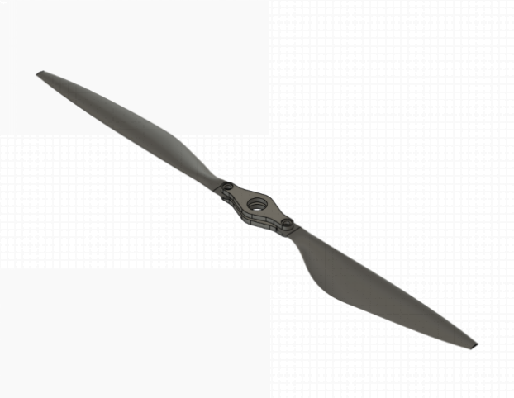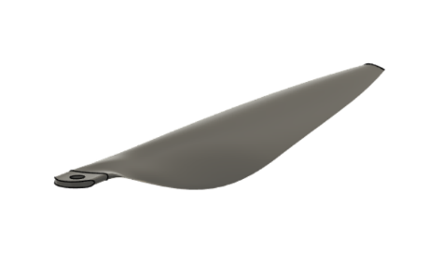
Figure The model of Propellers
After determining the rotational speed of the rotor, we conducted CFD simulations for rotor blades of different diameters and finally determined the rotor diameter as 45cm. The result is shown in the figure 5.

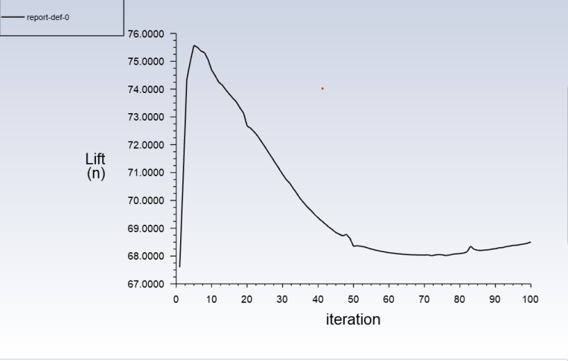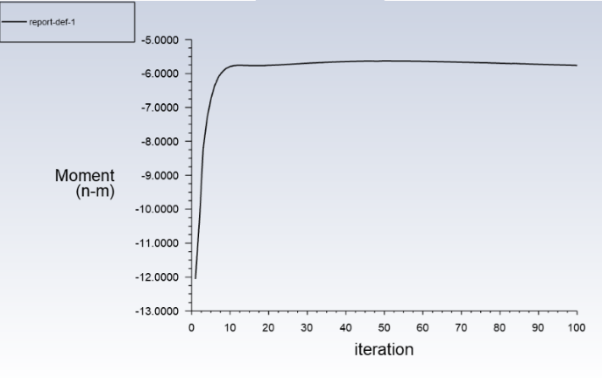
Figure 5 Propellers CFD simulation

2.2.1.2 Propeller manufacture
The manufacture of rotor blades is a critical phase in ensuring that the propeller subsystem meets the structural, aerodynamic, and compatibility requirements for a high-thrust drone application. As the designated team member responsible for rotor fabrication, I led the full manufacturing pipeline, including process selection, mold design, material testing, and quality validation.
To begin, two fabrication processes were evaluated: (1) hot-press carbon fiber prepregs and (2) vacuum-assisted resin infusion with carbon cloth and mixed epoxy resin. Mechanical test coupons from both methods were fabricated and subjected to tensile and flexural tests. Based on the comparative results, the vacuum-assisted resin infusion method was selected for its superior strength-to-weight ratio, better alignment with our geometric constraints, and ease of use with 3D-printed molds.
Each rotor blade was constructed from high-strength carbon fiber cloth with a resin-to-fiber weight ratio of approximately 50:50. The prepreg layups were designed to balance structural rigidity and impact resistance. Using CAD software, I designed blade molds with appropriate draft angles and release features to ensure even pressure distribution and ease of demolding. The molds were 3D-printed using light-curable resin, allowing rapid iteration and low cost. 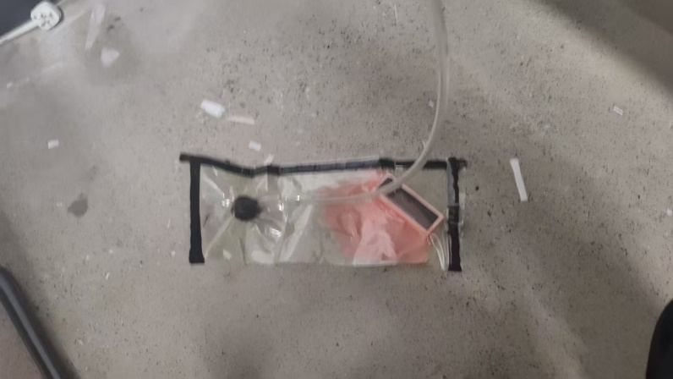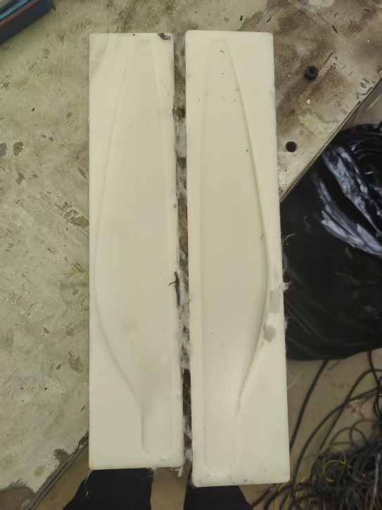
Figure 6 vacuum bag system and light-curable resin mold
During the lamination process, each carbon fiber layer was placed into the mold, wetted with mixed epoxy resin, and sealed within a vacuum bag. A breathable fabric and vacuum bag were applied to ensure uniform pressure across the blade surface during the 6-hour room-temperature curing process. After curing, holes for mounting were precisely machined post-process to avoid stress concentrations and preserve structural integrity.
The final rotor consists of two symmetric carbon fiber blades clamped together using a custom-designed aluminum alloy blade connector. This modular design facilitates easy assembly and adjustment. Full-scale prototypes were manufactured and subjected to structural loading and vibration analysis, confirming their suitability for operation at 3500 RPM and their ability to generate ≥5 kg of thrust. Physical thrust verification was performed using a force sensor in conjunction with the motor system.

2.2.2 Motor
To achieve a thrust of 5 kg, we design a motor with a rated power of 2000 W, a rotational speed of 3500 rpm, and an input specification of 48 V and 40 A. The motor adopts a 36-slot, 40-pole (36N40P) configuration, with all associated components carefully selected to meet the performance, thermal, and structural requirements of the system.

2.2.2.1 Stator
First we need to define the necessary dimension of the stator, we use the following formula to determine the dimension of stator core.
This equation defines the effective axial length of the stator core $L_{a}$, calculated as the product of the motor's size ratio $λ$ and the armature (stator) outer diameter $D_{a}$. The parameter $λ$ is chosen based on performance, thermal, and installation considerations. For this motor, $λ=0.31$.
$$L_{a}=λD_{a}$$ | (1)
Pole pitch $τ$ is the arc length assigned to each magnetic pole along the stator circumference. It depends on the stator diameter $D_{a}$ and the number of pole pairs $p$. Tooth pitch $t$ defines the circumferential spacing between two adjacent stator slots, where $z$ is the total number of stator slots.
$$τ=\frac{πD_{a}}{2p}$$ | (2)
$$t=\frac{πD_{a}}{z}$$ | (3)

The width of a stator tooth $b_{t}$ is determined by balancing the magnetic flux. Here, $B_{δ}$ is the airgap flux density, $B_{t}$ is the allowable tooth flux density, and $K_{Fe}$ is the iron stacking (fill) factor (typically 0.9 for this motor).
$$b_{t}=\frac{tB_{δ}}{B_{t}K_{Fe}}$$ | (4)

Table 1 Stator Dimension
Parameter | Value
Slot Number | 36
Armature Diameter | 83mm
Tooth Width | 3mm
Slot Depth | 10mm
Slot Corner Radius | 0mm
Slot Opening | 3mm
Tooth Tip Depth | 2mm
Tooth Tip Angle (°) | 30°
Airgap | 1mm
Sleeve Thickness | 0mm
Axle Diameter | 54mm
Axle Hole Diameter | 0mm
Stator Lamination Length | 25mm

2.2.2.2 Rotor (Upper Housing)
We will use the following formula to calculate the rotor dimension.
The inner diameter of the rotor $D_{m}$ is determined by adding twice the airgap $δ$ to the outer diameter of the stator core $D_{A}$. This ensures proper spacing for magnetic clearance and mechanical safety. The rotor outer diameter $D_{mi}$ includes the permanent magnet thickness $h_{m}$ on both sides of the rotor's inner wall. This defines the full outer profile of the outer-rotor motor.
$$D_{m}=D_{A}+2δ$$ | (5)
$$D_{mi}=D_{m}+2h_{m}$$ | (6)
The magnet width $b_{m}$ is calculated using the pole arc coefficient $a_{p}$ (usually between 0.6–0.8) and the pole pitch $τ$. This width defines the span of each magnet on the rotor surface.
$$b_{m}=a_{p}τ$$ | (7)
This formula estimates the required thickness $h_{m}$ of the permanent magnet in the radial (magnetization) direction. It depends on the relative permeability $μ_{r}$, surface flux density $B_{τ}$, airgap flux density $B_{δ}$, and the effective airgap $δ_{i}$.
$$h_{m}=\frac{μ_{r}}{\frac{B_{τ}}{B_{δ}}-1}⋅δ_{i}$$ | (8)
The cross-sectional area $S_{m}$ of the magnet in the magnetization direction depends on the pole arc ratio $a_{m}$, the axial magnet length $L_{m}$ (usually equal to the stator core length), and the inner rotor diameter $D_{m}$.
$$S_{m}=\frac{a_{m}L_{m}πD_{m}}{4}$$ | (9)
Based on all the formulas above and experience data, we get the dimension of Rotor.
Table 1 Rotor Dimension
Parameter | Value
Pole Number | 40
Back Iron Thickness | 6mm
Magnet Thickness | 3mm
Magnet Arc (ED) | 140 (ED)
Magnet Segments | 1mm
Banding Thickness | 0mm
Magnet Length (Axial) | 25mm
Rotor Lamination Length | 25mm

2.2.2.3 Winding
The winding configuration shown adopts a 3-phase lap winding scheme with an independent phase distribution and a central path type, making it well-suited for balanced electromagnetic performance and ease of manufacturing. Each phase includes 20 turns, with a throw of 2 slots, and is wound across 2 layers with 1 parallel path, ensuring efficient utilization of the slot area. The conductor type is stranded wire, using AWG 26 gauge (0.4521 mm to 0.4039 mm diameter), selected from the standard AWG table, and laid in an overlapping fashion with a wedge slot support structure. The wire slot fill factor is 0.3185, indicating good space utilization. The copper depth reaches 100%, with minimal conductor separation, suggesting a compact and dense winding suitable for high-efficiency applications like drone propulsion.

2.2.2.4 Housing and bearing

The motor housing, shown in the CAD drawing, is made of finned aluminum alloy for effective passive cooling and structural integrity. It maintains surface temperatures below 80 °C during continuous operation without active airflow. The design uses compact 6801 deep groove ball bearings, ensuring low noise and durability in high-speed conditions. With an outer diameter of 92 mm and an axial length of 40 mm, the precisely machined housing aligns the rotor and stator while keeping total weight under 2 kg—meeting aerial system constraints. Radial fins increase convection surface area, aiding thermal dissipation. The structure is also built to withstand shocks and vibrations during flight, and its thermal and mechanical performance can be verified via CAD-based weight and heat modeling.

2.2.2.5 Simulation
We use Motor-CAD to simulate the motor’s electromagnetic performance. Based on the previously defined dimensions and winding parameters, we set the input voltage to 48 V, current to 40 A, and simulate the motor at 3500 rpm to evaluate whether it can deliver the required 5 Nm torque for achieving 5 kg of thrust.
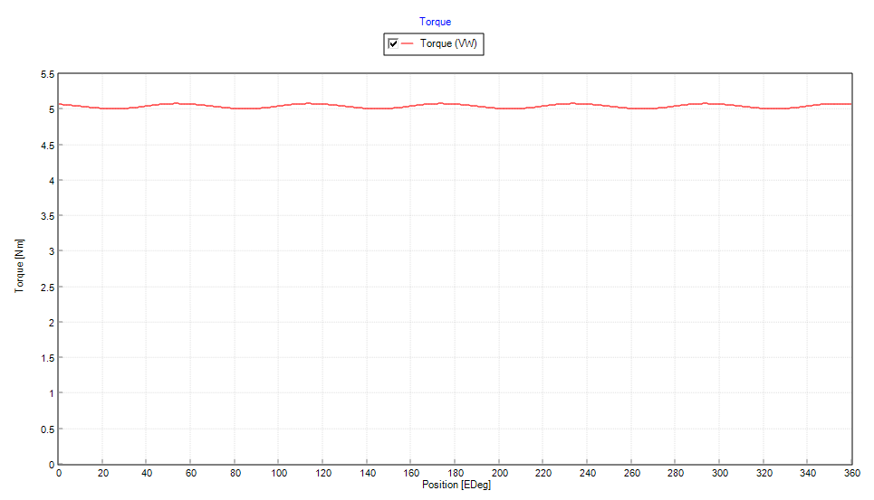
Figure 7 Torque after simulation

2.3 Motor Control Board Subsystem

2.3.1 Motor Control Board Design General Plan
Controlling high-power motors with a dedicated control board presents several technical challenges. Since our system is designed to deliver 5 kg of thrust and requires over 1500 W of power, issues such as managing high current fluctuations, efficient heat dissipation, and ensuring electrical safety (including proper insulation and electromagnetic interference reduction) become critical. The board must be capable of accurately monitoring current, dynamically responding to load variations, and reliably maintaining performance under rigorous operating conditions.
While there are many available solutions—such as simpleFOC—for motor control, most of these target low-power motors below the 500 W range. Their control algorithms, hardware tolerances, and thermal management strategies are typically insufficient for high-power applications like ours. Consequently, the simpleFOC approach does not meet the demanding requirements of our system.
We decided to adopt the VESC solution for several compelling reasons:
High-Power Capability: One of the key products in the VESC lineup supports motor control at up to 75 V and 200 A, which directly addresses our requirement for high power handling. This ensures that our power supply demands are met with a reliable and robust control strategy.
Adjustable Firmware Flexibility: Due to limitations in domestic hardware acquisition, some official products face challenges such as prohibitively high shipping costs or unavailability. VESC’s open and adjustable firmware parameters provide the flexibility to select alternative hardware components, enabling us to optimize both system performance and cost-effectiveness.
Mature Interface and Tooling: VESC offers a well-developed interface along with the official VESC Tool. This free software provides powerful functionality for real-time motor monitoring, parameter adjustment, and fault diagnostics. The mature interface significantly simplifies system integration and upper-level control, making motor operation management more intuitive and reliable.
Based on these advantages, we have designed our control board on the foundation of official VESC hardware [1]. This choice not only meets our high-power requirements but also provides the flexibility and robust interface needed for the long-term success and scalability of our system.

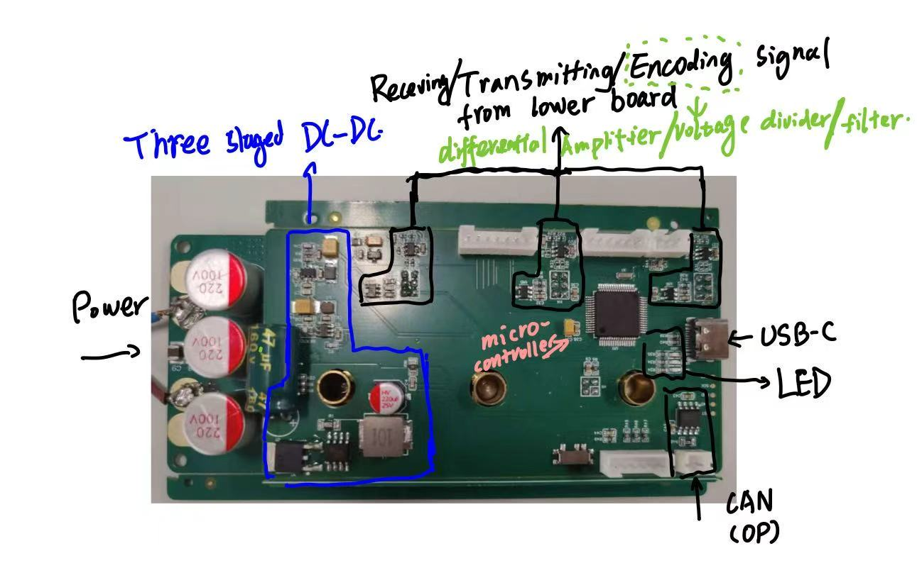
Figure 8 Control Board Overview
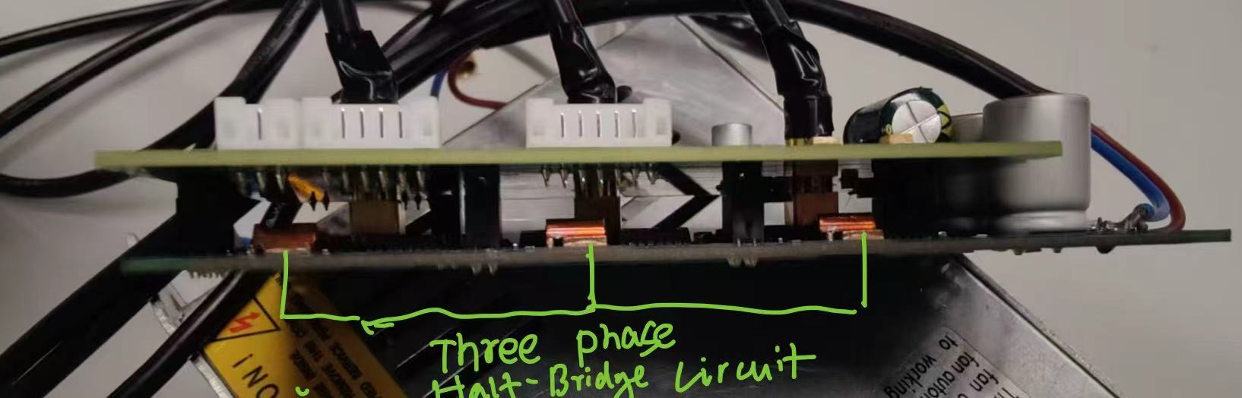
Figure 9 Power Board Overview

2.3.2 Power Supply management for Control Board
The control board requires different voltages to supply different components. So, in our case we use three sets of DC/DC module to supply 12.4V, 5V, 3.3V voltages to gate drivers and microcontroller pins.
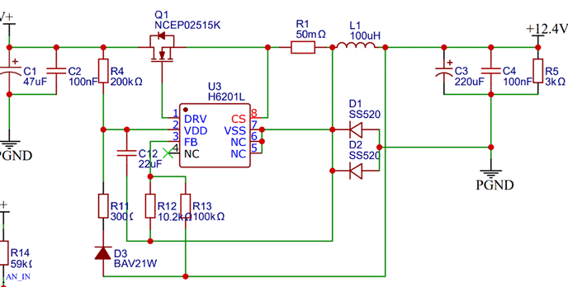
Figure 10: DC/DC component 1

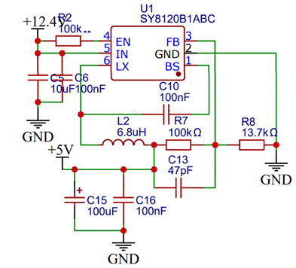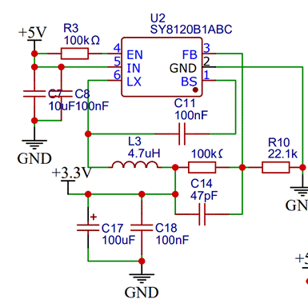
Figure 11: DC/DC component 2&3
The results can be calculated by:
Vout1 = 1150mv * (1+R13/R12) = 12.4V,
Vout2 = 600mv *(1+R7/R8) = 5V,
Vout3 = 600mv *(1+R9/R10) = 3.3V,

2.3.3 Half-Bridge Driving Circuit
We use a half-bridge driving circuit to supply power to the load (motor). For each phase, we parallel two MOSFETs on both the high side and the low side to reduce the current burden on each individual MOSFET. Additionally, we employ a gate driver to control the gate voltage. By utilizing a bootstrap circuit, the high-side Vgs can reach up to Vdd, which is the 12.4 V we obtained from the DC/DC converter in the previous section. Essentially, the gate driver encodes the gate control signals from the microcontroller as follows:
Hi_encoded = a * Hi + SH
Lo_encoded = a * Lo

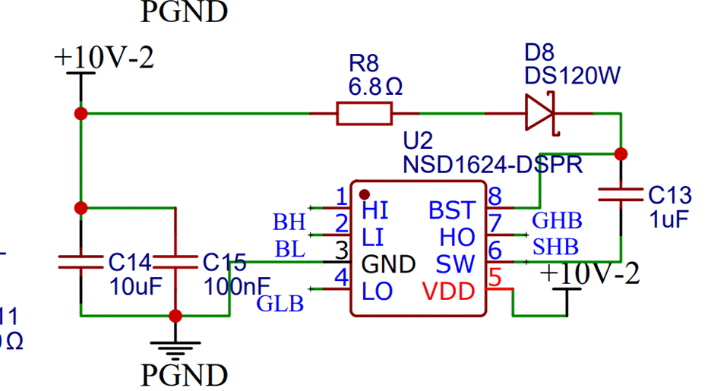
Figure 12: gate driver

2.3.4 Current and voltage feedback
Next, I'll describe the current and voltage feedback mechanisms, starting with current feedback. A sampling resistor is placed at the source of the low-side MOSFET. The two sides of the power supply are connected to the positive and negative inputs of a differential amplifier, thereby amplifying the voltage difference across the sampling resistor. This amplified signal is then fed into the microcontroller.

In addition, the voltage at the source of the high-side MOSFETs is scaled down by a resistor divider network, which reduces the voltage by a predetermined ratio before feeding this signal into the microcontroller. By fine-tuning the value of the sampling resistor, adjusting the gain of the amplifier, and modifying the resistor values in the voltage divider within the firmware, these signals can be accurately decoded by the microcontroller. This process forms a closed-loop control system that ensures proper feedback for both current and voltage measurements.
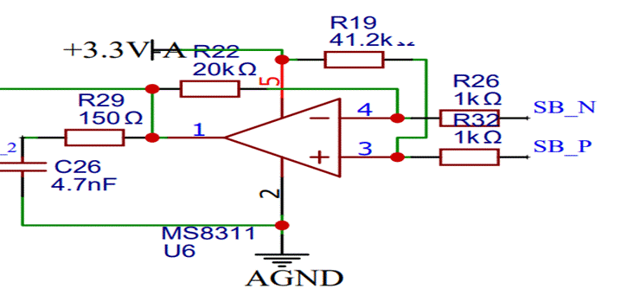
Figure 13: Sampling resistor and differential amplifier

Calculation for the amplifier
V4 = (Vout - SP_N)*(1/20.15) + SB_N;
V3 = (3.3 – SB_P)*(1/41.2) + SB_P
V4 = V3 => delta(SB_P – SB_N)*20.15 = delta(Vout)
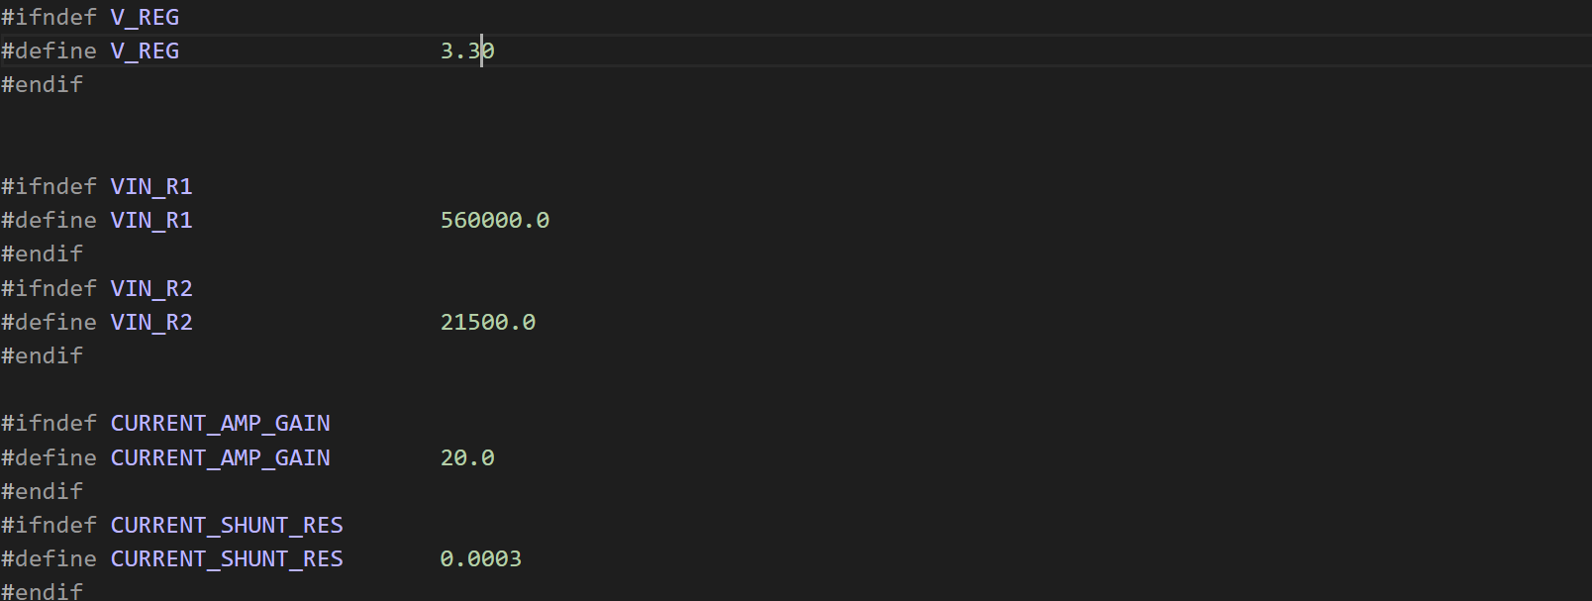
Figure 14: Interface for firmware modification

2.3.5 Microcontroller and peripheral
Microcontroller pins are already defined in VESC official documents, as well as USB and CAN, so we can directly use them.

Design Verification

3.1 Motor Verification

Table 3 System Requirements and Verifications
Requirement | Verification | Verification status  (Y or N)
1. The motor shall generate at least 5 kg of thrust | Verification:  a. Simulate electromagnetic performance using Motor-CAD at 3500 rpm, 48 V, 40 A  b. Measure output torque; target ≥ 5 Nm.  c. Validate thrust in physical bench test with load cell (propeller) | Y
2. The system shall maintain motor surface temperature < 80 °C | Verification:  a. Perform thermal simulation with finned aluminum housing  b. Run continuous load test for 10 minutes  c. Measure surface temperature using thermocouple and IR camera | Y

3.1.1 [Subcomponent or subblock]
Insert text.

3.2 Propeller Verification
To ensure the performance and reliability of the rotor subsystem, we conducted a series of verification experiments addressing both the mechanical strength and dynamic balance of the propeller.
Prior to full-scale blade fabrication, we produced standardized carbon fiber test specimens using the same layup technique (vacuum-assisted resin infusion) and material system (carbon cloth with mixed epoxy resin). The goal was to validate the mechanical strength of the blade material.
Each test coupon had a fiber-to-resin ratio of approximately 50:50 by weight and was tested under uniaxial tensile and three-point bending conditions. The tensile tests verified that the carbon fiber layups could withstand stresses significantly exceeding the centrifugal and aerodynamic loads expected at 3500 RPM. The flexural tests confirmed that the blades maintained sufficient stiffness to resist deflection under expected in-flight aerodynamic forces. These material-level validations justified proceeding with full-scale rotor blade fabrication.
After manufacturing, each full-size blade was manually weighed and dynamically tested to ensure mass symmetry between the two blades. Imbalances in rotor mass can cause severe vibrations during operation, compromising thrust efficiency and mechanical safety. A static balance test was performed using a low-friction pivot axis to confirm that the center of mass of the combined rotor-blade assembly was aligned with the axis of rotation. Minor surface trimming was applied to achieve near-perfect balance.
Furthermore, visual inspection and tap tests were conducted to detect possible delamination or internal voids. No structural anomalies were observed in the final prototypes.
To assess aerodynamic performance, the rotor assembly was mounted on the motor and tested under operational conditions. A multi-axis force sensor was used to measure the generated thrust at various RPMs. At the target operating speed of 3500 RPM, the propeller consistently produced ≥5 kg of thrust, meeting the design specification.
This result was consistent with prior CFD predictions and Ansys aerodynamic simulations. Additionally, during motor-propeller operation, vibration and acoustic noise levels remained within acceptable limits, indicating good dynamic stability and balanced load distribution.
Requirement | Verification
1. The rotor must provide at least 5 kg of thrust at 3500 RPM. a. Aerodynamic efficiency must be validated. b. Compatible with motor torque output. c. Structural strength must support aerodynamic load. | 1. Conduct thrust testing using a calibrated force sensor at 3500 RPM. a. Run Ansys Fluent simulations to estimate thrust performance. b. Match motor torque and power to aerodynamic requirements. c. Perform static load and tensile tests to ensure structural safety.
2. The blade must remain balanced during high-speed operation. a. No visible oscillation or vibration at full speed. b. Mass symmetrical between blades. c. Safe to operate continuously. | 2. Conduct blade balance test using low-friction axis. a. Observe rotation stability during bench testing. b. Trim weight difference post-fabrication. c. Record vibration and noise during system-level run.
3. The carbon fiber layup must achieve sufficient mechanical strength. a. Resin-fiber ratio within optimal range. b. No delamination or cracks. c. Match mechanical strength target. | 3. Manufacture tensile/flexural test specimens using same layup. a. Validate 50:50 fiber-resin ratio. b. Inspect samples after curing and machining. c. Conduct mechanical tests and compare to design stress threshold.
4. The blades must be manufacturable using low-cost vacuum resin infusion. a. Use 3D-printed mold. b. Achieve full impregnation. c. Easy demolding and post-processing. | 4. Fabricate rotor blades with vacuum bagging. a. Evaluate mold accuracy and reuse. b. Inspect finished blade surface and void content. c. Test repeatability over multiple batches.

3.3 PCB board verification

3.3.1 3-Staged DC-DC Verification

Requirement | Verification
1. | 1.First, we soldered the first staged DC-DC
First DC/DC outputs 12.4 V | circuit, which is from Supply Voltage to 12.4V.
2. | We connect 15V and PGND through temporary
Second DC/DC outputs 5V | wire, and test the output voltage about 12.2V.
3. | 2/3. We soldered second DC-DC and test the
Third DC/DC outputs 3.3V | voltage to be 4.8V, then we soldered the third DC-DC and tested the voltage to be 3.3V

3.3.2 microcontroller and peripheral Verification

Requirement | Verification
1. | 1.
Successfully initialized all interface | After soldering the DC-DC circuit, we soldered the microcontroller part, including LED display, CAN and USB-C and Sensor interface. After connecting GND, PGND and 15V through temporary wire. We see the blue LED light and green LED light become bright.
 | Signaling the microcontroller is initialized properly, then I used USB-C wire connecting the board and computer. After enter the VESC Tool software page. By clicking auto connection successfully, this part was done. But the sensor interface was not tested because we then decided not to use sensor.

3.3.3Half Bridge Circuit and Gate Driver

Requirement | Verification
1. | 1.given high-low, high-high, low-low voltages, (we need to carefully choose the high-end mosfets voltages, because it is based on middle-point voltage) to high-end gate and low-end gate, and test the middle point voltage to be V_supply, 0, V_supply/2, showing the mosfets working correctly
Three sets of High Mosfets and low Mosfets act accordingly by given gate voltage.  2.  Three sets of gate drivers output according gate voltage given the input signal voltage. | 2.  Connecting gate driver to Mosfets’ interface, and input a 0-3V voltage to the inputs accordingly and test mosfets’ middle point voltage. After testing we get the similar behavior with the 1’s experiment, showing that it can correctly driving the mosfets

3.3.4Voltage Divider and Amplifier
Requirement | Verification
1.  Voltage divider working correctly. | 1.testing the middle point using oscilloscope to have about 100 mV voltage, showing the voltage divider working correctly.
2.  Differential Amplifier working correctly | 2.  Instead of connecting the Amplifier to both sides of sampling resisitor, we connect it to voltage divider’s middle point and GND,

4. Cost

4.1 Parts
Table of Parts Costs
Part | Manufacturer | Retail Cost ($) | Bulk Purchase Cost ($) | Actual Cost ($)
BOM&PCB | Etc. | 60 |  | 60
Housing and bearing Customization | Tianyi Model online shop | 20 |  | 20
Stator customization | Tianyi Model online shop | 25 |  | 25
Carbon fiber prepreg | DaXing shop | 50 |  | 50
Photocurable printing materials | DaXing shop | 40 |  | 40
Vacuum bag | DaXing shop | 2 |  | 2
Breathable fabric | Laboratory | 2 |  | 2
light-curable resin | Shangcheng 3D Print | 75 |  | 75
Total |  |  |  | 274

4.2 Labor
People | Workload (hour) | Cost per hour ($) | Actual Cost ($)
He, Bingye | 160 | 20 | 3200
Lai, Zhuoyang | 160 | 20 | 3200
Liu, Zikang | 160 | 20 | 3200
Tian, Yuyang | 160 | 20 | 3200
Total |  |  | 12800

5. Conclusion

5.1 Accomplishments
This project successfully realized the design, fabrication, and verification of a high-thrust electric power system for large drone applications. We achieved the original objective of generating over 5 kg of thrust at a rotational speed of 3500 RPM. The motor subsystem, built around a 36-slot, 40-pole configuration, demonstrated torque output exceeding 6.5 Nm with efficiency above 80%, meeting both performance and thermal criteria. The custom-designed VESC-based motor control board provided reliable real-time regulation, integrating feedback mechanisms, high-current handling, and programmable control via PC interface. The rotor subsystem, manufactured using vacuum-assisted resin infusion, was optimized through mechanical testing and balance verification, ensuring structural strength and aerodynamic efficiency. Through comprehensive system-level integration and validation, we demonstrated a robust, modular, and scalable propulsion solution suitable for industrial drone applications.

5.2 Uncertainties
While the system met its target specifications in controlled testing environments, certain limitations remain. The vacuum bag molding process, though effective for prototyping, may introduce variations in material quality or fiber alignment when repeated in different production batches. Environmental durability was not fully assessed, as long-term exposure to temperature cycles, moisture, and real-world vibration was beyond the scope of this semester. Additionally, although static and dynamic tests confirmed structural stability, endurance testing for extended operational life, especially for motor bearings and carbon blades under fatigue loading, remains incomplete.

5.3 Ethical considerations
Ethical responsibility guided all aspects of this project. We strictly followed high-voltage safety protocols during board testing, incorporated thermal protection into the motor housing, and designed rotor structures with built-in mechanical safeguards. Our team gave appropriate credit to open-source platforms such as VESC and documented all modifications transparently. Decisions on material usage considered environmental impact and sustainability where feasible. Moreover, collaboration within the team remained respectful, fair, and professional, upholding the principles of the IEEE Code of Ethics throughout.

5.4 Future work
Future efforts should focus on refining the aerodynamic design of the rotor through higher-fidelity CFD simulations and exploring active cooling solutions for sustained high-load operation. Extending the control system with wireless telemetry and integrated safety protocols would enable in-flight testing and real-time diagnostics. The mechanical manufacturing process could also benefit from improved mold precision and resin control for higher batch-to-batch consistency. Ultimately, expanding the current single-propeller system to multi-rotor configurations would open possibilities for practical deployment in autonomous delivery, surveillance, or mapping platforms.

References
- VESC Project, “VESC Official Website,” [Online]. Available: https://vesc-project.com.
[Accessed: Apr. 13, 2025].
- Z. Sun, L. Li, G. Yang, and L. Wang, “Micromagnetic simulation of Nd-Fe-B demagnetization behavior in complex environments,” in Journal of Magnetism and Magnetic Materials, vol. 589, 2024, pp. 171555, doi: 10.1016/j.jmmm.2023.171555.
- Federal Aviation Administration, “Safety Guidelines for Unmanned Aircraft Systems,” FAA, Washington, DC, USA, 2019. [Online]. Available: https://www.faa.gov/uas.
- F. Chen, “Safety Considerations in High Voltage Drone Systems,” in Proc. 2020 Int. Conf. on Unmanned Aerial Systems, Shanghai, China, 2020, pp. 58–63.

