Final Report for ECE 445, Senior Design, Fall 2025
TA: Zheyi Hang
17 May 2025
Project No. 28
Haoyu Huang
Jiawei Wang
Xinchen Yin
Zaihe Zhang
Ziye Deng
By

A Bio-inspired AI-based Underwater Locating System
Abstract
The research of this project is a bio-inspired AI-based underwater locating system. The main problem to be solved is to imitate the perception and positioning of vibrations by fish underwater. Power System and vibrator system is used to simulate the movement of fish. The experimental method is to train the AI for positioning using neural network. Ultimately, the result we obtained is the system could process sensor data in real time and provide highly accurate analysis results, and it can accurately conduct underwater positioning. This research provides ideas for future bionic fish to perceive vibrations underwater.

Contents

1. Introduction 3
1.1 Introduction to the project 4
1.2 Review and Update from the proposal 5
2 Design 5
2.1 Design Visualization 6
2.2 Power System 6
2.2.1 Signal generator and Amplifier 7
2.2.2 DC Power 7
2.3 Electrical Control System 7
2.3.1 Servo Driver (DMS055A) 7
2.3.2 Servo Motor 8
2.4 Vibrator System 8
2.4.1 Filament Moving Device 8
2.4.2 Modal Vibrator (SA-JZ002) 9
2.5 Sensor System 9
2.5.1 Sensor Array 9
2.5.2 Data Acquisition Card 11
2.6 Data Preprocessing System 12
2.6.1 Normalization 12
2.6.2 S-Transform 13
2.7 Position Prediction Model 13
2.7.1 Problem Formulation 14
2.7.2 Network Architecture 14
3. Design Verification 15
3.1 Power System 16
3.2 Electrical Control System 16
3.2.1 Servo Driver and servo motor 16
3.3 Vibrator System 16
3.3.1 Modal Vibrator Verification 16
3.4 Sensor System 16
3.4.1 Sensor Array 16
3.5 Software System 18
3.5.1 Data Preprocessing System 18
3.5.2 Position Prediction Model 19
4. Costs 20
4.1 Salary Estimation 21
4.2 Parts Costs 21
4.3 Labor 21
5. Conclusion 22
5.1 Accomplishments 23
5.2 Uncertainties 23
5.3 Ethical considerations 23
5.4 Future work 23
References 23
Appendix ARequirement and Verification Table 24
Appendix BSchedule 27

1. Introduction

1.1 Introduction to the project
In underwater environments where visibility is often limited, traditional optical and acoustic systems struggle to locate underwater objects effectively. The lateral line system of fish enables them to detect vibrations and pressure changes in water. Inspired by this, we aim to design a bio-inspired, AI-driven underwater locating system. This project addresses the challenge of underwater object localization by capturing vibration signals through sensors and processing the data with machine learning algorithms to predict the position of the vibration source accurately.
The overview of our system can be seen in our block diagram (Figure 1). Our system is divided into 4 hardware subsystems and a software subsystem. Hardware subsystems include the power system, the vibrator systems, the electrical control system and the sensor system. The power system supplies DC power to other hardware systems and generates sinusoid signal to the vibrator system. The vibrator system contains a vibrator that can continuously oscillate underwater to emulate the vibration signals produced by a submerged object. The electrical control system sends rotation commands from the computer to the servo driver, positioning the vibrator accurately inside the tank. The sensor system contains 4 pressure sensors and a data acquisition card, which can collect the vibration signal sent by the vibration system. Finally, the software system will process the data collected by the sensor system and predict the position of the vibrator through a neural network model.
During this semester, we introduced a new system to our block-level design: the electrical control system. This module enables us to control the location of the vibrator automatically using rotation command. As a result, we can realize a more precise control of the vibrator compared with manual control.
Overall, the performance requirements of our system include correctly generating and collecting vibration data and correctly predicting the location of underwater vibrator based on the vibration signal. To realize this target, the power system should be able to generate sinusoid signal, send it to the vibrator system and provide enough power for the whole hardware system. The vibrator system should be capable of driving the vibrator to oscillate underwater, simulating a submerged object. The electrical-control system must relay position commands from the computer to the servo driver and motor, controlling the movement of the vibrator. The sensor system must record the resulting pressure changes with enough sensitivity and bandwidth, stream the data through the acquisition card, and deliver the data to the computer. Finally, the software system must preprocess those samples, run the neural network model, and display the predicted 2-D coordinates of the source with an average error of only a few centimeters.
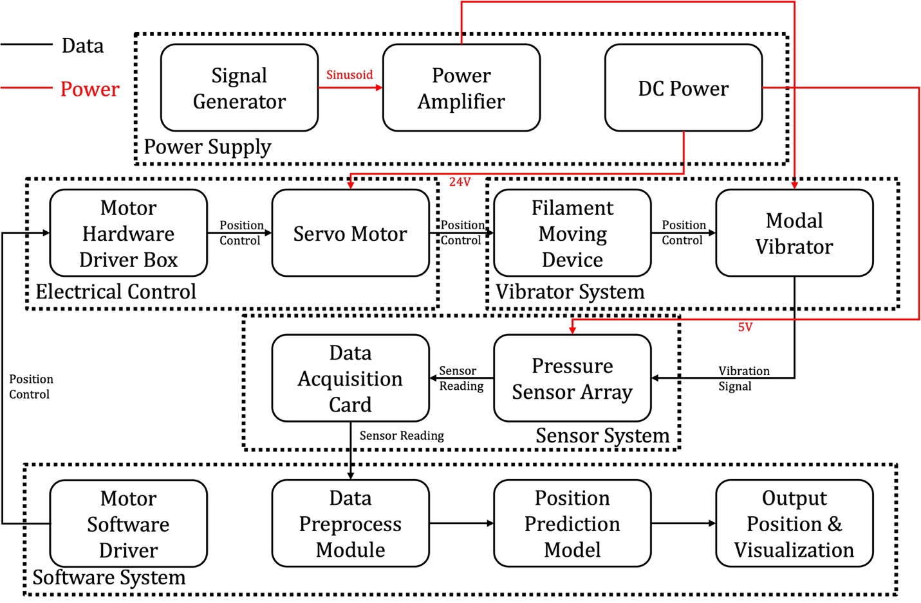
Figure 1 Block Diagram

1.2 Review and Update from the proposal
The report has been updated from the initial proposal, particularly in terms of hardware improvements and writing standardization.
In the hardware section, an additional enclosure was designed and fabricated to enhance both the appearance and the structural stability of the system. The electrical control module was also refined by clearly distinguishing its components into the servo driver, servo motor, and filament moving device, clarifying the specific role each part plays in the overall control system.
In terms of writing standardization, issues such as improper citation formatting found in the proposal have been corrected. Missing elements such as visual aids have also been added, making the report more complete and professionally presented.

2 Design
This section contains design diagrams, subsystem descriptions and requirements.
Our bio-inspired sensor array system employs a block diagram that illustrates the interconnected components working harmoniously to create a powerful location detecting system.

2.1 Design Visualization
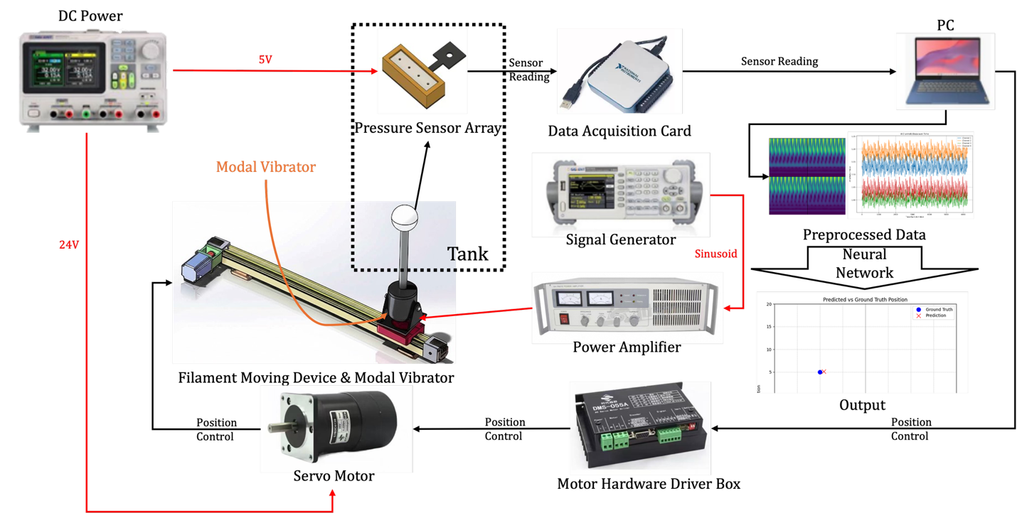
Figure 2 Visualization of overall design

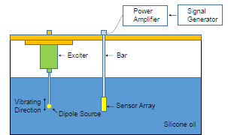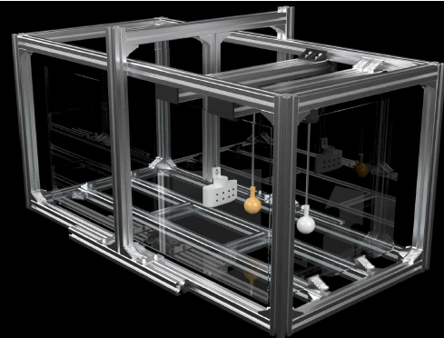
Figure 3 Physical Design of Tank

2.2 Power System
The power system is responsible for providing stable electrical energy to all functional components in the experimental setup. It consists of three main parts: a DC power source, a signal generator & amplifier, and a filament moving device. DC Power supplies regulated voltage to the sensor array, ensuring consistent signal acquisition performance during underwater vibration measurements. The Signal Generator & Amplifier produces a controlled excitation signal, which is then amplified and delivered to drive the vibrator.

2.2.1 Signal generator and Amplifier
The signal generator and the power amplifier module are essential components for accurately driving the vibrator through controlled excitation.
The signal generator produces periodic sine waves with predefined frequency and amplitude, serving as the initial input to the system. This signal is then received and amplified by the power amplifier to meet the operational requirements of the vibrator. We set the output signal to 5V peak voltage sinusoid and transmit the signal to the power amplifier.
The power amplifier used in this setup is the SA PA 020, which has a rated power of 204 watts. It amplifies the electrical signal from the generator to the voltage and current levels necessary to drive the vibrator effectively. In the project, we set the voltage roughly to 7.5V for the vibrator to work.
Table 1 Power Amplifier Key Parameters
Rated Output Voltage | Rated Output Current | Gain (100Hz)
17Vrms | 12Arms | 7V/V±2dB | 6A/V±2dB

2.2.2 DC Power
The DC power module provides a stable power supply to both the sensors and the servo driver. The sensor operates at 5V, while the servo driver requires a 24V input. Therefore, a dual-channel DC power source is used to supply the two different voltage levels simultaneously.

2.3 Electrical Control System
The electrical control system communicates with the servo driver through the computer to transmit rotation commands to the servo motor, thereby controlling the position of the vibrator within the fish tank.

2.3.1 Servo Driver (DMS055A)
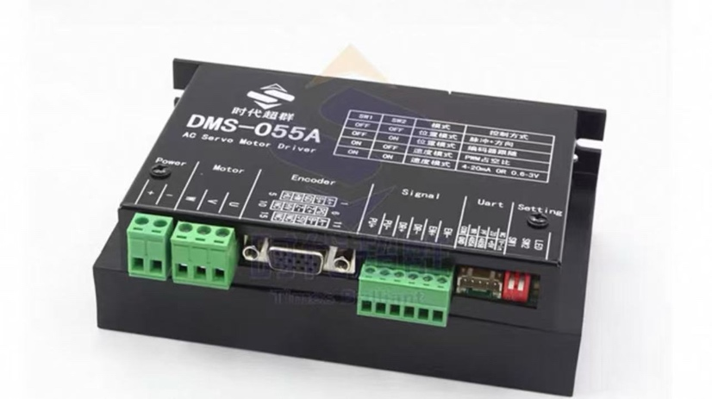
Figure 4 Servo Motor Driver
The servo driver serves as an interface between the personal computer and the motor. It supports the Modbus protocol and can be connected to the computer via USB. With the aid of dedicated software, control commands can be transmitted, enabling the motor to receive and execute instructions. In our project, the primary task is to send the command to control the motor’s movement, which allows for adjusting the position of the vibrator within the fish tank. The table below is the Control Mode of the servo driver. In the project, we set both switch1 and switch2 to OFF to select pulse mode.
Table 2 Servo Driver Control Mode
Switch1 | Switch2 | Mode | Control Method
OFF | OFF | Position Control Mode | Pulse and Direction
OFF | ON | Position Control Mode | Encoder Following
ON | OFF | Speed Control Mode | PWM Duty Cycle
ON | ON | Speed Control Mode | Voltage or Current

2.3.2 Servo Motor
The control signals transmitted from the computer are passed to the servo motor via the servo driver. The servo motor determines its behavior based on the selected control mode. Under the "pulse + direction" control mode, it is first necessary to enable both the Modbus function and the driver output.
After enabling, the target absolute position is sent as the desired destination. The servo driver then writes the lower 16 bits and upper 16 bits of this absolute position value into registers 22 and 23, respectively. Based on this target position, the initial speed, and the default number of pulses per revolution, the servo motor performs the corresponding motion.
Table 3 Key Servo Motor Control Register
Register Address | Argument Name | Type | Description
0 | Modbus Enable | RW | 0: Modbus disabled  1: Modbus enabled
1 | Drive Output Enable | RW | 0: Drive Output Disabled  1: Drive Output Enabled
22 | Absolute Position low 16 bits | RW | Low 16 bits of the step count
23 | Absolute Position high 16 bits | RW | High 16 bits of the step count

2.4 Vibrator System
The Vibrator System consists of a Filament Moving Device, a modal vibrator, a metal rod, and a vibrating head. The system is used to simulate the vibration of real objects. The vibrator is powered by 5V 10Hz sinusoid from power system. The entire system is controlled by an electrical control system. This system regulates the Filament Moving Device, controlling its number of rotations to achieve precise movement.
The vibrator system is used to simulate the vibration of real objects. This system will generate fluctuations in a silicone oil tank, and sensors will receive signals of pressure changes.

2.4.1 Filament Moving Device
The movement of the vibrating device on the movable platform is controlled by a servo motor, driven by the DMS-055A AC servo motor driver. This driver regulates the Filament Moving Device, controlling its number of rotations to achieve precise movement; for instance, 100,000 rotations correspond to 10 cm of displacement.
The Filament Moving Device controls the location of the vibrator, which is essential for accurately targeting specific points. This allows the system to apply vibration precisely where needed for data collection.
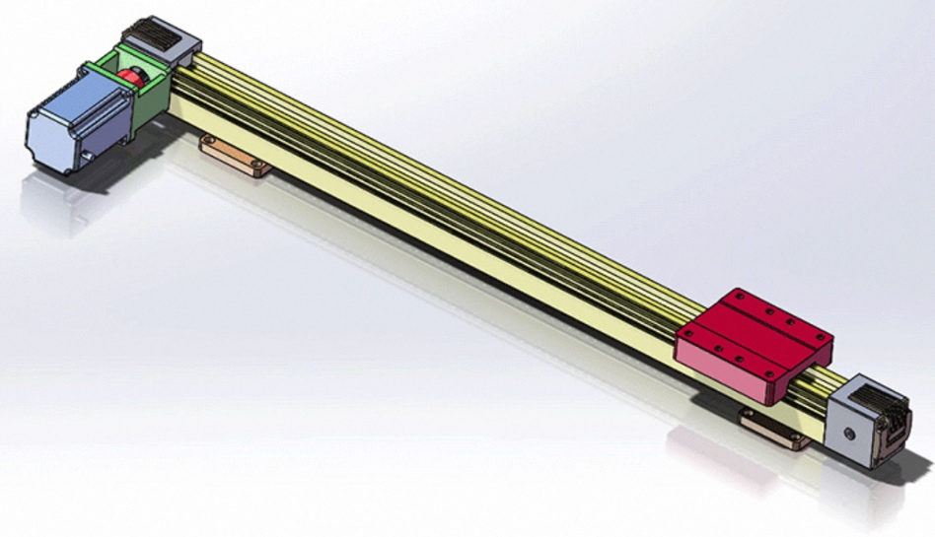
Figure 5 Filament Moving Device

2.4.2 Modal Vibrator (SA-JZ002)
The vibrator consists of a modal Vibrator, a vibrating head, and a metal rod. The modal Vibrator provides vertical motion, while the vibrating head, mounted at the lower end of the metal rod, generates oscillations. These components work together to simulate the vertical vibration of an underwater object.
Modal Vibrator is connected directly to the power system (signal generator and power amplifier).
Table 4 Modal Vibrator Requirement
Function | Requirement
Max. Excitation Force (N) | ≤20
Max. Amplitude (mm) | ±4
Overall Dimensions (mm) | Φ78x140
Weight (Kg) | 2
Recommended Matching Power Amplifier | 100W

2.5 Sensor System
This sensor system is used for collecting underwater pressure signals and is primarily composed of four pressure sensors and a data acquisition card (DAQ card). The system is powered by a 5V DC supply provided by a power system. Its DAQ card interfaces with a software system to collect data from the sensors for real-time display and further processing.

2.5.1 Sensor Array
The pressure sensor is an important component in the sensor array. It features 8 footprints and a pressure-sensitive head for pressure detection. The sensor is powered by 5V DC power. Table 5 details the operating characteristics of the pressure sensor, which operates on a 5V DC power supply and achieves high accuracy in underwater environments. For the pressure range assessment, the sensor is placed in silicone oil at a depth of 10 cm. The pressure at this depth is determined according to the formula:
$$P = ρ ⋅ g ⋅ h$$
$ρ ≈960 \frac{kg}{m^{3}}$ $g ≈9.8 \frac{m}{s^{2}}$ $h = 0.1m$
$$P≈ 940.8 Pa <3920 Pa$$
The static pressure is approximately 940.8 Pa, indicating that the sensor can operate underwater.

Table 5 Pressure sensor operating Characteristic
Characteristics | Min | Typ | Max
Pressure Range (kPa mm $H_{2}O$) | 0 | 3.92  400 | 3.92  400
Supply Voltage (Vdc) | 4.75 | 5.0 | 5.25
Supply Current (mAdc) | - | - | 10
Accuracy | - | - | 6.25
Sensitivity (Vkpa) | - | 1.0 | -

The Sensor Array is a key component within the Data Collection system. It consists of 4 sensors strategically arranged to detect the physical signals generated by the Vibrator. Powered by the DC supply, the array captures these analog signals from the environment. The collected signals from the Sensor Array are then sent directly to the Data Acquisition Card for digitization and further processing.
Figure 6 illustrates the footprint information of the pressure sensor. As shown, Footprint 2 is designated for the input 5V supply voltage (Vin), Footprint 3 is connected to the system ground reference, and Footprint 4 serves as the analog signal output which connects directly to Data Acquisition Card (DAQ Card).
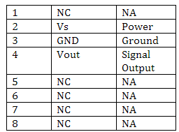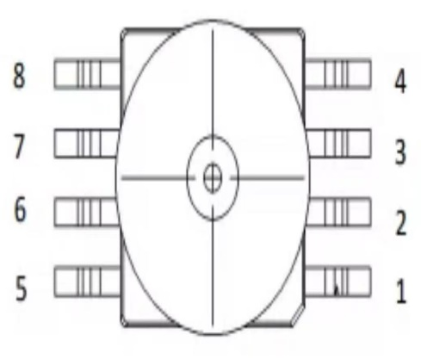
Figure 6 Pressure sensor footprint and pin connection

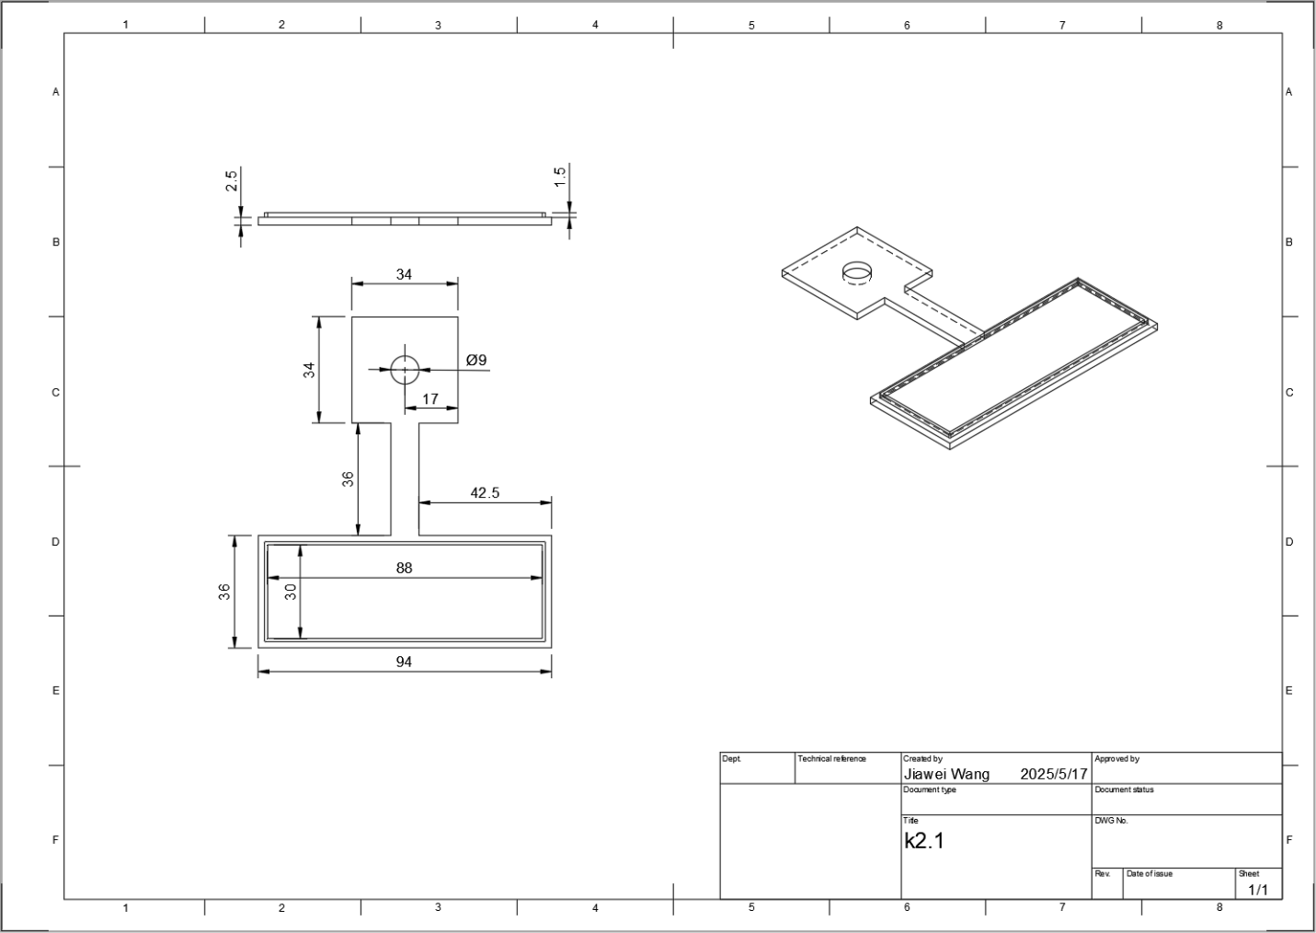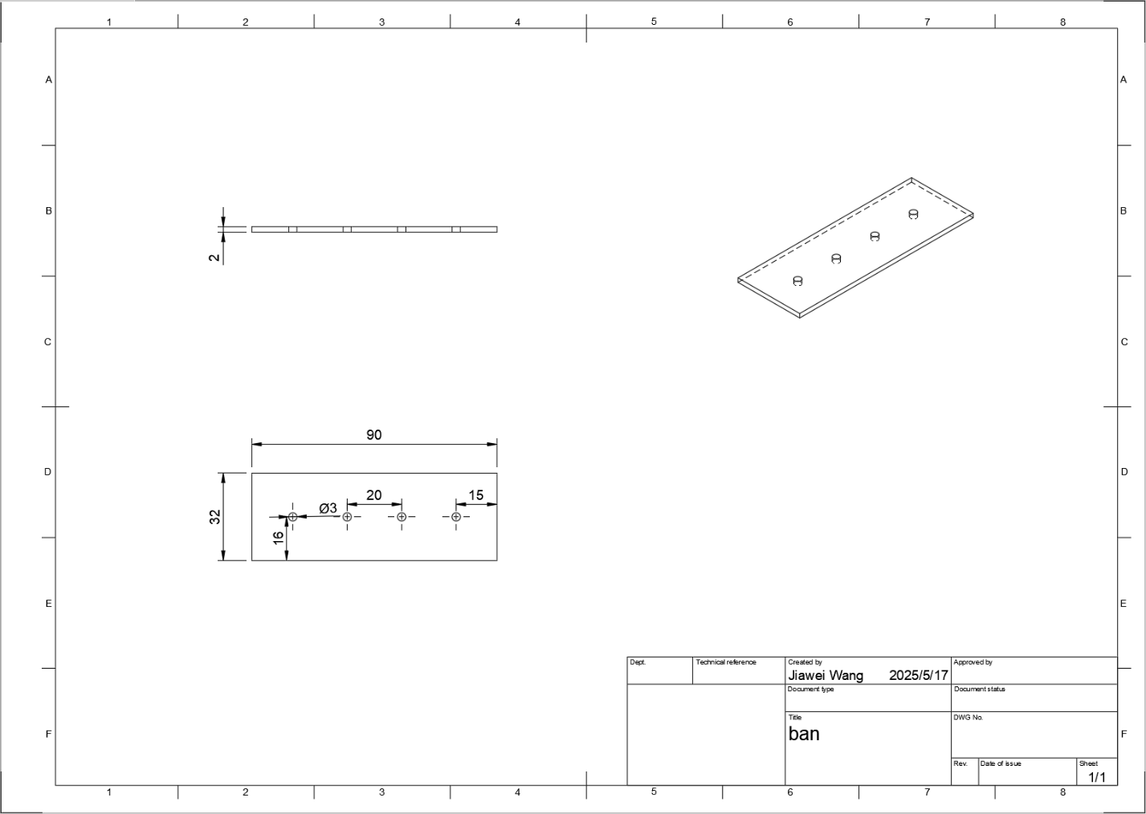
Figure 7 Sensor Array Layout

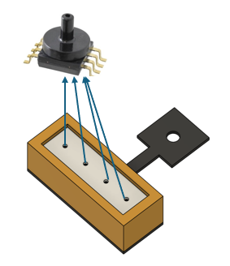
Figure 8 Sensor array

2.5.2 Data Acquisition Card
Serving as the crucial link between the physical sensors and the digital domain, the Data Acquisition Card (DAQ) is employed to precisely capture real-world analog signals originating from the Sensor Array. It efficiently digitizes these analog inputs and streams the resulting digital data to the connected computer. Once on the computer, this raw data is often converted or formatted into more accessible forms, such as dynamic visual waveforms for immediate monitoring or structured time-series data files (like Excel spreadsheets or TXT documents with time-vs-data columns) for easy storage, inspection, and subsequent in-depth analysis within the Data Processing system. Sensor directly connects to the data Acquisition card (Figure 9). We connect AI GND to ground, AI 0 to sensor1, AI 4 to sensor2, AI 1 to sensor 3, AI 5 to sensor 4.
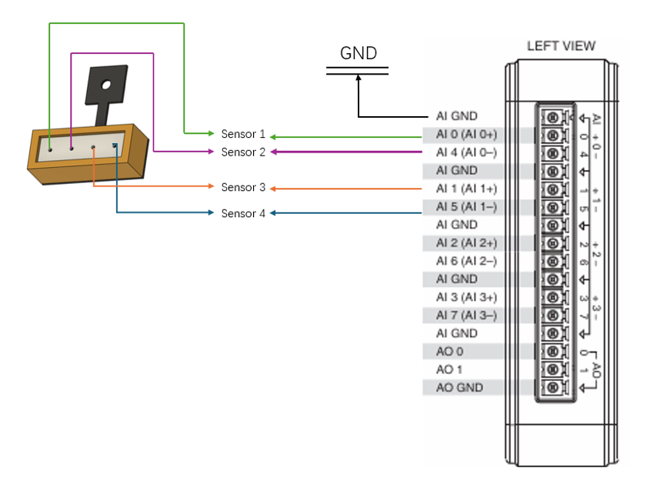
Figure 9 Data Acquisition Card

2.6 Data Preprocessing System
This subsystem is used to preprocess the raw data from the sensor system. The preprocessed data will be used as input to the position prediction model, which will increase the accuracy of the prediction.

2.6.1 Normalization
The raw vibration data scale is relatively small with values centered around 1. This narrow range makes it challenging for the model to deeply learn meaningful features in the data. Thus, we first applied normalization to map the data values into the range of [0, 255] with the following formula:
$$y=\frac{\left(y_{max}-y_{min}\right)×\left(x-x_{min}\right)}{\left(x_{max}-x_{min}\right)}+y_{min}$$
where $x_{min}$ and $x_{max}$ represents the maximum and minimum values of the raw vibration data. $y_{min}$ and $y_{max}$ represents the value of 0 and 255.
After normalization, the raw data will be transformed to 4 × 6250 grayscale images.
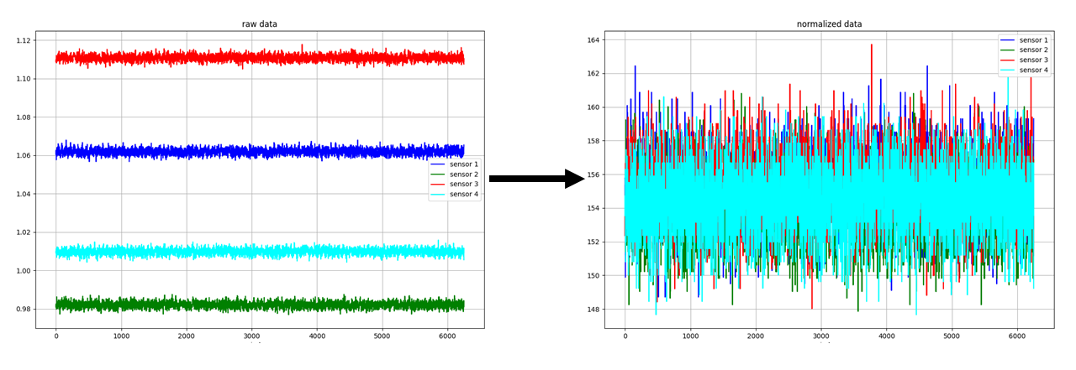
Figure 10 Data Normalization

2.6.2 S-Transform
Due to the nonstationary property of vibration signals, frequency analysis of vibration data is also helpful for target localization. As a result, we adopted Stockwell Transform (S-Transform) to transform the time-domain data into frequency-domain data. S-Transform is a special Fourier Transform, which can be expressed as:
$$S\left(τ, f\right)=e^{-i2πf}W\left(τ, f\right)$$
$$W\left(τ, f\right)=\int_{-∞}^{∞}{x\left(t\right)w\left(t-τ, f\right)dt}$$
Where $τ$ stands for the shift factor and $f$ stands for the frequency. $w\left(t-τ, f\right)$ stands for the Gaussian window function. It can be expressed as:
$$w\left(τ, f\right)=\frac{\left|f\right|}{\sqrt{2π}}e^{-\frac{t^{2}f^{2}}{2}}$$
After S-Transform, the raw vibration data will be transformed to 4 frequency-domain images corresponding to 4 sensor arrays. Then, we concatenated them into unified 2x2 frequency-domain images.
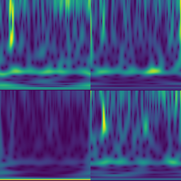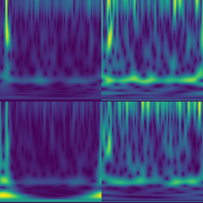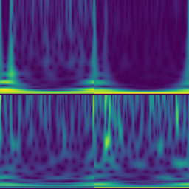
Figure 11 Frequency-domain 2x2 images

2.7 Position Prediction Model

2.7.1 Problem Formulation
After preprocessing, we seek to learn a mapping
$f:\left(S,I\right)↦P^{'}$,
where
- $S∈R^{4×6250}$ is the matrix of normalized time-series sensor readings,
- $I∈R^{3×256×256}$ is the S-transform image of original signals,
- and $P∈R^{2}$ is the ground-truth 2D target position.
The model is trained to minimize the expected Euclidean distance
$\min_{θ}{E_{\left(S,I,P\right)}}\left.| f_{θ}\left(S,I\right)-P \right.|_{2}^{2}$,
so that the predicted position $P^{'}$ lies as close as possible to the true position $P$.

2.7.2 Network Architecture
Here we mainly follow the previous work [3] with some modification due to different sensor setup and sampling frequency. We retain the dual-stream design (TDMod and TFDMod) but adjust each convolution’s channel widths and strides so that the final feature vectors match.
All attention modules (Channel Position Attention Module, CPAM) remain in place to let the network learn which channels and spatial regions (in the time-frequency maps) are most informative for localization.
Below is an overview figure of the network design and tables of detailed network structure. For further visualization, we choose to use python matplotlib package to show how the prediction compares to ground truth position on a grid.
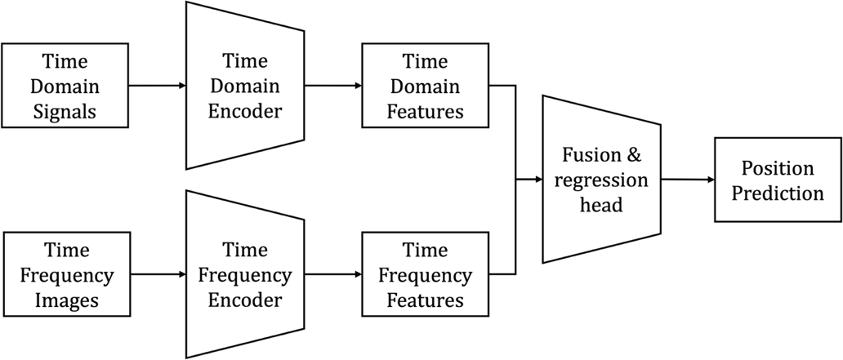
Figure 12 Overview of Position Prediction Model
Table 6 Time-domain branch
Stage | Layer | Input Shape | Output Shape | Notes / Activation
Input | — | (4, 6250) | (4, 6250) | normalized sensor reads
Conv1 + Pool | Conv1D(32, kernel=7, pad=3) | (4, 6250) | (32, 6250) | BN → ReLU
 | MaxPool1D(kernel=3, stride=2) | (32, 6250) | (32, 3125)
Res-Block ×3 | [Conv1D(32,3) → GLU → Add] | (32, 3125) | (32, 3125) | each: BN ReLU → skip
Res-Block ×2 | [Conv1D(64,3,stride=2) → GLU → Add] | (32, 3125) | (64, 1563) | doubles channels
 | CPAM attention | (64, 1563) | (64, 1563) | channel + position
Global Pooling | AvgPool1D | (64, 1563) | (64,)
FC projection | Dense(128) | (64,) | (128,) | → ReLU
Output feature | — | (128,) | (128,) | $$h_{TD}$$

Table 7 Time–frequency domain branch
Stage | Layer | Input Shape | Output Shape | Notes / Activation
Input | — | (3, 256, 256) | (3, 256, 256) | ST-transform images
Conv1 + Pool | Conv2D(64, 7×7, stride=2, pad=3) | (3, 256, 256) | (64, 128, 128) | BN → ReLU
 | MaxPool2D(3×3, stride=2, pad=1) | (64, 128, 128) | (64, 64, 64)
Res-Block 1 | Bottleneck(64→64) ×2 | (64, 64, 64) | (64, 64, 64) | each: BN ReLU → skip
Res-Block 2 | Bottleneck(64→128, stride=2) ×2 | (64, 64, 64) | (128, 32, 32)
Res-Block 3 | Bottleneck(128→256, stride=2) ×2 | (128, 32, 32) | (256, 16, 16)
Res-Block 4 | Bottleneck(256→512, stride=2) ×2 | (256, 16, 16) | (512, 8, 8)
Attention | CPAM (channel+spatial) | (512, 8, 8) | (512, 8, 8)
Global Pooling | AvgPool2D | (512, 8, 8) | (512,)
FC projection | Dense(128) | (512,) | (128,) | → ReLU
Output feature | — | (128,) | (128,) | $$h_{TF}$$

Table 8 Fusion & regression head
Stage | Layer | Input Shape | Output Shape | Notes / Activation
Concatenation | — | (128)+(128) | (256,) | $$\left[h_{TF},h_{TD}\right]$$
Channel Attn. | Small CPAM | (256,) | (256,) | recalibrate features
Dense 1 | Dense(128) | (256,) | (128,) | ReLU
Dropout | Dropout(p=0.5) | (128,) | (128,)
Dense 2 | Dense(64) | (128,) | (64,) | ReLU
Output layer | Dense(2) | (64,) | (2,) | linear → $\left[x^{'},y^{'}\right]$

3. Design Verification
This section shows our verification method for each subsystem.

3.1 Power System
The signal generator should be configured to output a sinusoidal signal with a 5 V peak voltage at a frequency of 10 Hz. The power amplifier should operate in high-impedance mode to enable current gain relative to the input voltage. By adjusting the amplifier’s gain, the output voltage can be set to 7.5 V. The DC power supply should provide 5 V for the sensor array and 24 V for the servo driver.

3.2 Electrical Control System

3.2.1 Servo Driver and servo motor
The servo driver should be applied to 24V voltage to work, the servo motor should move to the desired absolute location after setting the PU steps.

3.3 Vibrator System

3.3.1 Modal Vibrator Verification
Vibrator vibrates in the vertical direction. The vibrator shall generate vertical oscillations at a frequency of 8 Hz with an input voltage of 7.5 V. The test can refer to Appendix A.

3.4 Sensor System

3.4.1 Sensor Array
We designed two ways to verify the functionality of sensor devices.
Basic Testing with Oscilloscope and DAQ (Data Acquisition Card):
In-Air Sensor Test Procedure and Results: The sensor device was placed in an ambient air environment. Gentle pressure was then applied to the sensor using a gloved finger. To monitor the resulting signal variations, the sensor's output was interfaced with a Data Acquisition (DAQ) system. As depicted in Figure 13, the signal exhibited a distinct and rapid change around the 1.5-second mark corresponding to the application of pressure on the sensor.
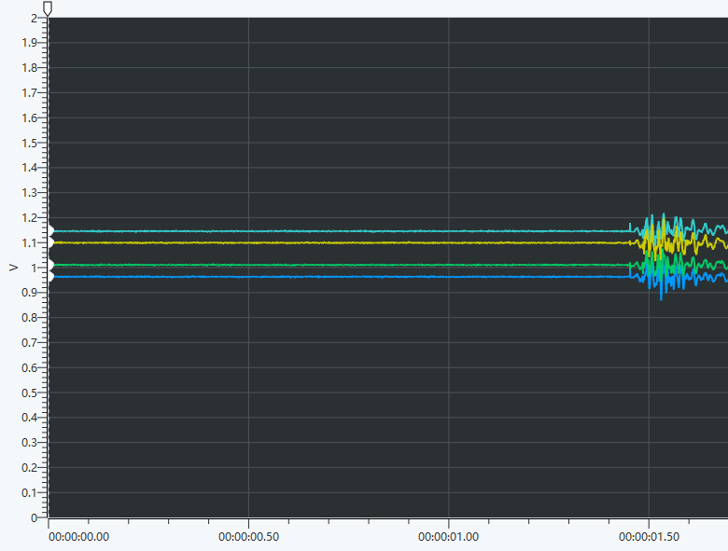
Figure 13 Sensor array verification in the air

Test in the water: We place the sensor device in the water and turn on the vibrator. We connect the output of sensors to DAQ to observe the change. The signal changes sharply around when we turn on the pressure sensor. In addition, the output signal from the pressure sensor was clearly periodic, indicating that it successfully reflected the vibrator's inherent periodicity. We also conducted an experiment to compare signals in different locations. At first, we placed the vibrator 10cm directly in front of the sensor block. Then we placed another vibrator 20cm directly in front of the sensor block. As shown in Figure 15, the two signals are different. When the vibrator is further away, the signal amplitude is smaller, and the frequency is lower.

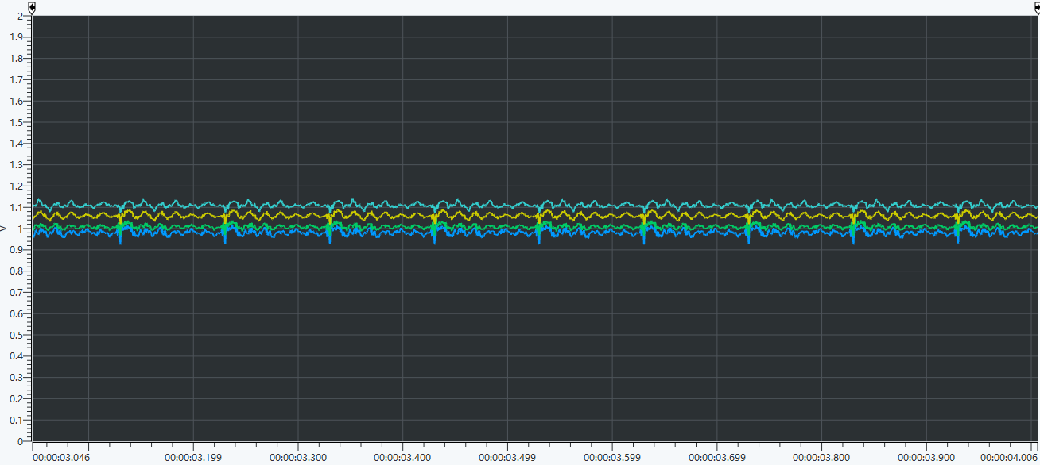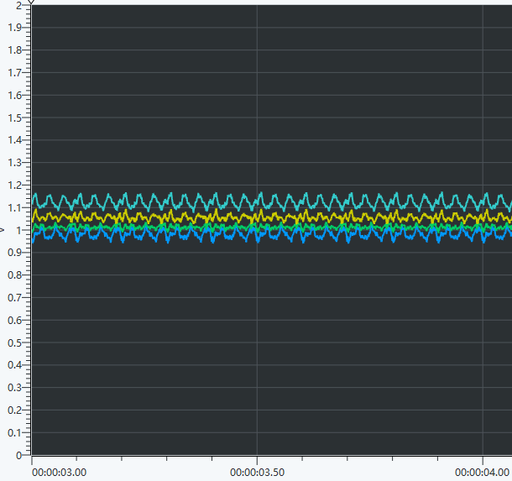
Figure 14 Visualization of Pressure Signal in Different Places

3.5 Software System

3.5.1 Data Preprocessing System
To verify the effectiveness of the data-preprocessing system, we compared the scale, range, and dimensionality of the data before and after processing to ensure the output matches the expected format. For the normalization step, we checked the maximum and minimum value in the data, which should be within the range of [0, 255].
Table 9 Verification for normalization
Time-domain | Before preprocess | After preprocess
Minimum | 0.8557 | 0.0
Maximum | 1.1859 | 255.0
For the S-Transform step, we checked the format and the size of generated frequency-domain images, which should be 3x256x256.
Table 10 Verification for S-Transform
 | Ideal Size | Actual Size
Color Channel | 3 | 3
Height | 256 | 256
Width | 256 | 256

3.5.2 Position Prediction Model
To verify that our modified dual‐stream architecture learns effectively and generalizes to unseen data, we analyzed both the loss trajectories during training and validation, and the final test‐set performance. Figure 15 plots the training‐loss and validation‐loss curves over the full training run. We observe that within the first 5 epochs, the training loss drops from its initial value of approximately 0.2 to below 0.02, indicating that the network quickly learns the dominant time–domain and time–frequency features.
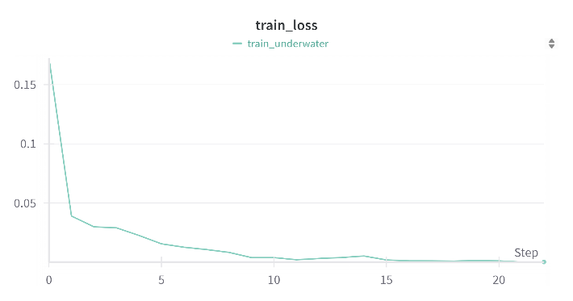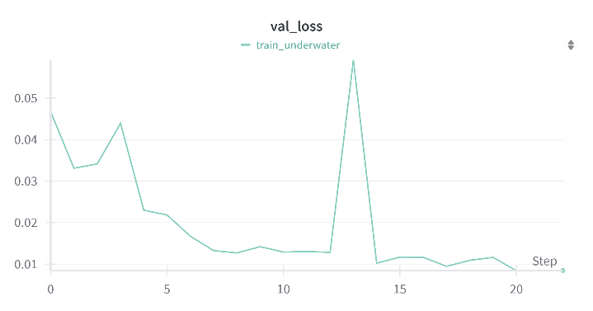
Figure 15 Validation plot (left) and training plot (right)
We assessed the model’s generalization by computing the mean absolute error (MAE) and root-mean-square error (RMSE) over the entire test set. The resulting low MAE and RMSE values demonstrate that, beyond merely fitting the training data, our network reliably produces precise position estimates on previously unseen sensor inputs. Table 11 shows the results on selected positions.
$$\text{MAE} = \frac{1}{N}\sum_{i=1}^{N}{\left(\left|x_{i}^{'}-x_{i}\right| + \left|y_{i}^{'}-y_{i}\right|\right)}$$
$$\text{RMSE}=\sqrt{\frac{1}{N}\sum_{i=1}^{N}{\left[{\left(x_{i}^{'}-x_{i}\right)}^{2}+{\left(y_{i}^{'}-y_{i}\right)}^{2}\right]}}$$
Table 11 Verification for different positions
Position | MAE | RMSE
(0, –1) | 0.0010 | 0.0015
(0, 0) | 0.0012 | 0.0015
(1, –1) | 0.0037 | 0.0040
(1, 0) | 0.0055 | 0.0074
(2, –1) | 0.0039 | 0.0049
(2, 0) | 0.0032 | 0.0038
Average | 0.0031 | 0.0039
To visualize our model’s localization accuracy, we overlay the predicted positions and the ground-truth positions on a common Cartesian grid. Ground-truth targets are shown as solid circles, while predictions are marked with crosses. By directly comparing each pair of markers in the same coordinate frame, one can immediately tell how closely the network’s estimates align with the true locations.
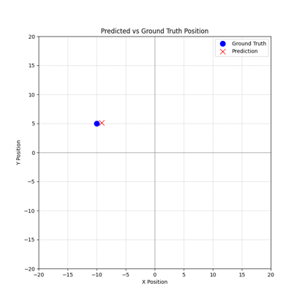
Figure 16 Visualization of prediction vs. ground truth

4. Costs

4.1 Salary Estimation
The estimated labor cost is listed in Labor Cost Analysis Table 12. We refer to the sample and past senior design projects to get the hourly salary and estimate total working hours based on our project workload and course credits
Table 12 shows the partner's name in the project (Partner), the hourly salary of partner (Hourly Salary), the working hours in the project per person (Working Hours) and the total salary per person (Total).

Table 12 Labor Cost Analysis.
Partner | Hoursly Salary | Working Hours | Total
Haoyu Huang | $40 | 160 | $40 ×160×2.5 = 16000
Zaihe Zhang | $40 | 160 | $40 ×160×2.5 = 16000
Jiawei Wang | $40 | 160 | $40 ×160×2.5 = 16000
Xinchen Yin | $40 | 160 | $40 ×160×2.5 = 16000
Ziye Deng | $40 | 160 | $40 ×160×2.5 = 16000
Sum |  | 80000

4.2 Parts Costs
Table 13 Parts Costs
Part | Manufacturer | Retail Cost ($) | Bulk Purchase Cost ($) | Actual Cost ($)
Signal Generator | Shengli Factory | 120 | 120 | 120
Pressure Sensor * 8 | Aidi Information Sensor Factory | 56 | 56 | 56
Serve Motor | SDCQ | 30 | 30 | 30
Filament Moving Device | SDCQ | 60 | 60 | 60
Data Acquisition Card | National Instrument | 135 | 135 | -
Dc Power | ZJUI Lab | 165 | 165 | -
Power Amplifier | ZJUI Lab | 768 | 768 | -
Modal Vibrator | ZJUI Lab | 274 | 274 | -
Total |  | 1608 | 1608 | 266

4.3 Labor

This section describes the division of labor. The schedule in Appendix B provides specific details on the current progress.
Haoyu is responsible for pressure sensor testing, power system designing and testing, vibrator testing, data collection, signal processing and model inference.
Xinchen is in charge of providing software support. He has done data preprocessing, network design, training and testing the model.
Jiawei is responsible for the construction of the sensor housing and the aesthetics of the whole equipment. He assisted in data collection and improved unreasonable parts of the equipment.
Ziye is responsible for constructing the software system. He prepared the data preprocessing module and assisted in building the neural network.

5. Conclusion

5.1 Accomplishments
The device has been implemented to capture underwater vibration signals with high sensitivity, allowing it to detect interference generated by the smallest possible objects in different aquatic condition.
The system already could process sensor data in real time and provide highly accurate analysis results.
The integrated hardware and sensor array have been able to operate continuously and reliably in different underwater environments, including changes in temperature, pressure, and turbidity, with no degradation in detection performance.

5.2 Uncertainties
The device is also not able to distinguish between different types of underwater vibration signals with high accuracy to ensure accurate identification of different types of objects.

5.3 Ethical considerations
Fairness and accessibility: The functionality of the system may depend on a particular infrastructure, which may prevent some users or regions from enjoying the technology, creating unfairness.
Environment Impact: In the experiment, we used silicone oil to simulate water, and its discharge may have an impact on soil and water. The degradation of silicone oil is slow, and it is easy to destroy the balance of the ecosystem.

5.4 Future work
Continue to improve the construction of the model, improve the position accuracy of underwater recognition, shorten the reaction time, and carry out preliminary exploration of the vibration of different objects.

References
[1] IEEE. “IEEE Code of Ethics.” (2016), [Online]. Available: https://www.ieee.org/
about/corporate/governance/p7-8.html (visited on 05/16/2025).
[2] K. He, X. Zhang, S. Ren, and J. Sun, "Deep residual learning for image recognition," in Proc. IEEE Conf. Comput. Vis. Pattern Recognit. (CVPR), 2016, pp. 770–778.
[3] Y. Pu, C. Zhu, K. Yang, H. Hu, and Q. Yang, "A Novel AMSS-FFN for Underwater Multi-Source Localization Using Artificial Lateral Line," IEEE Trans. Instrum. Meas., vol. 72, pp. 1–14,2023.
[4] Y. Pu, Z. Hang, G. Wang, and H. Hu, "Bionic Artificial Lateral Line Underwater Localization Based on the Neural Network Method," Appl. Sci., vol. 12, no. 14, Art. no. 7241, Jul. 2022, doi: 10.3390/app12147241.

Appendix A Requirement and Verification Table
Table 14 System Requirements and Verifications
Requirement | Verification | Verification status  (Y or N)
The signal generator shall output a sinusoidal waveform with a peak voltage of 5 V at a frequency of 10 Hz. The power amplifier shall output a voltage of 7.5 V. The DC power supply shall provide 5 V to the sensor array and 24 V to the servo driver. | The output parameters of the signal generator and the DC power supply, including amplitude and frequency, are visually confirmed via their front panel displays. The output voltage of the power amplifier is verified to be 7.5 V using the onboard analog meter. | Y
The servo driver should be applied to 24V voltage to work, the servo motor should move to the desired absolute location after setting the PU steps. We need 0, +10cm and –10cm three locations in y direction for our project, so the PU steps should be exact. | After a 24 V DC supply is applied, the signal indicator light on the servo driver turns on, indicating proper initialization. The theoretical resolution of the servo system is 1 µm per PU step. A command of 100000 PU steps is transmitted to the servo driver via Modbus. The servo motor responds accordingly, and the physical displacement is measured using a ruler, which is approximately 10 cm, which is consistent with the expected displacement based on the default configuration of 10,000 PU steps per revolution and a lead of 1 cm per revolution. | Y
Vibrator vibrates in the vertical direction. The vibrator shall generate vertical oscillations at a frequency of 8 Hz with an input voltage of 7.5 V.  The Motor a power input of approximately 20W | Apply a 7.5 V input to the servo motor and measure the vibration frequency of the vibrating head using a high-speed camera or motion sensor. Verify that the vertical oscillation frequency is 8 ± 0.5 Hz. Confirm that the motion is constrained to the vertical axis and the amplitude remains consistent.  Submerge the pressure sensor at a fixed distance from the vibrating head. Activate the vibrator at 8 Hz and 7.5 V. Verify that the pressure sensor output shows periodic pressure variations corresponding to the vibrator’s frequency. | Y
We encased the sensor in a 3D-printed housing and placed it below the surface of silicone oil.  The sensor array is powered by 5V DC supply  Three pins were extended from the sensor. (The pin connection can refer to Figure 7) | Basic Testing: In the air, gently press the sensor with a gloved finger. Place sensor in water; observe status and initial response through oscilloscope. Then turn on the vibrator to observe the change  Overall Performance Evaluation The validation of the sensor device also requires a data acquisition card. First, download the corresponding software for the data acquisition card on the computer. After properly connecting the sensor to the data acquisition card, click "Start Measurement." Once the vibrator is activated, regularly spaced pulses with similar amplitudes can be observed in the software's visualization interface. We will discuss the verification details and result in the next section. | Y
The pressure signal should change when we turn on the pressure sensors  The pressure signal should be different when we change the location of vibrator | The pressure array was placed underwater for data collection via DAQ software. A notable gap in the signal appears at 1.8 seconds in Figure 10, corresponding to the activation of the vibrator.  We also compared signals based on the vibrator's location relative to the sensor array. It was found that when the vibrator was positioned further from the sensor array, the generated signals had a lower amplitude. The difference in horizontal direction also has an impact on signal, which means our sensor array can work. | Y
Data preprocess module should generate two images in real-time. | At test time, we will have windows to visualize the two images. | Y
Position prediction model should predict accurate position of the signal sources at  test time. | Calculate distance between predicted and true positions at test time. We need to show the distance is  within reasonable range, here we will use 1  centimeter. | Y
Generate plots with icons at real time. | At test time, we will have windows to visualize the plot, including prediction and ground truth. | Y

Appendix B Schedule
Table 15 Schedule by member
Week | Xinchen Yin | Haoyu Huang | Zaihe Zhang | Ziye Deng | Jiawei Wang
2/24/25 | Paper reading and download original dataset | Order Component & Finish experiment setup | Finish experiment setup | Paper reading | Finish experiment setup
3/3/25 | Network design based on original paper due to no open-source code | Design the sensor array and solder the sensor with wire | Assists in designing sensor arrays | Design preprocessing module based on the paper | Measure the size of the equipment and draw a sketch of the vibrator based on this data
3/10/25 | Write code for network | Test the vibrator | Test the vibrator | Write code for preprocessing module and neural network module | 3D prints the vibrator
3/17/25 | Train model using original dataset and debugging | Test the filament moving device | Enable the servo motor and filament moving device | Optimize the preprocessing module | Modify the housing of the sensor according to the actual situation
3/24/25 | Train model using original dataset and debugging | Test the sensor array performance through oscilloscope | Test the sensor array performance through oscilloscope | Optimize the preprocessing module | Place the sensor in liquid
3/31/25 | Train model using original dataset and debugging | Test the sensor array under water | Test the sensor array under water | Debugging the code | Assists in testing sensor arrays underwater
4/7/25 | Train model using original dataset and debugging | Collect the data using data acquisition card | Collect the data using data acquisition card | Debugging the Code | Assists in collecting the data using data collection card
4/14/25 | Write code for preprocessing in our setup. | Continue improve the structure of the model | Continue improve the structure of the model | Integrate the codes into a cohesive unit | Repair and replacement of failed and broken parts in the unit
4/21/25 | Adjust model layers to fit our setup | Design software tool to visualize waveforms in real time | Design software tool to transmit analog signal in real time | Integrate the codes into a cohesive unit | Design and 3D print the enclosure that protects the power strip
4/28/25 | Train model using our dataset and debugging | Continue testing and debugging if needed | Continue testing and debugging if needed | Debug and optimize the code | Continue to test and improve if needed
5/5/25 | Train model using our dataset and debugging | Continue testing and debugging if needed | Continue testing and debugging if needed | Debug and optimize the code | Continue to test and improve if needed
5/12/25 | Continue testing and debugging if needed | Design model inference to predict vibrator location | Continue testing and debugging if needed | Continue testing the code | Improved housing to protect power strips

