A Bio-inspired AI-based Underwater Locating System

ECE 445 Design Document
Haoyu Huang
Ziye Deng
Xinchen Yin
Zaihe Zhang
Jiawei Wang
TA: Zheyi Hang
4/8/25

1 Introduction

1.1 Problem and Solution Overview
The objective of this design is to construct a device that can automatically locate underwater objects based on the vibration signals it generates. By replicating the vibration-detection capability of fish, the device aims to provide accurate localization of objects in aquatic environments, facilitating safer and more effective ocean exploration. To realize the function of our device, we research on both hardware and software solution. In hardware part, we aim at building a device that can

1.2 Background
Fish and other aquatic animals rely on the lateral line system to detect changes in water pressure and movement. This system is a complex network of sensory organs distributed along their bodies, which allows them to sense obstacles, predators, and prey in their surroundings, even in complete darkness or murky waters. Recognizing the efficiency of this natural mechanism, researchers have increasingly focused on translating such biological principles into engineering designs.
1.3 High-Level Requirements
· The device shall capture underwater vibration signals with a sensitivity that allows it to detect disturbances generated by objects as small as possible under varying aquatic conditions.
· The system shall process the sensor data in real time and provide object localization outputs with a high accuracy
· The integrated hardware and sensor array shall operate continuously in diverse underwater environments, including variations in temperature, pressure, and turbidity, without a degradation in detection performance.
· The software module shall implement an AI framework that distinguishes between different types of underwater vibration signals with a high classification accuracy, ensuring precise identification of objects.

2 Design

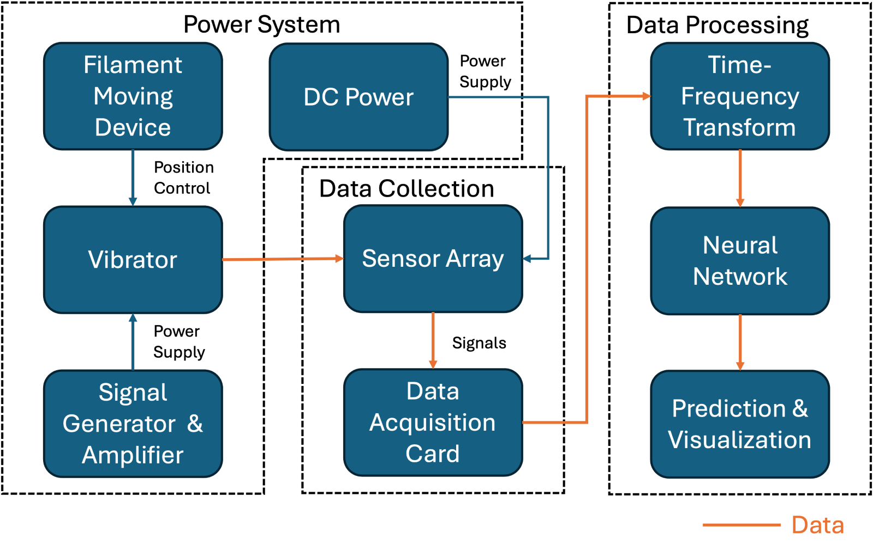
Figure 1 Block Diagram

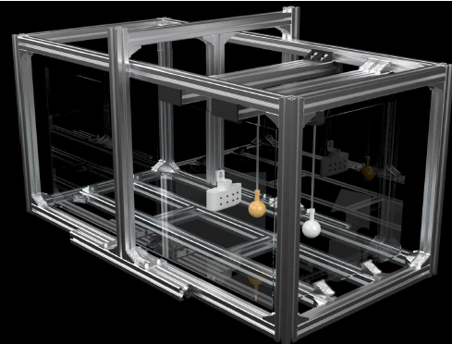
Figure 2 Physical Design

2.1 Power System
The power system is responsible for providing stable electrical energy to all functional components in the experimental setup. It consists of three main parts: a DC power source, a signal generator & amplifier, and a filament moving device. DC Power supplies regulated voltage to the sensor array, ensuring consistent signal acquisition performance during underwater vibration measurements. The Signal Generator & Amplifier produces a controlled excitation signal, which is then amplified and delivered to the vibrator. The Filament Moving Device provides position control for the vibrator. This mechanism ensures precise vertical movement, allowing for consistent and repeatable vibrational input.
2.1.1 Vibrator
The vibrator consists of a servo motor, a vibrating head, and a metal rod. The servo motor provides vertical motion, while the vibrating head, mounted at the lower end of the metal rod, generates oscillations. These components work together to simulate the vertical vibration of an underwater object.
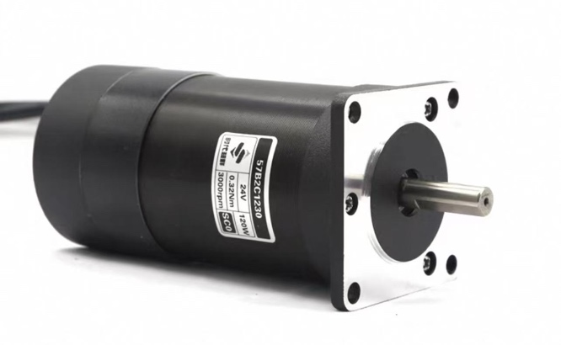
Figure 3 servo motor

Requirement | Verification
Vibrator vibrates in the vertical direction. The vibrator shall generate vertical oscillations at a frequency of 8 Hz with an input voltage of 10 V.  The Motor a power input of approximately 200 W | - Apply a 10 V input to the servo motor and measure the vibration frequency of the vibrating head using a high-speed camera or motion sensor. Verify that the vertical oscillation frequency is 8 ± 0.5 Hz. Confirm that the motion is constrained to the vertical axis and the amplitude remains consistent.  - Submerge the pressure sensor at a fixed distance from the vibrating head. Activate the vibrator at 8 Hz and 10 V. Verify that the pressure sensor output shows periodic pressure variations corresponding to the vibrator’s frequency.

2.1.2 Signal generator and Amplifier
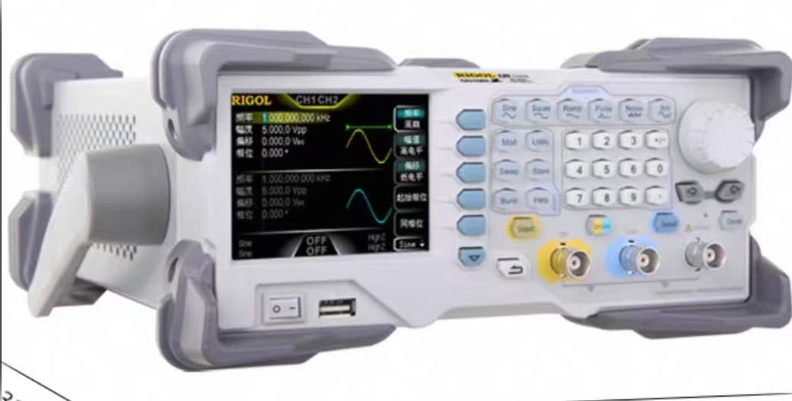
Figure 4 signal generator

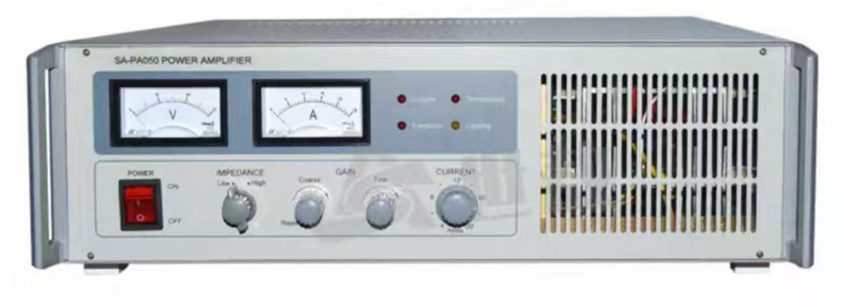
Figure 5 power amplifier
The signal generator and amplifier module play a crucial role in driving the vibrator with precise control over its excitation signal. This subsystem consists of two main components: a function generator and a power amplifier.
The signal generator is responsible for producing periodic electrical waveforms, such as sine waves, at a predefined frequency and amplitude. In this setup, it typically outputs a 5v peak low-power sinusoidal signal at 8 Hz. However, the signal generator can only supply up to 100 W, which is insufficient to drive the vibrator that requires approximately 200 W of power for stable operation.
The Power amplifier is used to boost the output from the signal generator to the necessary voltage and current levels. The amplifier amplifies the low-power 8 Hz signal to deliver a consistent 10 V excitation with sufficient current, enabling the vibrator to operate at the required power level and maintain stable oscillations.

Requirements | Verification
The signal generator shall output a sinusoidal waveform at 8 Hz with an adjustable amplitude and be configured to output a 5 V peak signal in this system.  The power amplifier shall amplify the 5 V, 8 Hz input signal to a consistent 10 V output with sufficient current to meet the vibrator’s 200 W power requirement. |  | - Use an oscilloscope to measure the output of the signal generator and verify that it produces a clean 8 Hz sinusoidal waveform with a 5 V peak amplitude.  - Connect the oscilloscope to the output of the power amplifier and verify that the signal is amplified to a 10 V output while preserving the waveform integrity.

2.1.3 DC Power
The DC power module is responsible for providing a stable power supply to low-voltage components in the system, such as sensors, microcontrollers, or communication modules. In this setup, it delivers a regulated 5 V output with a maximum current capacity of 2 A, ensuring reliable operation of all connected electronic devices.

Requirement | Verification
The DC power module provides a regulated 5 V output with a current supply capability of 2 A.  The output voltage shall remain stable within ±5% under varying load conditions. | Use a digital multimeter to measure the output voltage of the DC power module, confirming that the voltage remains within 4.75 V to 5.25 V.  Connect a dummy load or electronic load drawing 2 A and verify that the module sustains the output without voltage collapse or overheating.

2.1.4 Filament Moving Device
The servo motor is used to control the movement of the vibrating device on the movable platform.

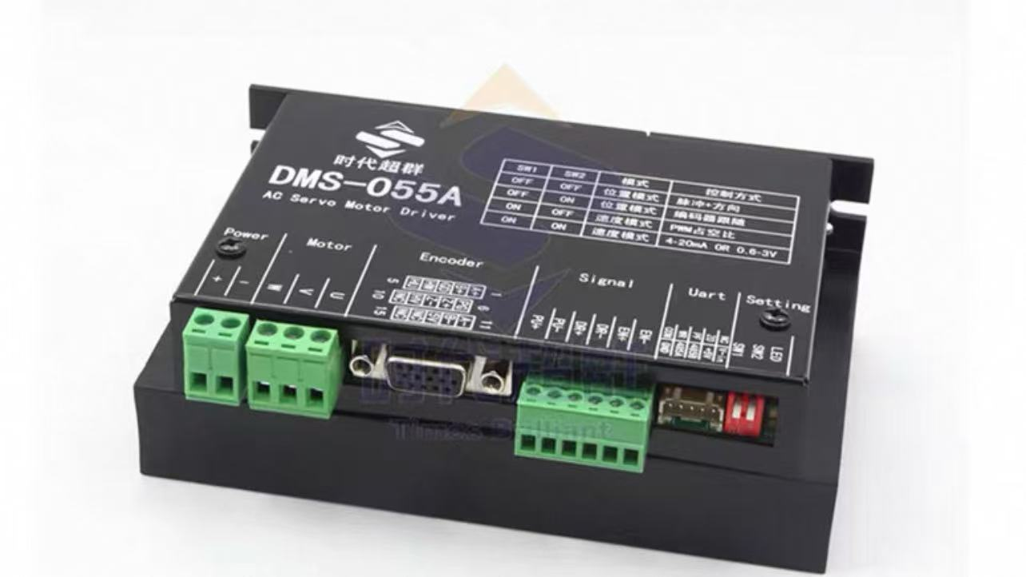
Figure 6 Motor Driver

Requirements | Verification
The servo motor should be powered by 24V DC, with the mode set to pulse mode. The USB is connected to the computer, and the corresponding driver software for DMS-055A is used to transmit signals. | In the driver software on the computer, set the enable Modbus to 1. Afterward, transmit the value of PU_all (steps), and the vibrating device's movement in the aquarium can be observed.

2.2 Data Collection Module
We use pressure sensors to measure the changes in underwater pressure generated by the vibrating device, simulating the data that humans can collect from the movement of underwater organisms.
2.2.1 Sensor Array
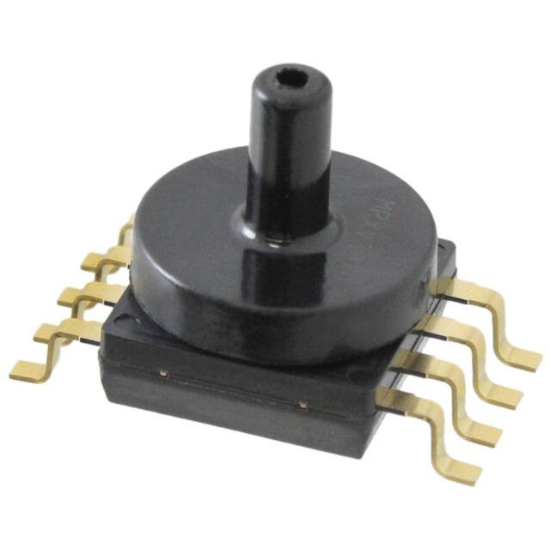
Figure 7 pressure sensor

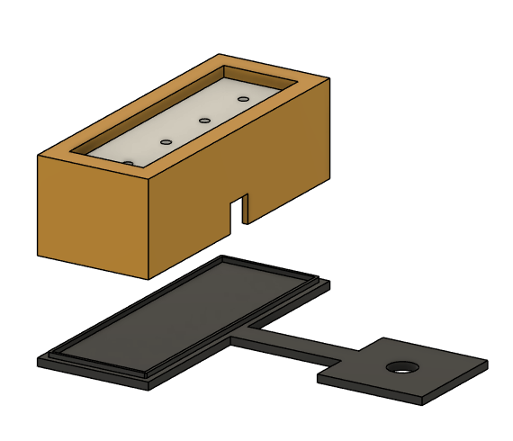

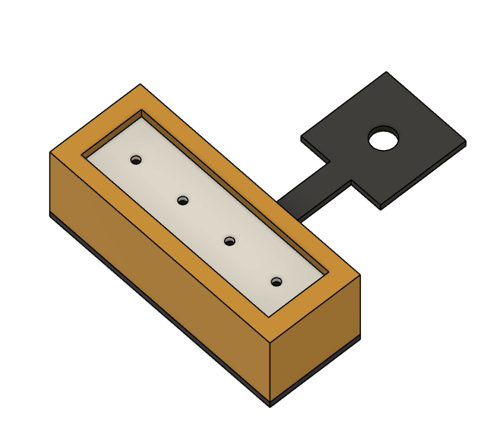
Figure 8 Sensor Array

Requirements | Verification
We encased the sensor in a 3D-printed housing and placed it below the surface of silicone oil. Three pins were extended from the sensor: two of them are the power and ground lines, which require a 5V DC supply for the sensor to function properly. The third pin is the data line, which needs to be connected to a data acquisition card. | The validation of the sensor device also requires a data acquisition card. First, download the corresponding software for the data acquisition card on the computer. After properly connecting the sensor to the data acquisition card, click "Start Measurement." Once the vibrator is activated, regularly spaced pulses with similar amplitudes can be observed in the software's visualization interface.

2.2.2 Data Acquistion Card
The data acquisition card is used to collect real analog data and transfer it to the computer, where it is converted into visual waveforms or time-vs-data Excel or TXT files for further processing.

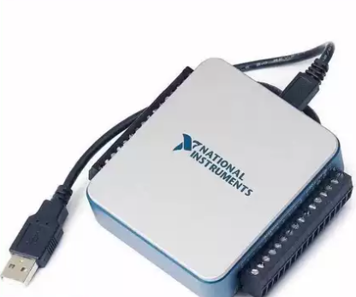
Figure 9 Data Acquistion Card

Requirements | Verification
The USB is connected to the computer, and the data line is connected to the sensor's data line. It is important to note that our project uses a single-ended signal mode rather than differential mode, so the software needs to be configured accordingly. | The validation method is the same as that described for the sensor array above.

2.3 Software Module
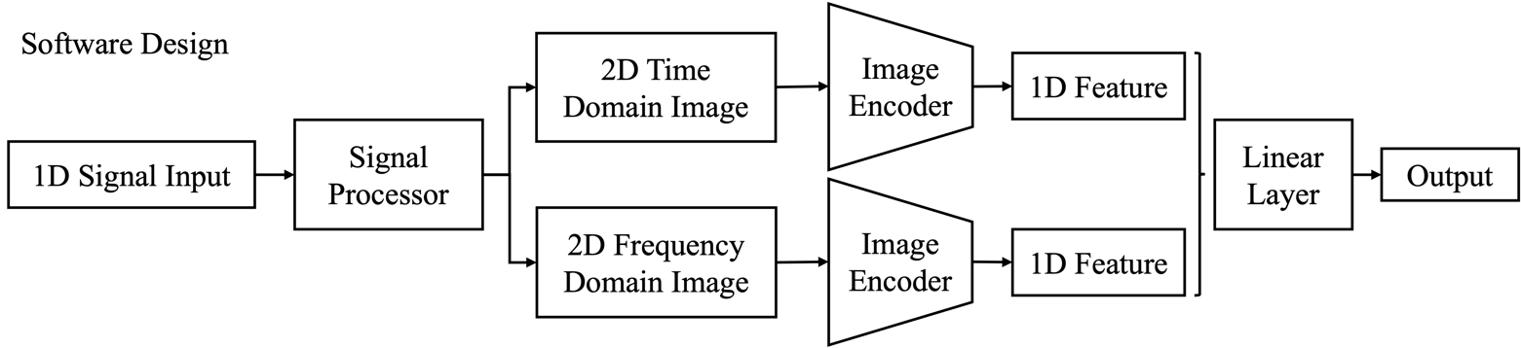
Figure 10 Software Design Diagram

2.3.1 Signal Processor
Description:
Converts 1D signals (e.g., N = 1000 samples) from data acquisition module into two standardized images that capture complementary information required for robust source localization. It provides dual-domain representations to enhance the downstream neural network’s ability to extract robust features.

Processing Steps:
- Normalization: Normalize original signal to [0, 255] for better plot resolution and unifying data, reducing the impact of sensor variability and improving feature consistency.
- Time Domain Image: Converts the normalized signal into a grayscale image using a plotting routine.
- Frequency Domain Image: Applies the S-transform to compute a time-frequency representation. The S-transform provides adaptive windowing, offering a balanced resolution in time and frequency domains. This is essential for detecting transient features and maintaining consistency with the time domain image’s resolution.

Interfaces:
Input: 1D signal vector with N samples from previous data collection block.
Output: Two images (time and frequency domains).

Requirements | Verification
Generate two images in real time. | At test time, we will have windows to visualize the two images.

2.3.2 Neural Network for Position Prediction
Description:
Extracts modality-specific features from the dual images and fuses them to predict the 2D position of the signal source. Serves as the intelligence core by combining complementary features into a robust localization prediction that meets accuracy and precision requirements.

Architecture:
- Dual ResNet Branches: Each branch (e.g., using ResNet-18) extracts features from one image, generating a 512-dimensional feature vector per branch. ResNet’s use of residual connections mitigates vanishing gradients during training. Separate branches capture distinct temporal and spectral features effectively.
- Feature Fusion & Prediction: Concatenate the two 512-dimensional vectors into a 1024-dimensional vector and apply a linear layer to map it to N * 2D coordinates depending on the number of signal sources. Concatenation preserves the unique information from each domain, while the linear layer performs a final mapping to spatial coordinates, directly addressing the localization requirement.
- Training Considerations: We will use Mean Squared Error (MSE) between predicted and true positions as loss function. MSE is a standard choice for regression tasks, ensuring quantitative minimization of prediction error. Training hyperparameters (learning rate, batch size, epochs) are set based on convergence and performance targets.

Interfaces:
Input: Receives dual-domain images from the Signal Processor.
Output: Generates a 2D coordinate vector (in consistent units, e.g., meters) for use by subsequent modules.

Requirements | Verification
Predict accurate position of the signal sources at test time. | Calculate distance between predicted and true positions at test time. We need to show the distance is within reasonable range, here we will use 1 centimeter.

2.3.3 Visualization
Description:
Visually represents both the predicted source position and the known receiver position on a spatial plot. Enhances system interpretability by providing immediate visual feedback, aligning with requirements for clarity and user validation.
Plot Generation:
Generate a spatial plot (at least 600 × 600 pixels) with distinct markers (e.g., square for source and circle for receiver), clearly labeled axes, grid lines, and legends. High-resolution plotting and clear markers ensure that subtle differences in positions are visible, supporting the requirement for precise and interpretable feedback.

Input: Receives coordinate data from the Neural Network and configuration regarding the receiver’s position.
Output: Produces a rendered plot for user review or system reports.
Requirements | Verification
Generate plots with icons at real time. | At test time, we will have windows to visualize the plot.

2.4 Tolerance Analysis
Power systems: The system must be capable of generating vibrations of varying intensity and location to enhance data diversity, which benefits model training and improves model robustness.
Data Collection System: The sensors will be submerged in kerosene for an extended period, which may lead to malfunctions and pose a risk to the success of the project. Therefore, it is essential to ensure that the sensors can operate stably under these conditions over the long term. Wire break poses a risk to the success of the project. We need to solder the sensor with the data acquisition card to ensure connection.
Data Processing System: The system must handle variations in signal quality due to environmental factors like temperature, humidity, and interference. The deep learning model should be robust to slight deviations in collected data.

3 Costs

Part | Cost
Signal Generator | $ 120
Pressure Sensor * 4 | $ 28
Total | $148

4 Schedule

Week | Software | Hardware
2/7/25 | Confirm the data format from hardware sensor | Purchase sensors, signal generator
2/14/25 | Build data preprocessing module | Finish experiment setup
2/21/25 | Build signal-image transform module (S-transform and grey-image transform) | Design the sensor array and solder the sensor with wire
2/28/25 | Build CNN module that can extract the feature of images | 3D prints the vibrator and test the vibrator
3/6/25 | Continue building CNN module, and test its functionality | Test the filament moving device to control the location of vibrator
3/13/25 | Build ResNet Module to further extract the feature of images, and make prediction to the object | Test the sensor block performance through oscilloscope
3/20/25 | Continue building ResNet Module | Test the sensor array under water
3/27/25 | Integrate all modules into a cohesive unit | Collect the data using data collection card
4/3/25 | Train the model | Continue improve the structure of the model
4/10/25 | Test the functionality of the whole framework in real situation | Design software tool to visualize waveforms in real time
4/17/25 | Continue testing and debugging if needed | Continue testing and debugging if needed
4/24/25 | Continue testing and debugging if needed | Continue testing and debugging if needed
5/1/25 | Prepare final presentation | Begin final report

5 Ethics and Safety
Ethic Issues:
Fairness and accessibility: The functionality of the system may depend on a particular infrastructure, which may prevent some users or regions from enjoying the technology, creating unfairness.
Environment Impact： In the experiment, we used silicone oil to simulate water, and its discharge may have an impact on soil and water. The degradation of silicone oil is slow, and it is easy to destroy the balance of the ecosystem.
Safety Issues:
Silicone oil long-term contact with the human body may cause allergic reactions, may lead to local skin resistance decline. We will wear gloves and masks to protect ourselves during the experiment.
Some sensors may stop working under pressure, causing the system to be unable to collect data and respond to the pressure. We will design redundant systems and emergency braking features to ensure safe stopping and replacement of sensors in the event of a system failure.
The oscillator may stop working due to overload, in which case the oscillator may overheat and cause a fire. We will design the temperature detection mechanism.

References
[1] Pu, Y.; Zhu, C.; Yang, K.; Hu, H.; and Yang, Q. 2023. A Novel AMSS-FFN for Underwater Multi-Source Localiza- tion Using Artificial Lateral Line. IEEE Transactions on Instrumentation and Measurement, 72: 1–14.
[2] Pu, Y.; Hang, Z.; Wang, G.; Hu, H. Bionic Artificial Lateral Line Underwater Localization Based on the Neural Network Method. Appl. Sci. 2022, 12, 7241. https://doi.org/10.3390/app12147241
[3] He, K., Zhang, X., Ren, S., & Sun, J. (2016). Deep residual learning for image recognition. In Proceedings of the IEEE conference on computer vision and pattern recognition (pp. 770-778).

