Project Proposal for
ECE 445
Senior Design

Project Title A device for evaluation of frictional properties of surfaces

Team Members Tiancheng Shi, Haoran Cheng, Zhongsheng Guan, Yang Li

Course Number 1287

Supervisor Olesksiy Penkov, Boyang Shen

Date 2025.3.12

Table of Contents

1 Introduction 2
1.1 Objective and Background 2
1.1.1 Problem 2
1.1.2 Solution 2
1.1.3 Visual Aid 3
1.2 High-Level Requirements List 3
2 Design & Requirements 4
2.1 Block Diagrams 4
2.2 Block Descriptions 4
2.2.1 Hardware System 4
2.2.2 Software System 5
2.3 Tolerance Analysis 6
3 Ethics and Safety 7
3.1 Ethics 7
3.2 Safety 7
References……………………………………………………………………….…………………8

Project Proposal
- Introduction

Objective and Background

Problem
Extensive research efforts have been devoted to understanding the complex mechanisms of friction wear to minimize their effects in sliding systems. Improvements in the instruments used to characterize the friction and wear phenomenon are required to enhance the effectiveness of the research method. In this project, our goal is to design and build an experimental platform that evaluates surfaces' frictional behavior.

Solution
The platform will be a modular friction test platform, which is capable of accurately measuring the friction, wear rate and contact behavior between surfaces of different materials. It will include high precision sensors, controllable condition system and data acquisition system and allow researchers to conduct experiments under a variety of conditions, such as temperature, load and velocity.
There are many circumstances when people can benefit from this platform. For instance, with this platform around, when carrying out an experiment that needs the friction data of unfamiliar materials, or multiple friction data sets under different conditions, instead of searching for the numbers for a long time, researchers could directly use the platform to get everything they need simply and quickly. In addition to measuring the friction, the platform could also quantize the wear condition of the materials.
There are many application scenarios for this platform. Fraction and wear measurement are needed in anywhere that relates to mechanical engineering, such as laboratory, factory and so on. The modular design of this platform is the key to its marketability. The platform will be divided into several parts that are independent from each other, and users can take any parts off in order to maintain or take it to other places. Both maintenance and transportation of the platform will be convenient.

Visual Aid
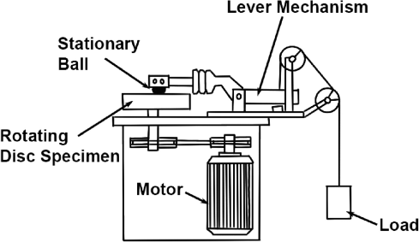[2]

High-Level Requirements List
- Measurement accuracy needs to be as high as µm level, which means that the Microscope used in the platform should have the resolution of µm level.
- Friction speed between the materials that are being measured should be controllable within the level of mm/s.
- There must be portable parts that can be removed from the whole platform and got repaired or changed.
- Design & Requirements

Block Diagrams
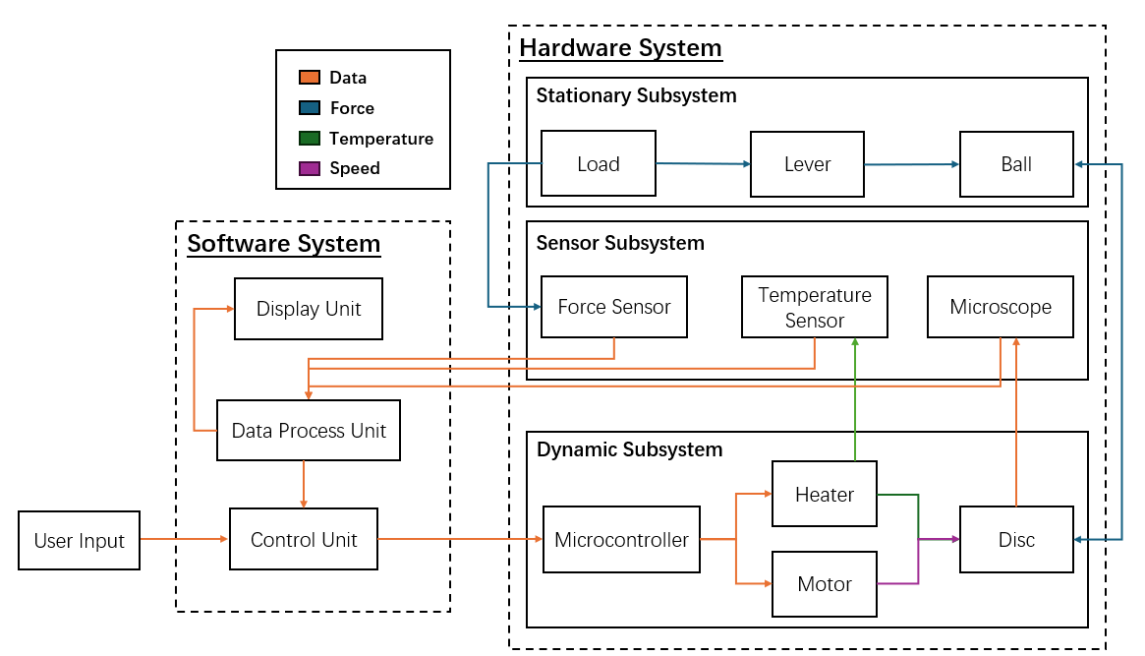

Block Descriptions
The whole platform can be divided into two systems, hardware and software. Hardware system is where the user primarily operates on, while software system will automatically take in measurement data and control the hardware system.

Hardware System
It can be divided into three more subsystems:
- Stationary Subsystem: Consists of the load, lever mechanism and a stationary ball. The ball, typically made of a rigid substance, is the subject that interacts with the material to be measured. When conducting measurements, users can set the quantity of normal force on the ball by changing the weight of load. The weight will be transported to the ball by a lever mechanism and become normal force that acts on the ball. The magnitude range of load should be 0.1 to 500 mN and the ball is changeable, making it possible for measuring a wide range of materials.
- Dynamic Subsystem: Consists of a microcontroller, a heater, a motor and a disc. The disc is or is made of materials to be measured. When the disc is interacting with the ball, spinning the disc will produce friction. The motor is the power source that makes the disc spin. Its power should be controllable so that users can control the linear speed of spinning in the range of 100.0 to 300.0 mm/s. The heater can heat up the disc to simulate different measuring conditions. It provides a temperature range from room temperature up to 100.0 degrees centigrade.[3] The microcontroller receives signals from users through the software system and controls the power of the motor and the heater to obtain the spinning speed and temperature needed.
- Sensor Subsystem: Consists of a force sensor, a temperature sensor and a microscope. This subsystem is the bridge between hardware and software. It gathers data from the hardware system and sends them to the software system. Force sensor measures the normal force acting on the ball, temperature sensor measures the temperature of the disc’s central, and edge and microscope measures the friction status.

Software System
This system consists of three units: data process, control and display. The data process unit is the core unit that takes in data collected by sensors and processes them into the form needed by the other two units. The control unit is controllable by users, where users can set the speed and temperature they want here before starting the platform. After the platform starts working, it will receive data from data process unit and automatically adjust the microcontroller in the hardware system according to the real time data and the target. The display unit shows users real time data, such as the temperature of the center of the disc, the spinning speed of the disc and so on, ensure that users are in control of the platform’s status at all times.

Tolerance Analysis
The heater component must be the one that poses a risk to success of our project. The first problem is that it’s hard to raise the whole disc’s temperature at the same time, it is possible that the center of the disc is not the same temperature as the edge portion of it. This may result in huge errors because the measurement is not carried out at the expected temperature. The second problem is how to control the power of the heater when the current and target temperatures are known. As the real time temperature of the disc rises, the voltage should decrease to reach the target. This requires us to develop an algorithm in the control unit that computes that relation between temperature and power.
Here is the power equation between input power P_{in}, current temperature T and voltage V:
$$P_{in}=\frac{V^{2}}{R(T)}=\frac{V^{2}}{R_{0}[1+α(T-T_{0})]}$$
And the equation for dissipation power P_{out} and T
$$P_{\text{out}}=k(T-T_{0})$$
With these two equations, we can calculate how to adjust the voltage to get the target temperature we want.

- Ethics and Safety

Ethics
If our platform causes harm to anyone, we will compensate and apologize accordingly. Our platform may need to collect data from users to see what weights, speeds, and temperatures they generally use to improve the platform. In addition to this, we will never cause any privacy breach of our users. Our platform also won’t have any problems with fairness and discrimination.

Safety
We believe our platform has very few security risks. The load’s weight of our platform is too small to cause any damage to the user. The spinning speed is also too slow to hurt the user. The only safety issue lies in the heater. If the user makes a mistake and sets the target temperature too high, which exceeds the ignition point of the material, a fire may break out and cause severe consequences. Even if there is no mistake, setting a high temperature may cause burns to the user. We could add some warning marks on the display unit or on the platform to tell users how to operate the platform properly.

References
- Muralidharan, K., et al. “Comprehensive Overview of Nano, Micro, and Macro Tribometers in Practice.” Journal of Bio- and Tribo-Corrosion, vol. 10, no. 3, May 2024, https://doi.org/10.1007/s40735-024-00849-x.
- Mahmud, Dayang nor Fatin, et al. “Influence of Contact Pressure and Sliding Speed Dependence on the Tribological Characteristics of an Activated Carbon-epoxy Composite Derived From Palm Kernel Under Dry Sliding Conditions.” Friction, vol. 7, no. 3, May 2018, pp. 227–36. https://doi.org/10.1007/s40544-018-0205-y.
- Thrush, Steven J., et al. “Growth and Morphology of Thermally Assisted Sinterable Zirconia Nanoparticle Tribofilm.” Tribology International, vol. 175, July 2022, p. 107820. https://doi.org/10.1016/j.triboint.2022.107820.

