ECE445
Senior Design Laboratory

Project Proposal

Design and Build a Spherical Bionic Tensegrity Robot

Member:
Yuan Fang (yuanf4@illinois.edu)
Yaoqi Shen ( yaoqis2@illinois.edu)
Ruiqi Dai ( ruiqid3@illinois.edu)
Yuhao Xu ( yuhaoxu3@illinois.edu)

Mar 14th, 2025

Contents
1. Introduction 3
1.1 Problem 3
1.2 Solution 3
1.3 List of Requirements 4
2. Design 5
2.1 Block Diagram 5
2.2 Subsystem Overview 6
2.2.1 Power Module 6
2.2.2 WIFI Module 6
2.2.3 Control Module 7
2.2.4 Driven Module 7
2.3 Subsystem Requirements 7
2.4 Tolerance Analysis 8
3. Ethics and Safety 9
3.1 Ethics Concern 9
3.2 Safety Concern 9
Reference 11

Introduction

Problem
Spherical robots based on the Tensegrity Structure (HTS) can achieve continuous rolling by altering the lengths of their connecting rods, typically utilizing liquid crystal elastomer (LCE) materials to achieve rod contraction. However, certain limitations persist, such as energy dependency. Traditional HTS robots often rely on external power sources, such as tether-based power supply, which restricts their mobility. Alternatively, the use of external batteries results in bulkiness [6]. Therefore, enhancing system integration has become one of the primary objectives of this study. While untethered HTS robots have made some improvements in addressing these issues, those based on LCE still depend on external thermal surfaces to induce temperature changes [2]. Laser-driven HTS robots, on the other hand, require constant recalibration of the light source to position the structural rods accurately, and face challenges in simultaneously moving multiple rods, leading to insufficient local control precision [1]. Additionally, the process of controlling the robot’s movement is often inconvenient and lacks real-time responsiveness [5], resulting in high complexity in human-robot interaction, which is another critical problem that needs to be addressed.

Solution
This study proposes a Tensegrity Structure (HTS) robot based on a built-in battery and remotely controlled LCE actuation, aiming to overcome traditional limitations through a highly integrated design. Firstly, the integration of the battery with the PCB control module replaces the rigid rods, enables untethered power supply and signal processing, and eliminates dependency on external power sources, significantly enhancing mobility autonomy. Secondly, leveraging the thermoresponsive properties of liquid crystal elastomer (LCE), it is integrated with serpentine conductive film, and a PCB-developed heating circuit capable of independent addressing or parallel control is employed to facilitate communication between the client and server. Additionally, a computer UI interface is developed to precisely regulate the heating state of any rod, thereby improving the convenience of human-robot interaction.
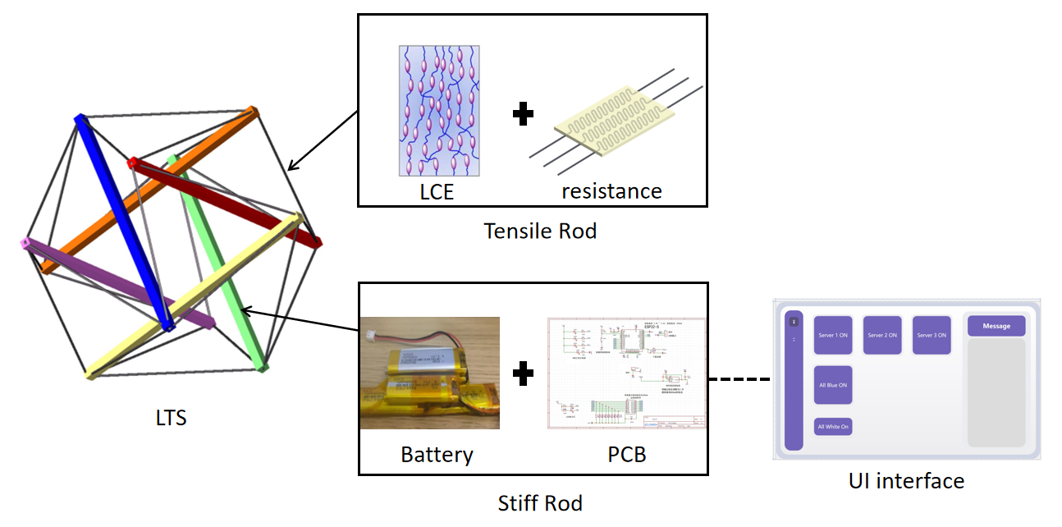
Figure 1. Visual Aid

List of Requirements
- The hard-soft hybrid structure (rigid rods connected by soft materials) must maintain stability in both static and dynamic states, with a maximum deformation of ≤ 5% under a load of 1 kg applied.
- The wireless control module, including the interactive UI, must achieve a signal transmission latency of ≤ 100 ms and support a control range of at least 10 meters.
- The user must be able to control the robot to move in four primary directions (forward, backward, left, right) with a directional accuracy of ±5° and a minimum turning radius of 20 cm.

Design

2.1 Block Diagram
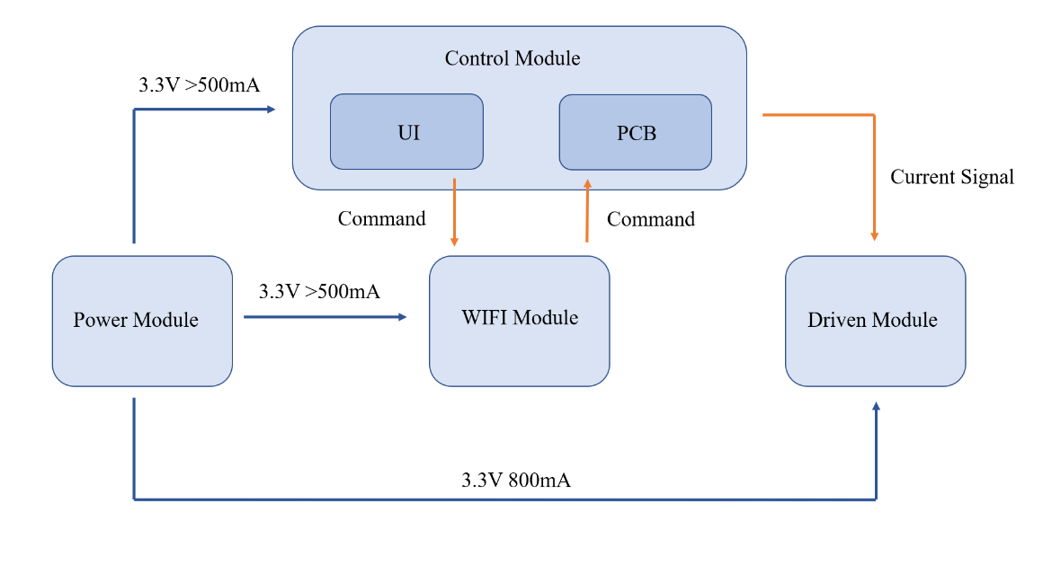
Figure 2. Control logic block diagram
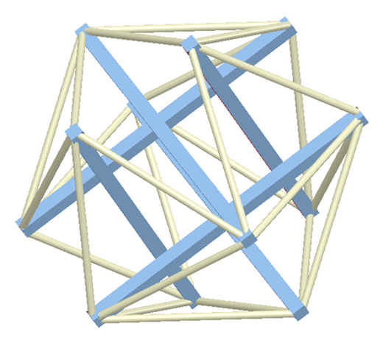
Figure 3. Structure modeling diagram

2.2 Subsystem Overview

2.2.1 Power Module
It is used to provide stable power supply to all subsystems, ensuring continuous operation in both static and dynamic states. For a single battery, it is LiPo battery (CL-601752, 3.7V, 600mAh, weight: 10.3g) with IC protection board. Then by different battery combination, achieve the the thickness of 6mm, weight of 31.8g, battery output is 12.16V and the endurance for over 20 minutes.

2.2.2 WIFI Module
Wi-Fi data protocols facilitate wireless communication between the user interface and the robot, enabling real-time control. The Wi-Fi chip employed is the ESP32-S (2.4 GHz, supporting Wi-Fi 802.11 b/g/n and Bluetooth 4.2), which operates at a high-frequency of up to 240 MHz. Utilizing TSMC’s low-power 40nm technology, the chip exhibits ultra-compact dimensions, high reliability, and ease of scalability. Furthermore, it incorporates an integrated PCB antenna to ensure stable signal transmission.
For the user interface, a custom UI was developed using a web-based framework (HTML + JavaScript).

Control Module
We will design three PCB plate, and each PCB plate will control 8 edges of the tensegrity rod. The PCB process user instructions and coordinate the operation of the Driven Module. For microcontroller, as mentioned, it is ESP32 (dual-core, 240MHz) for high-speed signal processing. And for logic circuits, AND/OR gates are decoding user instructions. By using the different color of RGB LEDs, it can visually represent logic operation results.

2.2.4 Driven Module
By execute precise deformation of the tensegrity structure through controlled heating of LCE materials. The rigid rod is 80 mm × 5 mm × 5 mm for carbon nano tube (CNT), and the flexible ropes is 27 mm × 5 mm × 0.6 mm for LCE.

2.3 Subsystem Requirements
  - Power Module: The voltage output should be stable (within 5% varying). The battery life must support continuous operation for over 30 minutes.
  - WIFI Module: The WiFi module must correctly transmit and receive user instructions with an error rate of < 0.1%. The signal transmission delay must be ≤ 100 ms under normal conditions.
  - Control Module: Each PCB must independently control its assigned 8 edges without interference from other PCBs. In the same time, it should also allow parallel operation logic.
  - Driven Module: The response time of heating should be quick, the LCE heating elements must reach the target temperature within 5 seconds. The structure should satisfy the stability, during deformation with a maximum deviation of ≤ 5% from the target shape. And the elastomer needs enough cycles not to suffer fatigue.

2.4 Tolerance Analysis
The battery must ensure that the geometric shape and balance of the spherical robot are not affected. Among different combinations of batteries of different models, it is necessary to ensure that the battery can output the correct voltage and current. However, the selection of batteries is limited by the batteries that have been produced on the market. The shape and weight of the battery will seriously affect the balance of the spherical robot. Therefore, we believe that there will be problems in the selection of batteries.
The quantification of the deformation of soft materials under different currents needs to be measured, and it will also change the output size of the power supply and control module. The relationship between the deformation of soft materials and the current size needs to be further measured, and the service life of soft materials also needs to be measured.

3. Ethics and Safety

3.1 Ethics Concern
The design and control of the robot have nothing to do with people of different colors since every person can control the robot independently and equally. In the experiment, no animal will be tested [7].

Safety Concern
  - The PCB design and test will use a voltage supply greater than 3V; the complicated interconnection may lead to a short - circuit, which may cause high temperature during the experiment.
  - The hard structure supports the balance of the robot; it must have enough strength to ensure the integrity of the robot. It should be ensured that the hard structure will not hurt people if it breaks.
  - The contacts of the soft material are controlled by current and strengthened at different temperatures. Since the soft material touches the ground directly, it should be ensured that the soft material and the ground won’t burn under the working temperature.

Reference
[1] Wang, Z., Li, K., He, Q., & Cai, S. (2018). A Light‐Powered Ultralight Tensegrity Robot with High Deformability and Load Capacity. Advanced Materials, 31(7). https://doi.org/10.1002/adma.201806849.
[2] Liu, C., Li, K., Yu, X., Yang, J., & Wang, Z. (2024). A multimodal Self‐Propelling tensegrity structure. Advanced Materials, 36(25). https://doi.org/10.1002/adma.202314093.
[3] Whitesides, G. M. (2018). Soft robotics. Angewandte Chemie International Edition, 57(16), 4258–4273. https://doi.org/10.1002/anie.201800907.
[4] Zhang, X., Pei, Z., & Tang, Z. (2025). Research on the range of stiffness variation in a 2D biomimetic spinal structure based on tensegrity structures. Biomimetics, 10(2), 84. https://doi.org/10.3390/biomimetics10020084.
[5] Xie, Y. (2018). Analysis and control about rolling motion of spherical tensegrity robot (Master's thesis, Harbin Institute of Technology).
[6] Hiller, J. D., & Lipson, H. (2015). Dynamic simulation of soft multimaterial 3D-printed objects. Soft Robotics, 2(1), 12–23.
[7] IEEE Code of Ethics. (n.d.). http://www.ieee.org/about/corporate/governance/p7-8.html.

