ECE 445
Senior Project

Proposal:
Cheat for lottery wheel based on servo motor control

Sponsor: Lin Qiu
TA: Shengwei Chen

Team Member:
Zhangyang He (zhe27)
Kaixin Zhang (kaixin3)
Bowen Shi (bowens10)
Yilin Liu (yilinl10)
Introduction
Problem:
In classic lottery wheel systems, the position of the pointer cannot be controlled accurately, which leads to completely random and unpredictable results. For some cases such as in controlled environment or for specific testing requirement it is required to manipulate the wheel outcome to land the wheel on a fixed position. This is especially necessary in applications where fairness or particular results need to be shown. The issue of obtaining high precision control while seeming random is a technical problem. This is not the only lottery application of this technology, but it can also be used in toy systems and wheel control applications. The system would include a random control function to ensure fair and unbiased results from the lottery industry when utilized.
Solution:
In response to this issue, this paper proposes a high-precision lottery wheel device based on the control of a servo motor. The main concept is to place a 24V/200W servo motor driven the pointer, with a negative feedback control system to maintain a constant spinning speed. There will also be a wireless remote switch controlling the instant stop of the pointer at a pre-defined position. The soluion utilises hardware for high frequency power devices, such as sampling circuits, DSP control circuits, signal conditioning circuits, high switching frequency power devices, motor control etc. Scalable system: Features like negative feedback control system ensure real-time monitoring of motor speed and wireless remote switch ensures instant stopping of the motor. As a solution, it not only conforms to the narrow demands of more accurate QA but can be seamlessly added to existing libraries. In the case of the lottery industry, the lottery bottom line random control function will be help by the system to ensure fair and just outcomes.
Visual Aid
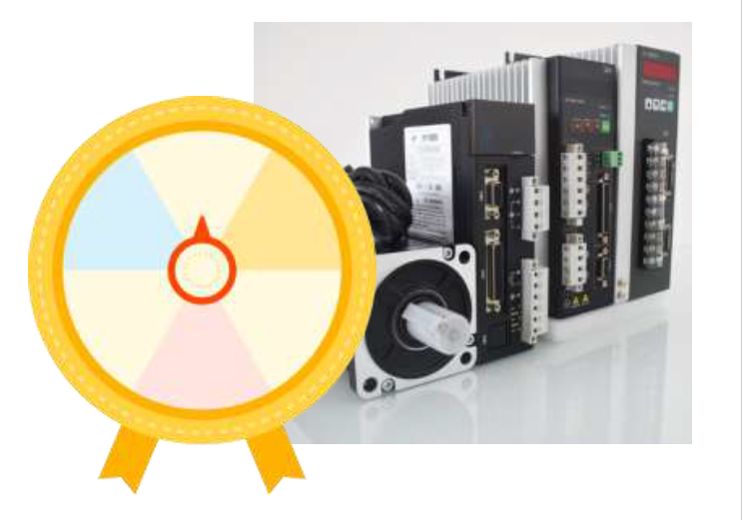
High-level requirements list
Precise Speed Control: The system must maintain the pointer's spinning speed at a constant rate of 1 RPM (revolutions per minute) with a tolerance of ±2%, achieved through a negative feedback control mechanism to ensure consistent operation.
Accurate Position Stopping: The system must be capable of stopping the pointer at a predetermined position with an angular accuracy of ±0.5 degrees, enabled by high-precision servo motor control and a wireless remote switch.

Instant System Halt: The system must include a remote switch that can halt the motor and stop the pointer within 0.2 seconds of activation, ensuring immediate response for safety and control purposes.
Random Control Function (if applicable): If applied in the lottery industry, the system must incorporate a random control function that ensures the pointer stops at a truly random position, adhering to fairness standards with a randomness accuracy of 2%.

Part 2: Design
Block Diagram
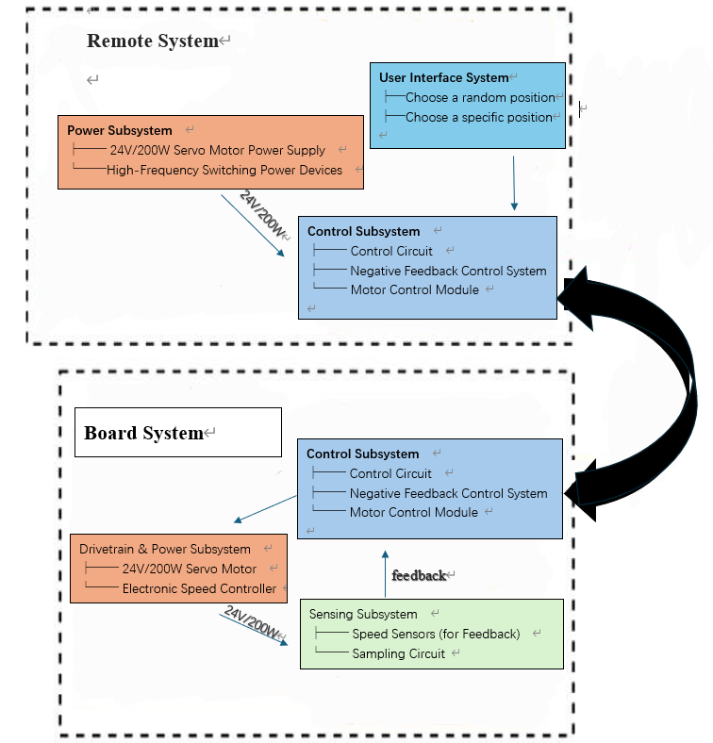

Subsystem Overview:
Power Subsystem
Power Subsystem supplies 24V/200W power to the device. This subsystem connects with the Drivetrain & Power Subsystem and Control Subsystem to provide energy.
Control Subsystem
The Control Subsystem manages the servo motor, which contains control circuit a feedback and control module. This subsystem connects with the Drivetrain & Power Subsystem to control the motor and can be controlled by the sensing subsystem.
Drivetrain & Power Subsystem
The Drivetrain & Power Subsystem connects with the 24V/200W power system to drive the motor move. It is connected with Control Subsystem and Sensing Subsystem, which will give information to the sensing system and be controlled by the Control system to control the motor’s speed.
Sensing Subsystem
The Sensing Subsystem can monitor the motor’s operation and control its speed using feedback circuit. It is connected with Drivetrain & Power Subsystem and control system, it can feedback to control the motor indirectly to control its speed and position.
Subsystem Requirements:
Power Subsystem
Block Description: Supply power to another subsystem.
Contribution: Power Subsystem supplies 24V/200W power to the device
Requirements: Supply 24V at 200W with <1% ripple.
Control Subsystem
Block Description: Manages the motor at a constant speed.
Contribution: Using the circuit to control the motor’s operation
Interfaces:
Remote System: Receive the information from the control system.
Drivetrain & Power Subsystem: Give feedback to Control system by feedback circuit.
Requirements: Receive and send command with <22ms late.
Drivetrain & Power Subsystem
Block Description: Drive the motor to move to make pointer move.
Contribution: Control pointer movement with a precise outcome.
Interfaces:
Control Subsystem: Receive signals.
Power Subsystem: Being supplied by 24V/200V.
Requirements:
- Operate at 24V/ 200W.
- Have speed control accuracy of ±1 RPM.
Sensing Subsystem
Block Description: Monitors motor speed and send feedback to control system.
Contribution: Control the motor’s speed and its position.
Interfaces:
Control Subsystem: Sends feedback to control system to recontrol it.
Requirements:
Send feedback data at ≥500Hz.
Tolerance Analysis
Aspect of Design: The motor’s speed and position control is critical, which means the control system, Drivetrain & Power Subsystem and sensing system operating at a high accuracy.
Risk: If the Drivetrain & Power Subsystem or sensing system operation have an error, it will change the pointer’s position absolutely.
Feasibility Analysis:
Using mathematical analysis and simulation demonstrate that the servo motor speed control system should at speed tolerance of ±1 RPM. Also, the control system is less than 30ms late, which can make the pointer at a more accurate position.

Part 3: Ethics and Safety
The Lottery wheel system - servo motor controlled, it uses a 24V/200W servo motor, would classify as there being a strict electrical and mechanical safety device implemented, as there would be high voltage components and moving parts. This is as per ECE 445 safety precautions, where some tasks require an additional class for high voltage while nobody can be in the lab alone in case the alarm set off and there are high voltages involved, resulting in dire consequences without a companionship that can quickly summon help in the lab [1]. We would have to complete standard safety training and observe general lab safety practices to satisfy university and course requirements, but the project will be conducted as an academic endeavor, not for commercial use.

Documentation
1.A pointer can spin on a lottery whell at a constant speed drive by a 24V/200W servo motor, adjust the motor with dynamic control, make sure it in our need speed
2. halt the whole system with remote switch, the pointer will directly stop
3.Stop the pointer
Cheat for lottery wheel based on servo motor control
Implementing a cheat for a lottery wheel based on a DC servo motor, by using a wireless switch to set the exact position it will stop at. Requires the implementation of high precision
and high-efficiency servo motor control, capable of controlling the output
variables of angle, speed, and position.
Deliverables:
Submit hardware for 24V/200W servo motor control based on high frequency power devices, including sampling, DSP control circuits, signal conditioning circuits, and high-switching-frequency power devices.

