Wireless Fast Charging Autonomous Car
Proposal for ECE445/ME470

Team number: TBD
Liheng Jing (lihengj2)
Yuyang Wei (yuyangw4)
Yuhang Wang (yuhangw3)
Hongye Dong (hongyed2)

Project Faculty: ZJUI

TA: Jing Sheng

Professor: Chushan Li

March 7, 2025

Content
- Introduction
  - Goals
  - Functions
  - Benefits
  - Features
  - High-Level Requirements List
2 Design
2.1 Block Diagram
2.2 Subsystem Overview
2.2.1 Wireless Charging Subsystem
2.2.2 Drive Subsystem
2.2.3 Sensor Subsystem
2.2.4 Chassis Subsystem
2.2.5 Processor Subsystem
2.3 Subsystem Requirements
2.3.1 Wireless Charging Subsystem
2.3.2 Drive Subsystem
2.3.3 Sensor Subsystem
2.3.4 Chassis Subsystem
2.3.5 Processor Subsystem
2.4 Tolerance Analysis
3 Ethics & Safety
3.1 Ethics Issues
3.2 Safety Issues
References

- Introduction
  - Goals:
- Design a car that integrates wireless charging, autonomous navigation, and obstacle avoidance functions, allowing it to move autonomously in the environment without human intervention.
- Optimize wireless charging technology.
- Ensure safety and reliability.

  - Functions:
- Wireless fast charging:
Support wireless fast charging capability of ≥ 20W to achieve efficient energy replenishment. Automatically detect the location of wireless charging stations and navigate to the charging point.
- Autonomous navigation and obstacle avoidance:
Integrating computer vision technology to achieve environmental perception and obstacle avoidance.
- Space optimization design:
The charging system is arranged at the bottom of the car to save space and avoid the land occupation problem of traditional charging stations.

  - Benefits:
- Improve charging convenience:
The car can automatically detect and navigate to the wireless charging station without manual operation, saving clients time and energy.
- Resolve the issue of space occupation:
The charging system is integrated at the bottom of the car, avoiding the occupation of space by traditional charging stations and suitable for limited space.
- Improve energy replenishment efficiency:
Supports wireless fast charging of ≥ 20W, combined with the fast charging and discharging capabilities of supercapacitors, significantly reducing charging time.
- Ensure safety and reduce long-term usage costs:
Supercapacitors are safer and more durable than traditional lithium-ion batteries, reducing the risk of battery overheating or damage and ensuring clients safety during use. The long lifespan and efficient energy management of supercapacitors reduce maintenance and replacement costs, saving clients long-term expenses.
- Intelligent experience:
Autonomous navigation and obstacle avoidance functions make cars smarter, reduce manual intervention, and enhance clients experience and satisfaction.

  - Features:
- Automatic wireless fast charging combined with navigation:
The existing cars require manual search for charging stations and insertion and removal of charging cables, while the vehicle can automatically detect charging stations and navigate to charging points, achieving fully automated charging.
- Bottom charging design:
Traditional charging stations require additional space for installation, while the charging system of this car is integrated at the bottom, saving space and being more aesthetically pleasing, suitable for various scenarios.

  - High-Level Requirements List:
- The wireless charging power $P_{in}≥20W$
- Car can automatically align to the charging coils
- Car can detect the place of wireless charging station
- Obstacles can be avoided during the driving

- Design
2.1 Block Diagram
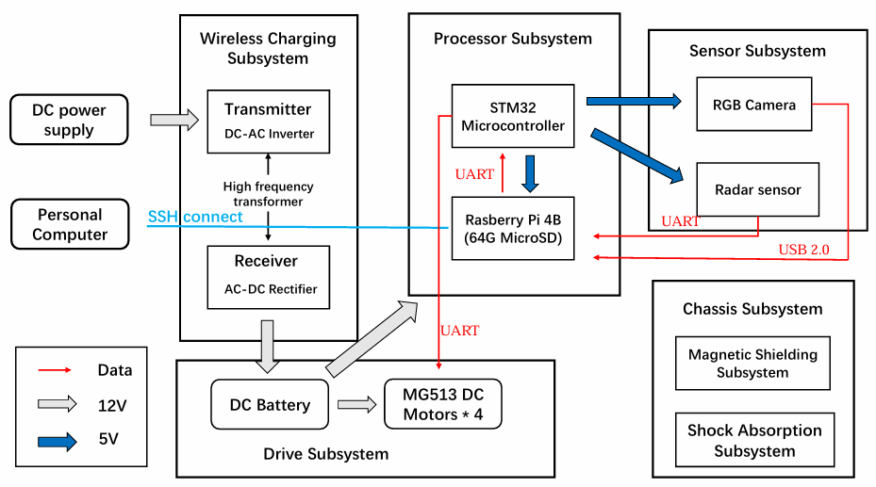
2.2 Subsystem Overview
2.2.1 Wireless Charging Subsystem
To achieve maximum and unlimited power transfer, the Wireless Charging Subsystem is crucial. In this section, we adopt a typical isolated bidirectional DC/DC converter topology for wireless charging. This topology includes an inverter network, high-frequency transformer, and rectifier network. The inverter network converts the input DC power to high-frequency AC, while the rectifier network converts the AC power back to DC, supplying the output after passing through the high-frequency transformer.
In our diagram, the subsystem mainly consists of a transmitter and a receiver. The transmitter receives a DC voltage, which is converted into AC suitable for wireless charging by its internal converter. Our electric vehicle is equipped with a receiver that contains a secondary coil. Through the inductive power transfer system, power is maximized between the two coils, achieving wireless charging.
We plan to use a Dual Active Bridge (DAB) topology. This topology uses full-bridge converters on both the primary and secondary sides to provide AC waveforms for transmission to the transformer. The main difference between this topology and its improved version lies in the filtering network, where only an inductor is present on the primary side. The Dual-Bridge Series Resonant Converter (DBSRC) provides greater advantages by adding a capacitor near the transformer to form a resonant loop, enabling Zero Current Switching (ZCS) or Zero Voltage Switching (ZVS) under load or voltage variations while maintaining the simplicity and intuitiveness of the DAB topology.
In our practical application, we will use PCB boards to simulate real wireless power transfer. Two PCB boards will be applied to form a CLLC charging system, with the capacitor and inductor values adjusted to meet charging requirements.
2.2.2 Drive Subsystem
This subsystem ensures that the vehicle can move intelligently based on processor or manual instructions, allowing precise control of its motion and posture. Ideally, by accurately controlling the vehicle's posture, we can further enable smart tracking, obstacle avoidance, and posture adjustments to maximize wireless power transfer. The vehicle uses four MG513 DC motors for movement. The motor specifications are: rated voltage 12V, rated current 0.36A, gear ratio 30, and a power of approximately 4W. The rated torque is 1kg.cm, with an unloaded speed of 366±26 rpm after the reduction. We will use the STM32 processor to control the vehicle's movement, referencing the F103VET6_mini vehicle source code.
2.2.3 Sensor Subsystem
The sensor subsystem serves as the vehicle's "eyes," ensuring it can perceive the surrounding environment for autonomous navigation and obstacle avoidance. We plan to use the Leishen N10P radar sensor to detect obstacles around the vehicle and the ASTRA S RGBD camera to capture surrounding images and color information, aiding in the creation of a 2D map in RViz. In this process, we initially plan to manually move the vehicle to build the map. Once a relatively complete map is formed, autonomous navigation and obstacle avoidance will become more straightforward and efficient. The RGB camera will enable intelligent visual tracking features.
2.2.4 Chassis Subsystem
- Shock Absorption Subsystem:
- Composition: Composed of four independent hydraulic shock absorber structures, each structure is independently connected to the chassis of the car.
- Function: The four shock-absorbing structures work independently, enabling the four Mecanum wheels to independently achieve shock-absorbing function in complex terrain. Ensure that the chassis of the car remains level.
- Advantages: Improve the overall stability of the car in complex terrain. Helps to improve wireless charging efficiency (chassis level is crucial for charging efficiency).
- Features: Four shock-absorbing structures work independently, adapting to complex terrain and enhancing stability. And using hydraulic shock absorption structure to provide better shock absorption effect.
- Magnetic Shielding Subsystem:
  - Location: Installed above the wireless charging structure of the vehicle chassis.
  - Function: Isolate the high-power magnetic field generated during wireless charging.
  - Advantages: Improve the reliability of vehicle control systems and avoid faults caused by magnetic field interference. Ensure the safety of high-power wireless charging and prevent damage to electronic components.
  - Feature: Specifically designed for high-power wireless charging scenarios to cope with strong magnetic field interference.
2.2.5 Processor Subsystem
This subsystem connects the sensor system to the drive system, ensuring the vehicle can automatically adjust its posture based on external information. Specifically, based on the source code of the F103VET6_mini vehicle, we use a Raspberry Pi 4B controller to receive information from the RGB camera and radar sensor, combining computer vision algorithms for further command processing and publishing. The STM32 microprocessor will receive and execute the commands.
2.3 Subsystem Requirements
2.3.1 Wireless Charging Subsystem
- 12V 5000mAh Lithium Battery or Ultracapacitor
- 220V / 20V Rectifier
- 20V / 12V Converter
- 100W Wireless Charging Coil Transmitter
2.3.2 Drive Subsystem
- MG513P30_12V DC Metal Gear Reduction Motor
2.3.3 Sensor Subsystem
- C70 wide field-of-view (FOV) RGB camera
- Time-of-Flight (TOF) LiDAR sensor
- GMR Encoder
2.3.4 Chassis Subsystem:
- All-metal dual-stage spring-loaded hydraulic shock absorbers.
- Ferrite material.
2.3.5 Processor Subsystem
- STM32F407VET6 Microcontroller
- Rasberry Pi 4B (CPU GPU/NPU 64G MicroSD)
2.4 Tolerance Analysis
The wireless charging subsystem is identified as the highest-risk area in our project due to its technical complexity and critical functionality. Wireless charging has revealed several defects, especially under high-power applications such as electric vehicle charging. First and foremost, the efficiency of power transmission is one of the largest concerns when it comes to energy-intense applications. Due to low mutual induction between the transmitter and receiver coils and low transmission factor, efficiency in WPT has long been a problem we have to live with.^{[1]} In this design we attempt to use the most basic components to improve efficiency to an acceptable range. Another challenge is the high voltage condition components used in the inverter and converter circuit are faced with. In a WPT system, these two circuits are used to ensure the energy communication between two DC sources. However, necessary switches will have much higher switching loss due to high turn-on voltage, heating the circuit more quickly. Fortunately, multiple topologies have been studied to reduce such loss while preserving the quality of output energy at the same time. Last but not least, foreign metal objects are easily affected by high-frequency EMF waves and cause safety issues.^{[2]} Such consequence may easily be caused by misalignment of the vehicle while charging.
A typical isolated bidirectional DC/DC converter topology consists of an inverter network, a high-frequency transformer and a rectifier network. The inverter network converts the input DC to high-frequency AC, and the rectifier network rectifies the input DC to DC for use at the output side after passing through the high-frequency transformer. The isolated bi-directional DC/DC converter that has been widely used is the Dual Active Bridge (DAB) topology. It employs a full-bridge converter on both the first and secondary side to provide AC wave that will be transmitted into a transformer. The main character that separates this topology from its improved versions is the filtering network which only consists of an inductor on the primary side.
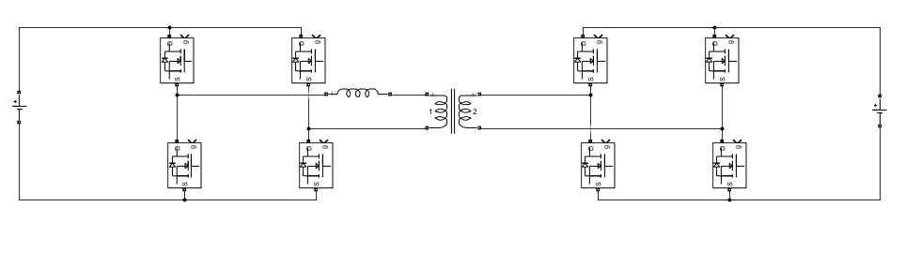
The dual-bridge series resonant converter (DBSRC) imposes a great advantage of zero-current or zero-voltage switching despite changes in load or supply voltage while still maintaining the intuitiveness and simplicity of previously mentioned topology by adding a capacitor near the transformer and forming a resonant circuit.^{[3]}
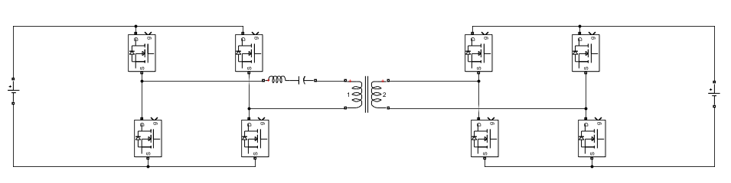
- Ethics & Safety
3.1 Ethics Issues
- Privacy Protection: The car uses computer vision technology for navigation and obstacle avoidance, which may collect and process data from the surrounding environment (such as images of pedestrians, vehicles, or buildings), posing a risk of privacy breaches.
- Fairness and Accessibility: The wireless charging and navigation functions of the car may depend on specific infrastructure (such as wireless charging stations), which may prevent some users or regions from enjoying the technology, resulting in unfairness.
- Environmental Impact: The production, use, and disposal of small cars may have an impact on the environment, such as the handling of batteries and supercapacitors, as well as the energy consumption of wireless charging.
  - Safety Issues
- Supercapacitors and batteries may overheat during rapid charging and discharging, posing a risk of fire or explosion. We will design temperature monitoring and overheat protection mechanisms and use high safety supercapacitors to reduce the risk of thermal runaway.
- Computer vision and navigation systems may malfunction, leading to collisions or loss of control of the car. We will design redundant systems and emergency braking functions to ensure safe parking in the event of system failure.
- The shock absorption system and chassis structure may fail due to overload or fatigue in complex terrain. We can adopt high-strength materials and optimize structural design to ensure mechanical reliability and regularly inspect and maintain mechanical components.
References
[1] C. B. Dwi Kuncoro, W.-J. Luo, and Y.-D. Kuan, “Effect of the Receiver Coil Rotational Motion on Induction Voltage of Wireless Power Charging,” in 2018 4th International Conference on Science and Technology (ICST), Aug. 2018, pp. 1–5. doi: 10.1109/ICSTC.2018.8528674.
[2] A. Ramezani, S. Wang, and M. Perry, “A Misalignment Tolerant Foreign Object Detection for EV Wireless Charging Applications,” in 2023 IEEE Wireless Power Technology Conference and Expo (WPTCE), Jun. 2023, pp. 1–5. doi: 10.1109/WPTCE56855.2023.10215967.
[3] X. Li and A. K. S. Bhat, “Analysis and Design of High-Frequency Isolated Dual-Bridge Series Resonant DC/DC Converter,” IEEE Trans. Power Electron., vol. 25, no. 4, pp. 850–862, Apr. 2010, doi: 10.1109/TPEL.2009.2034662.

