Final Report for ECE 445, Senior Design, Spring 2021
TA: Yichi Zhang
5 May 2021
Project No. 72
Jacob Connor
Yingtong Hu
Mehul Kaushik
By

smart key/key box
Abstract
This document outlines the concepts and findings of a project meant to solve the problem of lost/stolen keys at car dealerships. We wanted to address this problem by engineering a system that would allow for keys to be found within a 100-meter radius using a variety of different feedback features such as sound, visual cues, as well as a compass-like feature for longer distances. Additionally, we designed a jamming system that would prevent any communications from the key to the vehicle for the case of the key being most likely stolen. This jamming functionality is solely limited by the rf module range limit, which for our design is around two kilometers.

Contents

1. Introduction 1
1.1 Objective 1
1.2 Background 1
1.3 High-level requirements list 1
1.4 Subsystem Overview 1
2 Design 4
2.1 Design Procedure 4
2.1.1 Key 4
2.1.2 Key Box 5
2.2 Design Details 6
2.2.1 Key – Power Module 6
2.2.2 Key – Feedback Module 7
2.2.3 Key – Control Module 8
2.2.3 Key Box – Power Module 8
2.2.4 Key Box – Feedback Module 9
2.2.5 Key Box – Control Module 10
2.2.6 Software 10
3. Design Verification 11
3.1 Power Module 11
3.2 Feedback Module 11
3.2.1 Key Feedback Module 11
3.2.2 Key box Feedback Module 12
3.3 Control Module (Key and Key box) 12
4. Costs and Schedule 13
4.1 Costs 13
4.1.1 Parts 13
4.1.2 Labor 13
4.1.3 Sum of costs into a grand total 13
4.2 Schedule 14
5. Conclusion 15
5.1 Accomplishments 15
5.2 Uncertainties 15
5.3 Ethical considerations 16
5.4 Future work 17
References 18
Appendix A Requirement and Verification Table 19
Appendix B Detailed Circuit Diagrams 22
Appendix C Software Algorithm Flow Chart 27
Appendix D Table for Distance measurements using RF transceiver 28

1. Introduction
Our project aims to address the issue of keys being lost and/or stolen, specifically those owned by car dealerships. Our new and improved key/key box system will allow users to locate keys that are up to 100-meters away by using visual and audio cues, as well as a compass-like system. The next few sections will go into more detail about what specific problem we are facing, how we are solving it, and the design for our project that accomplishes these goals.

1.1 Objective
Car dealers deal with a lot of car keys during working hours and have a central location where they keep keys to the cars on the lot. Unfortunately, employees sometimes misplace the car keys, forget to return them after using them for test drives, or the car keys could even be stolen. Replacing car keys takes time and money and poses a security concern.
To combat all these issues, we are proposing a smarter set of keys and a corresponding key box to house all of these and some of the system's features. The keys would be able to be located by making sounds when looking for them. The key box system would be able to activate, deactivate the keys and give a direction to the key which the user is looking for.

1.2 Background
Car keys now have only a tag on each of them, dealers can know which employee took it and which car it belongs to, but not exactly where it is. When it comes to the case that an employee lost the key, dealers cannot do anything with a tag. The same can be said for if the key was stolen. Sure, the dealer could change the keyhole, but it may be stolen with the old key before the keyhole is changed because the thieves steal many keys before stealing cars [7], not to mention the time and hundreds of money associated with changing out the locks on the vehicle [8]. With our smart keys and key box, dealers will be able to find the key when it is within some distance away from the key box and be able to deactivate the key when it is too far away from the key box, which will help reduce the probability of a stolen key leading to a lost vehicle.

1.3 High-level requirements list
1) Keys that are within 5 meters can be tracked with accuracy over 80% via sound ques for when keys are out of the key box.
2) Keys must be able to be activated and deactivated from 100 meters in case if it were stolen.
3) Key subsection should be within the dimensions of 15 x 7 x 1 cm so that mass storage is convenient and is still easy to fit in pockets like regular keys
4) Box should be locked and display status of keys on LCD screen (accounted for, lost, deactivated, etc.)

1.4 Subsystem Overview
Before digging into the subsystems of our project in detail, we will briefly introduce each section and their overall purpose. For both the key and key box, we have a power module, control module, and feedback module as shown in Figures 1 and 2. The subsystems for the key and key box will have similar functionality but will be comprised of different components for the most part. For both systems, the power module will supply the correct voltage to all components, using voltage regulators as needed. Control modules will be almost identical for each system, both comprised of a RF module for communication and microcontroller running the necessary software. The feedback modules will vary considerably. The key’s feedback module will include an LED and speaker responsible for visual and audio cues when searching for the key. The key box will have an LCD providing feedback for how far away they are from the key, as well as reading the status of the selected key.
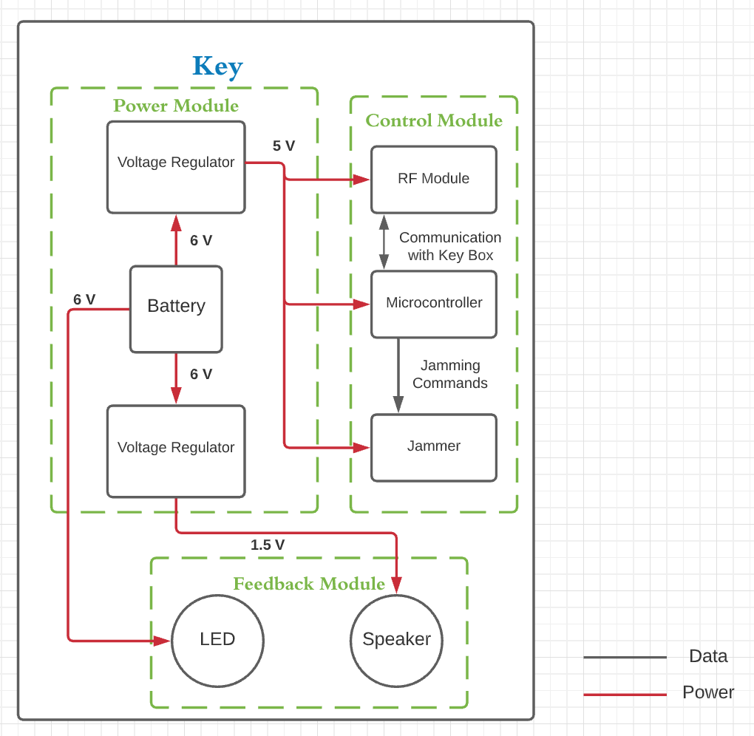
Figure 1 Key Block Diagram
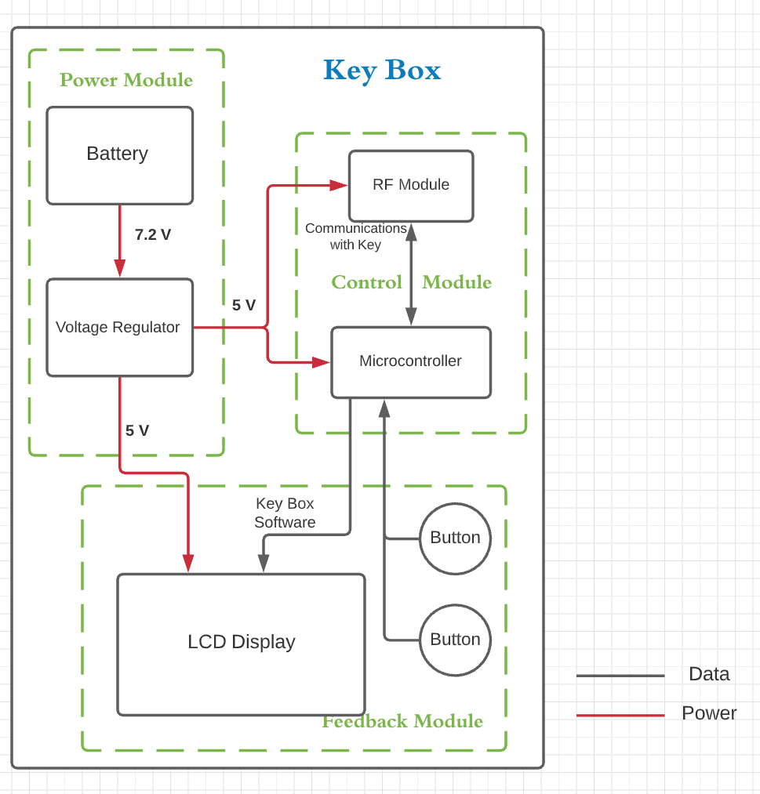
Figure 2 Key Box Block Diagram

2 Design
The design will be broken down into two different main components. The first will be the component located on the key, and the second being the key box. Within these two components are three subsystems each. For both the Key and Key Box to work, they both have a Power Module, Control Module and Feedback Module. These subsystems will be explained in more detail in their respective sections.

2.1 Design Procedure

2.1.1 Key
The key component of the project will be responsible for making sounds and flashing a light to guide users towards it and must be able to deactivate and activate the functionality of the key if a specific signal is received from the key box. The full key circuit diagram can be seen in Appendix B Figure x. This component consists of three modules: Power Module, Feedback Module and Control Module.
The Power module is responsible for supplying stable voltage to each component of the key system. This module consists of batteries and voltage regulators. Because we are implementing this circuit on a key, every module needs to be as small and compact as possible, and the battery needs to be easily replaceable. Thus, we chose to use two Lithium 3V non-rechargeable batteries in series to provide enough voltage output. We chose non-rechargeable batteries because the keys can go missing or be stolen and non-rechargeable batteries are generally cheaper than rechargeable batteries. Due to different voltage requirements of each component, we use two voltage regulators to adjust the voltage supply. One 5V output voltage regulator is used for Control Module, and one 1.5V output voltage regulator is used for the speaker in the Feedback Module.
The Feedback module will be responsible for guiding the user towards the misplaced key. It will do this by using a speaker and a LED that will vary in behavior depending on signals from the control module. There were many kinds of speakers and LEDs for us to choose from, but we have some requirements for them that needed to be met. The speaker needs to have sounds that are loud enough to be heard within 5 meters and the LED needs to be bright enough to be seen within 5 meters. They need to be small enough to fit in the key, with voltage supply that requires the least amount of voltage regulators in the Power Module. Thus, we chose to use LED Lighting series White, Cool 5000K 6V and Speaker 1.5V TOP PORT 81dB. According to How Loud Is 80 Decibels? written by Staff Writer [10], 80 dB is approximately as loud as a dishwasher, so this speaker should be loud enough to provide audible sound within 5 meters.
This module will be responsible for interpreting signals sent from the key box to determine distance, adjust the intensity of sound or light being produced by the feedback module, and control the jammer to disable the key’s functionality. This module consists of a microcontroller and a RF module. The microcontroller should be able to run the software containing system logic and the RF module should be able to measure distance within 100 meters and send out signals that will jam the key signals to the car within 100 meters. Thus, we chose to use a ATMEGA2560-16AU microcontroller provided by Arduino and a 433MHz 2KM RF module. Because we have worked with Arduino before, an Arduino microcontroller is preferable. A 2KM RF module can work within 100 meters, and there is an Arduino library that can provide distance calculations using 433MHz RF modules. We will be using Equation 1 to calculate the communication time:
(1)
$$Time of Flight = \hat{t_{p}}= {(τ}_{B1}-τ_{A1}+τ_{A2}-τ_{B2})/2$$
The parameters are explained in Figure 3, with Node A being key box and Node B being the key.
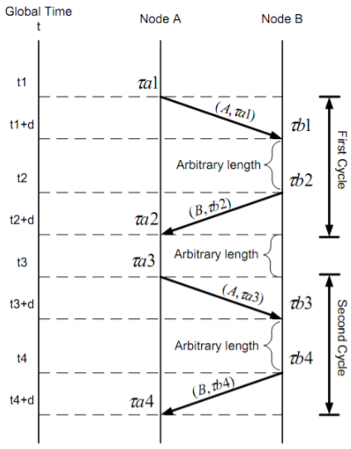
Figure 3 Communication Procedure of RF modules
Then we will use Equation 2 to calculate the distance between key and key box.
(2)
$$d=TOF*v$$

2.1.2 Key Box
The key box component of the project will be responsible for tracking the status of all keys. The full key box circuit diagram can be found in Appendix B Figure 1. It will also be the tool used by the user when searching for lost keys and will be able to remotely deactivate the key via button presses. The status for each key will be shown on an LCD display. Since the key box itself requires power and must be mobile, it will be powered by a rechargeable lithium-ion battery. This system also consists of three modules: Power Module, Feedback Module and Control Module.
The Power Module is responsible to supply steady voltage to each component in the system. It also consists of a battery and a voltage regulator. The Power Module of the key box does not have many requirements as the key, so we chose a compact Li-ion 7.2V rechargeable battery and a 5V output voltage regulator used for the Feedback Module and Control Module.
The Feedback Module will be the main interface used by the user for displaying data from the control module via LCD display and provide input data to the control module from the external buttons. The LCD display needs to be easily readable, and the buttons need to be easily pressed. Components that require the least voltage regulators in the Power Module would also be preferred. Thus, we chose a 5V 16x2 UWVD CHARACTER LCD and two Pushbutton Switches SPST-NO 5V. They require the same voltage supply as the microcontroller and RF module, so only one voltage regulator is needed. A 16x2 character LCD is enough for our system, so we chose it instead of the more expensive 20x2 LCD.
The control module will be responsible for incoming data and outputting data to the Feedback Module on the key box, as well as all the keys. This module consists of the microcontroller used to run software controlling the LCD, and the RF module to communicate with the keys. The microcontroller and RF module have the same requirements as the Key system, except that the RF module does not need to jam the key signals. Because of this, we chose the same kind of microcontroller and RF module as in Key system.

2.2 Design Details

2.2.1 Key – Power Module
Input: two Lithium 3V non-rechargeable battery
Output: +5V for Microcontroller
+5V for RF module
+1.5V for speaker
+6V for LED
This will be responsible for powering the microcontroller and in turn, powering the rest of the components. Because we need 5V for both the microcontroller and RF module, we will use 2 watch batteries to power the device due to their small size and long lifetime. We will use two voltage regulators to reduce 6V to 5V and 1.5V, as in Figure 5:
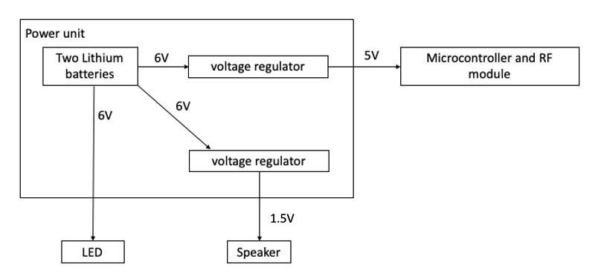
Figure 4 Power supply block diagram for keys
The wiring of the 5V voltage regulator is shown in Appendix B Figure 8. The wiring of the 1.5V voltage regulator is shown in Appendix B Figure 9.

2.2.2 Key – Feedback Module
The speaker represents the method for which the user will be able to find the lost device. When the user presses a button on the key box, a signal will be sent out to the respective key, and in turn the speaker will emit a sound. It will receive power via the control module.
The light will also assist in helping the user find the key. It must be bright enough to be seen from a fair distance away (around 5 meters), but also must be power efficient given the power constraints of a small device that has other features which require power.
Possible inputs and outputs to the speaker and LED are shown in Table 1.
Table 1 Data for Feedback Module of Key
Component | Input | Output
Speaker | SIGNAL HIGH | 81 dB SOUND
 | SIGNAL LOW | NO SOUNDS
LED | SIGNAL HIGH | LIGHT UP
 | SIGNAL LOW | NO LIGHTS
A detailed schematic of the Key Feedback Module is shown in Appendix B Figure 10.
The box at the top is the voltage regulator used for the Speaker. It will output steady 1.5V voltage to the Speaker. The PAD3 and PAD2 are two through holes for connecting the Speaker. Since the Speaker is not SMD format, we cannot directly put them in the PCB schematic. The light bulb at the bottom is the 5V LED connecting to the voltage regulator shown in Appendix B Figure 9.

2.2.3 Key – Control Module
The RF Module will be the component used to communicate with the key box. It will also determine distance from the key box via its time tracking capabilities, and using that information, send signals to the microcontroller to adjust the frequency of the speaker’s audio queues, as well as adjust the blink rate of the LED.
The microcontroller will adjust the frequency of the speaker’s audio queues, as well as adjust the blink rate of the LED based on data received by the RF module. Its final purpose is to control the jammer, which it will do if it has received the corresponding signal from the RF module.
The jammer will be the device responsible for “deactivating” the key. It will essentially block the operating frequency of the actual car key. This will render the key useless since the car will not be able to receive the key’s signals.
The detailed circuit schematic of Key Control Module is shown in Appendix B Figure 11.
The component in the middle is the microcontroller, on the left of it are some resistors and capacitors. These are connected according to the online source of this microcontroller [11]. The two components on the right are the RF module, the upper component is the Transistor and the other one is the Receiver. They are all connected to the microcontroller and will be controlled through the connected pins.
Possible inputs and outputs of RF modules are shown in Table 2.
Table 2 Data for RF Module of Key
Component | Input | Output
Transmitter | (HIGH, LOW) | Sending ‘10’ to Key box Receiver
 | (LOW, HIGH) | Sending ‘01’ to Key box Receiver
Receiver | 100 | Turn on/off LED and Speaker
 | 010 | Deactivate the Key
 | 001 | Activate the Key

2.2.3 Key Box – Power Module
Input: Li-ion 7.2V rechargeable battery
Output: +5V for Microcontroller
+5V for RF module
+5V for LCD display
+5V for buttons
The battery will power all components found in the Control Module and Feedback Module and must be able to do so for at least 12 hours (the operating hours of most dealerships). Because we need 5 volts for all the parts in the key box, we need to reduce 7.2V to 5V as in Figure 5:
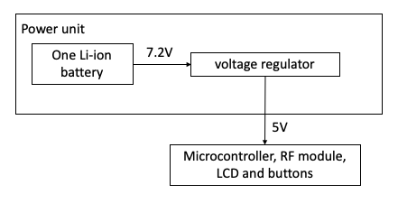
Figure 5 Power supply block diagram for key box
A detailed schematic of the Power Module of the Key Box is shown in Appendix B Figure 12.

2.2.4 Key Box – Feedback Module
The Feedback Module of the Key box consists of an LCD display and two buttons. It is used as the communication tool between the user and the system. The user can press the button to perform certain functions. The LCD display will in turn show the status of the key and currently performing functionality.
The buttons on the outside of the key box will function as the way for the user to search for or deactivate keys. The meaning of each button is shown in Table 3.
Table 3 Button functions
Part | Position | Magnetism
Pushbuttons | Upper | sends the ‘looking for missing key’ signal
 | Lower | sends the ‘activate/deactivate specified key’ signal
The LCD will be utilized by the microcontroller to update information on the status of keys. The LCD will be able to display the correct messages onto the screen according to the status of keys and the button pressed, as shown in Table 4. The user will be able to check information given by the software running on the microcontroller. Since the device may be used indoors or outdoors, the LCD Display must be bright enough to be easily seen in a variety of environments.

 | Table 4 Input signals and output messages on LCD display
Signal from Key | Button Pressed (position shown in Table 3) | Key Status | Message displayed
/ | Upper side button pressed | / | “Looking for key #...”
/ | Lower side button pressed | Activated | “Deactivating key #...”
/ | Lower side button pressed | Deactivated | “Activating key # …”
10 | / | / | “Success”
01 | / | / | “Fail”
The detailed circuit schematic of the Feedback Module of the Key box is shown in Appendix B Figure 13.

2.2.5 Key Box – Control Module
The RF Module will be the component used to communicate with the keys and output this data to the microcontroller. This unit will be identical to those used on the keys, so will share the same requirements. The transmitter will be sending data to the Receiver on the key, and the receiver will be receiving data from the transmitter on the key. Possible inputs and outputs of the RF modules are shown in Table 5.
Table 5 Data for RF Module of Key
Component | Input | Output
Transmitter | (HIGH, LOW, LOW) | Sending ‘100’ to Key box Receiver
 | (LOW, HIGH, LOW) | Sending ‘010’ to Key box Receiver
 | (LOW, LOW, HIGH) | Sending ‘001’ to Key box Receiver
Receiver | 10 | Display “Success” on LCD
 | 01 | Display “Fail” on LCD
The microcontroller will be running software that, given input data from the buttons and RF module, will update the LED’s. Fast processing power is not a high priority in this case since the program does not require the processor to be clocked high. Instead, power consumption is the most important factor since we want to maximize the battery life of the key box.
The detailed circuit Schematic is shown in Appendix B Figure 14.

2.2.6 Software
The software is the high-level controller of the whole system. It receives signals, checks signals, sends signals, displays corresponding messages on the LCD display and monitors the LED and speaker. The overall algorithm is shown in Appendix C Figure 15.

3. Design Verification
The most important part of our project was the successful execution of the Control module in key and key box, and its ability to establish communication between the key box and key. We were successfully able to test and meet this minimum requirement by showing that our design can indeed allow for the key box and key to communicate with one another. However due to certain hardware defects and limitations not meeting our standards, some other modules we had planned to implement were only shown to work with limited functionality. For quantitative results on our verification and tests, please refer to appendix A for summarized verification requirements we expected to meet.

3.1 Power Module
The hardware we planned to use needs a stable 5V power supply. We used voltage regulators that feed in power from the battery via another Li-ion battery compatible charging module that can charge the battery as well. We saw a steady voltage of about 4.95 ± 0.02 V at the output of the voltage regulators which is well within the tolerable range of the all the other hardware in the system.
The speaker on the Key requires lower voltages and hence we used a voltage regulator of 1.5V to power it. Upon measurement, this regulator produced steady 1.47 ± 0.03 V at the output which was well within our required range. The output swing was not of big concern since performance of the speaker output was not very crucial in our project and just serves as a signal to the user of the key’s position.
We could not test it in the consolidated design since we were missing our PCB which was delayed; but on its own, the power module functioned as intended. However, a stress test with all components connected to it was not possible due to the previously mentioned delay of our PCB.

3.2 Feedback Module
The key module’s feedback involves light and sound from a speaker and LED pair. It was relatively easy to confirm that the LED and speaker can be detected at a distance including and up to 5m. The key box, however, involves an LCD panel that displays communication with key and the status of the key in response to button presses on the key box. Verification involved watching the display react to button presses.

3.2.1 Key Feedback Module
The following table gives an idea of the qualitative performance of the LED and speaker. A quantitative analysis was unnecessary since our project was not very heavily dependent on the audio performance of speaker so gain calculations and other audio measurements were not needed.
The LED is surface mounted, so its directionality is severely limited at range, but was functioning as intended during testing and responds to the code on Arduino as well. Future plans may involve getting a protruding, bulb-based LED design for better spread and visibility. A detailed verification for Key Feedback Module is shown in Table 6.

Table 6 Verification for Key Feedback Module
Distance from feedback module (Meters) | Comments
 | LED | Speaker
1 | Very bright. Visible from all angles | Sound is painfully loud and will need to be adjusted
2 |  | Still quite loud but less disruptive
3 |  | Loud enough to pinpoint location of key
4 | Bright enough to be spotted from most angles | Loud enough to pinpoint location of key
5 | Bright only at certain angles | Loud enough to pinpoint location of key

3.2.2 Key box Feedback Module
The ordered LCD panel, unfortunately, showed a design defect where certain data pins on the panel appeared to be connected when we probed them. Further investigation showed that there were traces between those pins that shorted them and hence resulted in a burnout during testing. Nonetheless, we performed verification of software distance measurement and activation/deactivation of key using the serial monitor of the PC. We were successfully interacting with the Arduino using buttons by monitoring the output on the serial monitor of our PC.

3.3 Control Module (Key and Key box)
The control module consists of a microcontroller and RF transceiver for both, key box and key. We successfully verified that the key and key box can send messages to one another, but since we were working with 433MHz transceivers for both the encoder and decoder, we realized that the rate at which we could send large messages was severely limited. We found the rate to be quite unreliable for even 1 bit per second when the modules were talking between key box and key.
This prevented us from making long training messages to synchronize the clocks on key box and key for better measurement of time of flight between the devices. Without the clocks being in synch, we got the varying times as seen in the table found in Appendix D. The datasheet quotes a limit of <5kbps but the real measured time using our software suggests it is far less than that (1bps). Also, the datasheet quotes that it is compatible with ASK library by RadioHead but that does not seem to be the case since RadioHead library did not work upon testing it ourselves.
This proves that we meet the minimum requirement for at least maintaining a stable channel of communication. The only limitation on its functionality, however, is that we can’t make accurate distance measurements using these transceivers and hence better transceiver is recommended with higher bit rates with sufficient stability.

4. Costs and Schedule

4.1 Costs

4.1.1 Parts
 | Table 7 Parts Costs
Description |  | Manufacturer | Part Number | Retail Cost($) | Quantity | Actual Cost ($)
RF module |  | Seeed Technology Co., Ltd | 1597-1225-ND | 26.33 | 3 | 78.99
Microcontroller |  | Arduino | X000048 | 4.5 | 1 | 4.5
Microcontroller |  | Arduino | ATMEGA2560-16AU | 13.68 | 1 | 13.68
Button |  | Grayhill Inc. | GH1368-ND | 2.01 | 2 | 4.02
Battery(non-rechargeable) |  | Panasonic - BSG | P138-ND | 0.38 | 2 | 0.76
Battery(rechargeable) |  | Jauch Quartz | 1908-1346-ND | 28.08 | 1 | 28.08
Speaker |  | Soberton Inc. | 433-1104-ND | 1.73 | 1 | 1.73
LED |  | Cree Inc. | 2138-JK3030AWT-P-B50EB0000-N0000001TR-ND - Tape & Reel (TR) | 0.01 | 1 | 0.01
LCD Display |  | Focus LCDs | 2632-C162ALBVGSW6WN55PAB-ND | 8.58 | 1 | 8.58
Voltage regulator (1.5V output) |  | Texas Instruments | 296-12958-2-ND - Tape & Reel (TR) | 3.65 | 1 | 3.65
Voltage regulator(5V output) |  | Texas Instruments | 296-15015-2-ND - Tape & Reel (TR) | 0.7 | 2 | 1.4
Assortment of resistors, capacitors, oscillators etc. |  | Digikey(est.) | ~ | ~ | ~ | 8.0
Total |  |  |  |  |  | 153.4

4.1.2 Labor
 |  | Table 8 Labor Cost
Name | Hourly Rate ($) |  | Hours | Total ($) | Total * 2.5 ($)
Jacob Connor | 50 |  | 130 | 6500 | 16250
Yingtong Hu | 50 |  | 130 | 6500 | 16250
Mehul Kaushik | 50 |  | 130 | 6500 | 16250
Total |  |  |  |  | 48750

4.1.3 Sum of costs into a grand total
Table 9 Grand Total Costs
Section | Comment | Costs
Parts | Total 12 parts | 153.4
Labor | Total 3 workers | 48750
Total |  | 48903.4

4.2 Schedule
 | Table 10 Project schedule and project allocation
Week | Jacob Connor | Mehul Kaushik | Yingtong Hu
2/8/2021 | Come up with project ideas | Come up with project ideas | Come up with project ideas
2/15/2021 | Revise the whole proposal | Risk analysis, ethics and safety | Introduction, block diagram, ideas of parts
2/22/2021 | Discuss about project design | Discuss about project design | Discuss about project design
3/1/2021 | R&V tables, explanation of parts, block diagram, revising introduction | RF module, Microcontroller, Tolerance analysis | Looking for parts, visual aid, physical design, cost and schedule, revising ethics and safety
3/8/2021 | Order parts, schematics | Study datasheets for RF module, microcontroller | Study datasheets for all other parts, simulation of circuits
3/15/2021 | Test LED, Speaker, LCD and buttons | Program microcontroller | Software development
3/22/2021 | Assemble and test power units with other parts, build and test RF | Test microcontroller, build and test RF module | Test software
3/29/2021 | Fix remaining issues, design PCB | Fix remaining issues, design PCB | Fix remaining issues, design PCB
4/5/2021 | Fix remaining issues.  Assemble all components.  Test PCB | Fix remaining issues.  Assemble all components.  Test PCB | Fix remaining issues that can be solved online
4/12/2021 | Fix remaining issues.  Prepare for mock demo | Fix remaining issues.  Prepare for mock demo | Fix remaining issues.  Prepare for mock demo
4/19/2021 | Make adjustment to the circuits according to TA’s feedback.  Prepare for Demonstration | Make adjustment to the circuits according to TA’s feedback.  Prepare for Demonstration | Prepare for Demonstration.  Prepare for mock presentation
4/26/2021 | Finalize demonstration | Prepare final paper | Prepare presentation
5/3/2021 | Finalize final paper | Finalize presentation | Finalize final paper

5. Conclusion
By the end of the semester, we were able to achieve a considerable amount of overall functionality. We were able to communicate effectively within the desired distance range, store and update the status of the key we were communicating with, and send distinct signals to look for the key, deactivate the key or reactivate it. We were not able to achieve all functionality we had hoped to, due to the unexpected limitations of our RF modules. The full impact of these components will be explained more in-depth in later sections.

5.1 Accomplishments
As previously stated, we were able to send distinct signals from the key box to the key, as well as receive confirmation signals from the key. This allowed us to send deactivation and reactivation signals on one data channel, as well as a “looking for key” signal on a separate data channel. This allowed for us to activate the LED and speaker, as well as initiate the jamming protocol from anywhere within 100-meters of the key box.

5.2 Uncertainties
Despite some of our wireless communication features working, others that required more complex communication failed. These features include distance tracking, which was needed for the compass-like feature, as well as a functional jammer. Starting with the distance calculations required for the compass, we were not able to implement this functionality due to the limitations of our RF modules. Due to the speed of radio waves and size of our communication radius, precise synchronization is required in order to detect the small differences in time of flight used for distance measurements. The common Arduino library used to accomplish feats like this with RF modules is the RH.Ask library. What we quickly discovered is that in order to make use of this library, a high bit rate RF system is required and that our modules were not cut out for such a task. Our RF modules excel at basic, low bit rate communication within a large radius. This forced us to improvise, and attempt to develop our own drivers for the RF modules. We could not successfully implement a synchronization subroutine, and as a result, were forced to use delays to ensure successful communication. These delays in the software created uncertainty in the time it took to send a signal to the key, wait, and receive a confirmation signal. This made distance tracking impossible due to the very strict precision requirements explained earlier.
The other major functionality we failed to implement was a successful jammer. This functionality failed to work due to a major oversight when picking our RF module. The jammer would block communication from a key to the car it is synced to by flooding the frequency with garbage data. Unfortunately, we picked the same frequency we were jamming for the RF modules reserved for communication between the key box and key. This resulted in the communication between our key box and key being jammed whenever we activated the jammer. This would lead one to believe that the jammer would work once pressed, but then the key would just not be able to be reactivated. This is partially correct. We were able to remotely initiate jamming and lose communication with the key as a result. Unfortunately, however, the jammer itself did not entirely block communication from the key and vehicle regardless. This will be discussed more in future work.

5.3 Ethical considerations
Since our project relies heavily on RF communication with multiple keys, our project runs the risk of “emitting by products of radio emission” [1]. This means we would have to control our radio emission from radio frequencies to minimize disruption to other services working close to our device’s operating range. We will try our best to remain within FCC regulations for RF devices [2]. This is most relevant for when our radio jammer prevents cars from being opened using the key fob. We do not want to cause interference with nearby RF signals like garage doors, other car doors, emergency alarms etc. One way to curb this is to measure using a receiver if the key fob is being used, and only then apply the appropriate jammer frequency to the transmitter, limiting interference to the surroundings.
According to IEEE code of Ethics [9], we will try our best “to hold paramount the safety, health, and welfare of the public, to strive to comply with ethical design and sustainable development practices, to protect the privacy of others, and to disclose promptly factors that might endanger the public or the environment;”. We will make sure of this by considering the following parts: battery charging, acceptable sound and light, protection of the circuits and extension of the key.
We will be working with rechargeable batteries like Lithium-ion. To avoid harm to our consumer through shock via uncontrolled voltage/current and prevent overcharging of the batteries, we will do our best to adhere to all safety precautions related to Lithium-ion batteries. This may involve double checking our power supply voltages and currents, and work within the safe operating points of our chosen battery [2].
On keys, we add speakers and LEDs. For better user experience, we need to make sure that the sound of the speaker is not strident, and the light of LED is not dazzling, but they should still maintain the functionality of indicating the place of keys within 5-meters distance from the key box.
Although the key box will be indoor for most of the time, the keys are being carried around and have the possibility of experiencing rain and hit. We need to make sure that water and other damages to the key will not cause the inside circuit to be shorted, because short circuits bring danger to the user [6]. To deal with this problem, we will add extra protection onto the circuit inside the key. The LED and the speaker will be the connection of outside and inside of keys, so we also need to make sure that water will not go inside the key from these two places by adding additional protection.
Consumer safety may also extend to moving parts in our project: for example, the actuator that deactivates physical keys by lodging a piece of metal in the key that prevents it from fitting in the keyhole. One way to prevent harm to user of key in case the actuator is triggered, is to carefully control torque such that it has sufficient strength to block the key from usage but at the same time, it is slow enough and comes with a warning through sound to alert user of the deactivation process. The slower motor will be less of a mechanical hazard since it gives the user time to move out of its way through in future design, we will continue to work on this challenge keeping user safety and security in mind.
When we are working in lab, we will be working with all the electronic parts and may need to solder the circuit. We will also be working in the same lab with other people, which is a safety risk during the pandemic. To prevent possible harm to us and others, we will attend lab safety training, follow the instructions and be careful during work.

5.4 Future work
Our choice of RF modules was the cause of many shortcomings in the final functionality of our project, such as distance calculation and jamming functionality. In order for our design to be successful, we would need to pick a new set of RF modules, or use a different form of communication entirely. Choosing a set of modules that operates on a frequency other than 433MHz would be mandatory, since this is the frequency being jammed when the key is deactivated. The new set of modules would also have to still be able to satisfy the range requirement. Using a set of modules that have a high bit rate and operate on a frequency other than 433MHz would solve both problems described in Section 5.2 but would not fix the issue of the jammer not being fully effective. We are currently unsure as to what caused the jammer to not completely block communications between the key and vehicle, but these issues would need to be resolved in order to have a fully functioning system. More research would be needed to determine the exact cause of this behavior.

References

[1] “Equipment Authorization – RF Device.” Federal Communications Commission, 20 Mar. 2018, www.fcc.gov/oet/ea/rfdevice.
[2] Reczek, Karen, and Lisa M Benson. “A Guide to United States Electrical and Electronic Equipment Compliance Requirements.” 2017, doi:10.6028/nist.ir.8118r1.
[3] Garcia, Saul Emmanuel, Brian Shaw, and Ryan Joseph Dobbins. Software Defined Radio Localization Using 802.11-style Communications. : Worcester Polytechnic Institute, 2011.
[4] Chaudhari, Qasim. “There and Back Again: Time of Flight Ranging between Two Wireless Nodes.” DSP, 23 Oct. 2017, www.dsprelated.com/showarticle/1100.php.
[5] Baba, Asif Iqbal. “Calibrating Time of Flight in Two Way Ranging.” 2011 Seventh International Conference on Mobile Ad-Hoc and Sensor Networks, 2011, doi:10.1109/msn.2011.23.
[6] “Basic Electrical Safety” Aug. 15, 2020. Accessed on: Mar. 8, 2021. [Online]. Available: https://www.ehs.washington.edu/fire-life/basic-electrical-safety
[7] “5 vehicles, 45 car keys stolen by burglars at Ancira dealership, police say” Feb. 19, 2021. Accessed on: Mar. 8, 2021. [Online]. Available: https://www.ksat.com/news/local/2021/02/20/5-vehicles-45-car-keys-stolen-by-burglars-at-ancira-dealership-police-say/
[8] “Car key replacement for less” Consumer Reports magazine. July, 2013. Accessed on: Mar. 8, 2021. [Online]. Available: https://www.consumerreports.org/cro/magazine/2013/07/car-key-replacement-for-less/index.htm
[9] “IEEE Code of Ethics” IEEE. Accessed on: Apr. 2, 2021. [Online]. Available: https://www.ieee.org/about/corporate/governance/p7-8.html
[10] Staff Writter. “How Loud is 80 Decibels?”. March 25, 2020. Accessed on: May. 5, 2021. [Online]. Available: https://www.reference.com/science/loud-80-decibels-55b434cc4de10d3c
[11] ARDUINO MEGA 2560 REV3. Arduino. Accessed on: May. 5, 2021. [Online]. Available: https://store.arduino.cc/usa/mega-2560-r3

Appendix A Requirement and Verification Table
Table 11 System Requirements and Verifications
Requirement | Verification | Verification status  (Y or N)
- Speaker  - Must be loud enough to be heard from 5 meters away.  - Must be power efficient due to battery/power constraints (1V~2V) | - Perform tests within 5-meter radius and ensure it can be easily heard.  - Measure the input voltage and make sure the voltage is within the range of 1V and 2V before connecting to the speaker | Y
- LED  - Must be bright enough to be seen from 5 meters away.  - Must be power efficient due to battery/power constraints (6V) | - Perform tests within 5-meter radius and ensure it can be easily seen.  - Measure the input voltage and make sure the voltage is around 6V before connecting to the LED | Y
- RF Module for Key  - Must be able to accurately determine distance between itself and key box (accuracy of around 5-meter increments)  - Must consistently be able to send and receive signals from 500 meters away.  - Must be power efficient due to battery/power constraints (5V) | - Measure sound coming from speaker in decibels from any distance away.  - Move towards the speaker (covering at least 5 meters)  - Measure sound coming from speaker again.  - Ensure that there is a noticeable change in frequency of audio queues.  - Connect RF Module to microcontroller and LED for simple testing circuit.  - Set up camera to record circuit to monitor LED.  - Send signals from the RF Module on the key box at 500 meters or less.  - Observe camera footage and ensure that the signals were received | N
- Microcontroller for Key  - Must be able to control LED, speaker, and jammer simultaneously.  - Must be power efficient due to battery/power constraints (5V) | - Connect LED, speaker and jammer to the microcontroller.  - Activate the jammer.  - Attempt to power speaker and LED while jammer is active.  - Ensure that all components are working as intended throughout entire duration of test | Y
- Jammer  - Must not allow any signals to be received by vehicle when jammer is active.  - Must be power efficient due to battery/power constraints (5V) | - Determine operating frequency of the vehicle whose key is getting jammed.  - Initiate the jammer using the frequency found in 1.  - Attempt to use any function on key.  - Ensure that the car did not receive the key’s signals | N
- LCD Display  - Must be easily viewed in variety of lighting conditions (e.g., Daytime and nighttime)  - Must display the correct messages listed in Table 1 onto screen.  - Must operate at 5V voltage supply | - Bring the LCD outside and ensure that the screen is still easily readable.  - Press different buttons to see if the correct message is displayed.  - Measure the input voltage and make sure the voltage is around 5V before connecting to the LCD | N
- Buttons  - Must be easy to use, which means the user does not need to push very hard to trigger.  - Must be able to send out the correct signal stated before this R&V.  - Must operate at 5V voltage supply.  - Must be debounced | - Measure the input voltage and make sure the voltage is around 5V before connecting to the button.  - Press button  - Check signal received by the microcontroller to ensure there are no mechanical complications | Y
- RF Module for Key box  - Must be able to send data back to the key box within 500 meters | - Key box will receive packets of data containing enough information to carry out appropriate tasks in response | Y
- Microcontroller for Key Box  - Must use about 1W power consumption rate when running software and 0.25W during power save mode.  - Must successfully estimate the distance to a key within reasonable margin of error.  - Must be power efficient due to battery/power constraints (5V) | - Load software onto microcontroller and monitor power consumption to ensure it meets our standards.  - Carry out Time of Flight calculations for key and update LCD accordingly. The TOF must give a distance reasonably close to the actual distance of the key from the key box. | N
- Battery  - Must be able keep at least 90 mAH so that the box can run for the entire 12 hours on one charge. | - Load software onto microcontroller and monitor power consumption to ensure it meets our standards | Y

Appendix B Detailed Circuit Diagrams
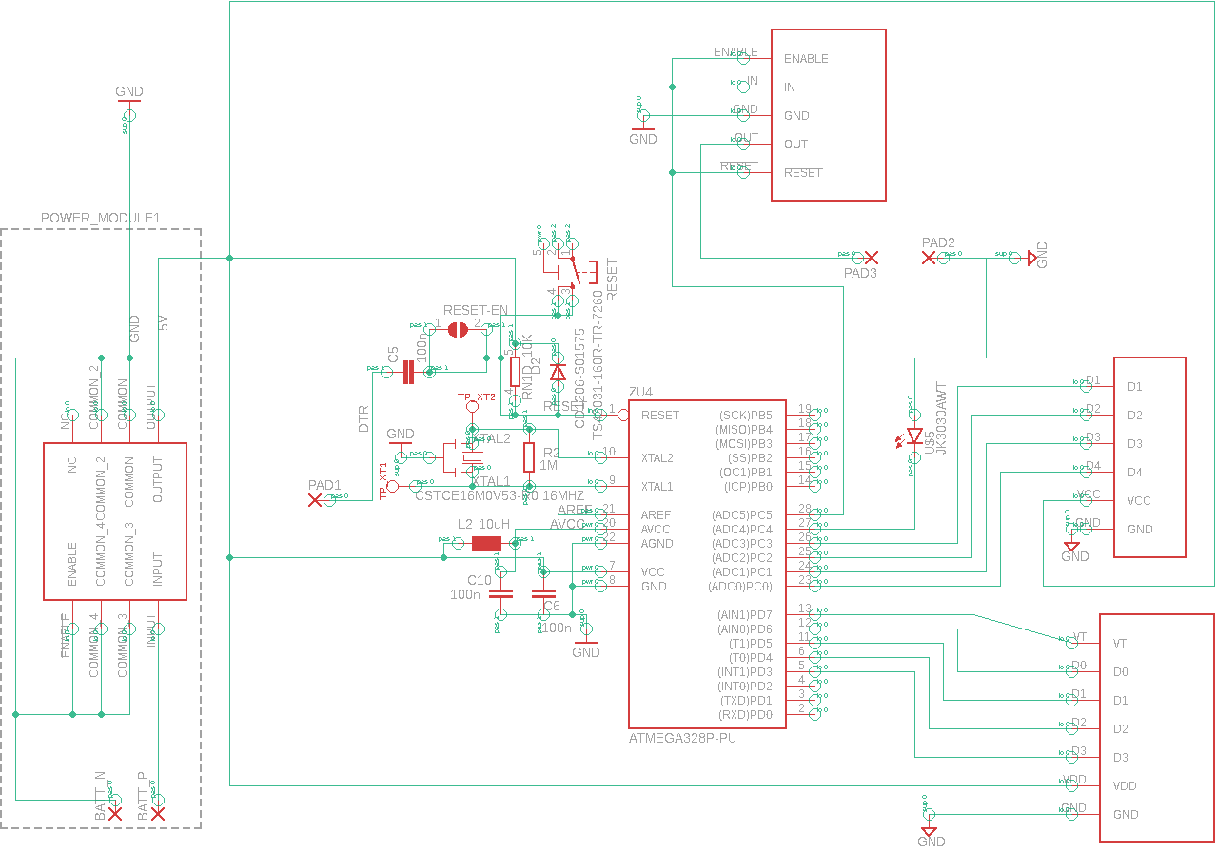
Figure 6 Key Circuit Diagram
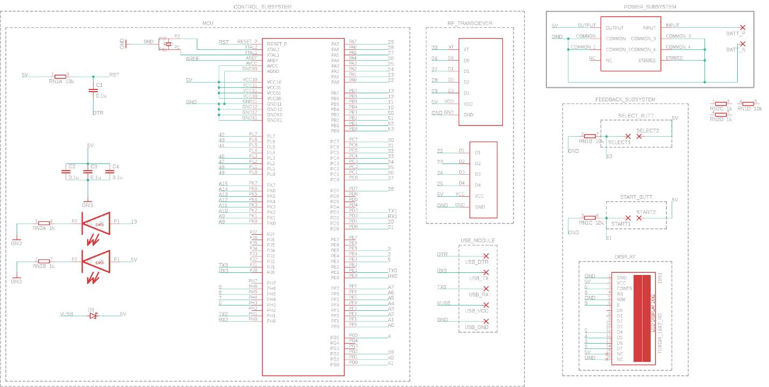
Figure 7 Key Box Circuit Diagram
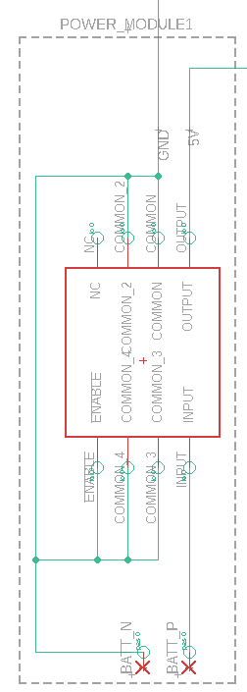
Figure 8 5V voltage regulator circuit schematic for keys
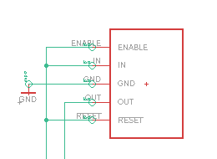
Figure 9 1.5V voltage regulator circuit schematic for keys
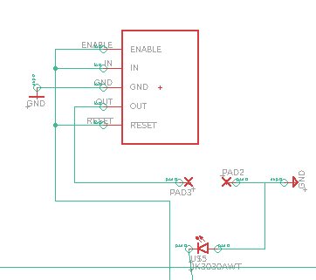
Figure 10 Circuit Schematic of Key Feedback Module
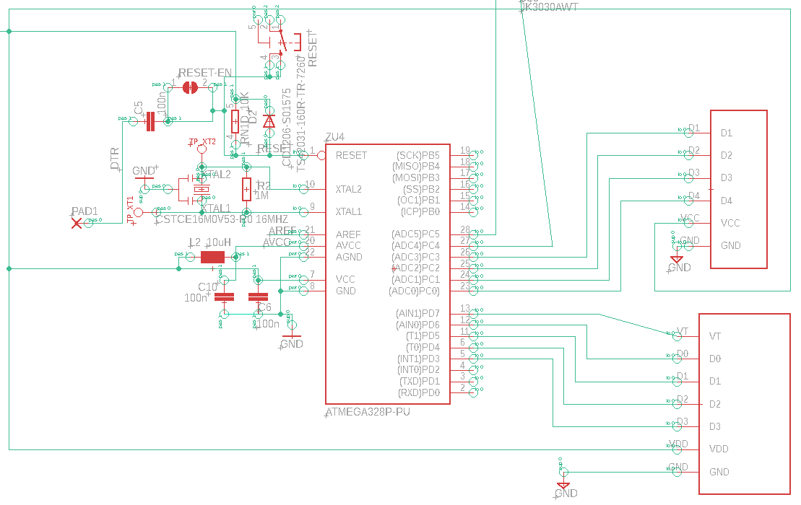
Figure 11 Circuit Schematic for Key Control Module
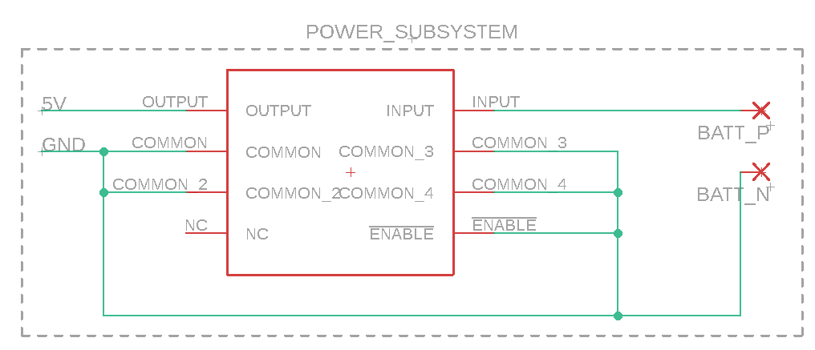
Figure 12 Circuit schematic of Power Module of Key Box
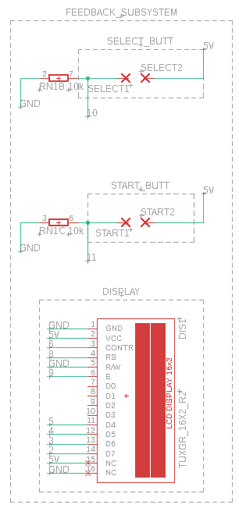
Figure 13 Circuit Schematic for key box Feedback Module
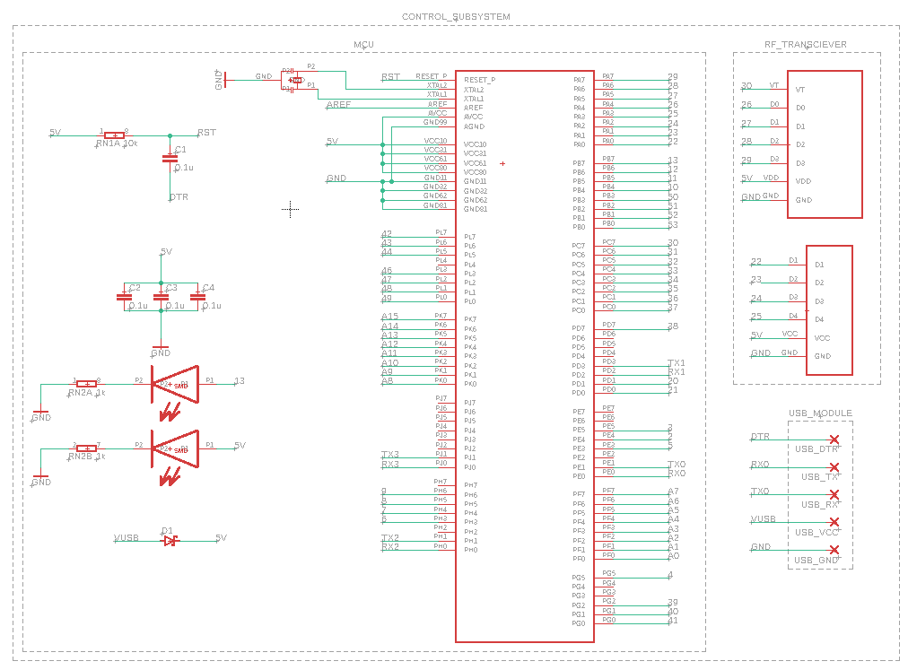
Figure 14 Circuit Schematic for key box Control Module

Appendix C Software Algorithm Flow Chart
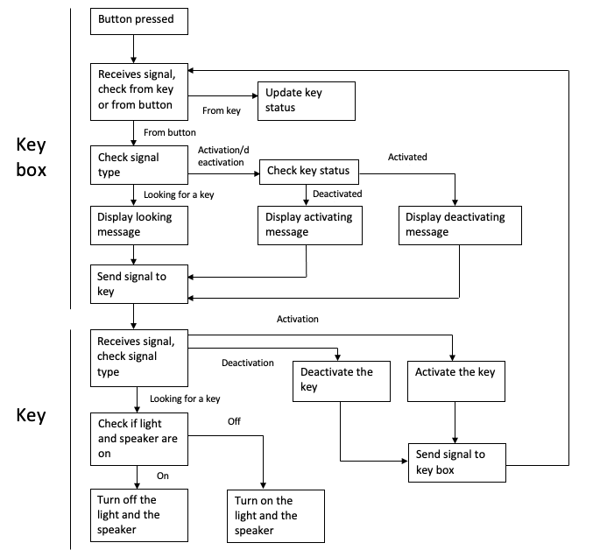
Figure 15 Software Algorithm

Appendix D Table for Distance measurements using RF transceiver
Table 12 Time taken for message to travel per round over same distance
Component | Round number | Time of Flight(ns)
RF Module | #1 | 3452983
 | #2 | 5324958
 | #3 | 1345093
 | #4 | 9584938
 | #5 | 2348593
 | #6 | 2234894
 | #7 | 5493094

