ECE 445 Design Document
Chilo Llamas, Immanuel Fernando, Nithin Nathan
Team 65
TA: Yichi Zhang
3/2/2021

Self-cleaning locker

1 Introduction

1.1 Objective

Sanitation means everything, especially in a pandemic. We must make sure that ourselves and our belongings are clean in order to help mitigate the spread of COVID. Especially with more companies, buildings, restaurants, and gyms opening up, it's becoming easier for the disease to spread. Particularly with gyms, people are constantly sharing lockers with others, which can easily spread germs due to the storage of their sweaty belongings and clothes.

To combat the spread of COVID, and germs in general, we are proposing a self-cleaning locker. When the locker detects that nothing is inside, it will automatically disinfect the inside of the locker using disinfectant sprays. An LED display on the outside of the locker door will display the status of whether or not it is cleaned, and if there is still disinfectant in the locker.

In addition, we will be building an app that will monitor the status of the locker. For gym owners, the app will allow them to keep track of all their self-cleaning lockers in their locker rooms and make sure that every locker is properly maintained for the safety of their employees and individuals using the gym’s lockers.

1.2 Background

We are trying to solve the issue of germs spreading between uses at gym lockers. The gym locker is the main area to hold someone’s belongings while using the gym, and everyone throws their belongings in there. However, no one knows who has used that particular locker before them, and if that person has been in contact with other people who have had COVID. Since the locker room is a shared space, an individual really has no choice where else to put their belongings, and whether or not the locker they choose is COVID, or germ free in general.

The gym is one of the easiest places where bacteria can spread. Many different parts of the building and locker room have a multitude of germs. For example, the gym faucet handle has 545,312 CFU (colony forming units), which has eight times as many bacteria than a school cafeteria water fountain spigot. Gym benches have 8,241 CFU, which has six times more bacteria than an animal cage [1]. Contact with these objects can easily lead to the spread of germs. In addition, research shows COVID can last up to two days on fabric, and even up to nine days on certain surfaces [2], [3].

This is where our project comes in. The main problem we are trying to solve is allowing users to have that ease of mind by not worrying about who has used the locker before them, and whether or not it’s clean to put their belongings in by eliminating bacteria that could be spread from surface to clothing, and ultimately an individual.

1.3 Physical Design
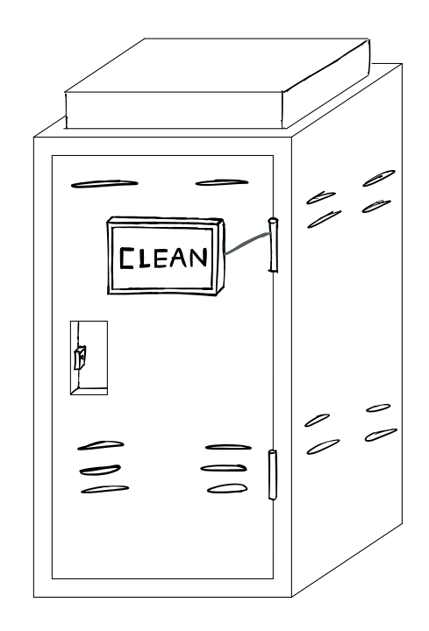
Figure 1: Sketch of locker front exterior
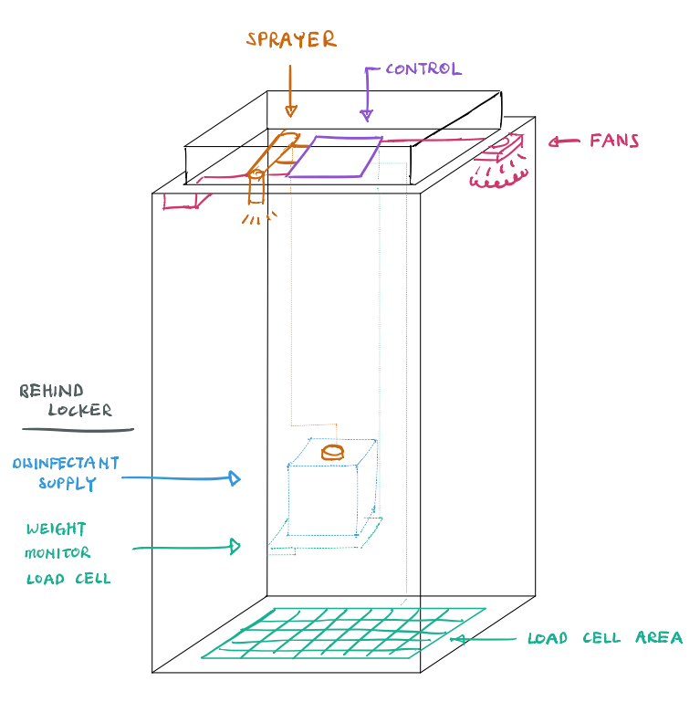
Figure 2: Sketch of locker interior with subsystems

1.4 High Level Requirements
- Weight sensors correctly detect when items weighing at least 250 grams are on top of them with an error range of roughly 5%.
- Spray correctly cleans the inside of the locker when it is empty and closed, covering at around 90% +/- 5% of the interior surface area.
- Project correctly detects different disinfectant supply levels with an error range of around 5% at each level.

2 Design

The three main subsystem modules we will be using for our project will consist of a control unit, disinfectant unit, and monitoring unit. We will go into each module into further detail.

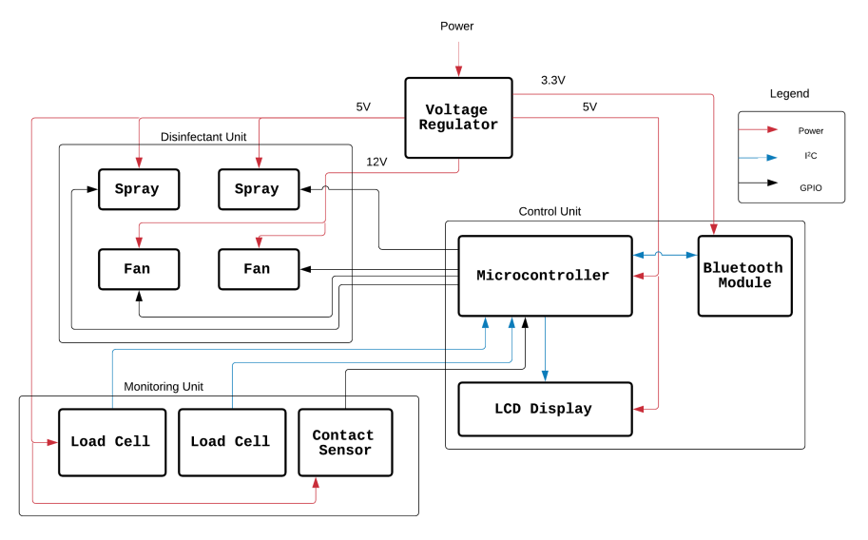
Figure 3: Block Diagram

2.1 Power Supply
Our locker will be plugged into a wall outlet but will make use of a voltage regulator to fine tune how much voltage we want to supply to certain components in our design. We will be using a power supply with two voltage rails. The first will be a 5V rail that will go to every device but the fans. We decided that we needed to have powerful fans to be able to quickly dry the locker after cleaning. Thus, we wanted to use bigger 12V fans optimized for airflow rather than tiny 5V fans that cannot really push much air.

2.1.1 Voltage Regulator
The voltage regulator will allow us to choose how much power to supply to each of our subsystems. Using our step-down power converters, we will output either +3.3V, +5V, and +12V to the corresponding subsystems / components we are using.

2.2 Control Unit
Our control unit allows for all our subsystems to communicate with one another on which actions to perform depending on the conditions met concerning the status of our locker. Our inputs for this subsystem will be +5V going into both our ATMEGA328P-PU microcontroller and LCD display, along with +3.3V going into our HC-05 Bluetooth module. The desired input voltages will come from using our voltage step-down power converters. The outputs from the control unit will be sent to our fans, sprays, and LCD display.

2.2.1 Microcontroller
The microcontroller we are using, the ATMEGA328P-PU, will be used to program our LED display, along with handling communication between all our subsystems. This will control when to activate our sanitizing module and fans, and then display on our LED display whether the locker is ready to use. Because the microcontroller is part of the Control Unit, it is imperative that the microcontroller transmits all the correct signals to the appropriate parts of the project.
Requirements | Verification
- Microcontroller should correctly communicate progress of sanitation cycle with LCD display.  - Microcontroller should program the Bluetooth module to transmit data to the Android application. | - Build clock circuit (as seen in circuit schematic).  - Check that LCD correctly displays “CLEANING” while sprayer and fan components are on.  - Check that LCD correctly displays “CLEAN” when sprayer and fan components are done / off.  - Check that LCD correctly displays “LOW SUPPLY” when disinfectant supply hits 25% +/- 5% error range.  - Microcontroller should take in data from load cell amplifier and output to Bluetooth module.  - Bluetooth module should change Android Studio global variable value based on load cell amplifier output

2.2.2 Bluetooth Transceiver
The Bluetooth module we will be using is the HC-05. This will be used to communicate the level of disinfectant supply within our locker to our Android application. This will take in the output of the weight sensor underneath our disinfectant supply tubes and forward it to our Android application.
Requirements | Verification
- Module needs to correctly communicate information about disinfectant supply level at 100%, 75%, 50%, 25%, and 0% (+/- 5% error range) with Android application.  - Module must be able to receive and transmit information accurately from up to 20-30 feet away. | - Using Bluetooth terminal application and serial communication on Android phone along with code on Arduino, check that output on Bluetooth terminal shows values equal to output of weight sensor for disinfectant supply in the correct format.  - Test that connection holds on physical Android phone 20-30 feet away from locker.

2.2.3 LCD Display
The LCD display will communicate with our microcontroller and will be used to display the current status of the locker’s interior to the user. It will be situated on the outside of the locker in order to not get affected by the sanitation cycle running in the interior of the locker.
Requirements | Verification
- LCD should be visible from one meter away  - LCD should display “CLEANING” when locker is sanitizing  - LCD should display “CLEAN” when locker sanitation has finished  - LCD should display “LOW SUPPLY” when disinfectant supply hits 25% (+/- 5% error range) | - Check that LCD display is visible within one meter of standing.  - Check that LCD correctly displays “CLEANING” using I2C communication while sprayer and fan components are on.  - Check that LCD correctly displays “CLEAN” using I2C communication when sprayer and fan components are done / off.  - Calibrate microcontroller and load cell amplifier with default weight (1000 grams).  - Place weight that is 250 grams (25% of 1000) and see if LCD correctly displays “LOW SUPPLY” using I2C communication.

2.3 Disinfectant Unit
The disinfectant unit will be responsible for sanitizing the interior of our locker when no items are inside of it. Fans will be used to help dry the interior after we spray disinfectant on the surfaces of the inside through the circulation of air. The main inputs for this subsystem will be power coming from our voltage regulator and signals coming from our Control Unit, letting the Disinfectant Unit know when to run its cycle. Our input will be information from our microcontroller to let this subsystem know when to turn on, along with +5V for our sprayer, along with +12V for our fans. These two separate voltage values will come from our step-down power converters. Our output for this subsystem will be our sprayers and fans turning on when desired.

2.3.1 Sprayer
We will use an automatic sprayer to spray our disinfectant and sanitize the interior of our locker. The input to the sprayers will be +5V and signals coming from the Control Unit. The sprayer will be oriented in such a way that at least 90% of the interior surface area is covered by the end of the sanitation cycle.
Requirements | Verification
- Have the spray be able to cover around 90% +/-5% of the interior surface area. | - Using a colored liquid, initialize spraying unit.  - Measure how much area spray covered of interior by hand and divide by total interior surface area. (Colored area in meters² / Total interior surface area in meters²; [m*m / m*m])

2.3.2 Fans
The fans will be used to circulate air throughout the interior of the locker after the sanitation cycle has run. The locker door should be closed when the fans operate. Additionally, the LCD should display the current status of the locker to the user as well.
Requirements | Verification
- Fans should be powered with 12V +/- 5% coming from the outlet plug.  - Fans should circulate air throughout the inside of the locker to ensure that the interior is dry. | - Connect multimeter and oscilloscope across the voltage regulator to measure if the potential difference across fan stays within 5% of +12V.  - Check that humidity of locker interior is no more than 20% of environment humidity using humidity sensor.

2.4 Monitoring Unit
The monitoring unit will be used to monitor whether there are items inside the locker and will communicate with our disinfecting unit on whether to initialize or not. This unit will also monitor the amount of disinfectant supply within the locker and will communicate with our LCD display and an Android app about certain locker information, such as supply level, and whether it is in use.

2.4.1 HX711 Load Cell Amplifier
The HX711 load cell amplifier will be used to be able to amplify the voltage output of our load cell. This will be used to find a more specific value for our disinfectant supply level. This will take in the wires from the strain gauge load cells as input, and then output to our microcontroller.

2.4.2 Load Cell (Locker bottom)
This load cell will be located at the bottom of the inside of the locker to detect if there are any objects on top of it to communicate to the MCU whether to start the sanitation process.
Requirements | Verification
- Check if load cell can detect at least 250 grams on top of it. | - Connect load cell to load cell amplifier. Have load cell amplifier output to LED.  - Place 250-gram object on load cell.  - See if LED lights up when object is placed.

2.4.3 Load Cell (Disinfectant Level Monitoring)
This second load cell will be used to measure how much disinfectant there is left in our locker in order to clean it.
Requirements | Verification
- Load cell should output different voltage values based on different weight values (increasing weight should correspond to increasing voltage out) | - Connect load cell to load cell amplifier.  - Place 250-gram object on load cell and check program if 250-grams is read correctly.  - Place 500-gram object on load cell and check program if 500-grams is read correctly.  - Place 750-gram object on load cell and check program if 750-grams is read correctly.

2.4.4 Contact Sensor
The contact sensor will be attached to the inside of the locker door to check whether the door is closed or not.
Requirements | Verification
- Have the sensor correctly output 0/1 based on whether the door is open / closed. (0 for open, 1 for closed) | - Connect output of sensor to breadboard and use a simple LED to check if sensor correctly outputs 0 if open and 1 if closed.

2.4.5 Application
The Android application will act as a central monitoring system for all connected lockers. Each locker will have its status listed for an employee to check on the locker room. This will be created using Android Studio.
Requirements | Verification
- Android application should be able to monitor locker disinfectant supply levels for 100%, 75%, 50%, 25%, and 0% levels (with around 5% error range).  - Android application should report information regarding status of locker to user.  - Android application should connect to Bluetooth transceiver within 20-30 feet of locker. | - Using Bluetooth terminal application on Android phone along with code on Arduino, check if global variable on Android Studio changes based on disinfectant supply levels.  - Test on a physical Android phone walking 20 to 30 feet away from locker and checking if connection holds.

2.5 Software

The software that will be used includes programming our microcontroller, as well as Android Studio to develop our Android application to monitor our disinfectant supply for our locker.
The microcontroller will be used to program what our LCD display shows based on our lockers condition. If there is no weight in our locker and the door is closed, the sanitation process will commence, and the LCD display will show the text “CLEANING”. Once the sanitation process is complete, the microcontroller will communicate to the LCD display to show “CLEAN”. Additionally, when the disinfectant supply level reaches 25%, that subsystem should communicate with the MCU to make the LCD display show “LOW SUPPLY”.
Android Studio will be used alongside the HC-05 Wireless Bluetooth RF Transceiver to monitor our disinfectant supply levels. We will connect our HC-05 to our microcontroller that communicates with the information from our disinfectant supply monitoring subsystem. We will have to download a Bluetooth Terminal Application on our Android phone to get information from our HC-05. Using Android Studio, we will create an application that reads the data from the HC-05 that comes from our microcontroller to display the amount of disinfectant supply at certain levels. The microcontroller will get the disinfectant supply data from our load cell amplifiers that will be connected to our strain gauge load cells for monitoring the disinfectant supply levels. The levels we want to show will be 100%, 75%, 50%, and 25% full. These will be represented by a full green battery icon for 100%, a 3/4 full green battery icon for 75%, a yellow 1/2 full battery icon for 50%, and a red 1/4 full battery icon for 25%. That way, a gym owner can see finer information about the supply levels of their lockers in a real-world application.

2.6 Schematics
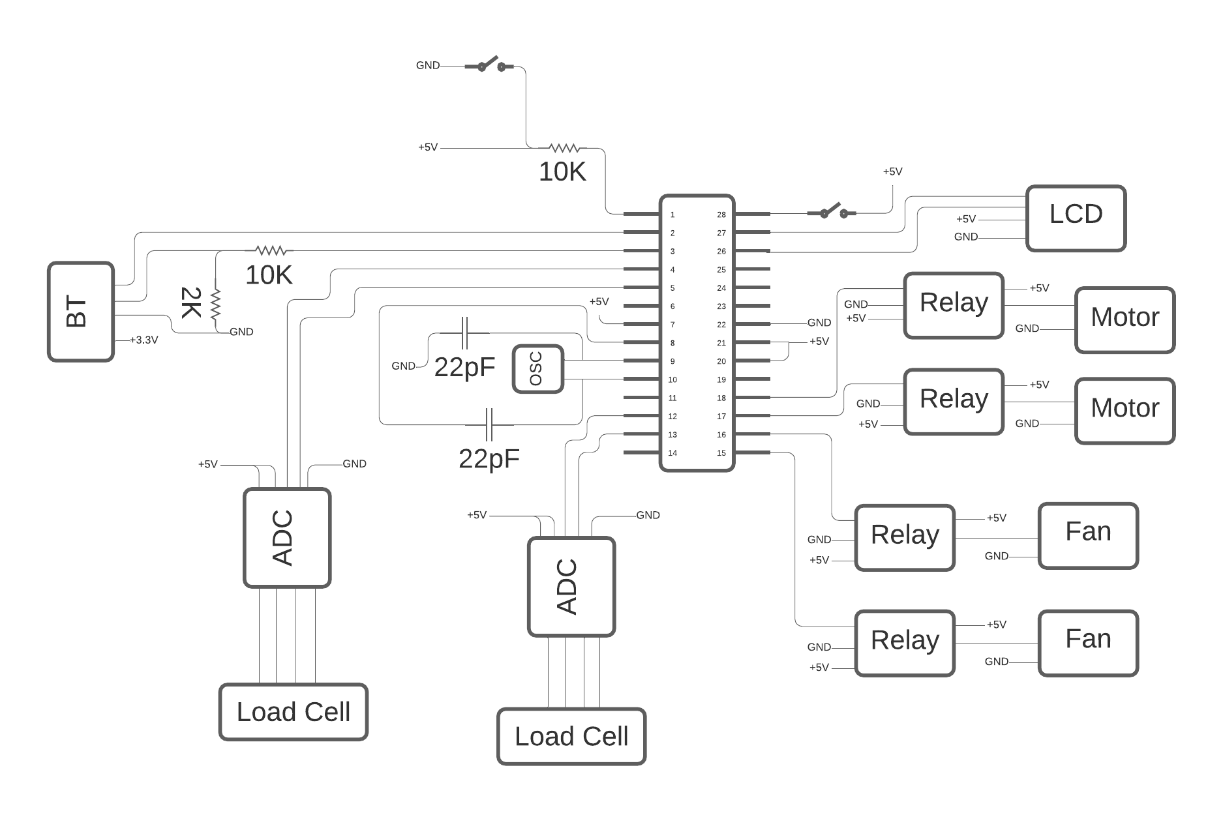
Figure 4: Circuit Schematic

2.7 Board Layout
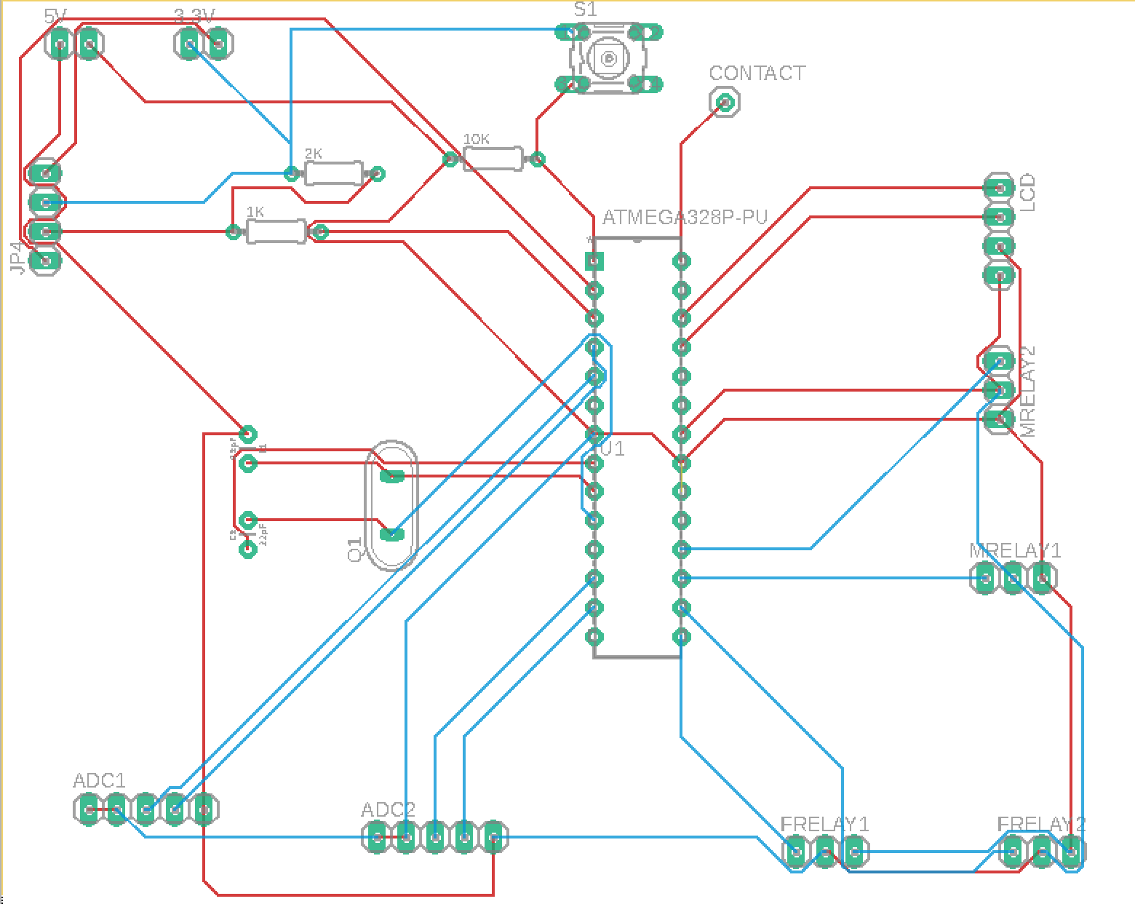
Figure 5: Board Layout

2.8 Tolerance Analysis

One important tolerance we want to maintain is being able to detect objects of at least 250 grams. Our strain gauge load cell will be used to detect if there are objects inside the locker to know whether to initiate cleaning. However, readings from the load cell are very small. Our load cell has a Wheatstone Bridge circuit built into it, with gauge sensors replacing the resistors shown in the figure below:
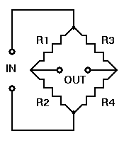
Figure 6: Wheatstone Bridge Circuit
These strain gauges commonly have a base resistance of either 120Ω, 350Ω, or 1000Ω (we will use 120Ω as a placeholder value, as the strain gauge load cells we ordered do not tell us) [7]. If R1 / R2 = R3 / R4, then our voltage output will be 0. However, when there is strain on one of these gauges, it will increase its resistance value based on the amount of strain. This percent change in resistance is given by:
$$\% Change in Resistance = \left[\left(Gauge Factor\right) · Strain\right] · 100$$ | (Eq. 1)

Based on the Wheatstone Bridge, the output Voltage will be calculated using:
$$V_{out} = \left[ \left(\frac{R3 }{ R3+R4}\right) - \left(\frac{R2}{R1+R2}\right)\right] · V_{in}$$ | (Eq. 2)
We want to be able to detect at minimum 250 grams. We calculate the amount of strain by first finding the amount of stress that at 250-gram object would create. We use the following stress equation along with our locker dimensions to find this value:
$$Stress =\frac{ Force }{ Area}$$ | (Eq. 3)

$$Stress =\frac{ \left(0.250kg · 9.81 m/{s^{2}}\right)}{\left(0.35m · 0.31m\right)} = 22.6 Pa$$

To find strain, we can use the following equation to find the relationship between stress and strain:
S$tress = \left(Elastic Modulus\right) · Strain$ | (Eq. 4)
The elastic modulus is the proportionality constant based on the material of the strained object. Our load cell is aluminum, so the modulus will have a value of 7.0 * 10^10 Pa [8]. Plugging these numbers into our equation 3, we get a strain value of 3.23 * 10^-10 ε. Plugging this strain value into equation 1, with a Gauge Factor of 2 (a common gauge factor for metallic strain gauges), we end up with a 6.46 * (10^-8) % change in resistance.
This change in resistance is very small, and plugging that into equation 2 for R1, with a voltage input of 5.5V, we would only get a voltage output of 0.0888 µV. While this value is what is expected out of a load cell, it is still a very small value to read.
To get more accurate measurements, especially with our load cells that will be reading change of weight on top of it (for our disinfectant supply monitoring system), we are using the HX711 Load Cell Amplifier. What this load cell amplifier does is allows our load cell output to be amplified with a gain of either 128 or 64, with a full-scale differential input voltage of +/-20mV or +/-40mV, based on what gain we choose [9]. Using this load cell amplifier, this will enable us to detect our base weight of 250 grams, along with being able to accurately tell between different weight values on our load cell to correctly implement our disinfectant supply monitoring system.

3 Costs

Our fixed development costs are estimated to be $40/hour, for 12 hours a week for three people. We are using the length of a semester to determine the number of weeks to work on this (16).
$$3 · \frac{\$40 }{hour } ·\frac{ 12 hours}{week}·16 weeks·2.5 = \$57,600$$ | (Eq. 5)

Part | Cost (prototype) | Cost (bulk)
Battery Powered Sprayer (Amazon; Craftsman; B08KH81W9Q) | $7.56 | $7.56
ATMEGA328P-PU Microcontroller (Digi-Key; Microchip Technology; ATMEGA328P-PU-ND) | $2.52 | $2.09
HC-05 Wireless Bluetooth RF Transceiver (Amazon; HiLetgo; B071YJG8DR) | $7.99 | $7.99
MC-38 Wired Door Sensor (Amazon; Gikfun; B0154PTDFI) | $6.98 | $6.98
DC 12V Cooling Fan (Amazon; PANO-MOUNTS; B07D493BDX) | $13.99 | $13.99
HX711 Load Cell Amplifier (SparkFun; SEN-13879 ROHS) x2 | $19.90 | $8.46
LCD Module (Amazon; KNACRO; B01ID8O574) | $6.22 | $6.22
Strain Gauge Load Cell - 4 Wires - 20Kg (Adafruit; 4543) x3 | $11.85 | $3.16
Locker (Ikea; 204.765.20) | $40 | $40
12V DC 2A Wall Power Supply Adapter (Amazon; XINKAITE; B07GRZB5Y9) | $9.99 | $9.99
10pcs Mini360 3A DC Voltage Step Down Power Converter (Amazon; SongHe; B07T7L51ZW) | $6.88 | $6.88
Capacitor Ceramic 22pF (SparkFun; COM-0857) x5 | $1.25 | $0.23
Oscillators (Digi-Key; 887-2015-ND) x3 | $0.90 | $0.14
Total | $136.03 | $113.69

We will only be making one locker, and therefore our total prototype cost will be $136.03 for one unit, which includes the locker cost. Without the locker cost, the rest of the components have a total of $96.03.
The total development cost will be $57,736.03. The quoted machine shop labor is $56.12 an hour, with 12-16 hours spent on it approximately.

4 Schedule

Week | Chilo | Nithin | Immanuel
3/8/2021 | Go to lab to start testing components and building subsystems | Go to lab to start testing components and building subsystems | Go to lab to start testing components and building subsystems
3/15/2021 | Develop baseline Android application | Continue building out physical circuit schematic | Finalize PCB Design 1
3/22/2021 | Test Bluetooth module with Android application | Testing load cell accuracy for overall project | Finalize PCB Design 2
3/29/2021 | Connecting sanitation subsystem to monitoring unit on breadboard | Connecting sanitation subsystem to monitoring unit on breadboard | Connecting sanitation subsystem to monitoring unit on breadboard
4/5/2021 | Program microcontroller | Program microcontroller | Finalize PCB Design 3
4/12/2021 | Final testing | Final testing | Final testing
4/19/2021 | Mock Demo & remove bugs | Mock Demo & remove bugs | Mock Demo & remove bugs
4/26/2021 | Demonstration | Demonstration | Demonstration
5/3/2021 | Presentation & Final Paper | Presentation & Final Paper | Presentation & Final Paper

5 Ethics and Safety

We are responsible for keeping the public’s safety, health, and welfare in mind when designing this project. This refers to the IEEE Code of Ethics, #1, stating “to hold paramount the safety, health, and welfare of the public” [10]. We must be sure that our locker does not pose any safety concerns for people when using our device. We will go into how we would implement the required safety restrictions in our project later in this section.
Another ethical concern that is out of our control would be the discrimination of use with our product. This refers to the IEEE Code of Ethics #7, stating “to treat all persons fairly and with respect, and to not engage in discrimination based on characteristics such as race, religion, gender, disability, age, national origin, sexual orientation, gender identity, or gender expression” [10]. While we will never discriminate the use of our product based on the characteristics of a person such as race and gender, in a real-world application of our product where it is readily available in public gyms, certain establishments may discriminate against certain people on the use of the lockers. We do not have a solution for this, as it is out of our control as to how someone else may allow others to use our locker. The best thing we can do is to investigate whether a buyer has a good record of respecting an individual’s race, gender, religion, etc., if we were to sell this product.
In terms of safety for our self-cleaning locker, we must make sure that our pressure sensor is accurate in detecting whether there are items, even small ones, in our locker. We must make sure that no one's belongings get wet on accident by our sensor not detecting that they are there. Another safety issue that can come up is the issue of wiring in our project. We want to make sure that our wires do not short and cause damage to anything. We will address this by covering our wires with electrical tape whenever possible, along with having circuitry in a separate encasing on the exterior of the locker.
Another health concern will be the issue of the toxicity of disinfectant used in our locker. There has been research on the effects of disinfectant spray inhalation and the effect that it has on people. There have been studies on asthmatic patients inhaling disinfectant spray (three doses of 0.6 mg of benzalkonium chloride in water), and 20% of those patients observed signs of Bronchoconstriction [11]. The amount of spray that is released and how much the fan dries it off to prevent inhalation of sanitation solution must be monitored carefully, along with looking at more research, to ensure that our locker does not pose any health concerns to users of the locker along with people in the surrounding area.
An additional health concern would be our locker being a potential fire hazard. Because we have electrical parts that could cause a spark when burning out or shorting, we must make sure that our disinfectant supply must not be flammable or combustible to prevent a fire in our locker, or even an explosion. The solution we decided on due to this issue is 3% Hydrogen Peroxide (H₂0₂), and this solution is not combustible [12].

References

- “Germs in the Locker Room,” FitRated. [Online]. Available:https://www.fitrated.com/resources/germs-in-the-locker-room/#:~:text=According%20to%20our%20test%20swabs,room%20faucets%20were%20even%20dirtier. [Accessed: 18-Feb-2021].
- J. Sensakovic, “How Long Does Coronavirus Last On Clothes?,” Hackensack Meridian Health, 27-Aug-2020. [Online]. Available: https://www.hackensackmeridianhealth.org/HealthU/2020/08/27/how-long-does-coronavirus-last-on-clothes/#:~:text=Research%20suggests%20that%20COVID%2D19,days%20for%20plastic%20and%20metal. [Accessed: 18-Feb-2021].
- J. Migala, “How is Coronavirus Spread? Here's What You Should (and Shouldn't) Worry About,” Health, 18-Aug-2020. [Online]. Available: https://www.health.com/condition/infectious-diseases/how-is-coronavirus-spread. [Accessed: 18-Feb-2021].
- “7-segment Display and Driving a 7-segment Display,” Basic Electronics Tutorials, 16-Feb-2018. [Online]. Available: https://www.electronics-tutorials.ws/blog/7-segment-display-tutorial.html. [Accessed: 19-Feb-2021].
- L. Ada, “Adafruit 16-Channel PWM/Servo HAT &amp; Bonnet for Raspberry Pi,” Adafruit Learning System. [Online]. Available: https://learn.adafruit.com/adafruit-16-channel-pwm-servo-hat-for-raspberry-pi/powering-servos. [Accessed: 19-Feb-2021].
- N. *, “Weight Sensor : Different Types and Its Specifications,” ElProCus, 03-Feb-2020. [Online]. Available: https://www.elprocus.com/weight-sensor-working-and-its-specifications/. [Accessed: 19-Feb-2021].
- S. Al-Mutlaq, Getting Started with Load Cells. [Online]. Available: https://learn.sparkfun.com/tutorials/getting-started-with-load-cells/all. [Accessed: 04-Mar-2021].
- W. Moebs, S. J. Ling, and J. Sanny, “12.3 Stress, Strain, and Elastic Modulus - University Physics Volume 1,” OpenStax. [Online]. Available: https://openstax.org/books/university-physics-volume-1/pages/12-3-stress-strain-and-elastic-modulus#fs-id1163713135600. [Accessed: 04-Mar-2021].
- “24-Bit Analog-to-Digital Converter (ADC) for Weigh Scale,” SparkFun. [Online]. Available: https://www.sparkfun.com/products/13879. [Accessed: 04-Mar-2021].
- “IEEE Code of Ethics,” IEEE. [Online]. Available: https://www.ieee.org/about/corporate/governance/p7-8.html. [Accessed: 18-Feb-2021].
- P. A. Clausen, M. Frederiksen, C. S. Sejbæk, J. B. Sørli, K. S. Hougaard, K. B. Frydendall, T. K. Carøe, E. M. Flachs, H. W. Meyer, V. Schlünssen, and P. Wolkoff, “Chemicals inhaled from spray cleaning and disinfection products and their respiratory effects. A comprehensive review,” International Journal of Hygiene and Environmental Health, 15-Aug-2020. [Online]. Available: https://www.sciencedirect.com/science/article/pii/S1438463920305381. [Accessed: 05-Mar-2021].
- Hazardous Substance Fact Sheet [PDF]. (2016, May). New Jersey Department of Health.

