ECE 445
SENIOR DESIGN LABORATORY
PROJECT PROPOSAL

Bike Theft Lock & Chain Detector

Team 74
Natasha Sherlock ,Jonathan Lee, Zhuoyuan Li
Spring 2024
Professor: Arne Fliflet
TA: Tianxiang Zheng
Contents
1. Introduction
1.1 Problem
1.2 Solution
1.3 Visual Aid
1.4 High-level Requirements
2. Design
2.1 Block Diagram
2.2 Subsystem Overview
2.2.1 Theft Detection Subsystem
2.2.2 Camera Subsystem
2.3 Subsystem Requirements & Verifications
2.3.1 Theft Detection Subsystem
2.3.2 Camera Subsystem
2.4 Tolerance Analysis
3. Ethics and Safety
4. Reference

Introduction

1.1 Problem
In the Champaign-Urbana area, an estimated 856-1070 bikes are stolen each year [1], with most perpetrators going unapprehended and missing bikes seldom recovered. A mere 5-10% of bike theft cases are solved in the campus area [2]. Bike theft often goes unnoticed when locks are cut, particularly during nighttime or with limited witnesses. The situation is only getting worse, with the number of bikes reported stolen on campus surging from about 51 bikes in 2021 to 148 bikes in 2023 [2].
1.2 Solution
In order to alert the bike user swiftly and provide important information about the thief, the proposed solution is a cable bike lock that detects when the cable is cut. A current will be passed through the cable and an open circuit will be detected by the microcontroller if the cable is cut. When the cable is cut, our cameras positioned on the cable and bike will record images that may potentially identify the criminal. The microcontroller will also send out a signal to trigger an alarm, as well as relay all this information to the user via bluetooth connection. The entire system serves to provide multiple layers of safeguards for the user’s bike. First, it deters theft attempts. Second, it alerts the public to a crime. Third, it captures evidence that can enable bike recovery.

1.3 Visual Aid
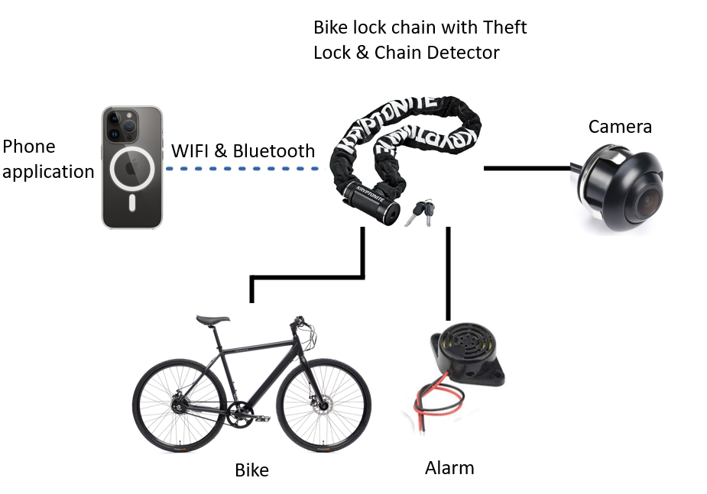

1.4 High-level requirements list
- Our system must achieve a 95% (± 3%) accuracy in detecting when a cable is cut, minimizing instances of false alarms.
- The system should capture and transmit images within 5 seconds (± 3 seconds) of detecting an open circuit. This will ensure that detection is prompt and evidence is collected in a timely manner.
- The system should set off an alarm within 5 seconds (± 3 seconds) of the cable being cut.
- The batteries of the device should last for about 3.0± 0.5 hours.

Design

2.1 Block Diagram
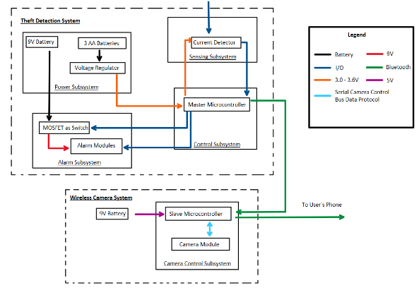
2.2 Subsystem Overview
2.2.1 Theft Detection System
Sensing subsystem:
The sensing system, or open circuit detection subsystem, is used to detect if the lock chain of the bike is cut and send signals to the microcontroller when the chain is cut. The system with its circuit is powered by the power system. The open circuit detection subsystem consists of a circuit along the lock chain and a current detector used to detect if such circuit is open. A signal will be sent to the microcontroller indicating that the circuit is open.
Sensing subsystem:
The sensing system, or open circuit detection subsystem, is used to detect if the lock chain of the bike is cut and send signals to the microcontroller when the chain is cut. The system with its circuit is powered by the power system. The open circuit detection subsystem consists of a circuit along the lock chain and a current detector used to detect if such circuit is open. A signal will be sent to the microcontroller indicating that the circuit is open.
Alarm subsystem:
The alarm subsystem guarantees that the alarm will be triggered within 5±3sec after the lock is cut. It consists of a voltage boost converter and an alarm module. The voltage boost converter serves to boost up the voltage received from the power supply subsystem so that the alarm module, with a higher voltage, can make a larger sound. The alarm is expected to make a sound of about 65dB.
Power subsystem:
The power supply system is used to supply power to our whole system. An alkaline 9V battery will be used to power the alarm system. Four 1.5V AA Alkaline batteries in series will be connected to an LM317 voltage regulator to supply 3.0 ~ 3.6 V to the ESP32-S3-WROOM microcontroller, and less than 10mA to the circuit cable in the open circuit detection subsystem. The power supply system will additionally use a 9V battery to power the speaker in the sound alarm subsystem.

Control subsystem:
The control subsystem in the theft detection system consists of a master microcontroller that controls the device. The system is powered by the power system. From the sensing subsystem, the microcontroller’s IO receives the signal that indicates the lock has been cut, and sends signals using its IO to the alarm subsystem, informing the alarm to sound. Meanwhile, the microcontroller sends signals via bluetooth to the remote camera control subsystem, which controls the wireless camera system. The ESP32-S3-WROOM, a generic Wi-Fi + Bluetooth LE MCU module, is used as the microcontroller.
2.2.2 Wireless Camera Systems
Power subsystem:
Since the wireless camera system is separate from the theft detection system, a separate power system will be used to power the camera system. Four 1.5V AA Alkaline batteries will be connected in series to an LM317 voltage regulator to get a lower voltage for the camera microcontroller. The power supply system is hardwired to our subsystems to supply 5V and 500mA to the ESP32-S in the camera controller subsystem.
Camera control subsystem:
This is the slave microcontroller to the control subsystem in the theft detection system. A ESP32-S microcontroller is used for this control system. Using its bluetooth 4, it receives the signal from the theft detection system. Then it sends a signal from its IO to the camera module, informing the camera to start shooting images. After the recording, the microcontroller receives the photos the camera captured and sends them to the user’s phone via bluetooth.
2.3 Subsystem Requirements
2.3.1 Theft Detection System
Sensing Subsystem:
Requirement | Verification
Within 7±3mA current runs through the circuit. | Use a small ammeter to detect current value.
Within 3.0V to 3.6V voltage to power the detector. | Use a multimeter to measure DC voltage.
Successful detection whether the current is lower than 5mA. | Detects whether the signal is high using an LED in the absence of the <5mA that should run through the cable.

Alarm Subsystem:

Requirement | Verification
65±15dB sound recorded from within 5 feet of alarm module | Use a microphone to capture alarm sound and measure dB.
Alarm will be triggered within 5±3sec after the lock is cut | Use a timer to detect the time the alarm triggered after the lock is cut.
Alarm signal from the microcontroller is received within 2±0.5sec. | Use a timer to detect the time when the alarm signal from the microcontroller is high at the end of the alarm subsystem.

Power Subsystem:

Requirement | Verification
The used battery provides constant DC voltage of 9±0.6V to the speaker in the sound alarm subsystem. | Use a multimeter to measure DC voltage.
Voltage regulator steps down the voltage from 6V to 3.3±0.3V to power the detector. | Use a multimeter to measure DC voltage.
Supply a 7±3mA current to the sensing subsystem. | Use a small ammeter to detect current value.

Control Subsystem:

Requirement | Verification
The control subsystem sends an alarm signal to the alarm subsystem after receiving the open circuit signal from the sensing subsystem within 0.5±0.1sec. | Check the time between the high open circuit signal and the high alarm subsystem.
The signal to the camera slave microcontroller is sent within 0.5±0.1sec after receiving the open circuit signal via bluetooth. | Check the time when the open circuit signal is high and the time when the bluetooth signal is sent by the microcontroller.
The subsystem provides a constant 3.3±0.3V voltage with a 15±3mA DC current to the sensing subsystem. | Use a small ammeter and multimeter to detect current and voltage value.

2.3.2 Wireless Camera System
Power Subsystem:
Requirement | Verification
Voltage regulator steps down the voltage from 6V to 3.0±0.3V to power the camera control subsystem. | Use a multimeter to measure DC voltage at the power pin of the microcontroller.
Ensure the maximum DC current provided to the camera subsystem is within 500mA±100mA | Use an ammeter to detect current value at the output of the LM317.
Ensure battery life of 3 hours ± 30 minutes | Use a multimeter to test the DC voltage of the battery supplies before using it in the system. When the batteries are connected to the system, read voltages at the input of the LM317, ensuring it is above 4.8V±0.2V

Camera Control Subsystem:

Requirement | Verification
The bluetooth module of the camera control subsystem successfully received the camera signal from its master microcontroller after 10±0.5 sec. | Connect LEDs to the receiver pin of the ESP32-S, and have a GPIO pin connected to another LED. Write code to power the LED via the GPIO pin on any signal received from the master microcontroller.
Ensure the camera-consent-signal is sent to the camera subsystem through the serial control bus within 5±3 sec after the camera signal from its master is received. | Connect the main microcontroller to the computer and ensure that proper protocols are written to have transmitter send to the receiver of the slave microcontroller
Ensure the microcontroller starts to send the image to the user’s phone 10±5 sec after it receives the image data from the camera module. | Check the code and ensure that proper Bluetooth 2 way communication protocols are set up properly, and test by attempting to find the module on a phone, and connecting to said module.

2.4 Tolerance Analysis
A key factor to the success of our project is the functionality of our power system. To properly power the rest of our project, we will need to apply the LM317 Voltage Regulator chip to step down the battery from 9V to an appropriate voltage between 3.0V and 3.6V.
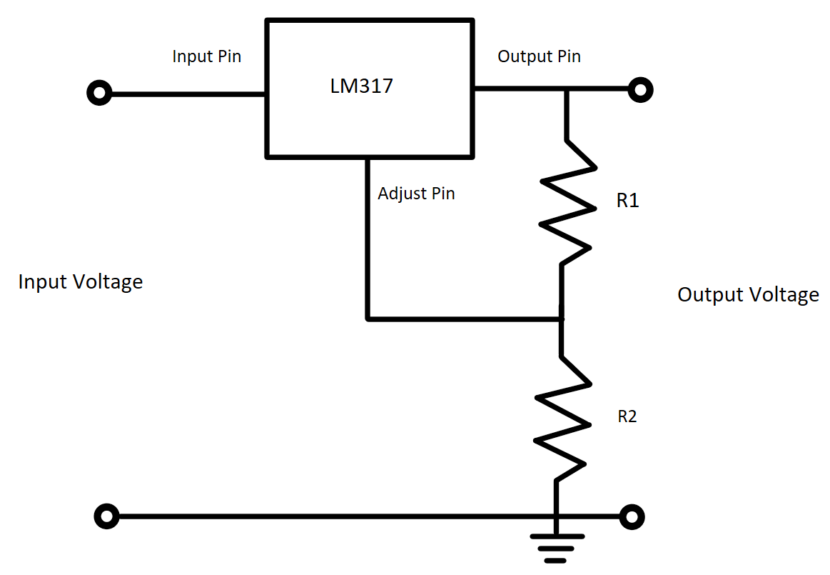
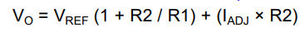
While the equation for the output voltage given by the datasheet [6] is shown in Equation 1, the output current from the adjust pin is listed as 50 microamps, and will not interfere with our application, thus simplifying to Equation 2.
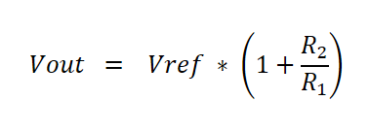
(2)

Since the regulator works by sourcing a current to output a voltage 1.25V higher than the voltage from the adjust pin, Vref will be set to 1.25. The equations can then be solved by picking an arbitrary output voltage between 1.25V and 37V by selecting physical resistors to create the ratio needed for the selected output voltage. Thus, a potential pair of resistors can have 470Ω and 750Ω values.
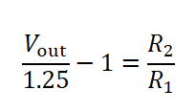
(3)

Ethics and Safety
Our project is guided by the IEEE Code of Ethics and the ACM Code of Ethics and strives to comply with all ethical standards. As our project involves capturing evidence of an alleged crime, we must ensure that we are complying with Section II of the IEEE Code of Ethics, which outlines the responsibilities of engineers to “avoid injuring others, their [...] reputation or employment by false or malicious actions [or] rumors”[3]. In accordance with Illinois privacy laws, a person may not be secretly recorded in certain private spaces, but public areas like bike racks and outside of university buildings do not fall under this prohibition. The purpose of this system is to alert and collect evidence, not to incriminate any individual.
In accordance with Section 1.2 of the ACM Code of Ethics, we will ensure that the current that will run through our system to detect bike lock tampering will not be significant enough to cause any harm to an individual [4].
The safety of all users who interact with the Bike Theft Lock & Chain Detector and the security of the users’ bike are of utmost importance.

References

[1] “Bike Theft in Champaign-Urbana,” Bikelab, Sep. 12, 2014. [Online]. Available: https://bikelab.shop/blog/bike-theft-champaign-urbana [Accessed Feb. 9, 2024].
[2] B Crane, “Bike Theft Surges on University of Illinois Campus, but Online Reporting System Aids Police Investigations,” January 4 2024. [Online]. Available: CU-CitizenAccess, https://cu-citizenaccess.org/2024/01/bike-thefts-surge-on-university-of-illinois-campus-but-online-reporting-system-aids-police-investigations/. [Accessed Feb. 9, 2024]
[3] IEEE, “IEEE Code of Ethics,” ieee.org, Jun. 2020. [Online]. Available: https://www.ieee.org/about/corporate/governance/p7-8.html [Accessed Feb. 10, 2024]
[4] ACM, “ACM Code of Ethics and Professional Conduct,” Association for Computing Machinery, Jun. 22, 2018. [Online]. Available: https://www.acm.org/code-of-ethics [Accessed Feb. 10, 2024]
[5]“Handson Technology Datasheet ESP32-CAM WiFi+Bluetooth+Camera Module.” [Online] Available: https://www.handsontec.com/dataspecs/module/ESP32-CAM.pdf [Accessed Feb. 10, 2024]
‌[6] Texas Instruments, "LM317 3-Terminal Adjustable Regulator," Texas Instruments, 2020, [Online]. Available: https://www.ti.com/lit/ds/symlink/lm317.pdf. [Accessed: Feb. 10, 2024]

