Final Report for ECE 445, Senior Design, Spring 2014
TA: Mustafa Mukadam
05 May 2014
Project No. 19
By
Gang Yang

James Kolthoff

Yandong Li
Crop Care Robot

Agronomic Sensing, Computation and Treatment Delivery
Abstract
We designed and built the sensing subsystem for the Crop Care Robot project. The Crop Care Robot is expected to accomplish agricultural work such as seeding at pre-determined GPS locations, removing weeds, spraying chemicals on crops etc. To be able to perform these tasks, the Crop Care Robot is equipped with a spectral sensor, which collects data that can be used to analyze the health of crops based on nitrogen and oxygen levels, as well as several other factors. The robot also uses a stereo camera, which detects weeds from a distance. The project also includes a home base, which is the command center of robots and communicates wirelessly with robots. The home base assigns tasks to robots, performs several maintenance tasks, and handles data provided by the robot.
Table of Contents
1.0 Introduction 1
1.1 Statement of Purpose 1
1.2 Objectives 1
1.2.1 Goals 1
1.2.2 Functions 1
1.2.3 Benefits 1
1.2.4 Features 1
1.3 High Level Project Division 2
2.0 Design 2
2.1 Control Unit 2
2.1.1 Power Electronics – 3.3 VDC Voltage Regulator 3
2.1.2 MCU1 3
2.1.3 MCU2 3
2.1.4 Multiplex3 Spectral Sensor 3
2.1.5 RS232 Level Converter 4
2.2 Plant/Weed Detector 4
2.2.1 Plant Detection 4
2.2.2 Distance Calculation 5
2.2.3 Crop/Weed Decision 5
2.2.4 Weed Detection Communication 5
2.3 Home Base 5
2.3.1 Power Electronics 5
2.3.2 Sensing 6
2.3.3 Battery Replacement 6
2.3.4 Wireless Communication 6
2.3.5 User Interface 6
2.3.6 Controller 7
2.3.7 Optional Data Storage 7
3.0 Design Verification 8
3.1 Control Unit 8
3.2 Plant Weed Detector 9
3.2.1 Plant Detection 9
3.2.2 Distance Calculation 9
3.2.3 Crop/Weed Decision 10
3.2.4 Weed Detection Communication 10
3.3 Home Base 10
3.3.1 Power Circuitry 10
3.3.2 Control and Sensing 10
3.3.3 Communication and User Interface 10
4.0 Cost 12
4.1 Parts 12
4.2 Labor 13
4.3 Total Costs 13
5.0 Conclusion 14
5.1 Accomplishments 14
5.2 Uncertainties 14
5.3 Ethical Considerations 14
5.4 Future Work 15
References 16
Appendix A Requirement and Verification Table 17

1.0 Introduction

1.1 Statement of Purpose
The Crop Care Robot is designed to perform several agricultural tasks in a field that can be as large as ¼ by ¼ mile. First, the robot seeds at pre-determined GPS locations. Once seeding is over and the crops begin to grow, its role is to take care of the crops. In this state of crop growth, the robot will help detect weeds among the crops and remove them. It will also analyze the crops’ nutrition levels and health status, and will spray chemicals on the crops if necessary. The project also includes a home base, which is the command center of the robots and communicates wirelessly with the robots. The home base assigns tasks to the robots based on a web-based user interface, stores plant data gained by the robots and resupplies the robots when they run out of batteries, seed or chemicals. The home base can also send data through the internet or a network (for example, a cloud storage) for long term storage.
Our project focuses on the sensing and control subsystem, which is in charge of detecting plant/weed, obtaining plant health and nutrition data and deciding what actions the robot should take. Moreover, our project also includes the controls and communication aspects of the home base (not the mechanical design).

1.2 Objectives

1.2.1 Goals
This project has several goals. The first goal is to successfully detect any weeds among crops (crop is seen as plant by weed/plant detector). We have an algorithm which uses GPS locations and camera detection of plants to achieve that. The second goal is to ensure smooth communications between sub-blocks of the robot and the home base. The third goal is to collect (using a spectral sensor) the crop health information and store the data. The fourth is to build the home base control and communication circuitry.

1.2.2 Functions
- Collect (using a spectral sensor) the crop health information and send it to a base station
- Detect weeds and send removal signal
- Controlling home base to store data and resupply robot
- Communicate with the other subsystems

1.2.3 Benefits
- Improved work efficiency with robot’s help
- No more need of human work when removing weed
- May eventually contribute to revolution of agriculture and help this earth feed more people

1.2.4 Features
- Uses GPS data to detect weeds
- Use stereo camera to detect plants and determine their location
- Have a home base capable of resupplying robot and determining robot schedule
- Keep track of plant health by data obtained from sensor

1.3 High Level Project Division

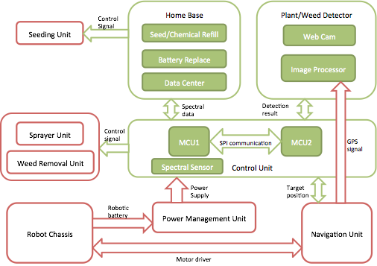
Figure 1: High Level Block Diagram

2.0 Design

2.1 Control Unit

The control unit would primarily interact with the spectral sensor, and send out the control signals to the other subsystems when actions are required. It also interacts with the Home Base to transfer data and commands. It takes inputs from the Plant/Weed Detector and the spectral sensor (Multiplex). The Plant/Weed Detector notifies the control unit when it detects a weed. Then the microprocessor drives a PWM pulse for the motor control to the Weeding Unit, and indicates the event by blinking the weed LED (LED_WEED). When the robot is scouting for plant health, the control unit will turn on the Multiplex3 spectral sensor, which uses the reflection/fluorescence spectrum to infer crop health information. Based on the sensor’s measurements, the control unit will determine if any actions are necessary. If an issue is detected for some crop, for instance, if it requires spraying fungicide or bactericide, the Control Unit would then drive a PWM pulse for the Sprayer Unit, and indicate the event by turning on the sprayer LED (LED_SPRAYER). For every crop, the Control Unit sends its crop health information from the Multiplex3 spectral sensor to the Home Base through wireless communication.

2.1.1 Power Electronics – 3.3 VDC Voltage Regulator
The PIC24F16KL402 microcontroller we chose operates at 3.3 VDC with a tolerance between 1.8V to 3.6V. Hence, we chose a popular Low-Dropout Regulator LM317T to convert the robot’s battery level from 12V down to 3.3V. We chose the LM317T both for its ease of use as well as ready availability at no cost in the ECE department's parts shop.

2.1.2 MCU1
The first microcontroller (MCU1) performs several functions in the control of the robot. It communicates with the Home Base to receive any commands and send data to the Home Base. It is also in in charge of controlling and communicating with the spectral sensor, sending control signals to the Sprayer Unit, and relaying information to the second microcontroller (MCU2). It uses 2 Serial Peripheral Interfaces (SPI), 1 universal asynchronous receiver/transmitter (UART) interface and 1 pulse-width modulation (PWM) module. The two SPI interfaces are scheduled separately to communicate with the wireless module and with MCU2. MCU1 receives the spectral data from the UART port (UART_IN) at a Baud Rate of 115200 bps, and sends it to the wireless module through SPI1, which is also configured at a Baud Rate of 115200 bps. When the sensor begins sending the spectral data, the receive LED (LED_RCV) blink once, indicating an incoming long sentence (refer to Multiplex3 spectral Sensor section). When the signal is sent to turn on the sprayer, the sprayer LED (LED_SPRAYER) is turned on and remains on until the sprayer is turned off.

2.1.3 MCU2
The second microcontroller (MCU2) also performs several functions in the control of the robot. It communicates with the Plant/Weed Detector, the Navigation Unit, MCU1, and also sends control signals to the Weeder Unit. It uses 2 SPI interfaces, 1 UART interface and 1 PWM module. The two SPI interfaces are scheduled separately to communicate with Panda Board ES and with MCU1. MCU2 communicates with the Navigation Unit through UART interface at a Baud Rate 115200 bps, and communicates with the Panda Board ES through SPI1, which is also configured at a Baud Rate of 115200 bps. The detected LED (LED_DETECTED) blinks once when an incoming interrupt from Panda Board ES is received. The weed LED (LED_WEED) turns on when the Weeding Unit is activated.

2.1.4 Multiplex3 Spectral Sensor
The spectral sensor, ForceA Multiplex3, is an active proximal vegetation sensor, with a spectral domain from UV (ultraviolet) to NIR (near-infrared). The spectral sensor has an artificial light source and detects its reflection and fluorescence from the plants. It works under daylight and at a distance of 10 cm according to the data sheet. It has 3 emission channels, which emit light 500 times per measurement. The sample rate is 0.5s per sample. The power requirement is 30V with 1.5A and the power source is expected to have a 3A internal fuse. The communication between the spectral sensor and microcontroller is set at a Baud Rate of 115200 bps, with 8 bits of data, no parity bit, 1 stop bit, and no flow control. Hence the efficiency of the data is 8/(8+1+1) = 80%, that is, 80% of the transmission consists of data. It takes 1s / 115200 bps = 8.68 us to transmit one bit.

2.1.5 RS232 Level Converter
The spectral sensor outputs the spectral data using the RS232 protocol, which defines logic 1 at +12V and logic 0 at -7V (or vice versa). Meanwhile the XLP PIC microcontroller outputs logic signals at 3.3V, i.e. 3.3V as logic 1, ground as logic 0, and any voltage greater than 3.6V is hazardous to the microcontroller. Therefore, we use a two stage level converter (Figure 5 and Figure 6) to do the work of signal level conversion.

2.2 Plant/Weed Detector

The Plant/Weed Detector is tasked with detecting plants and determining if each is a crop or a weed. It will signal the Control Unit if a weed is detected. This is done by using a stereo camera set to take pictures. After taking pictures, the camera will send them to the image processing unit. The first task is to detect plants. To do this, we had two potential algorithms. The first uses the normalized difference vegetation index (NDVI) as used in [1] to detect plants and establish their location on the image(x and y pixel coordinates). The second algorithm uses thresholding to detect plants and mark their location on the image. The second task is to determine the distance from the plant to the camera. For the distance calculation, the disparity map from the image taken by the camera is calculated and used to calculate the distance. The third task is to determine if the plant is a crop or a weed. From the distance calculation and the GPS location of the robot, a GPS location of the plant is calculated and then compared against known crop locations. If the GPS location of the plant does not match any known crop locations, then it is deemed a weed, and the information is reported to the Control Unit.
We used 2 Logitech C270 cameras as our stereo vision set. The original design was to use two IDS UI-1221LE cameras and add a dual pass-band filter in order to get the NDVI of the image. We expect that this algorithm using NDVI would be more accurate than simple color space thresholding. Unfortunately, this type of camera has too much lens distortion, which causes stereo calibration to be very difficult. Therefore we changed the cameras and used the color space thresholding algorithm instead. The hardware for the Plant/Weed Detector is the Panda Board ES. We will first verify the functionality of the algorithm itself using a PC.

2.2.1 Plant Detection
The plant detection algorithm uses green object detection. The image processing unit first transforms the incoming images from the Red Green Blue (RGB) color space to the Hue Saturation Value (HSV) color space. Then it applies a threshold on the image and changes it to a binary image. The threshold is:

Hue: 38-75
Saturation: 124-255
Value: 19-92

After thresholding most white pixels are plant pixels. Since we only need the pixel coordinate of plant, not the exact pixels of the plant, we apply a median filter on the binary image to reduce noise. We also set a size limit of the plant object according to the situation (in our demo it is height x width < 1000). After that, any “white cluster” on the image that has size higher than the limit is assumed to be part of the plant and we mark the pixel coordinates of them.

2.2.2 Distance Calculation
We use a stereo camera set for the distance calculation. The cameras are identical and are aligned on the same geometric plane (same vertical height and facing the same angle). Since the cameras have lens distortion, and camera placement can be slightly off from ideally aligned, we use stereo calibration to reduce the error caused by them. The stereo calibration is done by taking pictures of an 8 in x 6 in chessboard by both cameras at the same time. We take 35 pairs of images. The chessboard is placed at different angles for each pair of images. Then we use the stereoCalibrate OpenCV function to calculate the calibration matrices.
Once calibration is complete, the program uses the results of the stereo calibration to correct for distortion in all images the cameras take by using the initUndistortRectifyMap and remap OpenCV functions. Any point (for example, the vertex of an object) on the left image and right image will have the same y coordinate. The only difference is the x coordinate and we can use it to get the disparity map by using a Block Matching Algorithm. The parameters for the BM algorithm are:
Window size: 9
Number of disparities: 160
Minimum disparity: 0
Then we transform the disparity map into a 3D image by using the OpenCV function reprojectImageTo3D. Two of the three dimensions are the pixel coordinates and the other dimension is the distance between the midpoint of the cameras and the object on that pixel. By using the pixel coordinate of the plant detected in the plant detection phase, the distance between the plant and the cameras can be found.

2.2.3 Crop/Weed Decision
The program decides if the detected plant is a crop or a weed by comparing the distance it got in distance calculation phase and the GPS coordinates. If it is within 10 cm of a crop spot, we assume it is a crop. Otherwise we assume it is a weed and the Plant/Weed Detector will signal the Control Unit.

2.2.4 Weed Detection Communication
Communication is achieved using UART for data the transmission between the Plant/Weed Detector and MCU2 in the Control Unit. Since the output voltage is different on MCU2 (3.3V) compared to the Panda Board ES (6V), the signal will first go through a level converter that is included as part of the design for the circuit board used for MCU2.

2.3 Home Base

The Home Base is the base of operations of the robot. It will resupply the robot with essential chemicals and power. It will also collect and analyze data wirelessly. Lastly, the Home Base serves as the interface between the user and the robot system. The scope of this project for this team will not include the mechanical aspects of the Home Base. The mechanical interface between the robot and the Home Base is yet to be designed. The design features discussed below are merely to serve as the controls for the Home Base. Note that the design schematics for the home base are provided in appendix B.

2.3.1 Power Electronics
Several key circuit components are necessary to implement the features of the Home Base successfully. Firstly of course, is the power circuit. The Home Base is expected to operate on standard 120 VAC available on a wall socket. Naturally, the microcontroller used as well as the sensors chosen operate on DC power so a circuit was designed to convert the AC power provided into the appropriate DC voltages. For the sake of simplicity, a simple bridge rectifier with filter circuit was used. The basic framework was obtained from [2] and then modified. The circuit required 3.3 VDC for the microcontroller and 15VDC for one of the sensors. To supply both consistently and effectively, two voltage regulators were added and set up according to provide the necessary voltage levels. The LM317T was selected for the regulation because of the ease of use and ready availability of this components in the ECE parts shop at no cost to us.

2.3.2 Sensing
In order for the Home Base to resupply seeds and chemicals to the robot, it must be able to measure the levels of these in their containers. Since the design for the containers was not yet available, the physical requirements of the sensors needed to implement these measurements were not available at the time of design. However, a general idea of the expectations for these measurements was available, and sensors were selected for the purpose of successful demonstration of the control signals as well as proof of concept. We selected a diffuse photoelectric sensor to measure the seed level, as it was expected that this would work best for seeds, and was available at low cost. In particular we chose the FB6-LN-0E from Automation Direct. For the chemicals, we chose simple float level switch since these are very simple and inexpensive, and should work for any liquid. In particular we chose the FLS-VM-100 from Automation Direct.

2.3.3 Battery Replacement
No additional hardware was necessary for the control of the battery signals. We used LEDs to show the control signals. Without a determination of the battery mechanisms, it was difficult to determine any method to measure the charge of the battery. Regardless of this, it is expected as part of the design that the battery for the robot will be replaced after every mission and will be designed such that it will provide sufficient power at full charge to run the entire mission without recharging. Under these assumptions, we simply used control signals to resupply the robot every time a mission is completed.

2.3.4 Wireless Communication
The Home Base is required to communicate with the robot constantly while on a mission. In order for this communication to be successful, wireless communication at a minimum distance of 0.3 mi is necessary. Because of the long distance requirements of the wireless communication, we decided to use a high-power long distance wireless access point, and interface it with the controller through Ethernet. For the wireless access point, we chose the TP Link TL-WA5110G. We based this decision on the distance calculator available on the TP Link website [3]. In order to interface between the controller and the access point through Ethernet, we used the ENC28J60-H chip specifically designed to interface between PIC microcontrollers and Ethernet using SPI. This chip requires no other components to perform the interface, and implements its own protocol for Ethernet. This made it very simple to interface between the microcontroller and the Ethernet protocol of the access point.

2.3.5 User Interface
The Home Base is the only component of the robot designed to provide an interface with the user, as the robot is meant to be autonomous. We wanted to provide a web interface in order to store data from the robot on a cloud server and allow the user access to the robot’s status and control of missions scheduled from any web-enabled device. To allow the controller to access the internet, we again used a second ENC28J60-H to be connected to the internet through a wired connection.

2.3.6 Controller
For the controller, we decided to use the PIC24F16KL402 microcontroller because of its low power and many communication ports. Additionally, this was the same microcontroller to be used in the robots control unit which further simplified compatibility and design. The microcontroller provides digital I/O for the sensors and control signals for the batteries, chemical, and seed resupply. It also handles data storage, communication with the user interface, and communication with the robot.

2.3.7 Optional Data Storage
An SD card was also added to the design for the purpose of local data storage. This was not a necessary measure since the data could be stored through the user interface. However, this was a measure that would prevent data loss in the event of loss of connection or slow communication.

3.0 Design Verification

3.1 Control Unit

The power electronics can provide 3.3V DC to the microcontroller. The circuit takes an input voltage of 12V DC and down-converts it to 3.3V. We measured the voltage at the output of the regulator to verify the functionality of the power circuit. The resulting measurement was a voltage of 3.233 VDC, which is well within the tolerance required.

Logic conversions between different components were tested with signal generators and verified on the oscilloscope; spectral sensor interface on MCU1 was verified on the Microchip debugger to ensure the data received on MCU1 is correct; communications within MCU1 and MCU2 were verified on the debugger as well.

The two most sensitive parts to this subsystem are the real time control and the accuracy of the robot position. In terms of the position accuracy, we require the input GPS location to be accurate within 5mm (with aid from local radio beacon triangulation). On one aspect, the spectral sensor has a strict requirement on its working ranges, 10 cm ± 5 mm. Moreover, we want to ensure the accuracy from the Plant/Weed Detector to be guaranteed 0% false positive, and true positive as high as possible; that is we want to remove weeds but we don’t want to accidentally remove crops.
For the control systems to work correctly, we analyzed the processing time of the tasks running on the microcontroller and prioritized them accordingly. It is crucial that the tasks meet real time requirements, and do not skip samples. It is noted that all of the execution times are only a small fraction of their period. The total processor utilization of the four periodic tasks is only 21.3%. This is less than the utilization bound for 4 periodic tasks, which is U(4)=4(21/4-1)=72%. Thus, real time requirements are achieved.

3.2 Plant Weed Detector

3.2.1 Plant Detection
Since this part is mostly image processing, we can inspect the graphic result to verify functionality.
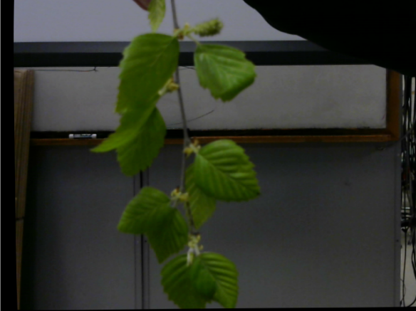
Figure 2: Plant Used for Detection Figure 3: Thresholded Image
Figure 2 is the input image. Figure 3 is the thresholded and median filtered image. As expected the white part on the right image shows the shape of the plant, demonstrating that it has correctly identified the plant within the image. The image processing unit is also programmed to draw a circle on the right image with the calculated pixel coordinate of plant as its center. The result shows that the center of circle marks the plant’s location successfully.

3.2.2 Distance Calculation
The proposed maximum error of our distance calculation is 10 cm. We tested 3 times for each distance and the results are as follows in Table 1:

Actual Distance (cm) | 1st Time Result (cm) | 2nd Time Result (cm) | 3rd Time Result (cm)
40 | 39.5056 | 40.5119 | 39.0511
50 | 49.6884 | 52.2406 | 49.5104
60 | 61.0192 | 60.1693 | 60.1093
70 | 72.3603 | 71.4014 | 71.8399
Table 1: Distance Calculation Results
We can see from the results in Table 1 that the measurements are well within the tolerance desired.
However, if we put an object closer than 30 cm from the plant, the disparity map becomes less accurate and causes the error to exceed the 10 cm tolerance in most cases.

3.2.3 Crop/Weed Decision
For this part, we tested by assuming that a crop is planted at 60 cm ahead and examined the result of the program’s calculation. The program should report a “crop” if the computed distance is within 10 cm of the crop and “weed” otherwise. The result is 100% accurate.

3.2.4 Weed Detection Communication
We were unable to verify the communication functionality for two reasons. Firstly we were unable to implement the algorithm on the Panda Board ES within the time we had for this project. This meant that we were unable to test the communication between the Panda Board ES and the Control Unit. We proceeded to verify the algorithm using a PC and succeeded in doing so. However we had some difficulty in establishing the UART communication for the PC, and once again ran out of time.

3.3 Home Base

3.3.1 Power Circuitry
The functionality of the power circuitry was verified using an oscilloscope. The measurement plots are included in appendix B for reference. Table 2 summarizes the DC voltage readings obtained.

Power Test | Load | V_{out} (V) (averaged)
15 VDC | No Load | 15.4013
15 VDC | 4.7 kΩ | 15.3825
3.3 VDC | No Load | 3.41250
3.3 VDC | 220 Ω | 3.43750
Table 2: Home Base Power Results

3.3.2 Control and Sensing
The functionality of both sensors was verified. Two test containers were used and filled with water and seeds respectively. It was verified that the correct control signals were sent to fill both seeds and chemicals. Similarly, we verified that the controller correctly sent signals to switch out the batteries. Note that all control signals were verified using LEDs.

3.3.3 Communication and User Interface
The communication and user interface portions of the Home Base were not successfully implemented. The issue with the implementation was the use of the ENC28J60-H chip. We had two problems with this component. The first problem was that this component has bigger power requirements than we anticipated. The ENC28J60-H uses draws a current in excess of 0.3 A each. The LM317t regulators that were not able to provide this current without overheating. To use this component successfully, redesign of the power circuitry is necessary to compensate for the large power consumption.
The second issue with the ENC28J60-H was that the SPI implementation for the PIC24F16KL402 is not compatible with this component. The ENC works using variable length messages. In particular, it needs 2 bytes minimum for each message. However, the microcontroller we are using only performs SPI communication in 1 byte messages, and interrupts the clock at the end of the 1 byte transmission. Because the ENC sends data only after it receives the first byte, the data from the ENC is not received by the controller. A different microcontroller is necessary to use this component.

4.0 Cost

4.1 Parts

Item | Part Number | Qty | Cost | Retail Price | Total Retail Price
Logitech C270 Webcam | 960-000694 | 2 |  | $25.99 | $51.98
Panda Board ES Rev B2 | 750-2170-003 | 1 |  | $181.00 | $181.00
RS232 Level Regulator | MAX232N | 1 | Free | $1.15 | $1.15
Microcontroller | PIC24F16KL402 | 3 |  | $2.42 | $7.26
MPLAB ICD 3 | MPLAB ICD 3 | 1 |  | $189.99 | $189.99
Spectral sensor | Multiplex3 MX 313337 | 1 | From John Deere | $48,018.91 | $48,018.91
Linear Regulator | LM317T | 4 | Free | $0.23 | $0.92
N-channel FET | 2N7000 | 7 | Free | $0.38 | $0.76
NPN Transistor | 2N2222 | 7 | Free | $0.33 | $0.66
Wireless Access Point | TL-WA5110G | 2 |  | $43.88 | $87.76
Diode | 1N4004 | 4 |  | $0.10 | $0.40
Float Level Switch | FLS-VM-100 | 1 |  | $9.50 | $9.50
Photoelectric Sensor | FB6-LN-0E | 1 |  | $21.50 | $21.50
Sensor Cable | CD12L-0B-020-A0 | 1 |  | $7.75 | $7.75
Ethernet to SPI Interface | ENC28J60-H | 3 |  | $19.53 | $58.59
SD Card Reader | VirtualBotix SD reader | 1 |  | $9.95 | $9.95
SD Card | SDSDB-008G-AFFP | 1 |  | $6.80 | $6.80
Transformer | Radioshack SKU: 273-1365A | 1 |  | $7.49 | $7.49
OP-Amp | LM358AN | 1 |  | $0.49 | $0.49
 |  |  |  | Total | $49,414.03
Table 3: Parts Cost

4.2 Labor

Name | Hourly Rate | Hours/Week | Weeks | Total
Yandong Li | $35 | 15 | 12 | $15,750
Gang Yang | $35 | 15 | 12 | $15,750
James Kolthoff | $35 | 15 | 12 | $15,750
Total | $47,250
Table 4: Labor Costs

4.3 Total Costs

Total Labor | Total Parts | Grand Total
$47,250 | $49,414.03 | $96,664.03
Table 5: Total Costs

5.0 Conclusion

5.1 Accomplishments
Through this project, we have implemented the sensing subsystem of the Crop Care Robot. The sensing subsystem can react to different scenarios and function properly. The image processing part can detect the plants and calculate the distance in most cases. Although there are still some issues to address and integrate with the other subsystems of the robot, Great progress has been made towards a fully functional Crop Care Robot.

5.2 Uncertainties
Despite the working project, one uncertainty lies in the accuracy of the GPS positioning. Firstly, we have strict requirements on the precision and accuracy of the GPS coordinates from the Navigation System. Secondly, the Plant/Weed Detector detects weeds from a distance and the detection results can be accurate within 3 cm. In the worst case, all these uncertainties would reinforce each other and we would get an accumulated error of 10 cm, which could be acceptable for crops like corn, but could be problematic when crops are small like barley. Further consideration of these measurement uncertainties must be taken moving forward with the project.

5.3 Ethical Considerations
We are aware we have a responsibility to make decisions to ensure the safety and welfare of the public and to make our project contribute to the development of humankind. In order to achieve this, we have to comply with the IEEE Code of Ethics [4]. The following standards apply to our project:

1. To accept responsibility in making decisions consistent with the safety, health, and welfare of the public, and to disclose promptly factors that might endanger the public or the environment;

Since our project is a robot that will be used in crop fields, we have to take great responsibility on our project. We have to take care that no part of the project will have hazardous effects on the crops or the land used to provide food for people.

3. To be honest and realistic in stating claims or estimates based on available data;

In order to make sure our project works as intended, it is very important to be honest on our project data. We must not fake any data on our project.

7. To seek, accept, and offer honest criticism of technical work, to acknowledge and correct errors, and to credit properly the contributions of others;

Since we are working with other teams, we must communicate with them well and make sure all parts of the whole Crop Care Robot project work coherently. If we find any error in our project, we must not hide it and use our full power to correct it. In our project, we will get help from faculty, sponsors and other people. We must give credit to all people that contribute to our project.

9. To avoid injuring others, their property, reputation, or employment by false or malicious action;

We must make sure that our project does no harm to people. If we discover any part of our project that could possibly harm people, it is our responsibility to make it harmless.

10. To assist colleagues and co-workers in their professional development and to support them in following this code of ethics.

Since we are working with other teams, we must make an effort to ensure that ethics are taken into consideration and good ethics are followed by all teams working on the project.

5.4 Future Work
While our project is functional and reacts well to all test scenarios, there are still many possible improvements. One possible feature for the Control Unit is the ability to auto-adjust the spectral sensor since spectral sensor is a short-distance sensor and it is best to be able to dynamically control the position and orientation of the spectral sensor.

For the Plant/Weed Detector, we switched to a color space thresholding technique since the cameras we originally chose for the NDVI approach did not work properly for stereo calibration. The NDVI detection algorithm is still a better choice in terms of plant detection. Finding a suitable replacement that is capable of obtaining images within the frequency range necessary for NDVI is a next step. This camera must have sufficiently low distortion such that stereo vision may be used to determine distance, and proper driver support is also necessary.
Also, it would be beneficial and potentially necessary to find an alternative to the disparity map algorithm for distance in order to reduce the error tolerance and improve the performance.
For the Home Base, there are several steps to be taken to ensure full functionality. The first is to modify the power circuit to account for the high power consumption of the ENC28J60-H. The design has to be further reconfigured by switching to a different microcontroller that is compatible with the ENC. Once this is done, wireless communication should be successfully achieved, but must still be verified. With the successful use of the ENC, the user interface can be designed as a web interface to provide control of the robot’s mission schedule, as well as status and data from the robot. Further design modifications may also be necessary pending the mechanical design of the home base, which has not been started, and is also part of the future work.

References

[1] Volker Dwoark, Joern Selbeck, Carl-Heinz Dammer, Matthias Hoffmann, Ali Akbar Zarezadeh and Christophe Bobda. (2013, Jan. 24) “Strategy for the Development of a smart NDVI Camera System for Outdoor Plant Detection and Agricultural Embedded Systems.” Sensors [Online]. Available: http://www.mdpi.com/1424-8220/13/2/1523
[2] Power support for the Home base
https://www.circuitlab.com/circuit/wrfeu3/120vac-to-12vdc-power-supply/
[3] Power support for the Home base
https://www.circuitlab.com/circuit/wrfeu3/120vac-to-12vdc-power-supply/
[4] IEEE. (2014). IEEE Code of Ethics [Online]. Available: http://www.ieee.org/about/corporate/governance/p7-8.html
[5] IEEE. (2014). IEEE Code of Ethics [Online]. Available: http://www.ieee.org/about/corporate/governance/p7-8.html
[6] Power supply for spectral sensor. Retrieved from
http://www.prodctodc.com/lm2577-dcdc-330v-to-435v-adjustable-stepup-converter-high-efficiency-boost-power-supply-p-98.htmlerter-high-efficiency-boost-power-supply-p-98.html#.UwlyvGJdXng
[7] MAX232 Dual EIA232 Drivers/Receivers. Retrieved from http://www.ti.com/lit/ds/symlink/max232.pdf
[8] IDS UI-1221LE Camera Webpage
http://en.ids-imaging.com/store/produkte/kameras/usb-2-0-kameras/ueye-le/ui-1221le.html
[9] PIC24F16KL402, Microchip. Retrieved from
http://ww1.microchip.com/downloads/en/DeviceDoc/30001037c.pdf
http://www.mouser.com/ProductDetail/Microchip-Technology/PIC24F16KL402-I-SO/?qs=%252bg1Dl/aibpGXoFjfxu5WVQ==
[10] Tips and Tricks for level shifting between 3.3V and 5V
http://www.newark.com/pdfs/techarticles/microchip/3_3vto5vAnalogTipsnTricksBrchr.pdf
[11] Jernej Mrovlje and Damir Vrančić. (2008, Oct.) “Distance Measuring Based on Stereoscopic Pictures”, [Online]. Available: http://photon07.pd.infn.it:5210/users/dazzi/Thesis_doctorate/Info/Chapter_6/Stereoscopy_%28Mrovlje%29.pdf
[12] Panda Board SPI description
http://www.omappedia.com/wiki/PandaBoard_SPI

Appendix A: Requirements and Verifications Table

- Plant/Weed Detector

Panda Board ES (and the Detection Program on it) Requirement | Panda Board ES Verification
1) Panda Board must be able to receive pixel values from camera that can be used to calculate NDVI | 1) Step 1: Let camera and Panda Board output pixel values in an image to a laptop. Then transfer the pixel values to Panda Board and let Panda Board output its version of pixel values to computer. Both outputs are saved as files on laptop.  Step 2: Use a file difference program to compare the Panda Board output and the camera output, if the program shows 0 differences then this part works.
2.1) Detection program must be able to detect plant/weed that is at least 10cm long and 10cm high (estimated typical weed size) from a picture that is taken at 1m away.  2.2) It must not false alarm and show there is a plant when there is no plant  2.3) Detection program must be able to calculate the location of plant/weed, the error must be smaller than 10cm | 2.1) Step 1: We use one plant/weed which has size of 10cm x 10cm x 10cm (smallest size) as test plant/weed. Let camera take pictures of test plant/weed at 1m distance (largest distance) and send it to Panda Board. Also make sure there is no other plants/weeds in camera range  Step 2: Let Panda Board output the result of test plant/weed detection, if Panda Board shows it detects plant/weed then this part works.  2.2) Let camera take picture in a room without plant. If Panda Board shows it doesn’t detect plant/weed then this part works.  2.3) Let Panda Board output the location of test plant/weed, if the difference calculated location and the exact location is smaller than 10cm, then this part works.
3) Detection program must be able to determine if detected plant/weed is on the spot of plant (the place that matches GPS coordinate of plant) and output the coordinate of weed if weed is detected. | 3) Step 1: We first set some coordinate as “crop spot” to emulate a crop field with crops growing. The coordinates will imitate 2 parallel crop lines with 35cm between each crop and 33cm between rows (estimated distance if corn is planted).  Step 2: Run the whole program 2 times. First time with test plant/weed on the crop spot. Second time with test plant/weed not on the crop spot. If the Panda Board output shows “plant” when plant/weed is on the spot of crop and shows “weed” when plant/weed is not on the spot of crop, then this part works.
4) Panda Board must be able to receive GPS coordinates from Control Unit without error | 4) Step 1: Let control output a set of pre-determined GPS coordinates to a laptop. The coordinates will imitate 2 parallel crop lines with 35cm between each plant and 33cm between rows. (same one as the coordinates used in verification of plant/weed detection)  Step 2: Let Control Unit transfer the GPS coordinates to Panda Board and let Panda Board output its version of GPS coordinates to laptop. Both outputs are saved as files on laptop.  Step 3: Use a file difference program to compare the Panda Board output and the camera output, if the program shows 0 difference then this part works.
Table 6: Plant/Weed Detector Verification and Requirements
- Control Unit Requirements and Verifications

Power Electronics on Control Unit Requirements | Power Electronics on Control Unit Verifications
1) Low-Dropout Linear Regulator LM317 is outputting at 3.3V:  a) VIN: 12V DC ± 0.1%  b) VOUT: 3.3V DC ± 0.5% | 1) Probe the output with a Volt-meter and read the voltage. Display signal on oscilloscope. Probe the input with a Volt-meter. Display signal on oscilloscope.
2) Linear Regulator LM2574 is outputting at 5V:  a) VIN: 12V DC ± 0.1%  b) VOUT: 5V DC ± 0.5% | 2) Probe the output with a Volt-meter and read the voltage. Display signal on oscilloscope. Probe the input with a Volt-meter. Display signal on oscilloscope.
Table 7: Power Verifications and Requirements for the Control Unit

Level Converter Requirements | Level Converter Verifications
1) The MAX232N level converter can transmit communication data at a baud rate of up to 120,000 bps. | 1) Set up the function generator to generate a square wave of frequency of 60 kHz (in one period there are two bits transmitted), verify on an oscilloscope that the output signal at pin 14 of the MAX232N reaches a steady logic signal (for both HIGH and LOW) in the middle of the pulse.
2) The second stage logic converter changes in between 3.3V and 5V with less than 1us rise and fall time. | 2) Connect the logic converter to a function generator outputting a square wave at levels of 3.3V and 5V respectively. Probe the output signal on the oscilloscope and measure the rise time and fall time of the signal.
Table 8: RS232 Level Converter Verifications and Requirements

Multiplex3 Spectral Sensor Requirements | Multiplex3 Spectral Sensor Verifications
1) The communication channel is set up using the 115200 baud rate, with 8 data bits, one stop bit, no parity, and no flow control. | 1) Set the UART configuration on MCU to match the configuration on spectral sensor, probe the UART_IN signal on MCU on an oscilloscope.
Table 9: Spectral Sensor Verifications and Requirements
- Home Base Requirements and Verifications

Power Electronics at Home base Requirements | Power Electronics at Home base Verifications
1) 120VAC to 16VDC Regulator  a) VIN: 110-126VAC (Wall outlet tolerance)  b) VOUT: 16VDC ± 1VDC | 1) Connect power circuit to wall outlet power. Probe the 16VDC pin with a Volt-meter and read the voltage. Display signal on oscilloscope.
2) Low-Dropout Linear Regulator LM317 is outputting at 3.3V:  a) VIN: 16V DC ± 0.1%  b) VOUT: 3.3V DC ± 0.5% | 1) Probe the output with a Volt-meter and read the voltage. Display signal on oscilloscope.
Table 10: Verifications and Requirements for the Home base Power Circuit

Data Center Requirements | Data Center Verification
1.) The data center must be able to communicate outdoors wirelessly with the robot to a minimum distance of 0.3 miles. | 1.) Test communication at a distance of 0.3 miles. If communication between the home base and the robot is still effective, then the requirement is satisfied.
2) The data center should be able to store data for at least 1 week without needing to delete any data. This is equivalent to an approximate 500MB storage capacity. | 2.) Store data into the SD card. Read the data using a computer to ensure that writing was successful. Verify the storage capacity of the SD card is at least 500MB using a computer.
Table 11: Data Center Requirements and Verification Table

User Input Requirements | User Input Verifications
1.) User input must correctly display system status on web interface. | 1.) Induce all possible system statuses, using user input as well as input from robot.  The correct system status must be displayed in each case.
2.) User input unit must be able to access data collected from the robot and display it. | 2.) Introduce dummy data into data storage. Access data using web interface. Data must match with original dummy data.
3.) User input module must correctly respond to user input of scheduling for robot’s operations. | 3.) Give scheduling command using the web interface; verify that the control unit of the robot receives the appropriate command.
Table 12: User Input Verifications and Requirements

Seed and Chemical Refill Requirements | Seed and Chemical Refill Verifications
1.) The system must identify when it is time to refill the seeds and chemicals, and send output signals based on the input received from the seed and chemical subsystems. | 1.) Send signals with low values of seeds, and chemicals. The system should output signals to each of the appropriate subsystems to begin refueling. The correct LEDs will turn on for each action.
Table 13: Seed and Chemical Refill Verifications and Requirements

Battery Replacement Requirements | Battery Replacement Verifications
1.) The system must send the appropriate signals to state which batteries are being charged, and which battery is currently on the robot. This will demonstrate that the output signals to place a battery on the robot is being sent. | 1.) Send a signal from the robot indicating that it has finished a mission and has docked at the home base. The battery LEDs should show that the current battery on the robot has changed.
Table 14: Battery Replacement Verifications and Requirements

Appendix B: Circuit Schematics
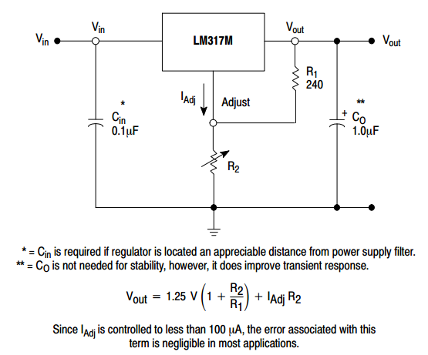
Figure 4: Schematic for 3.3 Voltage Regulation [Reference from http://www.onsemi.com/pub_link/Collateral/LM317M-D.PDF]
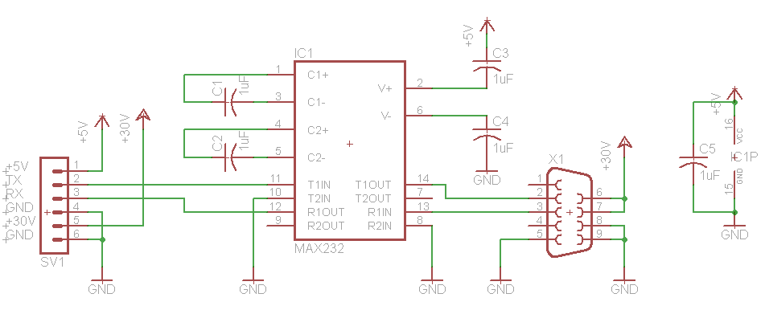
Figure 5: RS232 Level Converter Schematic
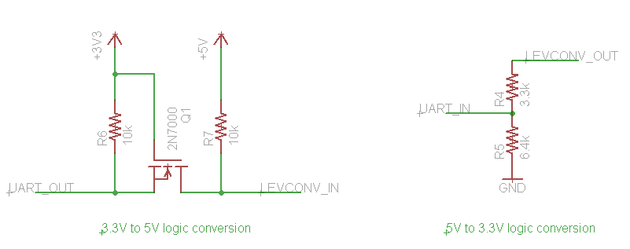
Figure 6 3.3 V to 5 V Level Converter
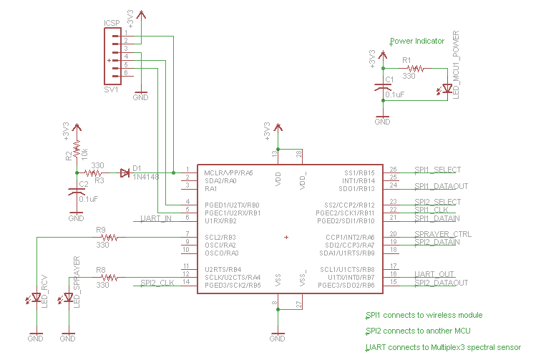
Figure 7: MCU1 Schematic
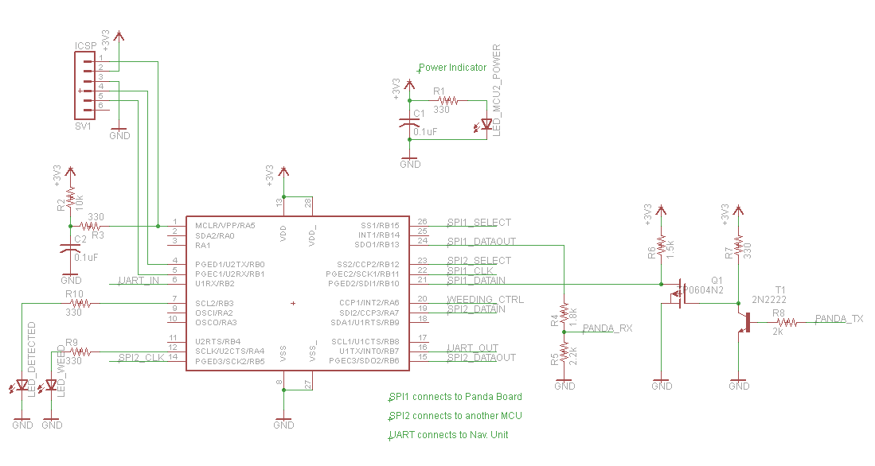
Figure 8: MCU2 Schematic
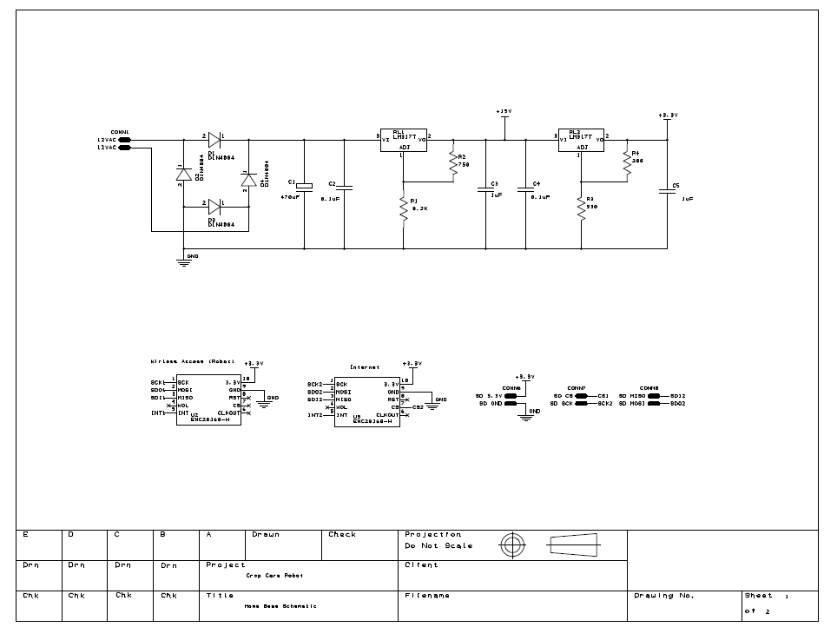
Figure 9: Home Base Schematic (Page 1)
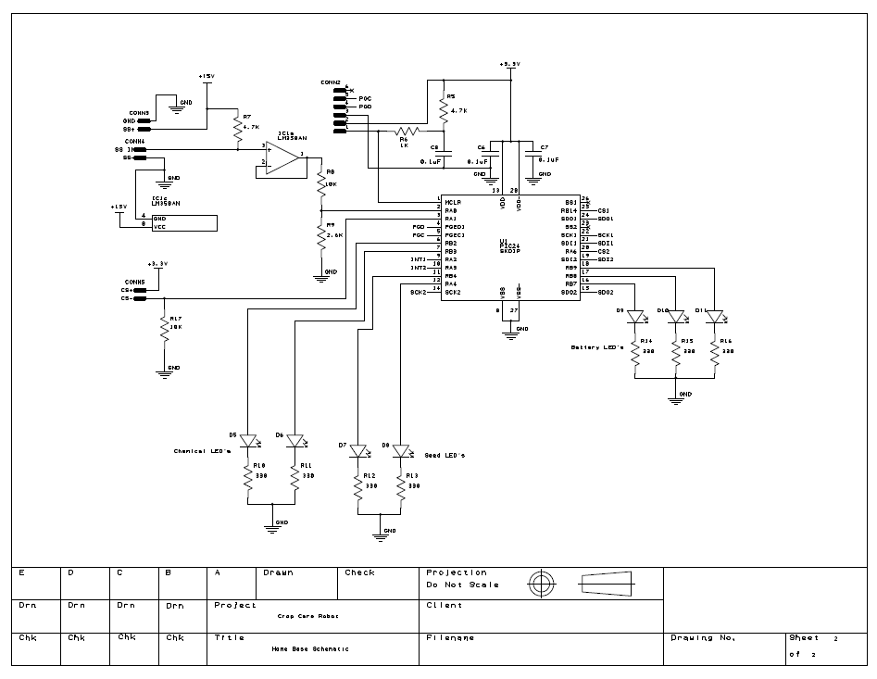
Figure 10: Home Base Schematic (Page 2)

Appendix C: Programming Flow Charts and other Figures

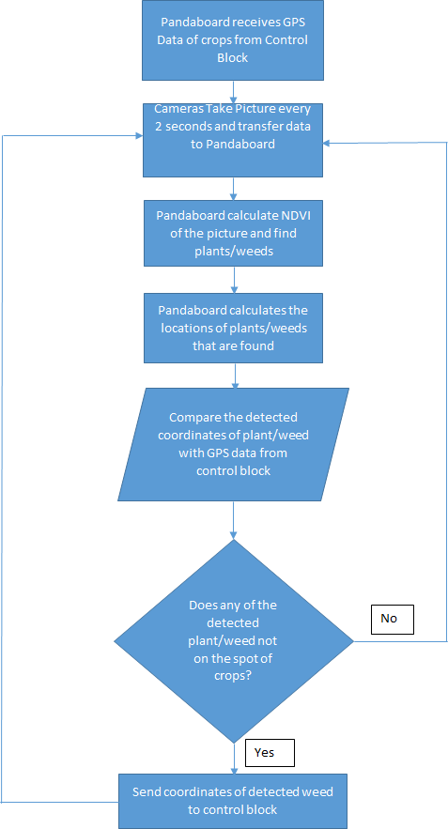
Figure 11: Flow Chart for the Original Plant Detection Algorithm
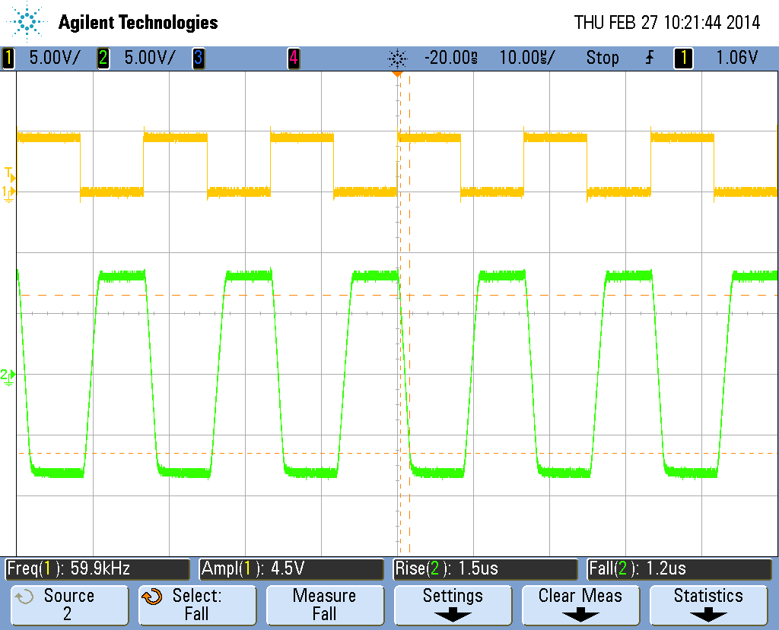
Figure 12: Waveform of the Level Converter at a Baud Rate of 120,000 bps

Please refer to appendix B for circuit schematics.
The detailed requirements and verification table is attached in appendix A.
Total Labor (per person) = Hourly Rate X Total Hours X 2.5

