LED SPHERE DISPLAY

By
Ashley Saju
David Heydinger
Stephanie Eze

Final Paper for ECE 445, Senior Design, Spring 2026
TA: Shiyuan Duan
6 May 2026
Project No. 52
Abstract
This project presents the design and implementation of a wireless persistence of vision (POV) LED sphere for real-time visual display. The system consists of a motor-driven rotating PCB with a perpendicular LED array, powered wirelessly through inductive coupling. An embedded microcontroller controls LED output and synchronizes display timing using a Hall sensor, while a custom web application enables remote updates of images, text, and countdowns.
The system theoretically achieves stable operation at 1500 RPM, with clear image visibility at a distance of 5 feet. Reliable power transmission to the rotating assembly and accurate timing synchronization were successfully demonstrated. However, mechanical imbalance at high rotational speeds limited overall stability and testing. Despite this limitation, the system met key functional requirements, including real-time display updates and consistent visual output.

Contents
1. Introduction 1
1.1 Problem and Limitations of Prior Work 1
1.2 System Overview and Proposed Solution 1
1.3 Key Features and Contributions 1
1.4 Summary of Results and Report Organization 2
1.5 Societal and Environmental Impact 2
2. Design 2
2.1 System Overview 2
2.2 Mechanical Subsystem 4
2.3 Power Subsystem 5
2.4 Spinning Control PCB 7
2.5 Control Logic and Timing 9
2.6 Z-Plane LED Array 11
2.7 Web Application 13
3. Design Verifications 15
3.1 Rotation Synchronization Test 15
3.2 LED Array Logic and Continuity Test 15
3.3 Mechanical Stability and Motor Control Test 16
3.4 Wireless Data Transmission Test 16
3.5 Power Regulation Test 16
3.6 Inductive Power Transfer Test 17
4. Tolerance Analysis 17
5. Costs 18
5.1 Parts 18
5.2 Labor 18
6. Conclusion 19
6.1 Accomplishments 19
6.2 Unmet requirements and uncertainties 19
6.3 Ethical Considerations 19
6.3.1 Ethics 19
6.3.2 Safety 20
6.4 Future Work and Alternatives 20
References 21
Appendix A. Firmware and Software Repository 22
Appendix B. Parts and Cost List 25

1. Introduction
This report presents the design and implementation of a wireless persistence of vision (POV) LED sphere for real-time visual display in escape room environments. The system is designed to improve reliability, maintainability, and interactivity compared to prior implementations. This section introduces the problem context, proposed solution, and key results of the project.

1.1 Problem and Limitations of Prior Work
This project is motivated by the increasing reliance on interactive and immersive technologies in escape rooms to enhance player engagement and enable dynamic puzzle experiences. Professor Kwiat of UIUC’s LabEscape proposed a spinning LED globe capable of generating a hologram-like display for presenting clues and countdown timers. While similar concepts have been explored in previous semesters and through commercially available products, past implementations resulted in systems that were unreliable, difficult to maintain, or insufficiently flexible for live gameplay scenarios.
One major limitation of previous designs was the mismatch between implemented hardware and available documentation, which made troubleshooting and repair difficult. Additionally, these systems lacked real-time interactivity and were limited to displaying a single preloaded image. Updating the display required a wired connection, which was impractical during operation. In escape room settings, where game masters must dynamically adjust clues and timing based on player progress, this limitation significantly reduced the usefulness of such systems.

1.2 System Overview and Proposed Solution
To address these challenges, we designed and implemented a wireless persistence of vision (POV) LED sphere that emphasizes reliability, maintainability, and real-time control. The system operates using high-speed rotation to create the illusion of a continuous image and runs at approximately 1500 RPM, exceeding the minimum speed required for persistence of vision.
The design consists of a stationary base and a rotating assembly that together generate the display. An embedded microcontroller controls LED output and synchronizes timing using a Hall sensor to ensure consistent image rendering. A perpendicular LED array forms the visible display as the system rotates.

1.3 Key Features and Contributions
A key feature of this design is its wireless capability, which allows images and display content to be updated in real time through a custom web application. This enables dynamic interaction during escape room gameplay, such as updating clues or adjusting countdown timers without interrupting system operation.
Additionally, the system was designed with a strong emphasis on documentation and consistency between hardware and schematics. This improves maintainability, simplifies debugging, and enables easier replication compared to prior implementations.

1.4 Summary of Results and Report Organization
The system successfully achieved operation at 1500 RPM, enabling clear image visibility at a distance of approximately 5 feet. Wireless communication allowed real-time updates to displayed content, and accurate timing synchronization was achieved using the Hall sensor. However, mechanical imbalance at high rotational speeds introduced limitations in overall stability.
The remainder of this report presents the system architecture, detailed design, testing methodology, and performance evaluation of the POV LED sphere.

1.5 Societal and Environmental Impact
In addition to solving immediate gameplay challenges for LabEscape, this project carries positive broader impacts. Societally, the device supports LabEscape’s core mission of scientific outreach, providing an engaging, educational demonstration of optical physics and electrical engineering to the general public. Environmentally and economically, the design promotes sustainability by reducing electronic waste. By utilizing a modular, reprogrammable LED array and an embedded SD card rather than purchasing standard, power-heavy commercial television monitors, escape room operators can continuously update the puzzle's theme and content for years without discarding obsolete hardware.

2. Design

2.1 System Overview
The wireless persistence of vision (POV) LED sphere was designed as a modular electromechanical system consisting of stationary power and motor subsystems, a rotating embedded control subsystem, and a perpendicular LED display subsystem. The system architecture emphasizes synchronized real-time LED control, wireless power delivery, and wireless communication to generate stable floating images during high-speed rotation.
The system relies on a central ESP32-WROOM-32E microcontroller to orchestrate both strict display timing and asynchronous wireless communication. The high-level functional flow begins at the 24 V wall adapter, which powers a brushless DC motor and stationary wireless power transmission circuitry. Power is transmitted wirelessly to the rotating assembly through inductive coupling. On the spinning PCB, the microcontroller reads image data from a microSD card and synchronizes the blinking of 64 LEDs with the rotational position of the motor using a Hall effect sensor.
LED control data is transmitted through SPI-connected shift registers to the Z-plane LED array, enabling high-speed updates required for persistence-of-vision image generation. Additionally, the ESP32 communicates wirelessly with a custom web application, allowing users to update displayed images, text, and timers in real time without interrupting system operation.
Figure 1 illustrates the interaction between the primary subsystems, including the stationary base, spinning PCB, LED array, and wireless communication interface. Additionally, the complete unified circuit schematic detailing all electrical connections prior to PCB separation is Figure 2.
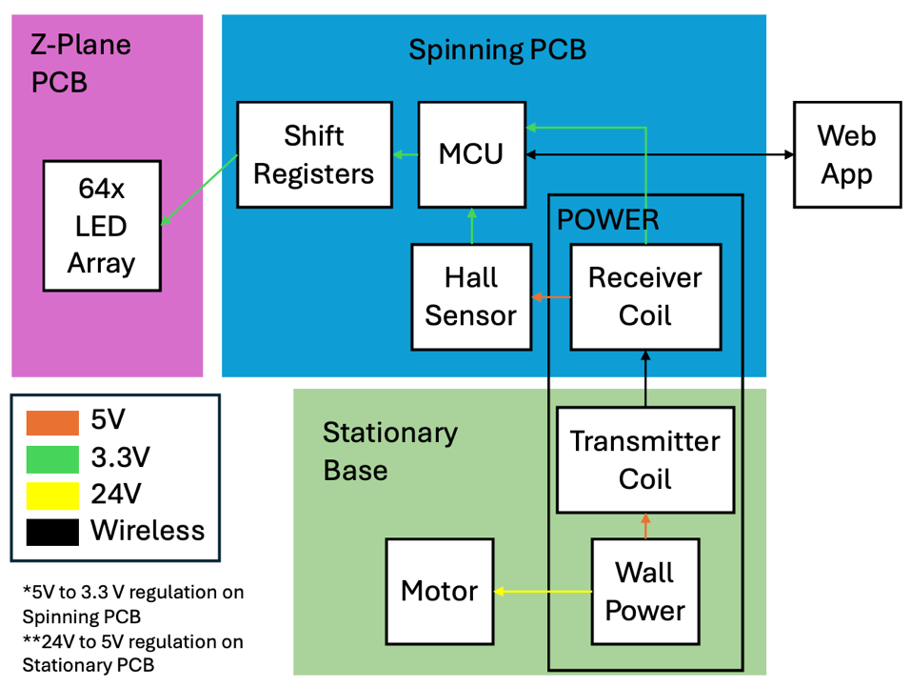
Figure 1. High Level Block Diagram
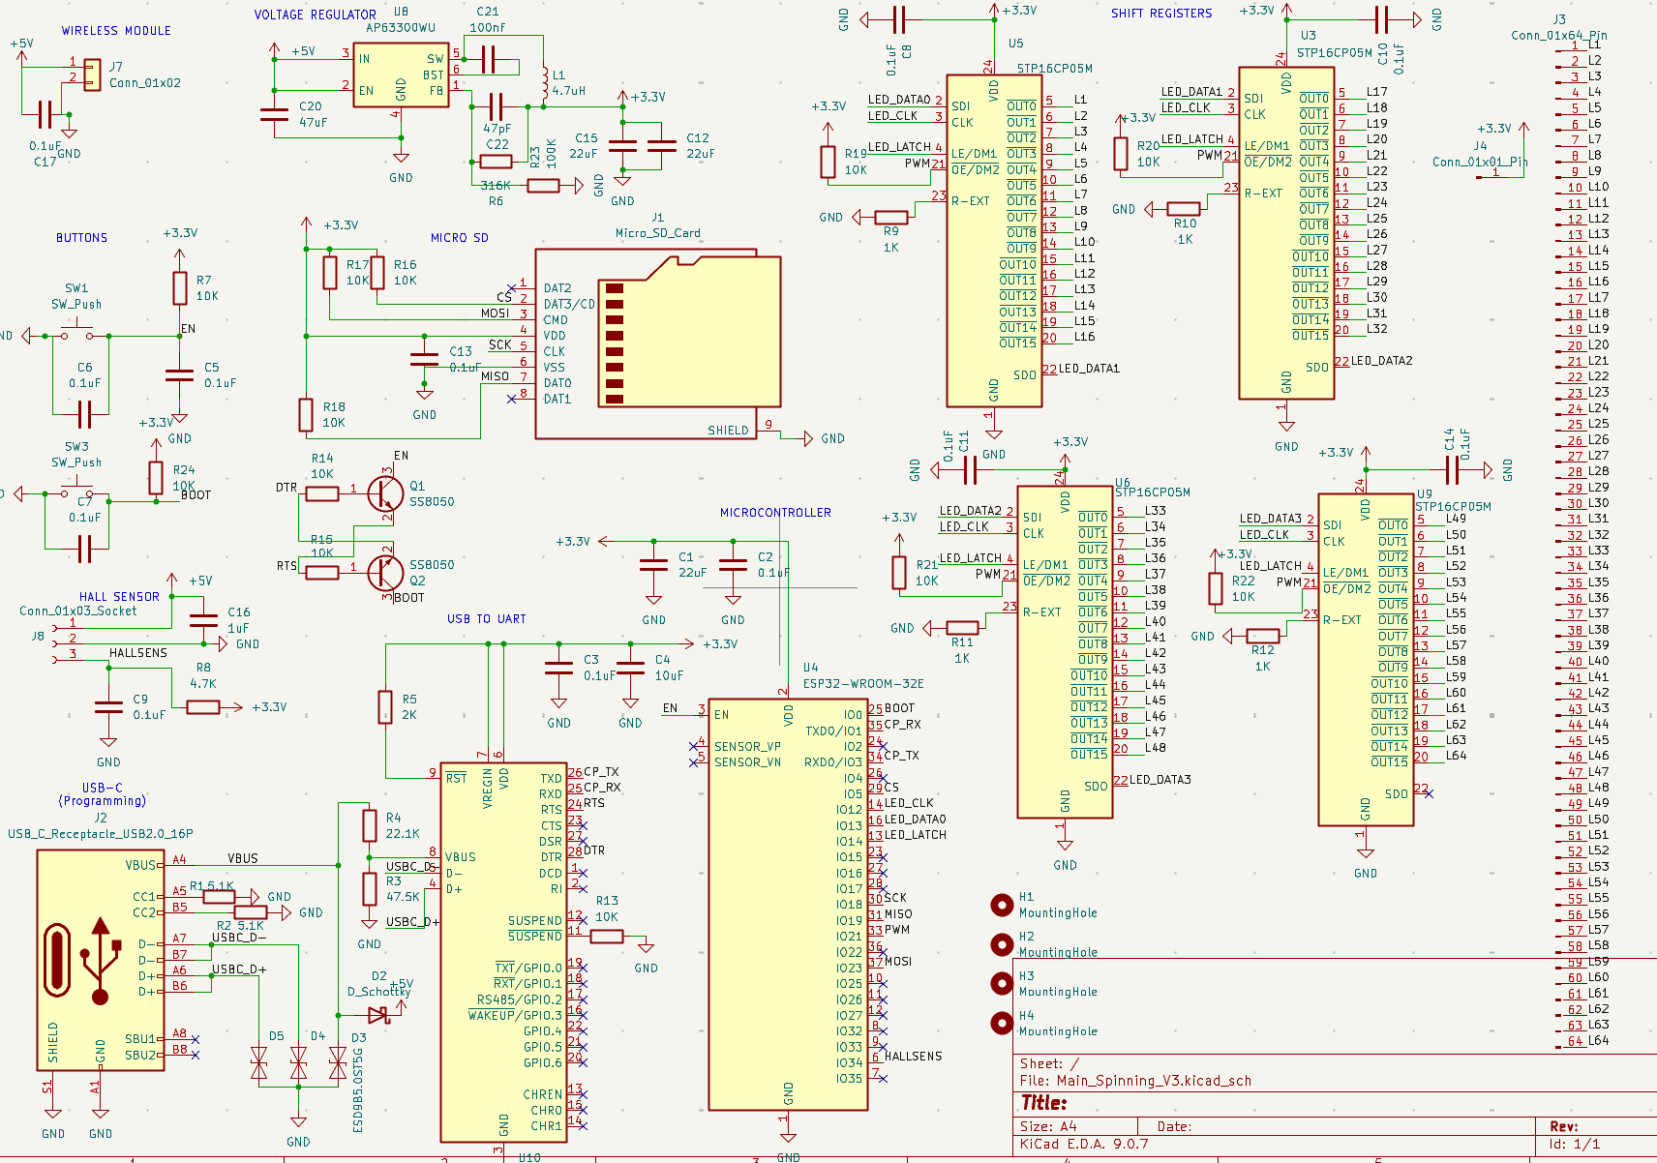
Figure 2. Complete System Circuit Schematic

2.2 Mechanical Subsystem
The mechanical system was designed to support stable high-speed rotation while maintaining alignment between the rotating electronics assembly and the stationary wireless power transfer system. The physical assembly integrates the electrical subsystems through a rigid central shaft driven by a brushless DC (BLDC) motor. A target rotational speed of 1500 RPM was selected to satisfy persistence-of-vision timing requirements while maintaining sufficient image stability for human perception.
The stationary structure consists of a machined steel base designed to provide sufficient mass and rigidity to minimize vibration during operation. A groove was machined into the top surface of the base to hold the stationary wireless power transmitter coil in a fixed position concentric with the motor shaft. The motor shaft was mechanically extended upward through a machined acrylic support structure that serves as the rotating platform for the electronics assembly.
The spinning subsystem consists of the main PCB, receiver coil assembly, and perpendicular Z-plane LED PCB. The receiver induction coil was mounted beneath the rotating acrylic platform to maintain close proximity to the stationary transmitter coil and maximize wireless power transfer efficiency. Four aluminum standoffs were mounted into the acrylic platform to support the spinning PCB approximately 2 inches above the rotating base while maintaining structural rigidity during rotation.
The spinning PCB was designed around a circular geometry with an approximate radius of 3 inches. This dimension was selected based on the spacing and package dimensions of the side-mounted surface-mount LEDs used within the Z-plane PCB [1]. The Z-plane PCB is mounted perpendicularly to the spinning PCB, allowing the linear LED array to sweep through a cylindrical volume as the system rotates. By synchronizing LED output with rotational position, the system generates the appearance of a continuous floating two-dimensional image.
Mechanical stability was a major design consideration due to the high rotational speeds required for operation. While the machined components ensured accurate alignment between the motor shaft and stationary coil assembly, instability was introduced because the rotating receiver coil assembly lacked a dedicated centering and constraint mechanism. As rotational speed increased, the unsupported receiver power assembly experienced wobble and imbalance, limiting safe high-speed testing of the fully integrated system. Future iterations of the design would incorporate a rigid centered mounting structure for the receiver coil to improve rotational balance and reduce vibration.
The complete assembled system integrating the stationary base, spinning PCB, wireless power system, and LED array is shown in Figure 3.
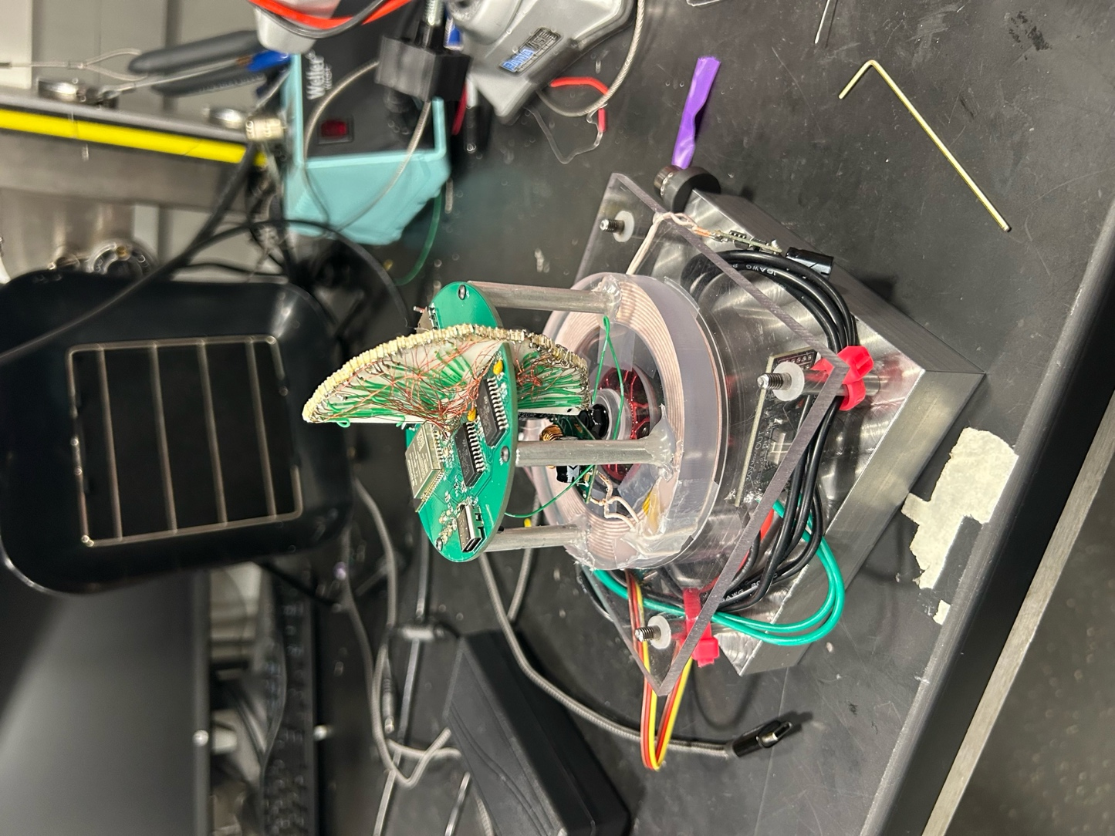
Figure 3. Fully Assembled POV System

2.3 Power Subsystem
The power delivery system was designed to provide continuous electrical power to both the stationary and rotating subsystems while eliminating wired electrical connections to the spinning assembly. The complete system is powered from a 24 V wall adapter connected through a PJ-102A barrel jack mounted on the stationary base. A simplified overview of the power architecture is shown in Figure 4.
The stationary base serves as both the physical and electrical foundation of the device. The incoming 24 V supply is divided into two primary power paths within the master schematic. The first path routes the unregulated 24 V rail directly to the LYWS BLDC controller, which performs the phase-switching necessary to drive the brushless drone motor.
The second 24 V power path is stepped down to 5 V using a DFRobot DC-DC buck converter before being supplied to the Taidacent wireless power transmitter circuitry. Voltage regulation was necessary because the inductive power transfer system is rated for operation at 5 V with a maximum current capability of 3 A. Supplying the transmitter circuitry directly from the 24 V rail would permanently damage the wireless power subsystem. The transmitter coil transfers power wirelessly to the rotating receiver coil through inductive coupling, eliminating the need for slip rings and reducing mechanical wear during continuous high-speed operation.
The rotating electronics subsystem primarily operates at 3.3 V. Therefore, the received 5 V wireless power input is regulated down to 3.3 V on the spinning PCB to supply the ESP32-WROOM-32E microcontroller, Hall effect sensor, microSD card, and LED driver circuitry [2]. Maintaining a stable regulated logic supply was particularly important due to the strict timing requirements associated with SPI communication, wireless networking, and LED synchronization.
The LED display subsystem consists of 64 surface-mount LEDs driven through SPI-controlled shift registers [1], [3]. Each LED was rated for a nominal current of 20 mA. Since the LED driver circuitry operates from the 3.3 V rail, the maximum LED-driver load is:
$$I_{LED,total}=64\left(20mA\right)=1.28 \text{A} \\ P_{LED}=3.3\text{ V}\left(1.28A\right)=4.22W$$ | (2.3.1)
The ESP32-WROOM-32E also draws current from the 3.3 V rail while hosting the web application, maintaining Wi-Fi communication, controlling SPI output, and accessing the microSD card. Based on the ESP32 datasheet, current draw during RF transmission can exceed 200 mA [2]. Using 250 mA as a conservative estimate for the ESP32 and peripheral overhead:
$$P_{MCU}=3.3 \text{V}\left(0.25 \text{A}\right)=0.825 \text{W}$$ | (2.3.2)
Therefore, the estimated maximum 3.3 V load is:
$$P_{3.3V,total}=4.22 \text{W}+0.825 \text{W}=5.05 \text{W}$$ | (2.3.3)
Because the wireless receiver provides 5 V before onboard regulation, the required 5 V input current depends on buck converter efficiency. Assuming approximately 85% efficiency:
$$I_{5V,in}=\frac{5.05 \text{W}}{5 \text{V}(0.85)}=1.19 \text{A}$$ | (2.3.4)
This remains below the 5 V, 3 A rating of the wireless power transfer system, providing adequate margin for the rotating electronics subsystem.
Wireless power transfer was successfully demonstrated during subsystem testing; however, we were not able to monitor the current draw due from the rotating PCB due to time. Mechanical instability in the unsupported rotating receiver coil assembly introduced wobble at higher rotational speeds, limiting reliable high-speed testing of the fully integrated system. Future revisions of the design would incorporate a rigid centered mounting structure keep the receiver coil PCB rigid to improve rotational stability.
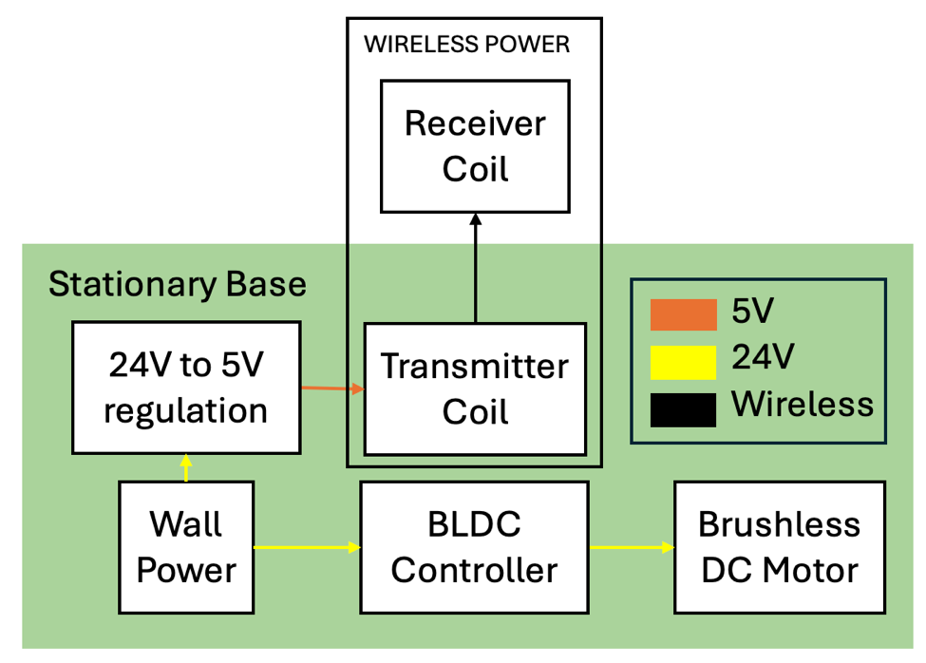
Figure 4. Power Delivery and Wireless Power Transfer Block Diagram

2.4 Spinning Control PCB
The spinning PCB serves as the main electrical interface between the rotating power system, embedded controller, LED driver circuitry, Hall sensor, and removable storage. The board was designed around the ESP32-WROOM-32E microcontroller because it provides integrated Wi-Fi communication, sufficient GPIO availability, and SPI support for both microSD communication and LED driver control [2]. The spinning PCB schematic and layout are shown in Figure 5.
The PCB includes an AP63300WU-7 buck converter to regulate the received 5 V supply to 3.3 V for the ESP32, microSD card, Hall sensor interface, and logic circuitry. This local regulation was necessary because the rotating subsystem contains several components that require a stable 3.3 V logic supply. Integrating the regulator directly onto the spinning PCB also reduced the need for additional wiring between the rotating power receiver and embedded electronics.
A CP2102N USB-to-UART bridge and USB-C connector were included to support programming, serial debugging, and firmware development without removing the ESP32 from the PCB. This design choice improved maintainability because firmware changes and diagnostic output could be accessed directly from the assembled board.
The board also includes a DM3D-SF microSD card connector for local image and sprite storage. Storing display data locally reduces dependence on continuous wireless transmission during operation and allows the ESP32 to retrieve preloaded image or timer data while maintaining timing-sensitive LED output.
LED output is routed from the ESP32 to the STP16CP05 LED driver shift registers, which provide current-controlled outputs for the 64-LED display array [3]. Using dedicated LED driver circuitry reduced the number of GPIO pins required and allowed LED data to be transmitted serially before being latched to the output array.
The PCB layout was constrained by the circular rotating form factor and the need to interface mechanically with the perpendicular Z-plane LED PCB. Component placement prioritized compact routing, short SPI signal paths, and practical access to the USB-C connector and microSD card slot. The layout also attempted to distribute component mass around the rotational axis to reduce imbalance during high-speed rotation.
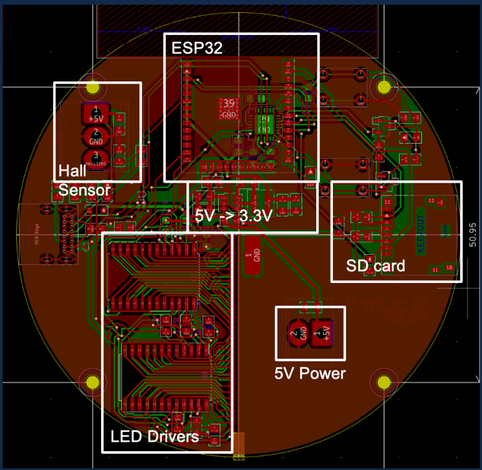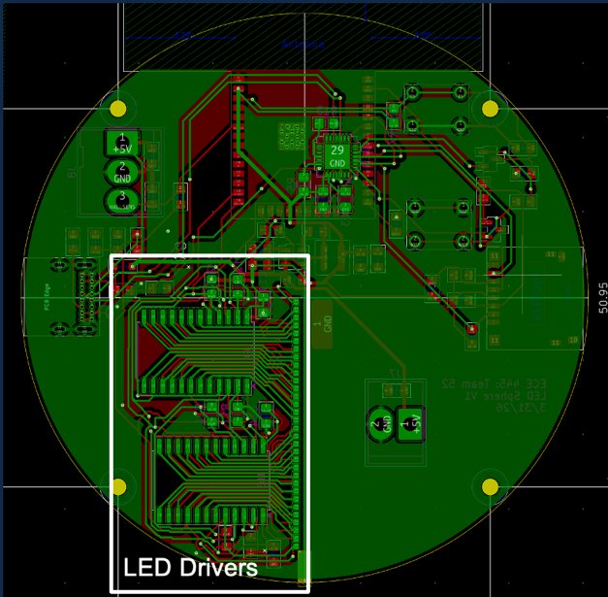
Figure 5. Spinning PCB Layout (Left: front, Right: back)
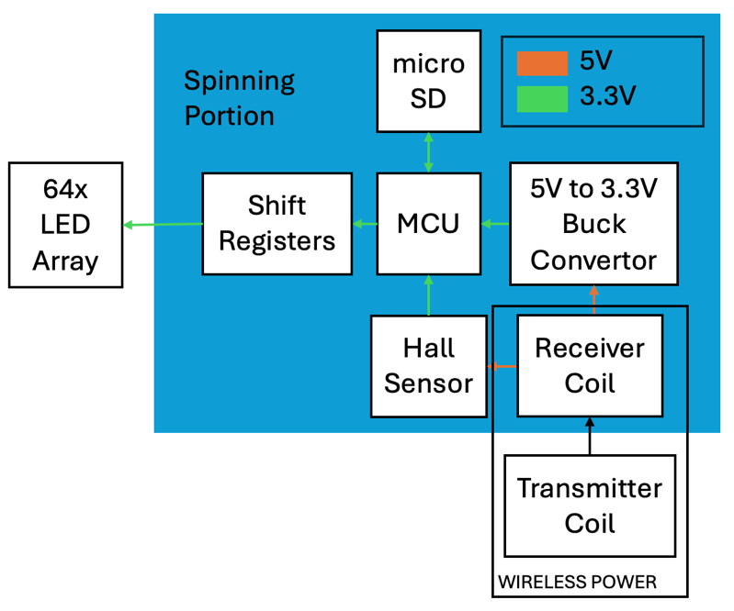
Figure 6. Spinning Portion Block Diagram

2.5 Control Logic and Timing
The embedded control system coordinates rotational synchronization, LED data transmission, image storage, and wireless communication to generate stable persistence-of-vision (POV) images during high-speed rotation. The ESP32-WROOM-32E serves as the primary embedded controller and manages all timing-critical display operations alongside asynchronous wireless communication tasks [2].
The firmware was designed using a modular architecture that separates Hall sensor processing, LED output generation, timer rendering, sprite loading, application state management, and web server communication into independent software modules. This structure simplified subsystem debugging and allowed individual firmware components to be validated independently during development. Complete firmware and web application source code are provided in Appendix A.
The rotational synchronization system was implemented using a TLE4906LHALA1 Hall effect sensor mounted on the rotating PCB [4]. A stationary magnet positioned at the same vertical height as the Hall sensor triggers the sensor once per revolution as the rotating assembly passes the fixed reference point. The Hall sensor output is active-low, meaning that detection of a sufficiently strong magnetic field produces a falling-edge transition at the ESP32 GPIO input. The firmware uses this falling-edge event as the primary rotational timing reference to determine the beginning of each rotational cycle. This synchronization signal allows LED output updates to remain aligned with angular position so that image slices are rendered consistently between successive revolutions.
The system originally incorporated a microSD card interface connected through SPI to provide local storage for bitmap sprite data used in timer display mode. The stored sprite set consisted only of numerical digits and colon characters required for countdown rendering. Local storage was initially selected to simplify display asset management and reduce firmware recompilation when modifying timer graphics.
However, reliable microSD card communication could not be achieved during integrated hardware testing. Investigation suggested that PCB layout constraints likely contributed to the issue, as several components were positioned directly beneath the microSD card. This arrangement may have interfered with mechanical contact integrity or signal reliability during operation. Because the required sprite assets occupied very little memory, the design was modified so that sprite data could instead be stored directly within the ESP32 firmware image. This workaround eliminated dependence on the unreliable microSD subsystem while preserving timer display functionality.
Local storage was selected to reduce dependence on continuous wireless transmission during operation and to simplify rendering of static images, timer displays, and bitmap sprites. During operation, the ESP32 retrieves sprite and display data directly from onboard firmware memory before serially transmitting LED control data to the shift register array.
High-speed SPI communication was used to drive four daisy-chained STP16CP05 LED driver shift registers [3]. SPI communication minimized GPIO usage while maintaining sufficiently high data transmission rates for POV image rendering. Once serial transmission is complete, the shifted LED data is latched simultaneously to update all outputs at once.
The firmware timing architecture was designed around the rotational speed and desired angular display resolution. The target rotational speed for the system was 1500 RPM, corresponding to a rotational frequency of:
$$f_{rot}=\frac{1500}{60}=25 Hz$$ | (2.5.1)
Using a target angular resolution of 360 slices per revolution, the maximum available update interval per slice becomes:
$$t_{slice}=\frac{1}{25×360}=111 μs$$ | (2.5.2)
Each display update requires transmitting 64 bits of LED data to the shift registers. At the selected 10 MHz SPI clock frequency, the transmission time is:
$$t_{SPI}=\frac{64}{10×{10}^{6}}=6.4 μs$$ | (2.5.3)
Because the SPI transmission time is significantly smaller than the available slice interval, sufficient timing margin remains for Hall sensor interrupt handling, SD card access, latch timing, and wireless communication overhead.
Timing-critical LED updates were executed using microsecond-resolution timing derived from the ESP32 micros() function. During normal operation, Hall sensor timing values were used to synchronize display updates with rotational position. If valid Hall timing was unavailable during startup or unstable operation, the firmware automatically reverted to a fixed timing interval to maintain continuous display output. This fallback architecture improved robustness during transient operating conditions.
The ESP32 simultaneously hosts a wireless web interface that allows users to upload images, modify displayed text, and configure countdown timers in real time. Wireless communication tasks operate asynchronously relative to the timing-critical LED update loop to prevent disruption of rotational synchronization and display stability.
During subsystem testing, Hall sensor synchronization, SPI communication, web server hosting, and microSD card access were independently validated. However, complete high-speed integrated testing was ultimately limited by mechanical instability in the rotating receiver coil assembly.

2.6 Z-Plane LED Array
The Z-plane PCB serves as the visual output subsystem for the device and contains the 64-LED linear display array used for persistence-of-vision image generation. The PCB is mounted perpendicularly to the spinning main PCB so that the LED array sweeps through a cylindrical volume during rotation. By synchronizing LED output with rotational position, the system generates the appearance of a stable floating two-dimensional image.
The Z-plane PCB was designed using a semicircular geometry to align mechanically with the rotational axis while maximizing usable display height within the physical constraints of the rotating assembly. A total of 64 side-mounted surface-mount LEDs were arranged linearly along the outer edge of the PCB [1]. Side-mounted LEDs were selected to maximize outward light projection while maintaining a compact PCB profile suitable for high-speed rotation.
The dimensions of the spinning PCB and LED array geometry were strongly influenced by the physical package size and spacing requirements of the selected LEDs [1]. The rotating PCB assembly was designed around an approximate 3-inch diameter to provide sufficient spacing for the LED array while maintaining manageable rotational imbalance and moment of inertia.
Custom PCB footprints were developed for both the side-mounted LED packages and the board-to-board electrical interface between the spinning PCB and the Z-plane PCB. The Z-plane PCB interfaces mechanically and electrically with the spinning PCB through dedicated contact pads positioned near the rotational axis. Separating the LED subsystem into an independent PCB improved modularity and simplified replacement or modification of the display array without requiring redesign of the main embedded control board.
Mechanical stability was an important consideration because the Z-plane PCB extends outward from the rotational axis and contributes significantly to rotational imbalance. Component placement and board geometry were designed to minimize excess mass while maintaining sufficient structural rigidity during operation. However, because the perpendicular LED PCB inherently creates asymmetric loading relative to the rotational axis, maintaining stable high-speed rotation remained a significant mechanical challenge during integrated testing.
Electrical routing on the Z-plane PCB prioritized uniform LED spacing and clean signal distribution from the spinning PCB interface pads to the LED array. Because all LED outputs are driven through SPI-controlled constant-current shift registers located on the spinning PCB [3], the Z-plane PCB primarily functions as a passive LED routing and mounting structure.
The complete Z-plane PCB layout, single LED schematic, and mounting interface custom footprints are shown in Figures 7–9.
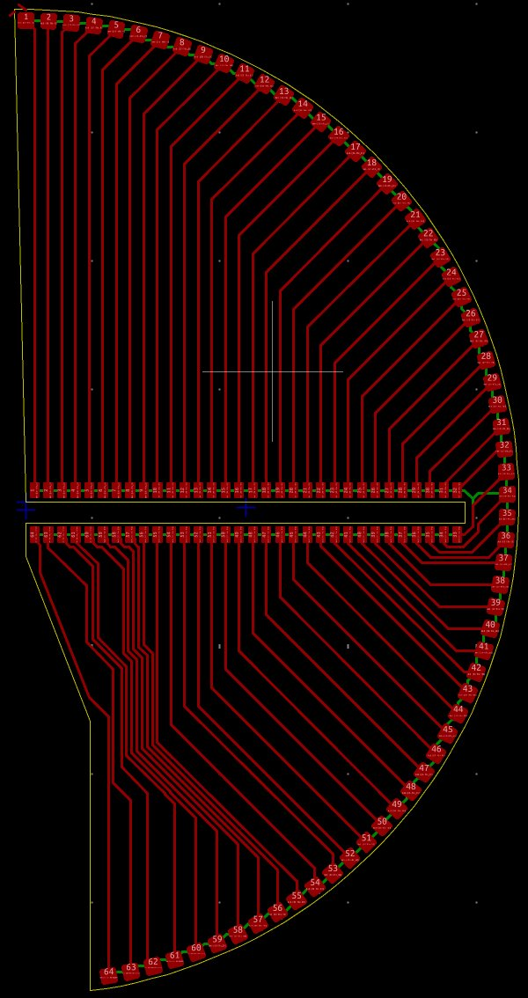
Figure 7. Z-Plane PCB
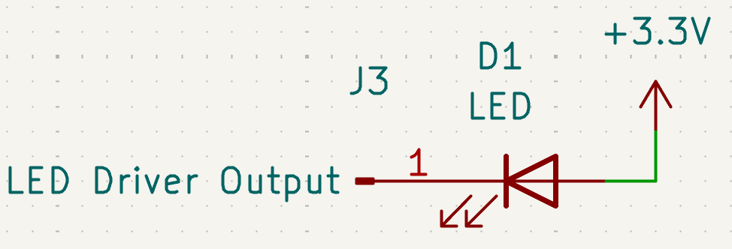
Figure 8. Simplified Single LED Schematic. Actual Schematic is this repeated 64 times.
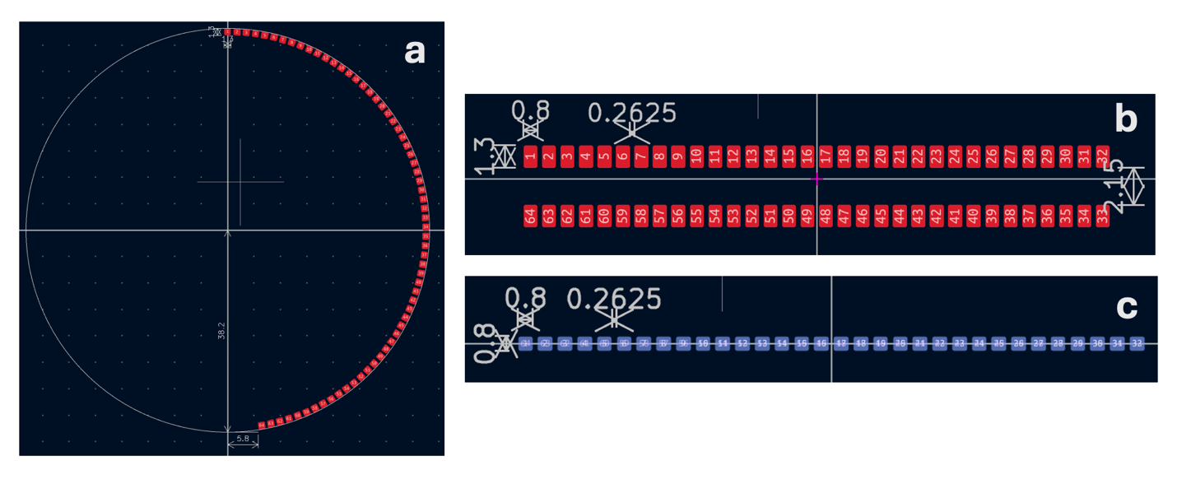
Figure 9. Custom Footprints Made. a) Circular aligning with LEDs, b) LED array footprint interfacing spinning PCB, c) Spinning PCB footprint interfacing LED array

2.7 Web Application
A wireless web application was developed to provide real-time user interaction with the POV display system. The ESP32-WROOM-32E hosts a lightweight onboard web server that allows users to connect directly to the rotating subsystem over Wi-Fi without requiring external networking infrastructure [2]. This wireless interface enables dynamic modification of displayed content during operation, which was a major functional requirement for escape room applications.
The web application was designed to support multiple display modes, including static image rendering, scrolling text, and countdown timer functionality. User inputs entered through the web interface are transmitted wirelessly to the ESP32, where they are processed asynchronously relative to the timing-critical LED rendering loop. Separating wireless communication tasks from the display synchronization logic minimized interference with Hall sensor timing and SPI-driven LED updates.
Under current demonstration conditions, the web application is self-hosted directly on the ESP32 rather than relying on external networking infrastructure. This configuration simplified deployment and improved reliability during live demonstrations by allowing nearby devices to connect directly to the embedded access point hosted by the microcontroller.
The frontend interface was implemented as a lightweight browser-based control panel hosted directly by the ESP32. This interface allows users to configure timer values, update displayed text, and upload image data without requiring physical access to the spinning assembly. Hosting the web application locally on the microcontroller eliminated dependence on external servers and simplified deployment within an escape room environment.
Wireless communication was also used to improve maintainability and usability compared to previous implementations of similar POV display systems. Earlier designs required wired updates or reprogramming to modify displayed content, limiting flexibility during live operation. By integrating wireless control directly into the embedded system architecture, the display can be updated in real time without interrupting rotation or disassembling the device.
Because the display synchronization loop operates with microsecond-scale timing constraints, firmware architecture was carefully structured to prevent wireless networking tasks from disrupting rotational synchronization. Timing-critical LED updates and Hall sensor processing were prioritized within the main control loop, while web server communication and user input handling were executed asynchronously in the background.
During subsystem testing, the ESP32 successfully hosted the onboard web application and demonstrated wireless communication with external devices. Timer configuration, text updates, and display mode switching were all successfully transmitted and processed during operation. However, full integrated wireless testing at elevated rotational speeds remained limited by the previously discussed mechanical instability within the rotating receiver coil assembly.
Additional implementation details regarding firmware organization, display timing logic, and wireless communication handling are documented within the firmware repository provided in Appendix A.
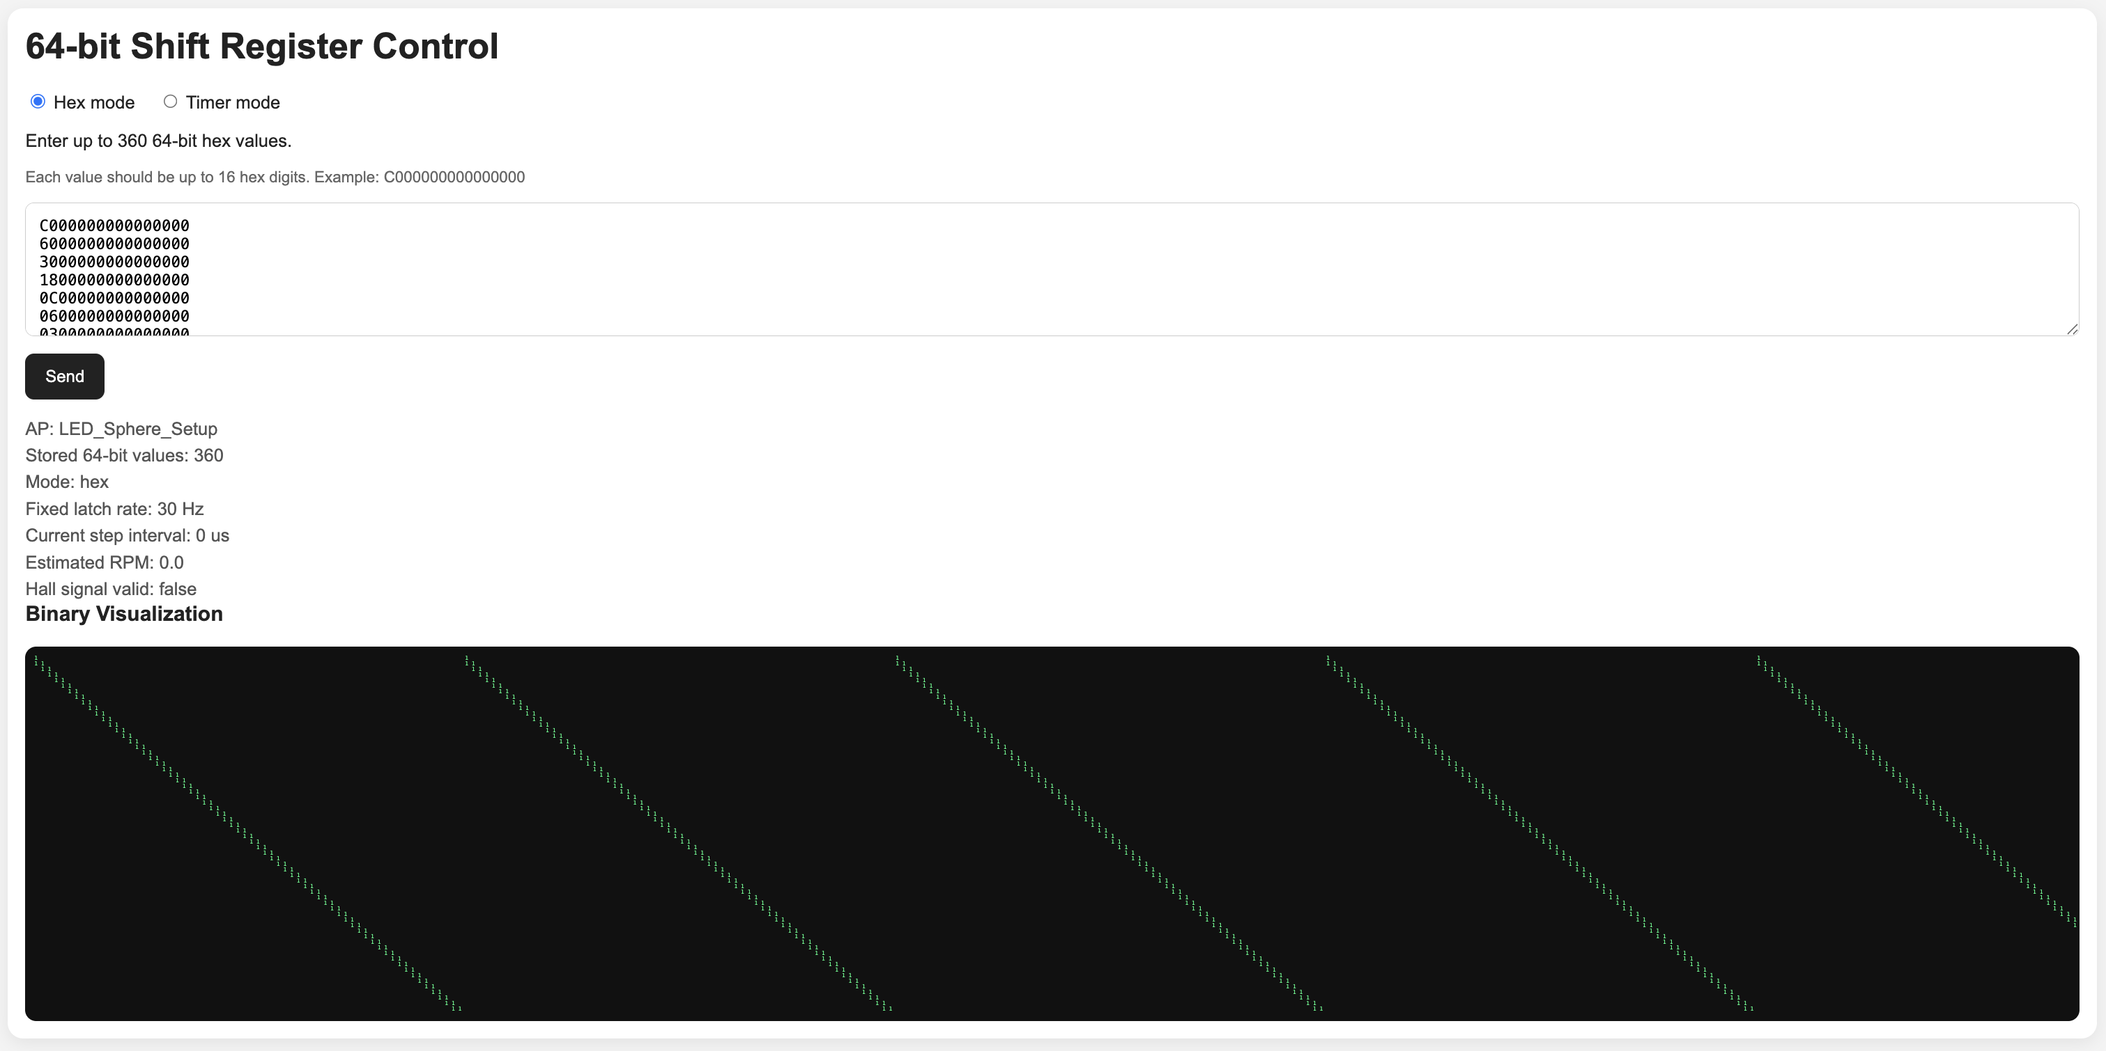
Figure 10. Web App Interface
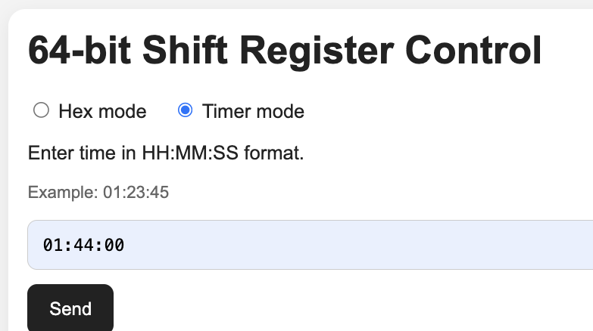
Figure 11. Timer Mode Interface

3. Design Verifications
This section details the testing procedures and verification results for the core subsystems of the LED sphere. Our testing methodology focused heavily on electrical probing, signal measurement, and controlled physical observations. While several individual components performed to specification, the integration of these subsystems revealed mechanical and hardware flaws that prevented the full operational verification of the visual display requirements.

3.1 Rotation Synchronization Test
- Requirement: The Hall effect sensor must trigger a software interrupt exactly once per 360-degree revolution to synchronize image rendering on the spinning display.
- Procedure: Because the physical assembly was mechanically unstable at operational speeds, we conducted a stationary test. We manually passed a magnet by the Hall effect sensor at varying intervals while we monitored the ESP32 via a serial terminal.
- Result: The diagnostic code successfully registered the software interrupts and logged the trigger events. The serial monitor confirmed the sensor's sensitivity and the code's accuracy without missing any detections during the manual test.

3.2 LED Array Logic and Continuity Test
- Requirement: All 64 LEDs on the Z-Plane array must individually illuminate and respond accurately to the shift register logic.
- Procedure: We uploaded a diagnostic "chase" code designed to sequence the LEDs individually. When the array initially defaulted to an unexpected "always on" state, we used an oscilloscope to verify the integrity of the SPI clock and latch signals sent to the LED drivers, and conducted a thorough review of the microcontroller firmware.
- Result: Signal verification confirmed that the hardware was receiving power and clock signals correctly without continuity shorts. The firmware review revealed that the data logic driving the shift registers was inverted in the code, causing the drivers to latch an unintended "always on" state. After correcting this logic inversion in the software, the array functioned perfectly. All 64 LEDs illuminated individually and responded precisely to the programmed shift register sequences, confirming full logical control for accurate pixel rendering.

3.3 Mechanical Stability and Motor Control Test
- Requirement: The stationary base and BLDC motor controller must provide stable, high-speed rotation while maintaining physical balance and minimal oscillation.
- Procedure: We manually adjusted the BLDC controller's potentiometer to gradually increase the rotational speed of the 24 V drone motor. We evaluated the mechanical stability of the assembly visually, both with and without the spinning receiver board attached.
- Result: Without the spinning assembly attached, the stationary components, including the motor, transmitter, and buck converter, operated with high stability and minimal vibration. However, once we attached the spinning receiver board, the assembly suffered from severe asymmetric mass distribution due to the heavy receiver circuit. As speed increased, the entire assembly visibly wobbled. We attempted to counter the mass by 3D printing a weight, but we lacked the time to print a sufficient counter-balance, and the spinning PCB severely limited the available spatial clearance for additional 3D printed components. The severe oscillations made it unsafe to operate the motor at full speed for extended testing.

3.4 Wireless Data Transmission Test
- Requirement: The custom Web App must successfully connect to the ESP32 microcontroller via Wi-Fi and transmit new text or timer data in under 10 seconds without any physical connections.
- Procedure: We programmed the Web App interface to send text strings and timer commands to the ESP32 over a local network.
- Result: The results for this requirement were inconclusive. Because the LED drivers were malfunctioning and all 64 LEDs remained in an "always on" state (as detailed in Section 3.2), we could not visually verify if the timer countdown or text data was successfully received and rendered by the globe. While the software and transmission logic were fully programmed, the hardware failures prevented a functional test of the wireless data display.

3.5 Power Regulation Test
- Requirement: The stationary board must receive 24 V from a wall adapter and regulate it down to a clean, stable 5 V to drive the inductive transmitter coil and sensitive logic components.
- Procedure: We used a digital multimeter to probe the input barrel jack and the output of the DFRobot buck converter. Additionally, we connected an oscilloscope to the buck converter's output to measure voltage ripple.
- Result: The multimeter confirmed a steady 24 V input and a stable 5 V output. The oscilloscope verified a clean DC signal with minimal voltage ripple, ensuring the sensitive logic components would not reset during operation.

3.6 Inductive Power Transfer Test
- Requirement: The inductive charging coils must transfer sufficient power across the air gap to the spinning receiver to power the electronics without the use of a mechanical slip ring.
- Procedure: We connected the receiver coil to the spinning PCB and measured the voltage at the input of the 3.3 V secondary buck converter using a digital multimeter.
- Result: The inductive coils provided continuous, frictionless power delivery. The voltage measurement confirmed a stable 5 V transfer across the air gap. This transferred power was sufficient to allow all 64 LEDs to illuminate brightly under standard laboratory lighting conditions.

4. Tolerance Analysis
This section analyzes the system’s ability to maintain functional operation under worst-case hardware tolerances and mechanical variations, specifically focusing on rotational timing margins and maximum power draw.
The persistence-of-vision display relies on the strict timing requirement that the SPI transmission time (t_{SPI}) and software overhead must not exceed the available time per angular slice (t_{slice} ). At the nominal rotational speed of 1500 RPM, t_{slice} =111μs and t_{SPI} =6.4μs. Due to the asymmetric mass of the Z-plane LED array, the BLDC motor experiences variable mechanical loading, which induces RPM fluctuations. Assuming a severe worst-case transient speed surge of +20%, the maximum rotational speed would reach 1800 RPM (30 Hz). Under this condition, the worst-case slice interval becomes:
$$T_{slice,min}=1/\left(30Hz×360slices\right)=92.59μs$$ | (4.1)
Even under this high-speed fault condition, the 6.4μs SPI transmission time consumes only 6.9% of the available timing window, leaving over 86μs for Hall sensor interrupt handling, latch timing, and ESP32 processing overhead. This calculation verifies that the timing architecture is highly tolerant to mechanical speed instability and will not experience data collision or image tearing under variable rotational loads.
Alongside timing stability, the system must also maintain safe electrical tolerances. The inductive power transfer system is rated for a maximum output of 3 A at 5 V. As calculated in Section 2.3, the nominal current drawn from the wireless receiver is 1.19 A. We must verify that component tolerances and thermal efficiency drops will not cause the system to exceed this limit. The current for the 64 LEDs is set by external current-limiting resistors on the STP16CP05 drivers. Assuming a standard 5% tolerance error on these resistors, the individual LED current could increase from 20 mA to 21 mA (2.3.1).
Furthermore, the efficiency of the DC-DC buck converter degrades under higher thermal loads. Assuming a worst-case efficiency drop from 85% to 80% during prolonged continuous operation, the new maximum total power and 5 V input current would be: (2.3.3), (2.3.4).
Under combined worst-case electrical component tolerances and thermal inefficiencies, the peak current drawn from the wireless receiver is estimated at 1.32 A. This maintains a 56% safety margin below the absolute maximum 3 A rating, verifying that the wireless power architecture is robustly over-designed for this application and highly tolerant to component variance.

5. Costs

5.1 Parts
The primary components used in the final design are detailed in Table B.1 in Appendix B. The total cost for the prototype was $210.05. As per ECE 445 guidelines, an estimate for the heavy steel base fabrication has been included in this total to account for machine shop costs. Minor passive components, such as standard resistors and capacitors, are included in the itemized list for completeness; however, because they were sourced directly from the ECE shop, they did not incur any additional project costs.

5.2 Labor
Labor costs are calculated based on an average starting salary of $95,000 for a UIUC Electrical Engineering graduate, translating to a conservative estimate of $25.00 per hour. The 300 total hours reflect a strategic division of labor where early planning and wiring were handled concurrently with the final PCB design for the LED strip. Using the standard ECE 445 multiplier, the labor costs are detailed in Table 2.
Team Member | Hourly Rate ($) | Hours Invested | Total Cost ($)
Ashley | 25.00 | 100 | 6,250.00
David | 25.00 | 100 | 6,250.00
Stephanie | 25.00 | 100 | 6,250.00
Total Labor |  | 300 | 18750.00
The total estimated project cost, combining both parts and labor, is $19,098.35.

6. Conclusion

6.1 Accomplishments
Despite encountering late-stage hardware failures, the project successfully validated several core subsystems required for a wireless POV display. The inductive power transfer subsystem successfully demonstrated wireless power delivery to the rotating electronics assembly without requiring mechanical slip rings. During stationary and limited rotational testing, the subsystem provided sufficient power for operation of the embedded electronics and LED array. Additionally, the Hall effect sensor and ESP32 synchronization architecture successfully detected repeated magnetic field transitions as a stationary magnet was moved across the sensor during testing, confirming proper interrupt triggering and timing detection functionality. The team also successfully developed and deployed a wireless Web App interface, enabling remote system control and wireless data transmission without physical tethering.

6.2 Unmet requirements and uncertainties
The final integration of the project revealed critical physical vulnerabilities that prevented the system from achieving its primary objective of rendering legible persistence-of-vision images. Initial assembly issues within the main spinning PCB introduced hardware shorts that interfered with proper LED control operation. Investigation determined that oversized capacitors contributed to soldering and clearance problems during assembly. Replacing these components with correctly sized capacitors intended for the PCB footprint resolved the issue and restored proper electrical behavior within the control circuitry.
The system also experienced severe mechanical wobbling caused by an unsupported receiver coil assembly and asymmetric rotational mass distribution. Because the instability made high-speed operation unsafe, full verification of the persistence-of-vision display functionality remained inconclusive.
Additionally, the microSD card subsystem could not be reliably detected during integrated testing. Investigation suggested that PCB layout constraints and component placement beneath the microSD card connector may have interfered with communication reliability. As a workaround, the required timer sprite assets were instead stored directly within ESP32 firmware memory.

6.3 Ethical Considerations

6.3.1 Ethics
In accordance with the IEEE Code of Ethics, the team has fully disclosed the hardware shorts and mechanical imbalances that prevented the final display from functioning. Reporting these failures honestly is critical for ensuring future iterations of this project can learn from these structural mistakes. Furthermore, the project utilized open-source software libraries for the ESP32's Wi-Fi capabilities, and the original developers have been properly credited to avoid plagiarism. The principles used to create such a display is not novel; however, the team fully reworked it from scratch not following other designs.

6.3.2 Safety
The testing phase illuminated severe mechanical safety hazards. Operating a high-speed drone motor at 1500 RPM with an unbalanced rotational mass created dangerous kinetic energy. The wobbling of the assembly emphasized the necessity of structural integrity in dynamic environments. Future operational models must include a shatter-proof enclosure to protect escape room players from potential projectile components if the assembly were to catastrophically fail.

6.4 Future Work and Alternatives
Future revisions of the system should prioritize mechanical stability, manufacturability, and subsystem reliability earlier in the design process. A rigid mounting structure or protective enclosure should be developed for the rotating receiver coil assembly to improve rotational balance and reduce vibration during high-speed operation. Additional dynamic balancing of the spinning subsystem would further improve operational stability.
A revised PCB layout should also be developed to improve manufacturability and subsystem reliability. Future board revisions should reposition components near the microSD card connector to improve mechanical clearance and communication reliability. Additionally, the ESP32 BOOT circuitry should incorporate a dedicated pull-up resistor to improve reliable firmware persistence and boot behavior following power cycling. The LED PCB should additionally be redesigned to reduce the risk of solder bridging and via contamination during assembly.
The wireless communication architecture could also be expanded beyond the current self-hosted ESP32 access point configuration to support integration with external Wi-Fi networks for improved usability in permanent escape room installations. Additional firmware improvements, including PWM-based LED brightness control and expanded sprite handling capabilities, would further improve display flexibility and visual quality.
Finally, after implementing a mechanically stable receiver coil mounting assembly, future work should focus on debugging and validating proper LED output behavior during full wireless Web App operation under high-speed rotational conditions.

References
- “150120GS75000 LED GREEN CLEAR 1206 SMD .” Accessed: Apr. 02, 2026. [Online]. Available: https://www.we-online.com/components/products/datasheet/150120GS75000.pdf
- “Espressif Documentation,” Espressif.com, 2025. https://documentation.espressif.com/esp32-wroom-32e_esp32-wroom-32ue_datasheet_en.pdf (accessed Mar. 22, 2026).
- “STP16CP05 Datasheet,” Apr. 08, 2024. https://www.st.com/resource/en/datasheet/stp16cp05.pdf (accessed Mar. 22, 2026).
- “DRV5023-Q1 Automotive Digital-Switch Hall Effect Sensor,” Mar. 2017. Accessed: May 06, 2026. [Online]. Available: https://www.ti.com/lit/ds/symlink/drv5023-q1.pdf?ts=1778070239795

Appendix A. Firmware and Software Repository
GitHub repository link: https://github.com/asaju67/POV-Sphere-Display
File | Module / Purpose | Main Function in System
POV_Display.ino | Main firmware entry point | Initializes serial, LED pins, Hall sensor, default pattern, Wi-Fi access point, web server, and timer mode; runs the main loop for web handling, Hall timing, timer countdown, and LED shifting.
config.h | Global configuration | Defines GPIO pins, AP credentials, pattern capacity, latch rate, Hall sensor settings, and output inversion flag.
app_state.h | Shared application state | Defines the global AppState structure storing pattern buffers, timer state, Hall timing data, RPM estimates, and web server object.
app_state.cpp | Global state instance | Instantiates the global appState object used across firmware modules.
hall_sensor.h | Hall sensor interface header | Declares Hall sensor initialization, ISR, timing update, and debug print functions.
hall_sensor.cpp | Rotation synchronization | Uses a falling-edge interrupt from the active-low Hall sensor to capture rotation timing, average RPM, calculate live slice interval, and detect timeout/loss of valid Hall signal.
led_output.h | LED output interface header | Declares LED pin initialization and 64-bit shift output function.
led_output.cpp | Shift register output driver | Configures data, clock, latch, and output-enable pins; shifts 64-bit LED patterns MSB-first to the LED drivers and latches outputs.
patterns.h | Pattern parsing header | Declares utilities for JSON escaping, hex conversion, default pattern loading, and parsing user-entered 64-bit values.
patterns.cpp | Hex pattern processing | Parses up to 360 user-provided 64-bit hex values, stores them in patternBuffer, rebuilds the displayed hex string, and creates the default shifting LED pattern.
web_ui.h | Web server interface header | Declares web page content and route handlers.
web_ui.cpp | Self-hosted web application | Hosts the browser UI directly on the ESP32, supports hex mode and timer mode, receives /submitPatterns POST requests, reports /status, and displays binary visualization, RPM, Hall validity, and current mode.
timer_mode.h | Timer mode interface header | Declares timer initialization, timer parsing, hex mode switching, timer state access, and countdown update functions.
timer_mode.cpp | Countdown timer logic | Parses HH:MM:SS, builds timer display patterns from digit/colon sprites, decrements countdown once per second, and updates the LED pattern buffer.
sprite_loader.h | Sprite file interface header | Defines 36 × 64 sprite data structures, sprite file constants, and sprite loading/building function declarations.
sprite_loader.cpp | Sprite loading and text rendering | Initializes SD card SPI, loads the .spr sprite file, validates sprite metadata, retrieves digit/colon sprites, and converts text into 64-bit LED column patterns.
data/number_sprites_36x64.spr | Binary sprite asset file | Stores 36 × 64 bitmap sprites for timer-mode digits and colon characters.
number_sprites_36x64.spr.txt | Text/exported sprite asset | Human-readable or repository-level version of the timer sprite file.
number_sprites_36x64_  loader_example.txt | Loader reference/example | Documents or demonstrates how the sprite file format can be loaded.
number_sprites_36x64_manifest.txt | Sprite manifest | Describes the sprite set contents, likely including supported characters and dimensions.

Appendix B. Parts and Cost List
Table B.1
Part Description | Link to Purchase | Manufacturer | Quantity | Cost Each($) | Total Cost($)
ESP32-WROOM-32E Microcontroller | https://www.digikey.com/en/products/detail/espressif-systems/ESP32-WROOM-32E-N8/13159522 | Espressif | 1 | 5.28 | 5.28
900KV Brushless Drone Motor | Amazon | Generic / Amazon | 1 | 88.96 | 88.96
Three-Phase BLDC Motor Controller | Amazon | LYWS | 1 | 13.99 | 13.99
Inductive Charging Coils | Amazon | Taidacent | 1 | 40.00 | 40.00
24V Wall Plug Power Adapter | Amazon | LED Lights World | 1 | 5.95 | 5.95
24V to 5V DC-DC Buck Converter | https://www.digikey.com/en/products/detail/dfrobot/DFR0831/14322651 | DFRobot | 1 | 4.90 | 4.90
STP16CP05TTR Shift Registers | https://www.digikey.com/en/products/detail/stmicroelectronics/STP16CP05MTR/1299905?s=N4IgTCBcDaIMoBUAKBGAbAYSQBgKwFkQBdAXyA | STMicro | 4 | 1.85 | 7.40
Green LEDs size 1206 SMD | https://www.digikey.com/en/products/detail/w%C3%BCrth-elektronik/150120GS75000/4489936 | AMS Osram | 80 | 0.10 | 8.16
CP2102N USB to UART Bridge | https://www.digikey.com/en/products/detail/silicon-labs/CP2102N-A02-GQFN28/9863477 | Silicon Labs | 1 | 4.32 | 4.32
USB-C Connector (USB4085-GF-A) | https://www.digikey.com/en/products/detail/gct/USB4085-GF-A/9859662 | GCT | 1 | 0.87 | 0.87
5VWM SOD923 TVS Diodes | https://www.digikey.com/en/products/detail/onsemi/ESD9B5-0ST5G/1646449 | onsemi | 10 | 0.02 | 0.20
30V 1A SOD323 Schottky Diodes | https://www.digikey.com/en/products/detail/diodes-incorporated/BAT760-7/697106 | Diodes Inc. | 2 | 0.47 | 0.94
TLE4906LHALA1 Hall Effect Sensor | https://www.digikey.com/en/products/detail/infineon-technologies/TLE4906LHALA1/954435 | TI | 1 | 0.92 | 0.92
AP63300WU-7 3.3V Buck Converter | https://www.digikey.com/en/products/detail/diodes-incorporated/AP63300WU-7/10491510 | Diodes Inc. | 1 | 0.60 | 0.60
SS8050 Transistors | https://www.digikey.com/en/products/detail/shenzhen-slkormicro-semicon-co-ltd/SS8050/21853087 | Slkor | 10 | 0.05 | 0.45
PJ-102A Power Jack | Amazon | CUI Devices | 1 | 0.59 | 0.59
DM3D-SF Micro SD Connector | https://www.digikey.com/en/products/detail/hirose-electric-co-ltd/DM3D-SF/1786510 | Hirose | 1 | 1.83 | 1.83
8GB Micro SD Card | https://www.digikey.com/en/products/detail/apacer-memory-america/AP8GMCSH10U1-B/5268724 | Apacer | 1 | 17.77 | 17.77
1/4 X 1/4 Neodymium Magnets | ECEB | ECE Supply Store | 2 | 1.33 | 2.99
B3F-1000 Push Buttons | E-Shop Self Service | Omron | 2 | 0.24 | 0.48
Inductor (74438357047) | https://www.digikey.com/en/products/detail/w%C3%BCrth-elektronik/74438357047/6833540 | Wurth Elektronik | 1 | 1.69 | 1.69
1.6mm Thickness Custom PCBs |  |  | 1 | 0.0 | 0.0
Resistors and Capacitors |  | ECE Shop | 41 | 0.0 | 0.0
Total Cost |  |  |  |  | $210.05

