By
[Matthew Jin]
[Timothy Fong]
[Ved Tiwari]

Proposal Document for ECE 445, Senior Design, [Fall/Spring 2026]
TA: [Zhuoer Zhang]
[13] [February] 2026
Project No. 11
[Group 11 ECE445 Proposal Document]
Abstract
This is a BattleBot under the 2-lb weight limit that utilizes weaponry and auxiliary subsystems to outmaneuver and tactically disable other entries within the tournament. Extensive countermeasures and engineering decisions have been synthesized, as covered in more detail later in this document.
Contents

1. Introduction 4
1.1 Visual Aid 4
2 Design 5
2.1 [Mechanical Subsystem] 5
2.1.1 [Motors] 5
2.1.2 [Wheels] 5
2.1.2 [IMU Sensors] 5
2.2 [Power Subsystem] 5
2.2.1 [LiPo 4S Batterypack] 5
2.2.1 [Voltage Regulator/Buck Converter] 5
2.3 [Microcontroller Subsystem] 6
2.3.1 [Wireless Comms Capability] 6
2.3.2 [Arduino IDE] 6
2.3.3 [Hardware Health Check service] 6
2.4 [Protection Subsystem] 7
2.4.1 [Current & Voltage Sensors] 7
3. Parts List 8
4. Conclusion 9
4.1 Uncertainties 9
4.2 Ethical Concerns 9
References 10

1. Introduction
The all-encompassing challenge of this Battlebot project is to weigh engineering decisions that allow for tactical and functional advantages over other Battlebot participants. This is encapsulated by aspects of high reliability, structural integrity, ideal component selection, and countermeasures sculpted by foresight. Throughout this document will be details depicting the design process, subsystems (and their interconnections), and a parts list spreadsheet. The final section will include considerations of project aspects with more subtle (yet important) ramifications.

1.1 Visual Aid
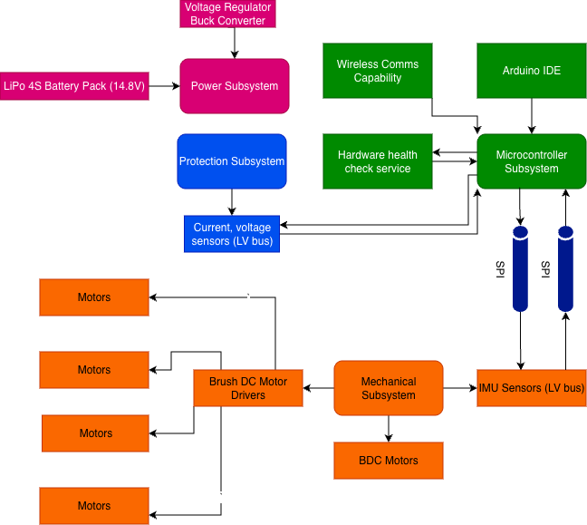
Figure 1: This is a high-level block diagram that captures the four subsystems of the robot, along with its components and interconnections.

2 Design
There are four subsystems whose design choices and engineering decisions will be explained in detail.

2.1 [Mechanical Subsystem]
There were several considerations to be conscious of when designing the mechanical subsystem. Given the 2-lb weight limit, the selected motors (including their drivers), wheels, and IMU sensors all had to be compact and reliable for their use cases.

2.1.1 [Motors]
For the motors, it was a toss-up decision between BLDC and BDC motors. Both are generally great for the purpose of lightweight battlebot competitions, but it was the BDC’s part availability that truly sold it to us.

2.1.2 [Wheels]
The wheels were chosen to be made of urethane, which provides the best combination of reliable grip and durability. 1.25’, or 32mm, were chosen for the diameter. This particularly small choice was due to the fact that these wheels will go inside the armored shell.

2.1.2 [IMU Sensors]
IMU sensors typically are classified as a combination of three sensors – gyroscope, accelerometer, and magnetometers. Per the NRC (National Robotics Challenge) rulebook, no metal is permitted for use in the antweight competition which voids the need for a magnetometer entirely. The accelerometer and gyroscope will be utilized by propagating feedback loops between themselves and the microprocessor. This allows for the capability to self-adjust in the event of imbalances or to prevent a flip-over scenario.

2.2 [Power Subsystem]
The power subsystem oversees the energization of all other subsystems (Microcontroller, sensors, and drive system) involved in this project.
Requirements:
- Buck Converters should be able to step down incoming 14.8 V to stable 3.6V and 12V.

2.2.1 [LiPo 4S Batterypack]
The LiPo 4S battery was specifically chosen to provide a clear balance between power and charge capacity. This way, any concerns of non-idealities in capacity storage capabilities and/or not lasting the entire match duration are null possibilities. Additionally, the loads (primarily the motors) are expected to have high current ramp rates due to the battlebot movements’ necessity to be nimble and responsive to threats. This battery configuration (4S) achieves this purpose.

2.2.1 [Voltage Regulator/Buck Converter]
Since the LiPo battery pack will have 14.8 V and the Adafruit Feather V2 only accepts 3.3 volts so a step down is necessary in order to prevent damage to the microcontroller. While the motor drivers can accept up to 37 V the motors themselves are only rated to 12 V. This is another use case of stepping down from 14.8 V to 12 V in the instance of the motors otherwise they can be damaged and prevent the robot from moving. Since these voltage conversions are quite high, then it makes more sense to use a buck converter over a linear

2.3 [Microcontroller Subsystem]
We decided to use an Adafruit ESP32 Feather V2 microcontroller for our design. This is the best microcontroller for our design compared to other popular microcontrollers like the STM32 for many reasons including price, compute power, energy efficiency, and native features supported by the board. This section will aim to discuss all of the subsections included in our Microcontroller subsystem and how those subsections interact with each other to provide compute abilities for the bot.

2.3.1 [Wireless Comms Capability]
From the client side (wireless laptop), we will need a way to transmit our control inputs wirelessly to the ESP32, and vice versa. The best approach for this would be to configure the ESP32 to host a webserver that’s connected to a shared router. We can then open a websocket connection from the client to the board to offer input requests and responses over one continuous connection. This server can be accessed through WIFI in a browser on an agreed-upon port (think :8000). In our case, the advantage of using the Adafruit ESP32 Microcontroller is that the wifi module is native to the board and the headerfile can imported using a straightforward #include <WiFi.h> in our code. More on the Arduino IDE in the next section
The payload will be transmitted through this websocket that is established upon boot time containing the values for the keys that are pressed along with an acknowledge bit from the server to ensure that our keystroke has been received all and well.

2.3.2 [Arduino IDE]
The Arduino IDE will prove to be instrumental in the development of the server and websocket setup, local algorithmic computations, as well as communication to the motors on board. We will use the Serial peripheral interface (SPI) communication protocol for all communication between the microcontroller and the motors and sensors. This allows for asynchronous communication between the master (in our case the microcontroller) and all of its slaves (sensors and motors). We chose to use the SPI communication protocol as opposed to the I2C protocol because there are two different lines for sending and receiving. This allows for us to send and receive signals through our server simultaneously.
All of the code will be organized similar to the diagram shown in figure 1 under the Arduino section. Namely, we will have separate files for the hardware health check service and the wireless communication service.

2.3.3 [Hardware Health Check service]
In efforts to add redundancy to our design in order to ensure the health of our hardware remains a top priority, the microcontroller will also have support to check the health of the hardware using data provided from the sensors. This is analogous to a “first step” for the user to check on the health of our hardware before it falls into the backup Protection Subsystem (More in section 2.4)
The hardware health check service on board will be programmed with algorithms to generate metrics to report the health of the system as a whole. These are included but not limited to: battery health and percentage, motor overload detection, and flip detection from the gyroscope in the IMU.

2.4 [Protection Subsystem]
Due to the extreme nature of a battlebot competition, ramp currents are expected to be quite extreme. The system will also need to step-down voltage from 14.8V to signal/comms voltage levels. It is imperative to not bank on the notion that our components will function perfectly as intended when sewn together. This protection subsystem was deemed necessary to uphold overall system reliability.

2.4.1 [Current & Voltage Sensors]
In lieu of the motors becoming overloaded and/or the presence of electrical faults, current and voltage sensors will be scattered at critical PCCs (points of common coupling) to monitor any long-term threshold violations that cannot be classified as transients/noise. Per the motor driver datasheet, the stall extrapolation current is 0.75A. Per the Gear Motor datasheet, the recommended brushed DC motor operation is 25% or less than the aforementioned current. Thus, 25% is where the OCPT (overcurrent protection threshold) will be placed. Voltage sensors will also monitor the low-voltage buses connecting to communications/signal channels to prevent the overloading of the microprocessor. Due to the absence of a BMS (due to its negative impact on antweight battlebot-specific performance), voltage and current sensors will need to be placed at the output terminals and common connection points of the battery pack to ensure proper operation. These sensors will be continually polled by the microprocessor’s Hardware Health Checkservice subcomponent, thus creating another feedback loop between the “brain” and the “body”.

3. Parts List
Below is the tentative parts list for the project. Cost at this point in development can only be estimated, including further labor costs (pending tariff information TBD).
Table 1 – Parts List
Part | Manufacturer | Special Notes
Adafruit ESP32 Feather V2 | Adafruit | Offers Native WiFi support, and has plenty of GPIO pins for our peripherals
Motor Bracket | Pololu
Gear Motors | Pololu
Brush DC Motor Driver | Pololu
Polyurethane Wheels | Motion RC

4. Conclusion
This proposal document sums the tentative plans, goals, and design choices reached to meet the former two. With the primary focus of this proposal document detailed, the document concludes with considerations of ethics and project uncertainties.

4.1 Uncertainties
Due to the inherent nature of using 3-dimensional computer aided design, there will be some level of dimensioning uncertainty that translates into the real world. Additionally, the 3D printing process may also not yield a perfectly polished product. The microprocessor may have manufacturer defects or other undesirable malfunctions. This summarizes all possible uncertainties that this project may encounter.

4.2 Ethical Concerns
There are no concerns of broken engineering ethics. All aspects of this project are designed in accordance with the National Robotics Challenge rulebook, which already upholds a baseline level of integrity and participant safety that must be followed. We will adhere to the following guidelines based on the rulebook:
- A maximum of 60 seconds to disconnect manually the power systems driving the robot in terms of the weapon or motors.
- An led that will display an on signal for when the robot is on and an off signal when the robot is turned off.
- A manual shutoff in the form of a switch should allow for a person to turn off the robot in 15 seconds or less.
- If remote connection is lost between laptop and robot, then the robot will stop moving and stay in stationary state until connection can be re-established.
Some operating procedures that we will strictly follow for testing or for initial set up of robot during competition is the following:
- Ensure the robot is in a closed environment and away from other robots or objects.
- Check to see status led is turned on to indicate the robot is powered on.
- Confirm the microcontroller is sending the same status by wifi to the laptop.
- Move robot to confirm controls work.

References

[1] Gearmotor HPCB 12V, datasheet, Polulu Corporation., 2026. Available at: https://www.pololu.com/product/3051
[2] National Robotics Challenge - The 2026 Contest Manual, web page. Available at: https://www.thenrc.org/contest-manual

