Final Report for ECE 445, Senior Design, Spring 2026
TA: Abdullah Alawad
13 February 2026
Project No. 70
By
Ahmet Colak
Jason Hart
Srijan Kunta

EduGrid Microgrid Demonstrator

Project Proposal
Abstract

EduGrid Microgrid Demonstrator is an interactive tabletop central power grid demonstrator that teaches protection, frequency control, and power factor correction through guided scenarios of real life grid faults.
An ESP32-S3 runs a state-machine grid model, drives an SSD1306 OLED, reads a rotary selector and breaker toggles, and keeps track of states which are then transformed into actual input output data via the use of transistors. Users initiate faults (ground fault , arc/lightning, undervoltage from excessive load, over-frequency from excess generation, and power factor control) and restore service by isolating the correct feeder section or shedding load/dispatchable generation; success is indicated by green status LEDs, no alarm, and an on-screen confirmation. For power-factor control, the PCB measures inserted capacitors/inductors using RC/RL time-constant timing (63.2% threshold) and computes power factor relative to a target, providing corrective prompts.
The prototype is validated by completing all five scenarios sequentially and meeting L/C measurement and indication requirements.

Contents

1. Introduction 1
1.1 Problem 1
1.2 Solution 1
1.3 Visual Aid 2
1.4 High Level Requirements 2
2 Design 3
2.1 Block Diagram 4
2.2 Subsystem Overview 4
2.2.1 Power Subsystem 4
2.2.2 Processing Subsystem 4
2.2.3 User Interface Subsystem 5
2.2.4 Status Devices Subsystem 5
2.2.5 Control Subsystem 5
2.3 Subsystem Requirements 6
2.3.1 Power Subsystem 6
2.3.2 Status Devices Subsystem 6
2.3.3 User Interface Subsystem 7
2.3.4 Control Subsystem 7
2.3.5 Processing Subsystem 8
2.4 Componenet Measurement Using RC/RL Time Constants 10
2.5 Power, Reactive Power, and Power Factor 11
2.6 MOSFET Logic Gate Creation Equations 13
2.7 Power + Regulation Support Equations 14
2.8 Tolerance Analysis 14
3. Costs 18
3.1 Parts 18
4. Conclusion 19
4.1 Accomplishments 19
4.2 Uncertanties 20
4.3 Ethical and Safety Considerations 20
4.4 Future Work 20
References 21

1. Introduction
The complexity of power grid protection and the role that power engineers play in designing it is not well supported or introduced in early education. Even within universities, grid infrastructure design and methods of protection for our grid is a subject where many students go through their whole educational careers without learning.
We propose a solution to this gap in education by creating a product aimed at all levels of education that give students varying levels of complex grid-scale problem solving opportunities. All of this will be achieved within a single tabletop package that provides numerous fault clearing objectives of increasing difficulty for the student, allowing for an intuitive hands-on approach to learn about the broad range of risks and corrective measures for our grid.

1.1 Problem
Students often have limited understanding of how the electric power grid is designed to stay safe and reliable, especially the protection systems, breakers, relays, and fault isolation methods that prevent small failures from becoming large outages. Because these concepts are not taught in a fun and accessible way, many students do not see what power engineers actually do or why the field matters, which can reduce interest in pursuing power and energy careers. Recent large scale outages, such as the winter storm related failures experienced in Texas, show how grid reliability, planning, and protection directly affect daily life and the safety of the public, highlighting the need for clear, hands-on educational tool.

1.2 Solution
Our product will include an interactable tabletop power grid that allows the user to see the flow of power from source to load, all while having access to switches and controls that aim to isolate faults, correct the power factor, understand automatic protection, stabilize grid frequency, and visualize the flow of power on our grid. Our system will simulate fault scenarios that occur in real world power grids, such as feeder short circuits, ground faults from vegetation contact, and arc faults at substations, and guide the user through the correct isolation and restoration steps. Our system will accomplish this by utilizing both a microcontroller-based state machine system as well as an on board display screen, rotary encoder, status LEDs, sound emitting device, and capacitive/inductive component recognition for power factor correction.
Users will be able to choose from multiple capacitor and inductor values to achieve the desired power factor correction. Our PCB will identify the selected component’s magnitude using DC based RC and RL time constant circuits to measure the time it takes for the voltage across a known resistor to reach the 63.2% threshold. This time constant, tau, will be used by our simulated model to solve for the capacitive/inductive value added to the board. The microcontroller will then mathematically compute the expected power factor correction using a predefined target value. Based on this calculation, it will determine whether the chosen capacitor/inductor value is correct and present the result on the display. The user will see a message that reads: “meets target,” “Increase C / Decrease L,” or “Decrease C / Increase L”. Additionally, our system will contain energy consumers/loads, such as family homes or factories, and we are going to model energy sources, such as a solar farm, nuclear plant, and a natural gas turbine plant. The system will react to the loads and sources in order to determine and display the simulated frequency of the grid. Our simulation state machine will also store breaker statuses, fault states and status, as well as LED states and clear fault logic conditions. Both the software and hardware systems will provide students with an intuitive and engaging tool to learn more about the important role of power engineers.

1.3 Visual Aid

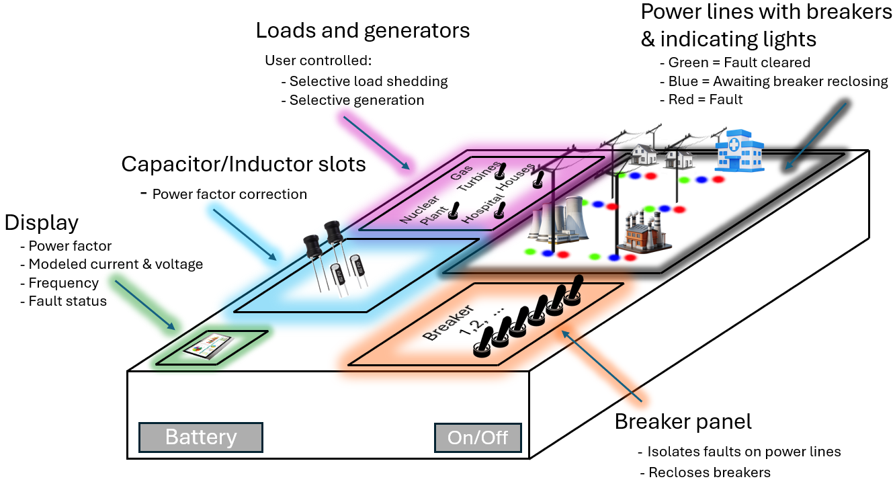
Figure 1: EduGrid Board Visual Aid

1.4 High Level Requirements

- The user can select and clear the five available fault scenarios (permanent faults, transient faults, undervoltage voltage and frequency droop under heavy load, overvoltage for selective generation, and power factor correction).
- The on-board display shows the relevant information for each fault scenario (power factor current state and target, frequency, voltage, and current simulation values).
- The user input capacitance and inductance values are accurately computed and displayed on the on-board screen.

2 Design
There were many alternatives possible for the design of this product. A few that we considered included a fully stepped down AC system relying on real time voltage and current measurements on multiple parts of the board to inject faults, check for cleared states, provide power factor correction measurements, and real time frequency monitoring. Another alternative was to create a software defined grid model that takes user input on buttons and components to update the model simulation and reflect changes to fault status visually. We chose to create a middle ground that involves a full DC based microgrid system that will include hardware and software defined solutions.
The hardware defined systems within the PCB will measure and compute the RC/RL time constant from user input capacitance and inductance through RL/RC circuit, OLED display of state-relevant grid quantities, and MOSFET logic to drive the buzzer system, LEDs, and current controlled rails. The software defined systems include our grid simulated measurements of voltage, current, frequency, load balancing, and power factor triangle.

2.1 Block Diagram
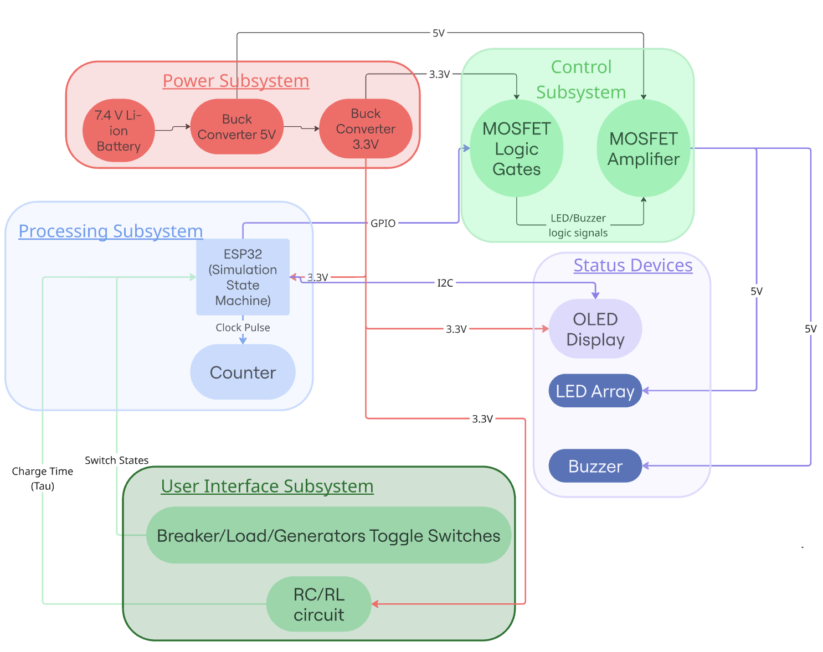Figure 2: Block Diagram

2.2 Subsystem Overview

2.2.1 Power Subsystem:

The power subsystem handles power distribution and DC/DC regulation. It provides stable regulated power rails for every subsystem. This allows the ESP32-S3, display, LEDs, noise devices, and indicators to operate reliably. This subsystem converts the main input supply into a clean 5 V rail and a clean 3.3 V rail, with protection and power indication.

2.2.2 Processing Subsystem:
The processing subsystem is the brain of the system that stores the simulation electrical values for the internal logic, states of feeders, fault type, phase angle, impedance, simulated IV measurements on the feeders, display text, and breaker status. The on-board display will show feeder voltage and current, and power factor, which is calculated using actual added capacitance or inductance physically into the board. This subsystem connects to the control subsystem to drive MOSFET logic and amplification for LEDS, as well as the status devices subsystems to drive the content on the OLED display.
To avoid any ESP32 brownouts, we will limit the total number of LEDs (WP7113) on our product to 15. Additionally, we will drive the LEDs with current through a MOSFET whose gate is controlled by our esp32. We will limit the brightness of these LEDs by using resistors to fix their current to below 6 mA each. Decoupling will be accomplished by using a bulk capacitor sized at around 200 uF to absorb any peak transient load from the LEDs. We will also include decoupling capacitors on the ESP32 at around 10 uF along with the display screen in order to reduce the risk of impacts from transient loads for our MCU. Our 3.3 V regulator will be sized to operate at less than half of its rated current. This gives a large enough margin to avoid ESP32 brownouts.

2.2.3 User Interface Subsystem:

User Interface Subsystem is comprised of parts of the board that are controlled by the user. These include: the Capacitors and Inductors the user chooses for power factor correction, breakers the user has to trip in order to separate faulty loads from sources, generator toggle switches that the user can decide to cut from the system in order to balance the power/frequency of the simulated grid.

2.2.4 Status Devices Subsystem

The Status Devices Subsystem contains the small OLED display, the LED array, and the Buzzer. This subsystem is used to display all of the important information of the simulation. The LED array will be used to display which power lines are active or dead. the OLED display will show information such as the Power Factor, voltage, and progress and status information about the user’s progress in the current level. The Buzzer will play when the demo begins, the user makes correct moves or mistakes, and when the user completes the demo successfully.

2.2.5 Control Subsystem
The control subsystem contains the MOSFETS used for both low level logic control as well as the current amplification to drive the LEDs. This ensures that the ESP32 does not experience any brownouts due to excess current draw. This subsystem communicates to the status devices subsystem in order to both drive the high current for the LEDs as well as to provide the buzzer component with the required voltage to sound only when the user has made a mistake in each given scenario.

2.3 Subsystem Requirements

2.3.1 Power Subsystem
The Power Subsystem converts the project’s Li-ion battery input into two regulated rails (5 V and 3.3 V) used by every other subsystem. It supports reliable operation of the ESP32-S3 processing block, SSD1306 display, LED array, buzzer, MOSFET amplifier, and MOSFET gate logic by maintaining supply voltage within tolerance during transient load events, for example multiple LEDs switching. The subsystem also provides power on/off control, and visual power indication so the board can be used safely as a portable tabletop device.
Li-ion battery pack (nominal 7.4 V).
5 V rail to LED/buzzer power stages and any 5 V peripherals.
3.3 V rail to ESP32-S3, OLED, and all logic-level circuitry (GPIO, I2C pullups, MOSFET gate networks).

Part List:
Li-ion battery pack: ICR18650-4400 W/JST-PHR-2P
Main power switch: SPST toggle/slide (EG1218)
5 V rail regulation: buck converter (TPS54202DDCR)
3.3 V rail regulation: LDO regulator (TLV75533PDBVR)
Reverse-polarity protection: series Schottky diode (SS14TR-ND)
Power indication: LED (WP7113SURDK14V) with current limiting resistor

2.3.2 Status Devices Subsystem
The Status Devices Subsystem is the primary user interface for the simulation, giving users real-time visual and audio feedback. It translates the internal logic of the simulation such as the power line status, electrical metrics, and game logic, and turns it into human-readable signals so the user can easily understand how their actions affect the simulation in real time.
The SSD1306 OLED display must communicate with the ESP32 via the I2C protocol at a rate of at least 100 kbps, preferably 400 kbps for smooth display operation and to ensure that the display lag is minimal.
All status components should operate within a 3.3V+- 5% range to prevent damage to the ESP32 GPIO pins or cause logic level mismatches.
The CUI CEM-1203 buzzer device must work properly and provide a Sound Pressure Level of at least 85 dB to ensure audibility of the sound.
This subsystem is functionally dependent on the 3.3V rail from the power subsystem to power the OLED and LEDs. If the voltage drops below 3.0V, the display will fail. It is also dependent on the processing subsystem to provide the I2C clock signal and GPIO triggers. Without the ESP32’s control logic, the status devices would remain at an idle state.
This subsystem does not affect the rest of the subsystems too much. If this subsystem fails, the simulation simply goes “blind”, in that the user will be unable to see the state of the simulation demo, and will not understand what is going on, even if the simulation continues to run correctly.

2.3.3 User Interface Subsystem
The user turns the rotary selector and chooses a fault scenario from the display. When activated, the MCU flags a specific feeder segment or node as faulted in the grid model and updates the board’s display. Fault detection is implemented by checking whether the faulted line/node is down. Protection is seen as successful when the user opens the correct nearest surrounding breakers so the faulted section is isolated while healthy sections can be restored, or else the activation light remains on and the buzzer alerts during solution check.
For power factor correction, the PCB will physically measure the user chosen component using DC RC and RL time constant circuits within the PCB. A known resistor will be used with a step voltage input into it, and an esp32 internal counter will capture the time it takes to reach 63.2% of the max voltage across the resistor. This will give us the tau value that the simulation model will use to calculate the value of the capacitor or inductor that the user chose to add to correct the power factor. These measured C and L values will be used by the MCU to compute the new PF and reflect it on the display.
- Manual rotary selector: PEC11R-4220F-N0012
- Fault selection/activation light: 160-1142-ND

2.3.4 Control Subsystem
The control subsystem facilitates the function of our entire project by allowing the safe operation of our LED array, buzzer component, and the safekeeping of our microcontroller. Without this system, the current draw from our MCU will cause a brownout in the device. The control subsystem requires the sufficient supply of voltage from the power subsystem as well as the correct GPIO logic signals from the ESP32. Without these, then the logic and amplification capabilities of the control subsystem would not function. This would result in the status device subsystem failing to send the required current and voltage to the necessary LEDs and buzzer when needed.
- MOSFETs used to drive higher current for LEDs (controlled by esp32) along with current limiting resistors to avoid esp32 brownout
  - CSD15380F3
  - CSD25501F3
Hardware logic and physical L/C measurement
We will implement key logic, measuring, and timing using MOSFET transistors.
- MOSFET nmos: CSD15380F3
- MOSFET pmos: CSD25501F3

2.3.5 Processing Subsystem
The processing subsystem allows the entire design to operate according to the user inputs and internal current state of the simulated model. The processing subsystem requires the functionality of the power subsystem to distribute a clean 3.3V rail to the ESP32 as well as requiring the simulated model and state machine to be accurate in terms of the current state and corresponding logic signals associated with each fault scenario.
  - Microcontroller: ESP32-S3
  - Counter : 595-CD4040BE
  - esp32 decoupling capacitors:
    - 200uF (647-UTH2G201MND),
    - 0.1 uF (C320C104K5R5TA73)
Simulated fault scenarios (to be picked by the user)
- Short circuit fault (line to line fault) & Ground fault (Line touches earth/ground) (Fallen tree), blown fuse
  - Permanent fault scenarios where the user must correctly choose the surrounding breakers nearest to the faulted zone and hit the test button to check if they accurately isolated the fault. In this event, the indicating line near the fault turns green from red and the buzzer does not sound.
- Lightning-induced fault, arc faults
  - Transient fault scenarios where the user must wait until either the primary automatic breaking isolates the fault or the secondary breakers downstream (on a time delay) break the fault upon primary breaker failure (demonstrating real world operation to the user). If the user reclosed the breakers too early (before the simulated clearing delay), the fault reappears. If they wait and reclose at the correct time, the line returns back to functional.
- Undervoltage (voltage and frequency droop under heavy load)
  - A load shedding scenario where too many loads are on the grid (factories, hospitals, houses) and the frequency and voltage droop. The user must selectively load shed in order to raise the frequency back to 60 hz and correct the voltage droop. This voltage droop and frequency change will be displayed to the user as the scenario occurs. Successful completion is determined when the correct load option (residential) is load shed (3D printed house piece is removed from the board) to preserve high priority loads just like in real grid operation.
- Generation disconnect to solve frequency droop
  - A frequency stability scenario where the frequency rises above 60 Hz because there is too much generation and not enough loads on the grid. The user selectively turns off generation sources that are quick to turn off and on (like natural gas turbines), and the MCU simulates the frequency response to load changes. Sources that are difficult to start up, like coal and nuclear behave differently than dispatchable sources like natural gas turbine generators. The display shows the resulting simulated frequency deviation and recovery. The user will correctly solve the scenario when they choose to disconnect the natural gas turbine from the set of generation sources on the board. If any other source is disconnected (nuclear or solar/wind) then the buzzer will sound.
- Power Factor Control
  - A power factor correction scenario where the user adjusts the system’s reactive behavior by inserting capacitors/inductors into the board. The PCB physically measures the inserted L/C using DC RC/RL timing circuits by measuring the time it takes for an inserted voltage to reach 63.2% of the max across a known resistor to find tau. The MCU uses the measured values in a mathematical PF correction model referenced to a predefined target PF for the user to attempt to match. The display shows the computed PF and recommends actions (“increase C / decrease L” or “decrease C / increase L”) until the target PF is met and the light goes green to show success.
- Correct isolation conditions
- The microcontroller will initialize fault scenarios that will require the user to manually trip breakers nearest to the fault on all necessary ends to isolate the fault. Correct isolation will be detected using internal logic that determines if the nearest breakers in the zone of protection were tripped. If not, then the user will hear a buzzer sound upon checking their solution correctness while seeing red lights continue to illuminate the faulted region.
- For the fault scenarios involving automatic tripping, the user’s success will be checked upon their decision of when to reclose the circuit. If they reclose the breakers too early before the primary and backup breaker protection has activated, then the buzzer will alarm. In this case, they must wait until the LEDs on the board show signs of effective simulated isolation before reclosing the breakers and hitting the test button to check accuracy.
- Our software defined symmetrical fault types include short circuit faults on various distribution lines, ground faults, or arc faults. The user will see the causes of these faults displayed to them via the on board display panel, whether caused by animal interference, vegetation, or lightning/earthquakes.
  - Breaker toggle switch: 100SP5T1B1M1QEH
  - Indicating LED: WP7113 SURD
    - Indicates state of line (faulted, cleared, in progress) (Red, Green, Blue)
    - “In progress” signals that the automatic breaker scenario is attempting to isolate the fault using primary breaker protection before its time delay triggers the secondary breaker protection to trigger. Once it's isolated, the user is then responsible for reclosing the correct breakers to bring the line back online. (For the automatic tripping demonstration scenario only)

2.4 Component Measurement Using RC/RL Time Constants

RC step response for capacitance measurement
$$v_{C}\left(t\right)=V_{step}\left(1 − e^{-\frac{t}{RC}}\right)$$
At the 63.2% point:
$$v_{C}\left(τ\right)=0.632 V_{step}⇒τ=RC$$
Capacitance estimate from measured $τ$and known $R$:
$$C=\frac{τ}{R}$$
$$t=-RCln\left(1 − \frac{V_{th}}{V_{step}}\right)⇒C=\frac{t}{-Rln\left(1 − \frac{V_{th}}{V_{step}}\right)}$$

RL step response for inductance measurement
Current growth in a series RL with step $V_{step}$:
$$i_{L}\left(t\right)=\frac{V_{step}}{R}\left(1 − e^{-\frac{tR}{L}}\right)$$
Time constant definition:
$$τ=\frac{L}{R}$$
Inductance estimate:
$$L=τR$$
If measuring at a threshold current $i_{th}$(or via $v_{R}\left(t\right)=i\left(t\right)R$):
$$t=-\frac{L}{R}ln\left(1 − \frac{i_{th}}{\frac{V_{step}}{R}}\right)⇒L=\frac{tR}{-ln\left(1 − \frac{i_{th}R}{V_{step}}\right)}$$

2.5 Power, Reactive Power, and Power Factor

Real, reactive, apparent power (single-phase / per-phase)
$$P=V_{rms}I_{rms}\cos{ϕ} \\ Q=V_{rms}I_{rms}\sin{ϕ} \\ S=V_{rms}I_{rms} \\ S=\sqrt{P^{2}+Q^{2}}$$
Power factor:
$$PF=\cos{ϕ}=\frac{P}{S}$$
Angle from PF:
$$ϕ=\cos^{-1}\left(PF\right)$$

Required reactive power change to hit a target PF
Given measured/known real power $P$, initial PF $PF_{1}$, target PF $PF_{2}$:
$$Q_{1}=P tan\left(\cos^{-1}\left(PF_{1}\right)\right) \\ Q_{2}=P\tan\left(\cos^{-1}\left(PF_{2}\right)\right) \\ ΔQ=Q_{2}-Q_{1}$$
Interpretation:
- If $ΔQ<0$: need capacitive compensation reduce lagging VARs
- If $ΔQ>0$: need inductive compensation reduce leading VARs

Capacitor/Inductor sizing for reactive compensation
Capacitor reactive power (at grid frequency $f$, RMS voltage $V_{rms}$):
$$Q_{C}=V_{rms}^{2}ωC \text{where} ω=2πf$$
So:
$$C=\frac{∣Q_{C}∣}{ωV_{rms}^{2}}$$
Inductor reactive power:
$$Q_{L}=\frac{V_{rms}^{2}}{ωL}$$
So:
$$L=\frac{V_{rms}^{2}}{ω∣Q_{L}∣}$$

2.6 MOSFET Logic Gate Creation Equations

Inverter (NOT) using N-MOS + pull-up
Output node:
Output node:
$${ V}_{out} is \left\{\begin{matrix}V_{DD}, & V_{in}=0 (\text{MOSFET OFF}) \\ 0, & V_{in}=V_{DD} (\text{MOSFET ON})\end{matrix}\right.$$

N-MOS series network implements AND-like “pull-down”
Two N-MOS in series to ground:
$$\text{Pull-down path exists }⟺ \left(A=1\right)∧\left(B=1\right)$$
With pull-up resistor, output behaves as:
$$Y=\overset{‾}{A⋅B}\left(\text{NAND behavior}\right)$$

N-MOS parallel network implements OR-like “pull-down”
Two N-MOS in parallel to ground:
$$\text{Pull-down path exists }⟺ \left(A=1\right)∨\left(B=1\right)$$
With pull-up resistor:
$$Y=\overset{‾}{A+B}\left(\text{NOR behavior}\right)$$

2.7 Power + Regulation Support Equations

Buck converter idealized efficiency estimate
$$P_{out}=V_{out}I_{out} \\ P_{in}=\frac{P_{out}}{η} \\ I_{in}≈\frac{P_{in}}{V_{in}}$$

LDO dissipation 3.3 V rail heating
$$P_{LDO}=(V_{in}-V_{out})I_{out}$$

Decoupling capacitor sizing transient droop estimate
If load draws an extra $ΔI$for time $Δt$and you allow droop $ΔV$:
$$C≥\frac{ΔI Δt}{ΔV}$$

2.8 Tolerance Analysis
Because our PCB identifies user-inserted capacitors and inductors by measuring an RC/RL time constant, the measurable component range is limited by the microcontroller’s ability to time short intervals. The ESP32 does not measure $C$ or $L$directly, instead, it will timestamp when the RC or RL response reaches a fixed fraction of its final value the 63.2% point. This measured time is the time constant $τ$, which is then converted into $C$or $L$using $τ=RC$ or $τ=L/R$. If the selected capacitor or inductor is too small, $τ$becomes very small and the current increases too quickly. In this case, the measured time is on the same order as the counter’s tick size and software latency, so the measurement becomes inaccurate meaning one or two timer ticks of error becomes a large percentage of $τ$. This directly increases the relative error in the computed component value and can cause the system to misclassify whether the user’s $C$or $L$choice meets the power factor correction target. We must constrain the selectable capacitor and inductor values so that $τ$remains sufficiently larger than the timer resolution, making sure that the 63.2% crossing occurs over a time interval that can be measured accurately.

A second tolerance related risk is possibilities of brownouts to the ESP32-S3 because it can not directly source the current needed for several LEDs without creating transient load steps that can cause a brownout. To prevent this, GPIO pins are used only as low current control signals with pull-up/pull-down resistors to guarantee defined startup states and avoid floating nodes. The LED current is handled by MOSFETs, which let the microcontroller control higher-current loads without stressing the GPIO improving rail stability and system reliability under worst case LED activity.

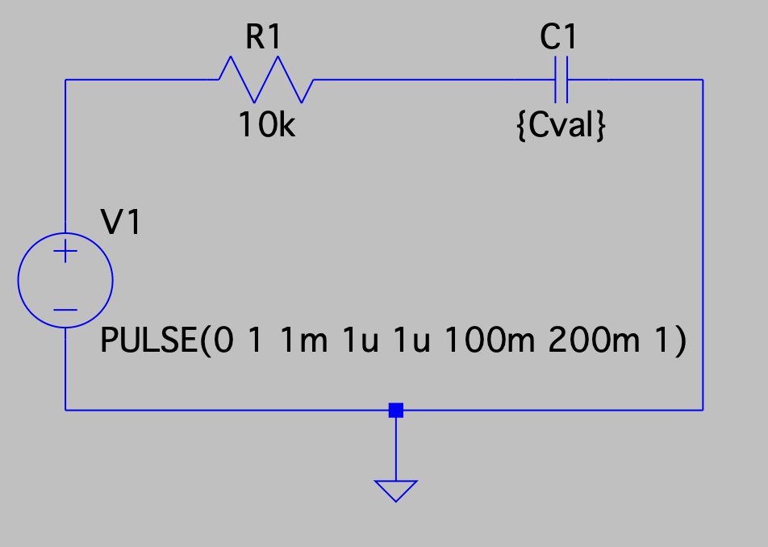
Figure 3: LTSpice Capacitor Circuit Schematic

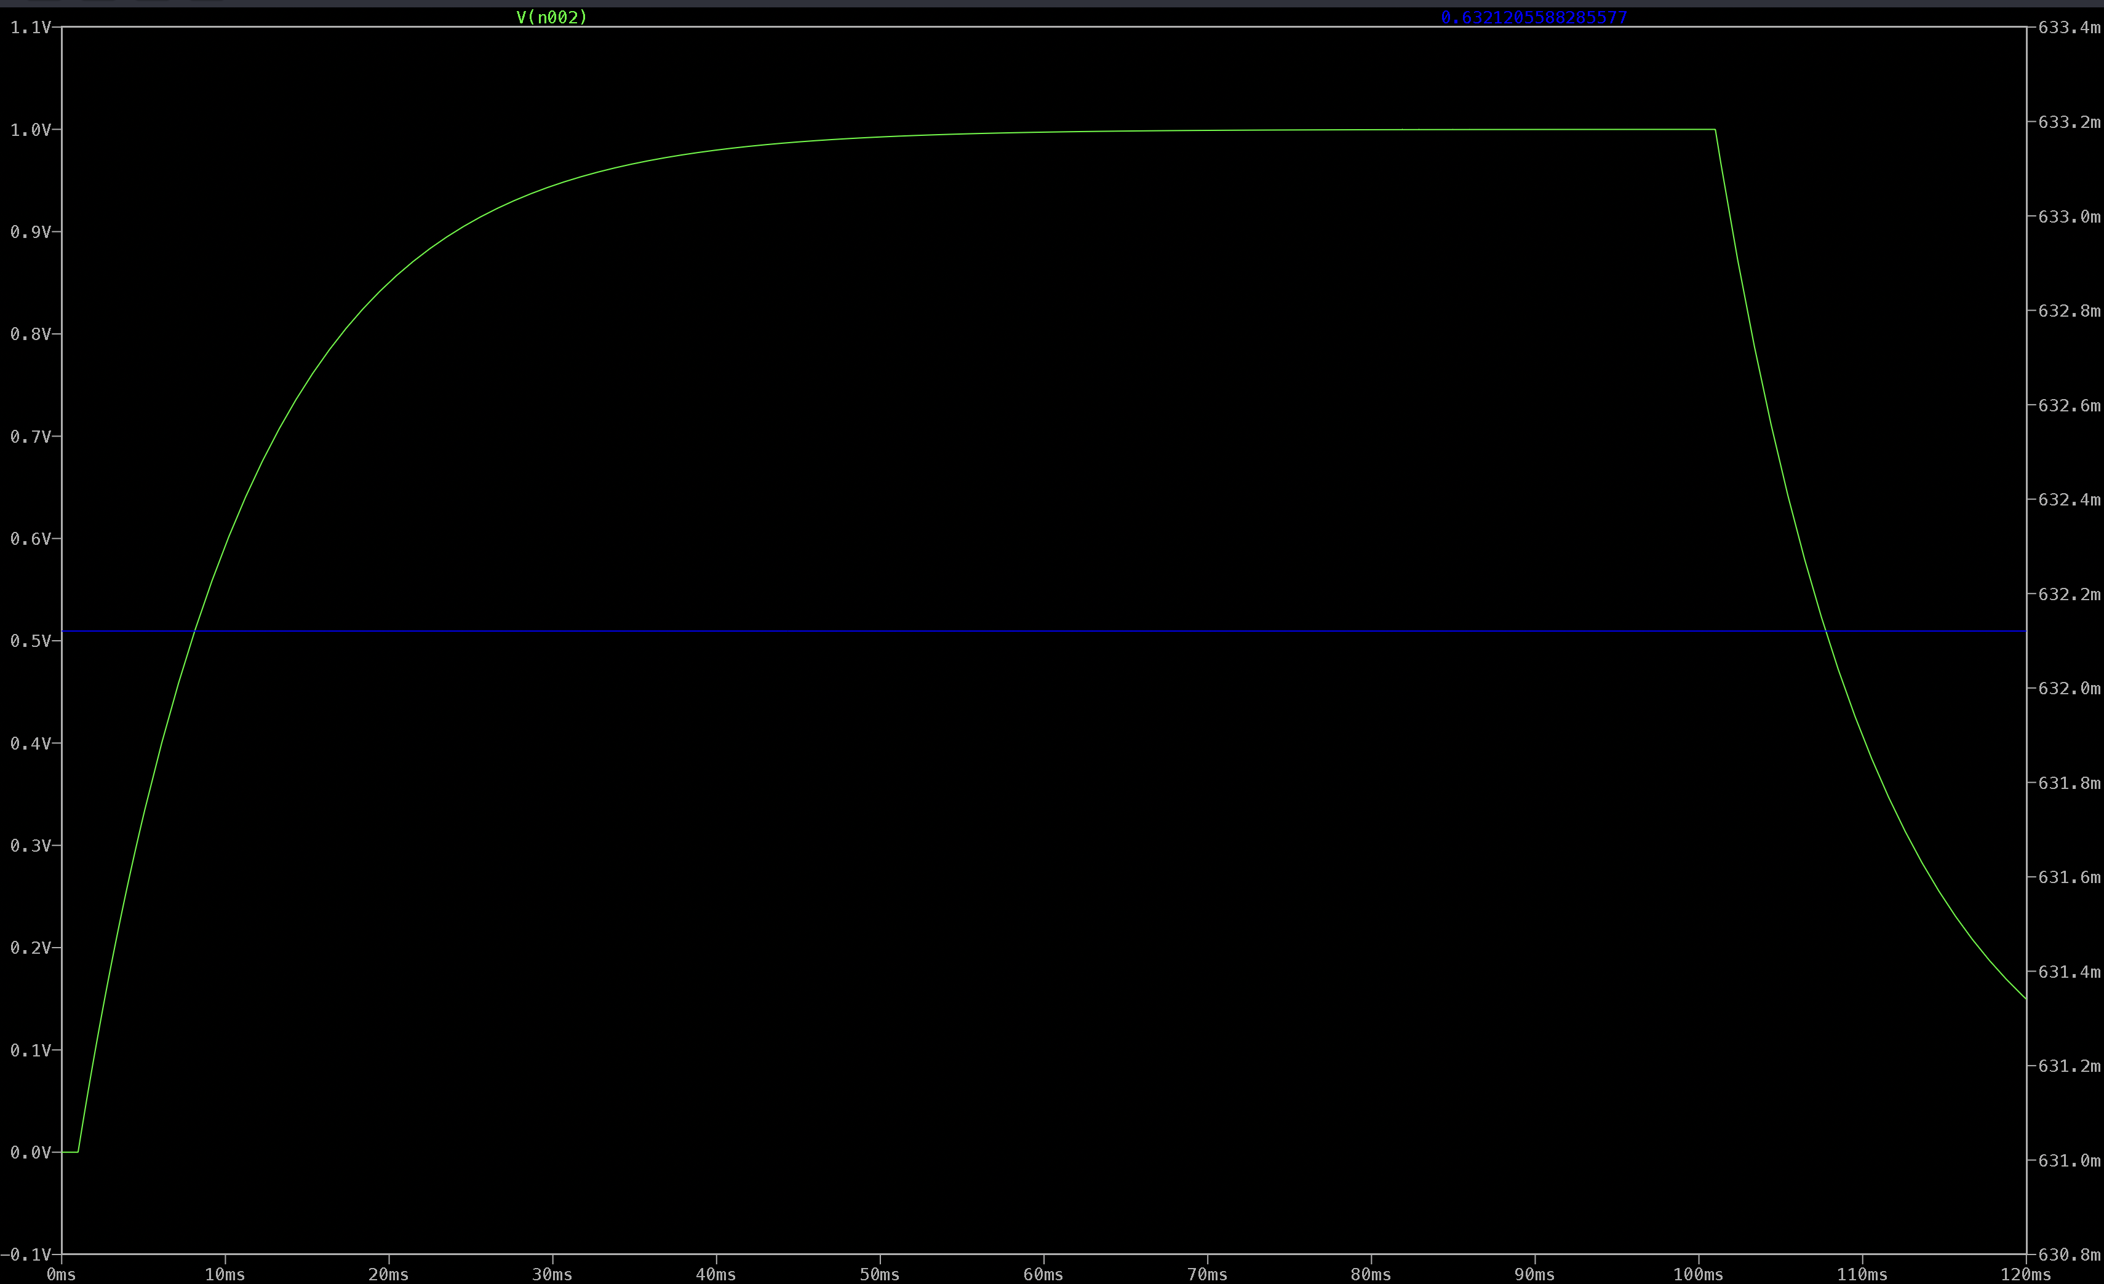
Figure 4: RC circuit 63.2% Simulation Full Graph
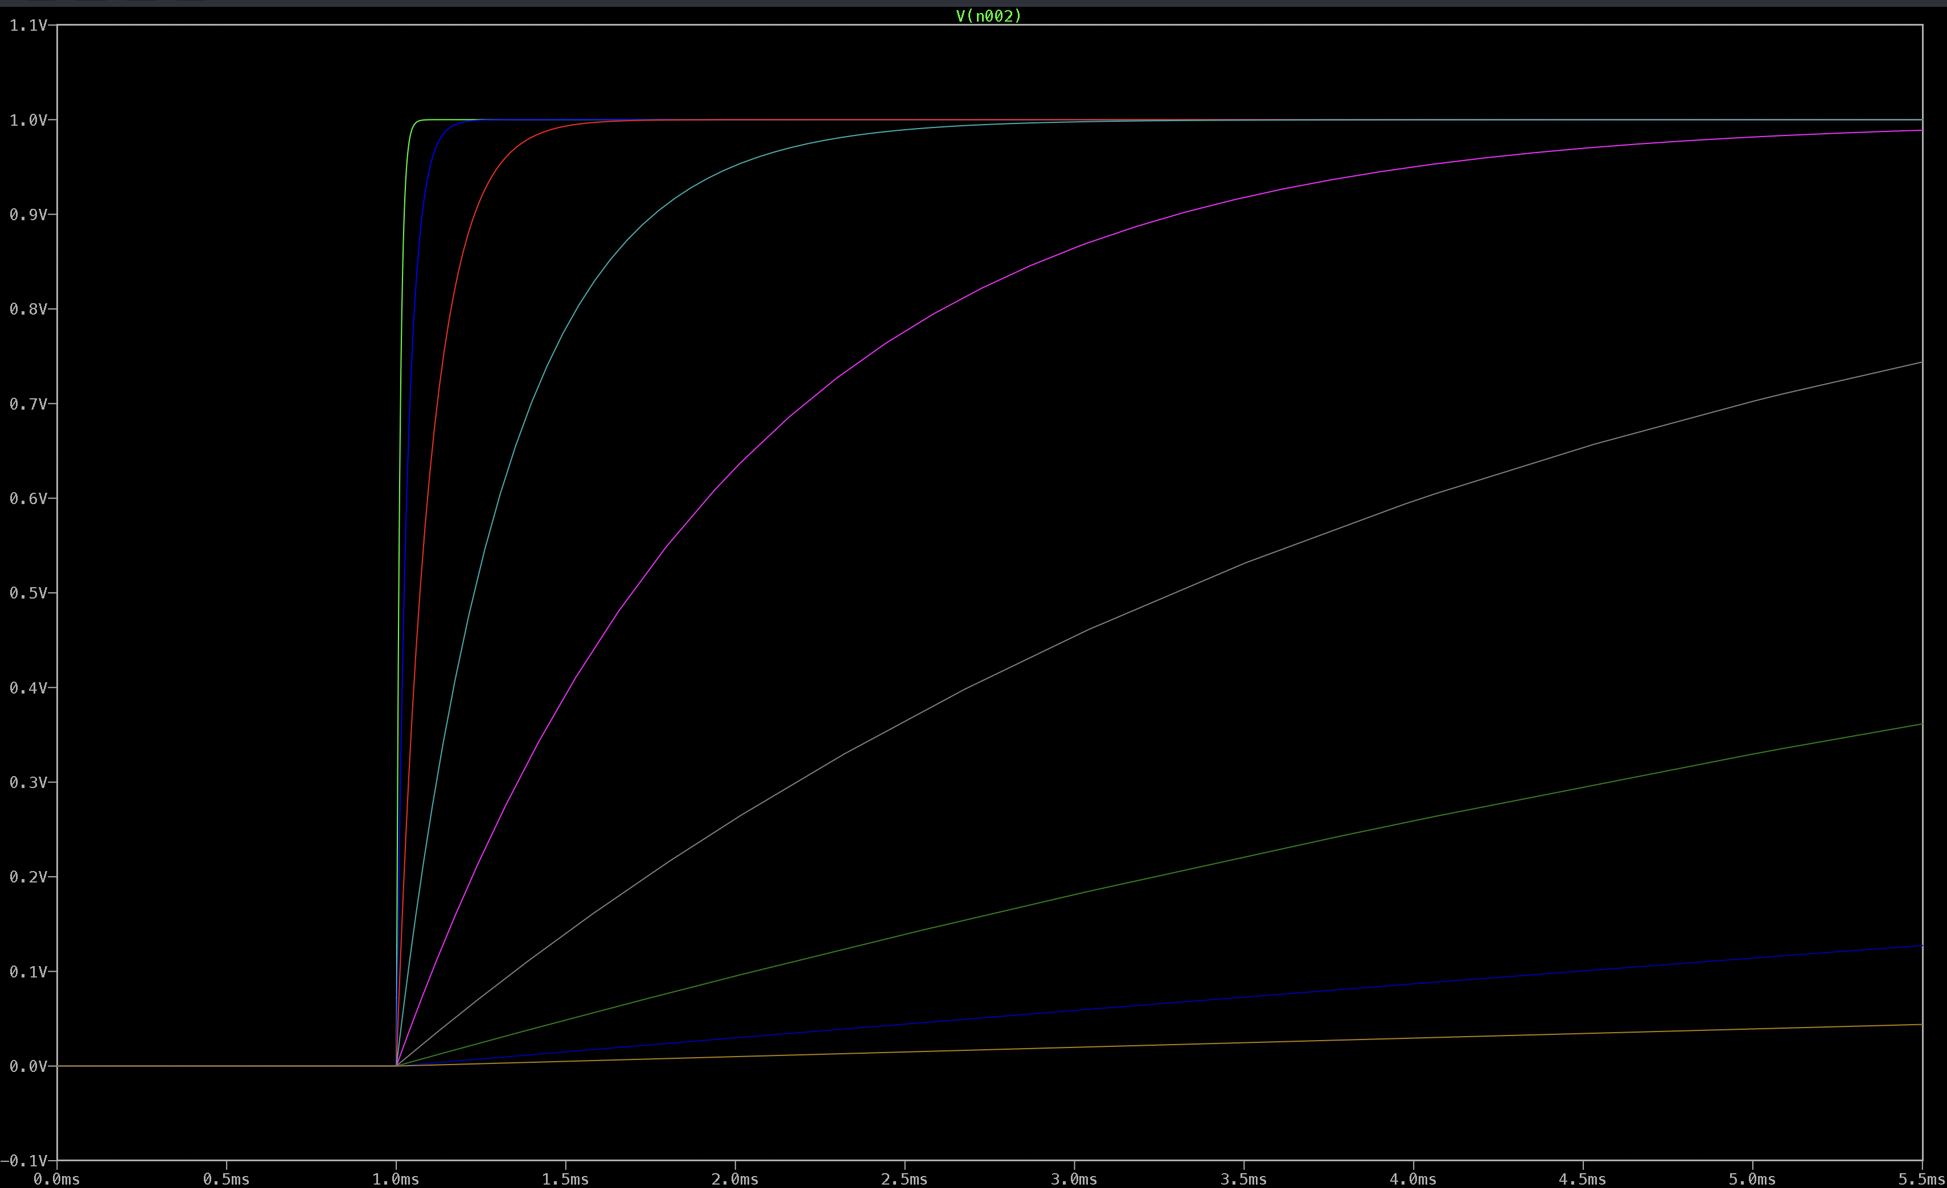
Figure 5: Different Capacitor Charging Times Simulation Full Graph
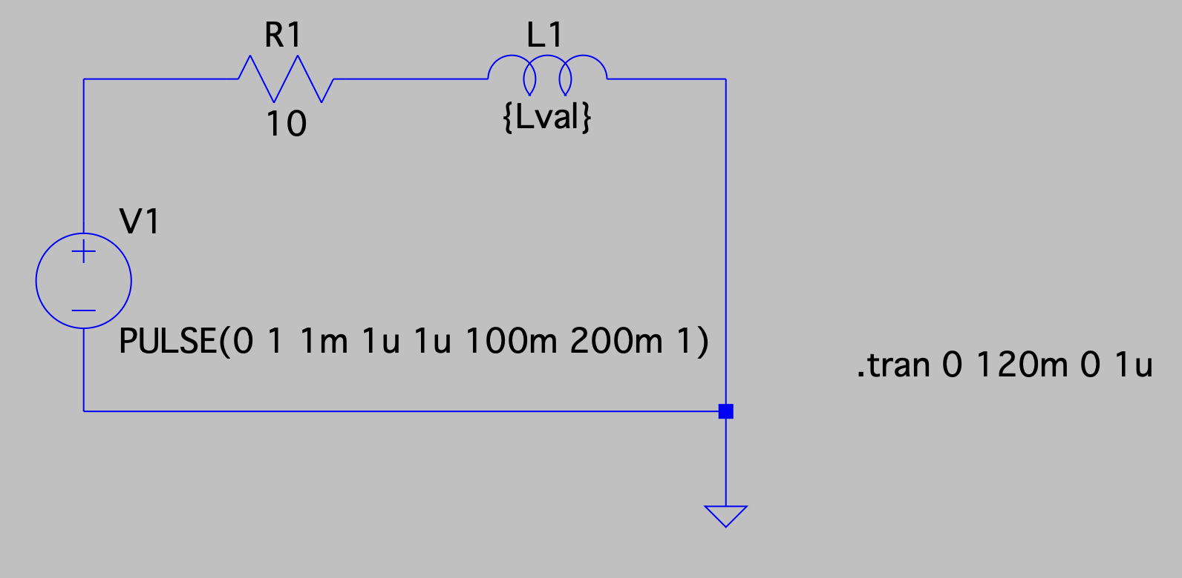
Figure 6: LTSpice Inductor Circuit Schematic

3. Costs

3.1 Parts
Parts Costs Table
Part | Manufacturer | Unit Cost ($) | Quantity | Actual Cost ($)
EG1218 | E-Switch | $0.72 | 1 | $0.72
TPS54202DDCR | Texas Instruments | $1.17 | 2 | $2.34
TLV75533PDBVR | Texas Instruments | $0.36 | 1 | $0.36
SS14TR-ND | Onsemi | $0.29 | 1 | $0.29
WP7113SURDK14V | Kingbright | $0.66 | 10 | $4.53 (Bulk)
CSD15380F3 | Texas Instruments | $0.32 | 1 | $0.32
CSD25501F3 | Texas Instruments | $0.38 | 1 | $0.38
1965-ESP32-S3-ND | Espressif Systems | $1.85 | 1 | $1.85
SSD1306 | HiLetgo | $7.00 | 1 | $7.00
647-UTH2G201MND | Nichicon | $5.40 | 1 | $5.40
C320C104K5R5TA73 | KEMET | $0.30 | 10 | $1.77 (Bulk)
PEC11R-4220F-N0012 | Bourns Inc. | $1.89 | 1 | $1.89
160-1142-ND | Lite-On Inc. | $0.14 | 10 | $0.94 (Bulk)
CUI CEM-1203 | Same Sky | $0.68 | 1 | $0.68
100SP1T1B4M2QE | E-Switch | $2.63 | 6 | $15.78
CSD15380F3 | Texas Instruments | $0.32 | 10 | $1.94 (Bulk)
CSD25501F3 | Texas Instruments | $0.38 | 10 | $2.32 (Bulk)
ICR18650-4400 W/JST-PHR-2P | PKCELL | $19.95 | 1 | $19.95
595-CD4040BE | Texas Instruments | $1.02 | 1 | $1.02
Total |  |  |  | $69.48

4. Conclusion

EduGrid Microgrid Demonstrator provides a hands on tabletop platform that makes power grid protection and operation easy to comprehend through guided interaction and hardware behavior. The system converts abstract concepts such as fault isolation and restoration, protection logic, frequency stability with load/generation balancing, and power factor correction into concrete user actions using breaker toggles, a rotary scenario selector, and physical capacitor/inductor insertion.
Users engage the system the way operators reason about the grid. They select a scenario, observe the resulting voltage/current, power factor, and frequency indications on the SSD1306 display, and then act using breaker toggles, a rotary selector, and removable load/source elements to isolate faults, restore healthy sections, and stabilize operating conditions. The ESP32-S3 executes a deterministic state machine model, and its decisions are expressed through circuit pathways on the PCB. The fault and breaker states drive LED and buzzer indicators through MOSFET logic gate circuit designs sized for load current, with proper gate biasing and current limiting so the microcontroller remains within safe drive limits. Power factor control is demonstrated with actual component insertion. The board measures user selected capacitors and inductors using RC/RL time-constant timing (63.2% threshold) and feeds those measured values back into the power factor correction computation, enabling corrective prompts that are grounded in hardware detection. System power is designed around portable operation. Li-ion battery input is converted through a buck-regulated 5 V rail and a regulated 3.3 V rail for the ESP32-S3 and peripherals, with current limitations via pullup resistors to prevent brownouts. Across all scenarios, the project demonstrate clearly observable outcomes, clear success/failure feedback, safe low voltage construction with no exposed conductors, and a validation flow that requires sequential completion of each scenario.

4.1 Accomplishments

This proposal establishes a complete system level design for EduGrid, including the user interface, electrical architecture, detailed description of fault scenarios, and verification path. The design specifies the set of guided scenarios and the user actions required to resolve each one using breaker toggles, a rotary selector, and load/source elements. It defines the control approach (ESP32-S3 state machine) and the corresponding hardware pathways that convert scenario state into observable outputs through PCB logic and indicator behavior. The proposal also defines a physical measurement method for inserted capacitors and inductors using RC/RL time-constant timing at the 63.2% threshold, enabling the power factor correction mode to be based on detected user chosen component value selection. Finally, the power delivery plan is established for portable operation, converting Li-ion battery input into regulated 5 V and 3.3 V rails for the controller and peripherals.

4.2 Uncertainties

Several implementation risks remain and will be addressed through building and measurement. The RC/RL time constant approach for identifying $C$ and $L$depends on resistor tolerances and threshold accuracy. These factors can introduce error or inconsistency that may require calibration and averaging. The MOSFET logic networks must be designed carefully to ensure valid logic thresholds, consistent behavior at startup, and precautions against floating nodes. Improper biasing could cause false success/failure indications or unstable output states. Power management is another risk worst case LED patterns, buzzer activation, and display refresh can produce loads that may trigger ESP32 brownouts if current mangement is insufficient.

4.3 Ethical and Safety Considerations

EduGrid is intended for education and public demonstration, so safety, clarity, and honest representation are essential. It is tied to the IEEE Code of Ethics through point 2: the ethical obligation to improve people’s understanding of the capabilities and societal implications of technology [1]. The system should operate at low voltage with no exposed conductors within the user’s reach, and electrical design choices (current limiting, protected rails, safe connectors) should reduce the risk of overheating, short circuits, or accidental contact. These safety protocols fulfill point 1 of the code, which requires a prioritization of safety and health of the public [1]. The display and scenario descriptions should clearly communicate that the observed voltage, current, power factor, and frequency behaviors are simplified and are used to teach principles, not meant to represent the full complexity of real utility protection systems. User feedback must be consistent and clear. Success should only be indicated when isolation conditions are satisfied and the intended learning action is taken, rather than allowing ambiguous solutions. The project should also be documented so future users understand operating limits, safe handling practices, and how to interpret the results responsibly.

4.4 Future Work

Future work will focus on improving accuracy, and instructional clarity. For the L/C measurement circuitry, we will implement calibration using known reference components, measure the error across the expected component range, and add averaging to improve reliability. For MOSFET logic gating, we will validate truth table behavior under real operating conditions and refine bias networks so logic states remain stable and consistent. The power subsystem will be tested under worst case load conditions and optimized with current management so the system remains stable during worst case LED/buzzer activity. Finally, user testing will be conducted to ensure the interface and prompts reliably teach the intended protection and stability concepts.

References

[1] IEEE, "IEEE Code of Ethics," IEEE.org, June 2020. [Online]. Available: https://www.ieee.org/about/corporate/governance/p7-8.html. [Accessed: Feb. 13, 2026].
[2] ESP32-S3-WROOM-1 & ESP32-S3-WROOM-1U Datasheet, v1.3, Espressif Systems (Shanghai) Co., Ltd., 2023. [Online]. Available: https://documentation.espressif.com/esp32-s3-wroom-1_wroom-1u_datasheet_en.pdf. [Accessed: Feb. 13, 2026].
[3] "SSD1306 OLED Display," ESPHome, web page. Available: https://esphome.io/components/display/ssd1306/. [Accessed: Feb. 13, 2026].
[4] University of Illinois Urbana-Champaign, “ECE 330: Review 1—Single-Phase AC Circuits (Complex Power, PF, Reactive Power of L/C),” Illinois.edu (course notes), [Online]. Available: https://courses.physics.illinois.edu/ece330/sp2021/review/review1.pdf. [Accessed: Feb. 13, 2026].
[5] OpenStax, “University Physics Volume 2—Power in an AC Circuit (Power Factor),” OpenStax, [Online]. Available: https://openstax.org/books/university-physics-volume-2/pages/15-4-power-in-an-ac-circuit. [Accessed: Feb. 13, 2026].
[6] Texas Instruments, B. Hauke, “Basic Calculation of a Buck Converter’s Power Stage (Rev. B),” Application Report SLVA477B, Aug. 2015. [Online]. Available: https://www.ti.com/lit/pdf/slva477. [Accessed: Feb. 13, 2026].
[7] Texas Instruments, “Power Supply Decoupling and Layout Considerations,” Application Report SPRA906, TI.com, [Online]. Available: https://www.ti.com/lit/an/spra906/spra906.pdf. [Accessed: Feb. 13, 2026].
[8] Texas Instruments, “TLV755 Low-IQ, Low-Dropout (LDO) Regulator Datasheet,” TI.com, [Online]. Available: https://www.ti.com/lit/ds/symlink/tlv755.pdf. [Accessed: Feb. 13, 2026].

