Date: September 3, 2025

Objectives:
Define the project topic and outline the problem and proposed solution for a wearable lifting-assist exoskeleton (“HARMONEX”).

Record of what was done:
We brainstormed potential project ideas and selected HARMONEX, a wearable exoskeleton aimed at assisting users in lifting objects up to ~10 kg with reduced muscular effort. We identified the core problem: repetitive lifting in daily life and industrial settings causes fatigue and risk of injury, while existing exoskeletons are often too heavy, not backdrivable, or overly complex for everyday use.
We converged on a concept for HARMONEX: a lightweight elbow exoskeleton using hybrid actuation (BLDC motor for high-torque lifting and a servo for holding torque), with torque amplified through a 64:1 planetary gear set and an additional linkage for mechanical advantage. We also decided on a detachable drivetrain to allow free arm motion when assistance is not needed and a carbon-fiber-reinforced nylon (PA-CF) structure for strength and low weight. The design is modular, starting with elbow actuation and potentially extendable to shoulder support.

Date: September 10, 2025

Objectives:
Determine a control strategy for the exoskeleton and select the primary sensing modality for user intent.

Record of what was done:
I brainstormed different control options for HARMONEX, including mechanical switches, IMU-based motion sensing, force/torque sensing, and EMG-based control. After comparing ergonomics, intuitiveness, and integration complexity, I concluded that EMG signals are the most suitable for seamless, intuitive control of the exoskeleton, since they directly reflect the user’s muscle activation.
I noted the need to research how EMG works in more detail—signal characteristics, electrode placement (especially around biceps and triceps), typical noise sources, and necessary analog front-end circuitry. I also sketched a preliminary signal chain showing EMG acquisition → conditioning → ADC on the MCU → control algorithm → motor drivers.

Date: September 17, 2025

Objectives:
Finalize the EMG sensing configuration and define how EMG signals will be interfaced with the MCU for intent detection.

Record of what was done:
I decided to use two EMG channels: one on the biceps and one on the triceps. This configuration is intended to distinguish between elbow flexion and extension by comparing relative activation levels of the two muscles.
I specified that the conditioned EMG outputs will be routed into two separate ADC channels on the MCU. The planned processing pipeline includes rectification, filtering, and normalization of each EMG channel, followed by combining EMG features with elbow angle feedback to generate control commands for the exoskeleton. I updated the system block diagram to reflect the two-channel EMG input and annotated it with the intended ADC assignments and basic feature extraction steps for the intention-detection algorithm.

Date: October 1, 2025

Objectives:
Redesign the F280049D MCU PCB schematics to remove the on-board XDS debug chip and support programming/debugging via an external debug probe, while reducing PCB size.

Record of what was done:
I worked on the schematics design for the F280049D MCU board. We decided the on-board XDS debug chip was redundant because it mainly bridges USB to JTAG and takes significant board space. To simplify the design and shrink the PCB, I removed the XDS device and its associated connections to the USB/isolation circuitry.
I then added an external JTAG/debug header and re-routed the essential JTAG signals from the F280049D directly to this header: JTAG clock (TCK), test mode select (TMS), JTAG data in (TDI), JTAG data out (TDO), test reset (nTRST or equivalent), device reset (XRSn). This configuration allows a standard TI external debug probe (e.g., XDS110) to be used for programming and debugging the MCU without the on-board XDS chip.
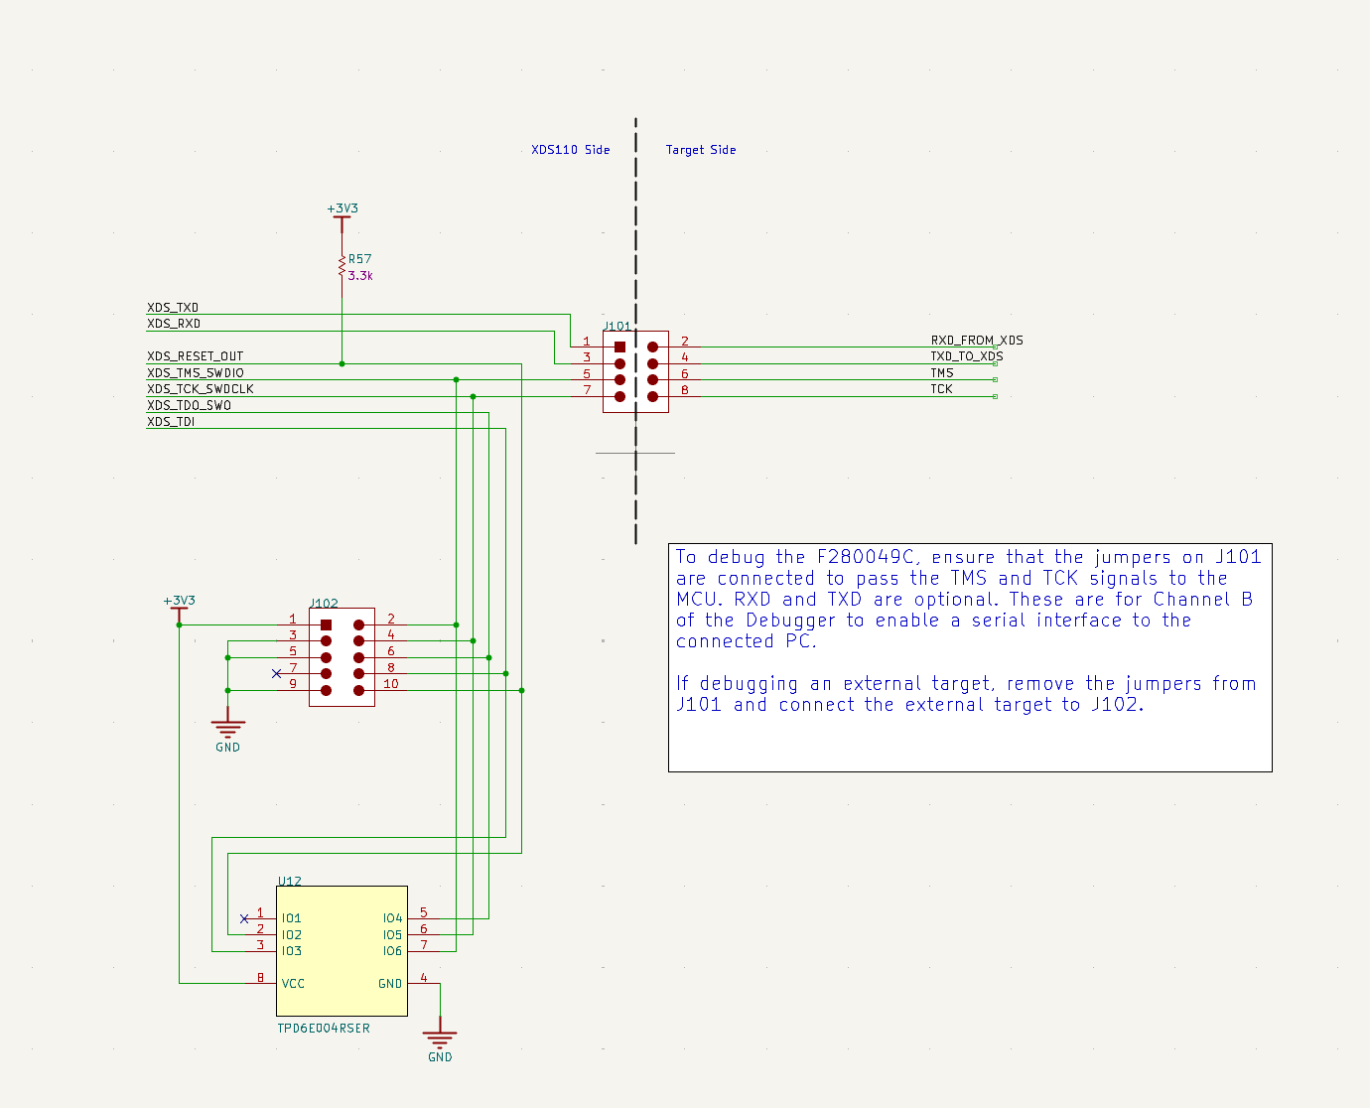

Date: October 2, 2025

Objectives:
Routing the F280049D MCU PCB.

Record of what was done:
We worked on the PCB routing for the MCU board. This included refining the placement and routing of signal traces around the F280049D and connectors to improve clarity and manufacturability.
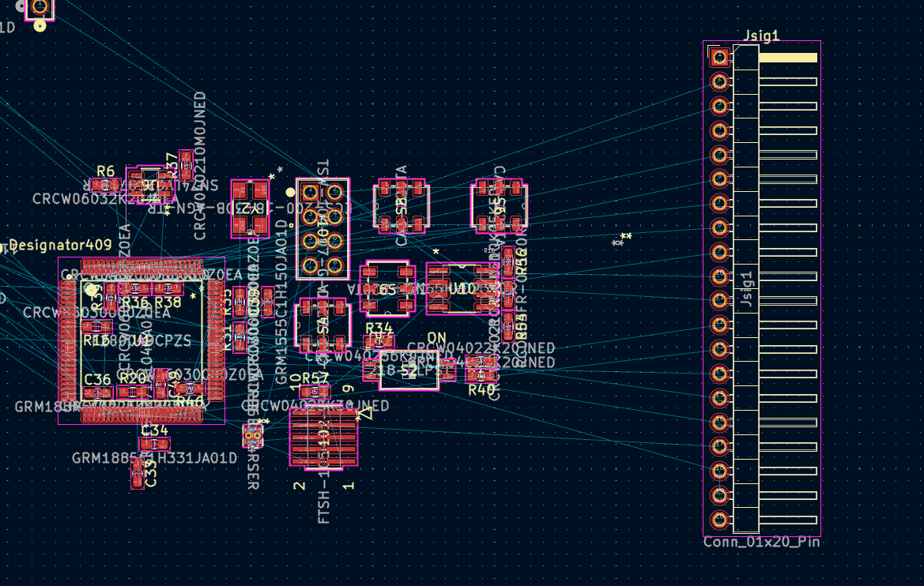
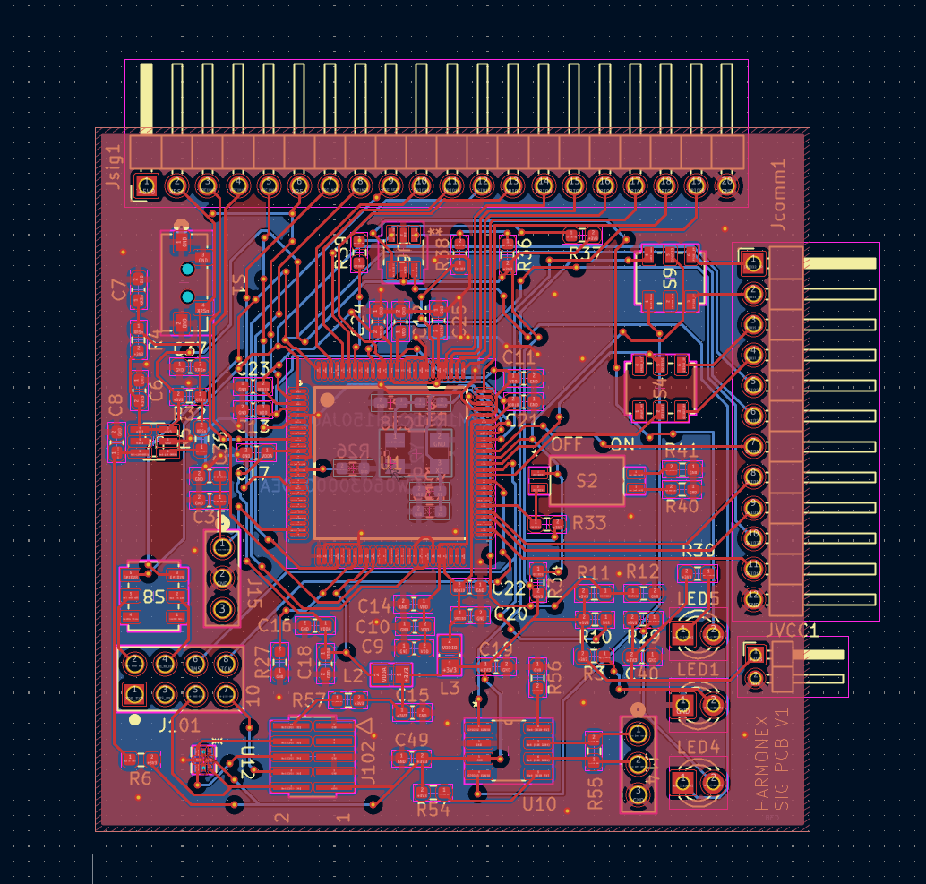
Date: October 15, 2025

Objectives:
Identify and correct PCB layout issues related to the system clock source.

Record of what was done:
During a review of the PCB layout, I discovered that I incorrectly placed on the backside of the PCB and connected through a via. This non-ideal placement could introduce additional and noise, potentially causing unstable or unreliable clock behavior. We corrected this by rerouting the board: the crystal and its load capacitors were moved to the same side as the MCU with short, direct traces, following standard layout guidelines for clock circuitry.
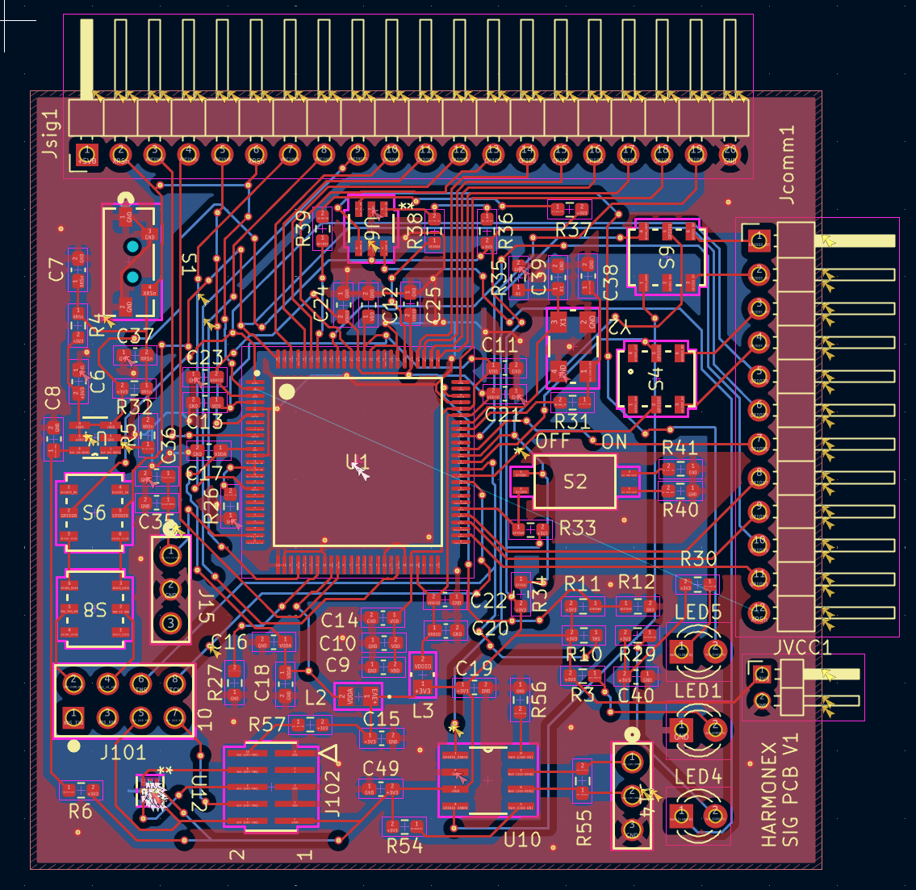

Date: October 22, 2025

Objectives:
Brainstorm and refine the BLDC clutch engagement mechanism for reliable alignment and engagement.

Record of what was done:
We discussed the design of the BLDC dog clutch, noting that since we are not using a friction clutch, we must handle cases where the clutch and socket are misaligned at engagement. I proposed adding a potentiometer to the axle shared by the base and the clutch, so the controller can measure the angular difference between the two sides. With this feedback, the system can automatically rotate the BLDC until the clutch and socket align before locking.
Alan then updated his mechanical design to incorporate this idea and reprinted the part with an integrated slot to mount the potentiometer.
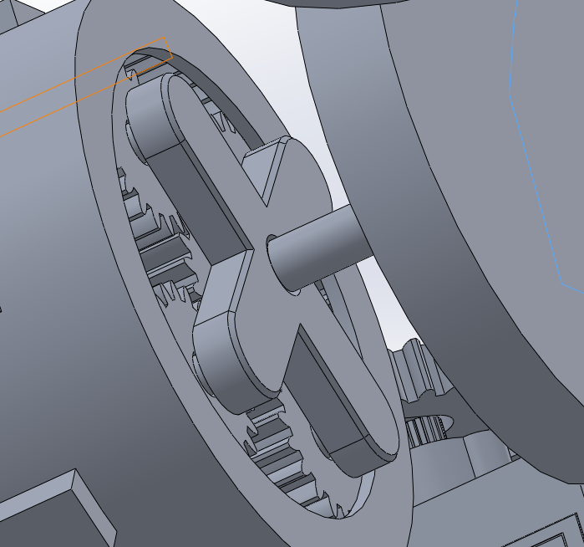

Date: October 27, 2025

Objectives:
Implement and test the first iteration of the EMG-based control pipeline for the exoskeleton.

Record of what was done:
With the mechanical portion of the exoskeleton functional, I started the first iteration of the EMG control design. We used MyoWare EMG modules, which output an analog voltage proportional to muscle activation. We measured the output voltage with multimeter and it outputs voltage of 0.5V when relaxed and 2.8V when fully contracted.
Two modules (biceps and triceps) were connected to separate ADC channels on the MCU and sampled at 100 Hz.
On the firmware side, I implemented a first-order IIR low-pass filter on each EMG channel to smooth noise. The filtered signals were then normalized, and we computed the difference between the two channels to infer flexion vs. extension intent. This difference signal was mapped to exoskeleton motion commands. At this stage, the EMG modules were powered by AA batteries connected in series. The system worked: we were able to control the exoskeleton motion using muscle activation alone, but it is unwieldy which the user must force the muscle to control the exoskeleton instead with natural movements, which we need to improve in later iterations.
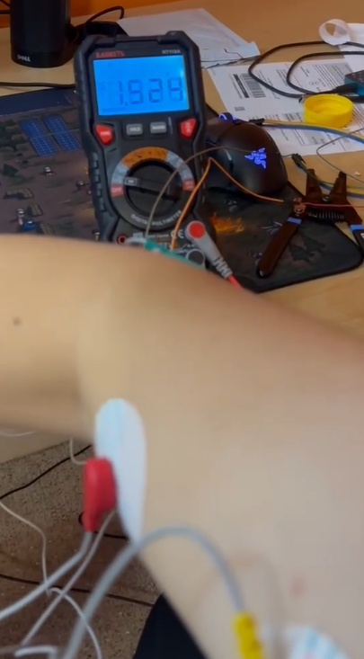

Date: November 3, 2025

Objectives:
Migrate EMG module power from temporary battery supply to the main power PCB and evaluate system behavior.

Record of what was done:
We tested powering the EMG modules from our power PCB, which steps down the main BLDC power rail to a lower voltage rail intended for control electronics and sensors. The goal was to eliminate the need for AA batteries and have a unified power system.
On the first test, we first verified the output of the PCB with multimeter, which showed a stable output of the EMG modules were damaged (fried). Alan investigated the issue and refined the PCB routing. We ordered budget-friendly EMG modules from Arduino due to budgetary concerns. It requires +-9v input instead of +5v, but it is less of a concern as we need to refine and reprint our power PCB.
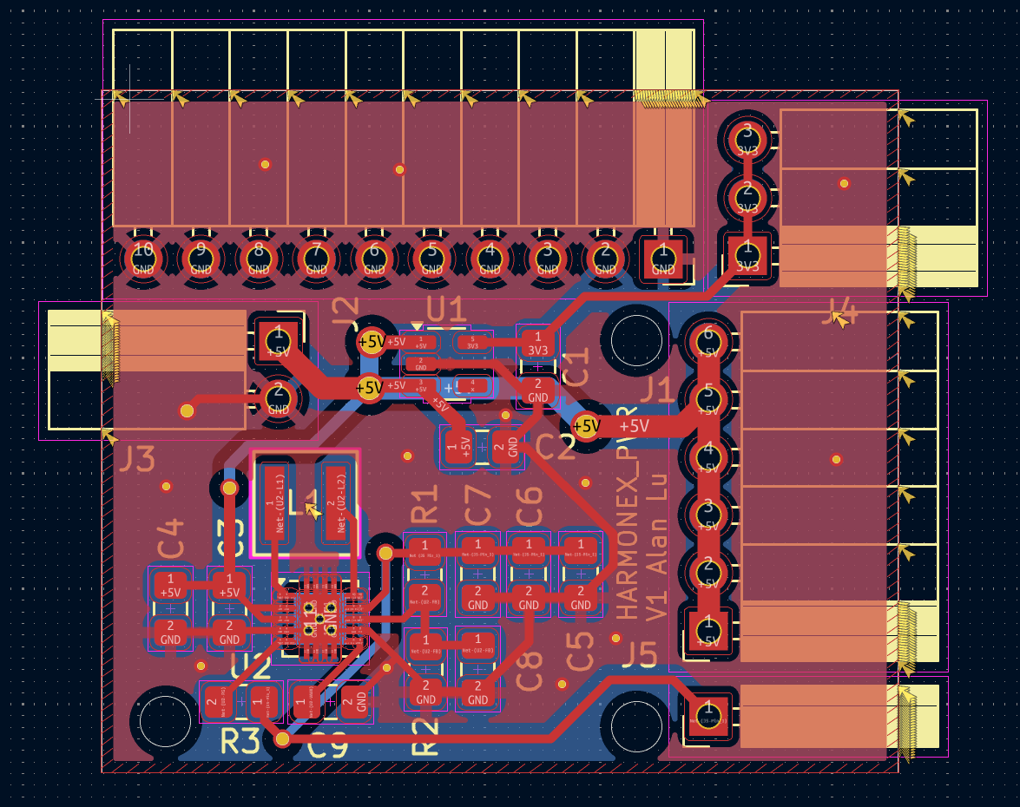

Date: November 12, 2025

Objectives:
Test new power PCB and new EMG modules.

Record of what was done:
The new power PCB has +-8v power output for the EMG module. We tested it with multimeter, and it shows stable output around 8.02v and -7.95v.

We then connected the EMG module to the power supply, but it fried the EMG modules again immediately. Alan investigated the issue further and found that the cause was poor isolation between the positive and negative rail.

Date: November 19, 2025

Objectives:
Bring the redesigned EMG power supply online and develop the next iteration of EMG-based control using a lightweight machine learning model that can run on the MCU.

Record of what was done:
Alan completed a redesign of the power PCB to fix the earlier isolation and protection issues. The new board now provides a stable ±8 V supply for the EMG front-end. We tested the MyoWare EMG modules on this board and confirmed that they operate reliably without damage, and that the output envelopes measured with multimeter are within range of 0 – 3.3v, and is clean and stable enough for control and data collection.

With the power problem resolved, I started designing an ML-based EMG control scheme suitable for deployment on the MCU. I first defined a dataset and collection procedure. The exoskeleton was worn in free-run mode (clutches disengaged) so that the motion was purely user-driven. At 100 Hz, I recorded three signals: biceps EMG ADC value, triceps EMG ADC value, and elbow angle from the exoskeleton. Each recording run was done in one of three workload conditions: unloaded (no weight), medium load (about 2 kg in hand), and heavy load (about 5 kg in hand). For each workload class, I collected roughly 20,000 samples for training and 5,000 samples for validation, giving a balanced dataset.

I then designed a first ML model with a 9–9–4 MLP architecture. The 9 input features were constructed from short 50 ms windows of data for each of the three signals (biceps, triceps, elbow angle). For each signal I used: mean of the previous 50 ms window, mean of the current 50 ms window, and the rate of change between these two windows. This gave three features per signal and nine features total. The idea was to keep the feature set small for MCU deployment, yet still capture both the current level and short-term trend of each signal with low latency.

These nine features were fed into a single hidden layer with 9 neurons. The hidden layer size was chosen to be small to limit memory and computation on the MCU and to simplify a potential fixed-point implementation. The output layer had four neurons. One neuron was used for regression to predict the elbow angle 50 ms into the future (desired angle), and the remaining three neurons were used for a three-class workload classifier (unloaded, medium load, heavy load). Using a shared representation for both tasks was intended to let the model learn a common embedding of motion and effort.

I trained this model on the PC using the collected dataset. The results were approximately 20 degrees mean error for the predicted future angle and about 80% accuracy on the three-class workload classification. These results were not sufficient for our control goals. A 20-degree prediction error is too large for precise and comfortable assistance, particularly during holding postures. An 80% workload classification accuracy also implies a non-negligible chance of misclassifying loaded motions as unloaded, which would be risky if used directly to control clutch engagement. These issues motivated a redesign of both the feature extraction and the network architecture, and a reconsideration of how many workload classes we need for safe and robust control.

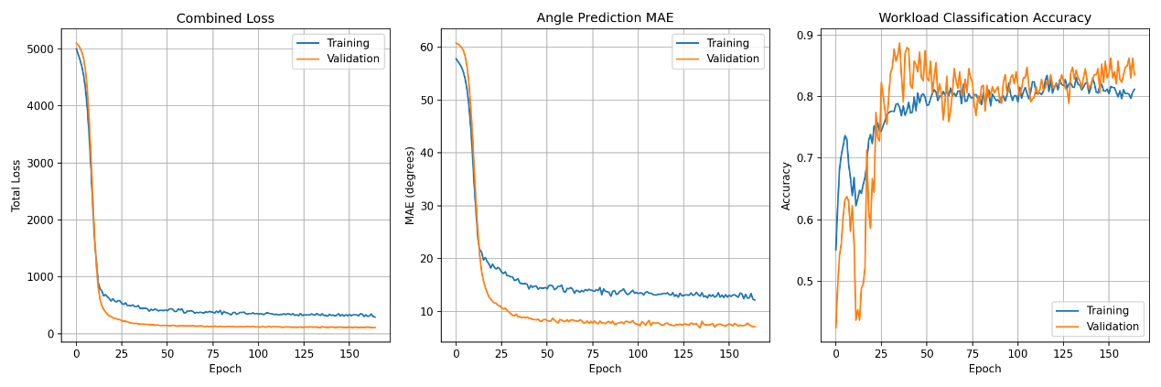

Date: November 24, 2025

Objectives:
Improve the EMG-based model using richer temporal features and a deeper MLP, and revise the workload classification and clutch control strategy to prioritize robustness and safety.

Record of what was done:
Based on the limitations of the previous 9–9–4 model, I redesigned the feature extraction pipeline and the network architecture.

Each inference now uses a 0.5 second sliding window of sensor data sampled at 100 Hz (50 samples per window) for three signals: biceps EMG envelope, triceps EMG envelope, and elbow angle. The longer window captures more context about motion and muscle activation while maintaining acceptable latency for intent prediction.

From each 0.5 second window, the MCU now extracts twelve scalar features. For elbow kinematics, it computes the mean elbow angle and an approximate angular velocity, obtained by taking the difference between the mean angle of the first half of the window and the mean angle of the second half. For the biceps EMG envelope it computes four statistics: mean, mean absolute value (MAV), root-mean-square (RMS), and variance. The same four statistics are computed for the triceps EMG envelope. Finally, two co-activation features are added: an EMG co-activation ratio (biceps mean divided by triceps mean) and the mean difference (biceps mean minus triceps mean). These features are chosen to capture overall activation level, variability, and the relative contribution of biceps and triceps, which are important for distinguishing flexion, extension, and holding behavior.

Each of the twelve features is normalized online using a per-feature mean and standard deviation learned during offline training and stored in flash. This keeps the feature distribution consistent between training and deployment and helps the MLP generalize better.

The normalized 12-dimensional feature vector is fed to a fully connected MLP with two hidden layers and ReLU activations. The first hidden layer has 24 neurons and the second has 16 neurons. The output layer has 3 neurons. The first output neuron is used for regression and predicts a future elbow angle (desired angle) that the controller can track. The remaining two neurons form a two-class softmax classifier that estimates whether the motion is unloaded or loaded.

I reduced the number of workload classes from three (unloaded, medium, heavy) to two (unloaded, loaded) and no longer let the EMG model controls the BLDC clutch. I revised the clutch control strategy to emphasize safety. The BLDC clutch is now switched only manually from the control panel, so an EMG or model misprediction cannot abruptly remove assistance altogether. The servo clutch is still controlled by a state machine driven by the model’s outputs. It engages when the motion is classified as loaded and the desired angle stays within a ±10° band for at least 200 ms, indicating a holding posture. It disengages when the desired angle moves outside a ±15° band, indicating the user intends to start a new movement. The use of separate engage and disengage thresholds introduces hysteresis and prevents rapid toggling when the predicted angle sits near the boundary.
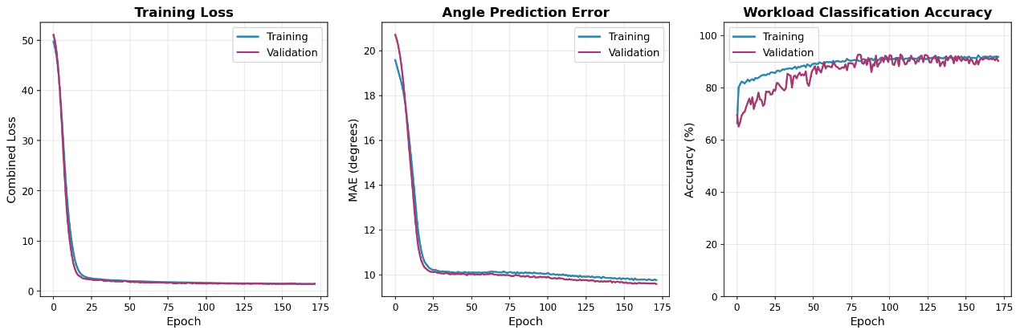

Date: November 29, 2025

Objectives:
Evaluate the deployed EMG-based model on the final exoskeleton hardware and correct mismatches between training-time and real-time EMG signal levels.

Record of what was done:
After Alan completed the final mechanical modifications to the exoskeleton, we deployed the new EMG-based model onto the system and tested it while wearing the device. Despite the good validation metrics on the PC, the model did not perform as well in actual use. The assisted motion felt inconsistent and sometimes incorrect.

We traced the issue to subtle drifts in the EMG output: over time, the baseline voltage and overall level of the EMG envelopes shifted compared to the data distribution used during training. This caused the live inputs to fall outside the range the model was tuned for.

To address this, we added a preprocessing stage in the software. This stage compensates for slow EMG baseline drift and rescales the signals so that their mean level and range are closer to those seen in the training data. With this preprocessing in place, the model’s behavior on the exoskeleton became more stable and more consistent with the performance observed during offline testing.

