Hand Crank Portable Charger

By
Achyut Agarwal
Rubhav Nayak
Shreyasi Ray

Final Report for ECE 445, Senior Design, Spring 2023
TA: Matthew Qi
03 May, 2023
Project No. 14

Abstract

This comprehensive final report outlines the problem that we have identified, presents our proposed solution, and details the implementation of our project for ECE 445. Within this report, one will be able to find detailed descriptions of the features, design, and cost of our product.
We begin by discussing the problem that served as the driving force behind our project. We provide an in-depth analysis of the issue, including its significance and potential implications. Subsequently, we introduce our innovative solution, explaining how it addresses the identified problem and offers unique advantages over existing approaches. We highlight the key features of our project, illustrating how they contribute to solving the problem effectively and efficiently.
Moreover, we delve into the design aspect of our project, elucidating the technical specifications, components, and architecture that were utilized. We present the design process, outlining the decision-making and problem-solving steps we undertook to create a robust and functional solution.

Table of Contents
1. Introduction 1
1.1 Problem 1
1.2 Solution 1
2. Product Outline 2
2.1 Introduction 2
2.2 Circuit Design 2
2.3 Subsystem Overview 3
2.4 Performance Requirements 3
2.5 Block-Level Changes 4
3. Design 5
3.1 Design Procedure 5
3.1.1 Decisions for the Microcontroller/Battery Subsystem 5
3.1.2 Decisions for the Electromechanical/Hand-Crank Subsystem 6
3.1.3 PCB Design 6
3.2 Design Details 7
3.2.1 Subsystem 1 - Microcontroller/Battery Subsystem 7
3.2.2 Subsystem 2 - Electromechanical/ Hand-Crank Subsystem 8
3.2.3 Physical Design 9
4. Verification 11
4.1 Testing and Verification for the Microcontroller/Battery Subsystem 11
4.2 Testing and Verification for the Electromechanical/Battery Subsystem 12
5. Cost and Schedule 14
5.1 Bill of Materials 14
5.2 Labor Cost 15
5.3 Total Cost 15
5.4 Schedule 15
6. Conclusion 18
6.1 Accomplishments 18
6.2 Uncertainties/Hurdles 18
6.3 Future Work/Alternatives 19
Citations 20
Appendix A: Verifications 22
A.1 Microcontroller/Battery Verification Results 22
A.2 Electromechanical/Hand-Crank Verification Results 29
Appendix B: Subsystem Design Data 35
B.1 Truth Table 35
B.2 PCB Design for Product 36
Appendix C: Safety and Ethics Considerations 38
C.1 Safety Considerations 38
C.2 Ethical Considerations 38

1. Introduction

1.1 Problem

In the present era, the reliance on technology and gadgets is steadily growing. This dependency, particularly on our smartphones, has reached an unprecedented level, with the average screen time per day being 6 hours and 37 minutes worldwide^{[1]}. This suggests that individuals have become highly accustomed to using devices for all aspects of their lives. Even during emergencies, we feel the necessity to utilize our devices for making calls, sending messages, and managing essential services and utilities through various applications. As a result of this escalating dependence on technology, ensuring these electronic devices remain charged has become a matter of utmost importance.

As a result of this issue, there is a growing demand for charging stations to meet the power requirements of devices, due to a lack of convenient access to a power outlet. Consequently, we frequently find ourselves in a helpless situation when our devices are running low on battery.
There are available products in the market that address this problem, but they often come with numerous features that are largely unnecessary for the average consumer. These additional features tend to make the product bulkier and also lead to a higher cost.

1.2 Solution

To address this issue, we have developed the Portable Hand-Cranked Charger as a solution. This innovative device allows users to generate electrical power by simply cranking it, utilizing their own kinetic energy. By doing so, they can charge their devices adequately, ensuring they have power available for emergencies even when a power source may not be available.
In addition, the product incorporates a built-in battery that users can charge either through a micro-USB input or using the hand-crank mechanism. This charged battery can then be utilized to charge their devices (also at a later time), essentially also functioning as a portable power bank.

The primary objective of this product is to be cost-effective and compact, allowing users to conveniently carry it with them. Its automated switching logic ensures efficient usage without any human interaction required. This product is designed to provide power in any location, ensuring that devices remain functional for an extended period, particularly during emergencies. The physical design of the product has also been designed while keeping this in mind.

2. Product Outline

2.1 Introduction
Our product offers two primary functionalities. Firstly, it allows users to charge their devices directly by utilizing the hand-crank mechanism. Users can simply crank at an optimal rate until they reach their desired charging level. Secondly, there is an alternative USB power source available. This source converts and regulates the energy to provide a consistent output for charging the device.
Given the presence of two input methods, it is essential to handle the scenario where both inputs are supplying energy. This ensures that the product is user-friendly, requiring no manual adjustments. Everything is automated to provide a seamless charging experience for the user.

2.2 Circuit Design

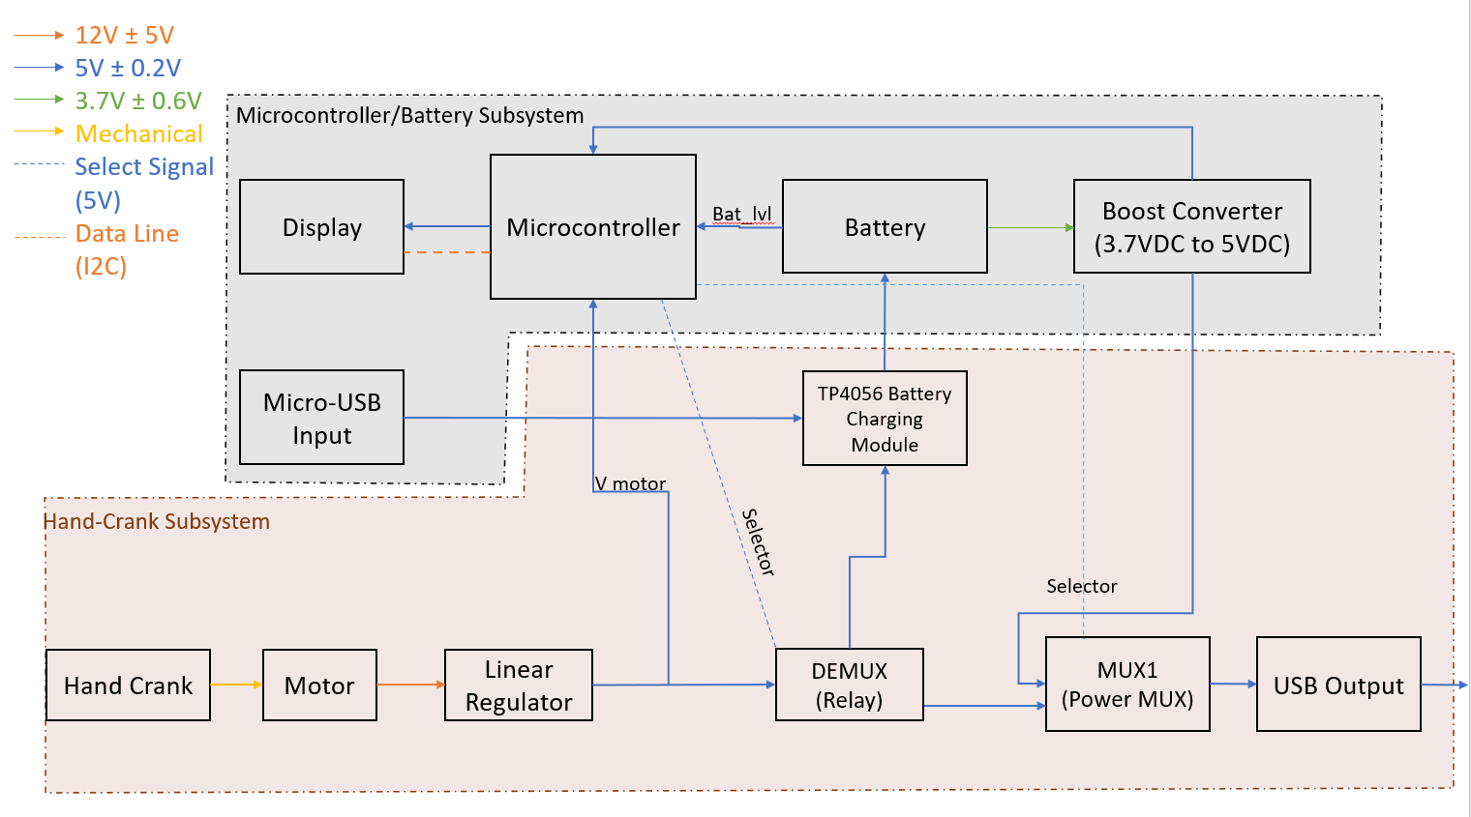
Figure 1 Block Diagram

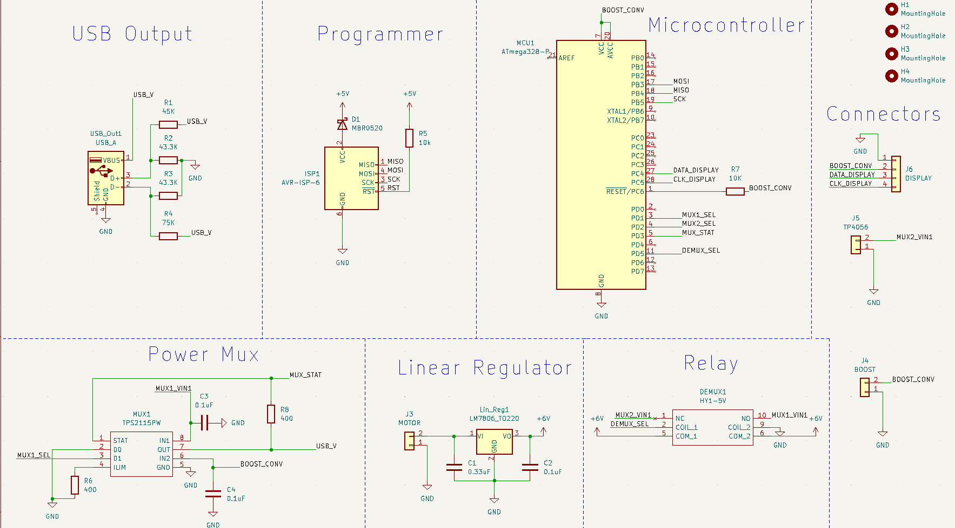
Figure 2 Circuit Schematic

2.3 Subsystem Overview

As seen above, we have divided the project into two blocks or subsystems: the microcontroller subsystem and the electromechanical subsystem (hand-crank).
- The microcontroller subsystem plays a crucial role in regulating the flow of electricity from the input sources (Micro USB In or Hand Crank) to the outputs (Battery or USB Out). It also includes a Display that provides the user with essential information regarding the device's current status. Moreover, the microcontroller subsystem manages the battery, ensuring its level remains within the desired range through effective battery management. This is important as we do not want the battery to get completely drained or overcharged.

- The hand-crank subsystem has the task of converting the kinetic energy generated by hand cranking into electricity using a motor. Additionally, it reduces the voltage to a more suitable stable 5V, which is the requirement for the USB Output and microcontroller. This subsystem encompasses the Relay and Power mux setup, which handle the flow of current to and from the battery and to the USB Output.

- The two subsystems are closely connected to one another at multiple places in our design. The interconnects between the two are mainly 5V traces that run from various components from one subsystem to the other.

2.4 Performance Requirements

- To facilitate the proper functioning of our Relay and Power mux, we use our microcontroller's pinouts as select signals. This ensures that the flow of current can be switched within a short time frame of 50ms. This quick switching allows for charging the appropriate component at the precise moment, ensuring efficient operation.

- Our product is designed to operate autonomously, requiring no user intervention in determining what to charge and when. The Microcontroller is responsible for receiving the appropriate inputs and sending the necessary signals to the Power mux and Relay, ensuring that our product functions seamlessly without the need for human interaction.

- The Microcontroller must effectively stop flow to the battery when it reaches its full charge level (4.2VDC ± 0.1VDC). Similarly, it should provide current to the battery when its level is low (3.1VDC ± 0.1VDC).

- The Microcontroller is capable of precisely calculating the voltage output of the motor by utilizing the appropriate signals. This calculation ensures that users can crank the device at the optimal efficiency rate, which is suggested to be 75% or higher. The suggested speed is displayed on the product's display, enabling users to follow it and adjust their cranking speed accordingly. Additionally, the display allows users to monitor the battery level of the internal battery by displaying the corresponding voltage. This comprehensive display provides users with a simplified method of understanding whether they need to crank at a slower or faster speed, without requiring knowledge of the underlying technical details of the product.

2.5 Block-Level Changes

Through the course of the semester, the team had to make many changes to the design of the blocks, to ensure efficient working of the product. Through trial and error, extensive research, and constant revisions of the design of the product, we made the following modifications:

- Initially, we had decided to use two Power muxes in the hand-crank subsystem. MUX1, controlled by a selector signal from the Microcontroller, would help decide whether the device connected to USB output would be charged through the hand-crank circuit or via the battery. Meanwhile, MUX2, controlled by another selector signal from the Microcontroller, would help determine whether the battery is charged by the hand-crank or the Micro-USB Input.
However, through more research, we used an off-the-shelf battery charging module - TP4056. This component performed the functionality of MUX2, and we were able to do away with the use of two muxes. This helped make the process more simple and made our product more safer as the TP4056 handles battery management and would add an extra layer of safety when it came to using our battery.

- During the initial ideation phase, we had planned to use a smaller motor (8V) but when we tested the current motor with a higher output of 12V ± 2V we had thought of splitting the voltage and charging the USB Output and Battery simultaneously as both required 5V ± 0.1V. Had we implemented this in our design, we would have had to ensure that the motor is always cranked at roughly 60 RPM or higher and leaves very little headroom for user comfort purposes. Therefore we decided to scrap the plan of charging both simultaneously and rather using a Relay to decide which of the two is charged.

3. Design

3.1 Design Procedure

3.1.1 Decisions for the Microcontroller/Battery Subsystem

During the ideation phase of the project we had many ideas and design considerations for the subsystem. Some of them are as follows:
- While implementing this, we decided to also use the battery as a secondary power source so the user can use our product as a power bank and have it store power as well. For this, we used a 1000mAh Lithium Ion battery as we decided it provides a good balance between size, cost, and capacity.

- Speaking more about the display we used, we wanted to use something simple like a 7-segment display as our requirements for the display were limited to displaying battery percentage and also the hand crank recommendation. Therefore we went with a 4-digit 7-segment display where the right 2 digits would be displaying the battery percentage and the left digit would display “F” for faster and “S” for slower. These are quality-of-life improvements we made to the device because we wanted to make the product production-ready and not purely a prototype. Also having worked with 7-segment displays before we knew that we could not use 8 GPIO pins per digit from the microcontroller and therefore we found a display that included an I2C backpack that allowed us to use the I2C Data Protocol reducing the number of required pins to just 4 of which 2 of them were +5V and Ground and the others were Clock and Data from the microcontroller.

- Another design revision we made was regarding the mux2. The mux2 was a component we were going to use and implement an in-house switching logic. The mux2 would be a power mux that would supply power to the battery and this supply would come from either a micro-USB input or from the hand crank. But given that we are charging a lithium-ion battery, we wanted to ensure that safety considerations were taken into account and we decided it would be safer to use an off-the-shelf battery management system, as they typically have safety protocols in place to prevent the battery from overcharging.

- The last change we made with this subsystem was deciding to use an external boost converter circuit instead of implementing one in our PCB. The reason we decided to do this was to isolate the high-frequency ripples from our main board. Also, the ICs we tried using to implement the boost converter were either in a package that was too small for us to viably implement or were out of stock with long lead times.

- We created a truth table to account for all states and the intended action that the device would take in those situations, more information can be found in Appendix B.

3.1.2 Decisions for the Electromechanical/Hand-Crank Subsystem

Our electromechanical subsystem had quite a few design considerations during the ideation and prototyping phases. This is largely because we wanted to ensure that this subsystem was efficient and that all the components would be appropriate for the voltage and current characteristics of our product.
One of the first design decisions we had to make was how we would implement the 2:1 multiplexing and 1:2 demultiplexing functionality.
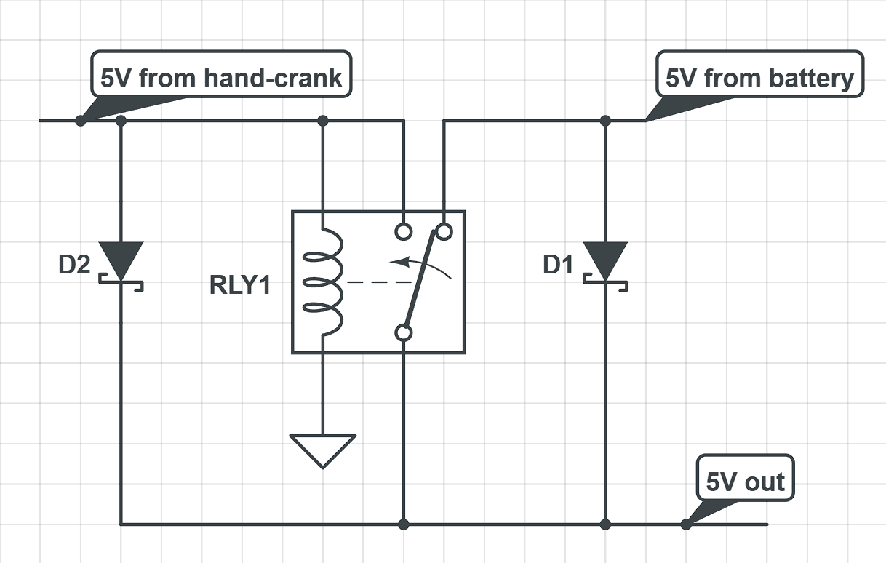
- Originally for multiplexing, we had considered using a relay and diode combination as shown in Figure 3^{[2]}
Figure 3 Alternative Multiplexing Circuit

- This promptly changed as upon performing research, we saw that a power mux would be more reliable and by relying on an input from the microcontroller rather than the hand-crank it would be more stable in its switching logic reducing overall time taken to switch.
- The power mux we wanted to use initially was the TPS2116, which we stuck with until we started designing the PCB when we realized that the part was in a DRL package and extremely small. Given our limited experience with soldering we decided to go with a TPS2115 which is an older generation component but is larger and TSSOP package, something we would be comfortable soldering.
- For the demultiplexing side, we were contemplating using silicon-controller rectifiers but given the lack of availability, we decided with using a relay as it was also a simpler component to integrate with our circuit.

3.1.3 PCB Design
- While designing the PCB we kept certain considerations in mind, mainly we wanted all the components to be laid out in such a way that it would be easy for us to debug issues by isolating each main part in its own area of the PCB. We also ensured that connectors were kept towards the outside of the PCB in order to prevent any interference with components on the PCB. Every connector was labeled appropriately to signify directionality and polarities. We also silkscreened key data like resistance and capacitance values to ensure that while soldering the parts were not incorrectly placed.
- Overall, we can consider our PCB design a success as we did not need any PCB revisions and our product worked as intended. Please refer to Appendix B.2 for visual diagrams of our PCB.

3.2 Design Details

3.2.1 Subsystem 1 - Microcontroller/Battery Subsystem

Parts Involved in Subsystem:
- Microcontroller - ATmega328p
- Battery - 1000 mAh
- Battery Module - TP4056
- Display - Adafruit 1002 with I2C Backpack
- Boost Converter - 2.5V-4.0V to 5V Boost

This subsystem is in charge of enabling the right circuit path in the hand-crank subsystem. We use the ATmega328p [3] and our Microcontroller has pinouts, sending signals to the Power mux [4]. It firstly helps determine whether the battery gets charged through the hand-crank or the USB In charging module (through the battery module). On the other hand, it also helps decide whether the device (to be charged) receives charge from the battery or the hand-crank directly (through the Power mux).

The circuit also makes use of a Lithium Ion Battery, roughly 1000 mAh. The battery has a potential of 3V ± 0.1V when completely drained, and 4.2V ± 0.1V when fully charged. As per our testing, the Boost Converter is able to boost the voltage range of the battery successfully to a stable 5V. This is used to power the various ICs on the circuit, the display and the Microcontroller, which sends selector signals to the Power mux.
We use an AdaFruit 7-segment display [5] which has four 7-segment units on it allowing us to display the battery level of the Lithium Ion Battery, along with the speed of the hand-crank to determine if the user is cranking at optimal rate or not. This helps indicate to the user if they should crank faster or slower. It works with the I2C Backpack, which enables us to use a significantly fewer number of pins of the Microcontroller, helping us utilize them for other use cases. The 4-digit 7-segment screen is divided into two sections. The two left digits indicate the Crank Speed, showing an "F" if the user should crank faster or an "S" (or 5) if they need to crank slower. The right-hand side of the display represents the battery level. This information was determined by measuring the battery voltage and performing simple calculations.

Furthermore, we were able to incorporate a USB Charging Input to enable the internal battery to be charged, providing the user with the option to maintain the device's power for future usage. This feature allows the device to function as a power bank, extending its functionality beyond just a hand crank device.

3.2.2 Subsystem 2 - Electromechanical/ Hand-Crank Subsystem

Parts Involved in Subsystem:

- Motor - Brushed 12VDC Pittman Motor (Output at 60 RPM: 12V ± 2V)
- Linear Regulator - LM7805
- Relay - Panasonic HY1-5V
- Power mux - Texas Instruments TPS2115

The subsystem includes the motor, linear regulator, circuitry for current flow control (Relay), and circuitry for selecting between two power sources (Power Mux). The motor is linked to a hand crank that the user operates to generate power.
To consider energy losses, we calculated the necessary motor voltage by analyzing the requirements at the device's output, and our motor can easily provide 8-20V with reasonable crank speeds. Since the USB standard can deliver current as long as it’s given a typical 5VDC ± 0.5V, we aimed for the Power mux output to provide a stable 5VDC. The Power mux determines whether the power is sourced from the battery or the hand crank. However, as we also utilize the hand crank to charge the battery, we used a Relay to split the current flow from the hand crank into the battery or the mux before reaching the USB output. To ensure a consistent 5V output, we consider the impedance caused by a current flow to a load. To ensure that the USB remains at 5V even through fluctuating generator voltages, we employ a 5V linear regulator. The linear regulator is capable of delivering a steady 5V output as long as it receives an input voltage of at least 6V [6].

The Power mux, present before the USB output, determines whether the current flows from the battery or directly from the hand-crank, with the help of signals from the Microcontroller. If the battery level of the product is low, the hand-crank prioritizes charging the battery first. Meanwhile, if the product has sufficient battery, the device can be charged with the help of the hand-crank directly. The Relay comes before the Battery Module, and helps determine whether the battery should be charged by the hand-crank or the USB Charging Input.

In this system, the microcontroller automatically prioritizes the USB Charging Input as the default route for charging the battery. However, when the hand crank is being turned, the microcontroller detects this and selects the Hand Crank as the power source for the battery. This decision is made to utilize the power generated by the hand crank rather than relying on the USB Charging Input when the hand crank is in use.

3.2.3 Physical Design

The product primarily serves useful during emergency situations, and hence, we made sure user comfort was an important feature in the physical design of the product. This would increase maximum efficiency of the product.
During the initial stages of brainstorming, we came up with features for the product, and how we would design it.
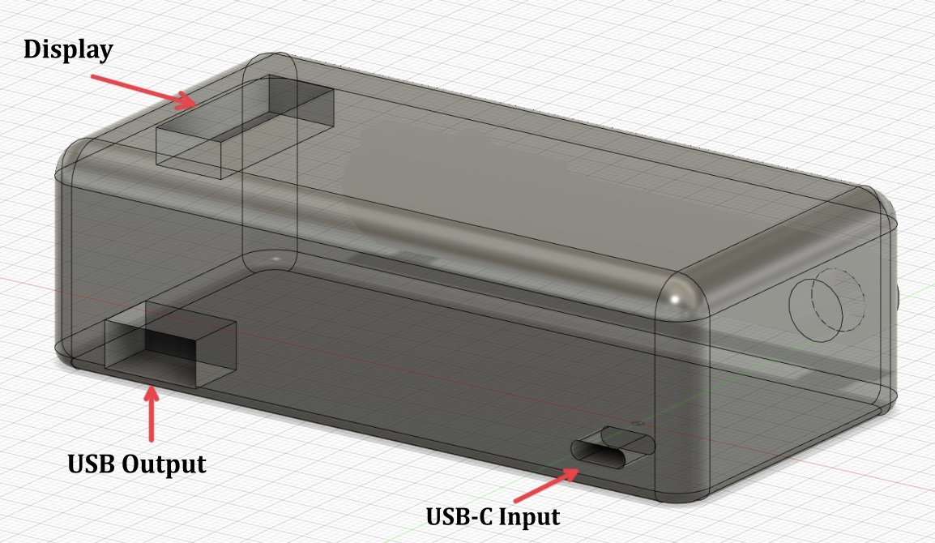
Figure 4 Product Design (Auxiliary View)

The outer casing of the product is made out of ABS plastic which helps prevent safety hazards such as electrocution. The casing protects the inner components from mechanical damage, and the product can be placed on any surface for use.

The motor has a metal reinforcement, since the torque of the motor might cause plastic material to crack. The metal also adds weight to the product which keeps the foundation steady, so that the product remains upright while users are cranking it. The casing is all-encompassing which prevents any kind of interior damage to the product.

Battery safety was a major precaution that had to be considered while designing the product. The casing prevents concentration of heat in any particular place, this tackles the issue of overheating batteries. DC power connectors have been used to keep the ground and live wires separate, ensuring extra protection for the circuit.
The product does not generate enough to cause the user any type of serious injury, and they need not be concerned about conduction or potential static discharge dangers.

The case surface has a display from which users get to know if they should crank faster or slower for optimal crank rate. It also displays battery percentage to help users keep track of how much power the battery still stores. The display is oriented in the direction of the user, which makes it easy for them to read the display while cranking the product.

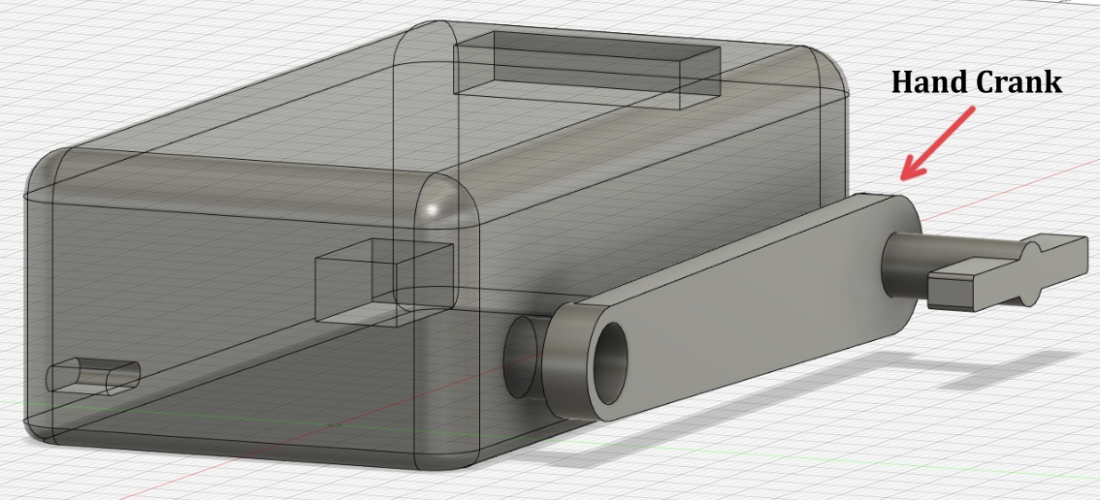
Figure 5 Product Design (Auxiliary View 2)

The team members wanted to decide on the length of the hand-crank, and we tested out several lengths and realized a length of 5 inches would be perfect to crank at the speed we want users to crank at. Being an emergency product, we wanted to ensure maximum comfort for users, for which the crank would have to be easily rotatable. The tip of the crank is also designed to rotate in all directions so that the user does not have to crank the product at awkward angles.

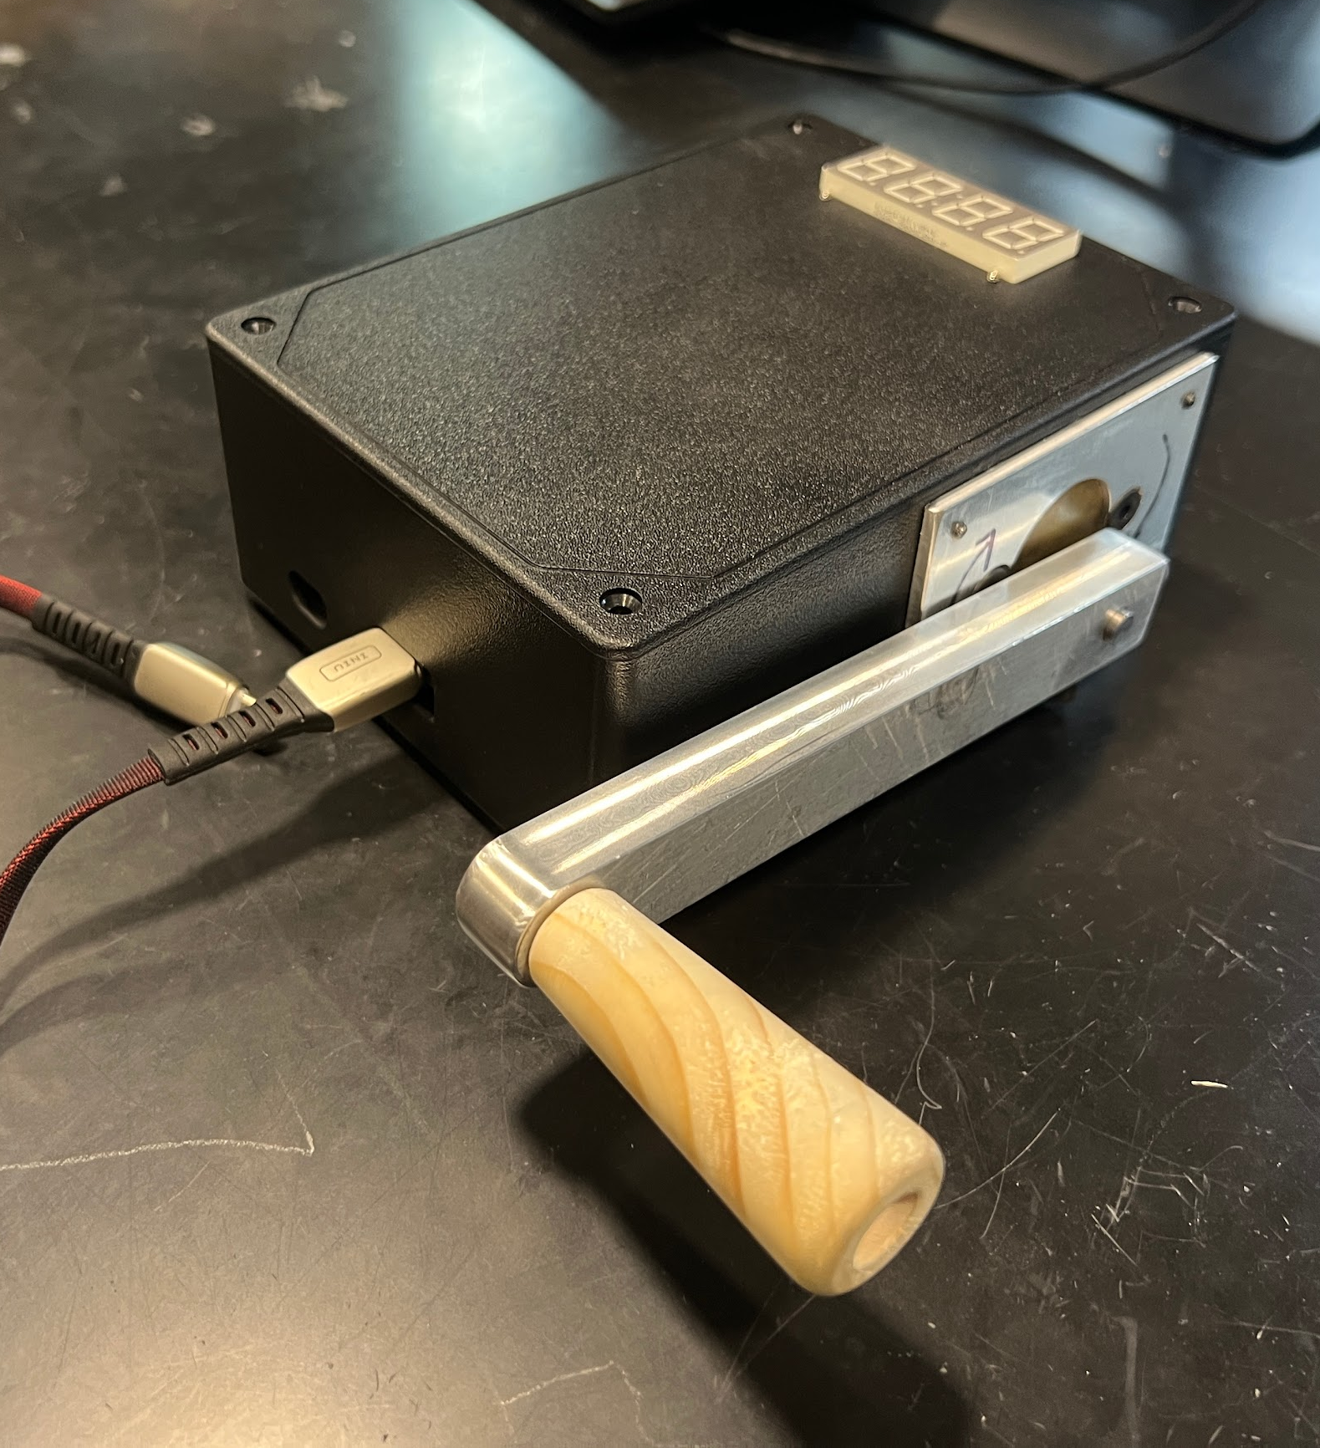
Figure 6 Actual Product

Figure 6 depicts our final product, with the hand-crank. Our final product has the USB cutouts on the side adjacent to the hand-crank, and not opposite to it as shown in previous figures, with the display successfully in the direction of the user.

4. Verification

4.1 Testing and Verification for the Microcontroller/Battery Subsystem

Table 1 System Requirements and Verification
Requirements | Verification | Verification Status
1.1 The Microcontroller outputs the correct signals to the Power mux | - Supply 5V±0.2V to linear regulator output through a DC power supply, to simulate the motor  - Connect the battery through the boost converter to the PCB  - Connect oscilloscope to pin 3 of MCU to check if selector pins for power mux and relay are set correctly | Verified
1.2 The Microcontroller outputs the correct signals to the Relay | - Supply 5V ±0.2V to linear regulator output through a DC power supply, to simulate the motor  - Connect the battery through the boost converter to the PCB  - Connect an oscilloscope  - to pin 11 of MCU to check if the selector pin for relay is outputting 5V±0.2V.  - If Battery is low, pin 11 should read 0V±0.2V. | Verified
1.3 The Battery Voltage is correctly measured,  The display indicates the correct battery level | - Connect a DC Power Supply to the Boost Converter and simulate different battery levels and check the corresponding percentage display on the display.  - At 3.0V, display should show 0±2, at 3.6V display should show 50±2 and at 4.2V display should show 100±2 | Partially Verified
1.4 The battery does not get completely drained | - Connect a DC Power Supply to Boost Converter and supply 3.5V  - Connect oscilloscope to TP4056 and to USB Output  - High Voltage should be measured at USB Output  - Drop Voltage to 3.3V (threshold to force battery charge)  - High Voltage should now be measured at Battery | Verified
1.5 The display correctly outputs the recommended crank speed modification | - Connect Oscilloscope  - MCU is polling the Linear Regulator  - When cranking very fast (generating >20V), “S” will be displayed and too slowly (generating <6V) “F” will be display | Partially Verified
1.6 The battery stops charging once 100% has been reached | - Connect DC Power Supply to Battery and test relay functionality  - The relay will switch to USB Output when the DC Power Supply is outputting 4.1V ± 0.1V | Verified
1.7 The battery circuitry is completely fine (essential for safety reasons) | - Use DC Power Connectors to increase safety of battery connections | Verified
1.8 The boost converter boosts the batteries 3.7 ± 0.6 VDC to 5 ± 0.2 VDC | - We connect a DC Power Supply to the input of the boost converter  - We probe the input as well as output of the boost converter using an oscilloscope  - We vary the voltage of the DC supply from 3.0V to 4.3V and observe the output voltage | Verified
1.9 The Microcontroller successfully identifies when a USB Device is plugged in | - Connect a USB Device to the USB A Female port  - Evaluate print statements in Boolean conditions verifying the USB is detected | Not Verified
1.10 The Microcontroller goes to sleep after period of inactivity | - Leave device for 5 minutes of inactivity  - Observe Display lights should turn off  - When cranking, display should turn on | Not Verified

4.2 Testing and Verification for the Electromechanical/Battery Subsystem

Table 2 System Requirements and Verification
Requirements | Verification | Verification Status
2.1 From the Hand Crank Motor, we get 12V ± 5V at 80RPM ± 20RPM. | - We connect the motor to the oscilloscope  - We measure voltage characteristics when cranked | Verified
2.2 The Linear Regulator regulates all Voltage in the range 6V to 20V down to 5V ± 0.25V | - We connect a DC Power Supply to the input of the Linear Regulator  - We connect the oscilloscope to the output of the Linear Regulator  - We provide a range of Voltages from 6V to 20V to see output Voltage Characteristics | Verified
2.3 The Relay changes output under 5ms when the coil is charged | - We connect one channel of Oscilloscope to Normally Closed and the other channel to Normally Open of the Relay.  - We connect a DC Power Supply to the input pin of the Relay supplying 5V ± 0.2V  - We connect the DC Power Supply also to the coil pin  - When the coil is energized with power we should see 5V at the Normally Open pin and when its not supplied with power, Normally Closed should have 5V.  - The transition between normally closed and normally open must occur in less than 5ms. | Verified
2.4 The power mux chooses between Hand Crank and Battery as per signal from Microcontroller | - We connect the Oscilloscope to the USB Output.  - We connect the DC Power Supply to the Boost Input and another Power Supply to the Hand Crank  - When the battery voltage is 4.2V ± 0.1V, the USB Output should get voltage from the Hand Crank  - When the Motor is not cranked, we should see the battery supply the voltage | Partially Verified
2.5 The Hand Crank charges the USB Output | - We plug in a USB A to USB C Cable and plug in various devices  - We see when we crank the hand crank the device should be charging with the charging symbol present. | Verified

To ensure that the electromechanical subsystem was functional, we just had to ensure that each of our low-level verification of our components passed. Since the electromechanical subsystem is about ensuring the flow of current across different components, successful verification of these components ensures that the whole subsystem functions as expected.
More details regarding the above information can be found in Appendix A.

5. Cost and Schedule

5.1 Bill of Materials

Table 3 Bill of Materials
Description | Part # | Manufacturer | Quantity | Total Price in USD
Ceramic Capacitor 0.1uF | 04023C104KAT2A-62 | Kyocera | 10 | $2.53
Ceramic Capacitor 0.33uF | GCJ219R71H334KA12D | Murata | 10 | $1.59
Linear Voltage Regulator | LM7806CV | STMicroelectronics | 1 | $0.77
Linear Voltage Regulator | LM7805CV | STMicroelectronics | 1 | $0.77
Resistor 10kOhm | RK73H2ATTDD1002F | KOA Speer | 10 | $0.33
Resistor 402 Ohm | 660-RK73H2ATTD4020F | KOA Speer | 10 | $0.40
Schottky Diode | MBR0520-TP | MCC | 5 | $1.00
Relay | HY1-5V | Panasonic | 1 | $3.98
USB A Female | USBR-A-S-F-O-TH | Samtec | 1 | $1.77
Li-ion 1000mAh Battery | ASR00012 | TinyCircuits | 1 | $7.46
Connectors | A31080-ND | TE Connectivity | 10 | $1.88
Connectors | A1921-ND | TE Connectivity | 10 | $1.46
Connector 6pin | 732-5394-ND | Wurth Elektronik | 2 | $0.96
Power Mux | TPS2115PW | Texas Instruments | 3 | $8.55
Display | ADA881 | Adafruit | 2 | $23.9
Microcontroller | ATMega328-PU-ND | Microchip Technologies | 3 | $10.60
Resistors 75kOhm | 311-75-KERCT-ND | Yageo | 10 | $0.35
Resistors 43.2kOhm | 311-43.2KFRCT-ND | Yageo | 10 | $0.38
Connection Header SMD | 455-1790-1-ND | JST Sales | 5 | $3.10
Resistors 43 kOhm | 311-43.0KFRCT-ND | Yageo | 5 | $0.50
Boost Converter | B091CRCZ65 | ANMBEST | 1 | $9.99
Battery Module | SGn37ifggw | MakerFocus | 1 | $8.99
Connector | ADA4390 | Adafruit | 1 | $3.5
Cable | ADA4424 | Adafruit | 2 | $1.90
Arduino Uno | Uno Rev3 | Arduino | 1 | $27.60
12VDC Motor | GM9213C177-R1 | Pittman Motor | 1 | $65.30
PCB | PCB | PCBWay | 10 | $50.40

Our total bill of materials comes to $239.96/-

5.2 Labor Cost

To make the physical product a reality, we asked the machine shop to cut the plastic box, create standoffs and perform other small tasks that would allow us to assemble the product. The total time the machine shop needed was 6 hours, and at their hourly rate of $50/hour, we see that the labor cost for the utilization of the machine shop is:

$$6 hours * \$50/hour = \$300.00$$

5.3 Total Cost

Adding up our labor cost and cost of parts gave us a total cost of:

$$\$239.96 + \$300 = \$539.56$$

5.4 Schedule

Table 4 Schedule
Week | Tasks | Members
Feb 20th - Feb 26th | Finalized the components we will be using | Shreyasi / Rubhav
Feb 20th - Feb 26th | Wrote up the Design Document | Shreyasi / Achyut
Feb 20th - Feb 26th | Started PCB Design | Rubhav / Achyut
Feb 20th - Feb 26th | Completed Team Contract | Team Work
Feb 27th - Mar 5th | Finalized Design as per review | Shreyasi
Feb 27th - Mar 5th | Completed PCB Design | Rubhav / Achyut
Feb 27th - Mar 5th | Tested through CAD Softwares | Rubhav
Mar 6th - Mar 12th | Worked on Teamwork Evaluation | Team (separately)
Mar 6th - Mar 12th | Finalized Machine shop designs | Achyut
Mar 13th - Mar 21st | SPRING BREAK | Team
Mar 13th - Mar 21st | Began Soldering (if parts and PCB Arrive) | Shreyasi / Rubhav
Mar 20th - Mar 26th | Ordered Parts | Shreyasi
Mar 20th - Mar 26th | Performed unit testing to ensure the functionality of each part and subsystem | Achyut
Mar 20th - Mar 26th | Evaluated if our PCB was completely working (before next round of PCB orders) | Rubhav
Mar 20th - Mar 26th | Programmed Microcontroller | Shreyasi
Mar 27th - Apr 2nd | Completed Individual Progress Report | Team (separately)
Mar 27th - Apr 2nd | Determined if hand crank output worked | Achyut
Mar 27th - Apr 2nd | Ensured Relay setup was working | Rubhav
Apr 3rd - Apr 9th | Evaluated Progress and attempted to complete the entire circuitry | Team
Apr 3rd - Apr 9th | Made sure last minute changed were completed | Team
Apr 10th - Apr 16th | Prepared for Demonstration of project | Team
Apr 10th - Apr 16th | Completed Team Contract | Team (separately)
Apr 17th - Apr 23rd | Did thorough testing before Mock Demo | Team
Apr 17th - Apr 23rd | Started writing up the final presentation and paper | Team
Apr 24th -Apr 30th | Finished up respective parts of presentation | Team
Apr 24th -Apr 30th | Completed Final Demo | Team

6. Conclusion

6.1 Accomplishments

When we started conceptualizing this project, we wanted to make a hand-cranked charger that can charge a device without requiring any additional power source. With that goal in mind, the project was a success as we were able to successfully charge a device just by hand-cranking a motor. We were able to get a steady 5V output to the USB Output and when connecting devices like Apple AirPod Pros and JBL Flip 5 Speakers, we saw them charge successfully and saw an increase in battery percentage.

The electromechanical subsystem was able to generate and direct the flow of current based on signals sent by the microcontroller, and if we had a working Power mux, the entire subsystem would work flawlessly. As we no longer had our power mux, the only thing that was no longer possible was allowing the battery to charge our device, as our default flow was our Hand Crank would charge the device. We were able to simulate this manually by using a breadboard and replicating the action ourselves to validate the functionality.

The microcontroller worked successfully, being able to trigger the relay as per the signal received by the battery. Our display was also working as expected outputting the battery percentage and the hand crank speed recommendations on it as intended, unfortunately the short caused the display to not work at the very end, but ordering a new piece and ensuring that the live and ground have no solder between them would also ensure our Microcontroller Subsystem would work flawlessly.

6.2 Uncertainties/Hurdles

While working on the project, we ran into some issues that led to our project not meeting all of our goals.

Towards the end of the project, there was an unintended short which caused quite a few of our components to get damaged, the two main components that we were unable to replace were the power mux and the display. The short was caused by slight bridging of live and ground at our display connector. This bridging went unnoticed during

The power mux had quite a few issues from the manufacturing side itself, based on our testing it appeared that it was switching rapidly between the two inputs without the select signal being set to high, therefore we had to use another power mux. The next one we ended up damaging as we passed in 6.2V from the linear regulator when the threshold on the power mux was 6.0V. This was because of the linear regulator not being able to regulate outside of optimal input voltage, therefore we decided to use a 5V linear regulator instead. The final one was damaged due to the unintended short. In order to rectify the issues with the power mux, we attempted to implement external circuitry on a breadboard through the use of MOSFETs and diodes but were unable to do so as the voltage and current characteristics of the parts were not in line with what we needed, and given the short time frame, we manually switched the input for demonstration purposes.

The display was working as expected until the short occurred at which point the segments were not lighting up. We could see that the I2C Backpack was still powered on correctly, but the LED segments on the display were no longer working. Given the short time frame we were unable to order a new display and therefore for demonstration purposes, we used print statements on the serial output of the Arduino IDE to showcase the display functionality.

6.3 Future Work/Alternatives

As we worked on this project, there were a few considerations we had in mind if we were to work on this project in the future again.

The first consideration would be to use a smaller motor. The current motor we used was a large and heavy motor that generated a much larger voltage than needed, something we do not actually need as the motor output immediately goes through a linear regulator bringing it down to 5V. We could therefore use a smaller, lighter and cheaper motor that would have an output of 6V - 9V at 80 ± 20 rpm giving the user adequate headroom for crank speeds and also make it more portable. We could also perhaps design our own gearing system to make the motor more reliable to use.
Another consideration we had was the use of an LCD Display rather than a 7-segment display. This would allow us to display more information that could provide quality of life improvements to the user. This would also make the use of the display more straightforward and would not require the user to read the product manual to understand the meaning of the display outputs.
Finally, we would like to make our PCB smaller. This is to make the product more portable and cheaper to manufacture. Given the prototyping phase of the project, we wanted to have a larger PCB to make it easier to debug issues and solder the parts, but in future revisions we could potentially use smaller footprints and smaller ICs as well reducing the PCB to a much smaller size.

Citations

[1] R. Moody, “Screen Time Statistics: Average in the US vs. rest of the world,” Comparitech,
Mar. 15, 2023
[Online]
Available: https://www.comparitech.com/tv-streaming/screen-time-statistics/
[Accessed: May 3, 2023]

[2] next-hack, “Auto-switching Power Mux with High Current Output for 5V Power
Sources”,Electrical Engineering Stack Exchange.
[Online]
Available: https://electronics.stackexchange.com/q/333364
[Accessed: May 3, 2023]

[3] Atmel, “8-bit AVR Microcontroller with 32K Bytes In-System Programmable Flash”
#7810D-AVR Datasheet,
[Revised Apr. 2000]
Available:https://ww1.microchip.com/downloads/en/DeviceDoc/Atmel-7810-Automotive-Microcontrollers-ATmega328P_Datasheet.pdf
[Accessed Jan 15, 2015]

[4] Texas Instruments, “Autoswitching Power Multiplexer”
#SLVS447A Datasheet,
[Revised Dec. 2002]
Available:https://www.ti.com/lit/ds/symlink/tps2115.pdf
[Accessed Feb 19, 2023]

[5] Melissa LeBlanc-Williams, “Adafruit LED Backpacks,” Revised Jan.13, 2023
[Online]
Available: https://cdn-learn.adafruit.com/downloads/pdf/adafruit-led-backpack.pdf
[Accessed Feb. 19, 2023]

[6] STMicroeclectronics, “L78 Positive Voltage Regulator ICs”
#DS0422 Datasheet,
[Revised Sep. 2021]
Available: https://www.mouser.com/datasheet/2/389/l78-1849632.pdf
[Accessed May 3, 2023]

[7] Electrochem Solutions, Raynham, Massachusetts, United States, Primary Lithium
Battery Safety and Handling Guidelines, Revised 2017
[Online]
Available:https://s24.q4cdn.com/142631039/files/doc_presentations/Resources/Battery-Safety-and-Handling-Guide.pdf
[Accessed Feb. 19, 2023]

[8] University of Illinois at Urbana Champaign, “Safe Practice for Lead Acid and
Lithium Batteries,” April.13, 2016
[Online]
Available:https://courses.engr.illinois.edu/ece445/documents/GeneralBatterySafety.pdf
[Accessed Feb. 19, 2023]

[9] Institute of Electrical and Electronics Engineers, “IEEE Code of Ethics,” June 2020
[Online]
Available: https://www.ieee.org/about/corporate/governance/p7-8.html
[Accessed Feb. 20, 2023]

Appendix A: Verifications

A.1 Microcontroller/Battery Verification Results

A.1.1 The Microcontroller outputs the correct signals to the Power mux

Figure 7 is an image verifying the requirement of microcontroller functionality.

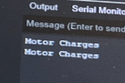
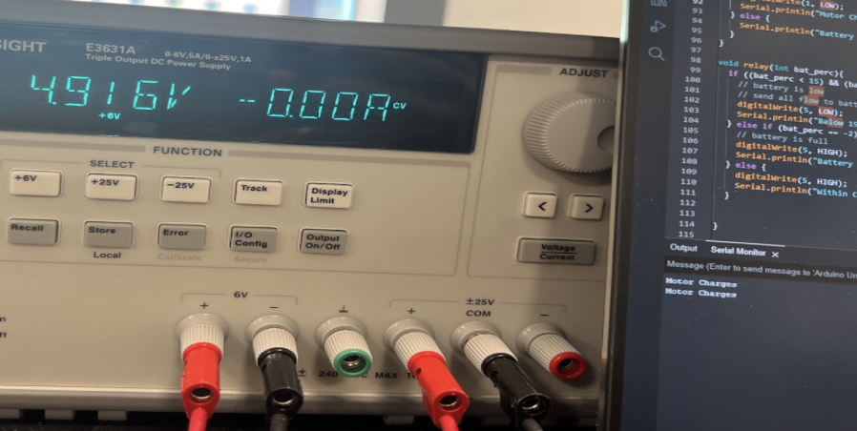
Figure 7

This requirement was verified as per the Figure 7, we can see that when we supply a 4.95V ± 0.05V to the AnalogRead pin on the microcontroller, it correctly reaches the boolean condition where the power mux select signal is set to high. The text in the red box indicates that the microcontroller outputs “Motor Charges” when the motor is supplying electricity.

A.1.2 The Microcontroller outputs the correct signals to the Relay

Figure 8 shows us verifying the requirement of microcontroller functionality.
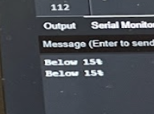
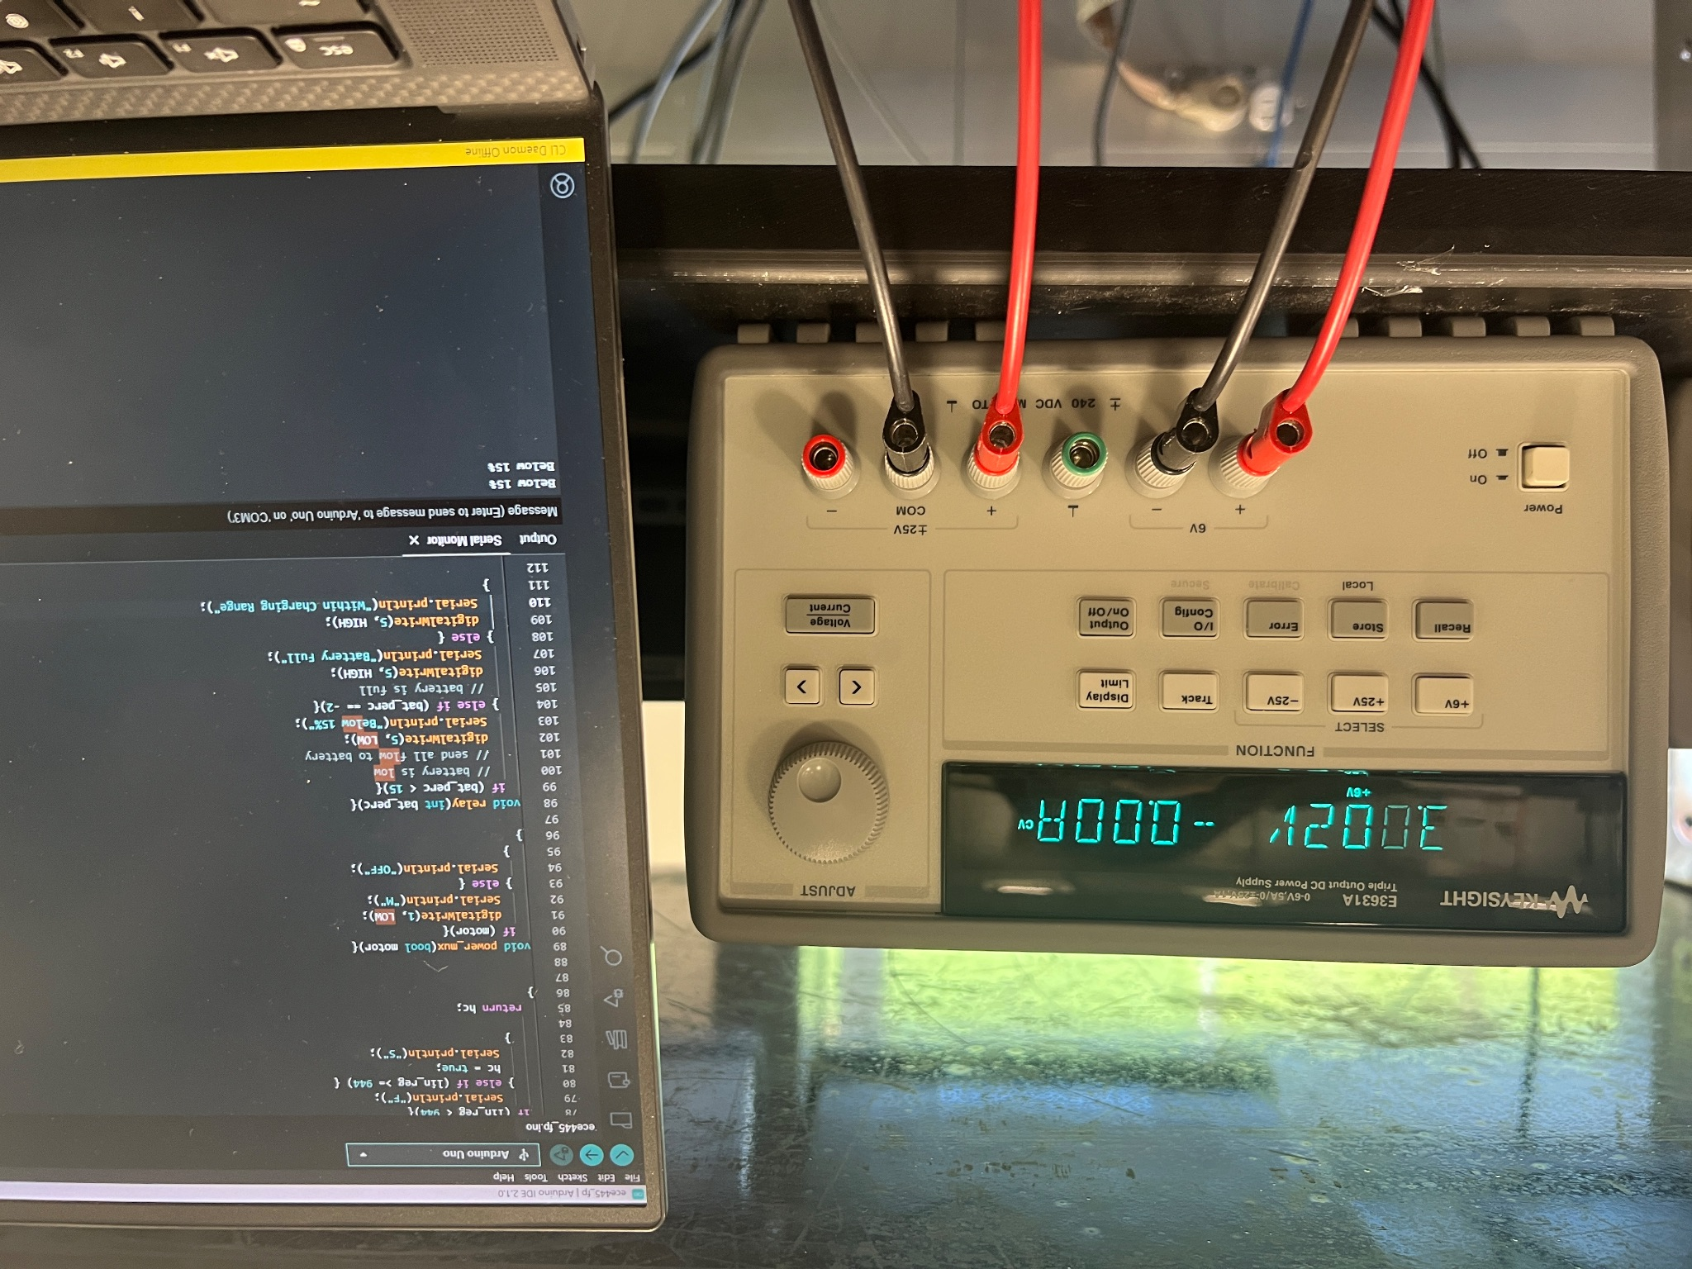
Figure 8

The requirement was verified by using print statements in the various boolean conditions where the relay should switch to the battery or the USB output. For example, when the battery is low on charge the print statement shows that we reach the boolean condition where the DigitalWrite would output to the relay indicating that we need to send power to the battery. The program also performs the same functionality at the different states which can be referred to at Appendix B.

A.1.3 The Battery Voltage is correctly measured, the display indicates the correct battery level

Figure 9 is verifying the requirement of microcontroller functionality.

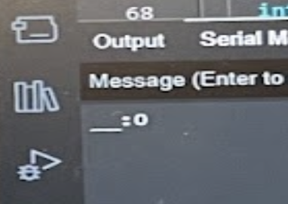
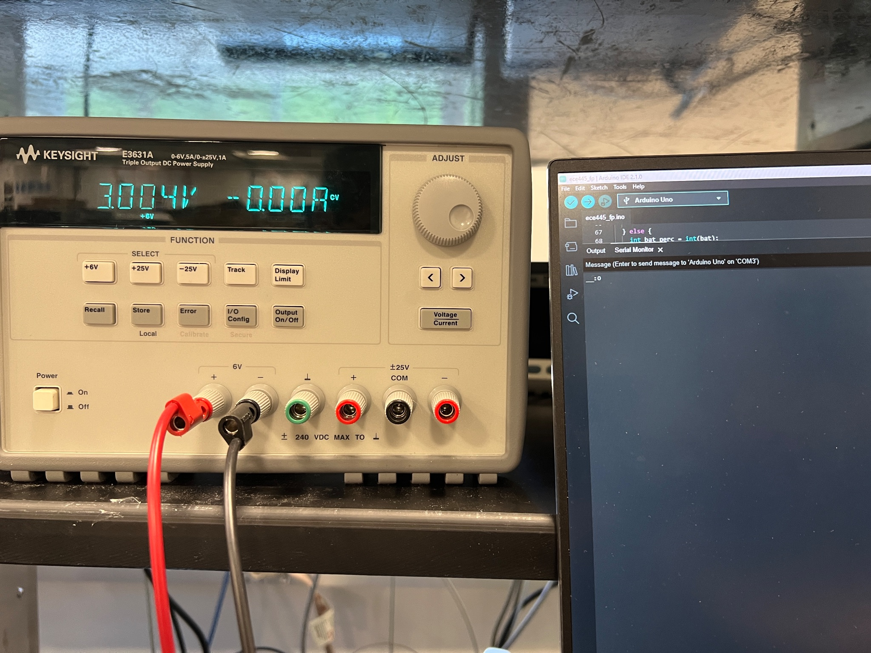
Figure 9

The test verifies that our microcontroller outputs the correct battery percentage at the various battery voltage values. As we know that the battery at 0% is 3.0V and at 100% is at 4.2V, we performed calculations in the program to get the right percentage. We see that at 3.0V the output is 0%.

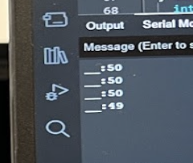
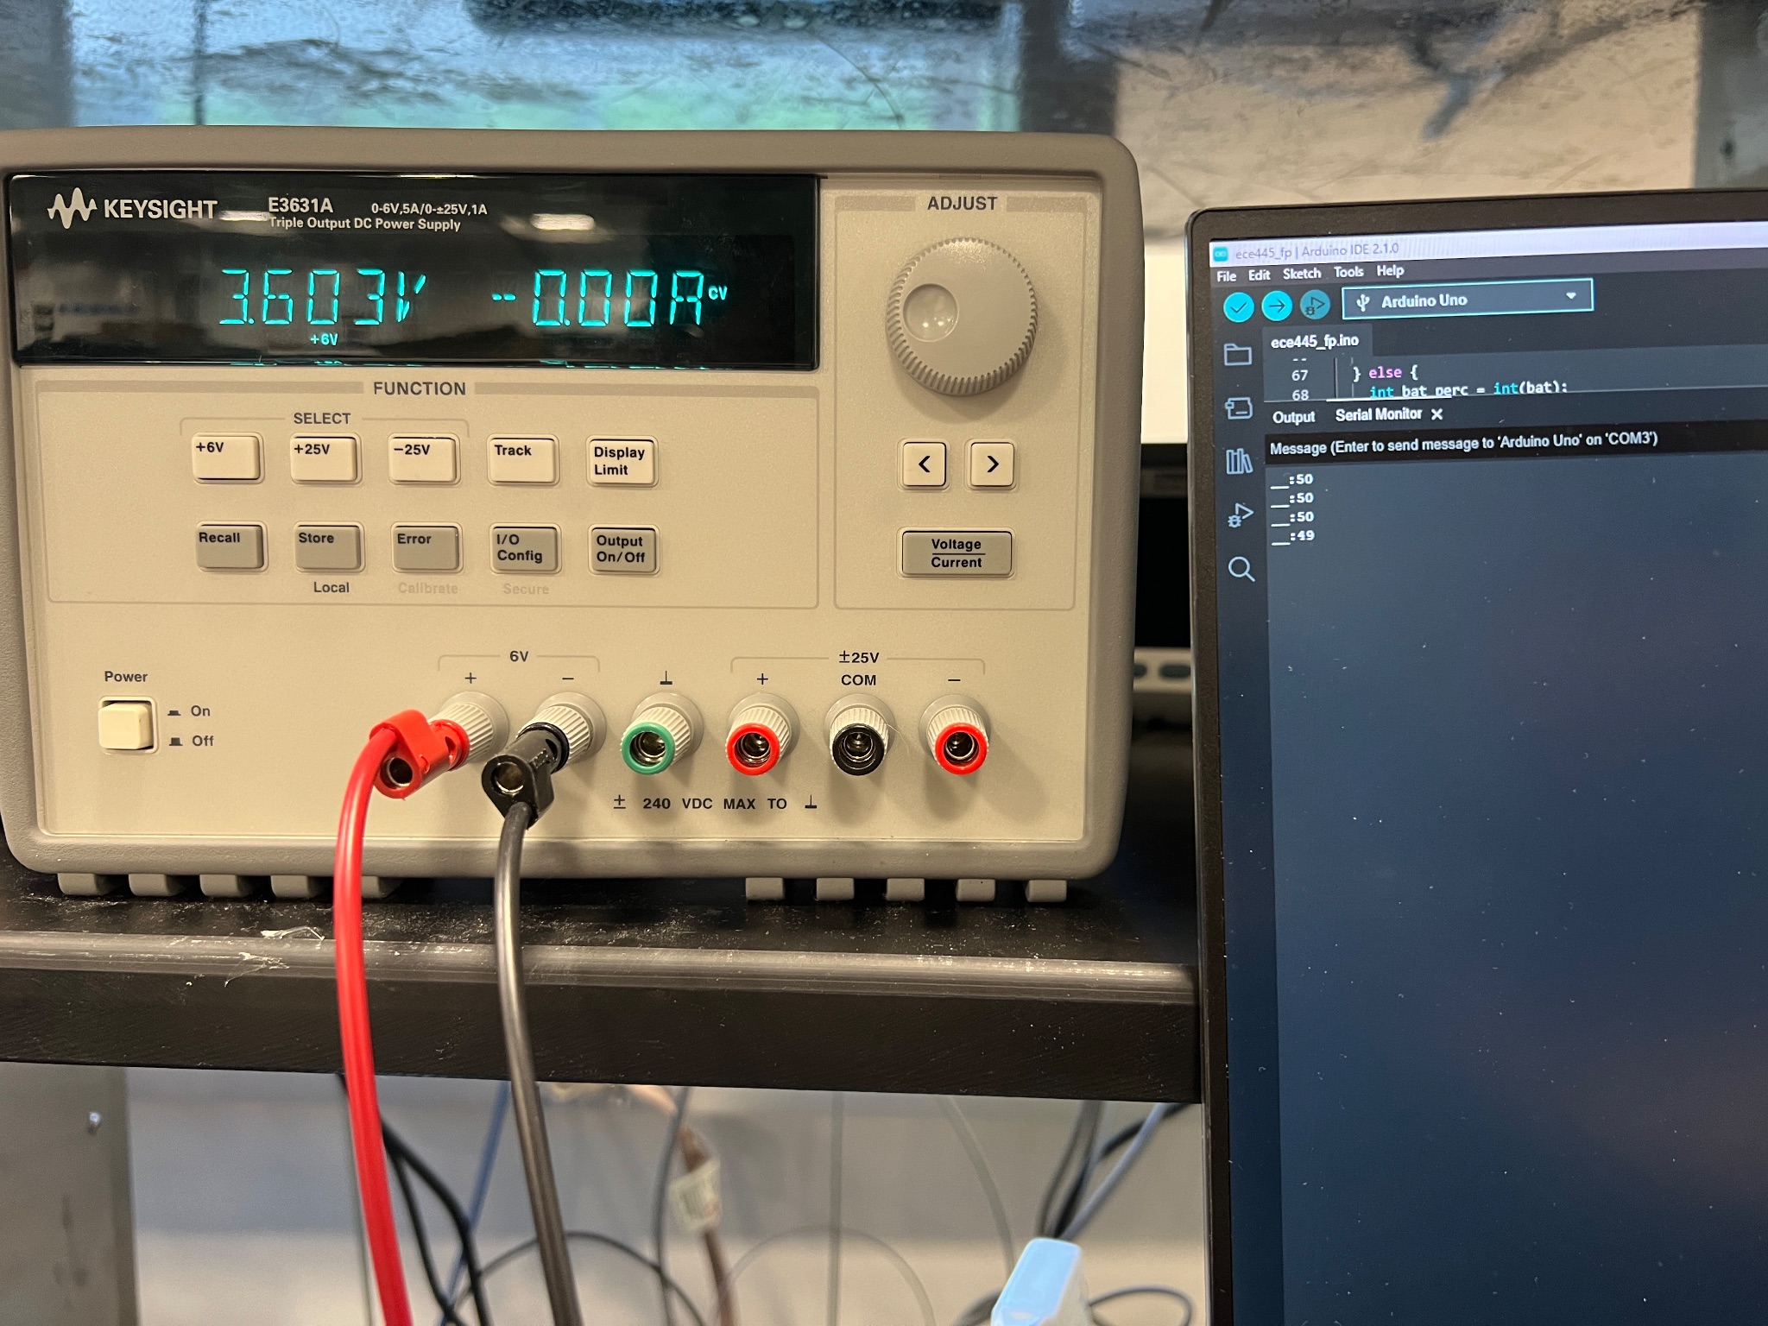
Figure 10

We see that at 3.6V, the output is 50% as expected.

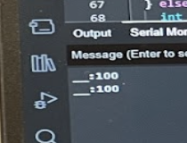
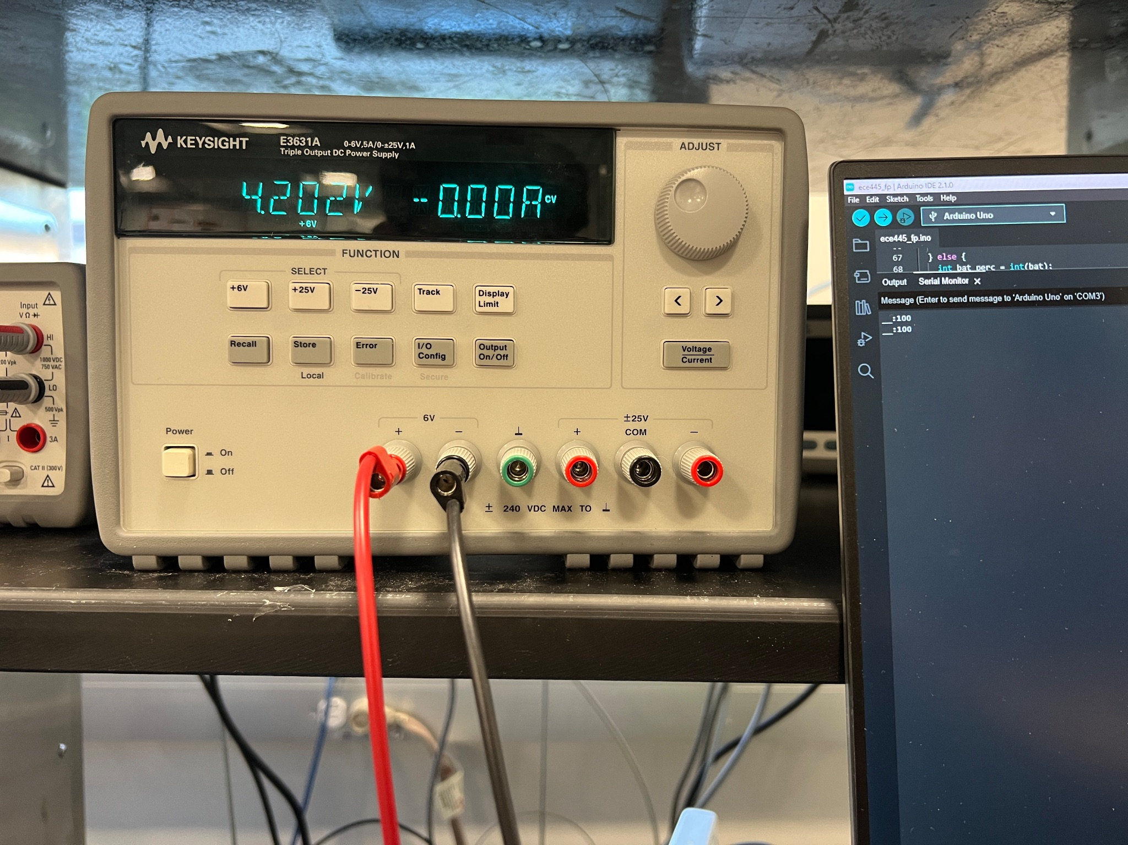
Figure 11

We see that at 4.2V the output is 100% as expected verifying this requirement at various test points.

A.1.4 The battery does not get completely drained

Figure 12 is the test to showcase that our program ensures that the battery will never get completely drained.

Figure 12

We see that at 3.0V (when battery is depleted) the program is in the condition block where the relay would send power to the battery (regardless of if the USB is connected).

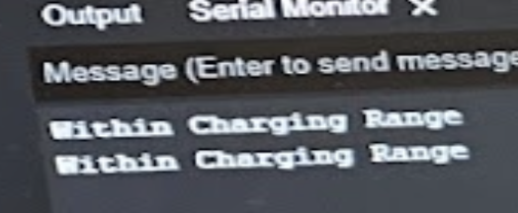
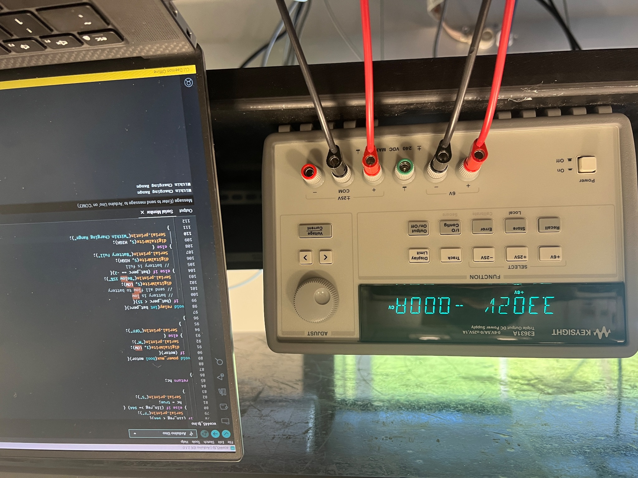
Figure 13

We see that at 3.3V (when battery is above 15%) the program is in the condition block where the relay would send power to the USB connection.
Therefore, this verifies this test.

A.1.5 The display correctly outputs the recommended crank speed modification

Figure 14 is the test performed to see if the hand crank speed recommendation is identified correctly by the program.

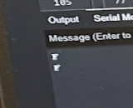
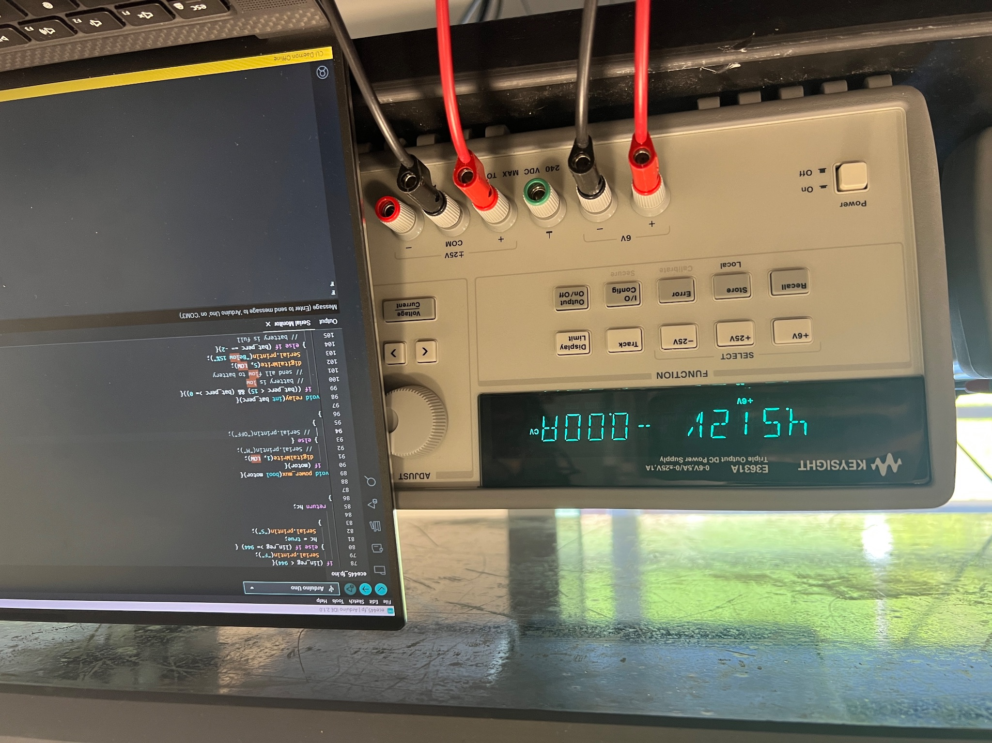
Figure 14

We see that at 4.5V at the motor (when motor RPM is too low for a linear regulator to output 5V) the program prints out “F” for go faster.

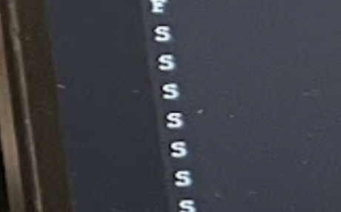
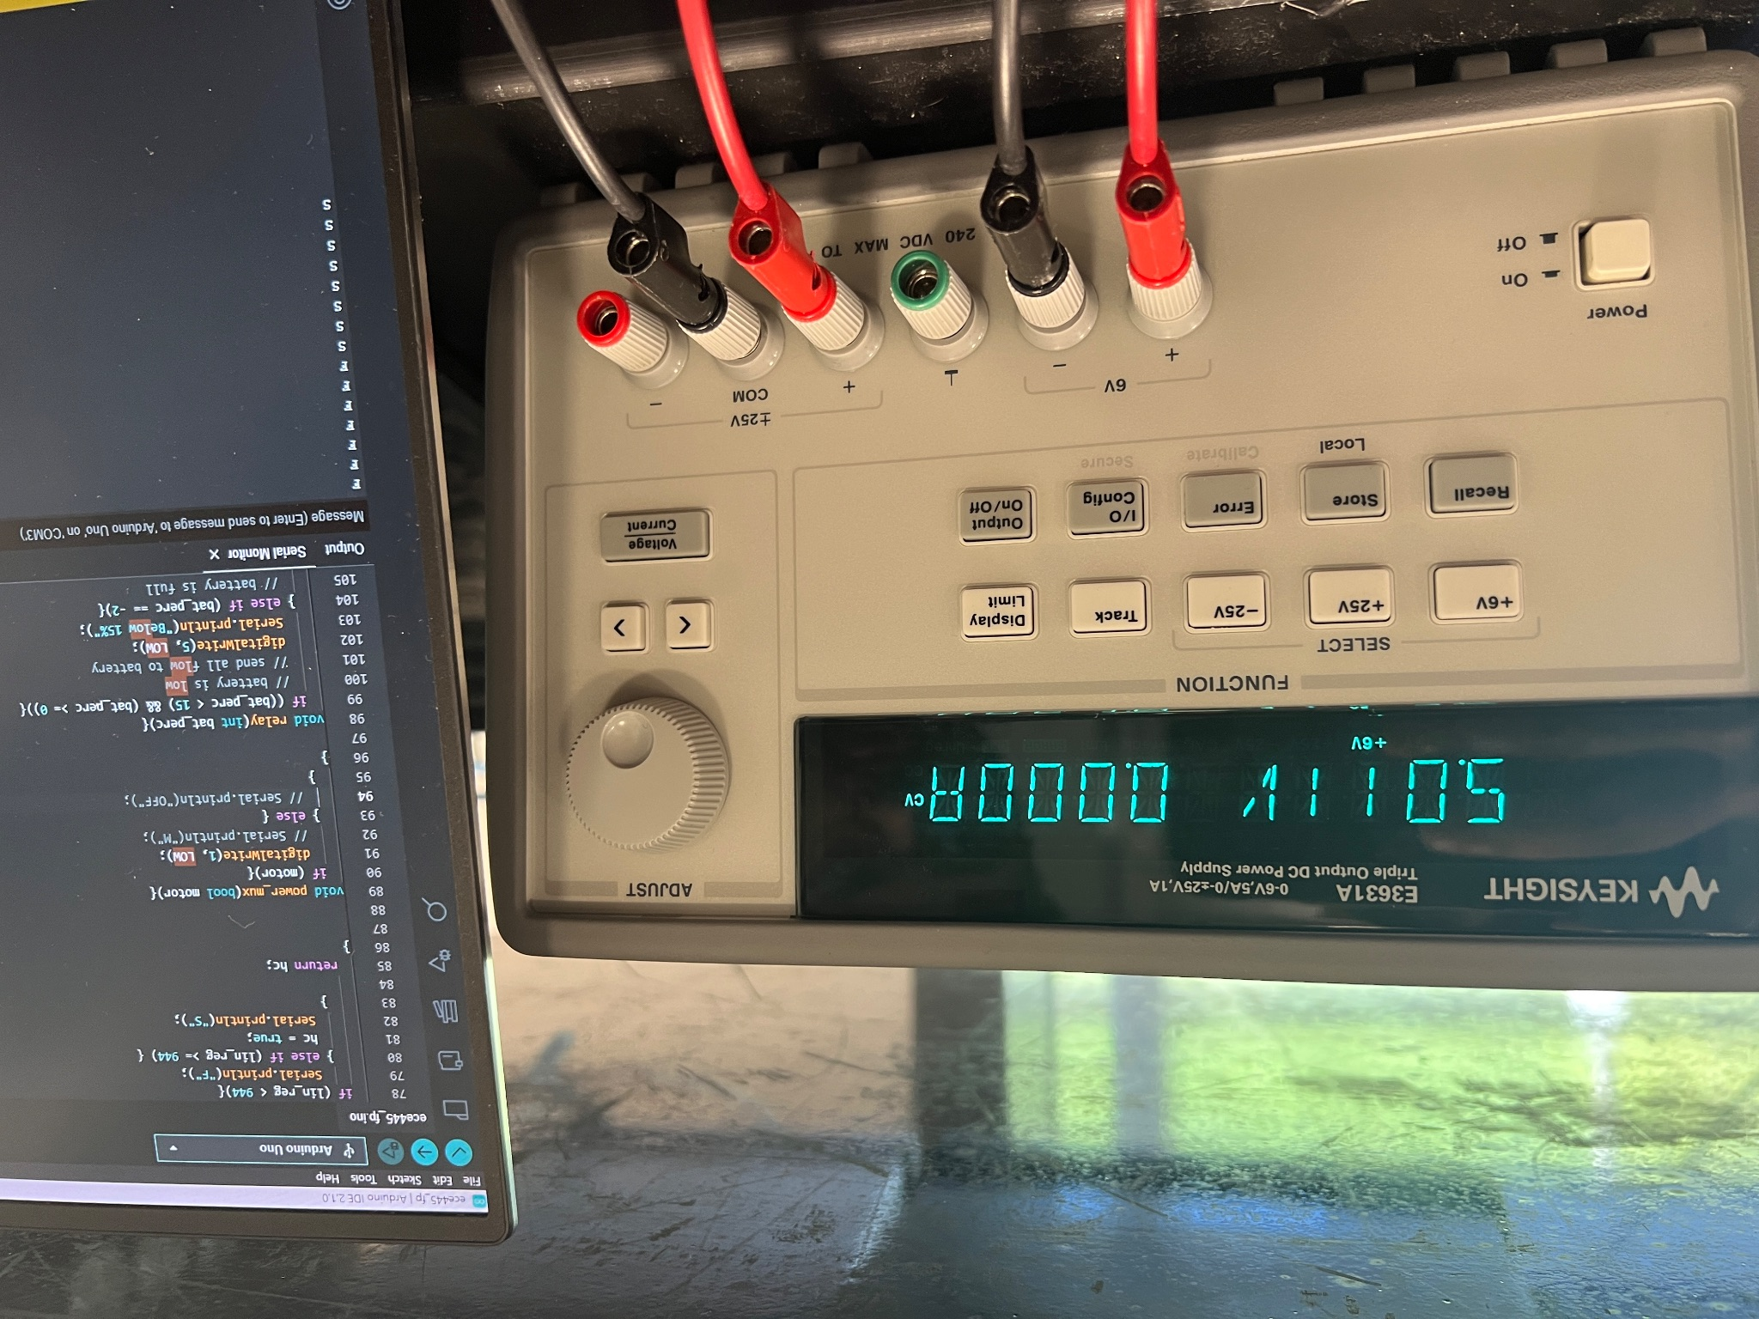
Figure 15

We see that at 5V at the motor (when motor RPM is sufficient for the linear regulator to output 5V) the program prints out “S” suggesting that the user can go slower if desired.

A.1.6 The battery stops charging once 100% has been reached

Figure 16 showcases the program functionality to ensure that the battery does not charge beyond 100%.

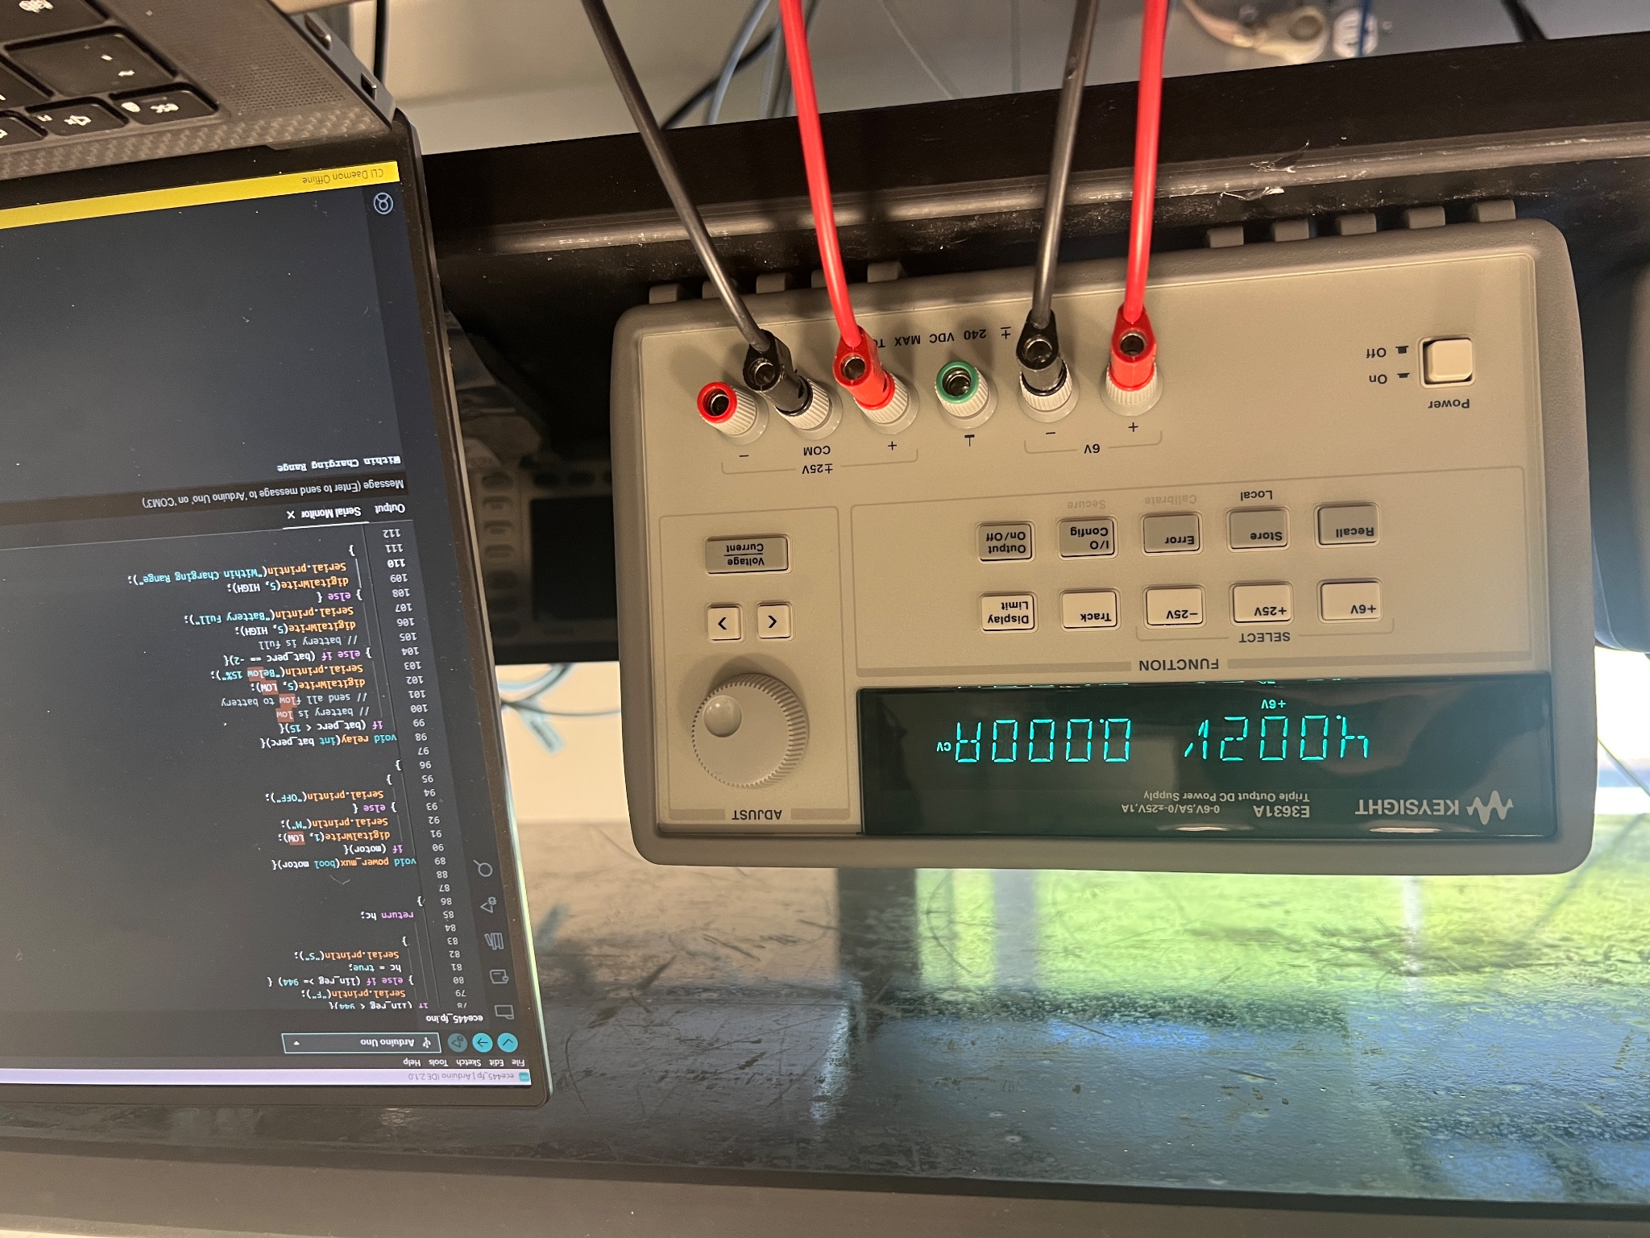
Figure 16

We see that when the battery is supplying 4.0V (<100%) the program is in the case where the battery can be charged.

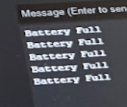
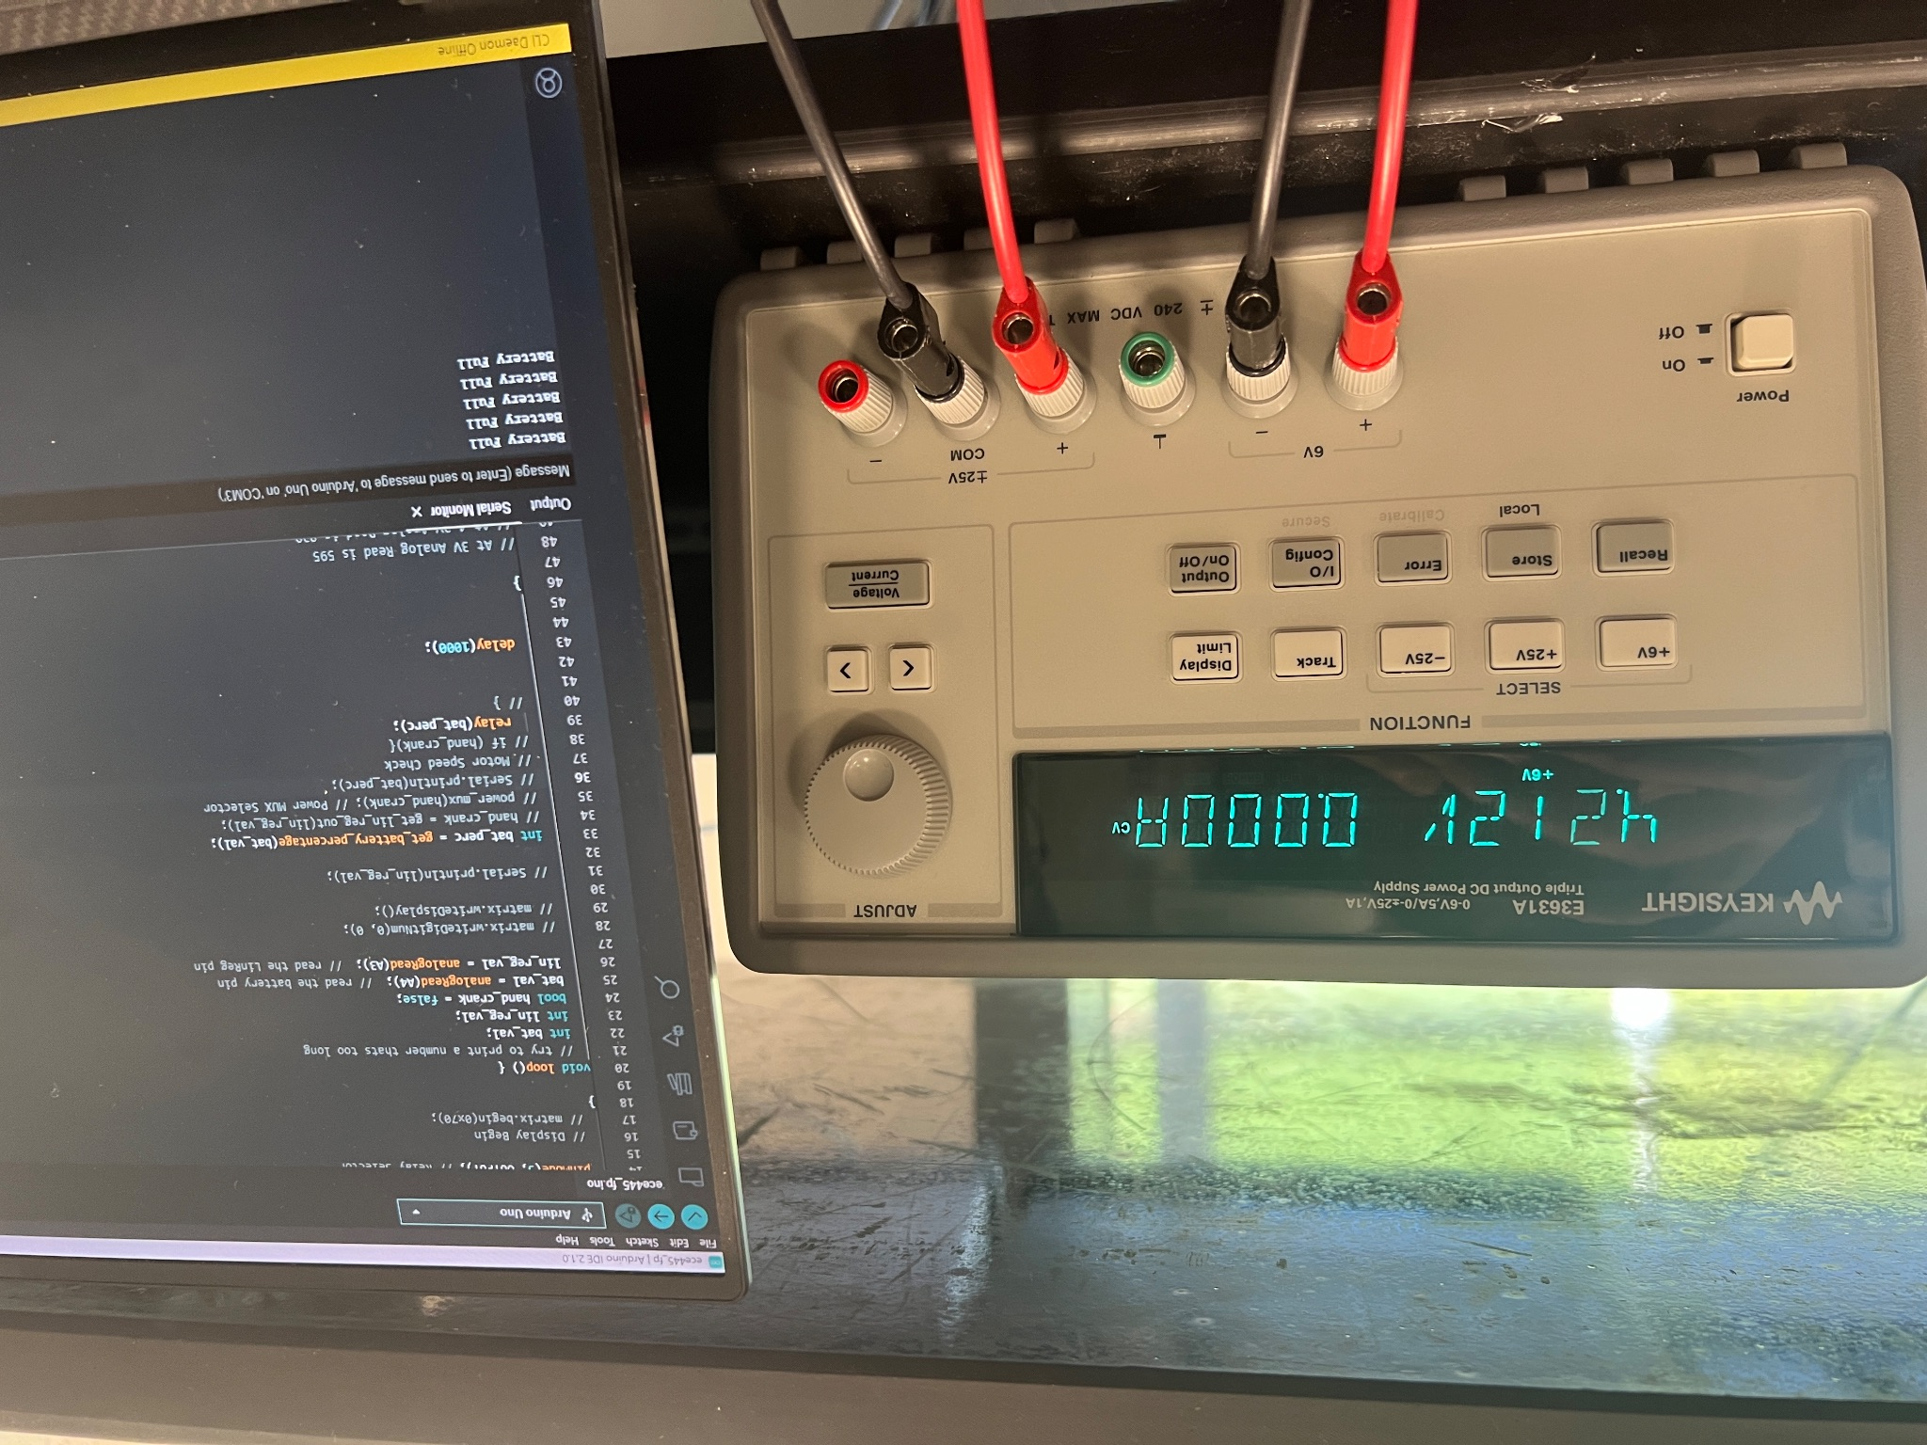
Figure 17

We see that when the battery is supplying 4.2V (battery is 100%) the program is in the case where the battery can not be charged and the relay does not ever supply power to the battery.

A.1.7 The battery circuitry is completely fine (essential for safety reasons)

This was verified as we used DC Power Connectors to connect the battery to the boost converter. This ensured that there was no risk of live and ground making unwanted contact with one another.

A.1.8 The boost converter boosts the batteries 3.7 ± 0.6 VDC to 5 ± 0.2 VDC

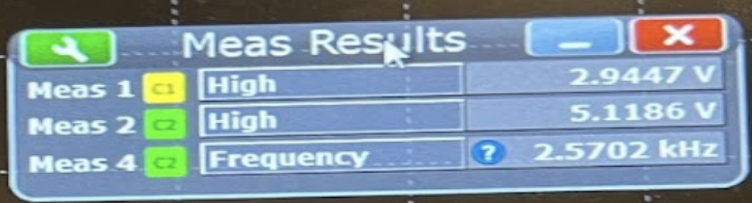
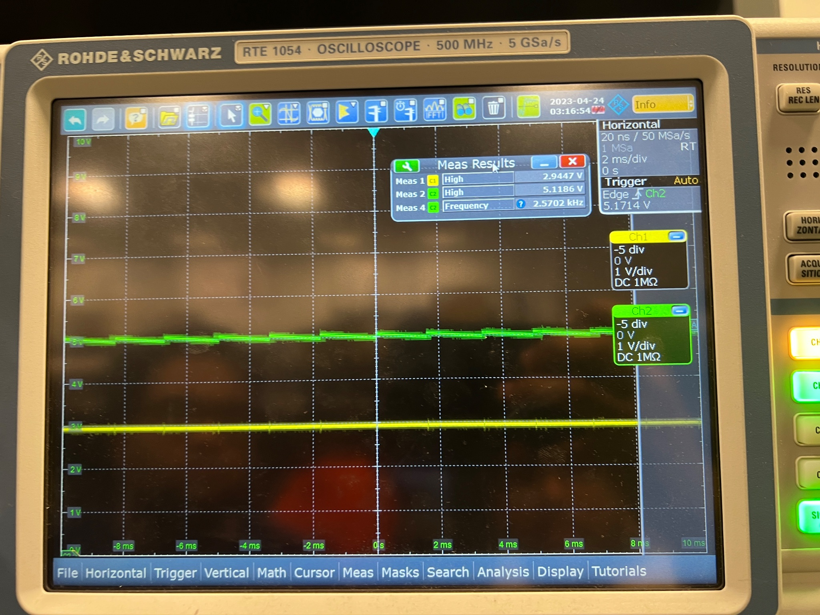
Figure 18

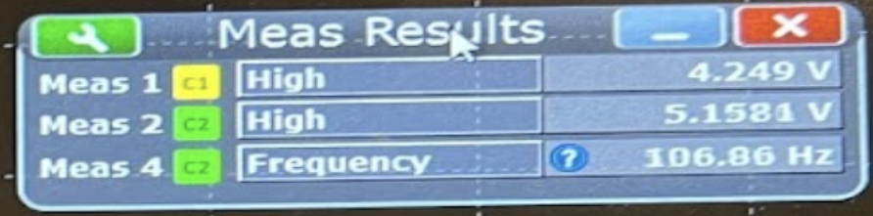
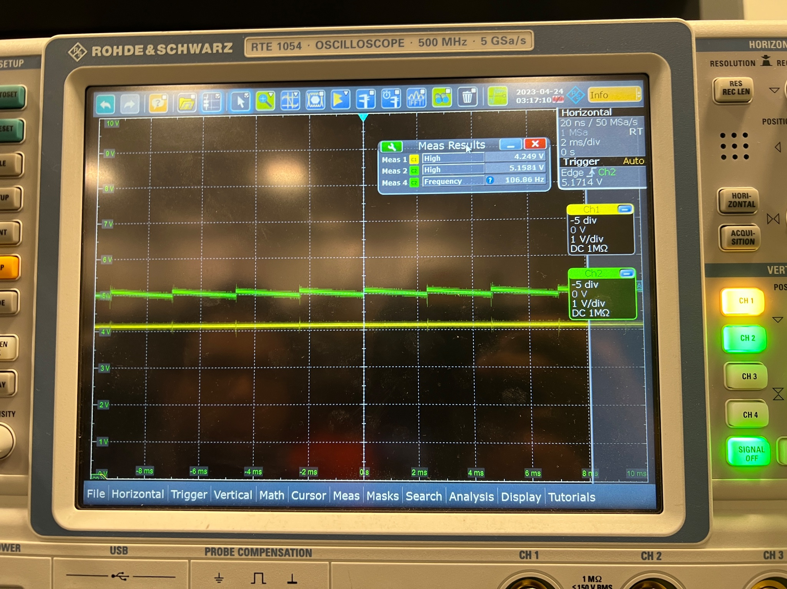
Figure 19

A.1.9 The Microcontroller successfully identifies when a USB Device is plugged in

Unfortunately we were not able to verify this as the microcontroller was not able to get the right signal when the USB was connected, therefore the switching logic occurs when the battery is too low. This was because we planned to use certain API calls for usb_connection that exist within the arduino community but given that we were using just the microcontroller we think we needed some additional circuitry to get that functionality working.

A.1.10 The Microcontroller goes to sleep after period of inactivity

This requirement was also something we were unable to verify as the sleep states on the microcontroller were not being configured as we had originally wanted it to be. The ability to wake up the microcontroller on an analog read had many issues and we were unable to get this working in time.

A.2 Electromechanical/Hand-Crank Verification Results

A.2.1 From the Hand Crank Motor, we get 12V ± 5V at 80RPM ± 20RPM

Below are the oscilloscope readings and data obtained when probing the output of the hand crank.

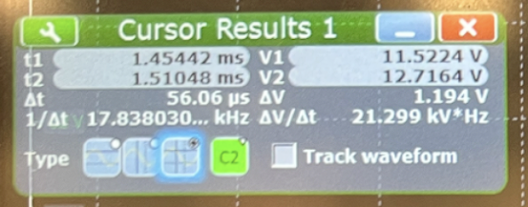
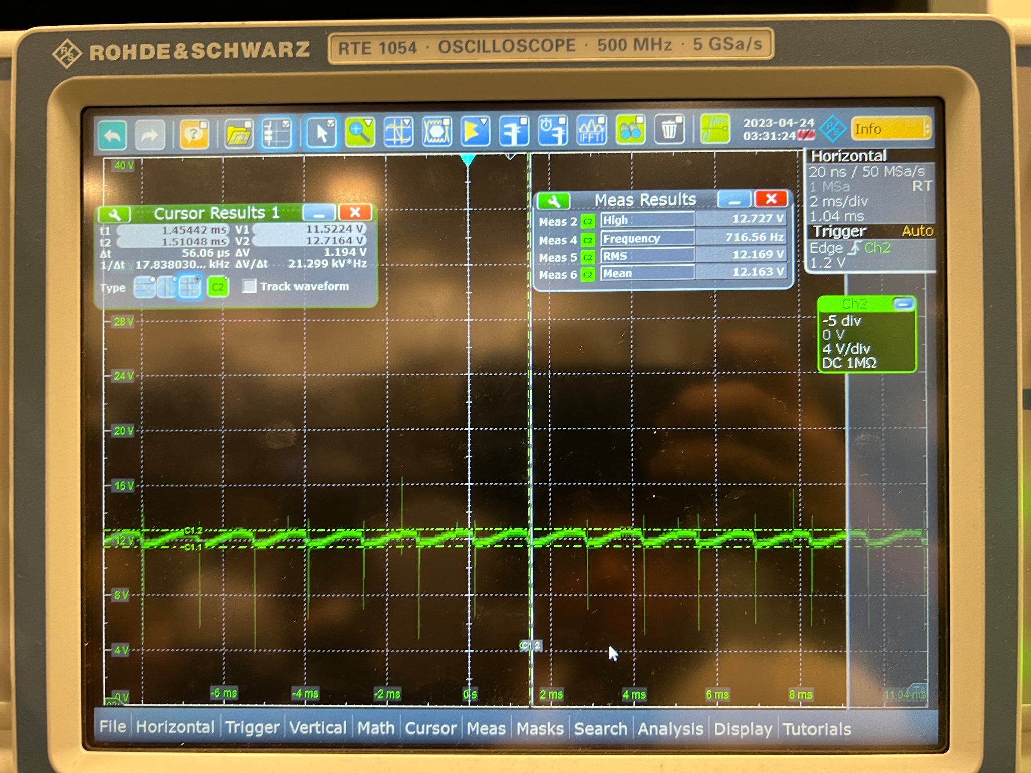

While there is an AC component to the motor signal, the peak-to-peak voltage is relatively small (ΔV = 1.194V), so when passing through the linear regulator, the perturbations are removed and we get a stable 5V without any ripples.

A.2.2 The Linear Regulator regulates all Voltage in the range 6V to 20V down to 5V± 0.25V

Below are the oscilloscope readings and data from our test. Channel 1 (yellow line) represents the input to the linear regulator while Channel 2 (green line) represents the output of the linear regulator.

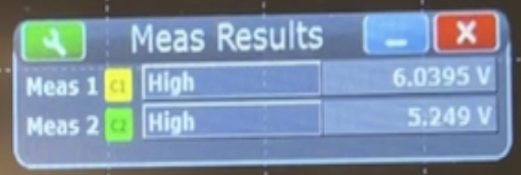
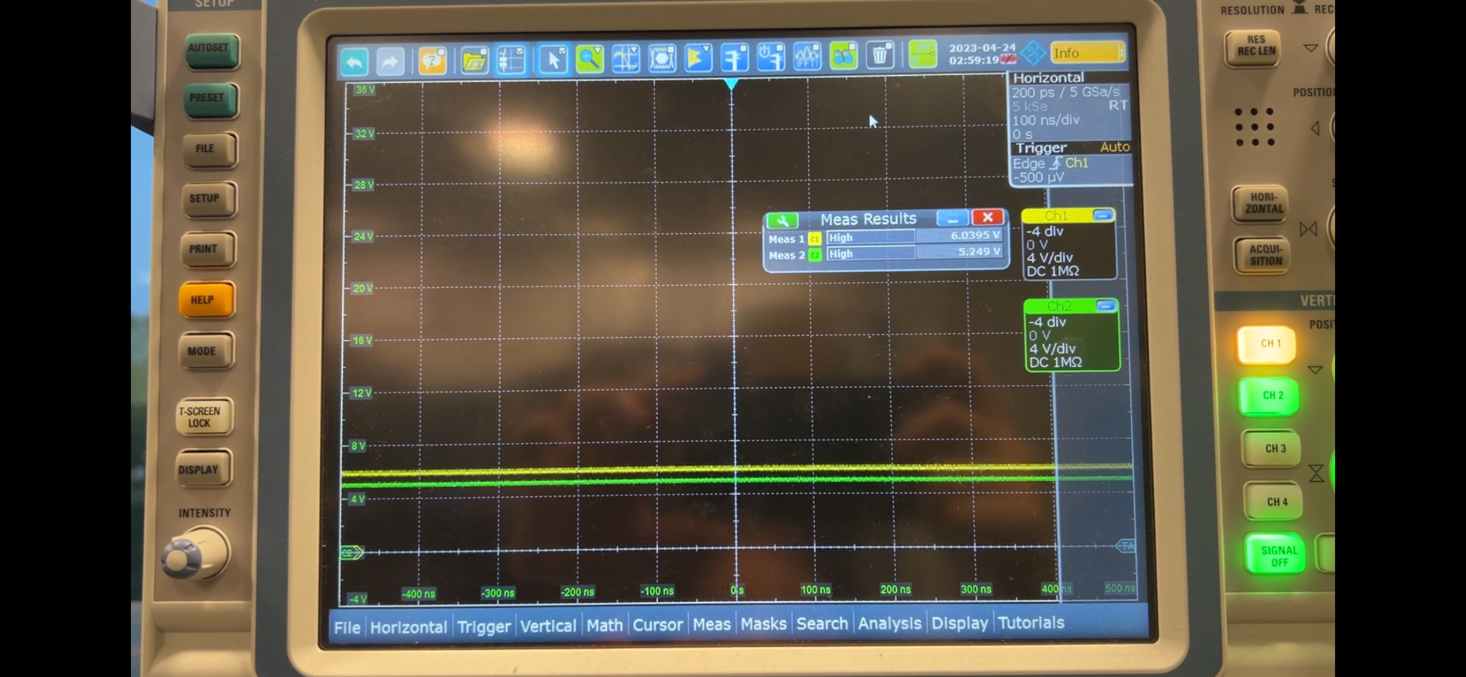
Figure 20

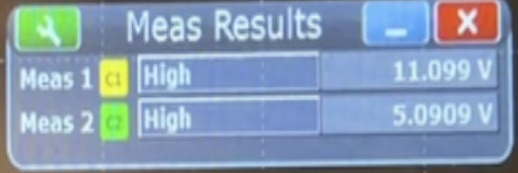
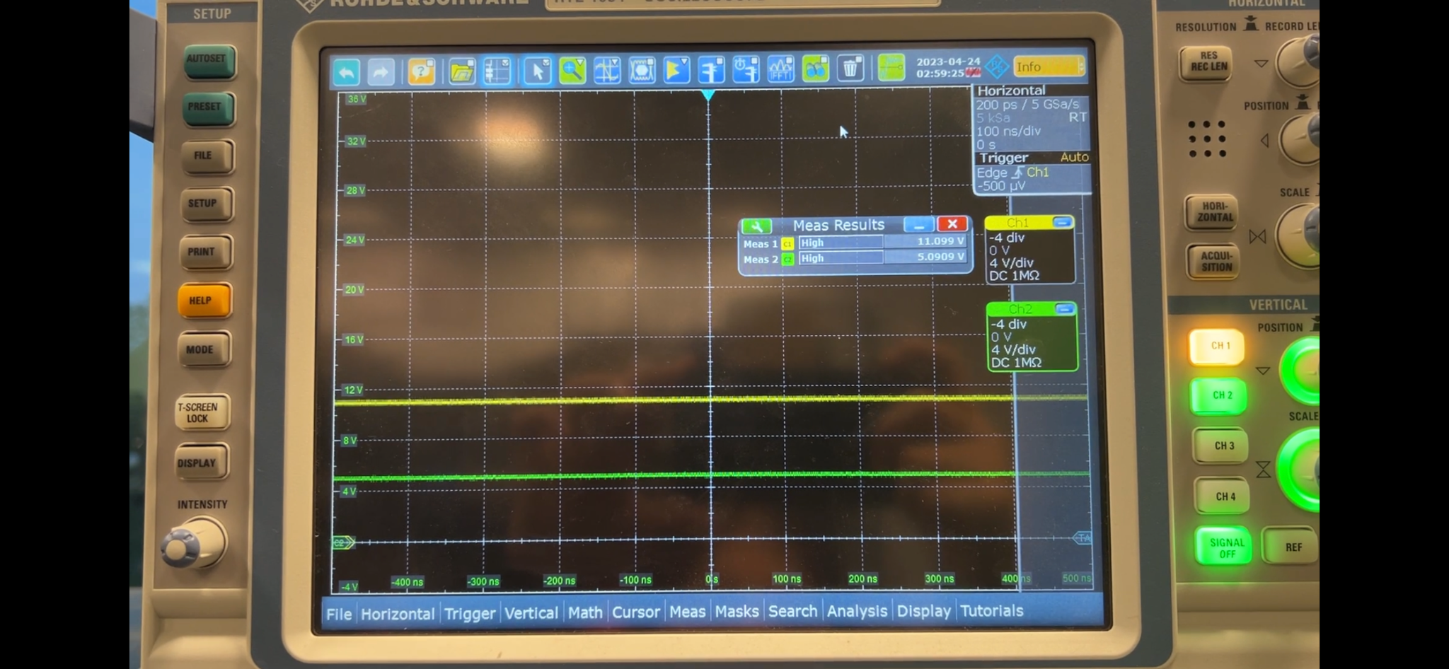
Figure 21

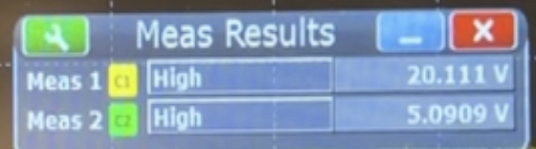
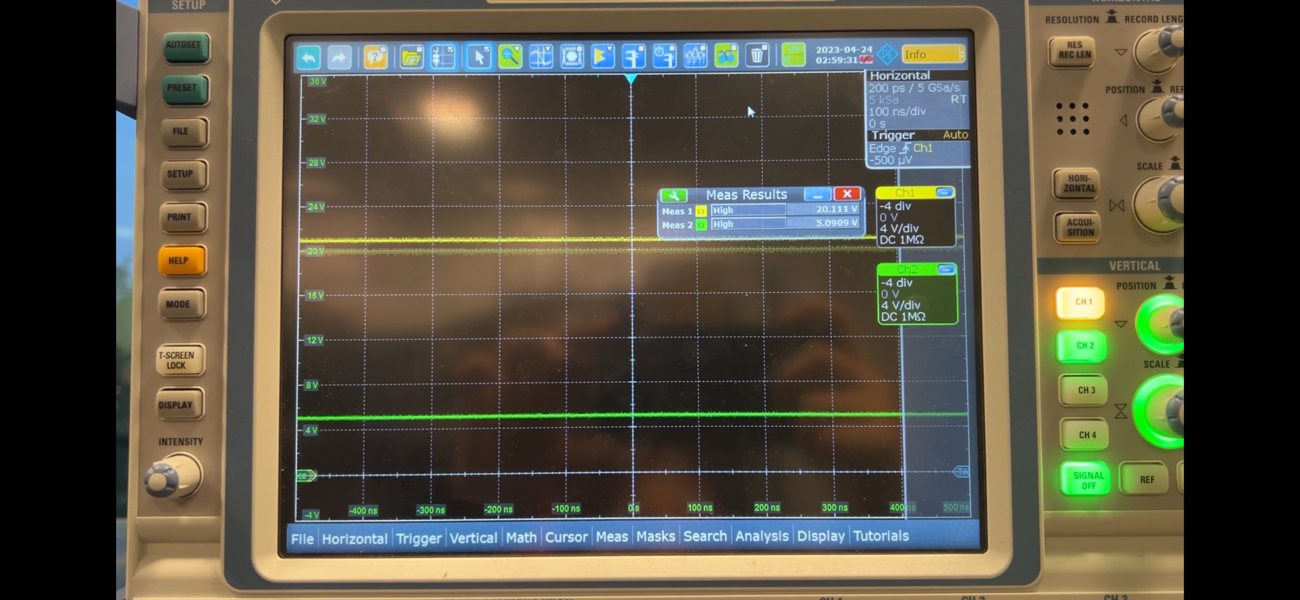
Figure 22

From these images, we can see that the linear regulator regulates all input voltages at the above specified ranges to 5.09V, which is within our tolerance.

A.2.3 The Relay changes output under 5ms when the coil is charged
Below is the oscilloscope data obtained when testing the relay characteristics.

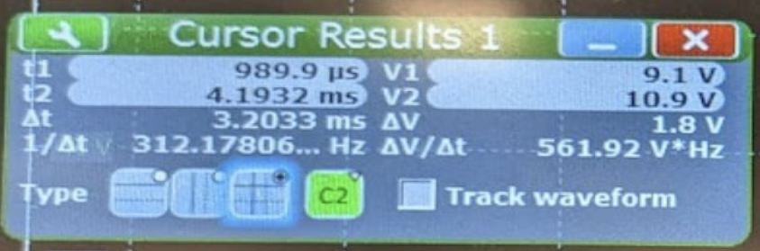
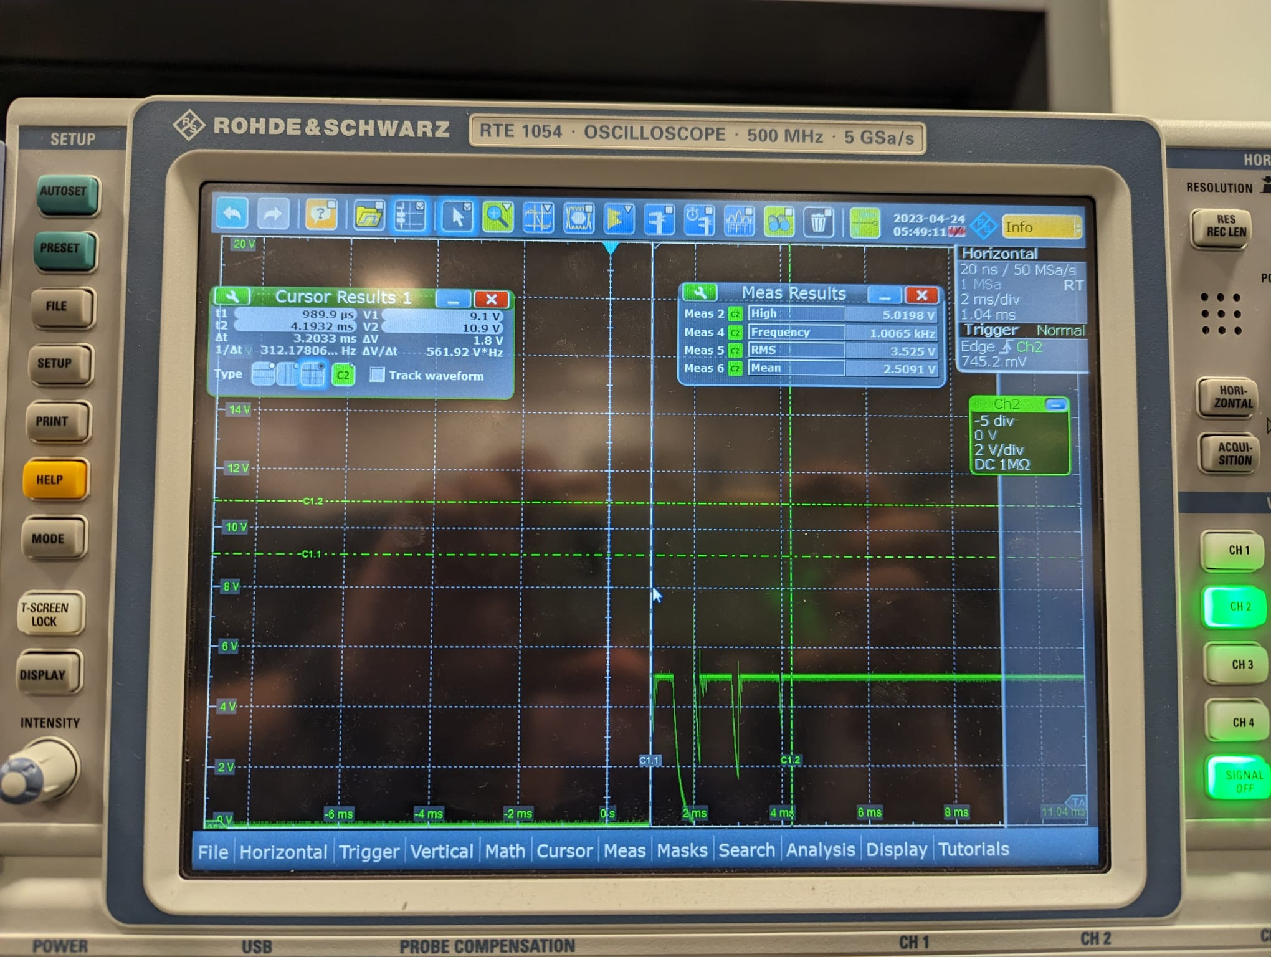

As we can see, the relay successfully settled in the normally open position within 3.20 ms, which is within our tolerance of 5ms.

A.2.4 The power mux chooses between Hand Crank and Battery as per signal from Microcontroller

We were unable to completely verify this test because we had troubles with our power mux. Some of them were damaged while we were testing other components, some were faulty and although our last power mux passed its verification tests, it was damaged due to an unintentional short in our board, so we were unable to present our product with working multiplexing functionality.

A.2.5 The Hand Crank charges the USB Output



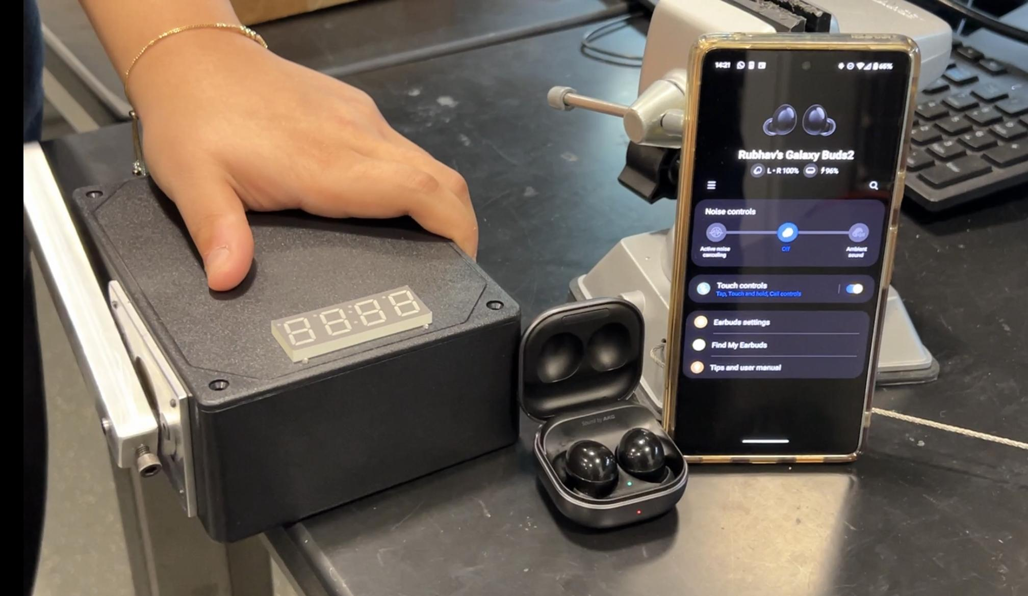
Figure 23

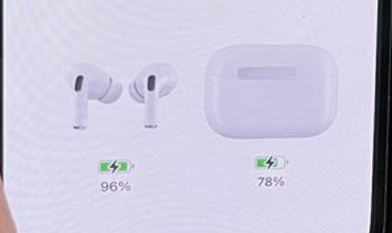
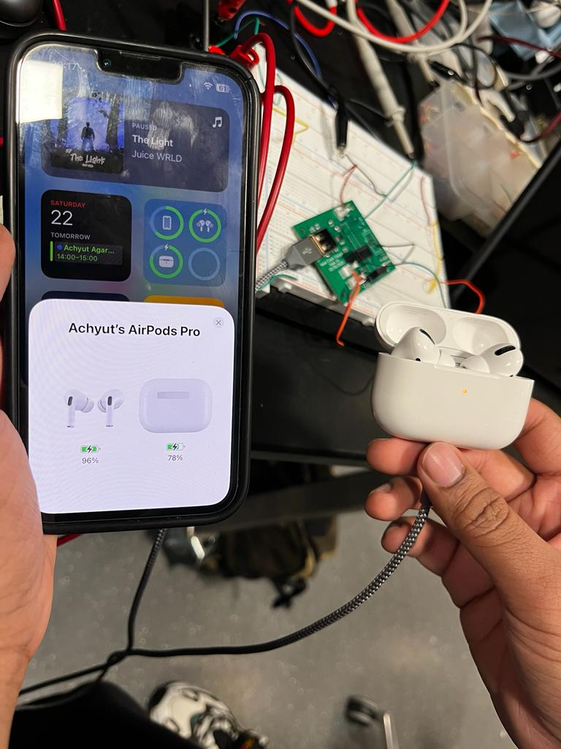
Figure 24

This test requires correct functionality of all the components listed above, and as shown above, when they are all connected together, turning the hand crank is able to charge a device.

Appendix B: Subsystem Design Data

B.1 Truth Table
The following table represents all cases for our product based on 5 parameters.

H C → Hand Crank Turned (1) or not (0)
USB In → USB Input supplied power (1) or not (0)
USB Out → USB Output has device connected (1) or not (0)
Batt Low → Indicates if the battery is low (1) or not (0)
Batt High → Indicates if the battery is high (1) or not (0)

Table 5 Truth Table
H C | USB In | USB Out | Batt Low | Batt High | Outcome | Consequence
0 | 0 | 0 | X | X | Sleep
0 | 0 | 1 | 0 | X | Charge from Battery
0 | 0 | 1 | 1 | 0 | Display LOW | Goes to Sleep
0 | 0 | 1 | 1 | 1 | Not Possible
0 | 1 | 0 | 0 | 0 | Charge Battery
0 | 1 | 0 | 0 | 1 | Stop flow at MUX 2
0 | 1 | 0 | 1 | 0 | Charge Battery
0 | 1 | 0 | 1 | 1 | Not Possible
0 | 1 | 1 | 0 | 0 | Charge Battery | Battery Charges USB Out
0 | 1 | 1 | 0 | 1 | Stop flow at MUX 2
0 | 1 | 1 | 1 | 0 | Charge Battery
0 | 1 | 1 | 1 | 1 | Not Possible
1 | 0 | 0 | 0 | 0 | Hand Crank Charges Battery
1 | 0 | 0 | 0 | 1 | Hand Crank to USB Out
1 | 0 | 0 | 1 | 0 | Hand Crank Charges Battery
1 | 0 | 0 | 1 | 1 | Not Possible
1 | 0 | 1 | 0 | 0 | Hand Crank to USB out
1 | 0 | 1 | 0 | 1 | Hand Crank to USB out
1 | 0 | 1 | 1 | 0 | Hand Crank to USB out
1 | 0 | 1 | 1 | 1 | Not Possible
1 | 1 | 0 | 0 | 0 | Hand Crank Charges Battery | Stops USB in Flow at MUX 2
1 | 1 | 0 | 0 | 1 | Hand Crank to USB out | Stops USB in Flow at MUX 2
1 | 1 | 0 | 1 | 0 | Hand Crank Charges Battery
1 | 1 | 0 | 1 | 1 | Not Possible
1 | 1 | 1 | 0 | 0 | Hand Crank to USB out | USB In charges Battery
1 | 1 | 1 | 0 | 1 | Hand Crank to USB out | Stops USB in Flow at MUX 2
1 | 1 | 1 | 1 | 0 | Hand Crank to USB out | USB In charges Battery
1 | 1 | 1 | 1 | 1 | Not Possible

B.2 PCB Design for Product

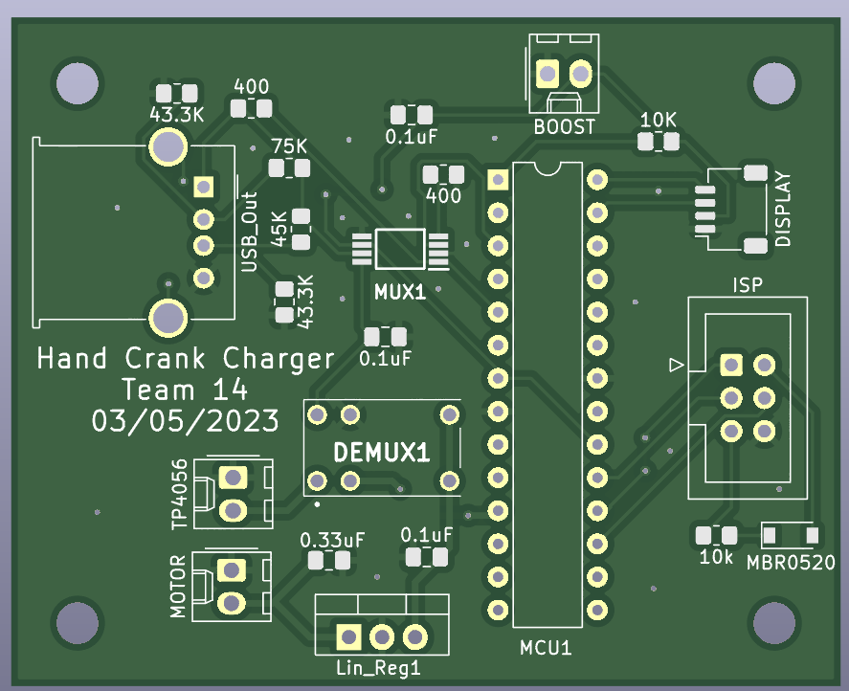
Figure 25 PCB Design Top View
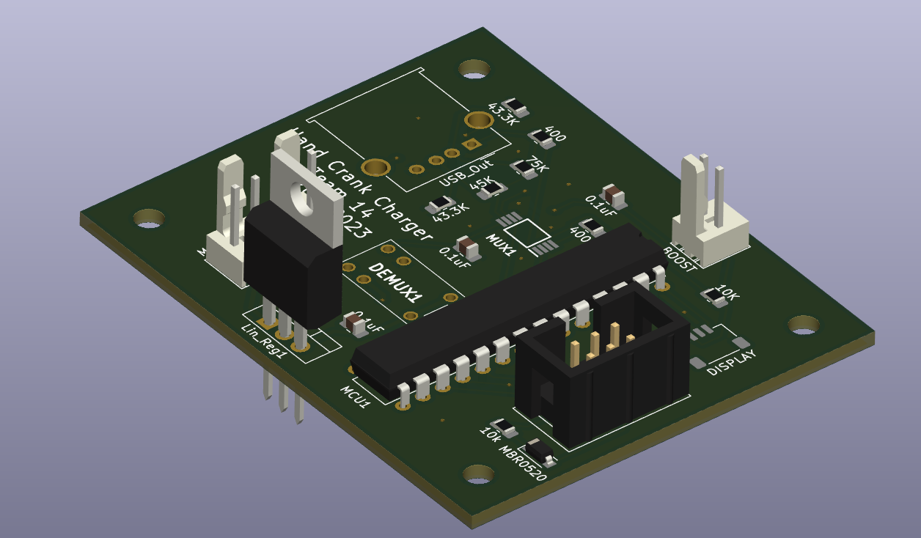
Figure 26 PCB Design Auxiliary View

Appendix C: Safety and Ethics Considerations

C.1 Safety Considerations

This project focuses on incorporating safety regulations into various aspects of the design to address any potential concerns for the end user. For general safety, it is recommended to use the product in dry conditions, and to keep flammable and combustible material away.

- Casing: The ABS plastic case prevents the risk of shock or electrocution through conduction. It helps prevent concentration of heat in any one point of the product/circuit, which helps in preventing overheating. Current does not conduct to the outer environment. The casing is strong enough to prevent any external damage to the product, and users can crank the product on any kind of surface. We suggest not trying to open the casing without proper training.

- Battery: The most important safety considerations have to be made for Lithium-Ion Batteries. The circuit does not generate enough heat for concern, however each battery has labels for warnings^{[7]} against overheating and unfavorable external conditions^{[8]}. Our circuit implements adequate protection against overcharging by cutting off supply once the battery is fully charged.

Before conducting any battery testing, we employed a multimeter and an e-load to verify that the current entering and exiting the battery falls within the specified limits. This step is crucial in ensuring the proper functioning of our software's switching logic, which plays a vital role in preventing issues like overcharging and other safety concerns mentioned earlier. Once we were confident in the circuit's safe operation, we proceeded to connect the battery, taking all necessary safety measures into account. This includes keeping a Class D fire extinguisher nearby, ensuring the battery remains untouched, and conducting the test in a temperature-controlled room away from direct sunlight.

C.2 Ethical Considerations

While working on this project, the team has maintained the highest standards of ethical conduct in their work.

- Throughout the development of this product, we have prioritized the utmost caution and adherence to the highest safety standards, in accordance with the IEEE Code of Ethics Section 1.1^{[9]}. We have taken care to disclose any features or factors that could potentially pose a risk to the user community or their environment.

- We want to emphasize the importance of Section 1.5 of the IEEE Code of Ethics^{[9]} and caution users to handle the product with care to ensure their personal safety. It is crucial to note that our claims and assumptions are based solely on the available data, and as such, user caution is vital when using the product.

- In accordance with Section 1.6 of the IEEE Code of Ethics^{[9]}, we prioritize working on this project with proper training and adherence to safety regulations. Our team members ensure transparency by making all relevant details regarding training and safety measures readily available. Furthermore, we are committed to providing comprehensive information about our product to ensure that users are well-informed about its design and any potential safety risks involved.

