ECE110/120 Honors Lab Report

Huihan Yan huihany2
Krish Naik Aparaj krishn2
Atharv Koshti koshti2
Rohan Harpalani rohanhh2
Constantin Legras clegras2
Xingzhi Ma xingzhi5

May 6, 2021
Introduction
The Purpose of this project is enhancing the player’s control over a regular RC car, and design a crash detection system to stop the car when detecting objects. Most of the toy RC cars can only move forward and backward with full speed and turn leftward and rightward with certain angles. This project uses Arduino based control unit to give the player control over the speed and turning angle of the RC car, and prevent the car from crashing.
The idea of this RC car control unit can is stimulated by a lot of videos showing professional RC cars drifting. However, those advanced RC cars can cost hundreds or even thousands of dollars. In this project, the designers are assigned with a maximum of 150 USD to design a fully functional RC car, so that the player can have more control over a RC car without spending a lot of money.
Design Details
Flow Chart and Circuit Schematics
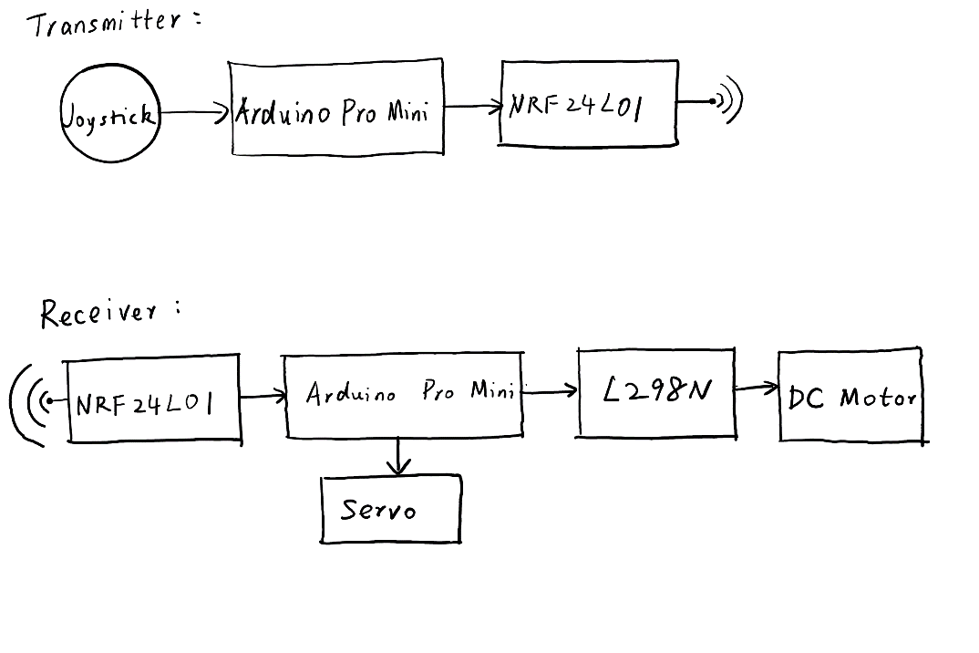
The design of the transmitter and receiver was inspired by some tutorials from “How to Mechatronics” [1, 2, 3] and “Just Do Electronics” [4]. Since the designers almost have no experience with Arduino Pro Mini and Arduino Programming, this project is more of a learning process of how to use Arduino Pro Mini to design products, so that the design of the circuit is almost the same as the ones in the tutorial.
One 5V Arduino Pro Mini is used as the base of the transmitter. The reason the 3.3V Pro Mini was not used is that the Two joysticks are powered by 5V source. In order to power the NRF24L01+ in the transmitter, VCC pin was connected with a AMS1117 voltage regulator to convert the voltage from 5V to 3.3V [3].
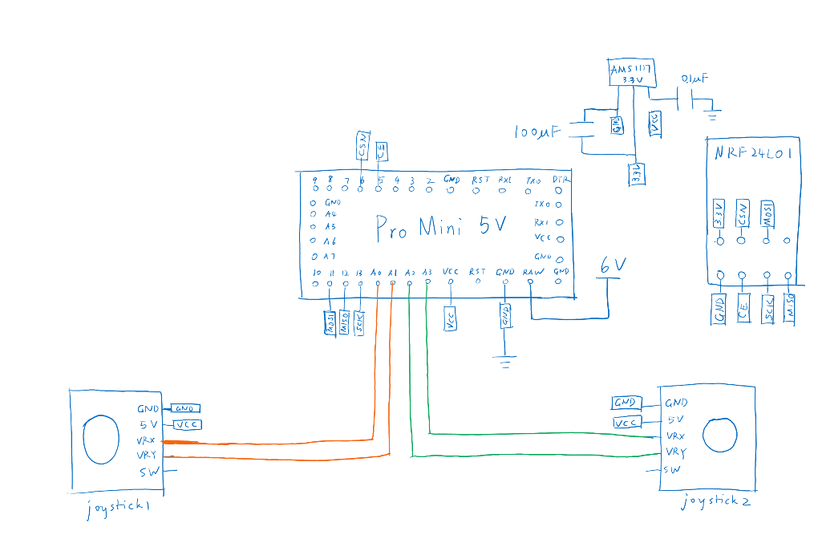
Transmitter
One 3.3V Arduino Pro Mini is used as the base of the receiver, and all the parts in the transmitter can be powered by 3.3V sources. The NRF24L01 is directly connected with the VCC. Also, a L298N module is used as a speed controller, and the DC motor is connected into one channel of the L298N [1, 2]. Moreover, a servo is directly connected with the Arduino Pro Mini to serve as the steering motor of the RC car [4].
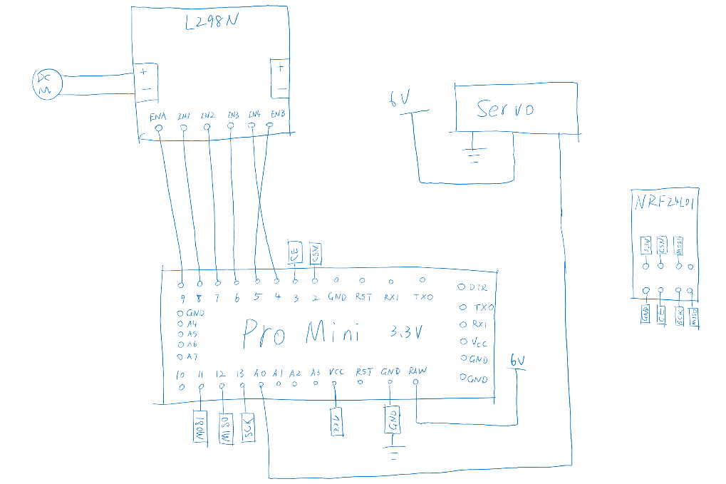
Receiver

To testify the functioning of our circuit, we used the open-source code from the author of “How to Mechatronics” and “Just Do Electronics” [1, 2, 3, 4].
Also, an ultrasonic sensor is connected to the Pro Mini and planned to be used as a object detector to stop the car. However, the transmitter and receiver modules are very complicated, so that there was not enough to figure out how to integrate a crash detection system.
Result
The designers made a lot of progress in learning the logic of the transmitter and receiver design from the tutorial. The circuit was connected accordingly, and the code was successfully downloaded into the Pro Mini Boards.
The project is stuck in the prototype development phase. The transmitter seems to have no control over the Receiver. When the motor is connected to channel 1 of the L298N speed controller, the motor does not rotate at all. However, when the motor is connected to channel 2 of the L298N, it rotates at a very low rate and cannot be stopped.
Moreover, since the transmitter and the receiver never worked properly, there was not enough time to integrate the ultrasonic sensor as the crash detector.
Challenges
There were a lot of challenges when figuring out the programming and assembling the circuit elements together.
First, the designers almost have no experience with Arduino Programming, so that it took several weeks to understand some of the code in the tutorial from “How to Mechatronics” and why the pins are connected in the way instructed. However, it is still very hard for designers to change the code according to the need, which also might be the cause of non-functioning prototype.
Second, assembling the AMS1117 into the circuit was a bit challenging. It can not be put into the breadboard because the pins are too close to each other, and it turns out AMS1117 need customized printed circuit board to be soldered. As a result, one designer purchased a random wire-wrap board, and used a electric soldering iron to solder its three pins with three wires to get it ready for connection.
Third, it is hard to put the designed receiver into the RC car because the space is really compact, so the prototype also needs to be revised and made more compact.
Future Plans
To be able to make this circuit functioning as wanted, the designers need to learn more about Arduino, especially programming. Also, the engineers need to learn how to design printed circuit board, so that the circuit can be made more compact, and the AMS1117 can be easily soldered together with other electronic elements in the circuit.
Appendix
Link to the presentation video: https://drive.google.com/file/d/1jE07yBMXqmlhoyMAKqyXTiWBDYhWdCW4/view?usp=sharing
Link to the codes being used:
https://howtomechatronics.com/projects/diy-arduino-rc-receiver/#:~:text=Nevertheless%2C%20the%20brain%20of%20this,connect%20from%206%20to%2012V.
https://howtomechatronics.com/projects/diy-arduino-rc-transmitter/
https://howtomechatronics.com/tutorials/arduino/arduino-dc-motor-control-tutorial-l298n-pwm-h-bridge/
https://www.prateeks.in/2020/05/nrf-based-servo-motor-control.html

Reference List
[1] Dejan, “Arduino DC motor control tutorial – L298N | PWM | H-Bridge”. How to Mechatronics. n.d. [online]. https://howtomechatronics.com/tutorials/arduino/arduino-dc-motor-control-tutorial-l298n-pwm-h-bridge/ [Accessed May 4, 2021].
[2] Dejan, “DIY Arduino RC receiver for RC models and Arduino projects”. How to Mechatronics. n.d. [online]. https://howtomechatronics.com/projects/diy-arduino-rc-receiver/#:~:text=Nevertheless%2C%20the%20brain%20of%20this,connect%20from%206%20to%2012V [Accessed May 4, 2021].
[3] Dejan, “DIY Arduino RC transmitter”. How to Mechatronics. n.d. [online]. https://howtomechatronics.com/projects/diy-arduino-rc-transmitter/ [Accessed May 4, 2021].
[4] Just Do Electronics, “NRF Based Servo Motor Control”. Just Do Electronics. 2020. [online]. https://www.prateeks.in/2020/05/nrf-based-servo-motor-control.html [Accessed May 4, 2021].

