NOTES:

The large wi-fi antennas are differentiated by a piece of duct-tape on the bag of Antenna 1

# Traces

## Nothing Attached

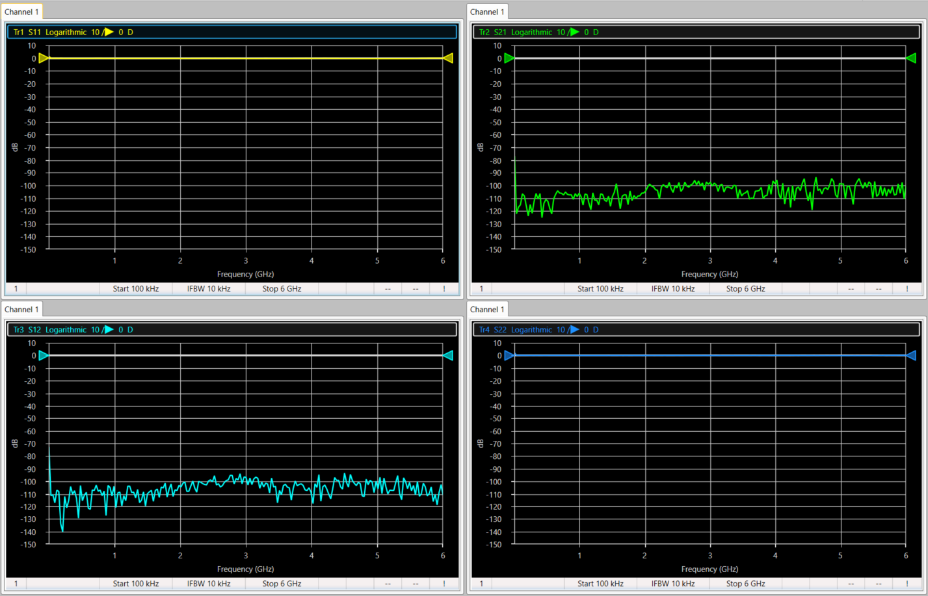

## Adapter (https://www.fairviewmicrowave.com/images/productPDF/SM4267.pdf) connected – Port 1

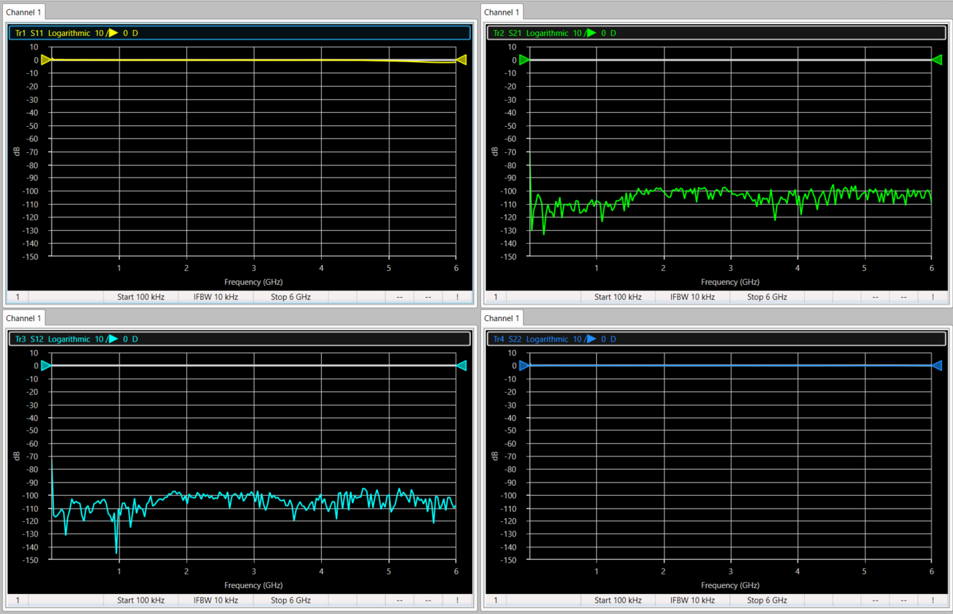

## Square U-Slot microstrip antenna + Adapter – Port 1

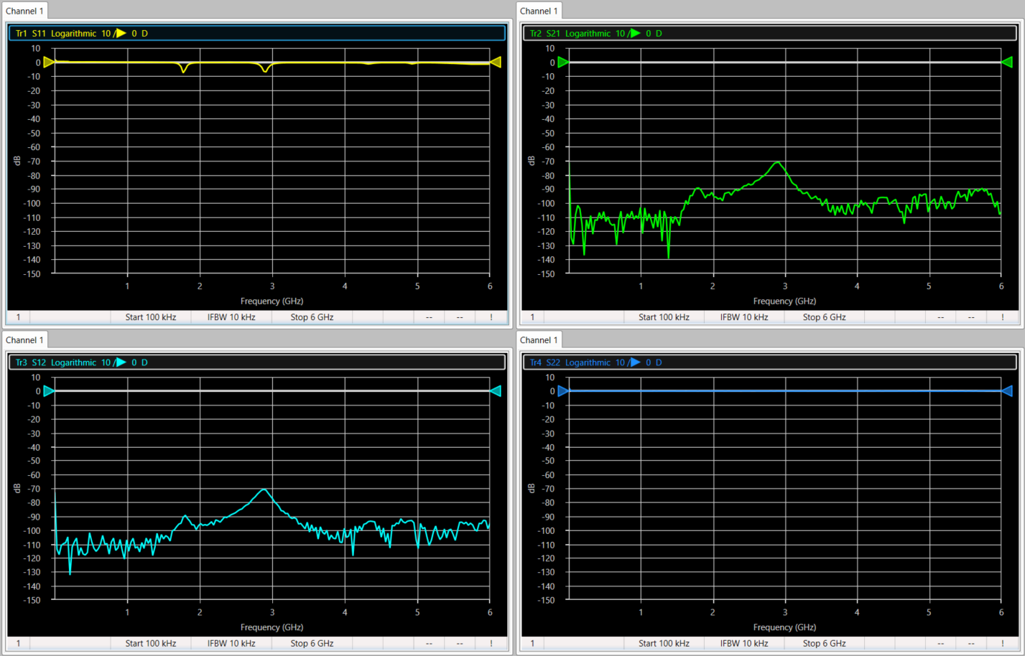

## Rectangular U-slot microstrip antenna + Adapter – Port 1

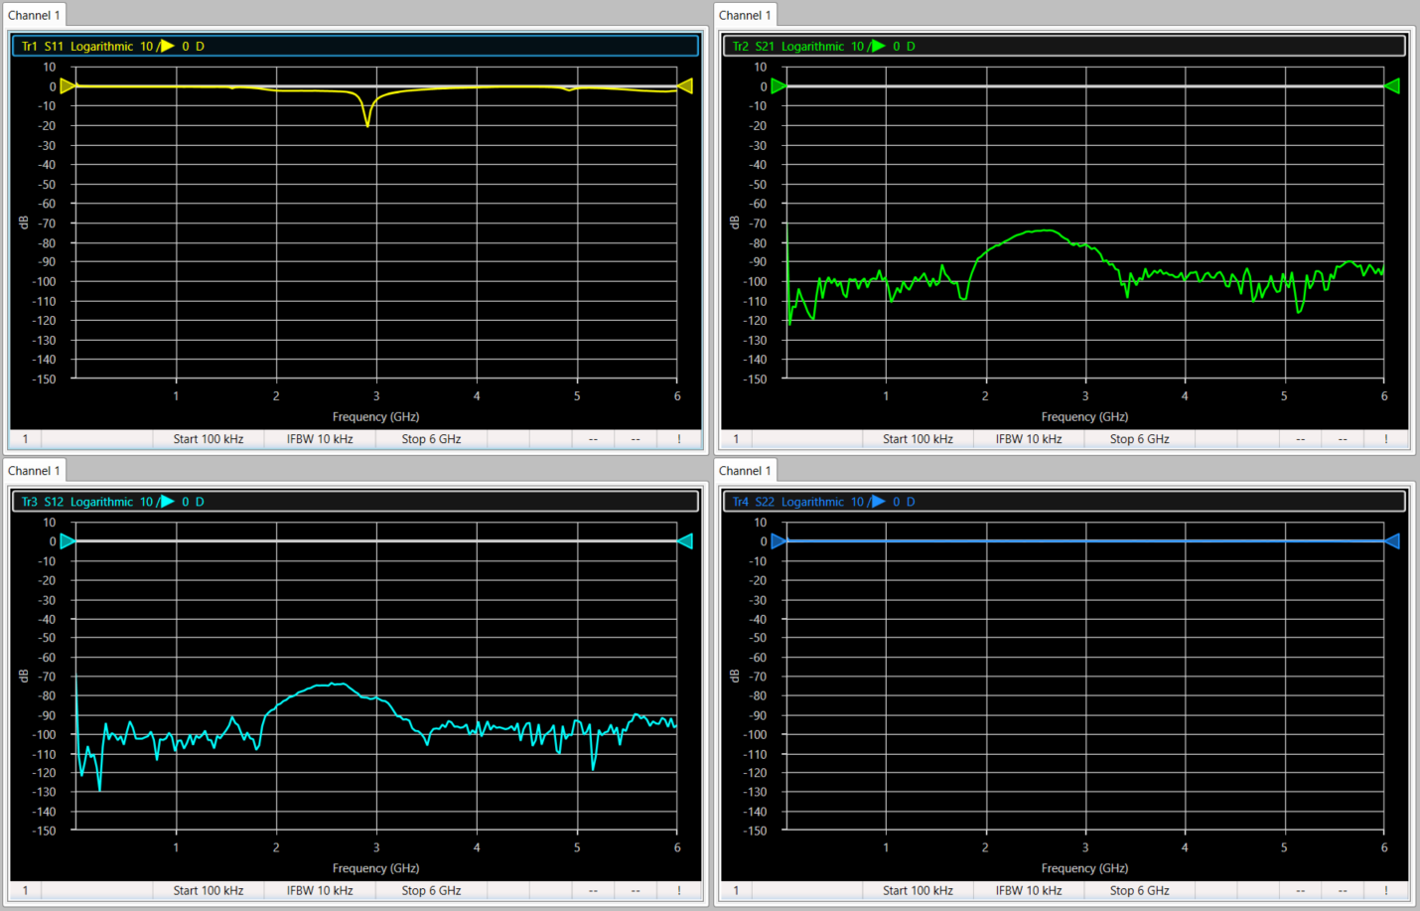

## Small Rectangular microstrip antenna + Adapter – Port 1

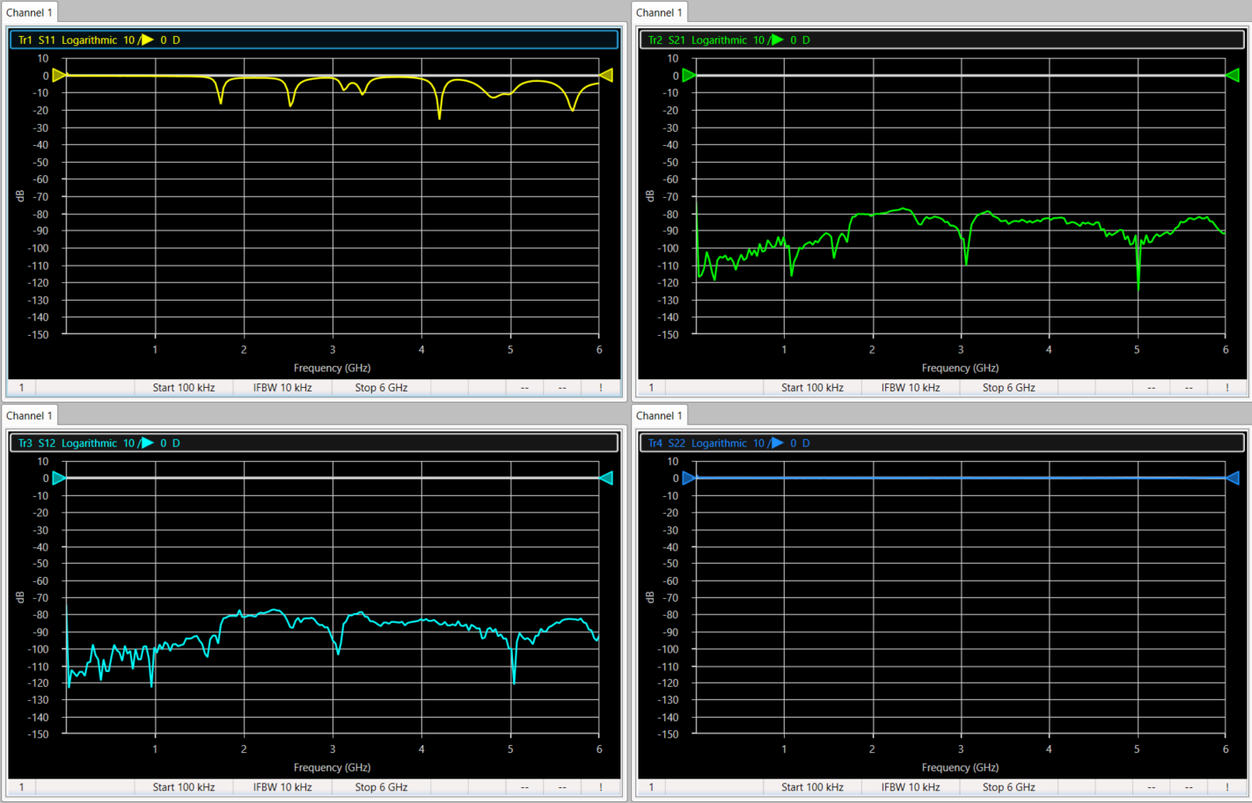

## Large Wi-fi antenna 1 (Straight) + Adapter – Port 1

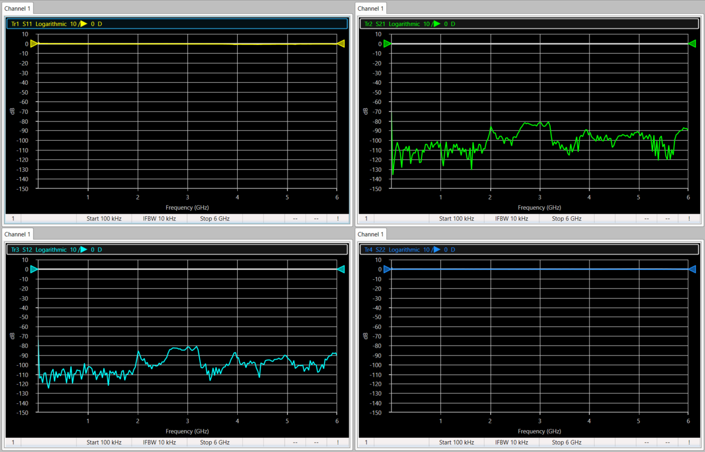

## Large Wi-fi antenna 1 (Bent) + Adapter – Port 1

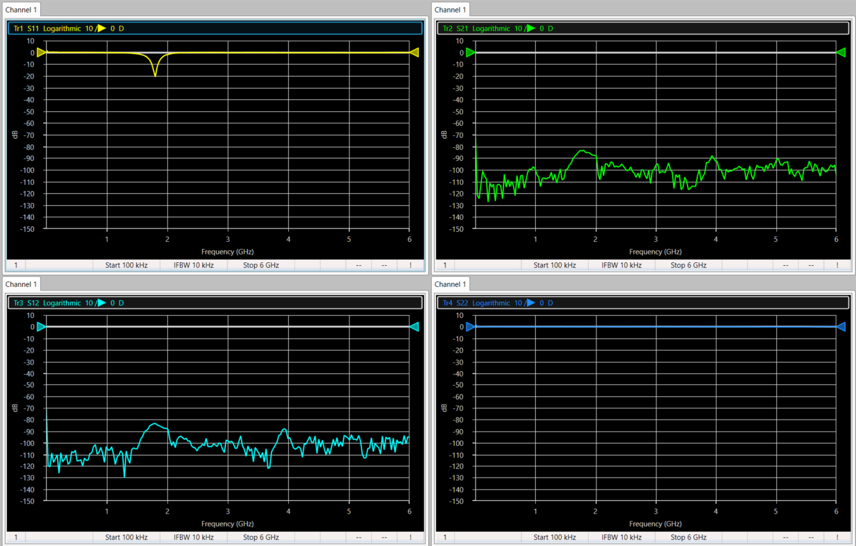

## Large Wi-fi antenna 2 (Straight) + Adapter – Port 1

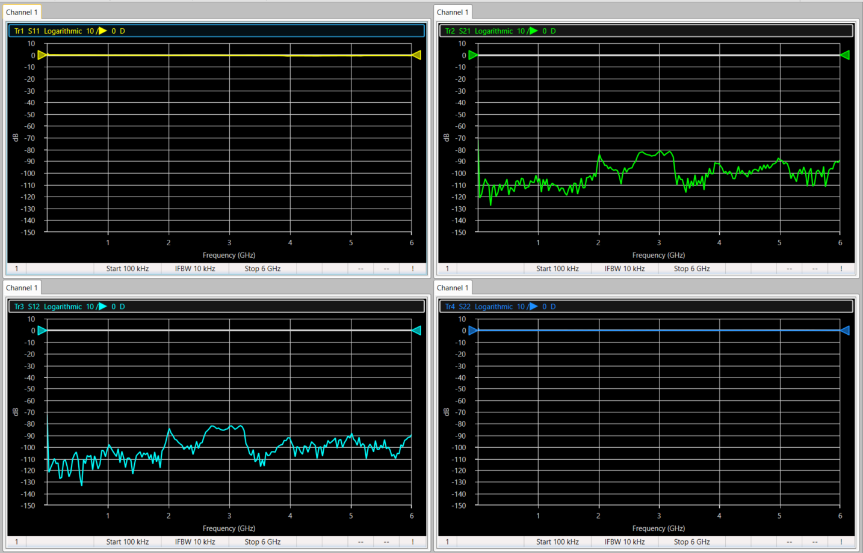

## Large Wi-fi antenna 2 (Bent) + Adapter – Port 1

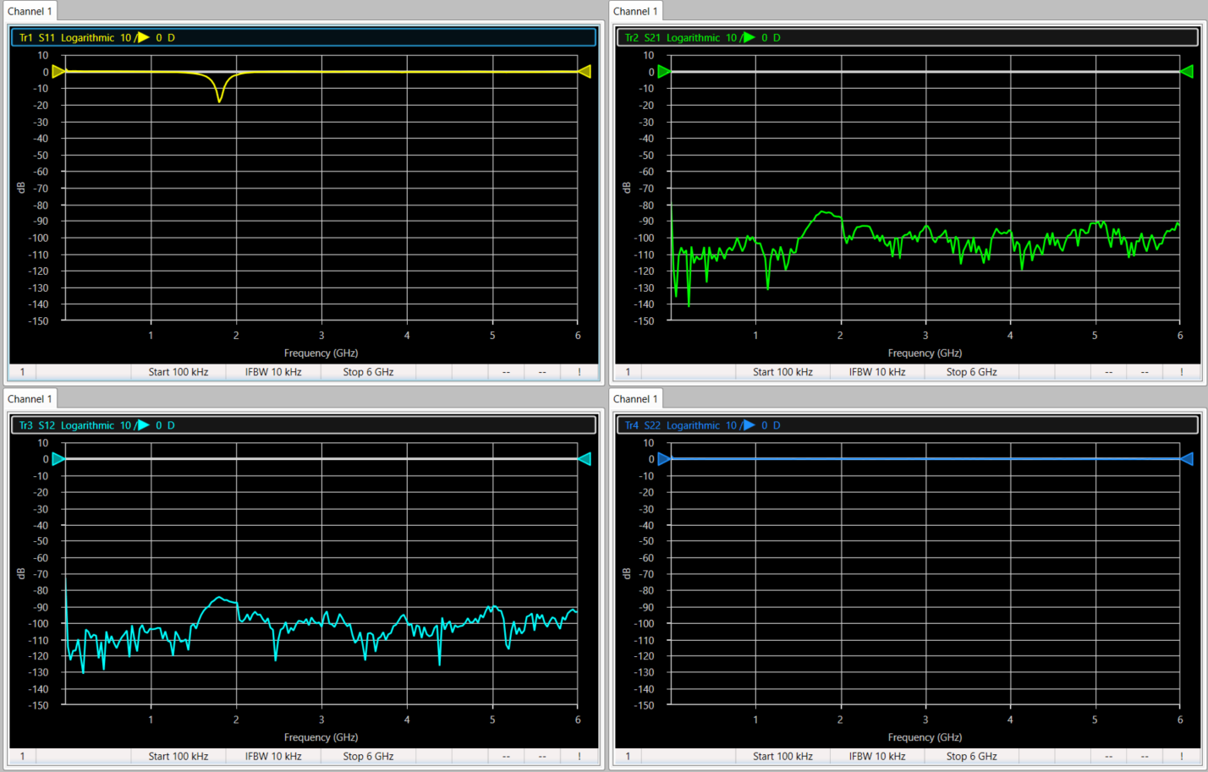

## Small Wi-fi antenna (Straight) + Adapter – Port 1

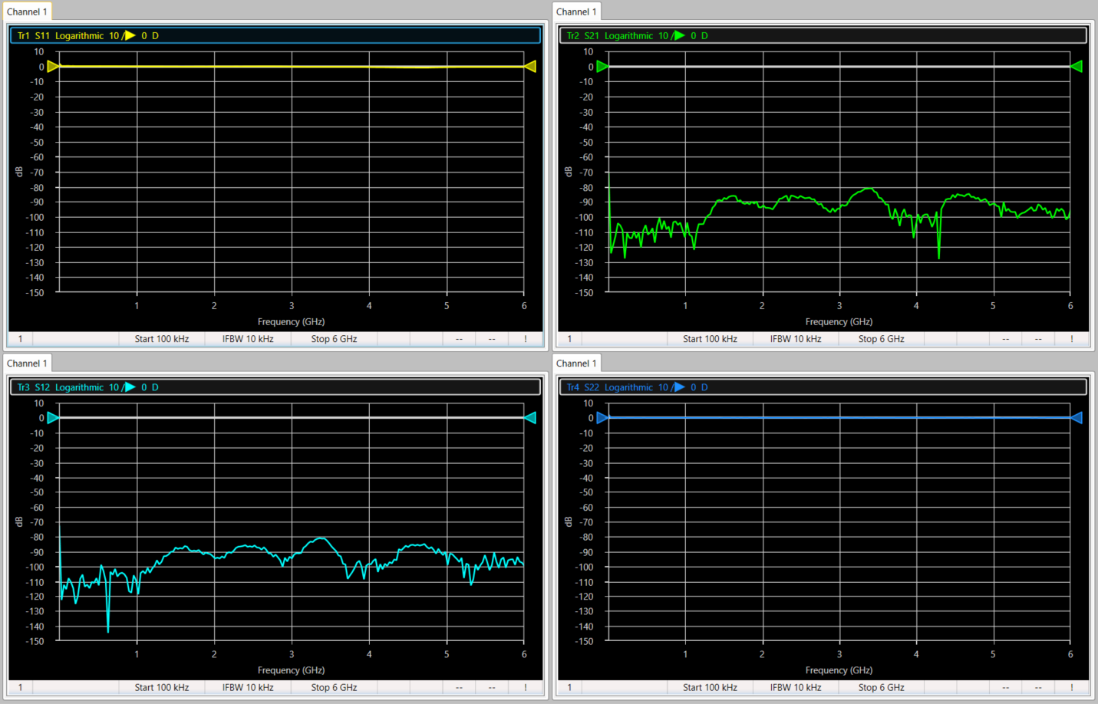

## Small Wi-fi antenna (Bent) + Adapter – Port 1

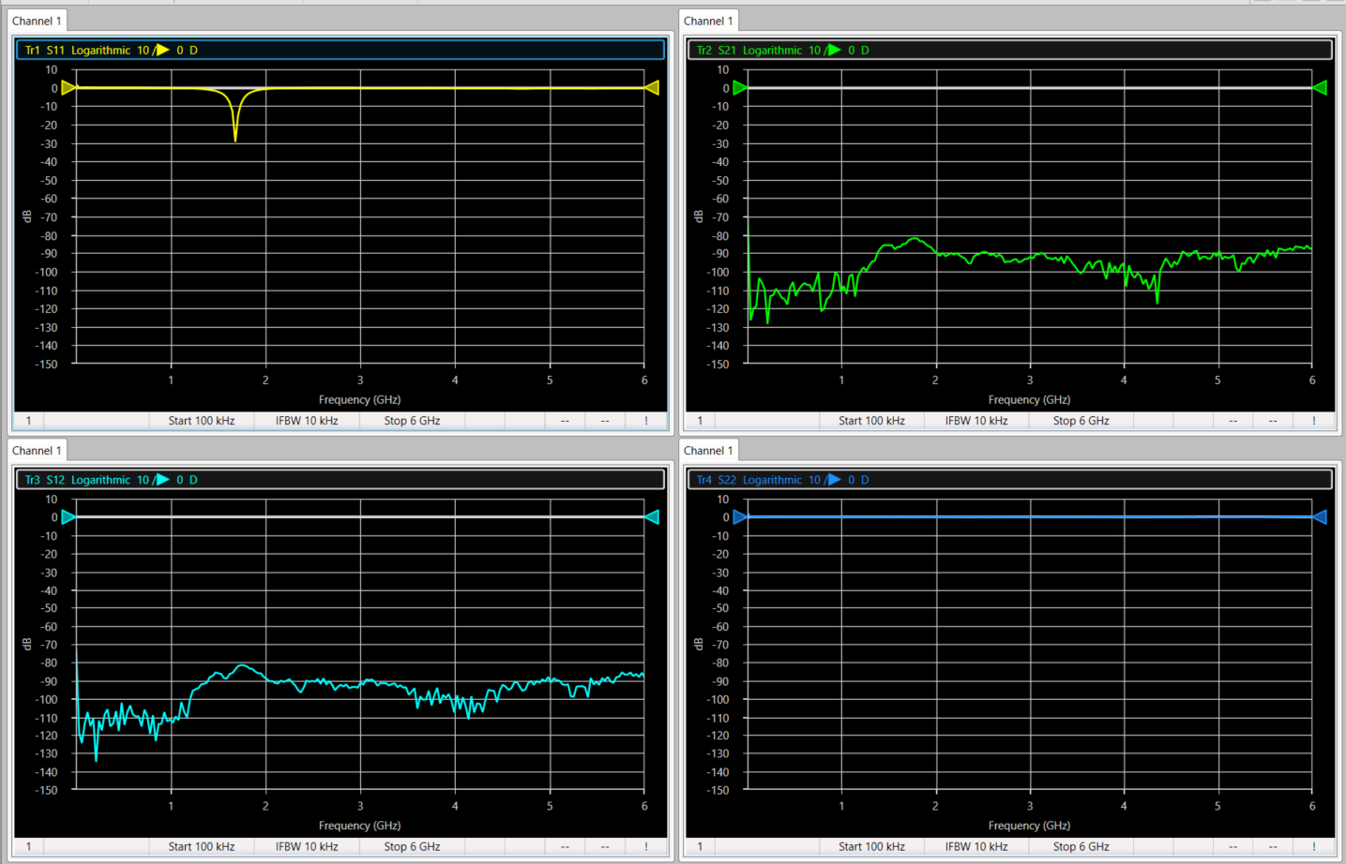

## Centurion BlueChip (scuffed) 2.4-2.5 GHz + Adapter – Port 1

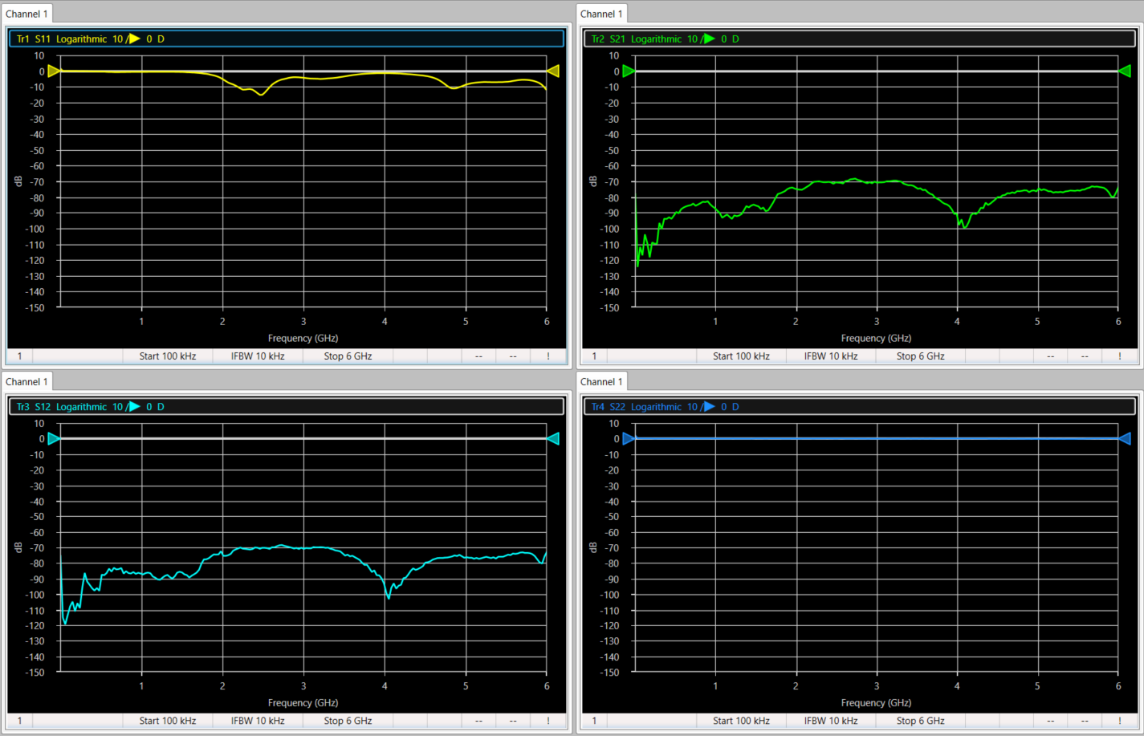

## Centurion BlueChip (clean) 2.4-2.5 GHz + Adapter – Port 1

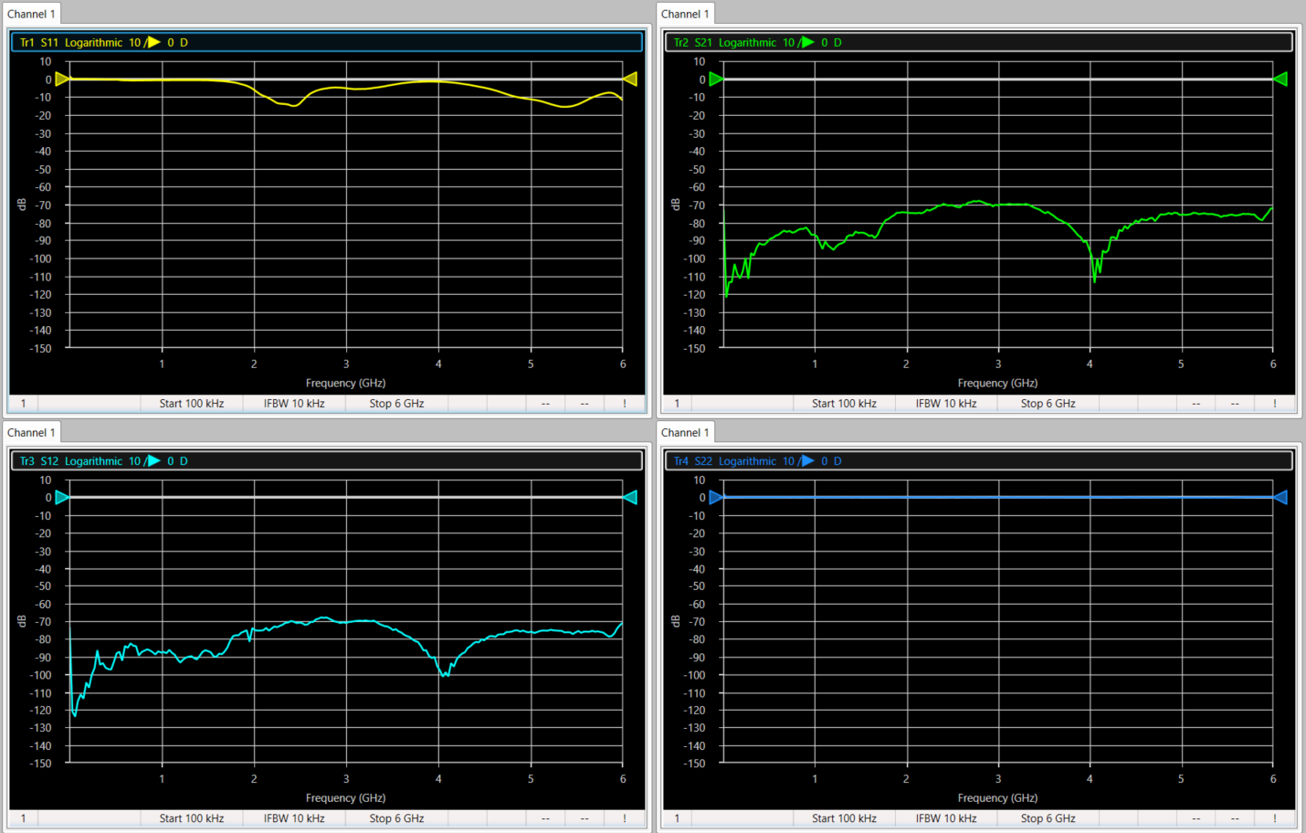

# Extra notes

The Centurion BlueChip antennae seemed to respond the most to changes in the environment. More testing is required, including attaching other antennas to Port 2.

Antennae to not use: Square U-slot, Small Rect. Microstrip (several radiating frequencies) ,Large Wi-fi 2 (very temperamental)