Ren Yi Ooi and Zhuxuan Liu

ECE 110H Lab

Rotating Solar Panel

12/10/2019

**ECE 110 Honors Final Report**

**1. Introduction**

1.1 Statement of Purpose

This project aims to create a single-axis, rotating solar panel that tracks the Sun’s movement to maximise power generation.

Solar power is one of the most promising sources of renewable energy due to the abundance of sunlight worldwide as well as the rapidly falling costs of solar cell production.

Efforts have been made to improve the efficiency of solar cells to increase the amount of sunlight that can be captured. One possible way is to ensure that panels face the Sun at an optimal angle to capture the most sunlight. Due to the rotation of the Earth, the position of the Sun relative to the Earth changes throughout the day. A rotating solar panel that tracks the rotation of the Sun can hence therefore be built to maximise the amount of sunlight captured.

1.2 Features and Benefits

Sun tracking solar panels are not an entirely new idea, and researchers have studied the feasibility of this idea on a large scale. Unfortunately, they have found that while sun tracking solar panels can help to increase the amount of sunlight and hence energy captured, the introduction of mechanical components into a solar panel can possibly complexities in terms of maintenance and reliability. With the sun tracker technology incorporated, additional costs might also be incurred.

While the feasibility of this technology on a large scale is still unclear, this idea has been found to be implementation on a mini-project scale.

Previous sun tracking solar panels projects are categorised into single and dual axis trackers, with the former tracking only in the X or Y direction and the latter tracking in both. Our project aims to focus on a single X axis tracker (left to right) and keeping the Y axis set at an angle of 45 degrees.

Additionally, sun tracking solar panels can also be active or scheduled (according to previous data on amounts of sunlight at different dates, times and locations). In order to involve the use of sensors, our project aims to create a rotating solar panel which responds to the changes to surrounding light intensity.

**2. Design**

2.1 System Overview

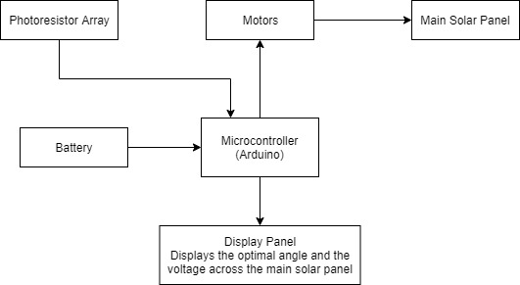

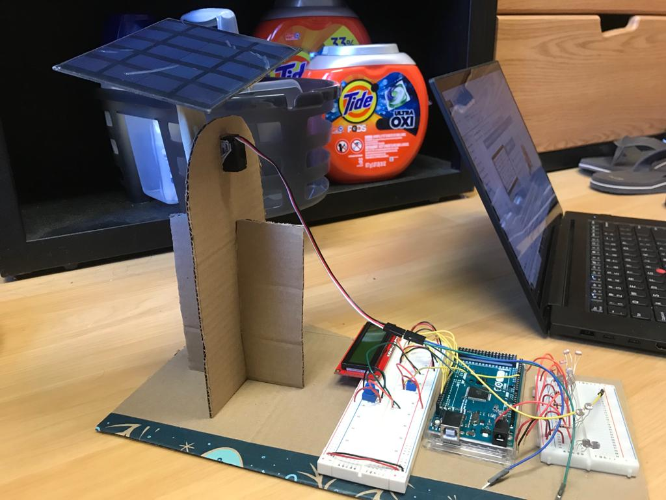 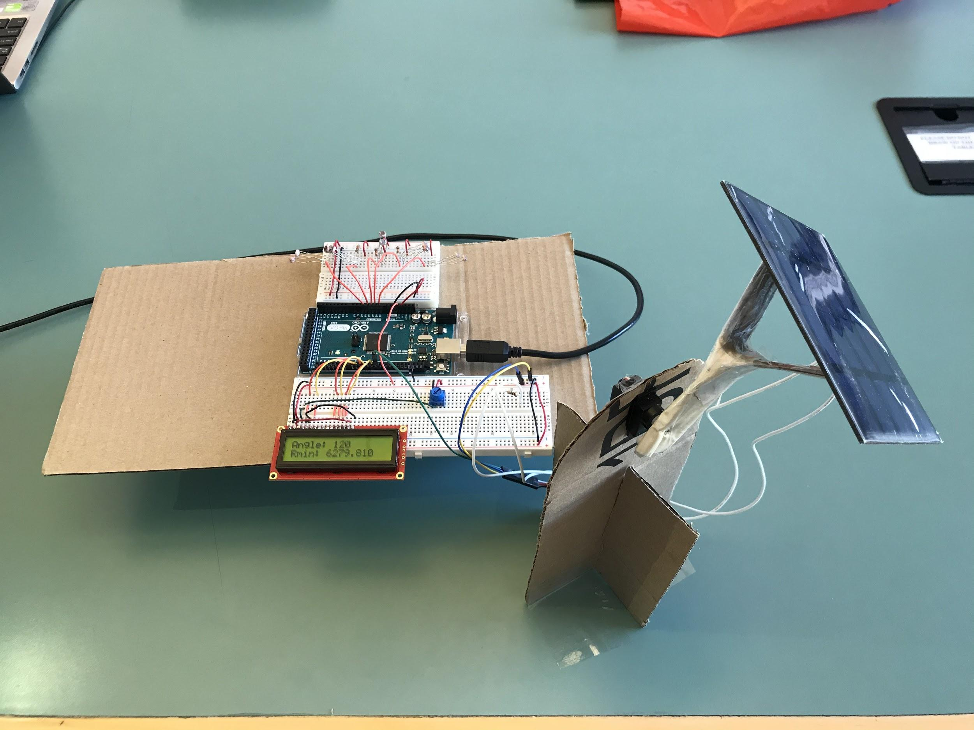

2.2 Design Details

*2.2.1 Main Panel*

The main panel will be rotated to the optimal angle as measured by the photoresistor array every second. The frequency of rotation can be modified by changing the program stored in the microcontroller.

*2.2.2 Power Data Tracking/Measurement*

The original plan was for a smaller tracking panel to be used for the scanning and determination of optimal angle. The tracking solar panel would be constantly rotating. At each angle the tracking solar panel covers, its power output will be taken. A comparison will be made across all measurement values that are taken, and an optimal angle which captures the most sunlight will be determined.

However, this method of power data tracking would entail that time is wasted in rotating the tracking panel at each interval, before an optimal angle can be determined. The sensitivity to changes in light intensity in the external environment is hence reduced. Instead of the tracking panel, a photoresistor array was used an alternative, where light intensity values will be picked up on a separate breadboard for the determination of optimal light intensity. Through the use of this photoresistor array, the power consumption is reduced as a motor will no longer be required to rotate a tracking panel.

*2.2.3 Process for Power Data Measurement/Tracking*

1. A photoresistor array with five pairs of photoresistors oriented at five different angles was built on a separate breadboard. For each of the five sets, the photoresistors are placed in series with a fixed resistor of 10 kOhms. The resistors are connected to ground while the first photoresistor is connected to the voltage source.
2. The voltage source of the breadboard is connected to the 5V output pin of the Arduino
3. At the node shared by a photoresistor and the fixed resistor, a connection is made to a different Arduino analog pin for each set of resistors, in order to read the voltage at the node.
4. Based on the current level of surrounding light intensity, each of these sets of photoresistors will have a different value of resistance. The photoresistors with fixed resistor act as a voltage divider. The brightest region will have the lowest photoresistor resistance, leading to the highest analog pin reading.
5. The value measured on analog pins are compared in order to determine the optimal angle which captures the most sunlight.
6. The main panel will then be rotated to this optimal angle. The next second this process repeats.

*2.2.4 Display Panel*

In deciding the information to be displayed on the two lines of the display panel, the optimal angle and lowest resistance among the photoresistors were chosen. The display can be reconfigured to display other information and debug the circuit as necessary. We have opted for the SparkFun LCD-14072 display.It has a 16x2 Black LCD Display and can be interfaced with using a microcontroller.

*2.2.5 Power Source*

A power source is necessary to power circuit components like microcontrollers and motors. The prototype we made used the Arduino, which was then powered by its USB connection to a laptop. The initial plan involved using 18350 batteries as the voltage source. However, we did not manage to procure functional connectors for the batteries.

*2.2.6 Motor*

A servo motor adjusts the plane of the solar panel to the optimal angle. The angle is controlled by Pulse-Width Modulation (PWM), where the duty cycle of the wave controls the angle the motor rotates to. The main panel is attached to the motor through a Y-shaped cardboard press fitted onto the base board.

*2.2.7 Microcontroller (Arduino)*

The microcontroller functions as the nerve center of the entire system, collecting the data inputs, interpreting it and feeding outputs for the main solar panel to be adjusted. We have opted for the Arduino Mega 2560.

Inputs include voltage/resistance readings across the sets of photoresistors in the separate breadboard while outputs include power, display panel data and the signal for motor rotation. The inputs are connected to analog pins and ground pins, while the outputs are the voltage pins and digital pins.

Additionally, the built-in oscillator in the microcontroller can be used to control the timing of events such as the adjustment of the solar panel angle.

The block diagram of the Arduino’s functionality is represented below.

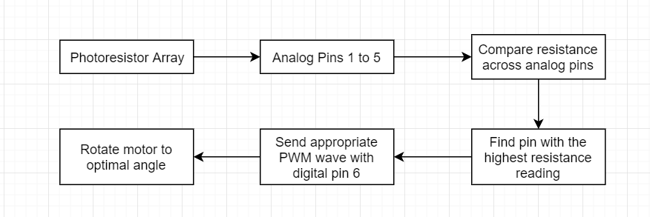

2.2.8 Circuit Schematic

The schematics for the circuit are provided on the following page, depicting the connections between the different circuit components.

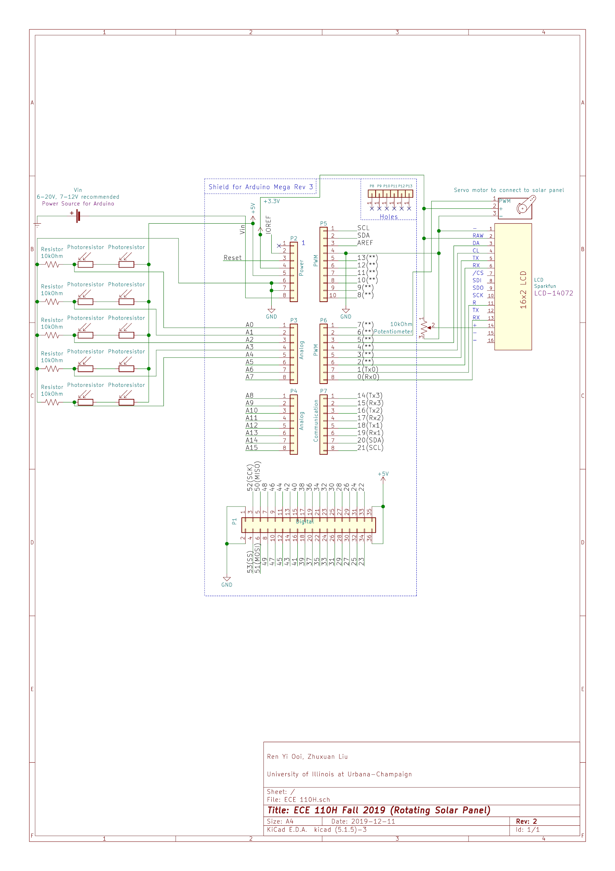

**3. Results**

Before building the photoresistor array, characterisation of the photoresistor was first performed to study how its resistance varies according to light intensity.

A single photoresistor was placed at different distances from a light source where the values of resistance were read from the microcontroller. Care was taken to ensure that the surrounding light is kept to a minimum so that it does not interfere with the light source.

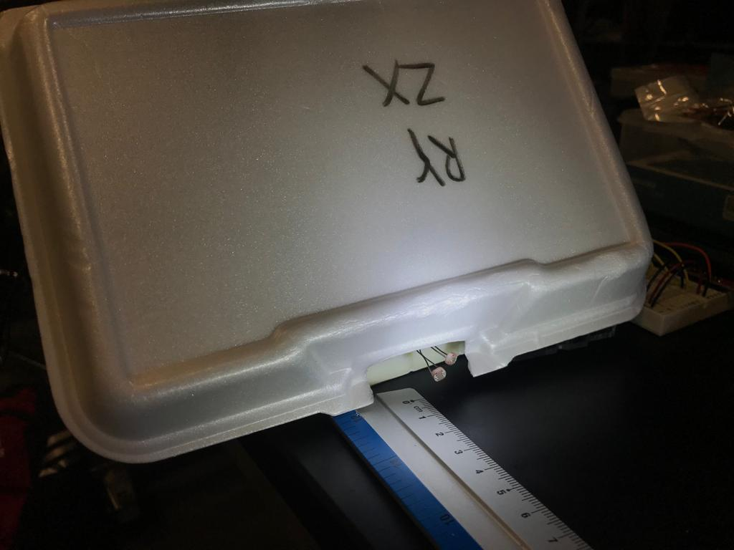 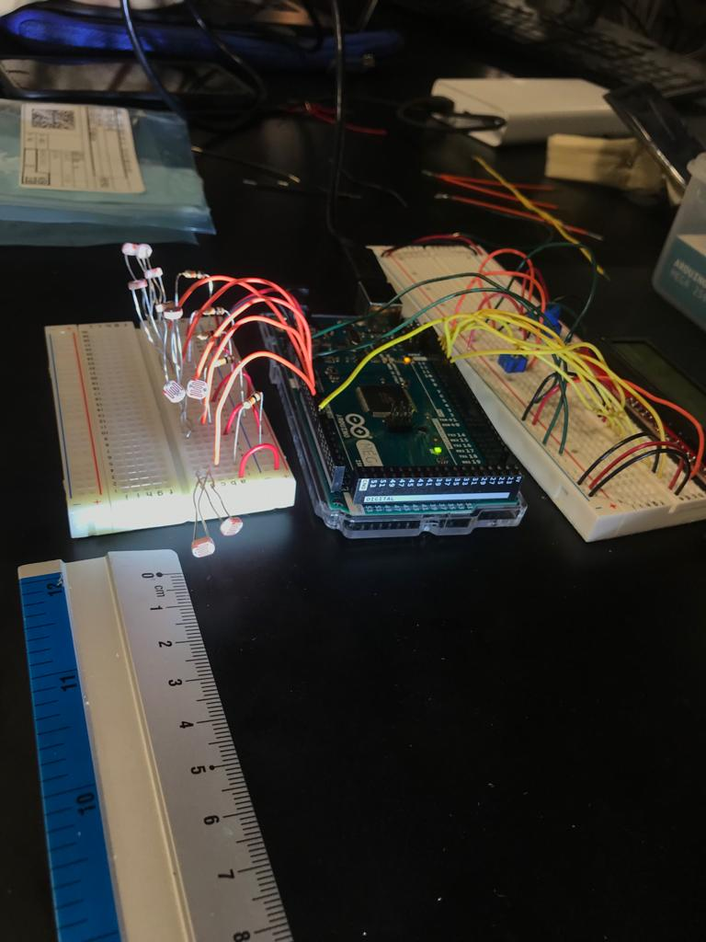

The results are represented in the table below. As postulated, the resistance value decreases as the light intensity increases.

|  |  |
| --- | --- |
| Distance between light source and photoresistor / cm | Resistance / Ohm |
| 30 | 833 |
| 25 | 603 |
| 20 | 475 |
| 15 | 340 |
| 10 | 300 |
| 5 | 260 |

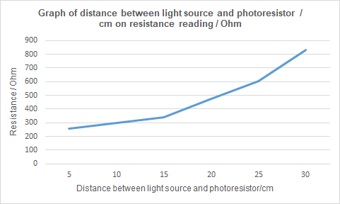

**4. Problems and Challenges**

One challenge that we faced early into our project was the interfacing of the microcontroller and the display panel. This was primarily because the display panel that we purchased was very different from those that were shown online, with differing pin numbers and descriptions. A code we referred to online used a different communication protocol from the one we wired the LCD for.

Additionally, as the display panel did not come with a male header pin for connection onto the breadboard, we had to solder a set of header pins.

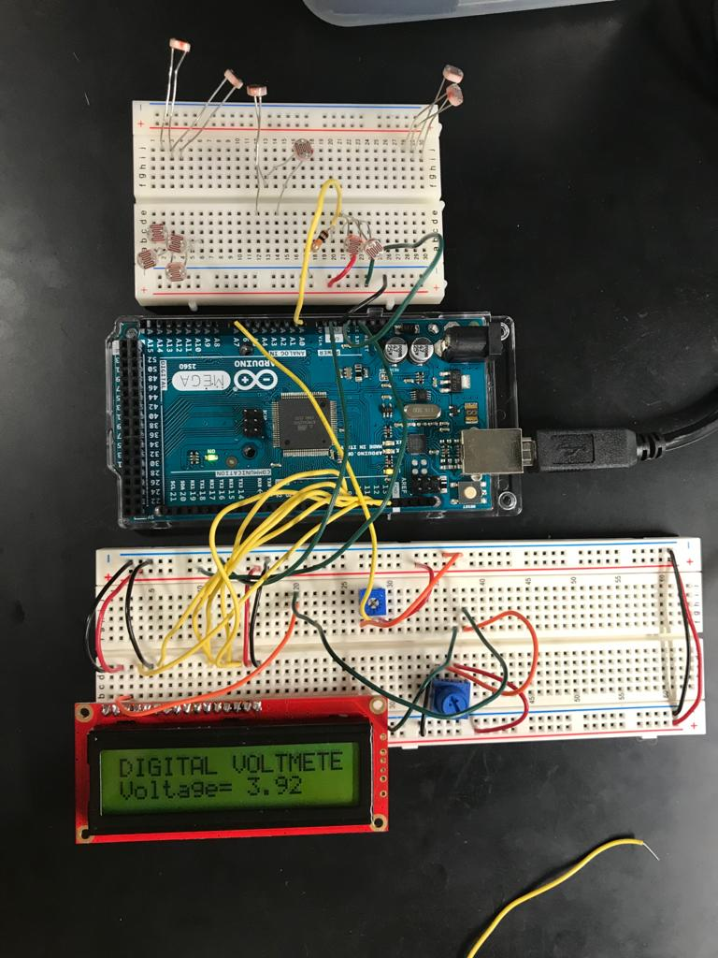 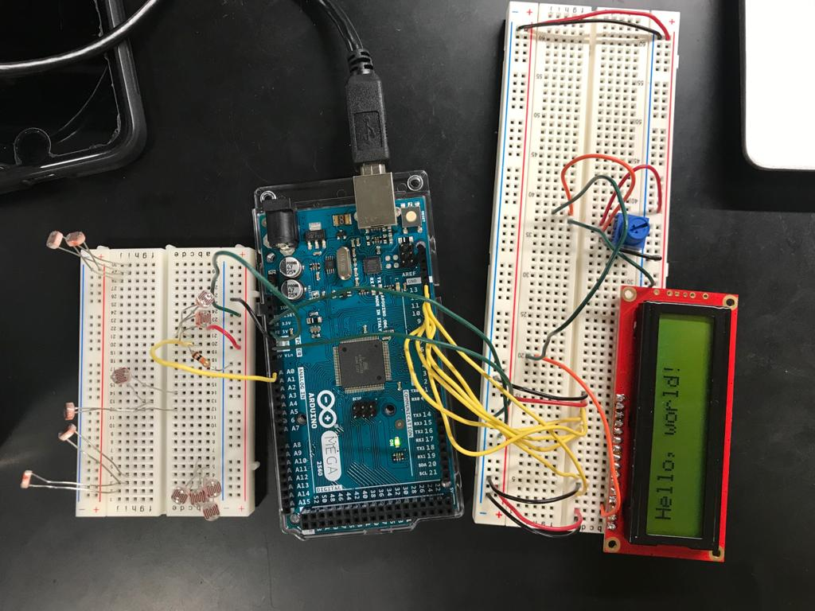

Another challenge that we faced was the mechanical construction of the main panel setup using press fit cardboard. Due to little prior experience, we had to be very careful during the process of designing the setup. The use of engineering drawings and accurate measurements for the cardboard helped us to visualise the components needed for the construction process, so as to reduce the possibility of loose cardboard fittings and hindrance to rotation of the main solar panel.

The panel was able to perform the task well, rotating as desired when the light intensity incident on the photoresistor array changes. However, there remains room for improvement which will be documented below. Although the plan significantly deviated from the original, it was able to achieve our intended design goals

**5. Future Plans**

The current solar tracker that has been built has a positive power consumption due to the use of the battery for the powering of the microcontroller and motor. Moving forward, one possible area to look into would be the use of rechargeable batteries, where the energy that is generated from the main solar panel itself can be used to charge the battery. If this energy produced is large enough, it could offset the power consumption by the other components of the circuit.

The scale of the project can also be increased by using a larger photoresistor array which spans across a larger area. This would allow us to perform more measurements of light that is coming from different angles. The number of intervals/angles can also be increased for higher precision. It would be ideal if it was possible to capture the variation of the light intensity with angle continuously rather than with discrete angles. Having the photoresistor array physically nearer to the solar panel would also lead to a more realistic capture of the light intensity incident upon the solar panel. A more aesthetic and longer lasting frame can be designed to support the solar panel instead of cardboard, potentially employing 3D printing.

**6. References**

[1] L.P. Guo, P. Curtis, A. Barendregt and A. Surillo, “AC 2009-354: A Sun Tracking Solar-Power System,” American Society for Engineering Education, Illinois, Senior Design Project Paper, 2009.

[2] “Simple Dual Axis Solar Tracker,” n.d. [Online]. Available: <https://www.instructables.com/id/Simple-Dual-Axis-Solar-Tracker/>. [Accessed: 20-Sep-2019]

[3] “Solar Tracker Arduino Project,” 2019. [Online]. Available: <https://www.cei.washington.edu/education/lessons/solar-tracker-arduino-project/>. [Accessed: 17-Sep-2019]

[4] “Sun Tracking Solar Panel,” September 5, 2018. [Online]. Available: <https://www.electronicshub.org/sun-tracking-solar-panel/>. [Accessed: 18-Sep-2019]

[5] “Basic Character LCD Hookup Guide,” n.d. [Online]. Available: <https://learn.sparkfun.com/tutorials/basic-character-lcd-hookup-guide/all>. [Accessed: 04-Nov-2019]

[6] “Arduino LCD Set Up and Programming Guide,” n.d. [Online]. Available <http://www.circuitbasics.com/how-to-set-up-an-lcd-display-on-an-arduino/>. [Accessed: 06-Nov-2019]

[7] “Displaying Sensor Values on LCD,” n.d. [Online]. Available <https://create.arduino.cc/projecthub/Guitarman1/displaying-sensor-values-on-lcd-c0c44f>. [Accessed: 24-Nov-2019]