Patrick Shalton - shalton3

Zexuan Cheng - zexuanc2

**Wireless Charging Cable**

1. **Introduction**

The purpose of our design is to build a simplified but well-functioning wireless charging device. We want the devices being charging are free from the traditional cable, which is inconvenient and may damage the device.

Our design mainly utilizes the concept of electromagnetic induction, which acts like a transformer consisting of a transmitting coil and a secondary coil. To specify, we have a transmitter connected to the source and a receiving coil fixed on the load devices. Basically, when the current go through, the induction coil can create an electromagnetic field, which can be “received” by the secondary coil. Therefore, electric power is transferred between the two-combined coils. In turn, secondary coil can convert it to electric current to charge the devices.

1. **Analysis of components**

In this project, we use ultrasonic sensor or a NFC module as a switch turning the charging on and off.

Ultrasonic Sensor:

Since the transmitter we used cannot tell the distance between the device to be charged and itself, and thus cannot determine when to turn on and off, it is obvious that we need components that can send signal to the transmitter when the device is placed near it. Keeping this in mind, we prototyped with an ultrasonic sensor. Since we only need to put the device in a really short distance from the charging base, we didn’t need the sensor to be super-sensitive. Even so, we noticed that ultrasonic sensor can be easily turned on by some unintentional actions. In order to prevent this kind of operation error, we switched to using an NFC module. Using a NFC module paired with the phone’s NFC, we can precisely control the charging process.

1. **Design description**

Block diagram:

Arduino

Relay

Ultrasonic sensor/NFC module

Transmitter

Arduino diagram:

**analog input** goes to ultrasonic sensor/NFC module

Digital output pins

goes to relay

**Power pins** goes to sensors and relay

Arduino

Diagram description:

In the actual project, due to the small current output of the Arduino, a relay is used so the Arduino can control the circuit. The NFC module is connected to its respective power, ground, analog, and digital pins and, if an NFC tag or device is brought near, it sends the device’s information to the monitor. If information is received, the Arduino will apply a high voltage to a digital pin connected to the switching side of the relay and allow current to pass through. If the device comes near the NFC module again, the Arduino will drop the high voltage, opening the circuit. This whole system acts as a splice in the transmitter circuit, thus allowing current to pass only when the NFC module detects a device.

**Schematics:**

For this circuit, we used an Arduino, sensors, a relay, and a transmitter. The main part of the circuit is between Arduino and transmitter. First, we set up the connection of the relay so that the small current generated by Arduino can control the transmitter which need more power than the Arduino could supply. We used a 171DIP-2 relay as the medium between the Arduino and transmitter.

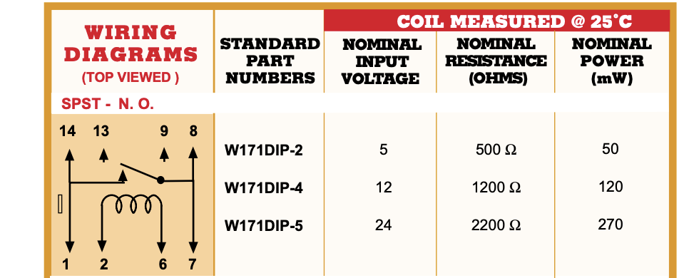



As seen in the data sheet shown above, we connected the chip’s pin2 with Arduino’s 5V pin and its pin6 to ground. Then, the normally open switch will close as a feedback of electromagnetic field created by the coil between pin2 and pin6. We also connected the transmitter into the relay circuit through its pin1 and pin7 so that small amount of current can turn the transmitter on.

1. **Conclusion**

Lessons Learned:

One of the unexpected obstacles was the limitation of current. As we mentioned above, Arduino cannot handle enough current required for charging. As a result, Arduino could not drive the transmitter on. Thus, we needed an electric switch which could drive a relatively high-power device with small current. Based what we learned this semester, a transistor such as a BJT is a way; or we can use a relay to achieve that.

Self-assessment:

Up to now, our project can charge the phone as effectively as normal charging cables. But it is not as powerful as those quick-charging cables. So, we can improve the project by figuring out how to make it more efficient. Plus, the project can also be optimized by integrating it into a portable and user-friendly metal box.