ECE Honors Lab Proposal

Shane O’Brien – Thomas Huang – Can Gulseren

Introduction

The aim of this project is to build and construct a flashlight that will operate using the current produced by shaking it. We will accomplish this by having a strong magnet (rare earth metal magnet) in a tube, and wire coiled around the tube. Shaking the flashlight, and therefore the tube, will move the magnet in and out of the coils. This movement will produce an electrical current which will be used to charge up the capacitor. We will have a voltmeter measuring the voltage across the capacitor, and will display the percentage it is charged and its expected run time.

Design

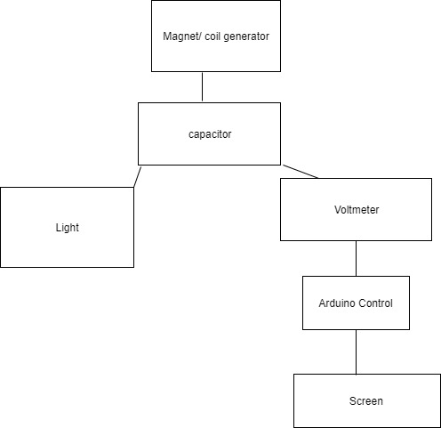

Parts

* Strong magnet (neodymium)
* Wire
* Capacitor
* LED bulb
* Tube (flashlight body)
* Arduino
* LCD or LED display

Challenges

One challenge we are currently facing is how to power the Arduino. Will the Arduino draw too much power from the capacitor for the LED bulb to light up?

References

"How Faraday Flashlights Work." *How Faraday Flashlights Work*. Shake Flashlights, n.d. Web.

Ohio State, Anderson. "Making a Faraday Flashlight." *Making a Faraday Flashlight*. Ohio State, n.d. Web.