ECE 205 Lab 1:
Battery Evaluation

Name(s) Date(s)
Zuofu Cheng 8/30/2019, lab work
9/09/2019, report

Statement of Purpose:
Write the statement of purpose for the lab. Parts of this may be directly copied from the lab prompt, but you may also add your own ideas

Many consumer electronic products use multiple AA or AAA batteries (remote controls, flashlights, smoke detectors, radios, etc.) When the device stops working, it is easy to assume that at least one of the batteries is no longer useful.
- However, how do we know which “one” is low?
- And what if anything can we say about the remaining “capacity” of the batteries?

Challenge: devise a simple means for testing small batteries, keeping in mind that the “open circuit voltage” of a battery tells you nothing about it’s operation under load.

Plan
You will likely need to come up with the procedure, as many of the lab prompts are open ended. You may have to do additional research here, e.g. from the device datasheet. You may also want to insert images such as a schematic to help yourself and the reader understand what to do. This section be sufficient for a person with reasonable technical competency (e.g. another student in ECE 205) to do the lab on their own and reproduce your work.

The open circuit voltage of the battery (i.e. the voltage measured simply by touching the battery with the voltmeter leads) only measures the “resting” state of the battery. It is necessary to measure the battery under load in order to evaluate it’s usefulness in real use.

The table shown in the “Encyclopedia of Electronic Components” (pg 14) suggests a test current of 20mA for both AA and AAA batteries, as used by the manufacturer for measuring the capacity (amp-hours) of the batteries. However, 20mA does not seem like much, and the manufacturer has a commercial interest in testing their batteries in a way that makes them look good

Since the lab has 22Ω, ¼ watt resistors available, the following test circuit is proposed

Fig. 1. Circuit to measure internal resistor of a battery.

At 1.5V (battery, nominal), this will draw (1.5V/22Ω =) 68.2 mA, nearly 3.5x more aggressive than the manufacturer’s test case. And under these conditions, the power dissipated by the resistor will be (1.5V*1.5V/22 Ω =) 0.102 watts, which is less than the 0.250 watt rating for the resistor. This circuit should be safe.

Execution
This section discusses what happened in the lab. At the minimum, your measurements go here. However, if there are aspects in the execution of the lab which are different from your procedure, they should also go here. For example, if you had to make a 5 Ω resistor from combining 10 Ω resistors, that note should go here. Some pictures of your completed circuit should also go here.

The circuit was constructed using
- one DMM
- common banana-plug cables (2 red, 2 black)
- one 22Ω, ¼ watt resistor
- one BNC/binding-post adapter
The BNC/binding-post adapter was used simply because it was available and convenient. The circuit could equally have been constructed with alligator clips, or a protoboard, or other.

The mechanical implementation is shown by the photo below.

to voltmeter
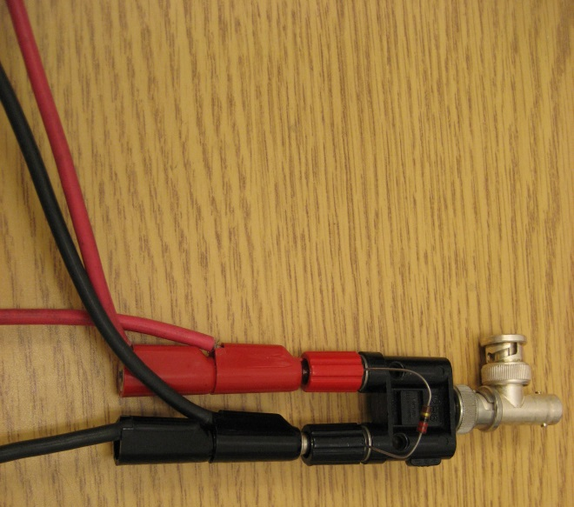to battery
Fig. 2. Example of measuring setup for 22Ω (nominal) resistor

The resistor had the following color-code markings
red-red-black <space> gold
indicating that it was (2 2 *10⁰, 5%) a 22Ω resistor. It was measured as 23.464 Ω using the ohmmeter.

Three batteries were tested and produced the data in Table 1.

Table 1. Open/closed circuit voltages of tested batteries.
ID | Type | Open Circuit | Under Load
“x” | AA | 1.486 | 1.36
“y” | AA | 1.463 | 1.42
“z” | AA | 1.482 | 1.40

Note that the voltmeter in the lab displays 5-6 digits, more than indicated in the data above. However, when making the measurements, the lower digits changed constantly. The data shown above reflects the “stable” (non-changing) part of the display.

Results and Conclusions
Your conclusion should discuss your numerical results from the previous section. In addition, you should discuss what went well in the lab and what didn’t. For example, if you had to significantly modify your procedure, why? (The how you modified part goes in the last section). You should also discuss some potential applications of what you learned.

From the data, the following is apparent
- All three batteries can provide at least 1.3v and 58mA
(1.36V/23.464 Ω; worst case)
- Although this is a small sampling, it is interesting that the open-circuit voltages tended to increase as the under-load voltages decreased(!) There is not enough data to suggest anything about what is really happening inside the batteries…
But it is clear that measuring only the open-circuit voltage tells me less-than-nothing about these batteries. If anything, the open-circuit voltage lies to me about the working strength of these batteries!
- It is interesting that the open-circuit measurements showed less noise (more digits were stable) than then under-load measurements. It is true that carbon resistors are more “noisy” than others (“Encyclopedia of Electronics”, pg 82), but it is beyond the scope of this lab assignment to confirm/deny where the measurement noise is coming from.

With respect to safety, and future use of this circuit, the ¼ watt resistor implies that the largest-safe test voltage is (V²/22Ω = 0.25 watt V=) 2.35V. This is a concern, because even just 2 AAA batteries in series (3V) will exceed the power rating of this circuit. If this circuit is to be used in general, either
- find a higher-rated power resistor, or
- label the circuit as “1.5V only!” and hope that no one tests a 9V battery(!)

