Resistor-Network Power Ratings

Current-Limiting Resistors
One use of a resistor is to limit the current flowing through a device by placing the appropriate resistance in series. For example, we can slow the motor of the Shadow Chassis car in our ECE 110 Electronics kit by adding a resistor in series with the motor. Unfortunately, this cannot be done without regard to physical limitations of the resistor. To investigate this further, let’s use the simulator tool at Falstad.com.

Model and Explore
To get started, point your browser to https://www.falstad.com/circuit. Start with CircuitsBlank Circuit. Then add a two-terminal voltage source and two series resistors with wire connections as shown in Figure 1. There are some hints to speed your learning process below.
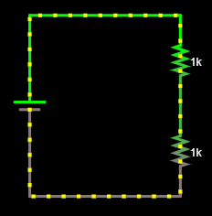
Figure 1: Falstad circuit, first steps.
To add the battery: You may use a keyboard shortcut by typing v and then left-clicking and dragging your cursor to draw it. For some reason, the tool can have glitches…for instance, the battery might not start to appear unless you start to draw it downward and then straighten it upward before releasing your button. You can also just go to DrawInputs and SourcesAdd Voltage Source (2-terminal).
To add a resistor: You may use a keyboard shortcut by typing r and then left-clicking and dragging your cursor to draw it. You can also just go to DrawAdd Resistor.
To add wire (nodes): You may use a keyboard shortcut by typing w and then left-clicking and dragging your cursor to draw a wire (more accurately, you are adding to a node!). You can also just go to DrawAdd Wire.
Also, don’t forget the other shortcuts from the earlier tutorial or be afraid to explore more on your own!
Now, change the value of the lower resistor to 30 Ohms. This will represent a simple model for your car motor. You will NOT change the value of the motor’s resistance again throughout this exercise. It should remain at 30 Ohms throughout.
Change the value of the battery to 9 volts DC with no offset. You will NOT change the battery’s voltage again throughout this exercise. It should remain at 9 volts throughout.
Your diagram should now look like the one in Figure 2.
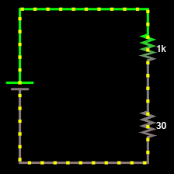
Figure 2: Motor with current-limiting resistor.
We will assume that the motor is rated to take the full 9-volt battery without damage. That is, even without the current-limiting resistor, we will assume the motor will run fast, but not burn out. In other words, we can assume the “motor” will not be stressed beyond its physical limitations in this exercise.
The current-limiting resistor, however, is assumed to come from our ECE 110 Electronics Kit. All of our resistors are rated at 0.25 watts and we can refer to them as “quarter-watt resistors”. That is to say, the square of the voltage across the top resistor divided by the resistance value must stay below 0.25 watts or the resistor will become very hot and eventually fail. Equivalently, the square of the current through the resistor times the resistance value must stay below 0.25 watts. If $R$ represents the value of the top resistor, $V_{R}$ represents the voltage across the top resistor, and $I_{R}$ represents the current through the top resistor, then the power rating states that we want to ensure that
$$\frac{V_{R}^{2}}{R}=I_{R}^{2}R<0.25 W$$
To make this investigation easier, let’s add a slider to the current-limiting (top) resistor. To do this, right-click over the top resistor and choose Sliders… then choose OK in the popup window. A slider titled “Resistance” will appear to the right allowing you to quickly change the value of the resistance between 1 and 1000 (1k) Ohms. Also, right-click the resistor and choose View in Scope. Now, you can also observe, in real time, the current through, the voltage across, the resistance of, and the power dissipated by the top resistor (or any other circuit device that you hover over).
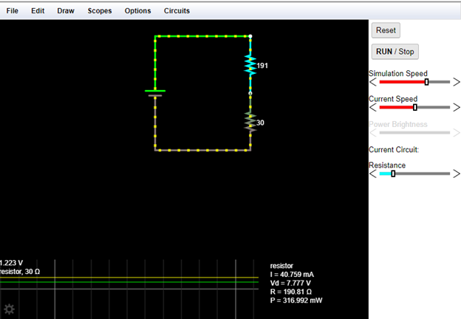
Figure 3: Motor with current-limiting resistor, a slider, and a scope plot.
Assume we want the motor to carry a current of $120 mA$. What value of the top resistor achieves this? Adjust the slider to get close, then hover over the resistor and right-click to edit its value more precisely.
Important Message!!: All questions are repeated on the last page so that you can fill it out there, print, and submit a single sheet of paper to GradeScope.

- Record this value and call it $R_{opt}$.
- Find the range of resistances for which the top resistor exceeds its power rating. Record that range here.
You should find that the value of resistance that creates the desired current is also in the range of resistances for which it exceeds its power rating! What can we do?
Let’s replace this single resistor with a network of resistors. To do this, multiply your desired value of the current-limiting resistor by, let’s say, a factor of 4. Place four resistors of value $4×R_{opt}$ in parallel with each other.
Important: If you attempt to draw one wire connecting the leftmost resistor to the rightmost resistor, only those two resistors will be connected to that node. When you want all resistors connected, you should wire from one resistor to the next, then to the next, then to the next.
Your diagram should now look like the one in Figure 4, but we have hidden the actual resistor values from you (use the value you found!). If you have selected them correctly (all the same value), you should be able to hover over the 30 Ohm motor-model resistor and find that it is carrying 120 mA. When you hover over any single resistor in the top resistor network, you will find that it is only dissipating power below the 1/4 -watt rating.
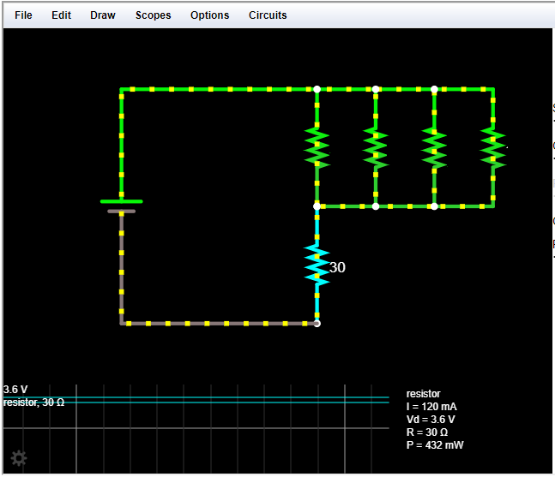
Figure 4: Motor with current-limiting resistor network.
- Explain why this network of parallel resistors was able to accomplish what a single resistor could not…precisely control the current in the motor while remaining below the power limit of the ¼-watt resistors.
- Could you find another arrangement (network, not necessarily parallel) of resistors that could solve the problem as well? Explain.
- Include a screen capture of your version of Figure 4.
- Record this value and call it $R_{opt}$.
- Find the range of resistances for which the top resistor exceeds its power rating. Record that range here.
- Explain why this network of parallel resistors was able to accomplish what a single resistor could not…precisely control the current in the motor while remaining below the power limit of the ¼-watt resistors.
- Could you find another arrangement (network, not necessarily parallel) of resistors that could solve the problem as well? Explain.
- Include a screen capture of your version of Figure 4.

Learning Objectives
- Use Ohm’s Law to determine how to limit current through a resistive-motor model.
- Use Ohm’s Law, the power equation, and analytical reasoning to find a range of resistances that should be avoided due to fabrication limits (power ratings).
- Explain why a resistive network could replace a single resistor in an application to avoid power-limit issues.
- Design an alternative configuration to show that the solution is not unique.

