The Sun Singer! A Light-Seeking Robot
The Sun Singer. [source: www.visitchampaigncounty.org/]

Laboratory Brief
This week, we’ll complete the build of a self-navigating car following the work done in your prelab. Specifically, we will merge two voltage-divider circuits with two “motor-drive” circuits and construct a car that will navigate from the shadows and stop under a bright light. You can imagine this behavior with, say, a planetary rover that must seek sunlight for recharging. In the process, we will gain some exposure to a device known as a transistor. In this exercise, you will also be asked to think like both a customer and a design engineer. Engineering design involves not merely following a set of instructions but devising a plan to meet certain goals.

Learning Objectives
- Devise design steps using tools of the trade.
- Appraise your own design based on appropriate engineering criterion.

Construction Warnings!
There are several mistakes that you must avoid in this exercise. We are listing them here so that you can be careful as you move forward. Some mistakes can cause physical harm, so we’ll start with that one.
- The nMOS transistor must have the motor between the Drain and the positive side of the battery. Why? If you connect the Drain to the positive side of the battery and the Source to the negative side of the battery, then, when the transistor’s Drain-to-Source resistance drops low, you will have essentially shorted your battery. The high current flowing through the transistor will make the transistor get very hot! It will likely burn your fingers.
- Another common mistake (related to the one above) is to accidentally attach the motor across the power rails. The motor needs to be connected between the positive power rail and the Drain. As mentioned above, the Drain should not be connected directly to the power rail. We can’t emphasize that enough.
- The motors are “symmetric” meaning that it will run no matter which way you plug it in (red vs black wires). It will merely change direction. The warning is: you want your car to go forward. If you find that one or both wheels is moving the wrong direction, just reverse the wires for that motor to correct it. There is no physical danger here.
- Damaging a potentiometer is easier than you may think! Common errors include turning the wiper with a heavy force near the ends of its mechanical limits. Damage can also occur when using it as a variable resistor and accidentally tuning its value into the range where power dissipation exceeds its rating.
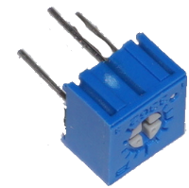

Recall Prelab
Recall our method of using an nMOS transistor as a light-controlled variable resistor. The motor in Figure 1 now responds to light in a manner that will allow us to build a light-seeking autonomous vehicle.
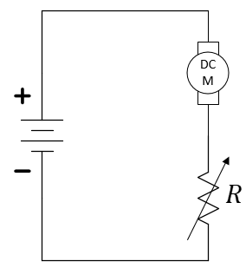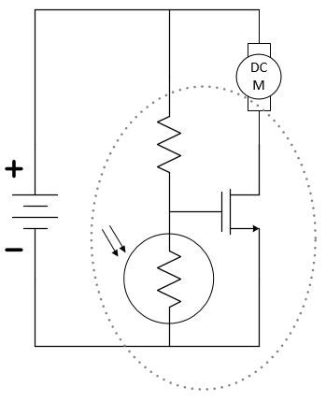
Figure 1: Replacing a mechanical variable resistor with an electronic one.
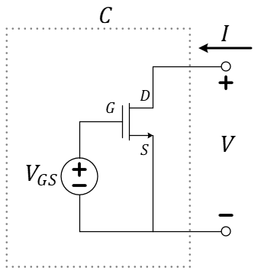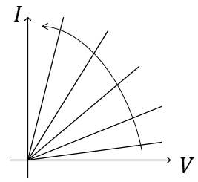
Increasing $V_{GS}$
Figure 2: Controlling the nMOS and investigating its IV characteristics as a two-terminal circuit.
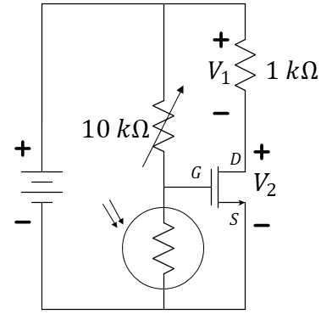
Figure 3: A simple schematic of a light-seeking robotic car built in your prelab exercise.
- Discuss the relationship between $V_{1}$ and $V_{2}$ as your hand shadows and unshadows the photo-resistor. Is it what you expect based on the earlier “model” of the transistor as a variable resistor?
- Measure $V_{1}$ and $V_{2}$ under the shadowed condition. Use your voltage measurements to estimate the effective resistance between the drain and source of the nMOS; we will call this $R_{DS}^{(dark)}$.
- Measure $V_{1}$ and $V_{2}$ under the bright-light condition. Use your voltage measurements to estimate the effective resistance between the drain and source of the nMOS; we will call this $R_{DS}^{(light)}$.
Replace the $1 kΩ$ resistor with one motor of your car. The light sensor should now control the motor. You should not need to adjust the potentiometer. If it doesn’t work, discuss with your teammates or your TA.

Build a Light-Seeking Car

The construction of a light-seeking car is now collapsed to a combination of nine electronic components! You will need your car chassis (with its two DC motors), two photo-resistors, two $10 kΩ$ potentiometers (labeled with 103 to be used as variable resistors), two 30N06L nMOS transistors, and one $9 volt$ battery as shown in the circuit schematic of Figure 3.
Note that in the schematic of Figure 3, the use of the potentiometers (3362R-103LF-ND, https://www.mouser.com/ProductDetail/Bourns/3362R-1-103LF?qs=fCVTrKU7SHhTM6Zk6txpow%3D%3D) as variable resistors is to allow for one-time tuning to account for differences between the nMOS transistors and the photo-resistors controlling each motor. Once tuned, they could be removed and replaced with fixed resistance of the same values, although we can also leave them for re-tuning as needed later.
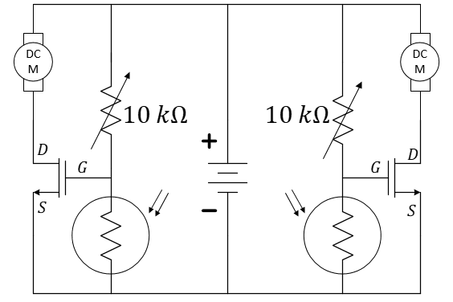
Figure 3: A simple schematic of a light-seeking robotic car.
In a bright space, place your car on the floor and make it move by shadowing the left sensor. The left wheel should move. Make it move by shadowing the right sensor. The right wheel should move. Try starting the car in the shadow of a chair and see if you can get it to move into the lighted area and stop. Even if the car doesn’t perform perfectly, group as a team and complete the questions/exercises on the next page.
- You will also submit a short video of your individually built post-lab car.

Team Submission Questions
Now we want you to start the process over (but you don’t need to completely disassemble your car). Complete this as a team, but each student must follow the devised procedure of Question 5 on their own car and submit a video of their own car.
- Place yourself in the position of your graduate Teaching Assistant. Devise three (or more) sequential tests, each in complete and intelligible sentences, which a student could follow to ensure the behavior of the light-seeking car. Hints: Consider the prelab exercise, too. Start with a strict control and end with a moving car. Include the M2k and tuning of the potentiometers.
- Follow the tests just derived to adjust your car, then “road test” your car. Discuss what is most challenging about the build. Record comments and suggestions that may help a student when following the original instructions of Question 4.
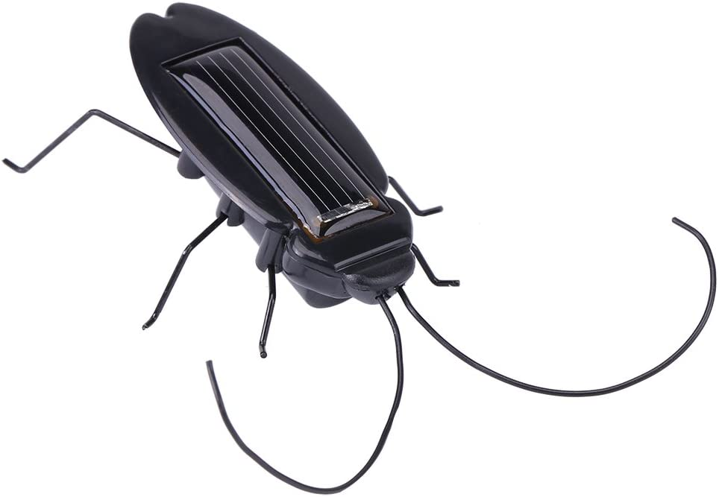
A cockroach robot. [source: https://www.amazon.com/Tnfeeon-Cockroach-Grasshopper-Educational-Simulation/dp/B07YY83TM7/ref=sr_1_3?dchild=1&keywords=cockroach+robot&qid=1632842474&sr=8-3]
- The Cockroach: Discuss and document changes to the circuit schematic to make the car shadow-seeking. As a team, modify one car to achieve the shadow-seeking cockroach behavior. The student whose car is modified may present the cockroach in their video instead of the light-seeker if they wish.

