Kirchhoff’s Laws

Learning Objectives
- Be able to identify a closed path for application of Kirchhoff’s voltage law.
- Be able to alter voltage polarities to ensure they match the intent of Kirchhoff’s voltage law.
- Define voltage variables, including polarity, and use measurements of those voltages to confirm Kirchhoff’s voltage law for a given circuit loop.
- Define current variables, including polarity, and use measurements of those currents to confirm Kirchhoff’s current law for a given circuit volume.

Kirchhoff’s Voltage Law (KVL)
In class we learned Kirchhoff’s voltage law. It is often stated that “The sum of voltages measured clockwise around a closed path is equal to 0.”
$$\sum_{closed path}{V_{k}^{(CW)}}=0$$
What exactly do we mean by this? A closed path is one that starts at a particular node and then passes through any number of elements and nodes before returning to that original node. What do we mean by “measured clockwise?” This is a reference that the direction in which the voltmeter is placed will affect the sign of the voltage measured. We need to affirm that the meter is always placed in the anticipated orientation with respect to the “positive” and “negative” probes. On our MN35, the positive probe is generally the red-colored cable plugged into the V-Ohm-mA jack and the negative probe is generally the black-colored cable plugged into the COM jack.
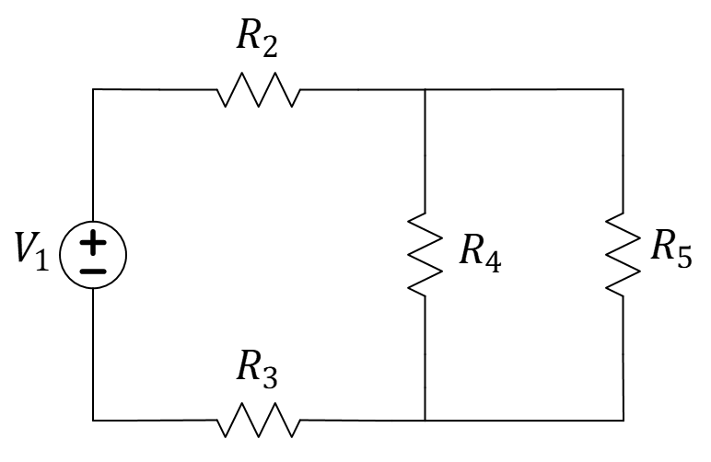
Figure 1: A typical idealized circuit.
Consider the circuit of Figure 1. When we apply KVL to the “outside loop” that passes through $V_{1}, R_{2}, R_{5}, R_{3}$, we anticipate each providing a voltage that we can sum and get 0. But we need to start by not only defining variable names for the voltage across each circuit, but also a polarity reference to each voltage. A polarity reference for voltage involves a plus sign (+) for the location of the positive probe of the meter and a negative sign (-) for the location of the negative probe of the meter. In Figure 2, we have added voltage labels and current labels to each circuit element. You might not be surprised that each current must also have a defined polarity reference. In the case of current, we use an arrow.
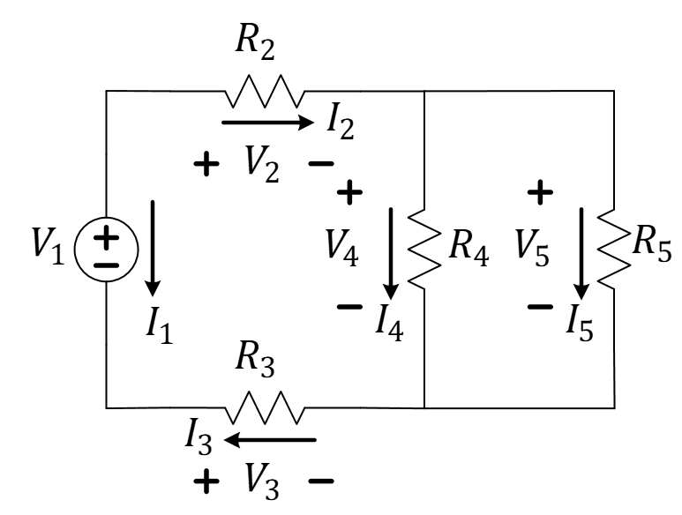
Figure 2: Same circuit with voltage and current labels.
As we become more advanced with our understanding of circuits, we may also want to reduce the number of variables introduced into our math. For example, Figure 3 shows the insertion of the voltmeter first to measure $V_{4}$ and then again to measure $V_{5}$. However, since the resistors associated with these voltages are in parallel (they share the same two nodes that we are measuring across), AND because $V_{4}$ and $V_{5}$ are defined with the same polarity reference (+ at the top and - at the bottom), they are the exact same voltage! We could have just referred to $V_{4}$ any time we would have used $V_{5}$.
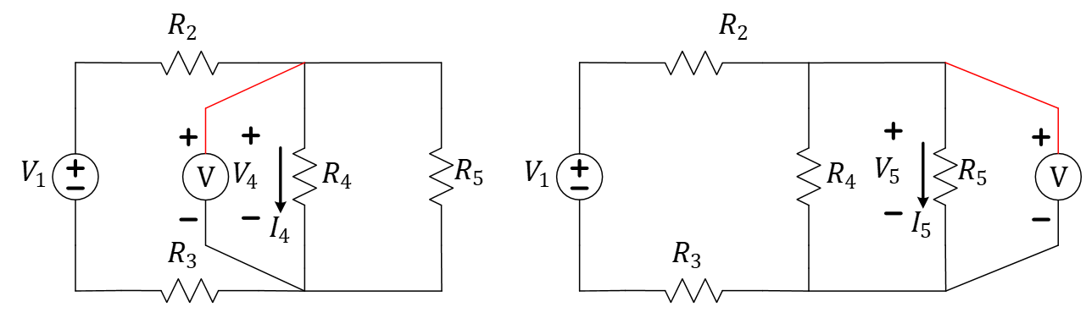
Figure 3: Measurement of $V_{4}$ is no different than measuring $V_{5}$.
Let’s now to get back to the KVL equation. We understand the idea of a path and the fact that voltage (and current) needs a polarity reference. So what do we mean when we say the sum of the voltages “measured clockwise?” It isn’t necessarily an absolute orientation of the voltmeter as much as it is a reference as to how the voltmeter will be shifted around the circuit path to collect all the voltage values.
This idea is demonstrated in Figure 4. In this figure, we have decided to start at the bottom-left node of the circuit and travel a closed path around the outside elements $V_{1}, R_{2}, R_{5}, R_{3}$. In order to measure $V_{2}$ and $V_{5}$ with the polarity indicated in Figure 2, we were “forced” to measure $V_{1}$ with the “wrong” polarity! The first measurement will provide the correct magnitude of $V_{1}$, but with the opposite sign.

shift the meter clockwise
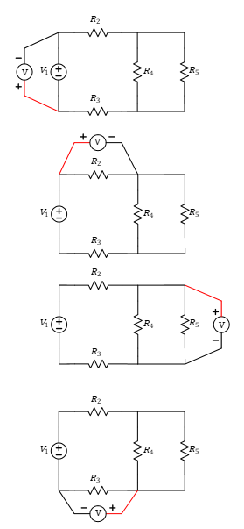
shift the meter
shift the meter

Figure 4: Schematic demonstrating clockwise shifting of the voltmeter.
After collecting the first voltage value in our path (a value of $-V_{1}$), we shift the voltmeter in a clockwise direction, continuing to lead with the black probe and follow with the red probe. In this way, the voltmeter measures $V_{2}$ with the same polarity indicated in Figure 2, then $V_{5}$ with the same polarity as in Figure 2 as well. The final measurement of $V_{3}$ has the opposite of the polarity reference defined in Figure 2, so this final measurement will be equal to $-V_{3}$. When we apply the formula to Figure 4, we get an equation that states
$$\sum_{closed path}{V_{k}^{\left(CW\right)}}=\left(-V_{1}\right)+V_{2}+V_{5}+\left(-V_{3}\right)=0$$
or
$$V_{1}+V_{3}=V_{2}+V_{5}$$
This latter formula also demonstrates why KVL is sometimes presented as “The sum of the voltage rises is equal to the sum of the voltage drops in any closed loop.”
$$\sum_{closed loop C}{V_{k}^{rise}}=\sum_{closed loop C}{V_{i}^{drop}}$$
Even this statement must be properly interpreted. We don’t often know in advance of solving for voltages relative to their polarity references) which are positive (rises?) and which are negative (drops?). What this statement really means is that the sum of the voltages with clockwise polarity references must equal the sum of the voltages with negative polarity references. It is just a restatement of the earlier equation but may prove to be a more comfortable interpretation to some people in some situations.

KVL Exercise
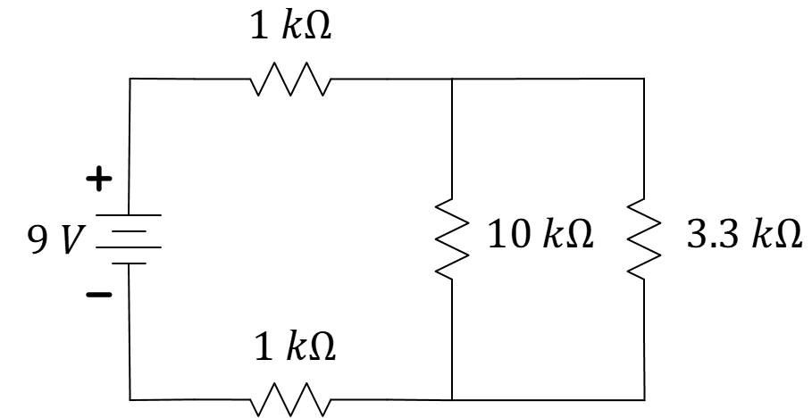
Figure 5: Same circuit using kit components.
In Figure 5, you will find a circuit that can be constructed with parts from your electronics kit. You will need to define voltages (including the polarity reference of each) directly on the circuit schematic and then take those measurements using your MN35 handheld multimeter. Carefully prove KVL while being careful that your measurements match what you defined on the circuit schematic. You should be able to find three loops in Figure 5 that can be evaluated. Please evaluate all three!
You will be asked to upload a document that includes
- For KVL
  - the circuit schematic with labels of all voltages (including the +/- polarity for each)
  - three equations using the voltage variables for each of the three loops (left, right, and outer)
  - the same three equations, now using the actual measured values for each voltage. Make a note of how closely each KVL equation “equals out” and determine if KVL is reasonably satisfied
You will also upload a short video (less than 30 seconds) that demonstrates how to measure all voltages in the “outer loop” in a clockwise direction using the MN35.

Kirchhoff’s Current Law
Kirchhoff’s Current Law states that the current flowing into a fixed volume must be matched by the current flowing out again. Often, we refer to that volume as a balloon that surrounds part of our circuitry. It may surround a node or it may surround a supernode (that is, the balloon-enclosed volume has one or more elements inside of it). Just like voltage, any current measurement is only known to its magnitude without the aid of a polarity reference to also provide the correct direction of its flow.
Also, like the voltmeter, the ammeter also has a polarity to its probes. The red-colored probe plugged into the V-Ohm-mA jack references the “start” or shaft of the arrow while the black-colored probe plugged into the COM jack references the arrowhead. Figure 6 demonstrates the proper use of an ammeter to measure the current $I_{2}$ including its polarity. While the voltmeter can be used to “probe” voltages without purposefully altering the circuit, the ammeter must be placed in series with the element whose current is to be measured.
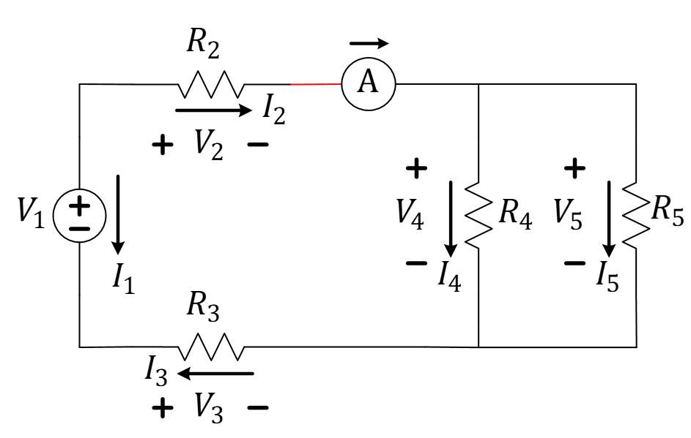
Figure 6: Orientation of the ammeter to measure $I_{2}$ with proper polarity.
This is demonstrated again in Figure 7 for the measurement of $I_{4}$. Think about this…could the ammeter have been placed above the resistor $R_{4}$ when taking this measurement? Yes, if it is still placed directly in series with this resistor, the measurement will remain the same. You can try this on your own!
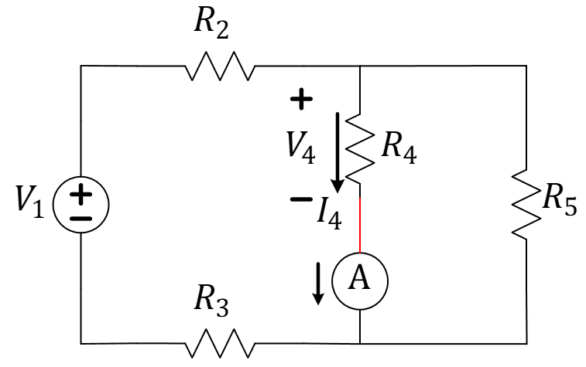
Figure 7: Orientation of the ammeter to measure $I_{4}$ with proper polarity.

KCL Exercise

Figure 8: Same circuit using kit components.
You will need to define currents (including the polarity reference of each) directly on the circuit schematic and then take those measurements using your MN35 handheld multimeter. Carefully prove KCL while being careful that your measurements match what you defined on the circuit schematic. There are three balloons indicated in Figure 9 that we would like you to evaluate explicitly.
BEFORE YOU START: Think about the currents you anticipate flowing in each element of Figure 8. Will any of these currents be greater than the $200 mA$ DC current limit of the MN35 multimeter? Which element carries the most current? What will the maximum current be? What mistake would lead to the ammeter carrying more than $200 mA$? Probably the most-common mistake is placing it incorrectly onto your breadboard where it is in parallel with the battery! It is recommended that you pause to evaluate your circuit any time you are about to insert your ammeter. A blown fuse will cause delays at best and a missed deadline at worst.
AN ALTERNATIVE TO THE AMMETER: If you are hesitant to use the ammeter, you could also consider first measuring the resistances of all four resistors. Application of Ohm’s law would allow you to use the voltages from the previous section to deduce the currents through each resistor. Just make sure you make the polarity reference of the current consistent with the polarity reference of the voltage when you apply Ohm’s law. This is also referred to as “Standard Reference.” It means that the current arrow should point from the positive-referenced node to the negative-referenced mode. If you look at Figure 6, you will see that we used Standard Reference for all elements except $R_{3}$. You can use a different polarity reference for $I_{3}$ if you choose the Ohm’s law method for finding the currents with a voltmeter.

Figure 9: Nodes/supernodes for KCL evaluation.
- For KCL you will be asked to include in your report…
  - the circuit schematic with labels of all current (including the polarity for each)
  - three equations using the current variables for each of the three nodes of Figure 9
  - the same three equations, now using the actual measured values for each current. Make a note of how closely each KCL equation “equals out” and determine if KCL is reasonably satisfied
  - if Ohm’s law was used to determine currents from the voltage and resistance measurements, include those calculations as well

Individual Submission
Upload a document that includes
- For KVL
  - the circuit schematic with labels of all voltages (including the +/- polarity for each)
  - three equations using the voltage variables for each of the three loops (left, right, and outer)
  - the same three equations, now using the actual measured values for each voltage. Make a note of how closely each KVL equation “equals out” and determine if KVL is reasonably satisfied
- For KCL
  - the circuit schematic with labels of all current (including the polarity for each)
  - three equations using the current variables for each of the three nodes of Figure 9
  - the same three equations, now using the actual measured values for each current. Make a note of how closely each KCL equation “equals out” and determine if KCL is reasonably satisfied
  - if Ohm’s law was used to determine currents from the voltage and resistance measurements, include those calculations as well
Upload a short video (less than 30 seconds) that demonstrates how to measure all voltages in the “outer loop” in a clockwise direction using the MN35.

