The RC Time Constant (Falstad)

Outline
3, 2, 1…Blast Off! Can we do a countdown with a circuit?
Typically, the path for charging a capacitor and the path for discharging the capacitor is current-limited by a resistor, the value of which can be changed to alter the rate at which charging or discharging can occur. This timing mechanism is exploited in the construction of oscillators that create controlled voltage swings at a given frequency, systems (filters) that respond favorably only to signals that change at particular rates/frequencies, and also electronic timing to delay a response. The calculation of the “time constant” and, even better, “rise time” of many of these devices is very simple, requiring a simple multiplication! Let’s learn more…

Prerequisites
- Familiarity with capacitors and their function as energy-storage devices by charge separation.
- Familiarity with the Falstad circuit simulator through a short tutorial or willingness to self-learn this simple tool.
Equation Reference: ECE210 textbook, page 97, Analog Signals and Systems by Kudeki and Munson.

Parts Needed
- A computer with an Internet browser. Access to https://www.falstad.com/circuit.

Learning Objectives
“on the order of”: In engineering, this may also be an expression meaning on the same “order of magnitude as” something else. Order of magnitude is usually expressed in powers of 10. For example, if $τ=5 s$, then most of the time it takes to charge is surely contained in the range $[0.5 s, 50 s]$.
- You will be able to provide a definition and formula of the RC time constant as well as the 10%-to-90% rise time.
- You will be able to predict how a change in the capacitor or resistor values will alter the time constant of a circuit.

Capacitor Charging and Discharging
When a capacitor is charged by a constant (DC) voltage supply of $V_{DD}$, the time-domain voltage across the capacitor is given as
$$v\left(t\right)=\left(V_{i}-V_{DD}\right)\left(e^{-\frac{t}{RC}}\right)+V_{DD}$$
where $C$ is the capacitance being charged, $V_{i}$ is the initial voltage on the capacitor at time $t=0$, and $R$ is the series resistance within the charging path. If the initial voltage is $0 V$ and the voltage supply is $9 V$, then this equation simply becomes
$$v\left(t\right)=\left(1-e^{-\frac{t}{RC}}\right)V_{DD}$$
The voltage across the capacitor would be asymptotically approaching $9 V$, although most of the charging occurs in a short time span on the order of the time constant which is the product $R times C$.
$$τ=RC$$
$$v(t)$$

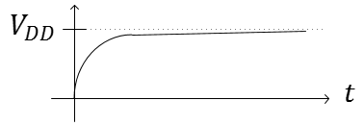
Figure 1: The waveform $v(t)$ across a capacitor while charging to $V_{DD}$.
When a capacitor is being discharged to ground voltage (0 V), the time-domain voltage across the capacitor is given by
$$v\left(t\right)=V_{start}e^{-\frac{t}{RC}}$$
where we are assuming the voltage across the capacitor is $V_{start}$ at the beginning of the discharge. As before, the decay of the capacitor to 0 volts follows an asymptotic path with much of the decay occurring, again, in the order of magnitude of $RC$.
$$v(t)$$

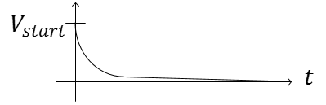
Figure 2: The waveform $v(t)$ across a capacitor while discharging to ground voltage.

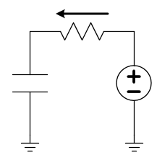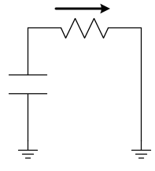
(a) (b)
Figure 3: Charging (a) and discharging (b) schematics for capacitor. The arrow shows the direction positive-valued current will flow as the capacitor charges and discharges, respectively.
The time constant, while a very simple equation, is neither easy to remember nor easy to measure. Technically, it is the time an uncharged capacitor would take to charge to 63.8% of its final voltage value. A better metric would be the 10%-to-90% rise time, which, for a capacitor charging from 0 to $V_{DD}$, it would be the time between the point the voltage reaches 10% of $V_{DD}$ until it reaches 90% of $V_{DD}$. Given a value for the capacitor, $C$, and the resistor, $R$, for Figure 3 (a), the capacitor will have a rise time given by
$$\boxed{t_{rise}≈2.2 RC}$$
Figure 4: The 10%-to-90% rise time.

Falstad
To create a short investigation into time constants, let’s build a circuit in Falstad’s circuit simulator at www.falstad.com/circuit. Start with CircuitsBlank Circuit. Use the keyboard shortcut v to draw a voltage source. Edit the value to $10 V$ (so that finding the 10%-to-90% rise time will not take any math!). Remember that the space bar can allow you to quickly drag an element if it doesn’t lie where you want it. Use c to add a capacitor. Set the value of the capacitor to $100 μF$ (it is fine to leave “Trapezoidal Approximation” checked and 1m as the initial voltage). Use S (capitalized) to add a single-pole-double-throw switch, r to add two resistors ($10 Ω$ and $100 Ω$), and w to complete the wiring as shown in Figure 5.
Warning: You cannot connect a wire from, say, the bottom of the battery to the bottom of the $100 Ω$ resistor without connecting first at the bottom of the capacitor. The simulator will not automatically make that connection!
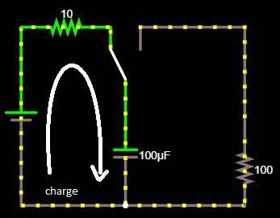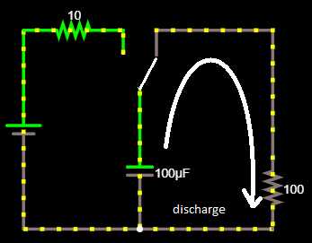
Figure 5: Falstad circuit simulation for studying timing circuits. On the left, the switch is charging the capacitor, on the right, the switch is discharging the capacitor.
The switch will now allow us to charge the capacitor through a 10 Ohm resistor and then, clicking on the switch, disconnect the charging circuit and connecting the discharging circuit (through the 100 Ohm resistor). Considering time constants, the capacitor is unchanged, but the resistance in each path differs by a factor of 10.

- Consider $t_{rise}=2.2 RC$. Use the equation to estimate the rise time of the voltage across the capacitor to be during the charging cycle. Which resistance do you use in this calculation?
Capacitors also discharge with a 90%-to-10% “fall time” given by the same calculation.
$$t_{fall}≈2.2 RC$$
- Use the equation to estimate the fall time of the voltage across the capacitor to be during the discharging cycle. Which resistance do you use in this calculation?
In your circuit simulation, toggle the switch several times and observe the current flow as the capacitor charges and discharges as evidenced by the moving dots. To get a time display of voltage and current, hover over the capacitor, right-click, and select View in Scope. Again, toggle the switch to make observations of the charging and discharging cycles. Press the RUN/Stop button to freeze the oscilloscope (scope) view with at least one full charging cycle and one full discharging cycle. Use your mouse to move a cursor over the plot.
- For a charging cycle, record the time the voltage reaches 1 volt (10%) and the time it reaches 9 volts (90%). Record these values and take the difference to find $t_{rise}$. The measurements will not be too precise, so don’t worry too much about precision, however you can right-click the plot and select Properties…, then Horizontal Scale to change the horizonal time/division to improve your precision.
- Repeat for a discharging cycle to find $t_{fall}$. Record the two observed times as well as the calculation.
- Without simulating it yet, use the equation to estimate rise and fall times if the capacitance is increased to $1000 μF$. Discuss both the charging (rise) and discharging (fall) times.
- Simulate the conditions of Question 5 and record the rise and fall times both before and after the capacitance is increased. Use the simluation results to confirm your predictions and comment here in a few sentences on the accuracy or failure of any predictions. Your answers to the previous question will not be counted against you as long as you can identify here what you did incorrectly!

