Straight-Run Car

Prerequisites
- You will need to have built the shadow chassis car.
- Start with a previous build of the nMOS-based motor-drive circuit.

Learning Objectives
- Build a circuit by following the design specified on a circuit schematic.
- Learn to control the duty cycle of a PWM signal using a turn pot and diodes.
- Use observations of your circuit to discern the change of certain components.
- Adjust your PWM signal to different duty cycles, make observations on the oscilloscope.

How it Works (skip this section if you are familiar with PWM)
Figures 2 and 3 describe how the output of the Schmitt trigger looks like either a voltage source (to charge the capacitor) or a short-to-ground (to discharge the capacitor). The Schmitt-trigger behavior is, in turn, controlled by the current voltage differential across that same capacitor creating a “control loop.” The diodes in combination with the potentiometer control the time-constant characteristics of these two separate paths, thus providing control of the duty cycle with the turn of the potentiometer.
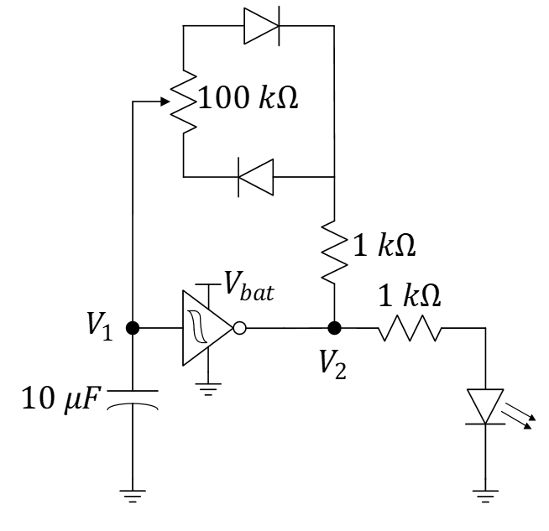
$$1 μF$$
Figure 1: Circuit schematic of an oscillator with a selectable duty cycle from an earlier exercise.

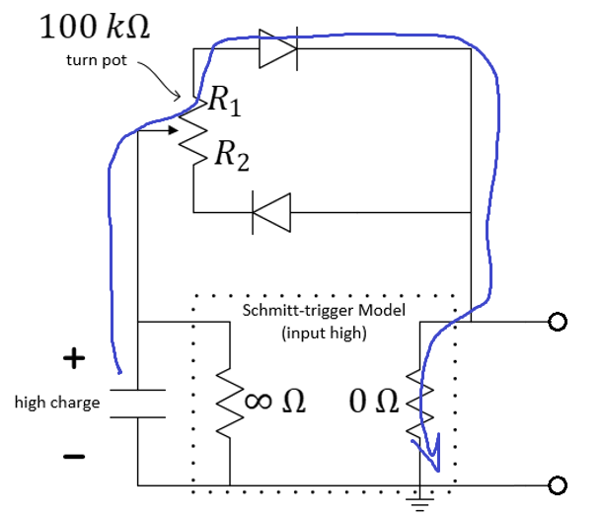
Figure 2: Oscillator with Schmitt-trigger modeled for “input high” (discharging cycle). (The extra 1 kOhm not shown.)
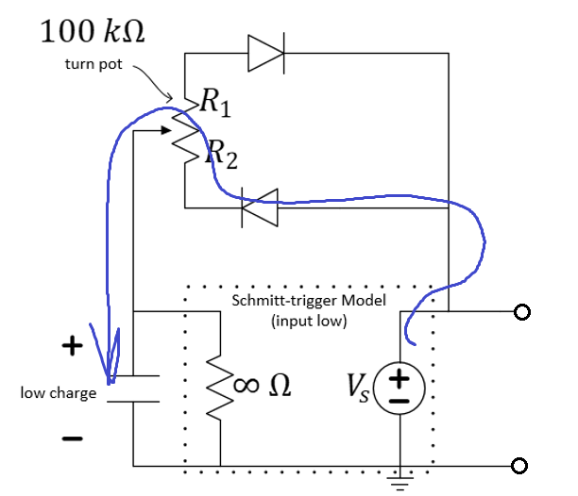
Figure 3: Oscillator with Schmitt-trigger modeled for “input low” (charging cycle). (The extra $1 kΩ$ not shown.)

How to Build it
We want the PWM signal to operate on the order of hundreds of $Hz$. Use a capacitor of value $1 μF$ (marked with 105 meaning 10 plus 5 more zeros or 1,000,000 $pF$). The smaller the capacitor, the faster it will charge and discharge. The smaller the charging and discharging time constants, the larger the frequency of oscillation of the PWM signal will be.
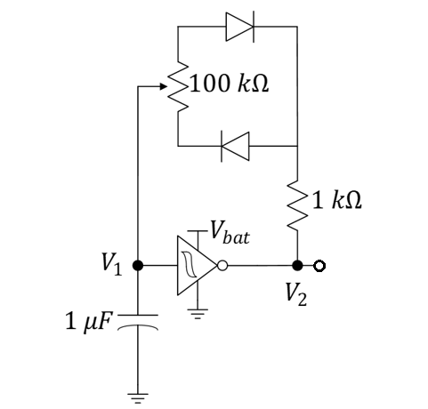
Figure 4: Circuit schematic of an oscillator with a selectable duty cycle and higher frequency of operation.
Build the motor-control circuit below that includes an adjustable wheel-speed balance potentiometer. You should see the familiar motor-drive circuits as well as the oscillator of Figure 4. You may be surprised to see three Schmitt-trigger inverters in this design. The first Schmitt-trigger is used in the PWM oscillator design. The second Schmitt trigger buffers the oscillator circuit from the MOSFET of one motor-drive circuit so that that circuit does not cause a significant load on the oscillator that might affect its behavior. The third Schmitt-trigger inverter inverts the previous signal such that the duty cycle of the second wheel is mirrored of that of the first motor. That is, while the first wheel is driven by duty cycles that can be adjusted from 0 to 100%, the second wheel is driven by duty cycles that vary from 100% to 0%, respectively. The two duty cycles will always follow $\%dc_{1}+\%dc_{2}=100$. The diodes across the motor are “flyback” diodes that will protect the MOSFETs from damage. The motors act much like inductors and their current cannot stop immediately (Physics 212 stuff). Flyback diodes allow a safe path for this current to travel when the transistors suddenly turn off (when the drain-to-source connection becomes an open-circuit).
Flyback Diode: Wikipedia, https://en.wikipedia.org/wiki/Flyback_diode
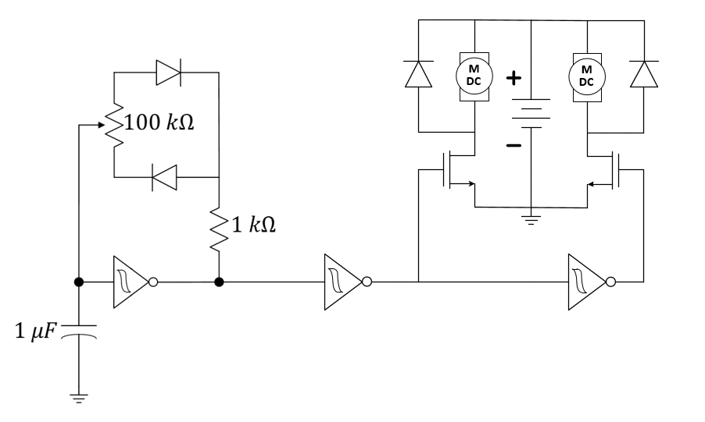
Use: Digital Invertor so that the duty cycle of the right wheel is complementary (orthogonal, in fact) of that of the left wheel.
The term orthogonal is derived from the Greek orthogonios ("ortho" meaning right and "gon" meaning angled).
Orthogonal concepts have origins in advanced mathematics, particularly linear algebra, Euclidean geometry and spherical trigonometry.

What is orthogonal? - Definition from WhatIs.com
Use: Buffers the oscillator from the motor-drive circuitry.
Figure 4: PWM-based wheel balancer. Be sure to apply power and ground to the Schmitt trigger. One IC can supply all three Schmitt triggers. See the datasheet.

Individual Questions
If your circuit is correct, this should take five to ten minutes. “Relatively straight” might mean being able to pass through a doorway several meters away.
- Tune the potentiometer to make the car chassis run in a straight line. You can first tune your duty cycle to 50% (using the oscilloscope if you wish), then do fine tuning by making small adjustments and running your car on the center table or ground. Once your car can travel relatively straight, demo to your TA. If time is tight, your TA may give you permission to submit a short video of your car with your own introduction.

Team Questions (to be discussed explicitly in the Team’s Weekly Report)

- Estimate the frequency of oscillation when the duty cycle is set to 50% for the oscillator of Figure 4. Explain your reasoning.
- What would happen if we removed the two diodes of the oscillator (not the flyback diodes), replacing them with wires, and then turn the potentiometer? Be explicit in discussing duty cycle and frequency.
- Work as a team to estimate an equation of duty cycle as a function of $R_{1}$ and $R_{2}$. Do this for the situation where the diodes are present and the situation when the diodes are removed.

